1)
<?xml version="1.0" encoding="utf-8"?>
<LinearLayout xmlns:android="http://schemas.android.com/apk/res/android"
xmlns:app="http://schemas.android.com/apk/res-auto"
xmlns:tools="http://schemas.android.com/tools"
android:orientation="vertical"
android:layout_width="match_parent"
android:layout_height="match_parent">
<LinearLayout
android:layout_width="match_parent"
android:layout_height="251dp"
android:orientation="vertical">
<Button
android:id="@+id/button4"
android:layout_width="wrap_content"
android:layout_height="wrap_content"
android:layout_weight="1"
android:text="Button" />
<Button
android:id="@+id/button5"
android:layout_width="wrap_content"
android:layout_height="wrap_content"
android:layout_weight="1"
android:text="Button" />
<Button
android:id="@+id/button6"
android:layout_width="wrap_content"
android:layout_height="wrap_content"
android:layout_weight="1"
android:text="Button" />
</LinearLayout>
</LinearLayout>

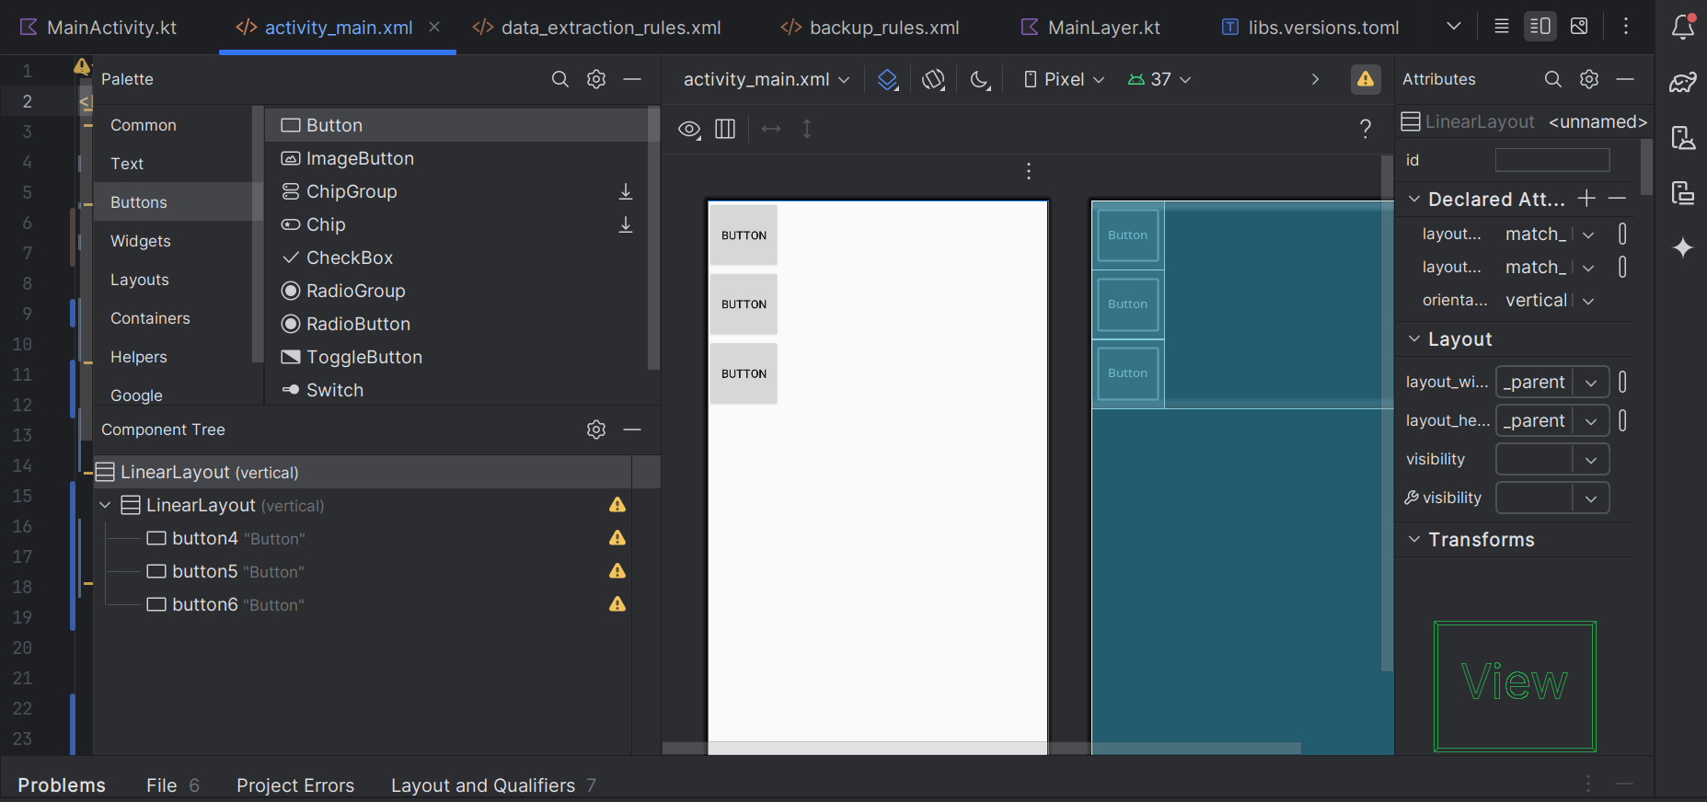
2)

<?xml version="1.0" encoding="utf-8"?>
<LinearLayout xmlns:android="http://schemas.android.com/apk/res/android"
xmlns:app="http://schemas.android.com/apk/res-auto"
xmlns:tools="http://schemas.android.com/tools"
android:orientation="vertical"
android:layout_width="match_parent"
android:layout_height="match_parent">
<LinearLayout
android:layout_width="match_parent"
android:layout_height="251dp"
android:orientation="horizontal">
<Button
android:id="@+id/button4"
android:layout_width="wrap_content"
android:layout_height="wrap_content"
android:layout_weight="1"
android:text="Button" />
<Button
android:id="@+id/button5"
android:layout_width="wrap_content"
android:layout_height="wrap_content"
android:layout_weight="1"
android:text="Button" />
<Button
android:id="@+id/button6"
android:layout_width="wrap_content"
android:layout_height="wrap_content"
android:layout_weight="1"
android:text="Button" />
</LinearLayout>
</LinearLayout>

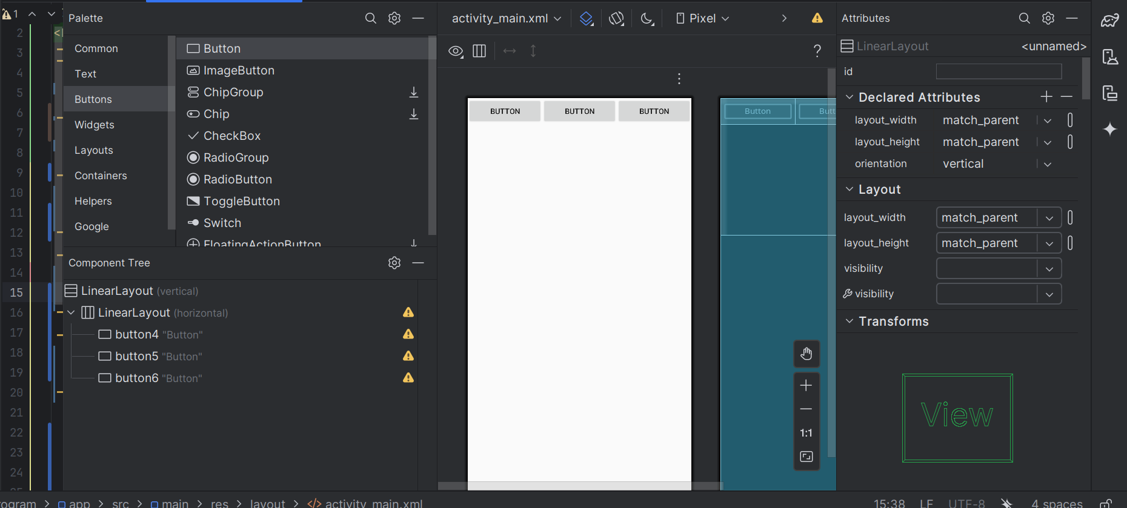
3)<?xml version="1.0" encoding="utf-8"?>
<androidx.constraintlayout.widget.ConstraintLayout xmlns:android="http://schemas.android.com/apk/res/android"
xmlns:app="http://schemas.android.com/apk/res-auto"
xmlns:tools="http://schemas.android.com/tools"
android:id="@+id/linearLayout"
android:layout_width="match_parent"
android:layout_height="match_parent"
android:orientation="vertical">
<ImageView
android:id="@+id/imageView2"
android:layout_width="351dp"
android:layout_height="708dp"
android:src="@drawable/cat"
app:layout_constraintStart_toStartOf="parent"
app:layout_constraintTop_toTopOf="parent"
android:layout_marginStart="-14dp"
android:layout_marginTop="-199dp" />
<Button
android:id="@+id/button8"
android:layout_width="116dp"
android:layout_height="71dp"
android:text="Button"
app:layout_constraintStart_toStartOf="parent"
app:layout_constraintTop_toTopOf="parent" />
</androidx.constraintlayout.widget.ConstraintLayout>

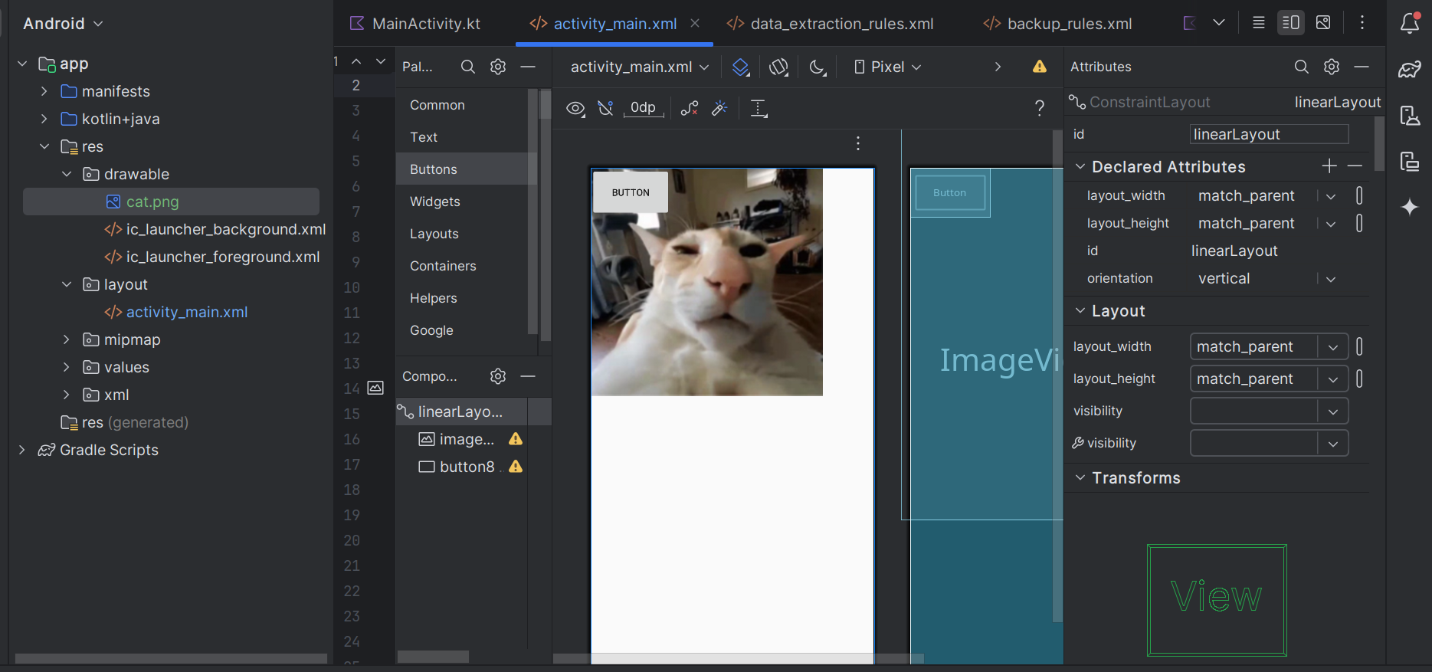
4)

<?xml version="1.0" encoding="utf-8"?>
<LinearLayout xmlns:android="http://schemas.android.com/apk/res/android"
android:layout_width="match_parent"
android:layout_height="match_parent"
android:orientation="vertical"
android:padding="8dp">
<ImageView
android:id="@+id/imageView2"
android:layout_width="wrap_content"
android:layout_height="wrap_content"
android:layout_gravity="center_horizontal"
android:adjustViewBounds="true"
android:src="@drawable/cat" />
<LinearLayout
android:layout_width="match_parent"
android:layout_height="wrap_content"
android:orientation="horizontal"
android:layout_marginTop="8dp">
<Button
android:id="@+id/buttonSmall"
android:layout_width="wrap_content"
android:layout_height="wrap_content"
android:text="Button" />
<Button
android:id="@+id/buttonWideTop"
android:layout_width="0dp"
android:layout_height="wrap_content"
android:layout_weight="1"
android:layout_marginStart="8dp"
android:text="Button" />
</LinearLayout>
<Button
android:id="@+id/buttonWideBottom"
android:layout_width="match_parent"
android:layout_height="wrap_content"
android:layout_marginTop="8dp"
android:text="Button" />
</LinearLayout>

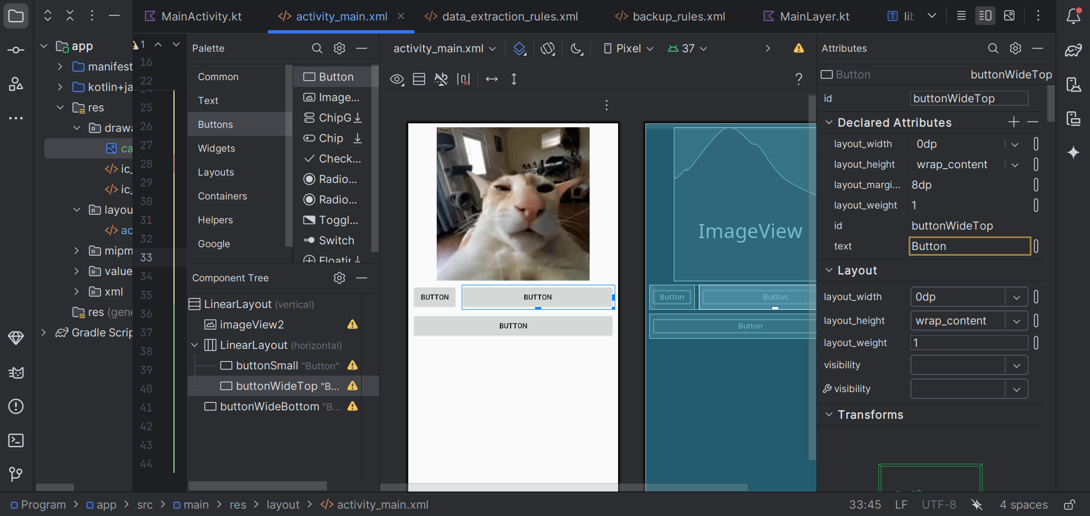
5)
<?xml version="1.0" encoding="utf-8"?>
<RelativeLayout xmlns:android="http://schemas.android.com/apk/res/android"
android:layout_width="match_parent"
android:layout_height="match_parent"
android:padding="8dp">
<Button
android:id="@+id/buttonLeft"
android:layout_width="wrap_content"
android:layout_height="wrap_content"
android:layout_alignParentStart="true"
android:layout_alignParentTop="true"
android:text="Left" />
<Button
android:id="@+id/buttonRight"
android:layout_width="wrap_content"
android:layout_height="wrap_content"
android:layout_alignParentEnd="true"
android:layout_alignParentTop="true"
android:text="Right" />
<ImageView
android:id="@+id/imageView2"
android:layout_width="wrap_content"
android:layout_height="wrap_content"
android:layout_below="@id/buttonLeft"
android:layout_centerHorizontal="true"
android:adjustViewBounds="true"
android:src="@drawable/cat" />
</RelativeLayout>

