Лабораторная работа #5

Код разметки
<?xml version="1.0" encoding="utf-8"?>
<ScrollView xmlns:android="http://schemas.android.com/apk/res/android"
xmlns:app="http://schemas.android.com/apk/res-auto"
android:layout_width="match_parent"
android:layout_height="match_parent"
android:fillViewport="true">
<LinearLayout
android:id="@+id/rootLayout"
android:layout_width="match_parent"
android:layout_height="wrap_content"
android:orientation="vertical"
android:padding="16dp">
<com.google.android.material.textfield.TextInputLayout
android:id="@+id/countDropdownLayout"
style="@style/Widget.Material3.TextInputLayout.OutlinedBox.ExposedDropdownMenu"
android:layout_width="match_parent"
android:layout_height="wrap_content"
android:hint="Количество чисел">
<AutoCompleteTextView
android:id="@+id/countDropdown"
android:layout_width="match_parent"
android:layout_height="wrap_content"
android:inputType="none"
android:text="2" />
</com.google.android.material.textfield.TextInputLayout>
<LinearLayout
android:id="@+id/numbersContainer"
android:layout_width="match_parent"
android:layout_height="208dp"
android:layout_marginTop="12dp"
android:orientation="vertical" />
<com.google.android.material.button.MaterialButton
android:id="@+id/btnFind"
android:layout_width="match_parent"
android:layout_height="wrap_content"
android:layout_marginTop="12dp"
android:text="Найти" />
<TextView
android:id="@+id/txtError"
android:layout_width="match_parent"
android:layout_height="wrap_content"
android:layout_marginTop="8dp"
android:textColor="?attr/colorError"
android:visibility="gone" />
<com.google.android.material.textfield.TextInputLayout
android:layout_width="match_parent"
android:layout_height="wrap_content"
android:layout_marginTop="12dp"
android:hint="НОД">
<com.google.android.material.textfield.TextInputEditText
android:id="@+id/txtResult"
android:layout_width="match_parent"
android:layout_height="wrap_content"
android:focusable="false"
android:inputType="none"
android:clickable="false" />
</com.google.android.material.textfield.TextInputLayout>
</LinearLayout>
</ScrollView>

Код MainActivity
package com.example.lab5true
import android.os.Bundle
import android.text.InputType
import android.widget.ArrayAdapter
import android.widget.AutoCompleteTextView
import android.widget.LinearLayout
import androidx.activity.viewModels
import androidx.appcompat.app.AppCompatActivity
import com.example.lab5true.databinding.ActivityMainBinding
import com.example.lab5true.viewModels.MainViewModel
import com.google.android.material.textfield.TextInputEditText
import com.google.android.material.textfield.TextInputLayout
class MainActivity : AppCompatActivity() {
private lateinit var binding: ActivityMainBinding
private val viewModel: MainViewModel by viewModels()
private val numberFields = mutableListOf<TextInputEditText>()
override fun onCreate(savedInstanceState: Bundle?) {
super.onCreate(savedInstanceState)
binding = ActivityMainBinding.inflate(layoutInflater)
setContentView(binding.root)
setupDropdown()
binding.btnFind.setOnClickListener { viewModel.onFindClick() }
viewModel.state.observe(this) { state ->
renderNumbers(state.numbers)
binding.txtResult.setText(state.result?.toString() ?: "")
binding.txtError.text = state.error ?: ""
binding.txtError.visibility =
if (state.error.isNullOrEmpty()) android.view.View.GONE
else android.view.View.VISIBLE
}
}
private fun setupDropdown() {
val options = listOf("2", "3", "4")
val adapter = ArrayAdapter(this, android.R.layout.simple_list_item_1, options)
binding.countDropdown.setOnItemClickListener { _, _, position, _ ->
viewModel.onCountChange(options[position].toInt())
}
binding.countDropdown.setText("2", false)
}
private fun renderNumbers(numbers: List<String>)
{
if (numberFields.size != numbers.size) {
binding.numbersContainer.removeAllViews()
numberFields.clear()
numbers.forEachIndexed { index, value ->
val textIntputLay = TextInputLayout(this).apply {
hint = "Число ${index + 1}"
layoutParams = LinearLayout.LayoutParams(
LinearLayout.LayoutParams.MATCH_PARENT,
LinearLayout.LayoutParams.WRAP_CONTENT
).apply { topMargin = 8 }
}
val textInputEditedText = TextInputEditText(this).apply {
inputType = InputType.TYPE_CLASS_NUMBER
setText(value)
addTextChangedListener(SimpleTextWatcher { s ->
viewModel.onNumberChange(index, s)
})
}
textIntputLay.addView(textInputEditedText)
binding.numbersContainer.addView(textIntputLay)
numberFields.add(textInputEditedText)
}
} else {
numbers.forEachIndexed { index, value ->
val et = numberFields[index]
if (et.text.toString() != value) et.setText(value)
}
}
}
}
class SimpleTextWatcher(private val onText: (String) -> Unit) : android.text.TextWatcher {
override fun beforeTextChanged(s: CharSequence?, start: Int, count: Int, after: Int) {}
override fun onTextChanged(s: CharSequence?, start: Int, before: Int, count: Int) {
onText(s?.toString() ?: "")
}
override fun afterTextChanged(s: android.text.Editable?) {}
}

Код ViewModel
package com.example.lab5true.viewModels
import androidx.lifecycle.LiveData
import androidx.lifecycle.MutableLiveData
import androidx.lifecycle.ViewModel
import com.example.lab5true.states.NodState
class MainViewModel : ViewModel() {
private val _state = MutableLiveData(NodState())
val state: LiveData<NodState> = _state
private val current: NodState get() = _state.value ?: NodState()
fun onCountChange(newCount: Int) {
val old = current.numbers
val resized = when {
newCount > old.size -> old + List(newCount - old.size) { "" }
newCount < old.size -> old.take(newCount)
else -> old
}
_state.value = current.copy(
count = newCount,
numbers = resized,
error = null,
result = null
)
}
fun onNumberChange(index: Int, value: String) {
if (value.any { !it.isDigit() }) {return}
if(value.length > 1 && value.startsWith("0")){
_state.value = current.copy(numbers = current.numbers, error = "Число не может начинаться с 0", result = 0)
return
}
val updated = current.numbers.toMutableList().apply { this[index] = value }
_state.value = current.copy(numbers = updated, error = null, result = null)
}
fun onFindClick() {
val parsed = current.numbers.map { it.toIntOrNull() }
if (parsed.any { it == null }) {
_state.value = current.copy(
result = null,
error = "Заполните все поля числами"
)
return
}
val ints = parsed.filterNotNull()
if (ints.any { it <= 0 }) {
_state.value = current.copy(
result = null,
error = "Числа должны быть положительными"
)
return
}
_state.value = current.copy(result = findNod(ints), error = null)
}
private fun findNod(numbers: List<Int>): Int {
if (numbers.isEmpty()) return 0
var result = numbers[0]
for (i in 1 until numbers.size) result = gcd(result, numbers[i])
return result
}
private fun gcd(a: Int, b: Int): Int {
var x = a; var y = b
while (y != 0) { val t = x % y; x = y; y = t }
return x
}
}

Скриншоты

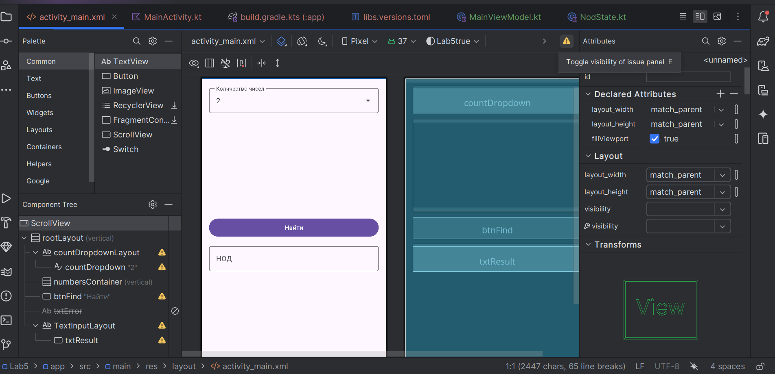
ds

