
The Arab American University
Faculty of Information Technology

No More Cheaters
AI-Powered Exam Proctoring System

Project Team:  Qutaiba Abualrob – CS  Mohamed Sbehat – CS  Haitham Khalil – CS  Mohammed Labadi – CS | Supervisor:  Dr. Ala Hamarsheh  Academic Year:  2025 – 2026

Declaration
We hereby declare that this graduation project, titled &#x201C;No More Cheaters: An AI-Assisted Exam-Proctoring Platform,&#x201D; represents our own original work and effort, except where otherwise acknowledged, and that it has not been submitted, in whole or in part, for any other degree or qualification at this or any other institution. All sources of information, data, and material used in this project have been properly acknowledged and referenced in line with academic conventions.
We also confirm that the system described in this report was designed, built, tested, and deployed entirely by the project team, and that any third-party libraries, tools, and datasets we used are appropriately cited.

Project Team:
Qutaiba Abualrob
Mohamed Sbehat
Haitham Khalil
Mohammed Labadi

Supervisor: Dr. Ala Hamarsheh
Faculty: Faculty of Information Technology
Institution: The Arab American University
Year: 2026

Signature: ______________________________ Date: ____________________

Abstract
Exams are still one of the most important ways to measure what students have learned, but keeping them honest has gotten much harder now that so many assessments happen remotely or at large scale. Traditional human proctoring simply cannot keep up, and the automated proctoring tools currently available tend to rely on constant, real-time surveillance that students find invasive and that has been criticized for being opaque and unfair. This project tackles these issues with No More Cheaters, an AI-assisted exam-proctoring platform that reviews recorded exam videos after the fact instead of watching candidates live.
The platform pairs a computer-vision pipeline, built on the YOLO11x object-detection and pose models along with OpenCV, with a role-based web application. The pipeline samples frames from each recording, spots suspicious behaviors like using a mobile phone or laptop or looking away from the screen, groups noisy frame-level detections into clear, timestamped incidents through temporal rules, and produces an annotated video where every flag is visually highlighted. These incidents feed into an interpretable, weighted cheating-probability report, and a human reviewer stays in charge of every decision, backed by an immutable audit trail. The system was built as a Django REST backend paired with a React single-page frontend, and deployed to a production environment on Amazon Web Services with a GPU-equipped compute instance, a managed relational database, an asynchronous job queue, and HTTPS.
The finished system supports three user roles &#x2014; instructor, dean, and administrator &#x2014; and was put through its paces with a comprehensive automated test suite and an end-to-end demonstration. By focusing on post-hoc analysis, interpretable scoring, visual evidence, and role-based human oversight, No More Cheaters offers a more transparent and accountable way to support exam integrity than the real-time surveillance model used by existing tools.

Keywords: examination integrity; online proctoring; computer vision; YOLO; object detection; pose estimation; deep learning; role-based access control; Django; React.

List of Tables
Table 2.1 Comparison of proctoring approaches and the position of the present project 17
Table 3.1 Functional requirements (FR1–FR14) 21
Table 3.2 Non-functional requirements (NFR1–NFR6) 21
Table 5.1 Summary of key project outcomes 41
Table 5.2 Principal limitations and their severity 44
Table 5.3 Phased future-work roadmap 46

List of Figures
Figure 3.1 Three-tier deployment architecture of the No More Cheaters platform 23
Figure 3.2 Context-level (Level-0) data-flow diagram 24
Figure 3.3 Use case diagram of the No More Cheaters platform 25
Figure 3.4 Sequence diagram for the upload-and-analyze workflow 28
Figure 4.1 UML class diagram of the No More Cheaters domain model 31
Figure 4.2 Entity–Relationship diagram of the database schema 32
Figure 4.3 End-to-end AI processing pipeline, from upload to completed report 35

List of Abbreviations
Abbreviation | Meaning
AI | Artificial Intelligence
API | Application Programming Interface
AWS | Amazon Web Services
BIPA | Biometric Information Privacy Act
CCPA | California Consumer Privacy Act
COCO | Common Objects in Context (dataset)
CORS | Cross-Origin Resource Sharing
CRUD | Create, Read, Update, Delete
CSRF | Cross-Site Request Forgery
CSV | Comma-Separated Values
CV | Computer Vision
DFD | Data-Flow Diagram
DPA | Data Processing Agreement
DRF | Django REST Framework
EC2 | Elastic Compute Cloud (AWS)
ER | Entity–Relationship
FERPA | Family Educational Rights and Privacy Act
FR | Functional Requirement
GDPR | General Data Protection Regulation
GPU | Graphics Processing Unit
HTTP | Hypertext Transfer Protocol
HTTPS | Hypertext Transfer Protocol Secure
JSON | JavaScript Object Notation
LMS | Learning Management System
LTI | Learning Tools Interoperability
MIME | Multipurpose Internet Mail Extensions
ML | Machine Learning
NFR | Non-Functional Requirement
OIDC | OpenID Connect
OTP | One-Time Password
PK | Primary Key
RDS | Relational Database Service (AWS)
REST | Representational State Transfer
SaaS | Software as a Service
SAML | Security Assertion Markup Language
SHA | Secure Hash Algorithm
SLA | Service-Level Agreement
SPA | Single-Page Application
SQL | Structured Query Language
SSO | Single Sign-On
TLS | Transport Layer Security
UML | Unified Modeling Language
URL | Uniform Resource Locator
UUID | Universally Unique Identifier
WCAG | Web Content Accessibility Guidelines
WSGI | Web Server Gateway Interface
YOLO | You Only Look Once

Acknowledgements
Above all, we thank God for giving us the strength, patience, and determination to see this project through to completion.
We owe a great deal of gratitude to our supervisor, Dr. Ala Hamarsheh, for his invaluable guidance, encouragement, and steady support at every stage of this work. His thoughtful feedback and deep expertise played a key role in shaping both the direction and the quality of this project.
We are also thankful to the Faculty of Information Technology at The Arab American University, and to all the faculty members and staff whose teaching and support gave us the foundation of knowledge and skills we applied throughout this project.
Last but not least, we want to express our heartfelt appreciation to our families and friends for their unwavering support, patience, and encouragement throughout our studies. None of this would have been possible without them.

Qutaiba Abualrob, Mohamed Sbehat, Haitham Khalil, Mohammed Labadi

Chapter One
Introduction

1.1 Background and Motivation
Exams continue to be one of the most common ways to assess what students have learned, and the value of any academic qualification hinges on the assumption that the work behind it is genuinely the student&#x2019;s own. Academic integrity is not some peripheral concern &#x2014; it is foundational to the credibility of higher education. Unfortunately, academic dishonesty is nothing new and far from rare. In their influential review of a decade of research, McCabe, Trevi&#xF1;o, and Butterfield (2001) showed that cheating is widespread among college and university students and that several forms of it have grown significantly over time, with students&#x2019; perceptions of how their peers behave emerging as one of the strongest predictors of misconduct. Put simply, the challenge of maintaining integrity during exams has been around for as long as formal examinations have existed.
Over the last twenty years or so, this age-old problem has been reshaped by the shift toward online teaching and assessment &#x2014; a transition that the COVID-19 pandemic dramatically accelerated. When campuses shut down, institutions moved exams to remote settings practically overnight, and the adoption of online and remote proctoring services surged accordingly; by April 2020, more than half of surveyed institutions reported using some form of online or remote proctoring, with many more planning to follow suit (Inside Higher Ed, 2020). This rapid shift heightened concerns that the lack of a physical invigilator would make cheating easier. Systematic reviews of the literature confirm that cheating in online exams is indeed common and that the move to unproctored or loosely supervised remote assessment opened up real new avenues for misconduct (Noorbehbahani, Mohammadi, &amp; Aminazadeh, 2022; Newton &amp; Essex, 2024).
The typical response to this risk is direct human supervision &#x2014; whether an invigilator in an exam hall or a live remote proctor watching a webcam feed. Both approaches, though, struggle to scale. Human invigilation is labor-intensive and expensive, and it becomes impractical when hundreds of candidates are sitting an exam at the same time or asynchronously across different locations and time zones. Reviewing recorded exam videos after the fact is just as demanding: no instructor can realistically watch hours of footage for every student, and manual review is slow, inconsistent, and vulnerable to fatigue &#x2014; so real violations easily slip through while honest behavior may be unfairly flagged.
Commercial proctoring platforms try to bridge this gap with automated, real-time monitoring, but they have drawn significant criticism. Researchers and commentators have raised serious concerns about privacy, surveillance, transparency, and fairness &#x2014; pointing out that continuously recording a student&#x2019;s private space can expose sensitive personal information, that proprietary detection algorithms often work as opaque &#x201C;black boxes,&#x201D; and that automated flagging can disproportionately and unfairly impact certain groups of students (Swauger, 2020). The feeling of being watched can also ramp up test anxiety. These criticisms suggest that the real goal should not be replacing human judgment with an automated verdict, but rather supporting it: a well-designed system should surface evidence for a human to review, not issue accusations on its own.
At the same time, the technical tools for automatically analyzing visual data have matured rapidly. Modern deep-learning object detectors can identify objects in images and video in real time with high accuracy. The You Only Look Once (YOLO) family of detectors, introduced by Redmon, Divvala, Girshick, and Farhadi (2016), reframed detection as a single regression problem and made fast, accurate, single-pass detection practical. Meanwhile, large annotated datasets like Microsoft COCO (Lin et al., 2014) provide the common object vocabulary &#x2014; including everyday items like mobile phones and laptops &#x2014; on which these detectors are trained. Paired with pose-estimation techniques that infer head and gaze orientation, these advances make it entirely feasible to analyze recorded exam footage automatically and flag the behaviors most commonly associated with cheating.
These two threads &#x2014; a persistent integrity problem made worse by remote assessment, and a rapidly maturing toolkit of computer-vision technologies &#x2014; together motivate this project. No More Cheaters is an AI-assisted exam-proctoring platform that analyzes recorded exam videos instead of monitoring students in real time. It automatically flags suspicious behavior such as the presence of a phone or laptop and a candidate repeatedly looking away from the screen, then presents the resulting evidence through a role-based web dashboard. By working with recordings after the fact, keeping a human reviewer in the loop, providing an interpretable score alongside the visual evidence behind it, and logging every action in an immutable audit trail, the system is deliberately positioned as a decision-support tool. This approach addresses several of the fairness and transparency concerns raised against existing solutions while freeing instructors from the impractical burden of manual review.

1.2 Aims and Objectives
The main goal of this project is to design and build an AI-assisted proctoring platform that helps academic staff maintain exam integrity at scale. It does this by automatically analyzing recorded exam videos, flagging likely instances of misconduct with supporting visual evidence, and presenting those findings through a secure, role-based interface that leaves the final call in human hands. To achieve this goal, the project pursues these specific objectives:
- Build an automated video-analysis pipeline. Develop a computer-vision pipeline that pulls frames from recorded exam videos and runs object detection and pose analysis to spot the behaviors most linked to cheating &#x2014; namely the presence of mobile phones and laptops and a candidate consistently looking away from the screen.
- Convert raw detections into meaningful incidents. Use temporal rules to merge noisy, frame-level detections into a small set of consolidated, timestamped events. This filters out fleeting false positives so that reviewers see coherent incidents rather than thousands of isolated hits.
- Produce an interpretable integrity score. Combine the detected incidents into a single, explainable cheating-probability score for each exam session, complete with severity levels and per-behavior weighting that a reviewer can easily understand and justify.
- Provide annotated visual evidence. Create an annotated version of each recording with bounding boxes and per-incident markers, so every flag can be traced back to concrete visual evidence and verified by a human.
- Design a secure, role-based web platform. Build a web application that authenticates users and tailors its features to three roles &#x2014; instructor, dean, and administrator &#x2014; supporting video upload and analysis, result review, institutional oversight, and system administration, each limited to the appropriate role.
- Ensure accountability and transparency. Keep a human reviewer in the loop for all flagged incidents and maintain an immutable, append-only audit trail of security-relevant actions, so that decisions can be reviewed and the system&#x2019;s use can be held accountable.
- Support configurability and responsible data handling. Let detection sensitivity be tuned through configurable thresholds and provide controls for video retention, so the platform can be adapted to fit institutional policy and privacy requirements.
- Validate the system. Confirm the platform&#x2019;s correctness and reliability through a comprehensive automated test suite covering the data model, the service and API layers, and the analysis workflow.

1.3 Problem Statement
The rise of remote and large-scale exams has created a volume of recorded assessment footage that is simply too much for academic staff to review by hand. Manual review of exam recordings is slow, inconsistent, and mentally exhausting, which means real violations often go unnoticed while honest candidates can end up being misjudged. Live human invigilation, whether in person or through a remote proctor, does not scale to large or distributed groups and is expensive to provide.
Current automated proctoring solutions try to tackle the scale problem, but they bring issues of their own. Many depend on continuous real-time surveillance that students find intrusive and anxiety-inducing; their detection logic is usually proprietary and opaque, giving little explanation for why a student was flagged; and their automated decisions have been criticized as unfair and potentially biased against certain groups (Swauger, 2020). Perhaps most importantly, several of these systems blur the line between detecting a possible irregularity and accusing a student of misconduct, with limited room for transparent human review of the underlying evidence.
There is clearly a need for a proctoring approach that brings together the scalability of automation with the accountability of human oversight. The problem this project addresses is how to design and build a system that can automatically analyze recorded exam videos, reliably flag the behaviors most associated with cheating, express its findings as an interpretable score backed by concrete visual evidence, and deliver those findings through a secure, role-appropriate interface &#x2014; all while keeping the final determination with a human reviewer, recording its actions transparently, and respecting the privacy of the students it observes.

1.4 Contributions
In tackling the problem described above, this project makes the following key contributions:
- An end-to-end AI-assisted proctoring platform. A complete, working system that takes in recorded exam videos, analyzes them automatically, and presents the results through a role-based web dashboard &#x2014; showing that post-hoc, evidence-centered proctoring is entirely practical to build with mainstream technologies.
- A decoupled computer-vision pipeline. A standalone analysis pipeline that pairs YOLO-based object detection (for phones and laptops) with a pose-based heuristic for catching looking-away behavior. It is designed to be independent of the web framework so it can be developed, tested, and swapped out on its own.
- A temporal consolidation strategy. A rule-based layer that merges same-behavior detections within a short time window, keeps the strongest evidence, and throws out events too brief to be meaningful &#x2014; turning raw frame-level noise into clean, reviewer-friendly incidents.
- An interpretable scoring model. A transparent cheating-probability measure that blends per-incident confidence with behavior-specific risk weights using an independent-evidence formula, giving reviewers a clear, explainable summary rather than an opaque verdict.
- A governance-oriented, role-based architecture. An access-control design with distinct instructor, dean, and administrator roles, human-in-the-loop review of every alert, and an immutable audit log &#x2014; directly targeting the transparency and accountability gaps found in existing tools.
- Configurable, privacy-conscious operation. Adjustable detection thresholds and video-retention controls that let the platform align with institutional policy and student-privacy expectations.
- A validated implementation. A fully realized system built on a modern web and machine-learning stack, accompanied by a comprehensive automated test suite &#x2014; providing a tested reference implementation that can serve as a foundation for further research and development.

1.5 Structure of the Report
The rest of this report is organized into four additional chapters that take the project from its conceptual grounding all the way through to its design and conclusions:

Chapter | Focus
Chapter 2 — Literature Review | Surveys prior work on academic integrity and on human-proctored, automated, and AI-assisted online proctoring, and identifies the gaps this project sets out to address.
Chapter 3 — System Analysis | Defines the functional and non-functional requirements, the user and administrator requirements, the overall architecture, and the development methodology adopted for the project.
Chapter 4 — System Design | Presents the detailed design: the class diagram and object model, the relational database design, the AI processing pipeline, the interface design, and the technology stack.
Chapter 5 — Conclusions and Future Work | Summarizes what was achieved, discusses the limitations of the current system, and outlines directions for future improvement in detection capability, scalability, and integration.

Taken together, these chapters follow the project from the problem and its context, through the requirements and design, to a reflection on what was achieved and where things could go next.

Chapter Two
Literature Review

2.1 Overview
This chapter looks at the body of work surrounding the problem of maintaining exam integrity in remote and large-scale assessments, and places the No More Cheaters platform within that landscape. The review serves two purposes: to map out the existing proctoring approaches and the technologies behind them, and to highlight the gaps that a new system can meaningfully address. Proctoring, in its broadest sense, means supervising candidates during an assessment to deter and detect dishonest behavior. How that supervision actually gets delivered, however, has changed dramatically as assessment has moved online.
The underlying problem has been around for a long time. Studies on academic integrity have consistently shown that cheating is common among students and that contextual factors play a big role in shaping it (McCabe, Trevi&#xF1;o, &amp; Butterfield, 2001). The shift to online exams, which the COVID-19 pandemic sped up considerably, revived concerns that weaker supervision would make misconduct easier. Systematic reviews confirm that cheating in online exams is both widespread and varied in form (Noorbehbahani, Mohammadi, &amp; Aminazadeh, 2022; Newton &amp; Essex, 2024). These findings have fueled a rapid expansion in proctoring technology and a growing body of research evaluating it.
The proctoring approaches found in the literature can be organized along two dimensions: who or what does the supervising, and when it happens. On the first axis, supervision ranges from a human invigilator, to a remote human proctor watching a live feed, all the way to a fully automated system that uses artificial intelligence to analyze the candidate&#x2019;s behavior. On the second axis, supervision is either synchronous &#x2014; happening live as the candidate sits the exam &#x2014; or asynchronous, carried out after the fact on a recording. Recent advances in AI and sensor-based analytics have steadily pushed the field from manual toward automated supervision, enabling real-time monitoring, behavioral analysis, and the automatic flagging of anomalies (Nigam, Pasricha, Singh, &amp; Churi, 2021).
These automated systems share a recognizable set of computer-vision and signal-processing building blocks. Common components include face detection and recognition for identity verification, gaze and head-pose estimation to tell when a candidate looks away from the screen, audio analysis to pick up speech, and object detection to spot prohibited items like mobile phones (Nigam et al., 2021; Atoum, Chen, Liu, Hsu, &amp; Liu, 2017). The object-detection component, in particular, has been transformed by deep-learning detectors like the You Only Look Once (YOLO) family (Redmon, Divvala, Girshick, &amp; Farhadi, 2016), trained on large datasets such as Microsoft COCO (Lin et al., 2014), which together make fast and accurate detection of everyday objects practical. Yet alongside these technical advances runs a persistent tension: the very capabilities that make automated proctoring scalable also raise serious concerns about privacy, surveillance, transparency, and fairness (Swauger, 2020). The sections that follow look at how existing systems try to balance these competing pressures.

2.2 Existing Systems
Existing proctoring solutions fall into three broad categories: human-proctored approaches, commercial automated and AI-assisted platforms, and academic research systems. Each category sits at a different point on the trade-off between scalability, cost, intrusiveness, and transparency.
2.2.1 Human-Proctored Approaches
The classic approach is in-person invigilation, where one or more proctors physically supervise candidates in an exam hall. This method is well understood and offers immediate human judgment, but it does not scale well: it is labor-intensive, expensive, and simply not available when candidates sit exams remotely or asynchronously from different locations. The online equivalent is live remote proctoring, offered by services like ProctorU and Examity, where a human proctor watches a candidate&#x2019;s webcam and screen feed in real time, sometimes with software assistance to pre-flag suspicious moments. Live remote proctoring keeps the human element intact but inherits and amplifies the cost problem &#x2014; a proctor can only monitor a limited number of candidates at once &#x2014; and it brings scheduling constraints along with significant privacy and anxiety concerns, since a stranger is observing the candidate in their private space (Swauger, 2020).
2.2.2 Commercial Automated and AI-Assisted Platforms
To cut down on the need for human proctors, commercial vendors have rolled out increasingly automated platforms. Respondus pairs a locked-down browser &#x2014; which blocks access to other applications during an exam &#x2014; with Respondus Monitor, which records the session and runs automated analysis so instructors can review flagged segments afterward, prioritized by apparent risk. Proctorio works as a browser extension integrated with learning-management systems, offering configurable lockdown, recording, and verification options along with automated behavioral analysis. Honorlock takes a blended approach, combining automated AI monitoring (including detection of secondary devices) with the option for a live proctor to &#x201C;pop in&#x201D; and intervene when the system flags something suspicious, rather than leaving everything for post-exam review.
These platforms do deliver real scalability and have seen widespread adoption, but the research literature highlights recurring shortcomings. Their detection logic is typically proprietary and opaque, leaving both students and instructors unable to understand why a particular session was flagged. Automated decisions have been criticized as potentially biased against some student groups, and the continuous recording of a candidate&#x2019;s private environment raises substantial privacy concerns while also heightening test anxiety (Swauger, 2020; Nigam et al., 2021). In short, commercial tools solve the scaling problem but often do so at the expense of transparency, fairness, and student trust.
2.2.3 Academic Research Systems
Alongside commercial development, the academic community has produced a range of research prototypes exploring the computer-vision techniques that underpin automated proctoring. A widely cited example is the multimedia-analytics system by Atoum et al. (2017), which fuses several visual and audio cues &#x2014; including gaze and head-pose estimation, detection of the active application window, and the presence of additional persons or devices &#x2014; to estimate the likelihood of cheating from recorded exam footage. Comprehensive surveys of this literature, most notably Nigam et al. (2021), catalog the architectures, the behavioral parameters considered, and the open challenges of AI-based proctoring systems, noting a clear shift from manual toward fully automated supervision while cautioning that security, privacy, ethics, and trust remain unresolved. These academic systems push the boundaries of detection, but they tend to stay at the prototype stage, focused on the analysis algorithm itself, with limited attention to the broader institutional workflow &#x2014; role-based access, human review, auditability, and configurability &#x2014; that a deployable platform needs.

Comparison of proctoring approaches. Table 2.1 summarizes the main categories of proctoring system reviewed above, contrasting how each works, when supervision occurs, and the key limitations reported in the literature, and shows where this project fits in.

Approach / Example | How it works | Timing | Main limitations
In-person invigilation | A human proctor supervises candidates in an examination hall. | Live | Labor-intensive and costly; unavailable for remote or large distributed cohorts.
Live remote proctoring (ProctorU, Examity) | A human proctor watches webcam and screen feeds in real time, sometimes after software pre-flagging. | Live | Costly and hard to scale; scheduling constraints; privacy intrusion and test anxiety.
Record-and-review (Respondus Monitor) | The session is recorded and automatically flagged; the instructor reviews prioritized segments afterwards. | Post-hoc | Still requires review effort; opaque flags; false positives to sort through.
Automated AI proctoring (Proctorio, Honorlock) | Browser lockdown plus AI analysis of face, gaze, audio, and secondary devices, with optional live intervention. | Live / hybrid | “Black-box” decisions; bias and fairness concerns; continuous surveillance.
Academic CV systems (Atoum et al., 2017) | Multimedia analytics fusing gaze/head-pose, active-window, and person/object detection. | Post-hoc / real-time | Research prototypes only; limited workflow integration; computationally heavy.
This project (No More Cheaters) | Post-hoc analysis of recordings using YOLO object and pose-based gaze detection; consolidated alerts and an interpretable score with role-based review and audit. | Post-hoc | Current detection limited to phones, laptops, and looking-away behavior.
Table 2.1 — Comparison of proctoring approaches and the position of the present project

2.3 Summary
What the literature reveals is a field caught between two goals that are hard to achieve at the same time: supervising exams at scale, and doing so in a way that students experience as fair, transparent, and respectful of their privacy. Human-proctored approaches offer trusted judgment but cannot scale; commercial automated platforms scale effectively but are widely criticized as opaque, potentially biased, and intrusively surveillant; and academic research systems advance the underlying detection techniques but largely stop at the algorithm, leaving the institutional workflow around it underdeveloped.
Several specific gaps stand out from this analysis. First, most deployed systems rely on continuous, real-time observation &#x2014; which is the main source of their privacy and anxiety problems &#x2014; while comparatively little attention has gone toward post-hoc analysis of recordings, which can deliver the same evidence with a much lighter footprint. Second, the decision logic of commercial tools is rarely transparent, and few systems offer an interpretable score backed by the concrete visual evidence behind it. Third, academic prototypes rarely wrap their detection capabilities in a complete, role-aware platform with human-in-the-loop review, an immutable audit trail, and configurable sensitivity &#x2014; the governance features that make a system trustworthy and practical to deploy.
The No More Cheaters platform is built to address these gaps head-on. Instead of monitoring candidates live, it analyzes recorded exam videos after the fact; instead of delivering an opaque verdict, it produces an interpretable, weighted probability score backed by annotated visual evidence and per-incident alerts; and instead of stopping at the detection algorithm, it wraps that algorithm in a secure, role-based workflow that keeps a human reviewer in control and logs every action in an immutable audit trail. The detailed requirements and design that bring this approach to life are presented in the chapters that follow.

Chapter Three
System Analysis

3.1 Introduction
This chapter digs into the No More Cheaters platform to turn the problem and context established earlier into a precise set of requirements and an architecture that meets them. System analysis bridges the gap between the high-level motivation for the project and its detailed design: it identifies who will use the system and what they need from it, lays out the functional and non-functional requirements, defines the architecture that supports those requirements, and models the system&#x2019;s behavior using established notations. The analysis presented here is grounded directly in the system as built &#x2014; an AI-assisted exam-proctoring platform that analyzes recorded exam videos, flags suspicious behavior, and presents the results through a role-based web dashboard.
Here is how this chapter is laid out. Section 3.2 analyzes the shortcomings of existing systems and draws out the implications for this project. Section 3.3 spells out the functional and non-functional requirements. Section 3.4 covers the design objectives, the user requirements for each role, and the overall system architecture. Section 3.5 walks through the development methodology and models the system using a context data-flow diagram, a use case diagram with detailed descriptions, and a sequence diagram. Section 3.6 wraps things up.

3.2 Analysis of Existing Systems
As we saw in the literature review, existing proctoring solutions fall into three broad groups, each with its own characteristic weaknesses. Human-proctored approaches &#x2014; whether in an exam hall or via a live remote proctor &#x2014; offer trusted judgment but cannot scale to large or distributed cohorts and are costly to run. Commercial automated platforms scale well but depend on continuous real-time surveillance that students find intrusive, use proprietary and opaque decision logic, and have been widely criticized on fairness and privacy grounds. Academic research prototypes push the underlying detection techniques forward but typically stop at the analysis algorithm, paying little attention to the institutional workflow &#x2014; role-based access, human review, auditability, and configurability &#x2014; that a deployable system needs.
This analysis leads to several concrete implications that shape what the new system needs to do. First, analyzing recorded videos after the exam, rather than watching candidates live, removes the most intrusive aspect of existing tools while still preserving the evidence needed to catch misconduct. Second, the system should not hand down an opaque verdict; it should produce an interpretable score accompanied by the specific visual evidence behind each flag, and it should keep a human reviewer in charge of the final judgment. Third, the detection capability needs to live inside a complete, role-aware platform that distinguishes between instructors, deans, and administrators, records its actions in an immutable audit trail, and lets detection sensitivity be configured. These implications feed directly into the requirements spelled out below.

3.3 System Requirements
3.3.1 Functional Requirements
The functional requirements lay out the specific behaviors the system needs to provide. Fourteen functional requirements (FR1&#x2013;FR14) were identified, each realized by one or more components of the implemented platform, as summarized in Table 3.1.

ID | Requirement | Description
FR1 | User and role management | Register and authenticate users by email, assign the roles Administrator, Dean, or Instructor, and manage accounts and per-user preferences.
FR2 | Exam video upload | Allow an instructor to upload a recorded examination video through a multipart request.
FR3 | Upload format validation | Validate the uploaded file’s media type and extension, accepting only supported video formats.
FR4 | Duplicate detection | Compute a SHA-256 hash of each upload and reject duplicate recordings to prevent redundant storage and analysis.
FR5 | Exam session management | Create and manage one examination session per student per exam, enforcing uniqueness of student within an exam.
FR6 | Analysis dispatch | Queue and run an AI analysis job for an uploaded video, supporting both synchronous and asynchronous execution.
FR7 | Video analysis pipeline | Sample frames from the recording and detect prohibited objects (phones, laptops) and looking-away behavior.
FR8 | Alert generation | Create a timestamped alert for each consolidated suspicious incident detected in the video.
FR9 | Severity and confidence scoring | Assign a confidence score and a severity level (low, medium, or high) to every alert.
FR10 | Alert review | Allow an authorized reviewer to mark an alert as reviewed, keeping a human in the loop for every flag.
FR11 | Report generation | Aggregate a session’s alerts into a report with an overall, interpretable cheating-probability score.
FR12 | Dashboards and history | Present role-appropriate statistics, recent activity, and a history of completed analyses.
FR13 | System configuration | Manage global and per-user detection thresholds and other administrator-controlled settings.
FR14 | Audit logging | Record all security-relevant actions in an immutable, append-only audit trail.
Table 3.1 — Functional requirements (FR1–FR14)
3.3.2 Non-Functional Requirements
The non-functional requirements describe the quality attributes the system needs to exhibit. Six non-functional requirements (NFR1&#x2013;NFR6) were identified, as summarized in Table 3.2.

ID | Attribute | Requirement
NFR1 | Security | Communications use HTTPS/TLS; the system enforces CSRF and CORS protection, session- and token-based authentication, hashed passwords, role-based access control, and an immutable audit trail.
NFR2 | Performance | Analysis remains tractable through frame sampling and an asynchronous job queue with optional GPU acceleration, while the single-page interface stays responsive.
NFR3 | Reliability | Analysis jobs run within database transactions and failures are recorded by marking the job and session as failed, so the system degrades gracefully and failures can be retried or investigated.
NFR4 | Usability | The interface adapts to each role, distills detection sensitivity into a single intuitive control, and presents sanitized, friendly error messages rather than technical detail.
NFR5 | Scalability | A decoupled queue and background worker, a managed relational database, and a stateless API allow the workload to be scaled out under increasing demand.
NFR6 | Privacy | Recorded videos are retained for a limited period (30 days), data exposure is minimized, and technical information is never leaked to end users.
Table 3.2 — Non-functional requirements (NFR1–NFR6)

3.4 Design Objectives and Requirements
The requirements above come together under a small set of guiding design principles: keep detection decoupled and replaceable, keep the web layer thin by concentrating business logic in a service layer, enforce authorization consistently by role, and make every significant action observable through auditing. These principles inform both the user requirements that follow and the architecture described after them.
3.4.1 User Requirements
The platform serves three distinct user roles, each with its own set of needs. The user requirements below describe, in the users&#x2019; own terms, what each role needs to be able to do.
Instructor. As the primary user, an instructor needs to log in securely, upload recorded exam videos, kick off their analysis, and view the resulting report with its overall score and supporting alerts. The instructor should also be able to review and acknowledge individual alerts, look back through a history of completed analyses, adjust detection sensitivity to suit a particular assessment, and manage a roster of students.
Dean. A dean needs a bird&#x2019;s-eye view across instructors rather than hands-on analysis. The dean should be able to log in, view summaries of instructors and their activity, manage exam halls and exams, assign supervisors, and review analysis results &#x2014; all in order to keep tabs on integrity at the faculty level.
Administrator. An administrator needs full control over how the platform operates. This means being able to log in, manage user accounts and roles, set global detection thresholds and system settings, and keep an eye on things through audit logs and runtime metrics.
3.4.2 System Architecture
The system uses a decoupled client&#x2013;server architecture organized into three tiers, as shown in Figure 3.1. The client tier is a single-page application built with React 19 and Vite, hosted on Vercel; it runs entirely in the user&#x2019;s browser and talks to the backend exclusively over HTTPS using a REST API. The application server tier, deployed on an AWS EC2 instance with GPU support, places Nginx as a reverse proxy that terminates HTTPS (with certificates from Certbot) in front of a Gunicorn server running the Django 5.2 and Django REST Framework application. Within the backend, HTTP views are kept thin and hand off work to a service layer, with data access centralized in selectors.
The heavy lifting of analysis is separated from request handling. When an analysis is requested, the backend places a job onto a Redis-backed queue, and a background worker (rqworker) picks it up and runs it, calling the AI pipeline built on YOLO11x object detection, a YOLO11x-pose model, and OpenCV. The data tier consists of a managed RDS MySQL database for relational data and EC2 disk storage for uploaded videos and annotated output files, while transactional email &#x2014; for verification and notifications &#x2014; is handled by the external Resend service. This setup lets the same codebase run synchronously on a developer machine with no extra infrastructure and asynchronously on a GPU server under production load.
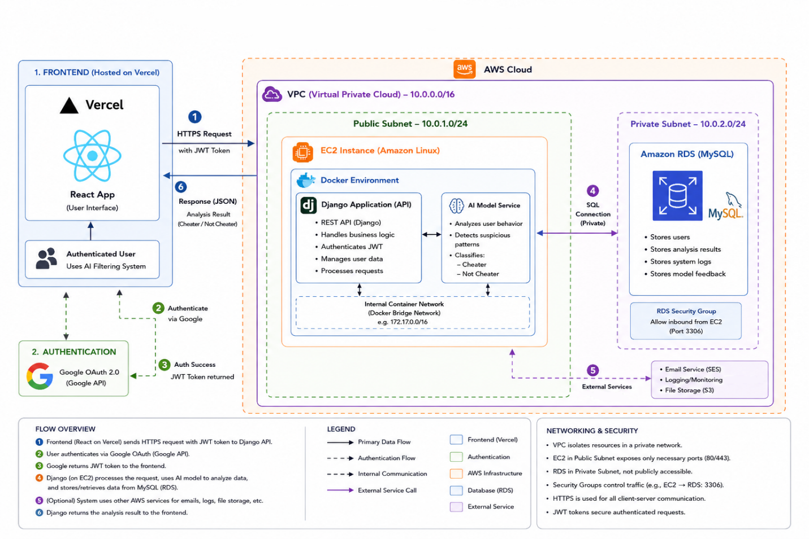
Figure 3.1 — Three-tier deployment architecture of the No More Cheaters platform

3.5 Development Methodology
The project followed an Agile development methodology, building the system incrementally through a series of short, time-boxed iterations rather than in one big push. Each iteration delivered a working slice of functionality &#x2014; for example, the data model and authentication first, then the analysis pipeline, then the role-based interface and oversight features &#x2014; which allowed requirements to be validated continuously and priorities to shift as the system matured. This iterative, feedback-driven approach was a natural fit for a project whose AI component carried inherent technical uncertainty and benefited from early, repeated testing.
3.5.1 Modeling Approach
The system was modeled using the Unified Modeling Language (UML), supplemented by a data-flow view of the system&#x2019;s context. UML use case and sequence diagrams capture, respectively, the functional scope from the actors&#x2019; perspective and the dynamic interaction between components during the core proctoring workflow. To complement these object-oriented models with a process-oriented view, Figure 3.2 presents a context-level (Level-0) data-flow diagram, showing the system as a single process exchanging data with its external entities &#x2014; the instructor, dean, administrator, and the external email service.
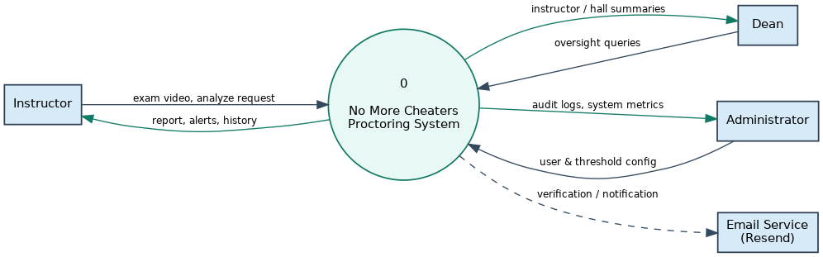
Figure 3.2 — Context-level (Level-0) data-flow diagram
3.5.2 Use Case Diagram
The use case diagram in Figure 3.3 lays out the functional scope of the system by connecting the three actors to the use cases each can perform. All actors share the Authenticate use case, while the rest are split by role: the instructor handles upload, analysis, review, and configuration; the dean handles oversight and hall management; and the administrator handles user management, configuration, and monitoring. The Analyze Video use case includes Generate Alerts and Generate Report, reflecting that analysis naturally produces both as part of a single workflow.
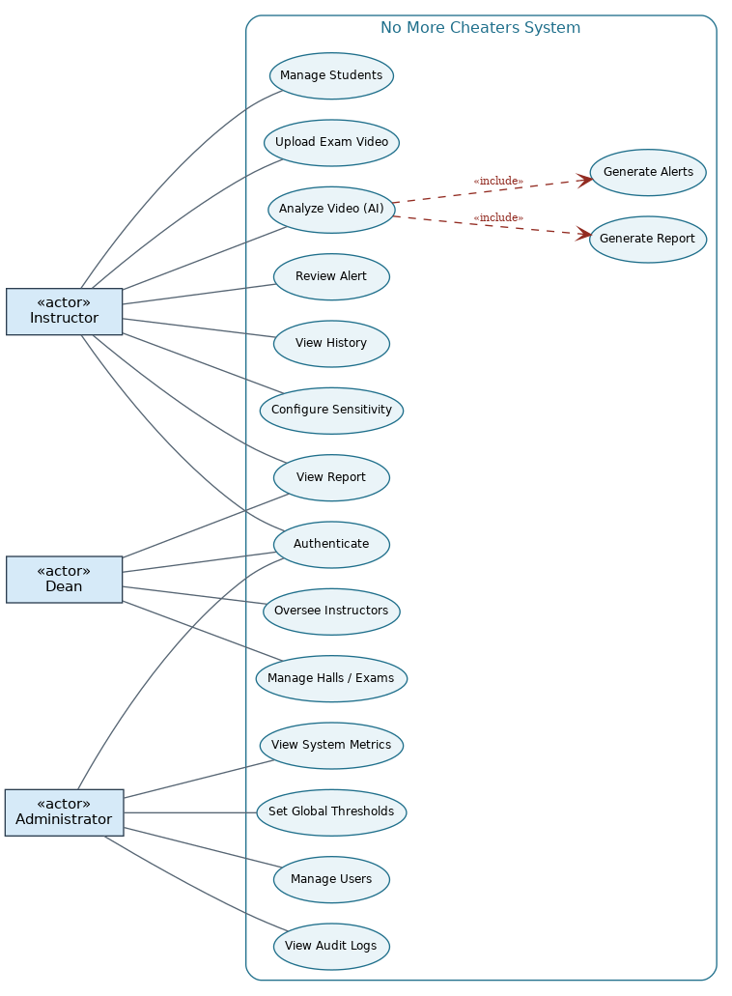
Figure 3.3 — Use case diagram of the No More Cheaters platform

3.5.3 Detailed Use Case Descriptions
The most important use cases are described in detail below, covering their actors, preconditions, main and alternative flows, and postconditions.

Use Case 1 — Upload and Analyze Exam Video
Use Case | Upload and Analyze Exam Video
Actor | Instructor
Description | The instructor uploads a recorded examination video and requests its automated analysis.
Preconditions | The instructor is authenticated and possesses a valid recorded video file.
Main Flow | 1. The instructor selects a video file and submits it for upload.  2. The system validates the file format and computes its SHA-256 hash.  3. The system creates a video record and an examination session and logs the upload.  4. The instructor requests analysis of the uploaded video.  5. The system queues an analysis job and runs the AI pipeline (frame sampling, object and pose detection, consolidation).  6. The system stores the generated alerts and report and marks the session completed.  7. The system presents the report, overall score, and alerts to the instructor.
Alternative Flows | 2a. If the file format is invalid, the system rejects the upload with an explanatory message.  2b. If the file is a duplicate (matching hash), the system rejects it as already present.  5a. In asynchronous mode, the system returns an “accepted” response and the instructor consults the history view once processing completes.  5b. If analysis fails, the system marks the job and session as failed and records the error.
Postconditions | A report and its alerts exist for the session, or the session is marked failed; the actions are recorded in the audit log.

Use Case 2 — Review Alert
Use Case | Review Alert
Actor | Instructor
Description | The instructor looks at a flagged incident and records a review decision.
Preconditions | An analysis report with one or more alerts exists for the session.
Main Flow | 1. The instructor opens the report and selects an alert.  2. The system displays the alert’s behavior type, timestamp, confidence, severity, and supporting visual evidence.  3. The instructor evaluates the evidence and marks the alert as reviewed.  4. The system records the reviewer and the time of review and updates the alert’s status.
Alternative Flows | 3a. The instructor may clear a previously recorded review, returning the alert to an unreviewed state.
Postconditions | The alert’s reviewed status and reviewer are recorded; the action is written to the audit log.

Use Case 3 — Manage Users
Use Case | Manage Users
Actor | Administrator
Description | The administrator creates, updates, or removes user accounts and assigns their roles.
Preconditions | The administrator is logged in with administrative privileges.
Main Flow | 1. The administrator opens the user-management view and the system lists all users.  2. The administrator selects a user to edit, or chooses to create a new account.  3. The administrator updates the account’s details, role, or active status, or deletes the account.  4. The system applies the change and records it in the audit log.
Alternative Flows | 3a. If a non-administrator attempts the action, the system denies it on authorization grounds.  3b. If a uniqueness constraint (such as a duplicate email) is violated, the system reports the conflict.
Postconditions | The user account reflects the requested change; the action is recorded in the audit log.

3.5.4 Sequence Diagram
The sequence diagram in Figure 3.4 shows the dynamic interaction between components during the central upload-and-analyze workflow from Use Case 1. It traces how a request flows from the instructor through the single-page frontend to the backend API, the service layer, the AI pipeline, and the database, and how results travel back along the same path. The diagram also illustrates the two-stage nature of the workflow &#x2014; upload followed by analysis &#x2014; and the system&#x2019;s support for both synchronous completion (returning the finished report right away) and asynchronous processing (returning an accepted response for later retrieval).
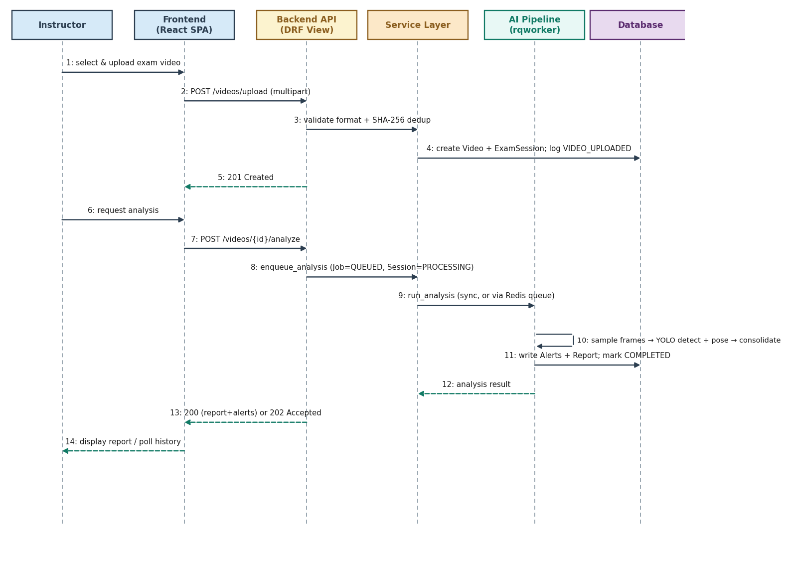
Figure 3.4 — Sequence diagram for the upload-and-analyze workflow

3.6 Summary
This chapter analyzed the No More Cheaters platform and laid the groundwork for its design. Drawing on the limitations of existing systems, it identified fourteen functional requirements and six non-functional requirements that together call for a scalable yet transparent, privacy-conscious proctoring system built around post-hoc video analysis, interpretable scoring, human review, and role-based governance. It described what each user role &#x2014; instructor, dean, and administrator &#x2014; needs and presented a three-tier deployment architecture that separates a React single-page client from a Django REST backend and an independent, queue-driven AI pipeline.
The chapter also covered the development methodology and modeled the system using complementary notations: a context-level data-flow diagram placing the system among its external entities, a use case diagram defining its functional scope, detailed use case descriptions for the key interactions, and a sequence diagram tracing the core proctoring workflow. Together, these models provide a precise and validated picture of what the system must do and how its parts interact, setting the stage for the detailed design in the next chapter.

Chapter Four
System Design

4.1 Introduction
This chapter takes the requirements from the system analysis and turns them into a concrete technical blueprint for the No More Cheaters platform &#x2014; an AI-assisted exam-proctoring system that analyzes recorded exam videos to flag suspicious behavior and presents the results through a role-based web dashboard. Where the previous chapter described what the system needs to do, this chapter explains how it is structured to do it: the object model that organizes the domain, the relational schema that stores it, the AI pipeline that generates the evidence, the interfaces users interact with, and the technologies that tie everything together.
The system follows a decoupled client&#x2013;server architecture. A single-page web application built with React 19 and Vite communicates over HTTPS with a Django 5.2 REST backend, which in turn coordinates a self-contained computer-vision pipeline built on the YOLO family of models. The backend is organized around a thin-view, service-layer design: HTTP views hand off business logic to a dedicated services module, data access is centralized in selectors, and the AI pipeline is fully decoupled from the web framework so it can be developed, tested, and run independently. This separation of concerns is the guiding principle behind every design decision presented in the sections that follow.
The remaining sections of this chapter present the design from the inside out. Section 4.2 presents the class diagram and the object model. Section 4.3 goes into the relational database design. Section 4.4 describes the AI processing pipeline. Section 4.5 covers the interface design, and Section 4.7 wraps up the chapter.technology stack, and Section 4.7 concludes the chapter.

4.2 Class Diagram
The domain model consists of ten persistent classes that together capture users, exams, recorded sessions, and AI-generated evidence. The design revolves around a clear ownership hierarchy: a User who is an instructor owns Exams; each Exam contains many ExamSessions, one per student; and each ExamSession brings together the artifacts produced for that student &#x2014; the uploaded Video, the AnalysisJob tracking processing, the Alerts recording individual suspicious incidents, and the Report summarizing them. Two cross-cutting classes, AuditLog and SystemSettings, handle governance and configuration, while UserPreferences holds per-user settings.
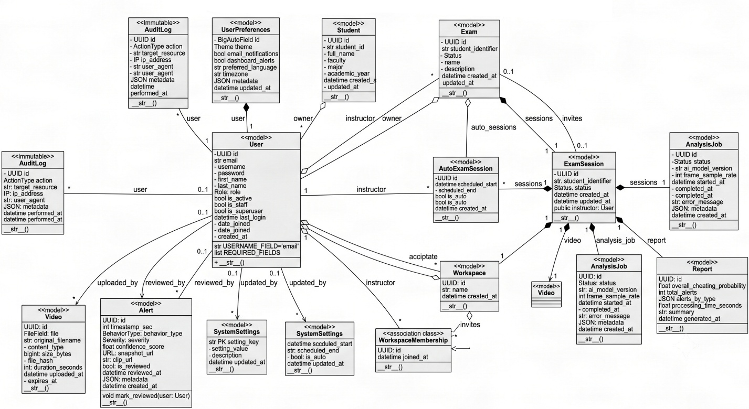
Figure 4.1 — UML class diagram of the No More Cheaters domain model
Several design choices stand out in the model. Every core entity uses a non-sequential UUID primary key, which avoids exposing record counts and makes identifiers safe to share in URLs. The User class extends Django&#x2019;s abstract user to authenticate by email rather than username and carries a role attribute with three values &#x2014; ADMIN, DEAN, and INSTRUCTOR &#x2014; that drives authorization throughout the system. The relationships are deliberately constrained: Video, AnalysisJob, and Report each have a one-to-one association with ExamSession, reflecting that a session has exactly one recording, one processing job, and one summary report. Alert, on the other hand, has a one-to-many association since a single session can raise multiple incidents.
The behavioral surface of the model is deliberately minimal, in line with the thin-model, rich-service approach the backend adopts. The Alert class exposes a mark_reviewed(user) operation that records who reviewed an incident and when, supporting the human-in-the-loop review requirement. The AuditLog class is designed to be append-only: it records security-relevant actions along with the acting user, IP address, and user agent, and the system does not allow editing or deleting its records so the trail stays tamper-evident. The rest of the business logic &#x2014; analysis dispatch, threshold resolution, probability scoring, and report assembly &#x2014; lives in the service layer rather than on the entities themselves, keeping the object model focused on structure and integrity.

4.3 Database Design
The object model maps directly onto a normalized relational schema of ten tables. During development, the system runs on SQLite for zero-configuration setup, while the target production deployment uses a managed MySQL instance; since the persistence layer is accessed exclusively through Django&#x2019;s object-relational mapper, the schema works across both engines without any code changes. The entity&#x2013;relationship diagram in Figure 4.2 shows the tables, their primary and foreign keys, and the cardinality of every relationship.
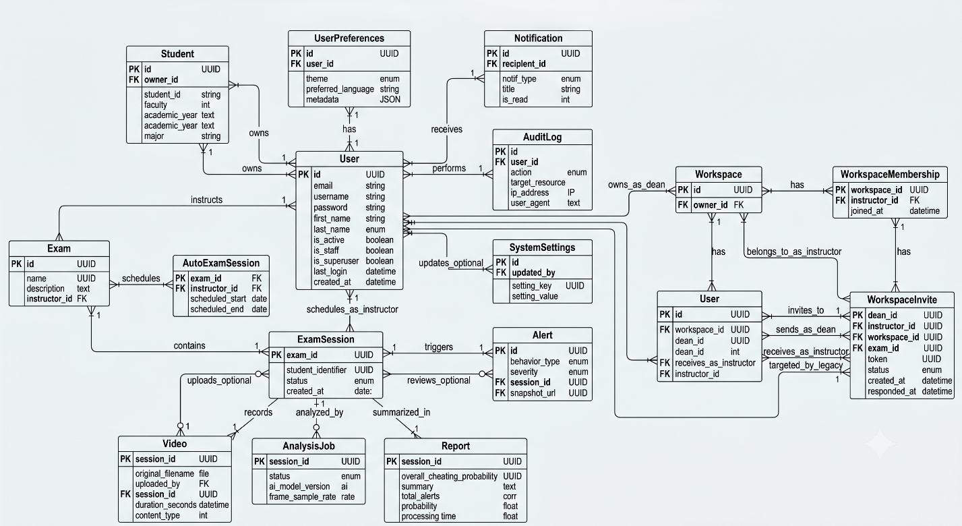

Figure 4.2 — Entity–Relationship diagram of the database schema
Referential integrity is enforced right at the schema level. The relationship from ExamSession to its child tables is keyed on session, and the pair (exam, student_identifier) carries a unique constraint so the same student cannot be registered twice within one exam. The Video table enforces a unique SHA-256 file_hash, providing content-level deduplication: an identical recording cannot be uploaded twice, and the hash also doubles as an integrity check. Foreign keys referencing the acting user on AuditLog, Alert.reviewed_by, and SystemSettings.updated_by are nullable and set to null on user deletion, so historical records survive even when an account is removed.
To keep query performance predictable as the data grows, the schema defines composite indexes on the access patterns the application actually uses. The table below summarizes the ten tables and their primary roles in the design.

Table | Primary Key | Purpose
User | UUID | Authenticated account; email login with ADMIN / DEAN / INSTRUCTOR role.
UserPreferences | BigAuto | One-to-one per-user settings (theme, language, notifications, AI threshold overrides).
Exam | UUID | An exam owned by an instructor; groups student sessions together.
ExamSession | UUID | One student&#x2019;s sitting within an exam; unique per (exam, student_identifier).
Video | UUID | The uploaded recording; unique SHA-256 hash, 30-day retention via expires_at.
AnalysisJob | UUID | Tracks the AI processing lifecycle (QUEUED &#x2192; PROCESSING &#x2192; COMPLETED / FAILED).
Alert | UUID | A single flagged incident with behavior type, severity, and confidence score.
Report | UUID | Aggregated per-session result: overall cheating probability and alert totals.
AuditLog | UUID | Append-only, immutable record of security-relevant actions.
SystemSettings | setting_key | Administrator key/value configuration, including global AI threshold defaults.

One notable design detail is that the Alert and Report tables also include denormalized JSON fields &#x2014; alerts_by_type on Report and a per-event metadata object on Alert &#x2014; which store structured detail (event start and end times, frame counts, and per-type tallies) without needing additional tables. This hybrid of strict relational keys for core entities and flexible JSON for descriptive metadata keeps the schema lean while preserving the rich, evidence-level information the dashboard shows to reviewers.

4.4 AI Processing Pipeline
At the heart of the system is a self-contained computer-vision pipeline that turns a raw exam recording into a set of structured alerts and an overall integrity score. The pipeline is completely decoupled from the Django web layer: it works with plain video files and produces framework-agnostic results, and its heavy dependencies &#x2014; OpenCV and the Ultralytics YOLO models &#x2014; are loaded lazily so the rest of the system stays lightweight. Figure 4.3 traces the flow from upload to completed report.
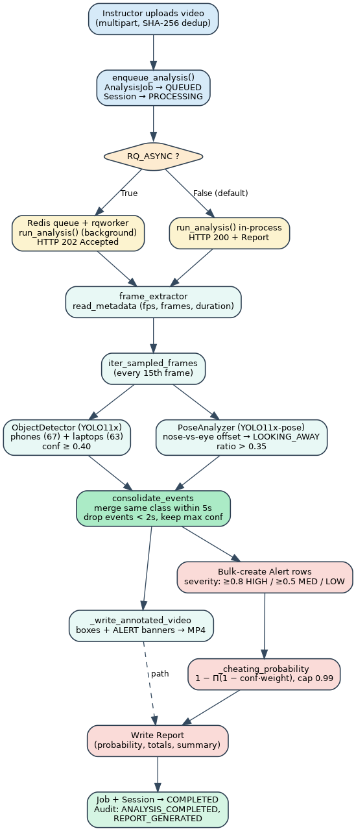
Figure 4.3 — End-to-end AI processing pipeline, from upload to completed report
Processing kicks off when an instructor uploads a recording. The upload is deduplicated by SHA-256 hash, an AnalysisJob is created and marked QUEUED, and the session moves to PROCESSING. The system supports two execution modes controlled by a single configuration flag. In the default synchronous mode, the analysis runs in-process and the API returns the finished report right away with an HTTP 200 response; in asynchronous mode, the job goes onto a Redis-backed queue, gets processed by a background worker, and the API responds with HTTP 202 Accepted while the client polls for completion. This dual-mode design lets the same code run on a developer laptop with no extra infrastructure and on a GPU server under production load.
Frame extraction. An OpenCV reader inspects the video to get the frame rate, frame count, and duration, then samples every fifteenth frame instead of processing each one. This sampling cuts computational cost by roughly an order of magnitude while still being dense enough to catch transient events like a quick glance away from the screen.
Detection. Each sampled frame goes through two models in sequence. An object detector based on YOLO11x is scoped to two COCO classes &#x2014; mobile phones and laptops &#x2014; and reports detections above a 0.40 confidence threshold. A pose analyzer based on YOLO11x-pose estimates head orientation using a geometric heuristic: it measures the horizontal offset of the nose from the midpoint between the eyes, normalizes it by inter-eye distance, and flags a LOOKING_AWAY event when the ratio exceeds 0.35. The two models run sequentially rather than in parallel because sharing a single GPU model across threads is unreliable.
Temporal consolidation. Raw per-frame detections tend to be noisy, so a consolidation layer applies temporal rules: detections of the same behavior within a five-second window get merged into a single event that keeps the maximum observed confidence, and any event shorter than two seconds is tossed out as spurious. This step converts thousands of frame-level hits into a manageable set of meaningful, human-readable incidents.
Scoring and persistence. Each consolidated event becomes an Alert whose severity is bucketed from its confidence &#x2014; high at 0.80 and above, medium at 0.50 and above, otherwise low. An overall cheating probability is then computed by treating each event as independent evidence and combining the per-behavior risk weights using the formula P = 1 − ∏(1 − confidence × weight), capped at 0.99. Phones carry the highest weight (1.0), followed by laptops (0.9), multiple or other persons (0.8), generic objects (0.6), and looking away (0.4). The events and the resulting probability are saved as Alert and Report records, and an annotated MP4 &#x2014; with bounding boxes and per-event alert banners &#x2014; is rendered for review.
Once processing wraps up successfully, the AnalysisJob and ExamSession are marked COMPLETED and the pipeline writes ANALYSIS_COMPLETED and REPORT_GENERATED entries to the audit log; if anything goes wrong along the way, the job and session flip to FAILED and the failure is recorded so it can be retried or investigated. It is worth noting, in line with the stated scope of the project, that the current detector only produces alerts for phones, laptops, and looking-away behavior; the remaining behavior categories defined in the model and weighting scheme are provisioned for future expansion.

4.5 Interface Design
The user interface is a single-page application that adjusts its layout based on the role of the signed-in user. Rather than showing one generic dashboard, the app renders a role-specific navigation shell and gates each route behind both authentication and role checks, so instructors, deans, and administrators each see only the features relevant to them. The interface is built around a persistent sidebar, a header with notifications and the user profile, and a main content area; transitions and interactive elements use lightweight animation to keep things feeling responsive without distracting from the proctoring task.
Access is organized in two tiers. A set of shared pages &#x2014; the dashboard, video processing, analysis reports, calendar, AI thresholds, and profile &#x2014; is available to any authenticated user. Beyond these, role-gated routes open up specialized tools: instructors get a history view of completed analyses; deans get instructor-oversight and hall-management workspaces; and administrators get user management, system logs, and runtime metrics. The table below maps the three roles to their primary interface areas.

Role | Primary Interfaces | Purpose
Instructor | Dashboard, Video Processing, Analysis, Calendar, Students, AI Thresholds, History | Upload and analyze recordings, schedule sessions, tune detection sensitivity, review past results.
Dean | Overview, Workspace, Instructors, Halls, Calendar, Analysis, Students | Oversee instructors, manage examination halls, assign supervisors, and invite staff to workspaces.
Administrator | Operations, Users, Workspaces, System Logs, System Metrics, Support | Manage user accounts and roles, audit system activity, and monitor runtime health.

The heart of the proctoring workflow is the video-processing interface, which offers two complementary capture modes. In manual mode, an instructor drags a recording onto the page, watches animated upload and processing stages, and gets a results panel showing the flagged-incident count, the overall confidence, and a plain-language summary; the interface handles both immediate and queued responses seamlessly. In automatic mode, the app schedules a future recording session and, when the time comes, opens the webcam, draws a live framing guide on the candidate&#x2019;s face, records for the scheduled duration, and feeds the result into the same analysis pipeline. A month, week, and day calendar ties these sessions to scheduled exams, while the AI-thresholds screen distills the pipeline&#x2019;s various numeric thresholds into a single, intuitive sensitivity slider ranging from strict to highly sensitive.
Consistency and resilience are woven into the presentation layer. A shared component library &#x2014; branded layout shells, modals, charts, an activity visualization, profile avatars, and a unified icon set &#x2014; gives every screen a coherent visual language. A global error boundary catches unexpected failures and turns them into friendly, recoverable error states instead of blank pages. Error messages are deliberately sanitized so that technical details like stack traces or framework identifiers never reach end users; instead, the system presents clear, actionable guidance.

4.6 Technology Stack Summary
The platform is made up of three cooperating technology layers &#x2014; a presentation layer, an application-and-data layer, and an artificial-intelligence layer &#x2014; along with the supporting infrastructure that hosts everything in production. The choices below favor mature, widely supported tools and a clean separation of responsibilities between the browser client, the REST backend, and the computer-vision pipeline.

Layer | Technology | Role in the System
Frontend | React 19 + Vite + TypeScript | Single-page application with build tooling and type safety.
Frontend | Tailwind CSS v4, Framer Motion | Utility-first styling paired with interface animations.
Backend | Django 5.2 + Django REST Framework | Web framework and REST API.
Backend | django-allauth (headless) | Handles email-based authentication, verification, and password reset.
Backend | django-rq + Redis | Asynchronous background queue for running analysis jobs.
AI / CV | Ultralytics YOLO11x & YOLO11x-pose | Object detection (phones, laptops) and head-pose estimation.
AI / CV | OpenCV (headless) | Video decoding, frame sampling, and annotated-video rendering.
Database | SQLite (dev) / MySQL (prod) | Relational persistence via the Django ORM.
Infrastructure | AWS EC2 (GPU), Vercel | Backend GPU compute and frontend hosting.
Infrastructure | Nginx, Gunicorn, Certbot | Reverse proxy, application server, and HTTPS certificates.
Email | Resend (SMTP) | Transactional email for verification and notifications.

How the work is split across these layers reinforces the architecture described throughout this chapter. The frontend focuses solely on presentation and user interaction; the Django backend owns business logic, authorization, and persistence; and the AI layer is an independent, swappable component that the backend calls through a narrow interface. This loose coupling means each layer can evolve &#x2014; a different detection model, an alternative database engine, or a redesigned interface &#x2014; with minimal impact on the others.

4.7 Summary
This chapter laid out the complete design of the No More Cheaters platform, moving from the conceptual object model to the concrete technologies that bring it to life. The class diagram established a clear ownership hierarchy rooted in the User and Exam entities and flowing down to the per-session Video, AnalysisJob, Alert, and Report artifacts, supported by audit and configuration classes. The database design mapped this model onto a normalized, integrity-constrained relational schema with content-level deduplication and an immutable audit trail, portable across SQLite and MySQL through the ORM.
The AI processing pipeline was presented as a decoupled, dual-mode computer-vision workflow that samples frames, detects prohibited objects and looking-away behavior with YOLO models, consolidates noisy detections into meaningful events through temporal rules, and scores each session with a weighted independent-evidence probability. The interface design showed how a single-page application adapts to three distinct roles while keeping the core upload-and-analyze workflow centralized, and the technology summary outlined the three-layer stack and its supporting infrastructure. Together, these designs form a coherent, loosely coupled system where presentation, business logic, and machine intelligence each have a well-defined boundary &#x2014; providing a solid foundation for the implementation and testing described in the next chapter.

Chapter Five
Conclusions, Limitations, and Future Work

5.1 Conclusions
This project set out to design and build an AI-assisted exam-proctoring platform that helps academic staff uphold exam integrity by automatically analyzing recorded exam videos, flagging likely instances of misconduct with supporting visual evidence, and presenting these findings through a secure, role-based interface that keeps the final call in human hands. The completed system, No More Cheaters, delivers on this aim: it is a fully implemented, deployed, and tested platform that detects suspicious behavior in recorded exam videos using YOLO11x computer vision and presents its findings through a role-based dashboard for instructors, deans, and administrators.
The delivered system covers the entire stack. The backend, built with Django 5.2 and the Django REST Framework, includes fourteen domain models and thirty-two API endpoints organized around a thin-view, service-layer architecture. The frontend is a responsive single-page application built with React 19 and Vite, featuring twenty-four pages, fifteen shared components, and eleven API modules, all connected to the backend. At the platform&#x2019;s core is a self-contained computer-vision pipeline that samples frames from a recording, runs object detection, pose analysis, and face and object scanning, consolidates detections into coherent timestamped events using temporal rules, and renders an annotated video where each flagged incident is visually marked. All told, the project comes in at over twenty-two thousand lines of Python and TypeScript.
The analysis pipeline handles six categories of suspicious behavior &#x2014; phone use, laptop use, looking away from the screen, the presence of multiple faces, an unexpected person, and unauthorized objects. For each exam session, the system rolls up the detected incidents into a report with an interpretable, weighted cheating-probability score and a per-type breakdown, and it maintains a human-in-the-loop review workflow where every alert can be examined against its visual evidence and explicitly acknowledged. Every consequential action gets recorded in an immutable audit trail.
The platform was deployed to a production environment on Amazon Web Services, with the Django application running under Gunicorn behind an Nginx reverse proxy on a GPU-equipped EC2 instance, a managed RDS MySQL database, a Redis-backed asynchronous job queue, HTTPS through Let&#x2019;s Encrypt, the frontend hosted on Vercel, and transactional email delivered through Resend. The system&#x2019;s correctness was validated by a suite of sixty-eight automated tests &#x2014; fifty on the backend and eighteen on the frontend &#x2014; all passing. Its end-to-end behavior was confirmed through a rehearsed demonstration workflow covering login, analysis, threshold configuration, audit review, and administration.
Measured against the objectives laid out in Chapter 1, the project hit every one of its targets: it built an automated video-analysis pipeline, converted raw detections into meaningful consolidated incidents, produced an interpretable integrity score, generated annotated visual evidence, delivered a secure role-based web platform, preserved human oversight with an immutable audit trail, supported configurable detection sensitivity and responsible data retention, and validated the result through automated testing. Table 5.1 summarizes the key outcomes.

Dimension | Outcome
Frontend | 24 pages wired to the backend, 15 shared components, 11 API modules; responsive and animated.
Backend | 14 domain models and 32 REST API endpoints built on a thin-view, service-layer architecture.
AI pipeline | Six behavior types detected, with temporal consolidation and annotated-video output.
Interpretability | Weighted cheating-probability score, per-type breakdown, and human-in-the-loop review.
Deployment | AWS EC2 (GPU), RDS MySQL, Redis, Nginx/Gunicorn, Let’s Encrypt HTTPS, Vercel, Resend email.
Validation | 68 automated tests passing (50 backend, 18 frontend) plus a verified end-to-end demonstration.
Scale of work | More than 22,000 lines of Python and TypeScript across the full stack.
Table 5.1 — Summary of key project outcomes
Taken together, these results show that the approach proposed at the start of this work is viable: exam integrity can be supported at scale through post-hoc analysis of recorded video, in a way that is transparent, evidence-centered, and governed by role-based human oversight &#x2014; rather than through opaque, intrusive, real-time surveillance. As an academic graduation project, No More Cheaters achieves what it set out to do and provides a tested, working foundation for further development.

5.2 Limitations
While the system meets its academic objectives as a complete and functioning prototype, it is important to take an honest look at how it stacks up against the demands of a sustainable, market-ready product. From that perspective, the platform faces a number of significant limitations. These are predominantly commercial, organizational, and regulatory rather than technical, and they define the gap between a successful graduation demonstration and a deployable proctoring service. They are discussed below across six dimensions and summarized in Table 5.2.
5.2.1 Cost Structure and Unit Economics
The economics of running the platform at scale have not been worked out yet. The system currently has no per-customer usage tracking, metered billing, or cost attribution for storage and GPU time, which means the cost of serving any single institution cannot be calculated and a defensible price cannot be set with confidence. The fixed costs, dominated by a continuously running GPU instance, are relatively high &#x2014; on the order of several hundred dollars per month for the baseline infrastructure &#x2014; while variable costs remain unclear. Because analysis is GPU-bound, costs scale roughly linearly with the number of customers, and demand is highly uneven: a flood of uploads right after a final exam can require many times the capacity that otherwise sits idle.
5.2.2 Integration Gaps
The platform does not connect with the institutional systems that universities expect a proctoring tool to work with. There is no integration with learning-management systems like Moodle, Canvas, or Blackboard, and no compliance with the Learning Tools Interoperability (LTI) standard that such integration requires; rosters have to be imported manually instead. It also lacks single sign-on through SAML or OpenID Connect, which in higher education is typically a procurement requirement rather than a nice-to-have, and there is no integration with institutional calendaring or room-booking systems. In practice, the absence of LMS integration and single sign-on would keep the product from getting past the initial screening of most institutional procurement processes.
5.2.3 Market Position and Competition
The platform is entering a market already occupied by established commercial providers &#x2014; including ProctorU, Honorlock, Respondus, and ExamSoft &#x2014; which have large institutional customer bases and offer mature feature sets including live proctoring, browser lockdown, and deep LMS integration. Against these incumbents, the system currently does not present a clear point of differentiation in price, accuracy, ease of deployment, or feature breadth. The broad post-pandemic demand for remote proctoring has also cooled as many institutions returned to in-person exams, and growing scrutiny of automated proctoring on privacy and fairness grounds further narrows the market window.
5.2.4 Commercial and Legal Readiness
The system is missing the commercial and legal scaffolding needed to actually transact with institutions. There is no payment or invoicing capability, so revenue cannot be collected, and there is no legal and compliance framework &#x2014; no terms of service, privacy policy, data-processing agreement, service-level agreement, or documented compliance with regulations like FERPA &#x2014; without which an institution simply cannot sign a contract. The platform also lacks the supporting infrastructure institutional customers expect: a ticketing system, a documented knowledge base, a public status page, an on-call support rotation, and any structured sales and onboarding process.
5.2.5 Regulatory and Geographic Constraints
Since the system is deployed in a single region and stores video on cloud servers in one jurisdiction, it cannot meet the data-residency requirements that govern many markets, including the EU&#x2019;s GDPR and the data-localization laws of several Middle Eastern countries. Its interfaces and reports have not been audited against accessibility standards like WCAG 2.1 AA, which public institutions receiving government funding are typically required to meet. Most importantly, the system processes faces and head poses, which count as biometric data subject to strict consent and handling requirements under laws like the Illinois Biometric Information Privacy Act and the GDPR; processing such data without proper consent and safeguards carries real legal risk.
5.2.6 Scalability Constraints
Several parts of the current deployment would hit bottlenecks as the customer base grows. Local disk storage for videos is the first constraint to kick in, running out of capacity at a modest number of institutions; the single database instance and its limited connection pool become a constraint as concurrent users increase; the single GPU worker processes analyses one at a time and would struggle with peak-time demand; and single-region hosting adds latency for geographically distant users. Beyond a few tens of institutions, the unit economics also deteriorate unless pricing and infrastructure are restructured, since support and infrastructure costs grow faster than flat-rate revenue.

Limitation | Severity | Indicative effort to resolve
No LMS / LTI integration | Critical | Certification + development
No single sign-on (SAML / OIDC) | Critical | Development + provider setup
No defined pricing model | Critical | Analysis of usage data
No legal framework (ToS, DPA, privacy, SLA) | Critical | Legal counsel
No billing / payment system | Critical | Development
No GDPR / CCPA compliance and data residency | High | Legal + development
No accessibility (WCAG) compliance | High | Audit + remediation
No support infrastructure | High | Operational investment
No differentiation versus competitors | High | Strategic positioning
Unproven unit economics | High | Usage-data collection
Table 5.2 — Principal limitations and their severity
To put it simply, the current system is best understood as a complete and capable technical prototype rather than a finished commercial product. Its core proctoring capability is one well-engineered module within what established competitors already offer as full platforms, and the limitations described above &#x2014; which are overwhelmingly commercial, legal, and organizational &#x2014; spell out exactly the work needed to bridge that gap. For a graduation project, this outcome is entirely appropriate: the goal was to demonstrate a working, well-designed system, and that goal was met.

5.3 Future Work
The limitations outlined above naturally translate into a roadmap for future development. The directions below would harden the platform, address its commercial and regulatory gaps, and gradually move it from an academic prototype toward a deployable service. They are grouped into four areas &#x2014; security and authentication, billing and monetization, video and AI enhancements, and infrastructure and scalability &#x2014; and then organized into a phased implementation plan.
5.3.1 Security and Authentication
Several improvements would bring the platform&#x2019;s security posture up to the level institutions expect. The most pressing is rate limiting and brute-force protection on authentication endpoints, which should come before any public deployment. Beyond that, two-factor authentication using one-time codes (via SMS or authenticator app), along with trusted-device handling and backup codes, would protect accounts against credential compromise. Social login through Google and Microsoft would reduce sign-up friction and align with the identity providers most institutions already use. Session-management features &#x2014; letting users view and revoke their active sessions &#x2014; would round out the needs of security-conscious institutions.
5.3.2 Billing and Monetization
For the platform to start generating revenue, it would need a subscription and billing system built on a payment provider like Stripe, introducing tiered plans &#x2014; say a free tier, a starter tier, a professional tier, and a custom enterprise tier &#x2014; differentiated by monthly analysis volume, number of users, processing priority, and storage. This requires usage tracking, tier-enforcement logic, subscription and invoice management synced through provider webhooks, and a customer-facing pricing and checkout experience. Usage-based add-ons like additional analysis quota, extra user seats, white-label branding, or programmatic API access would supplement the base subscriptions.
5.3.3 Video and Artificial-Intelligence Enhancements
The analytical capability can be expanded in several valuable ways. Batch upload and parallel processing would let instructors with large classes submit and analyze many recordings at once. A live, real-time proctoring mode &#x2014; streaming webcam frames over WebSockets for immediate inference and alerting &#x2014; would be a major differentiator, transforming the system from a review tool into a true real-time proctoring platform, though at the cost of sustained GPU capacity. Moving video storage to a cloud object store with a content-delivery network would eliminate the single-disk bottleneck and support lifecycle-based retention. Report export to PDF and CSV would give academic staff portable, archivable evidence, and a per-institution model-fine-tuning capability would let large customers tailor detection to their specific exam environments.
5.3.4 Infrastructure and Scalability
On the infrastructure front, containerizing the application with Docker &#x2014; and eventually orchestrating it with Kubernetes &#x2014; would make builds reproducible and deployments fast while laying the groundwork for elastic scaling. Auto-scaling of the web tier and a queue-driven, GPU-backed worker pool (using spot instances and scaling to zero when idle) would match capacity to the highly uneven demand of exam seasons while keeping costs in check. Comprehensive monitoring and alerting (error tracking, server and queue metrics, uptime checks, and a health endpoint) would provide the operational visibility needed to run a paid service. Scoped API keys would enable external integrations, and an automated backup and disaster-recovery regime would support any service-level commitment.

Phase | Horizon | Representative work items
Phase 1 — MVP+ | ≈ 2 weeks | Rate limiting, containerization, monitoring, cloud video storage, initial billing tiers, report export.
Phase 2 — Growth | ≈ 1 month | Two-factor authentication, session management, batch upload and processing, API keys, batch export.
Phase 3 — Scale | ≈ 2 months | Social login, auto-scaling, live real-time proctoring, custom AI training, disaster recovery.
Phase 4 — Enterprise | 3+ months | White-label branding, enterprise SSO, dedicated per-tenant GPU, on-premise option, SLA-backed support.
Table 5.3 — Phased future-work roadmap
Pursued in this order, these directions would systematically close the gaps identified in Section 5.2 and evolve No More Cheaters from a successful academic prototype into a robust, integrable, and commercially viable proctoring platform. Even without that commercial trajectory, the system stands as a complete and validated demonstration of how modern computer vision can be applied to exam integrity in a transparent, evidence-centered, and accountable way &#x2014; which is precisely what this project set out to achieve.

References
Atoum, Y., Chen, L., Liu, A. X., Hsu, S. D. H., & Liu, X. (2017). Automated online exam proctoring. IEEE Transactions on Multimedia, 19(7), 1609–1624. https://doi.org/10.1109/TMM.2017.2656064
Inside Higher Ed. (2020, May 11). Online proctoring is surging during COVID-19. Inside Higher Ed. https://www.insidehighered.com/news/2020/05/11/online-proctoring-surging-during-covid-19
Lin, T.-Y., Maire, M., Belongie, S., Hays, J., Perona, P., Ramanan, D., Dollár, P., & Zitnick, C. L. (2014). Microsoft COCO: Common objects in context. In Computer Vision – ECCV 2014 (pp. 740–755). Springer. https://doi.org/10.1007/978-3-319-10602-1_48
McCabe, D. L., Treviño, L. K., & Butterfield, K. D. (2001). Cheating in academic institutions: A decade of research. Ethics & Behavior, 11(3), 219–232. https://doi.org/10.1207/S15327019EB1103_2
Newton, P. M., & Essex, K. (2024). How common is cheating in online exams and did it increase during the COVID-19 pandemic? A systematic review. Journal of Academic Ethics, 22, 323–343. https://doi.org/10.1007/s10805-023-09485-5
Nigam, A., Pasricha, R., Singh, T., & Churi, P. (2021). A systematic review on AI-based proctoring systems: Past, present and future. Education and Information Technologies, 26(5), 6421–6445. https://doi.org/10.1007/s10639-021-10597-x
Noorbehbahani, F., Mohammadi, A., & Aminazadeh, M. (2022). A systematic review of research on cheating in online exams from 2010 to 2021. Education and Information Technologies, 27, 8413–8460. https://doi.org/10.1007/s10639-022-10927-7
Redmon, J., Divvala, S., Girshick, R., & Farhadi, A. (2016). You only look once: Unified, real-time object detection. In Proceedings of the IEEE Conference on Computer Vision and Pattern Recognition (CVPR) (pp. 779–788). https://doi.org/10.1109/CVPR.2016.91
Swauger, S. (2020, August 7). Software that monitors students during tests perpetuates inequality and violates their privacy. MIT Technology Review. https://www.technologyreview.com/2020/08/07/1006132/

Appendices

