Sign in to ParkInIT_mobile
4

Steps
Created By
Dea

Bonetic
Updated
Apr 15, 2026
View latest
Open in Tang
o
Sign in to ParkInIT_mobile
ParkInIT_mobile
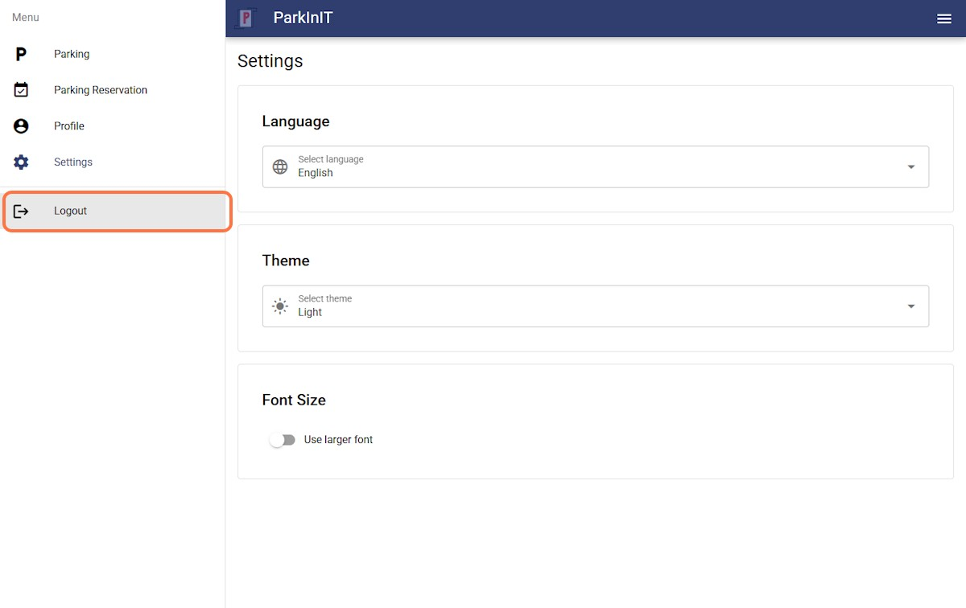
ParkInIT_mobile
4

Step
s
1
Click on Izborni
k
2
Select an optio
n
Sign in to ParkInIT_mobile
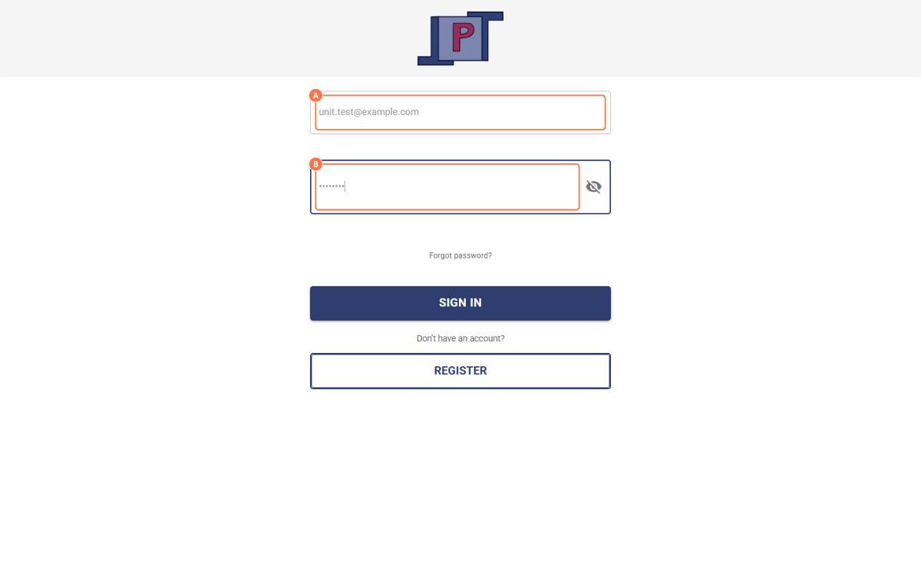
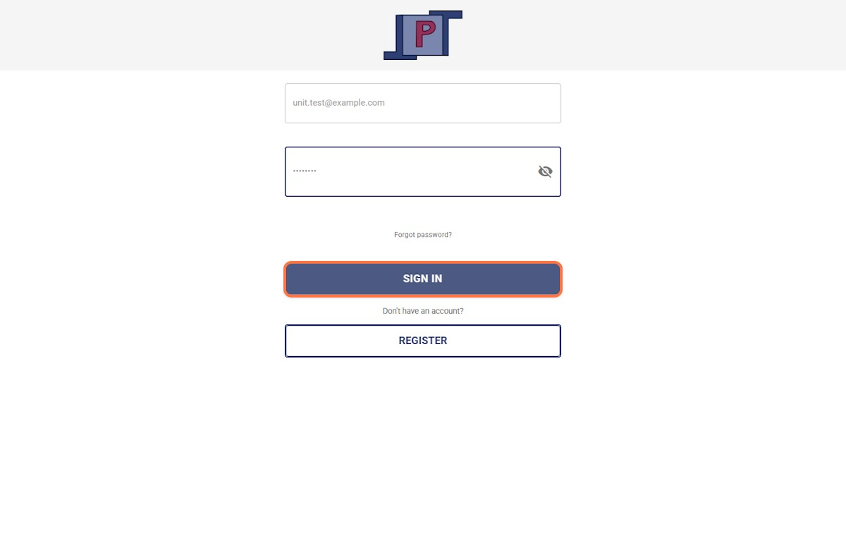
- Paste text into input
3
4
- Type password
Click on SIGN IN

Add Vehicle Profile in ParkInIT_mobile
7

Steps
Created By
Dea

Bonetic
Updated
Apr 15, 2026
View latest
Open in Tang
o
ParkInIT_mobile
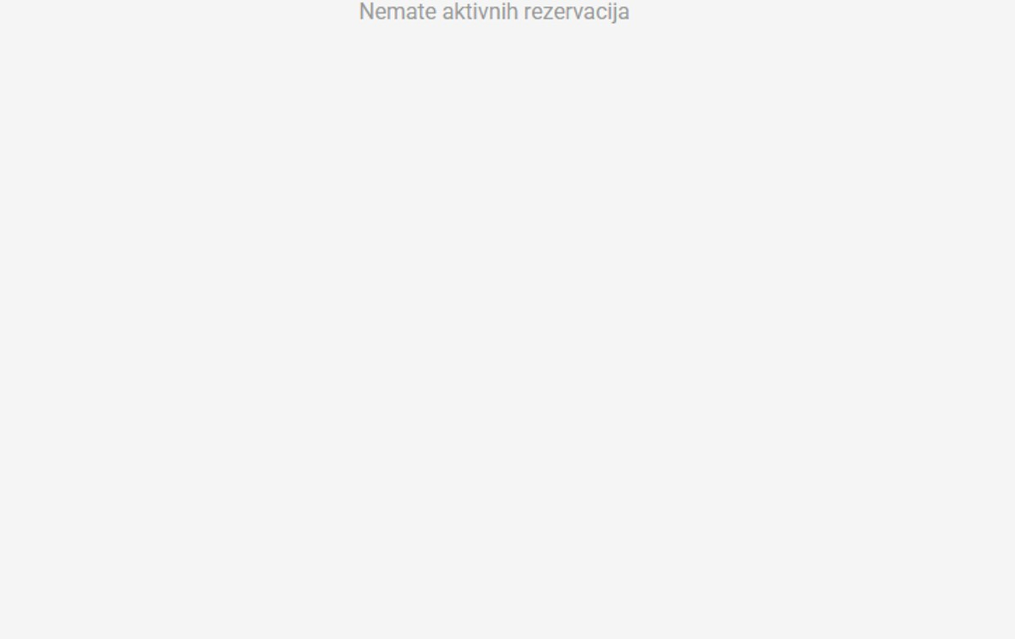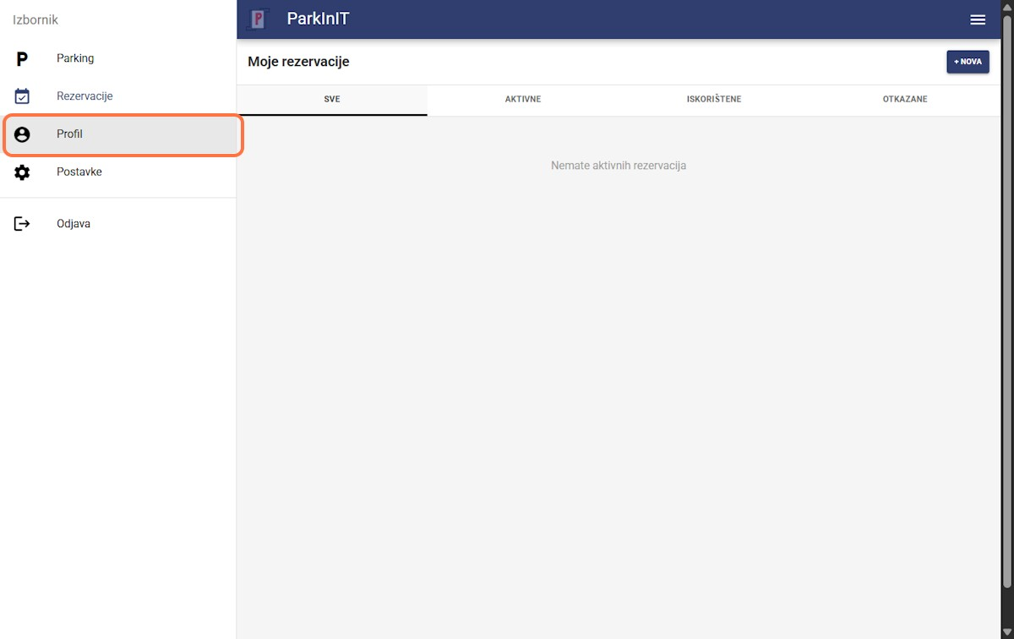
ParkInIT_mobile
7

Step
s
1
Click on Izborni
k
2
Select an optio
n
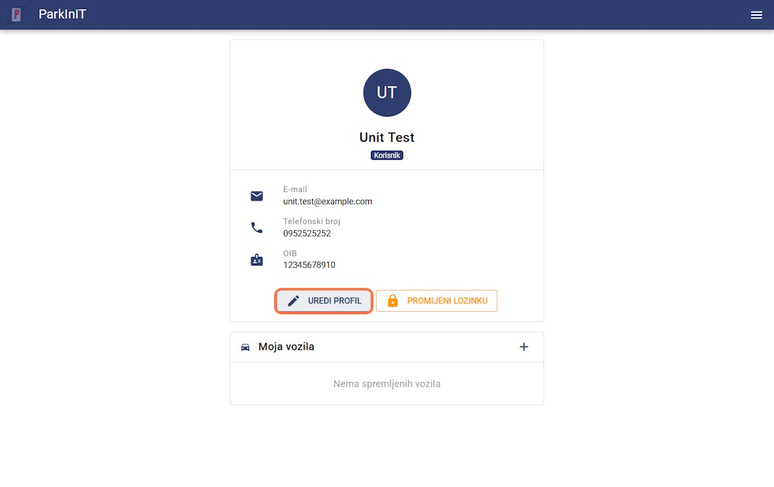
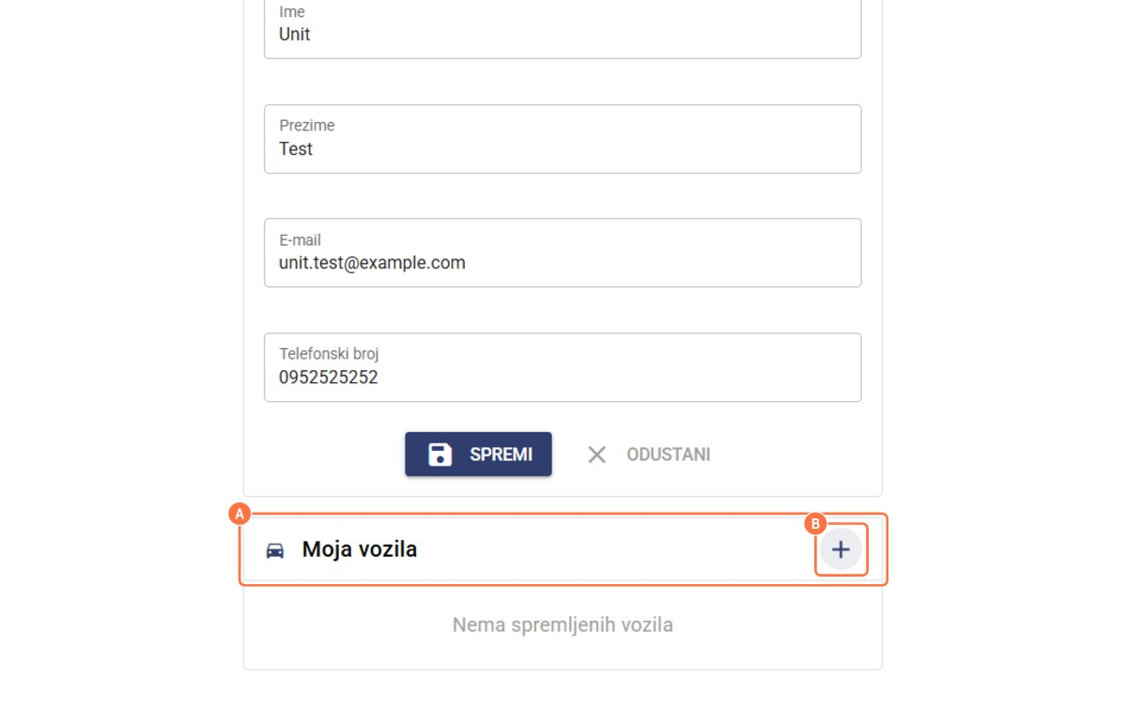
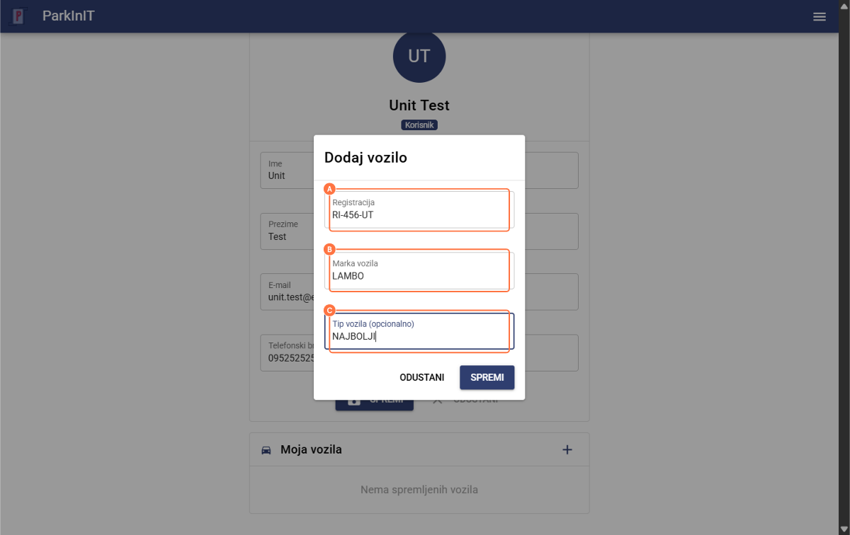
Click on Uredi profil
3
4
5
- Click on Moja vozila
- Click on add
- Type Registracija
- Type Marka vozila
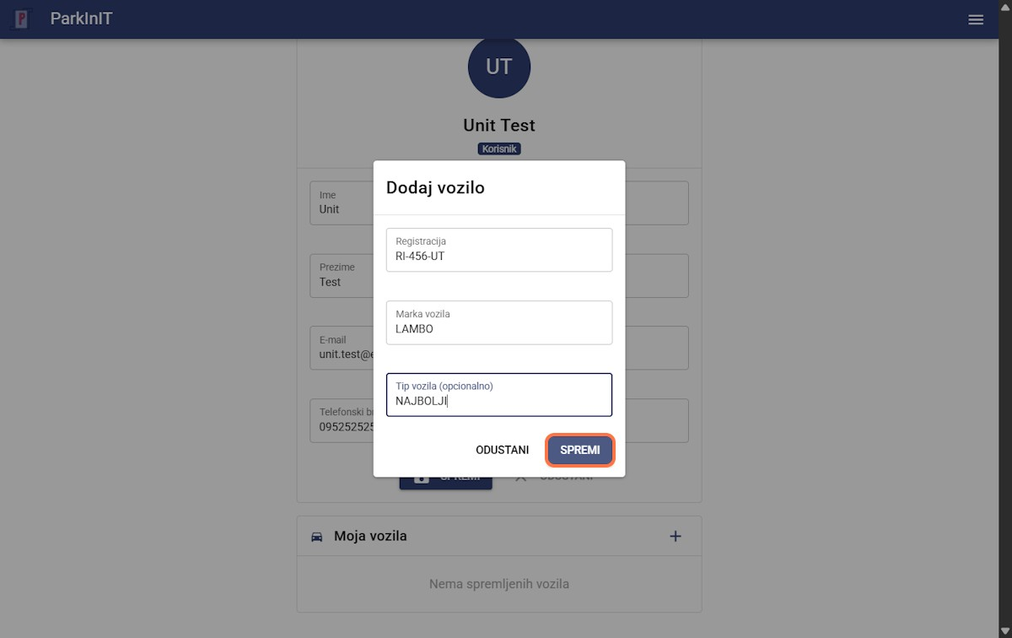
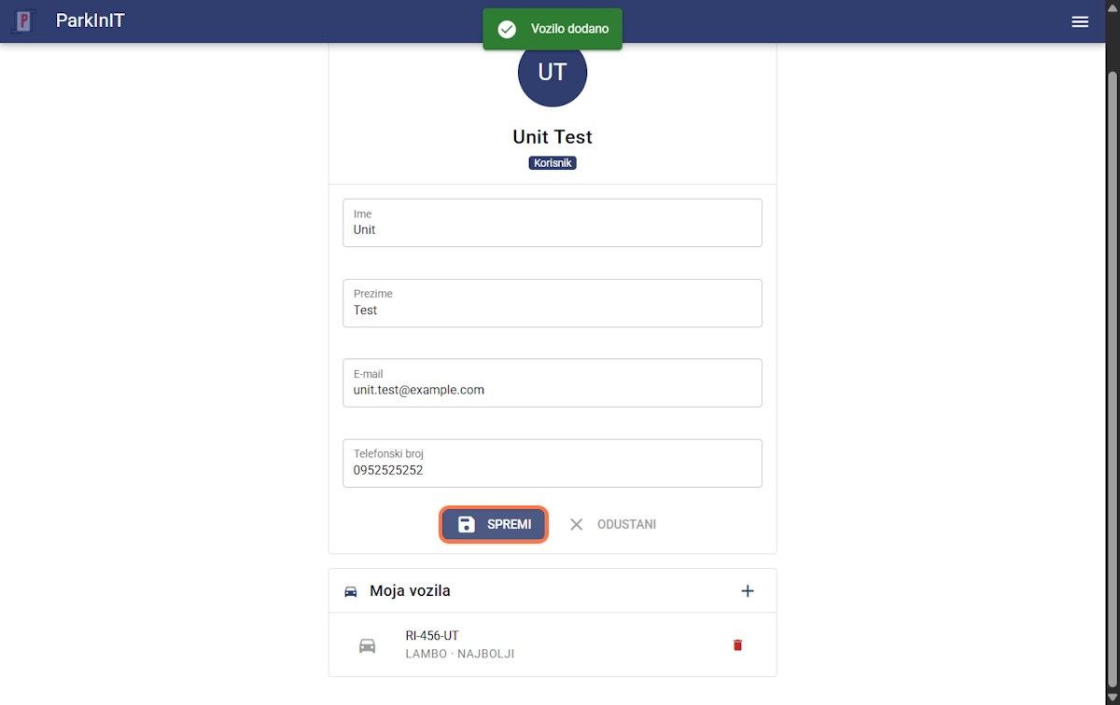
- Type Tip vozila (opcionalno) Click on SPREMI
6
7
Click on Spremi

Set Accessibility Options in ParkInIT_mobile
4

Steps
Created By
Dea

Bonetic
Updated
Apr 15, 2026
View latest
Open in Tang
o
Set Accessibility Options in ParkInIT_mobile
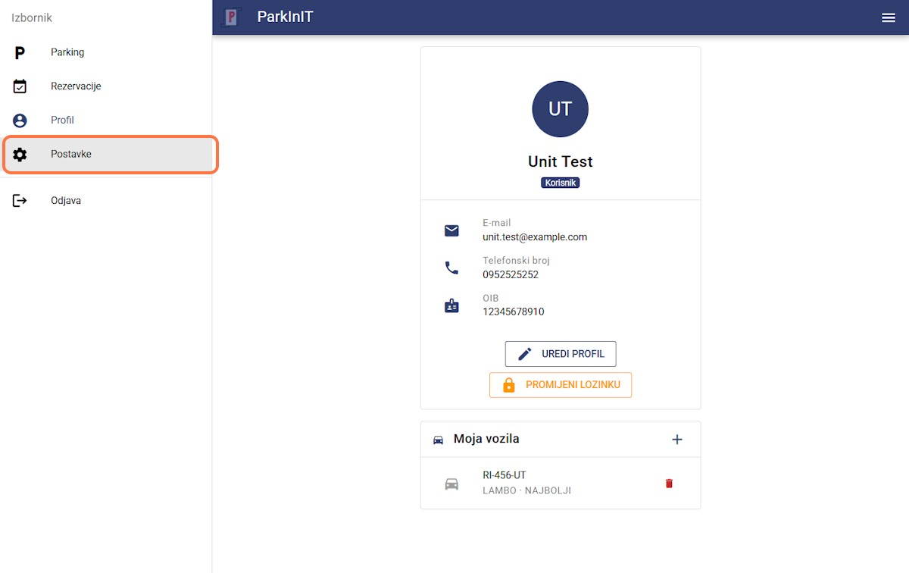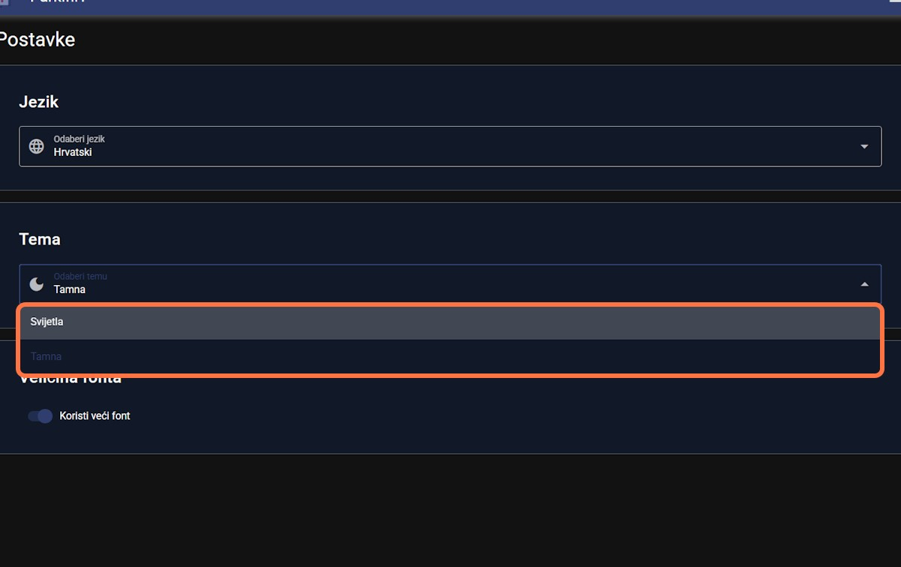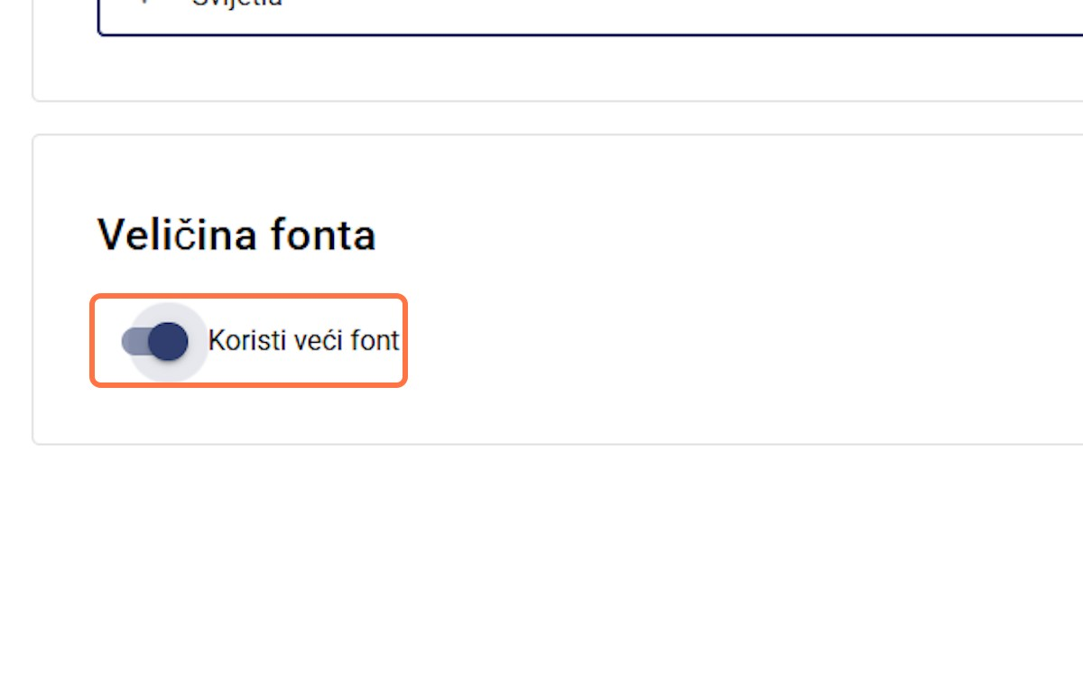
ParkInIT_mobile
4

Step
s
1
Select an optio
n
2
Select Odaberi temu
…
3
Select Koristi veći fon
t
Set Accessibility Options in ParkInIT_mobile
Select Odaberi jezik… 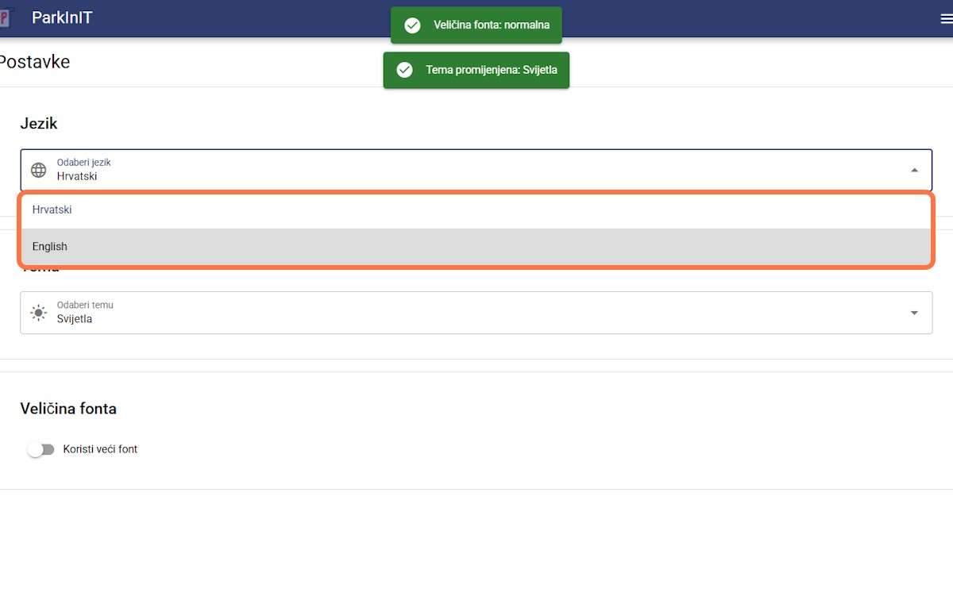
4

Pay for Parking in ParkInIT mobile
5

Steps
Created By
Dea

Bonetic
Updated
Apr 15, 2026
View latest
Open in Tang
o
Pay for Parking in ParkInIT mobile
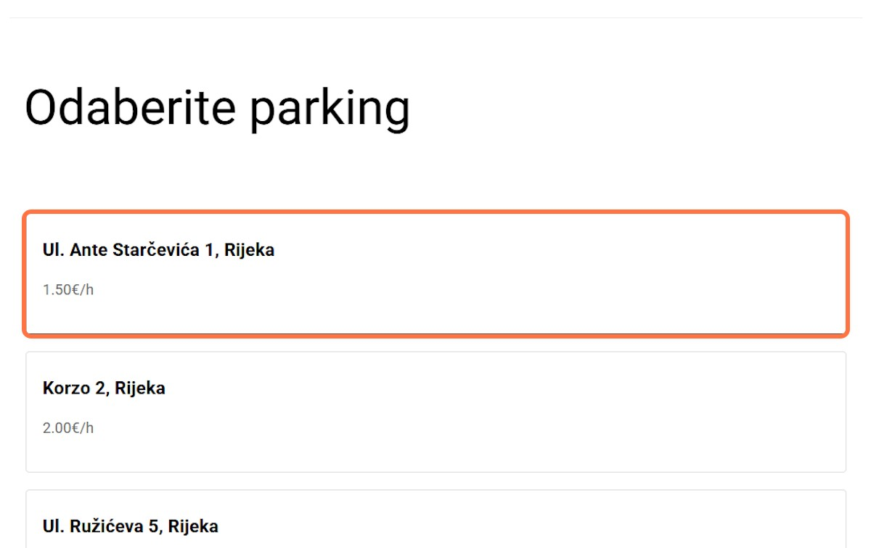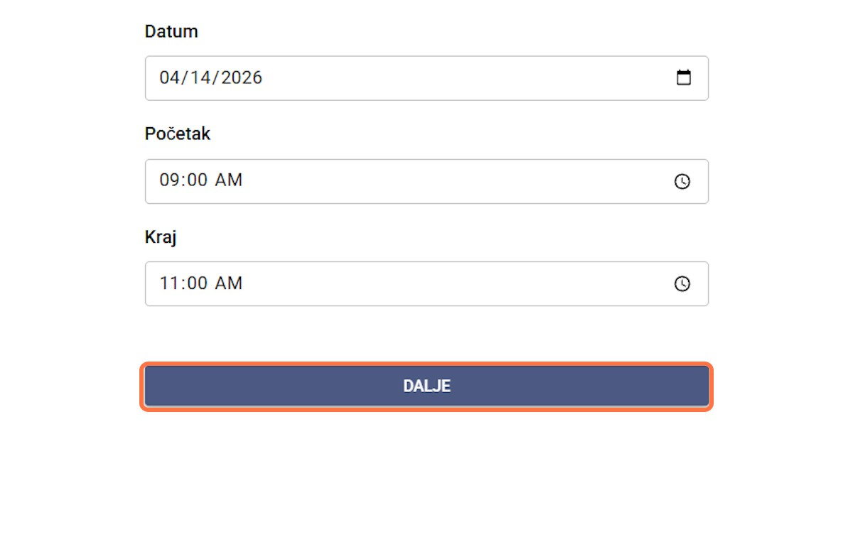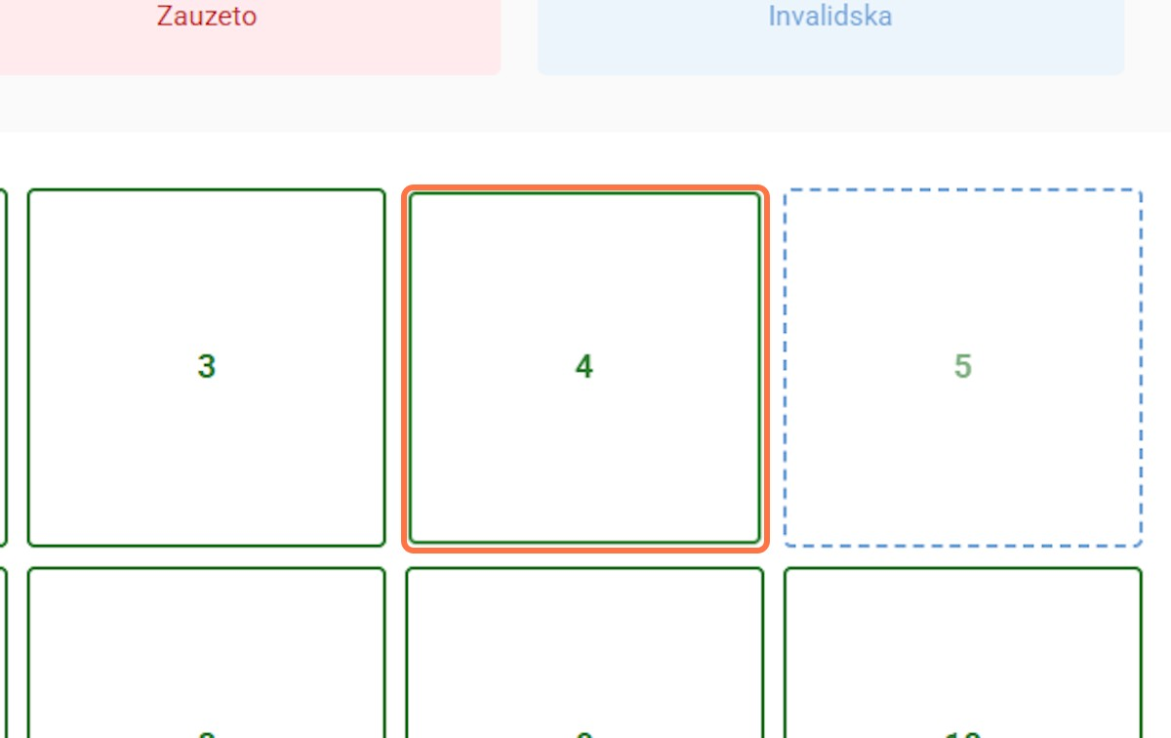
ParkInIT_mobile
5

Step
s
1
Click on Ul. Ante Starče
-
vića 1, Rijeka
…
2
Click on DALJ
E
3
Click on
4
Pay for Parking in ParkInIT mobile
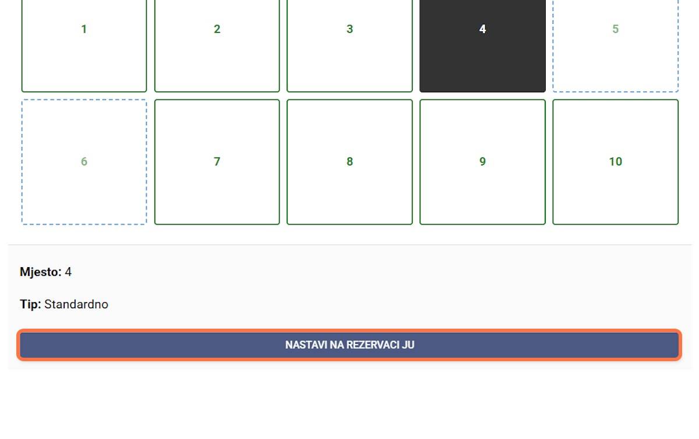
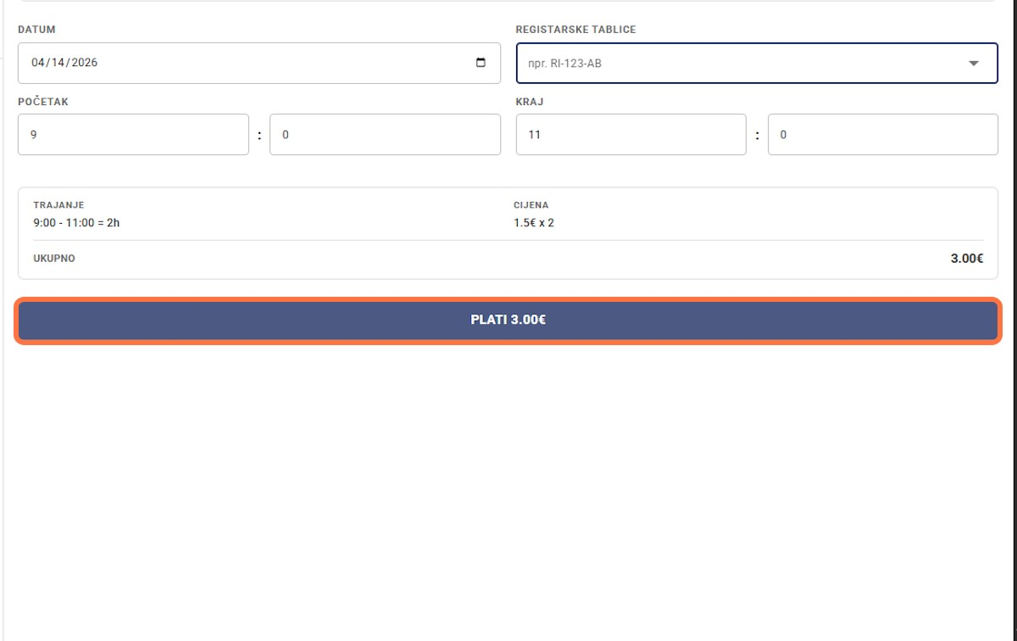
Click on NASTAVI NA REZER-
4
5
VACI JU
Click on PLATI 3.00€

