IGRIS CODER
TO'LIQ AUDIT HISOBI + SIFAT O'LCHAMLARI + TUZATISH REJASI
UI/UX · MEMORY · BRAIN · WEB-AI-BRIDGE · 5 SIFAT O'LCHAMI · 15 SOHA KATEGORIYASI

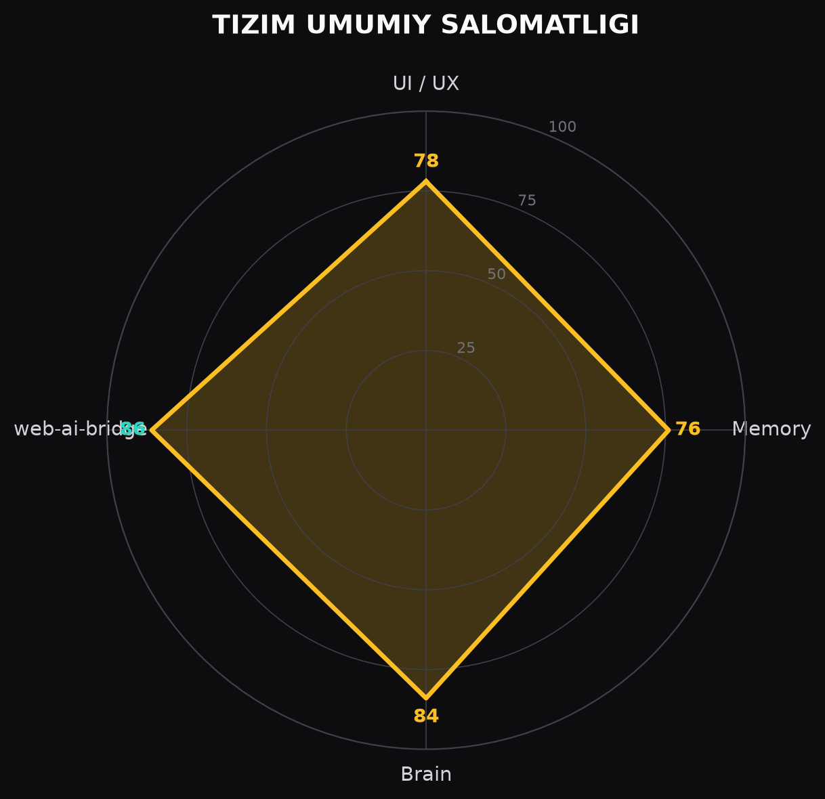
Sana: 2026-08-11 · Loyiha: C:\Users\user\Desktop\IGRIS_Coder
Muammolar va tuzatish rejasi: problems_to_fix.md (Word oxirida ham keltirilgan)

HISOBOTNI QANDAY O'QISH KERAK
Audit ikki qatlamda o'tkazildi:
• 1-qatlam: 4 texnik kategoriya (UI/UX, Memory, Brain, web-ai-bridge) — to'liq o'rganildi.
• 2-qatlam: 5 ko'ndalang SIFAT O'LCHAMI — aniqlik, tezlik, noisga aldanmaslik, data kontrol, sifat.
• 3-qatlam: 15 SOHA KATEGORIYASI (Real Coder Agent uchun) — mavjud/mavjud emas, sifat bo'yicha baho.
• Har bir kamchilik uchun: nima, nima sababdan paydo bo'ladi (ildiz sabab), ta'sir, yechim, ustuvorlik.
Rang shkalasi: yashil ≥85 · amber 75-84 · ko'k 65-74 · qizil <65. Soha jadvalida: ✅ mavjud · ⚠ qisman · ❌ yo'q.

IJROIYA XULOSASI — HOZIRGI HOLAT
IGRIS gibrid kodlash agenti 4 asosiy komponentdan iborat: brain (deterministik+LLM+RAG), xotira (18 L1 + 24 L2), interfeys (web/desktop/CLI) va real-brauzer bridge. Tizim barqaror ishlayapti (watchdog 0 restart). Ushbu hisobot 'bor va ishlaydi' darajasidan tashqari 5 ta sifat o'lchami bo'yicha chuqur audit qiladi.
JONLI HOLAT
Watchdog  ● ishlaydi | Backend  online (8765) | Ollama  online (11434) | Model  qwen3:8b | Restartlar  0× | Chatlar  7

Solution L2  330 | Experience L2  105 | Short-turn L1  330 | Telemetry  160 | Snapshotlar  10 | Probe outcome  0.0 (fix)

4 TEXNIK KATEGORIYA — BAHO
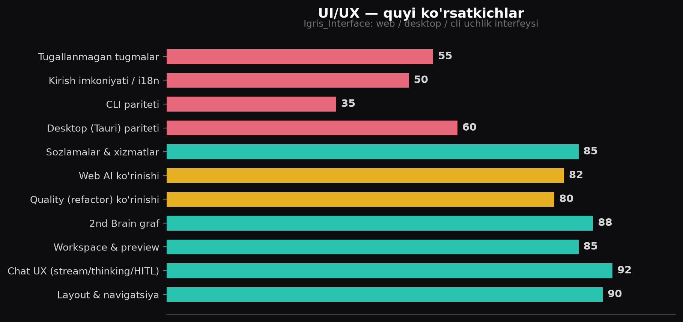
Kategoriya | Baho | Holat | Xulosa
1. UI / UX | 78 | Yaxshi | CLI stub, Tauri backend zair, a11y yo'q
2. Memory | 76 | Yaxshi | Sxema to'liq; MultiAgentSync o'lik, poisoning ulangan emas
3. Brain | 84 | Kuchli | CAG/MAG/intellekt a'lo; God-file, probe outcome=0.0
4. web-ai-bridge | 86 | Kuchli | 24 tool, xavfsizlik a'lo; selektor chidamsiz

UMUMIY BAHO: 81 / 100 — funksional kuchli, sifat kafolati (verifikatsiya) qo'shilsa 90+ bo'ladi.
5 SIFAT O'LCHAMI — YIG'MA BAHO
Sifat o'lchami | Baho | Asosiy kamchilik
Q1 Aniqlik | 70 | LLM javobi semantik tekshirilmaydi; probe outcome=0.0
Q2 Tezlik | 72 | RAG har query'da to'liq skan; frontend polling-ga tayangan
Q3 Noisga aldanmaslik | 62 | Poisoning ulangan emas; RAG/web injection xavfi
Q4 Data kontrol | 68 | Kirish validatsiyasi zaif; JSONL kompaktlashmaydi
Q5 Sifat | 71 | Eshiklar faqat kod/drawing; probe 4 task

SIFAT O'RTACHA: 69 / 100 — mavjud tizim ishlaydi, lekin kafolatlash (verifikatsiya, xavfsizlik, kontrol) zaif.

1/4 — UI/UX AUDIT (Igris_Interface)
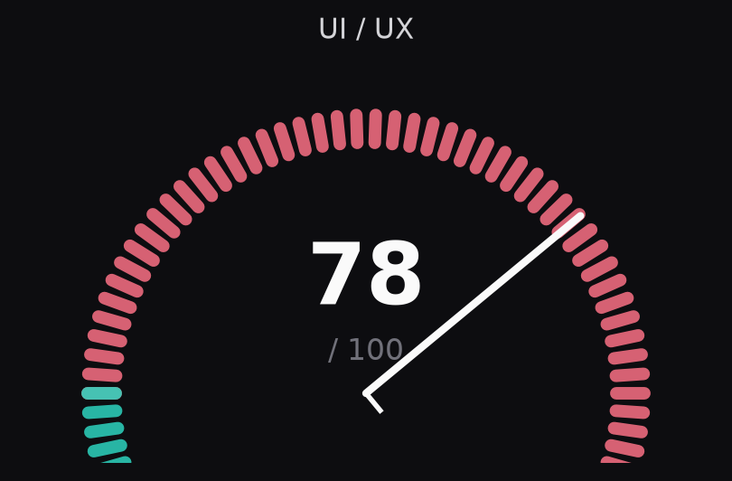
Komponent | Holat | Izoh
AgentConsole + shared/store.ts | ✓ | Zustand markazi, SSE streaming, HITL, drawing kartalar
PipelineStepper | ✓ | Plan→Read→Edit→Test→Review — REAL backend stage
LiveBuildView / LiveBuildHTML | ✓ | SVG elementma-element + uibuild qatlam qurilish + WebM
BrainView | ✓ | interaktiv graf: drag/zoom/semantic/live 4s
RefactorView | ✓ | telemetry + report + probe + assess
WebAIBridgeView | ✓ | tablar + screenshot + consent gate
SettingsModal | ✓ | model/speed/services/watchdog boshqaruvi
cli/ | ~ | Preview/Brain/WebAI stub (faqat platsent matn)
desktop/ (Tauri) | ~ | send_chat_message stub; frontend aslida FastAPI'ga
WorkspaceToolbar | ⚠ | New File/New Folder/Collapse — handler'siz

Zaif tomonlar va ildiz sabablar
Muammo | Ildiz sabab | Yechim
CLI viewlar stub | Faqatgina ma'lumot paneli yozilgan, backend ulanish yo'q | CLI'ga real chat/graf/preview
Tauri backend stub | Rust qismi FastAPI'ga proxy qilinmagan | proxy yoki olib tashlash
Ishlamaydigan tugmalar | UI yozilgan, onClick'lar bog'lanmagan | backend chaqiruvlarini ulash
A11y yo'q | ARIA/keyboard standartlar rejasi yo'q | axe-scan + ARIA qo'shish

2/4 — MEMORY AUDIT (Igris_Memory)
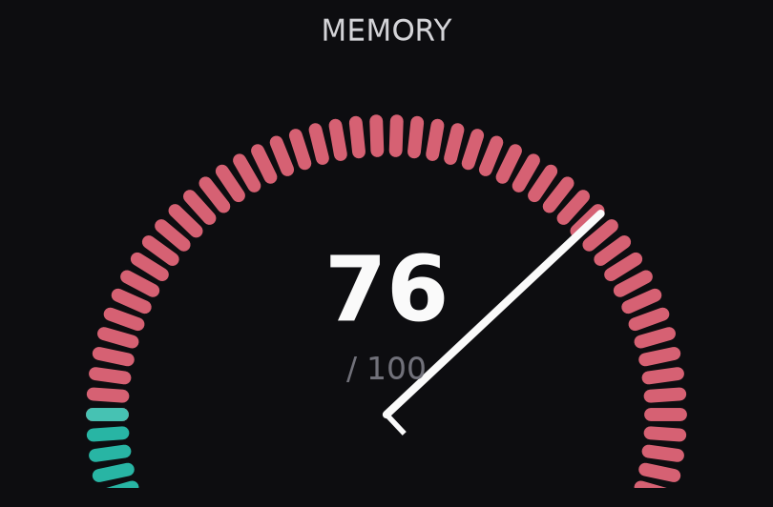
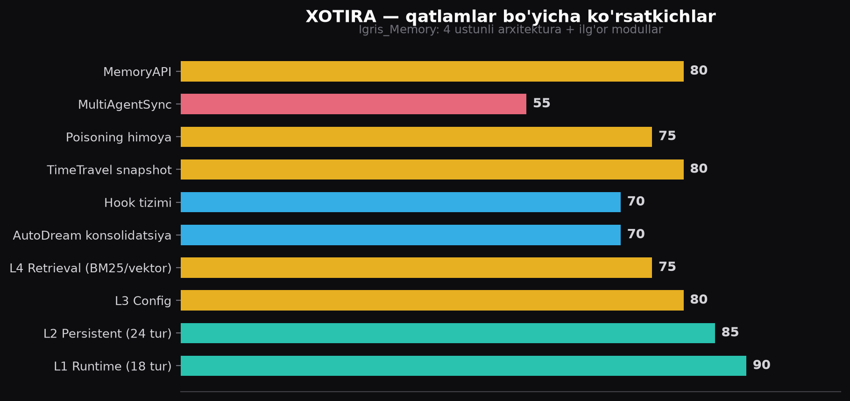
Modul | Holat | Izoh
L1 Runtime (18 tur) | ✓ | deque+TTL+JSONL; get_context_summary 1.5B mos
L2 Persistent (24 tur) | ✓ | duplicate-hash, consolidate, cleanup_stale
Retrieval (BM25/RRF) | ~ | BM25 ishlaydi; Vector FAISS opsional/amalda o'chiq
AutoDream | ~ | 5-pass bor; pattern id hash() noaniq
TimeTravel | ✓ | 10 snapshot olingan
PoisoningProtection | ⚠ | KLASS BOR, HECH QAERGA ULANGAN EMAS
MultiAgentSync | ⚠ | yozilgan, hech kim chaqirmaydi (o'lik kod)
MemoryAPI | ✓ | remember/recall/search/context/status/forget

Zaif tomonlar va ildiz sabablar
Muammo | Ildiz sabab | Yechim
Poisoning chaqirilmayapti | MemoryBridge.on_resolve/recall'da check_entry yo'q | yozish+o'qishda tekshirish
Retrieval har query'da rebuild | index diskda emas; yozuvdan so'ng _built=False | SQLite/FTS5 incremental
MultiAgentSync o'lik kod | agentlararo sync ishlatilmayapti | ulash yoki olib tashlash
forget() faqat long-term | boshqa turlar uchun not_implemented | barcha L2'ga kengaytirish
Autodream hash() id | Python built-in hash randomize | barqaror uuid/sha1

3/4 — BRAIN AUDIT (Igris_brain)
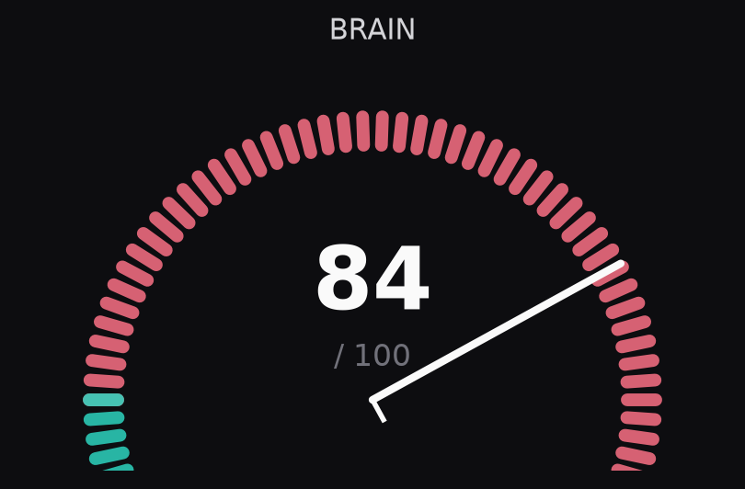
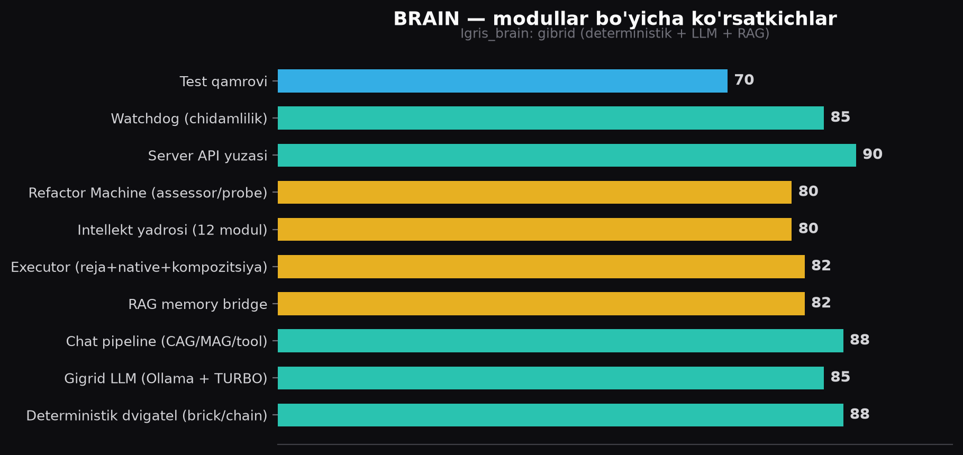
Modul | Holat | Izoh
igris_agent.py (2942 satr) | ~ | yadro; CAG/MAG/intellekt integratsiyasi — lekin God-file
server.py (2100+ satr) | ~ | FastAPI+SSE+HITL+probe; katta monolit
executor.py (3 rejim) | ✓ | run/run_native/run_composition
IntelligenceCore (12 modul) | ✓ | harm-filter, user-model, tone, logic, spatial...
RefactorMachine + assessor | ~ | telemetry+probe bor; DIKW standart mavjud
svg_validator | ✓ | chizma sifatini avto-baholaydi, xotiraga yozadi
watchdog | ✓ | backend+ollama auto-restart, lock

Zaif tomonlar va ildiz sabablar
Muammo | Ildiz sabab | Yechim
Probe outcome=0.0 | quality gate fayl mavjudligini tekshiradi, bajarilishini emas | run-based deliverable tekshiruv
God-file lar | modullashtirish qadami yo'q | ≤500 satr qoidalar, complexity check
try/except pass | xatolar yashirilgan | log+metric yozish
confidence sun'iy | logprob/self-eval ishlatilmaydi | confidence=f(verifikator+logprob)

4/4 — WEB-AI-BRIDGE AUDIT (web-ai-bridge)
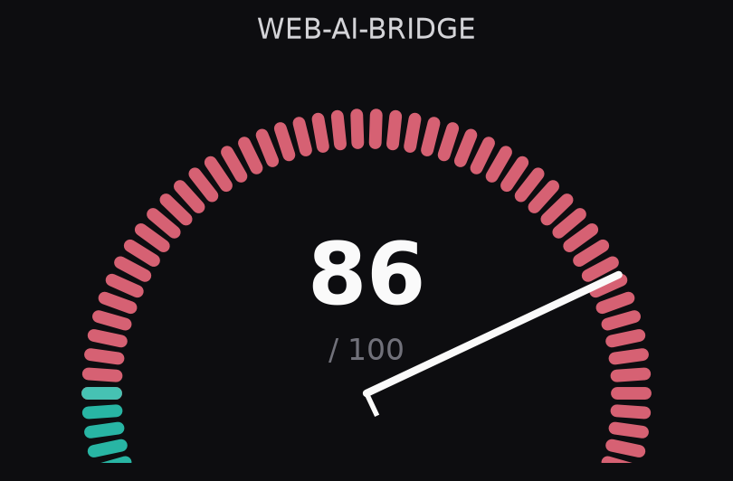
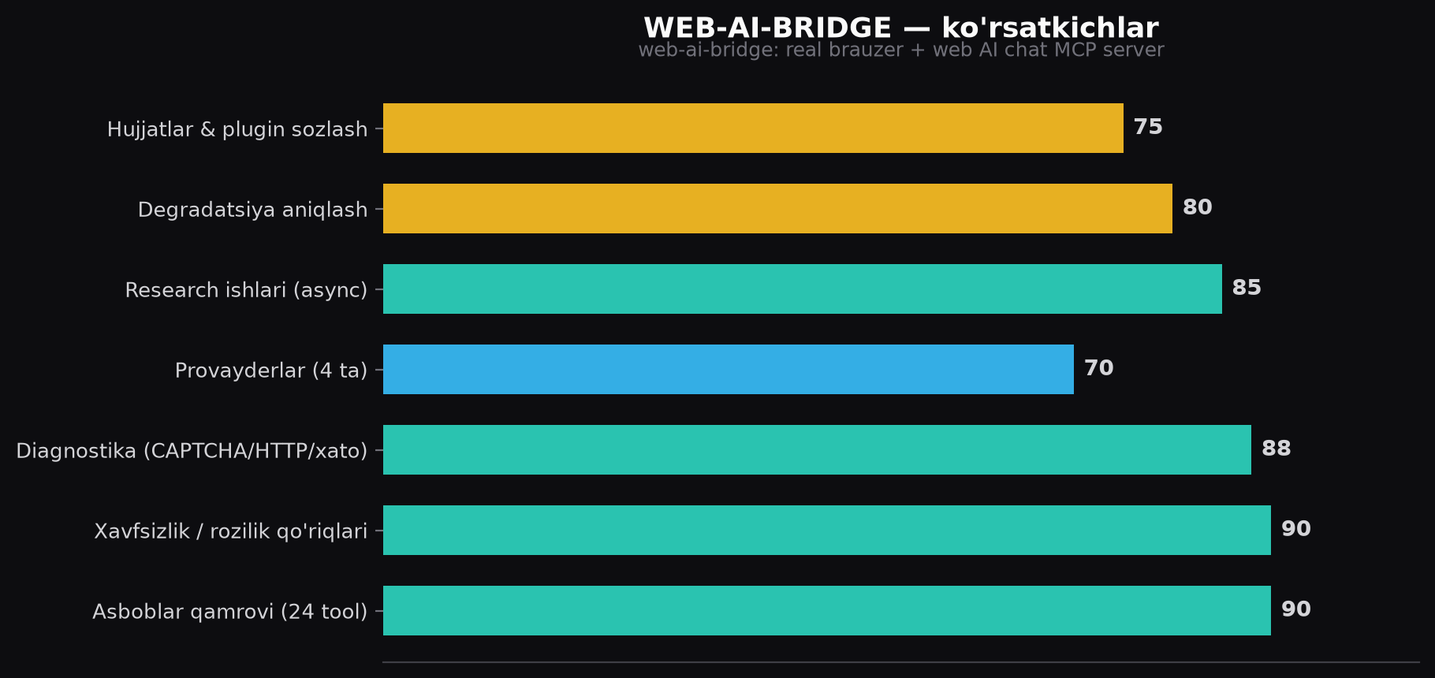
Komponent | Holat | Izoh
24 tool (index.js 1197 satr) | ✓ | browser_* + web_ai_*; WHEN_TO_USE har tool'da
Xavfsizlik qo'riqlari | ✓ | consequential-action roziligi + guard-secrets (hooks.json)
Diagnostika | ✓ | CAPTCHA/HTTP/file/obstruction klassifikatsiyasi
providers.js (4 ta) | ~ | selektorlar qo'lda; UI o'zgarsa buziladi
Research async | ✓ | start→poll→check; tab-ni kuzatadi
Degradatsiya aniqlash | ~ | reply vaqtlari process xotirasida (restart'da yo'qoladi)

Zaif tomonlar va ildiz sabablar
Muammo | Ildiz sabab | Yechim
Selektor chidamsiz | provayderlar UI'sini tez o'zgartiradi; qo'lda saqlanadi | selector probe test + avtomatik qayta topish
index.js monolit | bitta faylda barcha handler | modullarga bo'lish
Degradatsiya yo'qoladi | statika faqat process xotirasida | diskga saqlash

CHUQUR AUDIT — QO'SHIMCHA MODULLAR (V3)
Avvalgi 4 kategoriya arxitektura darajasida ko'rib chiqilgan edi. Bu bo'lim hali o'rganilmagan modullarni (tools, MCP serverlar, assessor, intellekt, CLI, desktop, bridge ichki) kod darajasida tekshiradi. Yangi topilmalar — V3.
DA-1 · TOOLS QATLAMI (xavfsizlik muhim)
Tool | Holat | Topilma / ildiz sabab
Workspace.resolve | ✓ | path-traversal himoyasi bor (root ichida). LECHIN symlink orqali chiqib ketish mumkin — os.path.realpath ishlatilmaydi
read/write/apply_patch | ✓ | barchasi Workspace orqali, sanitized
python_exec | ⚠ | 'sandbox' deb atalgan, lekin cheklanmagan: to'liq OS/network/disk kirish — faqat timeout+cwd
run_command | ⚠ | shell=False yaxshi; lekin deny-pattern (rm -rf / sudo) tekshiruvi tools qatlamida yo'q (faqat config'da)
web_fetch | ✓ | http/https + max_bytes cheklovi bor; web content injection-scan yo'q (N3 ga ulangan)
apply_patch (simple) | ⚠ | '+' qatorlar fayl oxiriga append qilinadi (heuristic) — murakkab patchda faylni buzishi mumkin

DA-2 · MCP SERVERLAR (art / ui_builder / skills)
Server | Qamrov | Topilma / ildiz sabab
art_server + art_svg | ~ | 12 PNG + 19 SVG oddiy predmet (olma, uy, mushuk...) — 'real image generatsiya' emas, juda tor qamrov
ui_builder | ✓ | 8 app deterministik spec: dashboard/login/chat/settings/profile/mobile/todo — yaxshi, LiveBuildHTML bilan mos
skills_server | ✓ | 7 tool: skills_list/load/plan/recall/cag_status/cag_invalidate/mag_context — SKILL.md lar bilan
mcp_bridge (McpBridge) | ✓ | stdio server boshqaruvi, list_tools/describe_all/call_tool/status

DA-3 · ASSESSOR / REFACTOR MACHINE
Modul | Holat | Topilma / ildiz sabab
KnowledgeAssessor | ✓ | DIKW 4 o'lchov (situation/information/volume/semantics) + og'irliklar — ASSESSMENT_STANDARDS bilan mos
BrickExperienceClassifier | ✓ | brickness/experientiality tasnifi (Tulving matritsasi)
RelationshipLinker | ✓ | surface/domain/session overlap asosida link
ProcessAnalyzer (telemetry) | ✓ | ok_rate/confidence/trend/suggestions — kuchli
RefactorMachine | ~ | Yaxshi, lekin FAQAT refactor/report yo'lida; chat javoblariga, yangi domainlarga qo'llanilmaydi (S1 bilan birga)

DA-4 · INTELLEKT MODULLARI (12)
Modul | Hajm | Holat | Topilma / ildiz sabab
harm_filter (2.10) | 8.8 KB | ✓ | tor zarar filtri — chat birinchi qadami
user_model (2.6) / tone_detect (2.12) | 8.9/6.5 KB | ✓ | profil+ohang moslashuvi (regex/qoida)
language (2.1) / logic (2.2) / spatial (2.4) | 6.5/6.0/5.0 KB | ✓ | CoT, safe_math, layout tahlil
self_eval (2.7) / creative (2.11) / naturalist (2.8) / music (2.3) | 6.1/4.8/6.9/3.1 KB | ✓ | ishonch kalibratsiyasi, variantlar, muhit xulosasi
Orchestrator | 8.5 KB | ✓ | yagona oqim: screen→adapt→evaluate; avtonomiya NOL tamoyili

DA-5 · PROBE / BENCHMARK / HOOKS / SKILLS
Modul | Holat | Topilma / ildiz sabab
probe_decisions.py | ✓ | 5 o'lchov: tool_selection/args/reasoning/recovery/outcome; ammo 4 task va outcome=0.0 (A3)
benchmark.py | ✓ | run_benchmark + agg + report — bor
hooks.py (AgentHookBus) | ~ | on_plan/on_step_*/on_task_done bor; faqat executor yo'lida, kichik
skills/ 7 SKILL.md | ✓ | svg-artist (6.5KB), progressive-visual (11.3KB), cag/mag/rag/plan — mazmunli

DA-6 · CLI (Igris_Interface/cli)
Komponent | Holat | Topilma / ildiz sabab
Sidebar FileTree | ⚠ | INITIAL_TREE (hardcoded mock) ishlatadi — REAL workspace emas!
AgentPanel | ⚠ | qwen3:8b, '39%', '12.4K/32K tokens' — HARDCODED FAKE ma'lumot (agentInfo'dan emas!) — foydalanuvchini aldaydi
ChatView | ✓ | store orqali real chat ishlaydi; lekin thinking/drawing ko'rsatilmaydi
Preview/Brain/WebAI view | ⚠ | faqat platsent matn (stub)

DA-7 · DESKTOP / TAURI
Komponent | Holat | Topilma / ildiz sabab
TitleBar.tsx | ⚠ | window.electronAPI (ELECTRON API!) ishlatadi — app TAURI; tugmalar hech narsa qilmaydi (undefined→silent). 'Anchor' brend qoldig'i (IGRIS emas)
tauri.conf.json | ⚠ | csp: null — Content-Security-Policy O'CHIQ (XSS xavfi)
web/tauri.ts | ⚠ | get_memory/set_memory/... komandalar yozilgan, lekin hech kim chaqirmaydi — o'lik scaffolding
src-tauri/src/lib.rs | ~ | memory commands in-memory (restart'da yo'qoladi); send_chat_message stub

DA-8 · WEB-AI-BRIDGE ICHKI
Komponent | Holat | Topilma / ildiz sabab
browser.js | ✓ | CDP real Chrome, user profil, downloads track, context events — kuchli
diagnostics.js | ✓ | CAPTCHA/cookie/newsletter/RISKY_ACTION + classifyNetError — aniq
guard-secrets.js | ✓ | Luhn karta tekshiruvi + secret pattern + fail-open — namunali
hooks.json | ✓ | PreToolUse guard + SessionStart setup-deps — to'g'ri ulangan

CHUQUR AUDIT — XULOSA
Yangi topilma | Jiddiylik | Yechim
CLI AgentPanel fake data (qwen3:8b/39%/12.4K) | Yuqori | agentInfo'dan real qiymat olish yoki '—' ko'rsatish
TitleBar electronAPI (Electron) Tauri'da o'lik | Yuqori | Tauri API (getCurrentWindow) ga o'tkazish
tauri.conf csp:null | Yuqori | CSP o'rnatish
python_exec haqiqiy sandbox emas | O'rta | restricted env / faqat workspace kirish / deny list
run_command deny-pattern yo'q | O'rta | deny-pattern qo'shish (config'dagi kabi)
workspace symlink escape | O'rta | os.path.realpath asosida tekshirish
art_server 12 predmet — tor qamrov | O'rta | rastr generatsiya/PIL qatlami qo'shish
web/tauri.ts o'lik kod | Past | olib tashlash yoki ishlatish

SIFAT O'LCHAMLARI — 5 KO'NDALANG KATEGORIYA
ASSESSMENT_STANDARDS.md (DIKW + Wang & Strong 4 klaster: intrinsic, contextual, representational, accessibility) bilan mos 5 ta amaliy o'lchov. Har biri uchun: ta'rif, o'lchov, hozirgi holat, kamchilik+ildiz sabab, yechim.
Q1 — ANIQLIK (Accuracy)
NIMA: Chiqish to'g'ri, vazifaga mos, hallucination yo'q. Javob 'bor' degani uchun emas, haqiqatan to'g'ri bo'lishi.
O'LCHOV: probe score (tool_selection/args/reasoning/recovery/outcome), confidence, verifikator natijalari.
HOZIRGI: Deterministik dvigatel ishonchli; LLM fallback confidence=0.85 sun'iy; probe outcome=0.0 (fix_code partial).
Kamchiliklar va tuzatish rejasi:
# | Muammo | Ildiz sabab | Yechim | Ust
A1 | LLM javobi semantik tekshirilmaydi | faqat struktura tekshiruvi; oracle yo'q | per-domain verifikatorlar (pytest/lint/DRC/mesh) | Yuqori
A2 | confidence sun'iy (0.85/0.9) | logprob/self-eval ishlatilmaydi | confidence=f(verifikator, logprob, self-eval) | Yuqori
A3 | probe outcome=0.0 | gate fayl mavjudligini tekshiradi, ishlashini emas | run-based tekshiruv + probe 4→20 task | Yuqori
A4 | web/fakt manba tekshiruvsiz | web content trust | 2 manbadan tasdiqlash, manba bilan solishtirish | O'rta

Q2 — TEZLIK (Speed)
NIMA: Javob va qidiruv imkon qadar tez; kutish real-vaqtda ma'lum qilinadi; ortiqcha ish qilinmaydi.
O'LCHOV: recall_ms, duration_ms, CAG hit_rate, TURBO tez-model, poll davrlari.
HOZIRGI: CAG LRU + TURBO + quick weather/math + BM25 primary bor. Ammo RAG har query'da to'liq skan; frontend polling.
Kamchiliklar va tuzatish rejasi:
# | Muammo | Ildiz sabab | Yechim | Ust
T1 | RAG har query'da to'liq skan+rebuild | index diskda emas, incremental yo'q | SQLite/FTS5 incremental + SessionCache | Yuqori
T2 | sessiya starti butun katalogni o'qiydi | load_documents to'liq walk | mtime cache + cheklangan chuqurlik | O'rta
T3 | vektor search amalda yo'q/sekin | 80MB model, lazy encode | 128-dim hash-embedding yoki top-k encode | O'rta
T4 | frontend polling (2-4-20s) | SSE faqat chat'da | SSE/WebSocket barcha jonli ma'lumotga | O'rta
T5 | creative 3x LLM chaqiruv | parallel/kesh yo'q | asyncio parallel + CAG | Past

Q3 — NOISGA ALDANMASLIK (Robustness)
NIMA: Shovqin, dublikat, prompt-injection, zaharlangan xotira va buzilgan web content'ga aldanmaslik.
O'LCHOV: poisoning stats, harm-filter blocks, web diagnostika, junk-filter, secret guard.
HOZIRGI: harm-filter (kirish) va web diagnostika bor; svg script/event strip bor. AMMO PoisoningProtection ulangan emas; RAG konteksti tozalanmaydi.
Kamchiliklar va tuzatish rejasi:
# | Muammo | Ildiz sabab | Yechim | Ust
N1 | PoisoningProtection ULANGAN EMAS | on_resolve/recall'da check_entry yo'q | yozish+o'qish yo'lida ulash | Yuqori
N2 | RAG konteksti system prompt'ga xom kiradi | sanitizatsiya yo'q | delimiter + pattern-scan | Yuqori
N3 | web text chiqish-tomon tekshiruvsiz | output guard yo'q | injection pattern tekshiruvi | Yuqori
N4 | karama-qarshi/dublikat yozuvlar ajratilmaydi | dedup faqat yozishda; contradiction ishlatilmaydi | retrieval'da contradiction flag | O'rta
N5 | probe/bench yozuvlari xotirani ifloslantiradi | junk-filtr faqat graf uchun | yozishda junk yorlig'i | O'rta

Q4 — DATA KONTROL (Data control)
NIMA: Kirish tekshiriladi, kelib chiqish (provenance) aniq, takrorlanuvchan, o'lcham cheklangan, secret himoyalangan, yo'qotish yo'q.
O'LCHOV: schema limitlar, max_keep/max_files, JSONL append, secret guard, validatsiya.
HOZIRGI: Schema limitlar, max_keep=60, workspace 400 fayl chegarasi, guard-secrets bor. Ammo kirish validatsiyasi zaif, JSONL kompaktlashmaydi.
Kamchiliklar va tuzatish rejasi:
# | Muammo | Ildiz sabab | Yechim | Ust
D1 | API kirish validatsiyasi zaif (path/length) | Pydantic faqat tip | middleware: path canonicalize + limit | Yuqori
D2 | JSONL hech qachon kompaktlashmaydi | scheduler yo'q; cleanup on-demand | compaction + muntazam scheduler | O'rta
D3 | provenance/version yo'q | checksum/model yo'q | artifact manifest + timeline | O'rta
D4 | token/cost telemetry yo'q | hisoblagich yo'q | /api/usage + UI | O'rta
D5 | workspace rollback yo'q | fayl versiyalash yo'q | write history + revert | Past
D6 | UI holati localStorage'da | export/sync yo'q | export/import | Past

Q5 — SIFAT (Quality / standartlar)
NIMA: Chiqish standartga javob beradi; mustahkam, maintainable, accessible, testlangan.
O'LCHOV: ASSESSMENT_STANDARDS (DIKW 4 o'lchov), svg_validator score, telemetry ok_rate/confidence, probe.
HOZIRGI: RefactorMachine + svg_validator + quality gate executor'da bor; ASSESSMENT_STANDARDS.md mavjud. Ammo eshiklar yoyilmagan, probe kichik, a11y yo'q.
Kamchiliklar va tuzatish rejasi:
# | Muammo | Ildiz sabab | Yechim | Ust
S1 | sifat eshiklari faqat kod/drawing | standards registry yoyilmagan | per-domain standartlar + chat yo'li | Yuqori
S2 | probe 4 task | kengaytirish rejasi yo'q | 20+ task (web/PCB/3D/audio/injection) | O'rta
S3 | telemetry alert emas | alerting yo'q | threshold → degraded flag | O'rta
S4 | a11y yo'q | standart yo'q | axe-scan + ARIA | O'rta
S5 | God-file lar | refactor qadami yo'q | ≤500 satr + complexity check | Yuqori

SOHA KATEGORIYALARI AUDITI (Real Coder Agent — 15 ta)
Har bir soha kategoriyasi 5 sifat o'lchami bo'yicha baholanadi: Aniqlik / Tezlik / Noisga aldanmaslik / Data kontrol / Sifat. ✅ bor · ⚠ qisman · ❌ yo'q · — (modul yo'q, baholanmadi).
Soha kategoriyasi | Aniqlik | Tezlik | Noise | Data | Sifat | Asosiy kamchilik / bo'shliq
1 Code Intelligence | ✓ | ✓ | ~ | ~ | ~ | God-file, probe outcome=0.0, verifikator yo'q
2 UI/UX Frontend | ✓ | ✓ | ~ | ~ | ~ | CLI stub, a11y yo'q, tugmalar ishlamaydi
3 Diagramma & Sxema | — | — | — | — | — | Mermaid/Graphviz tool yo'q
4 Rasm (Image) | ~ | ~ | ✓ | ~ | ✓ | rastr tahrir/image→code/OCR yo'q; svg_validator bor
5 Video | — | ~ | — | — | — | faqat WebM build-record; ffmpeg/storyboard yo'q
6 Audio | — | — | — | — | — | TTS/musiqa/transkripsiya umuman yo'q
7 3D Model | — | — | — | — | — | OpenSCAD/STL/render yo'q
8 Hardware 3D | — | — | — | — | — | slicer/G-code/preflight yo'q
9 Schematics & PCB | — | — | — | — | — | KiCad/Gerber/DRC/SPICE yo'q
10 Office hujjatlar | — | — | — | — | — | DOCX/PPTX/XLSX/PDF yo'q
11 Audit & Review | ~ | ✓ | ~ | ~ | ~ | faqat kod/telemetry; per-domain eshiklar yo'q
12 Detallashtirish | ~ | ~ | ~ | ~ | ~ | generic planner; per-domain template yo'q
13 MCP domain-serverlari | ~ | ~ | ✓ | ~ | ✓ | art/ui_builder bor; 3d/eda/office/media/audio yo'q
14 Memory kengaytirish | ✓ | ~ | ~ | ~ | ~ | L2 24 tur; domain-turlar yo'q
15 Verifikatsiya & Test | ~ | ~ | ~ | ~ | ~ | faqat pytest+svg; DRC/mesh/PDF-extract yo'q

USTUVOR QURILISH TARTIBI (bosqichlar)
Faza | Kategoriyalar | Nega avval?
Faza 1 (1-2 hafta) | Q1-Q5 tuzatishlar + Office + Diagramma | mavjud modullarni ulash — eng past texnik to'siq, darhol qiymat
Faza 2 (2-4 hafta) | Rasm + Audio + Video | media pipeline — ffmpeg/PIL/piper bilan tez natija
Faza 3 (1-2 oy) | 3D + Hardware 3D + PCB | matn asosidagi (OpenSCAD/KiCad) — LLM uchun ideal, lekin murakkab

MUAMMOLAR VA TUZATISH REJASI (problems_to_fix.md)
Quyida barcha muammolar yig'indisi — to'liq jadval problems_to_fix.md faylida. Har bir muammo uchun ildiz sabab aniqlangan: ko'pchilik 'yangilik yozish' emas, MAVJUD MODULNI ULASH edi.
ID | Sifat | Muammo (qisqa) | Ildiz sabab | Yechim (qisqa) | Ust
A1 | Aniqlik | LLM javobi tekshirilmaydi | oracle/verifikator yo'q | per-domain verifikatorlar | Yuqori
A2 | Aniqlik | confidence sun'iy | logprob yoki self-eval yo'q | confidence=f(verifikator) | Yuqori
A3 | Aniqlik | probe outcome=0.0 | gate faqat fayl borligini tekshiradi | run-based tekshiruv + 20 task | Yuqori
N1 | Noise | PoisoningProtection ulangan emas | on_resolve/recall'da chaqiruv yo'q | yozish+o'qish yo'lida ulash | Yuqori
N2 | Noise | RAG kontekst tozalanmaydi | sanitizatsiya yo'q | delimiter + injection-scan | Yuqori
N3 | Noise | web text output-guardsiz | output side tekshiruv yo'q | chiqishda injection pattern | Yuqori
T1 | Tezlik | RAG har query'da to'liq skan | index diskda emas | SQLite/FTS5 incremental | Yuqori
D1 | Data | kirish validatsiyasi zaif | Pydantic faqat tip | middleware path/length | Yuqori
S1 | Sifat | eshiklar faqat kod/drawing | standards yoyilmagan | per-domain registry | Yuqori
S5 | Sifat | God-file lar (2942-1197 satr) | refactor qadami yo'q | ≤500 satr + complexity check | Yuqori
D2 | Data | JSONL kompaktlashmaydi | scheduler yo'q | compaction + cron | O'rta
D3 | Data | provenance/version yo'q | checksum model yo'q | artifact manifest | O'rta
D4 | Data | token/cost telemetry yo'q | hisoblagich yo'q | /api/usage | O'rta
T2 | Tezlik | sessiya starti sekin | to'liq katalog walk | mtime cache | O'rta
T4 | Tezlik | frontend polling | SSE faqat chat'da | SSE/WebSocket | O'rta
N4 | Noise | karama-qarshi yozuvlar | contradiction ishlatilmaydi | retrieval flag | O'rta
S2 | Sifat | probe 4 task | kengaytirish yo'q | 20+ task | O'rta
S3 | Sifat | telemetry alert emas | alerting yo'q | degraded flag | O'rta
S4 | Sifat | a11y yo'q | standart yo'q | axe + ARIA | O'rta
D5 | Data | workspace rollback yo'q | versiyalash yo'q | write history + revert | Past
T5 | Tezlik | creative 3x sekin | parallel/kesh yo'q | asyncio + CAG | Past
D6 | Data | UI holat export yo'q | sync yo'q | export/import | Past

CHUQUR AUDIT (V3) — YANGI TOPILMALAR
ID | Modul | Muammo (qisqa) | Ildiz sabab | Yechim (qisqa) | Ust
Dp1 | CLI | AgentPanel fake data (qwen3:8b/39%) | agentInfo o'rniga hardcode | real qiymat yoki '—' | Yuqori
Dp2 | Desktop | TitleBar electronAPI (Electron) Tauri'da o'lik | Electron'dan ko'chirilgan, Tauri API'ga o'tkazilmagan | getCurrentWindow API | Yuqori
Dp3 | Desktop | tauri.conf csp:null — CSP yo'q | CSP sozlanmagan | CSP o'rnatish | Yuqori
Dp4 | Tools | python_exec 'sandbox' emas — to'liq OS kirish | faqat timeout+cwd cheklovi | restricted env + workspace-only | O'rta
Dp5 | Tools | run_command deny-pattern yo'q | tools qatlamida tekshiruv yo'q | deny list qo'shish | O'rta
Dp6 | Tools | workspace symlink escape mumkin | realpath ishlatilmaydi | realpath tekshiruv | O'rta
Dp7 | Image | art_server 12 predmet — tor qamrov | faqat qo'lda chizilgan predmetlar | PIL/rastr + generatsiya | O'rta
Dp8 | Tools | apply_patch '+' oxiriga append — buzish xavfi | oddiy heuristic | satr-pozitsiyali patch | Past
Dp9 | Desktop | web/tauri.ts o'lik scaffolding | komandalar ishlatilmayapti | olib tashlash/ishlatish | Past

XULOSA: 3 TO'PLAM
To'plam | Qamrov | Kutilayotgan natija
Tez natija (1-3 kun) | N1-N3, D1, T1, A1-A2 | Xavfsizlik + validatsiya + tez qidiruv — xavf darhol kamayadi
O'rta (2-4 hafta) | Q1-Q5 verifikatorlar, Office/Diagramma/Audio, S5 modullashtirish | Sifat kafolati + yangi 3 soha kategoriyasi
Uzoq (1-2 oy) | 3D, Hardware 3D, PCB, Video, a11y, CI+alerting | To'liq Real Coder Agent — 15/15 kategoriya

To'liq jadval: problems_to_fix.md (loyiha ildizida, ushbu Word bilan sinxron)
— Hisobot tugadi —

