

**SHOP SNEAKER: QSNEAKER PROJECT**

***Problem:*** Nowaday, in the 4.0 era, digital technology is developing, people's shopping needs are increasing, buyers need a technology to help them shop at home, and sellers do not need to rent space at high prices to be able to display products, and the QSneaker project to solve these issues.

“Shopping easy, comfortable”

“Save product storage space”

“Be able to interact with a large number of customers”

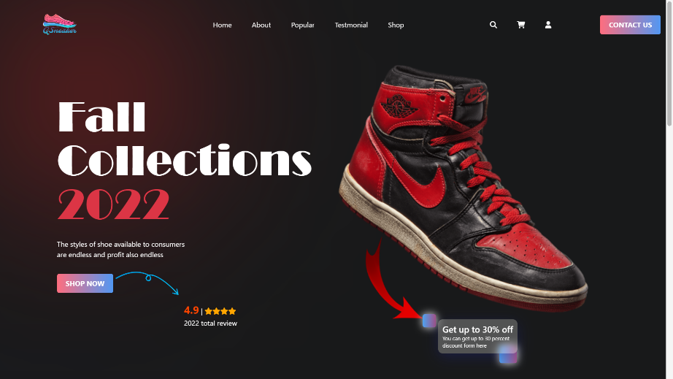***Solution:***

For buyers: To make a first impression on people who start shopping at the Web Shop, we create a page called a "Landing Page".

In there, we intro about Qsneaker, show best-selling products, and event of shop.

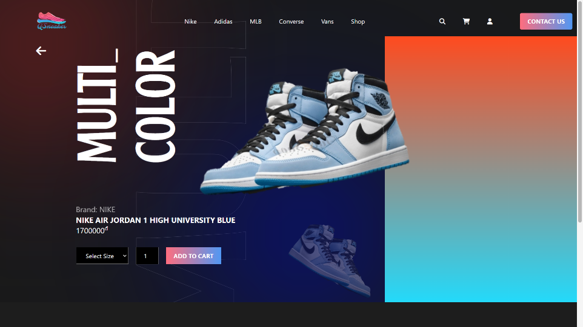For each product, the design part is very important to leave an impression on the user, instead of using a white background like shopee, tiki, here we use a black background together to be able to turn on the product.

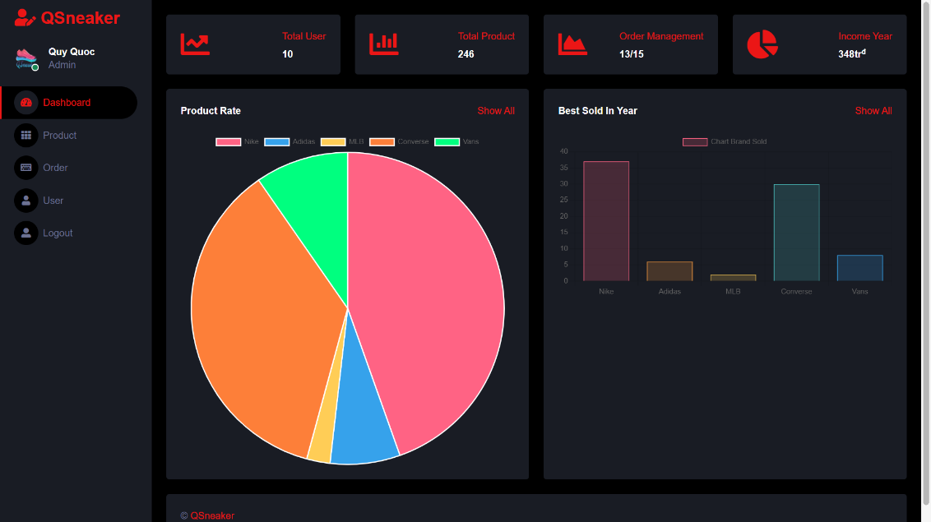

For sellers: We designed a “dashboard” page: based on which they will quickly capture information about the number of users, the total types of products being sold, manage invoices, income in the current year, and a chart showing the number of shoe brands that have successfully sold:

Of course, sellers can add and remove items and manage invoices based on 2 pages "Product-management" and "Order-management".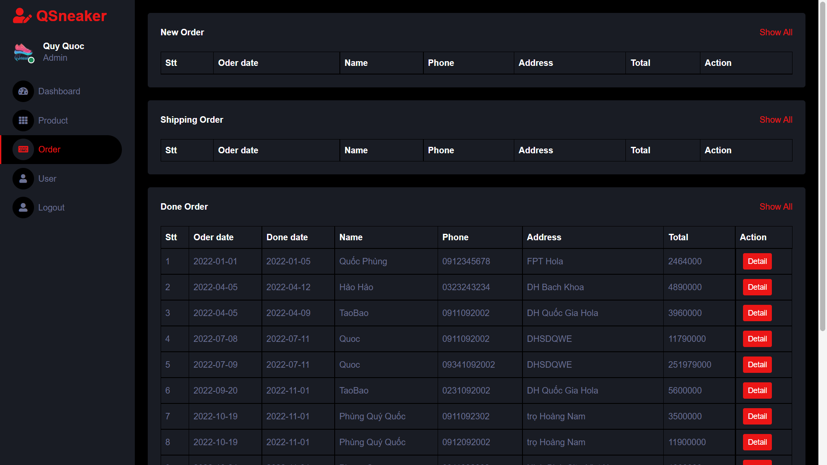

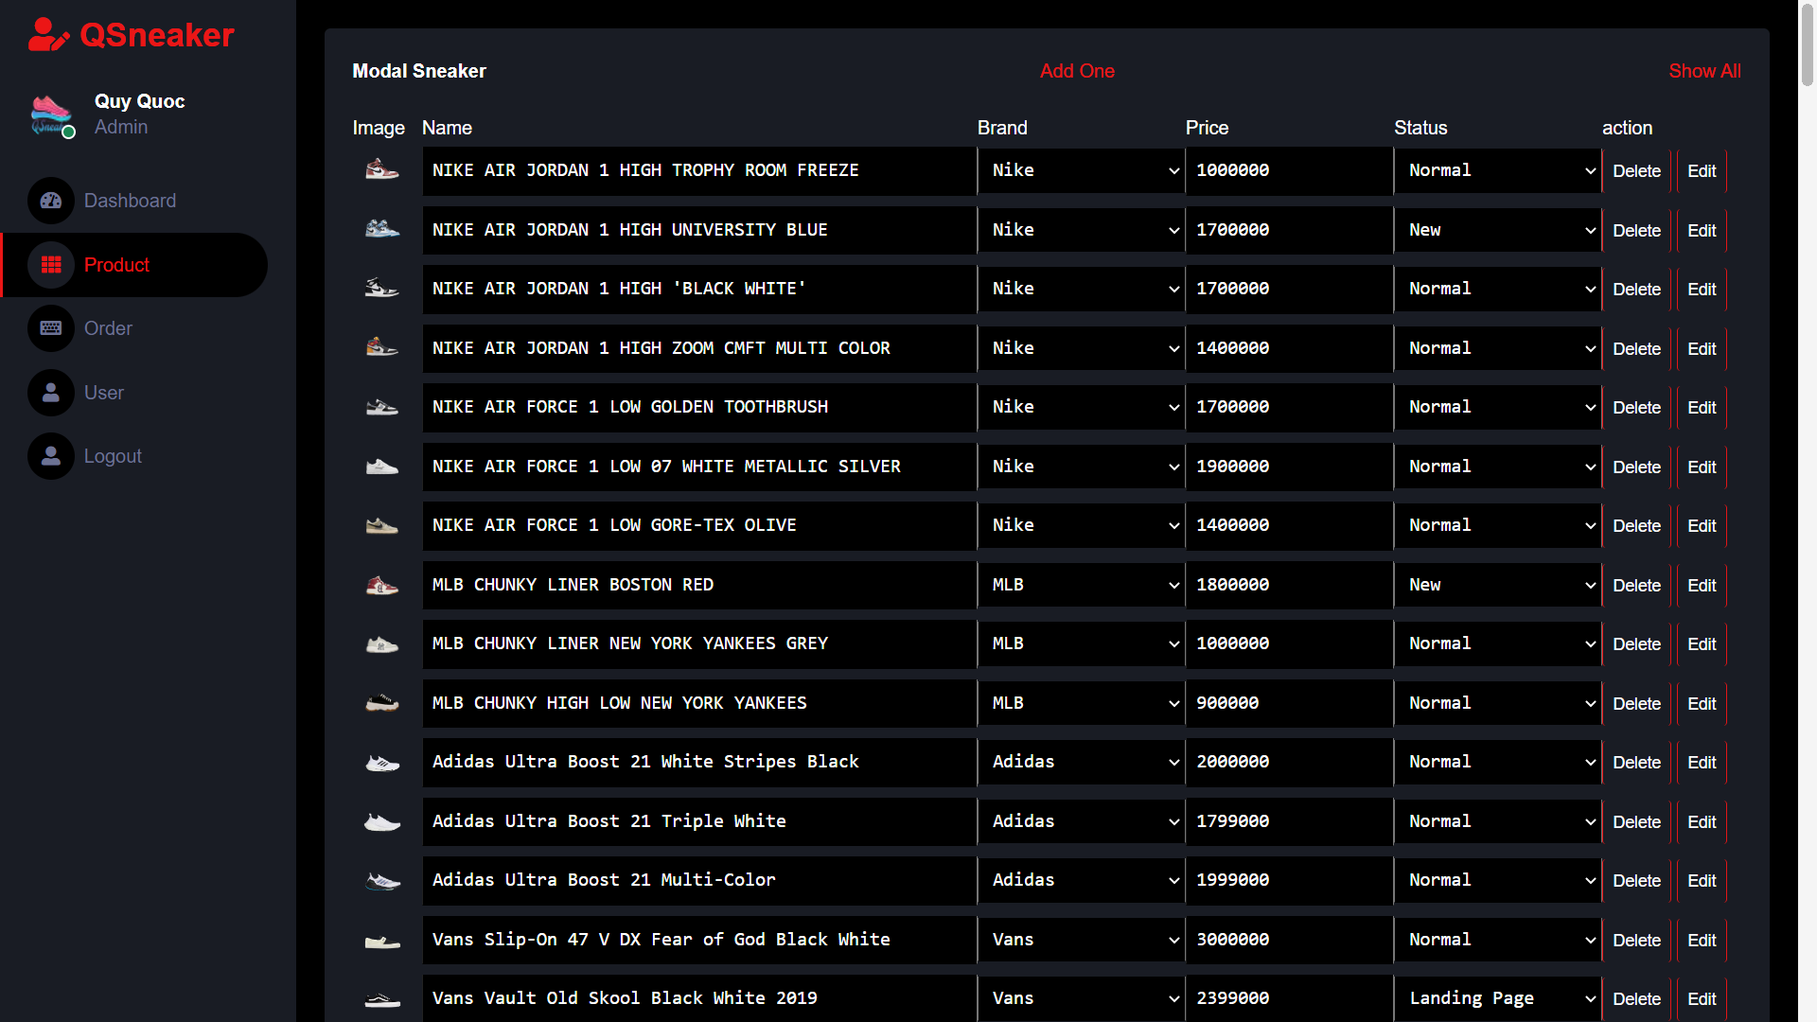

At this project to work with the management system we have used the following programming software:

1. SQL
2. Java
3. HTML
4. CSS
5. JS

SQL SERVER:

To build a diagram of the management system of shoe models, sizes, brands, quantities, revenue sources, orders, ...

Build query commands to sort products, calculate revenue sources, search for products, change order status, ...

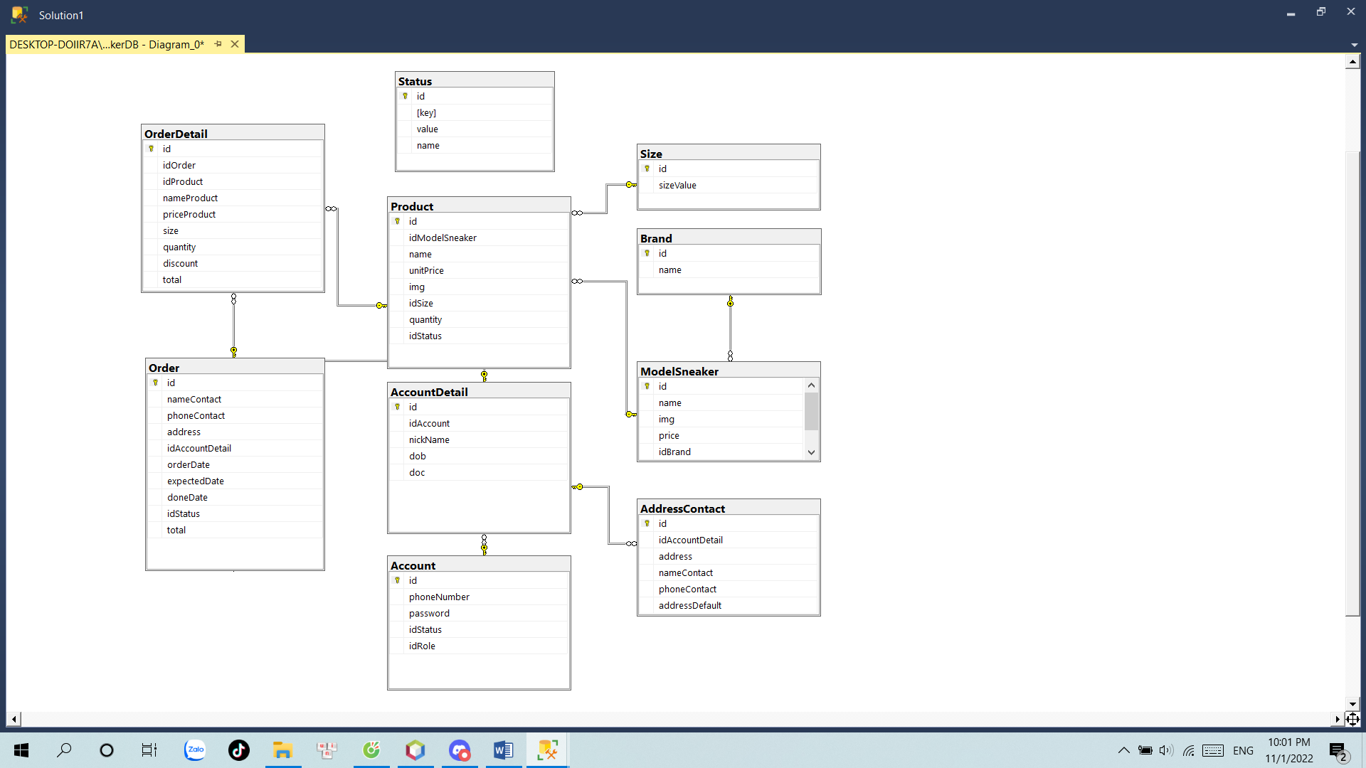

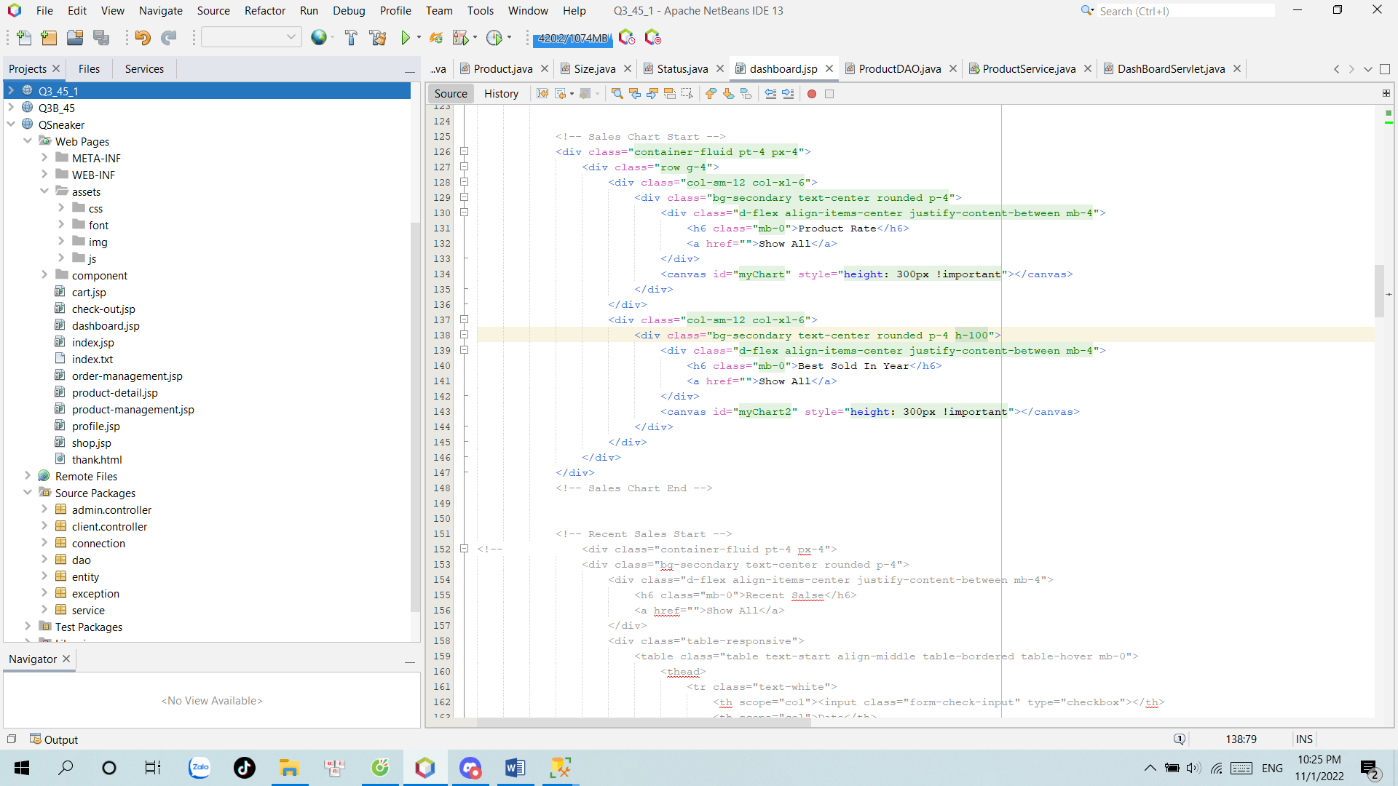JAVA:

At Folder assets we have files to serve web design such as css, img, js, ...

JSP files to receive attributes sent from the servlet and displayed on the website.

In the connection folder containing the java file receives the task of connecting java to the database in SQL.

Each table in the database corresponds to a class in the entity folder.

Folders contain code files that take care of data from the database by using methods that perform queries and return objects or object lists.

The Servlet file plays the role of executing the commands contained in the knife folder and sends data to the jsp file.

In the **admin.controller** folder contains Servlet files to handle the incoming data for the admin management page.

In the **client.controller** folder contains Servlet files to handle the incoming data for the shop page.

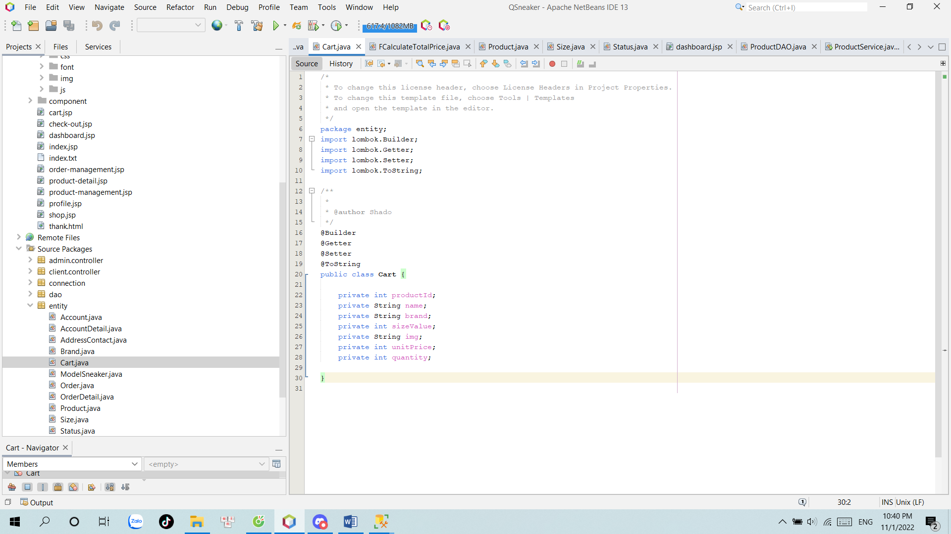In the package entity there is 1 more class "Cart". This class will define the products in the cart and store it as a session.

Here, the project uses the Lombok library to simplify the code to flexibly edit the properties of the object.

Session: Login Account, ListCart

* Store accounts and shopping carts so that we do not lose data when we transfer between pages.

With an account with an admin role, you can go to separate pages for admins such as dashboard, product management.

Users can search and sort and filter products by price, size, brand,... to be able to find the right product as quickly as possible through the "side bar".

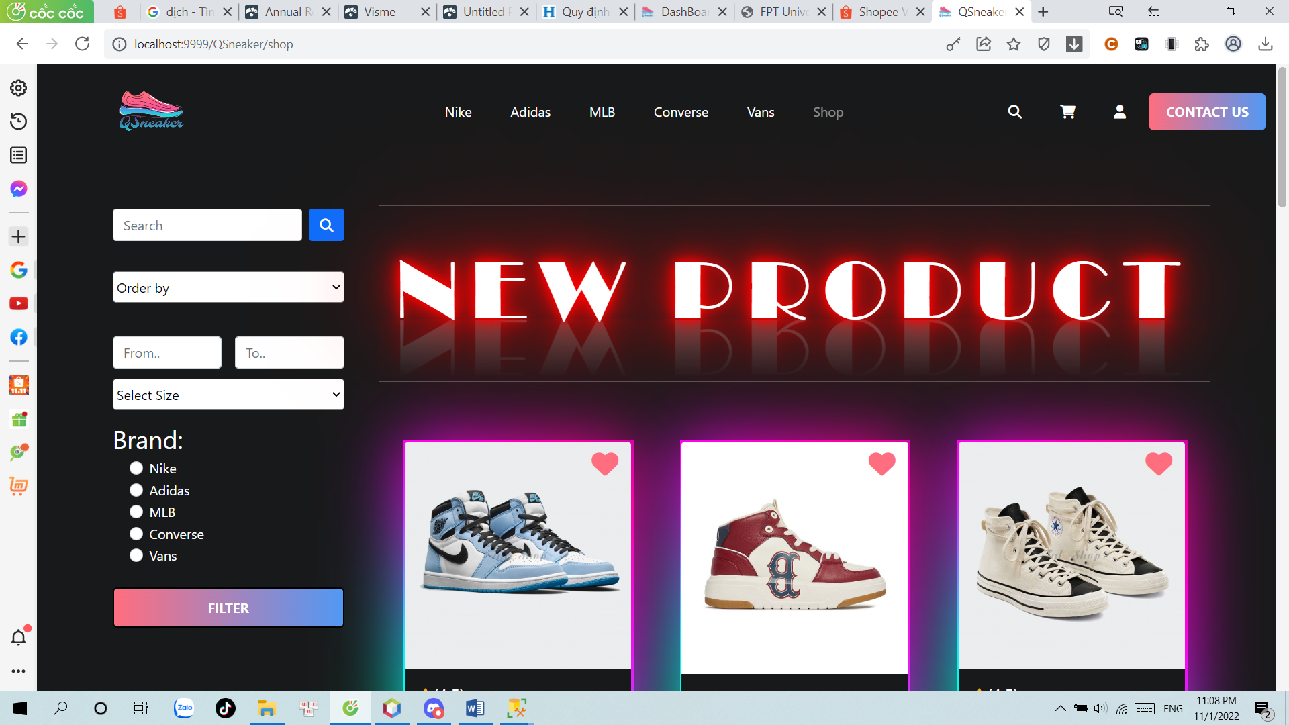

Naturally users can change personal information: 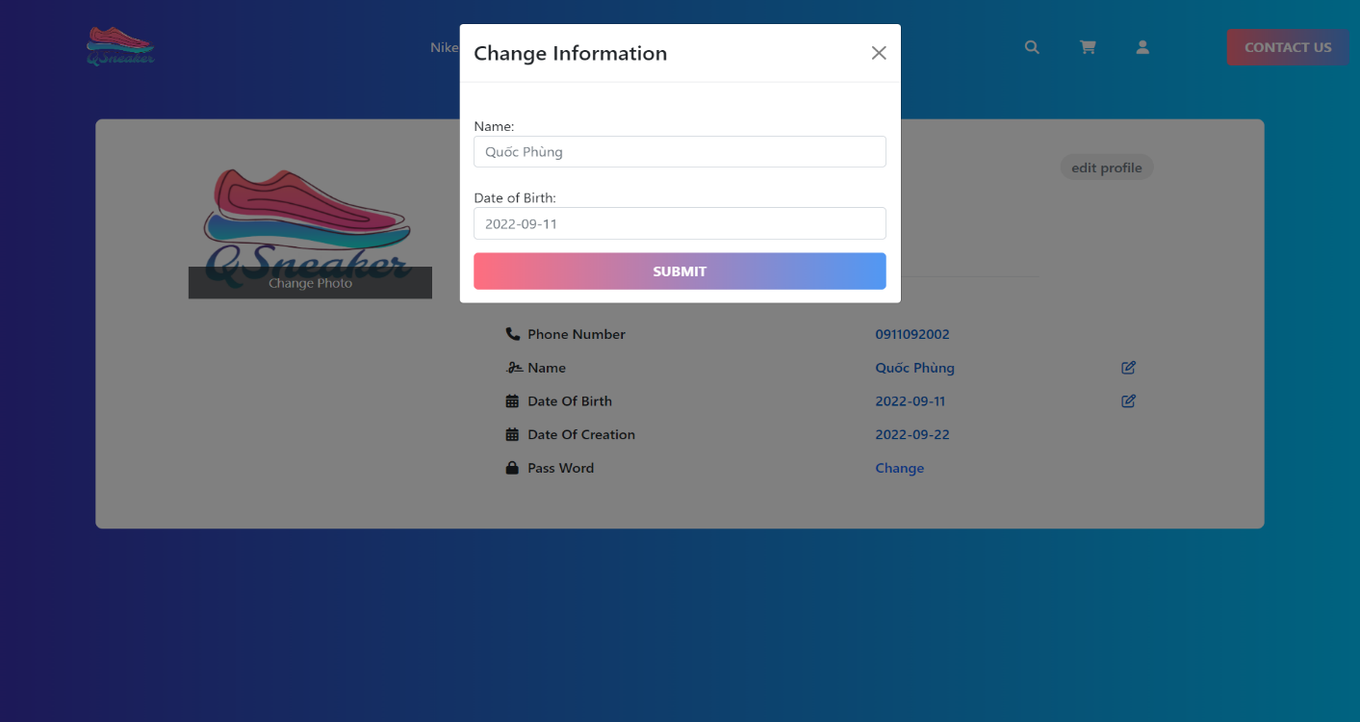

As well as adding deletion edits, considering the default address:

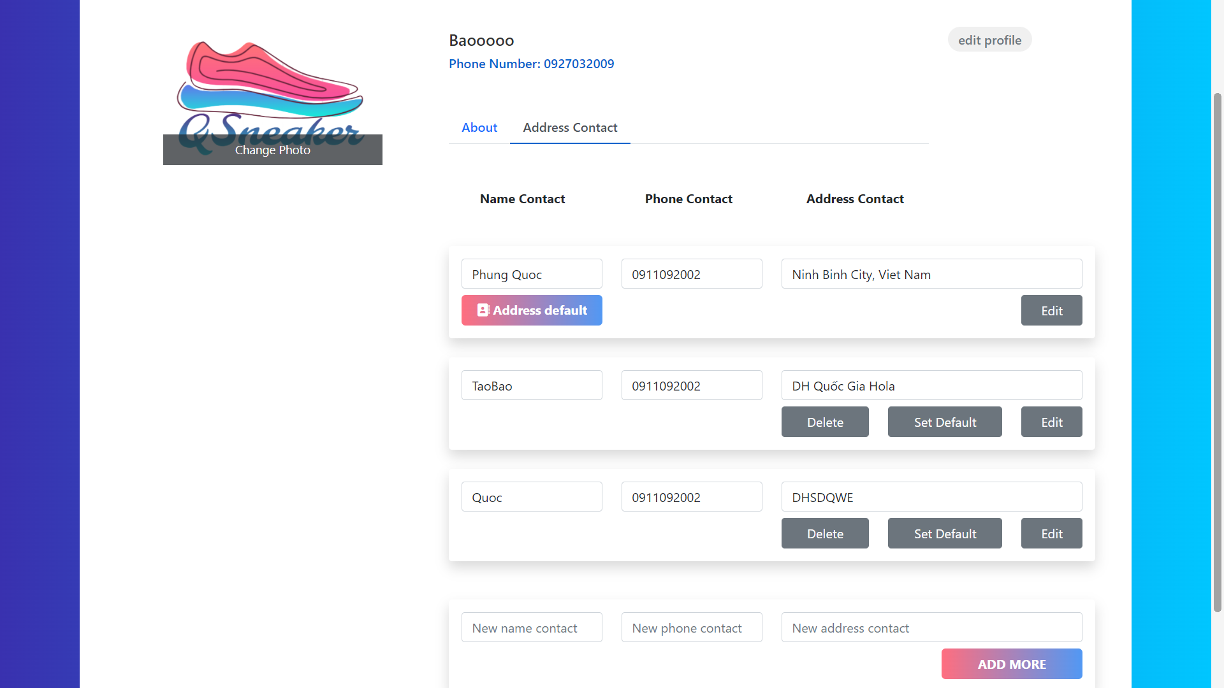

**Conclusion:**

Project QSneaker is a project on shopping and managing shoes in particular and business items in general. The original purpose of the project was to help buyers easily access the latest and most beautiful products in an attractive way. Addition , we want to help business people have a good environment to compete as platforms and websites are increasing. Our website was created with the following criteria: simple, user-friendly and effective. The QSneaker project has only just started and completed within two weeks, but we have tried to bring the best core values to the user. Fortunately for us, the project developed quite successfully and was well received and responded to by everyone. We will accept user contributions to edit and improve the project better and better.