
HMI INTERFACE DESCRIPTION
ORMIN / ORMECO Monitoring System
INITIAL CUSTOMER SUBMISSION

1. Purpose
This document provides a brief description of the Human–Machine Interface (HMI) supplied for the ORMIN / ORMECO monitoring system. The HMI provides live equipment monitoring, historical trends, fuel-consumption analysis and system-status information.

2. System Interface
The HMI is a web-based application connected to the monitoring system through the following interfaces:
- Field communication: Modbus TCP
- Live-data processing: HMI backend server
- Historical-data storage: SQLite database
- Operator interface: Standard web browser
- Data update: Automatic periodic refresh
Sensors / PLC | Modbus TCP | HMI Backend | Web HMI Display
3. HMI Screens
Screen | Description
Overview | Summary of the main operating parameters for D/G No. 1 to D/G No. 4.
Engine | Detailed operating parameters for the selected engine.
Engine Status | Engine operating and status indications.
Device Status | Operating condition of monitored equipment and devices.
P&ID | Process values and equipment status on the system diagram.
Pressure Trend | Historical pressure values compared with engine load.
Exhaust Temperature Trend | Cylinder and turbocharger temperatures compared with engine load.
Fuel Consumption | D.O. and H.O. inlet flow, return flow and calculated consumption.
Administration | Authorized signal, collector and database configuration functions.
4. Displayed Information
The HMI displays operating information including:
- Engine power, speed and running hours
- Fuel-oil, lubricating-oil, cooling-water and intake-air parameters
- Cylinder exhaust and turbocharger temperatures
- Fuel inlet, return and transfer flow
- Equipment running, stopped, trip and fault conditions
- Communication status and historical trends
5. Status and Communication
The HMI uses values, text, symbols and colours to identify normal, stopped, warning, trip, fault and communication-unavailable conditions. Live information is acquired through Modbus TCP. Historical information is stored locally for trend and fuel-consumption display.
If communication is interrupted, the HMI provides a communication-status indication. Displayed information must not be considered current until communication is restored.
6. Scope and Confirmation
The current HMI is intended primarily for monitoring, visualization and operational analysis. Final signal addresses, equipment descriptions, engineering units, status colours, alarm limits and screen arrangements are subject to customer review and project commissioning.

Appendix A – HMI Screen Captures
Replace each grey placeholder with the applicable approved HMI screenshot before final submission.
A.1 Overview
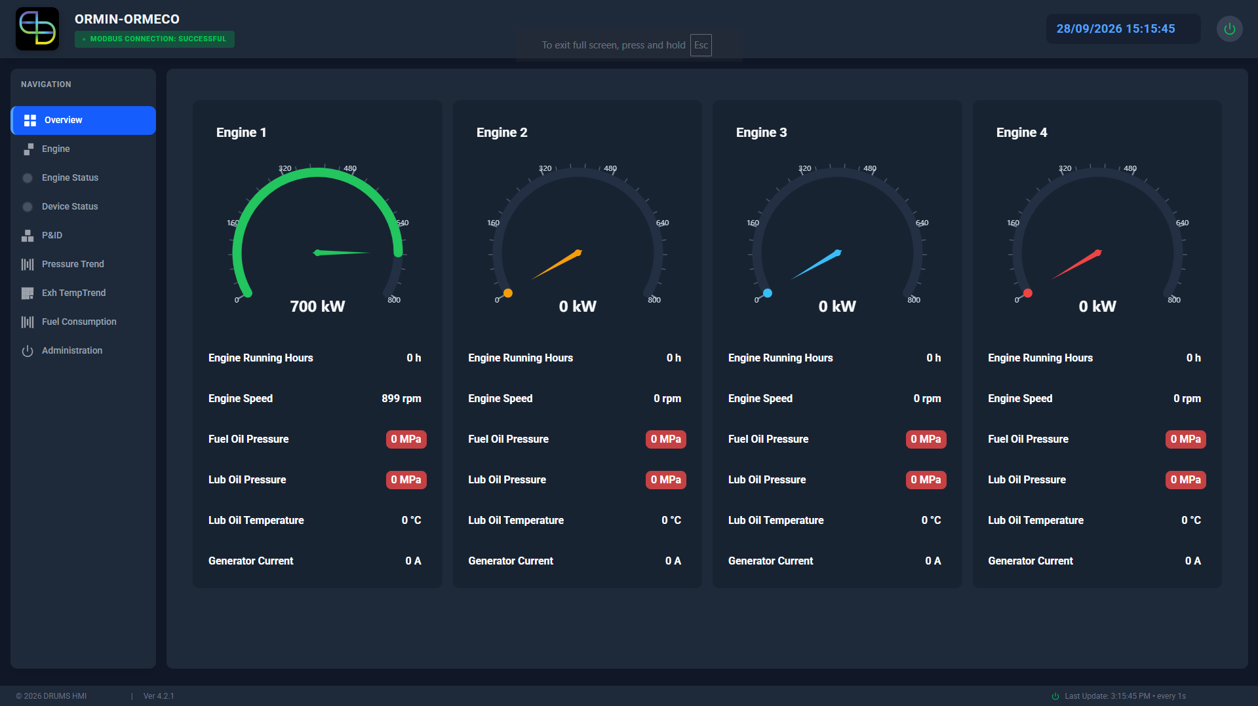

A.2 Engine
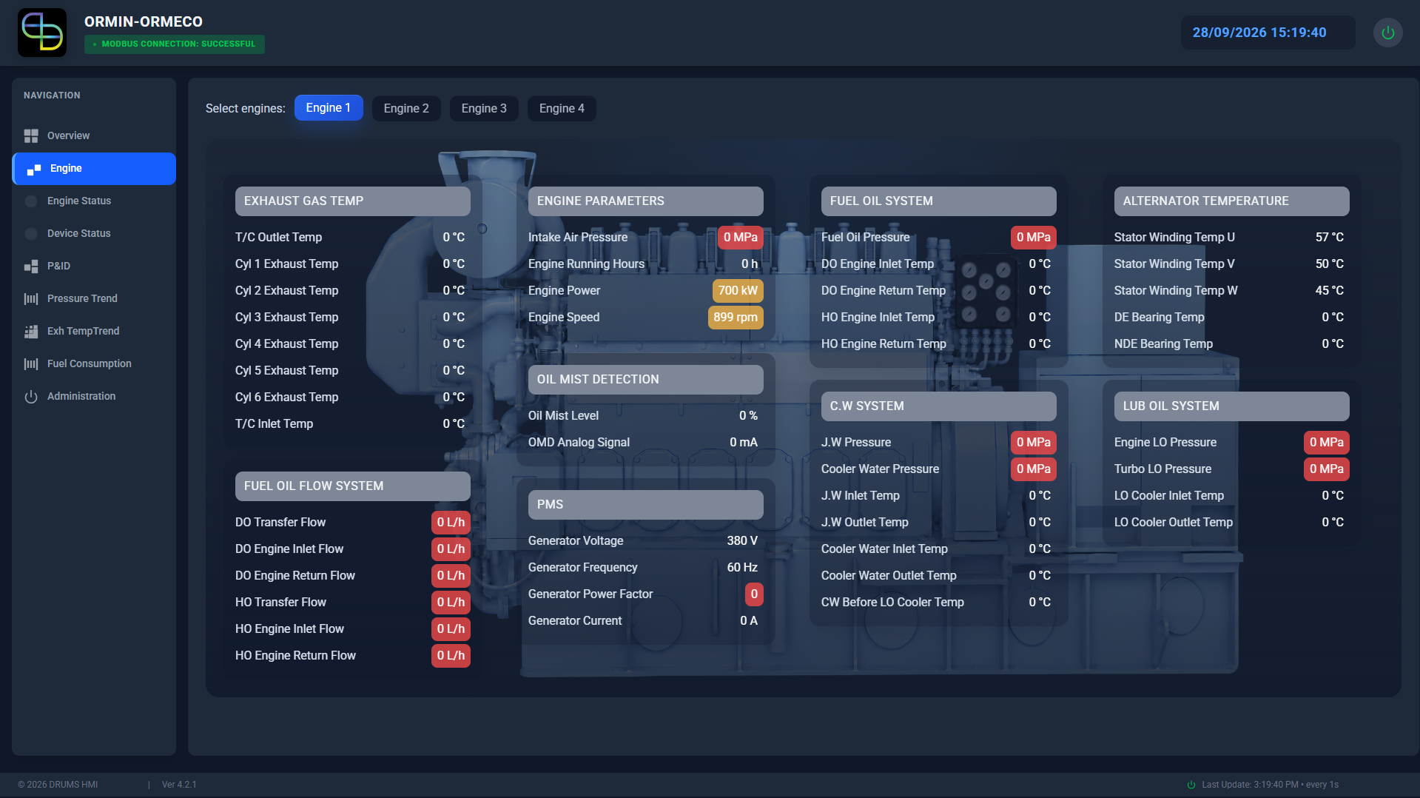

A.3 Engine Status
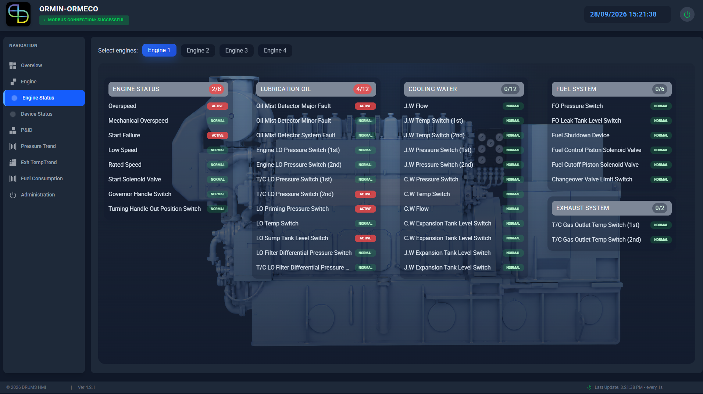

A.4 Device Status
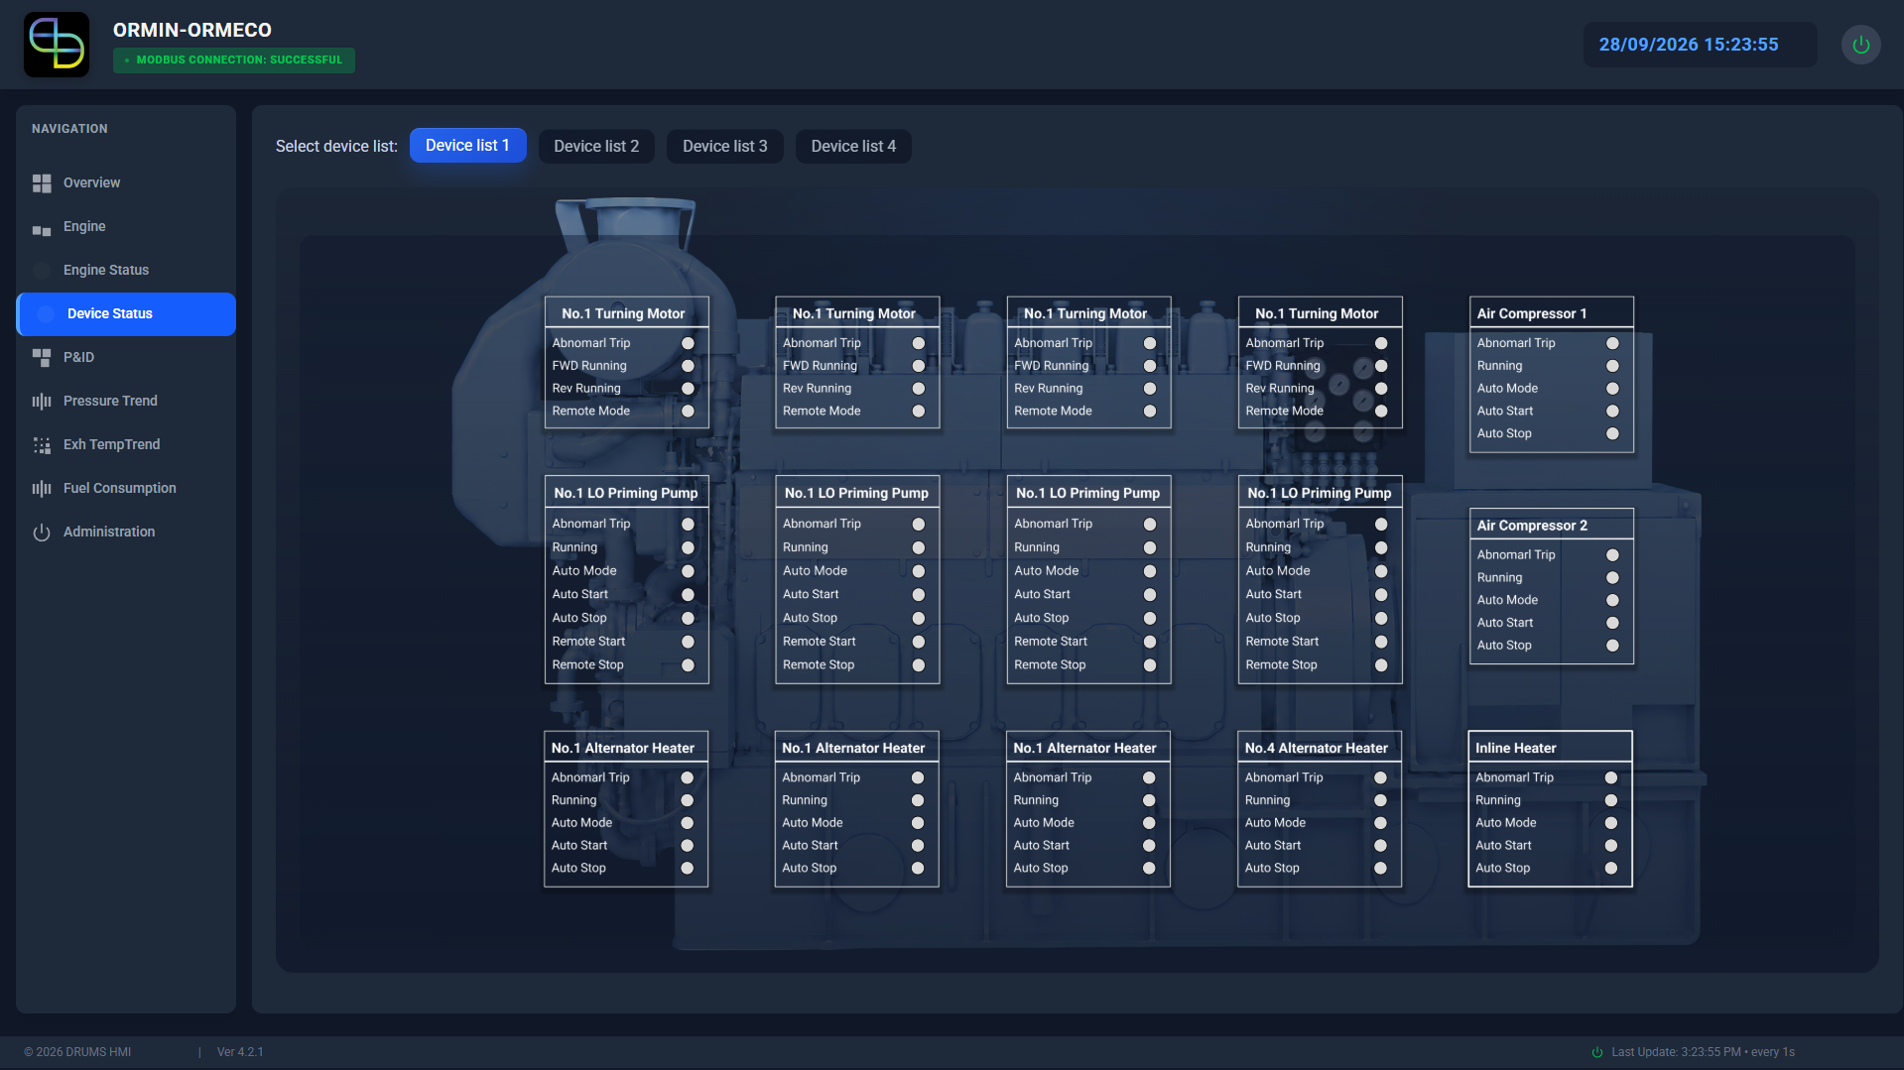

A.5 P&ID
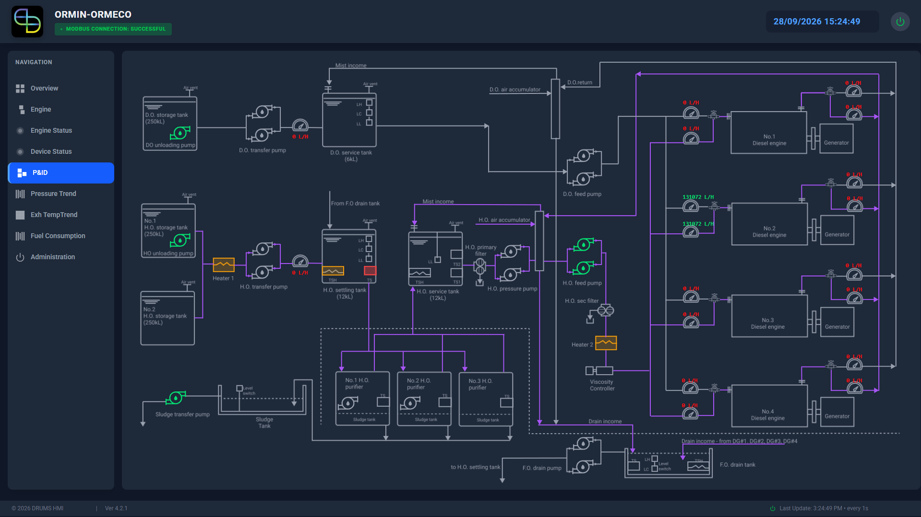

A.6 Pressure Trend
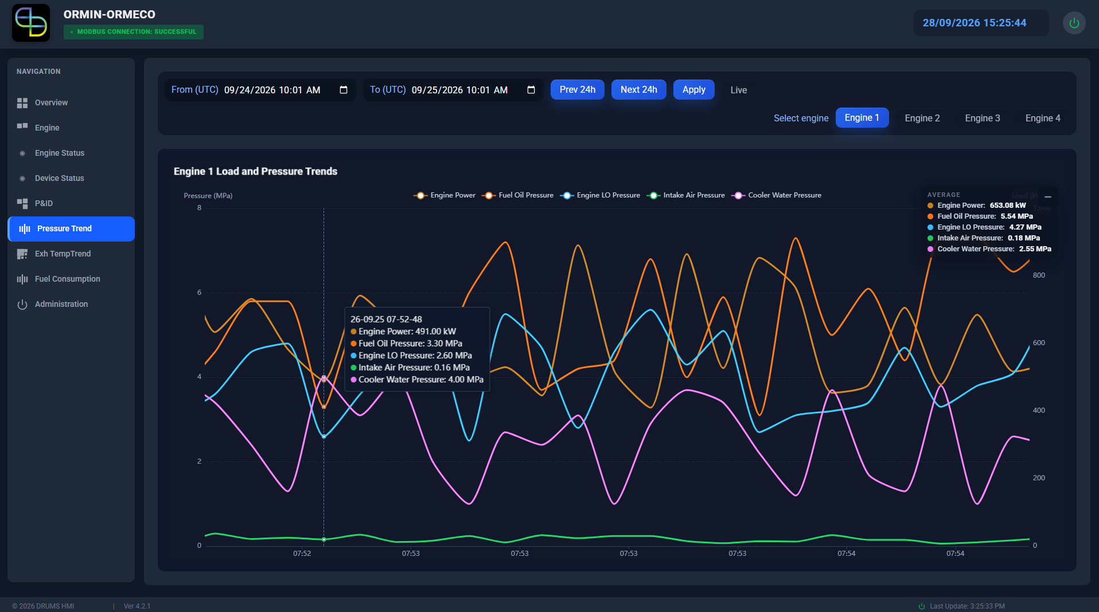

A.7 Exhaust Temperature Trend
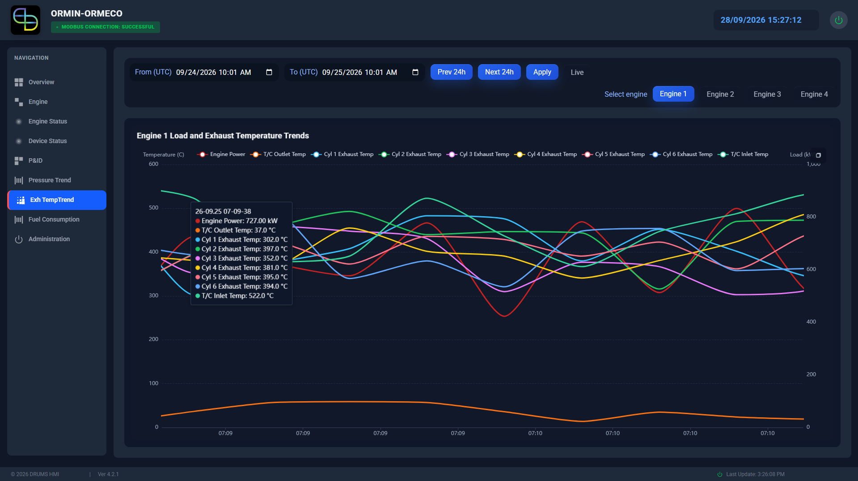

A.8 Fuel Consumption
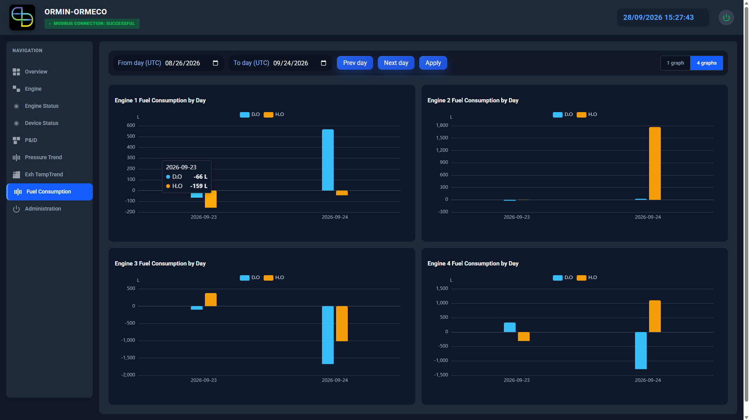

A.9 Administration


