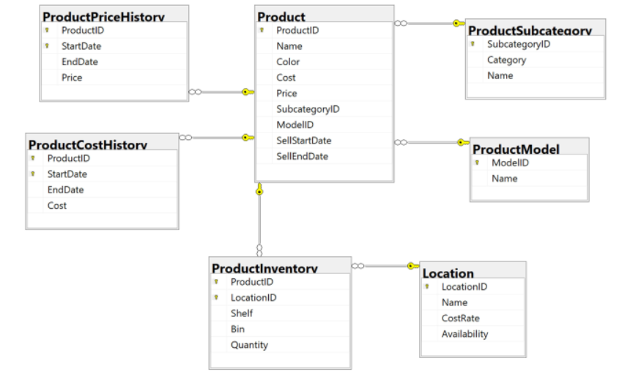

CREATE TABLE Departments

(

DeptID VARCHAR(20) PRIMARY KEY,

name NVARCHAR(200),

office NVARCHAR(100),

)

CREATE TABLE Employees

(

EmpCode VARCHAR(20) PRIMARY KEY,

Name NVARCHAR(50),

BirthDate DATE,

DeptID VARCHAR(20) REFERENCES Departments(DeptID)

)

CREATE TABLE Dependants

(

Number INT PRIMARY KEY,

EmpCode VARCHAR(20) REFERENCES Employees(EmpCode),

Name NVARCHAR(50),

BirthDate DATE,

Role NVARCHAR(30)

)



