**Question 1**

**Write a SELECT statement to show all students have the FirstName is ‘Long’ as following**:

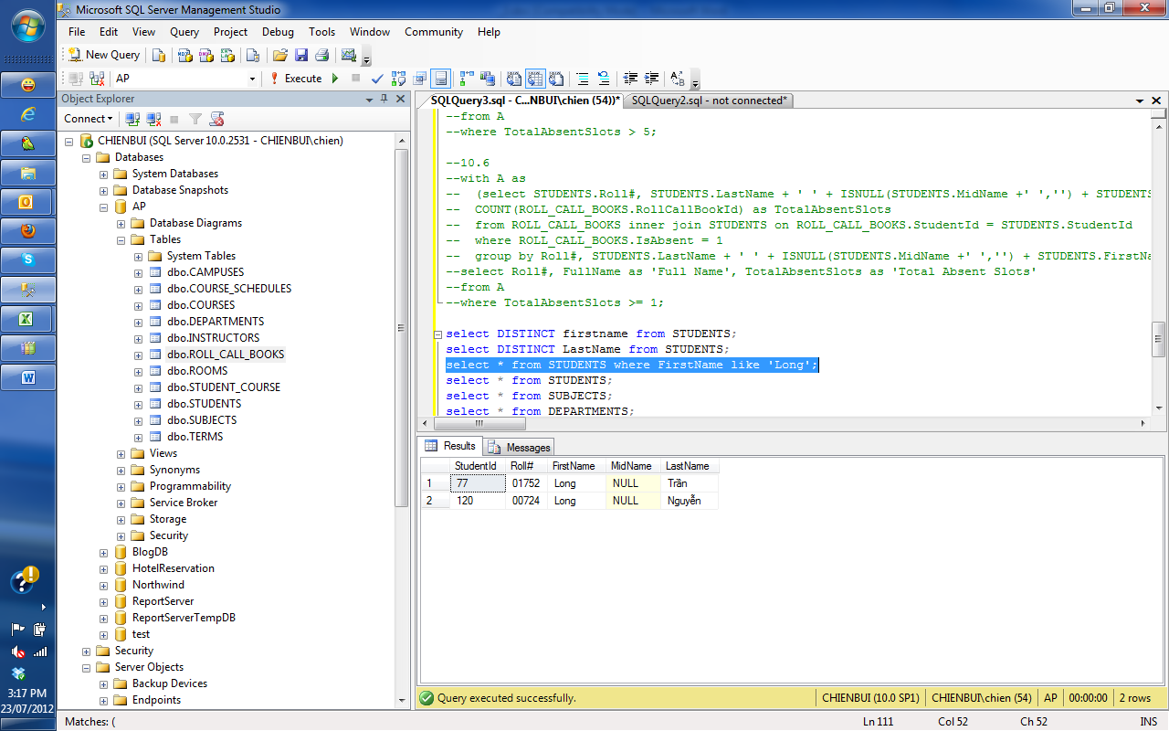

Question 2

**Write a SELECT statement to show all students have the LastName contains exactly 5 characters as following**:

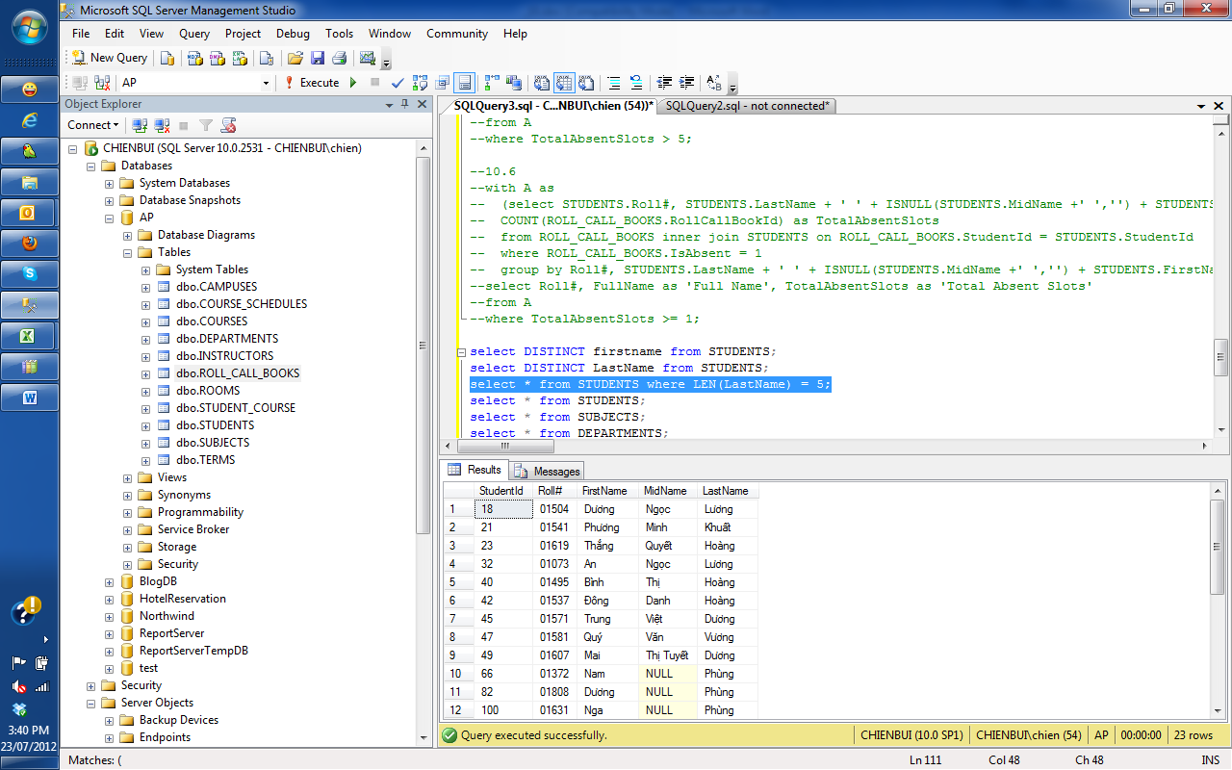

**Note**: The actual output may have more records than the above picture

Question 3

**Write a SELECT statement to show rooms, courses and their teaching usage as following**:

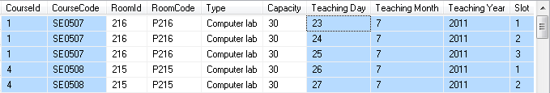

**Note**:

* Teaching Day, Teaching Month, Teaching Year are calculated from TeachingDate in the table COURSE_SCHEDULES
* The actual output may have more records than the above picture

**Question 4**

**Write a SELECT statement to show the total rooms of each room type of “BSE-HN” campus and “BSE-HN” campus’s total room as following**:

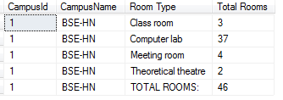

**Question 5**

**Write a SELECT statement to show subjects, courses and their total joined students as following**:

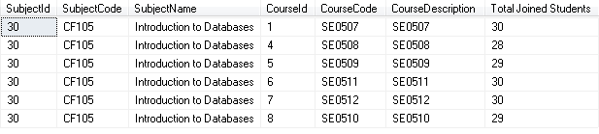

**Question 6**

**Write a SELECT statement to show all campuses that have maximum total room as following**:



**Note**: Don’t hard-coded. Carefully if you use TOP

**Write a SELECT statement to show all department(s) that has/have minimum total instructors as following**:

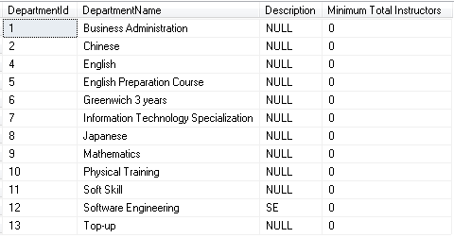

**Question 7**

**Write a SELECT statement to show all campuses and their total room and their total capacities as following**:

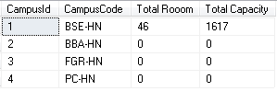

Question 8

**Write a SELECT statement to show students and their instructors in each course as following**:

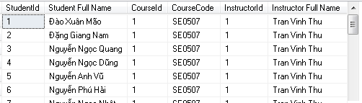

**Note**:

* Student Full Name and Instructor Full Name must contain only 1 space character if the Mid Name is null
* The actual output may have more records than the above picture

**Question 9**

**Write a Stored Procedure**

**insertStudent(@id int, @rollnumber nvarchar, @firstname nvarchar, @midname nvarchar, @lastname nvarchar)**

to insert one student into Students table.

**Question 10**

**Write a Stored Procedure**

**getNumberOfStudent(@count int out)**

to count the number of records in Students table. The return value must set into @count.