Nhu Bui

Software Development Project

Assignment 2

**THEORY PART**

Version control is a system that records changes to a file or set of files over time so that you can recall specific versions later.

A Version Control System allows you to: revert files back to a previous state, revert the entire project back to a previous state, review changes made over time, see who last modified something that might be causing a problem, who introduced an issue and when, and more. Using a Version Control System also means that if you screw things up or lose files, you can generally recover easily.

**PRACTICAL PART**

First, I create a new Visual Studio project

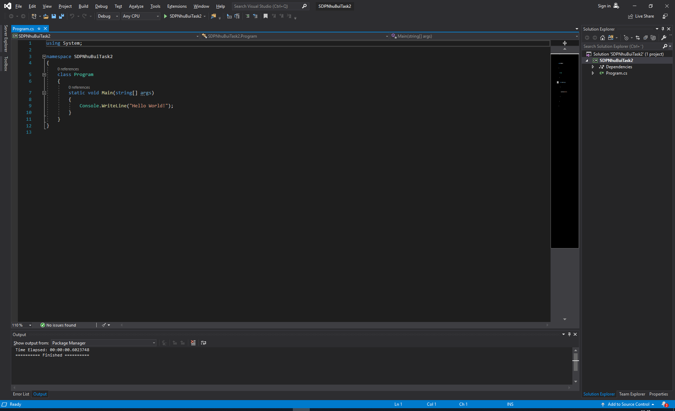

Then in the right corner, choose Add to Source Control and choose Git

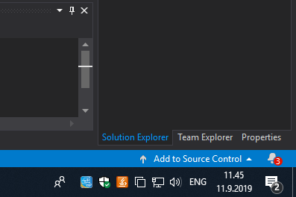

Here is the result

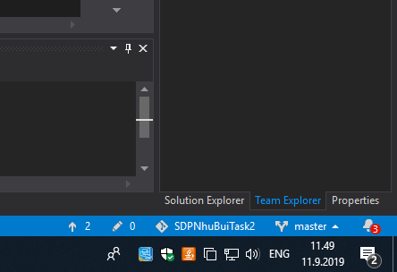

Now we have .git folder inside the project

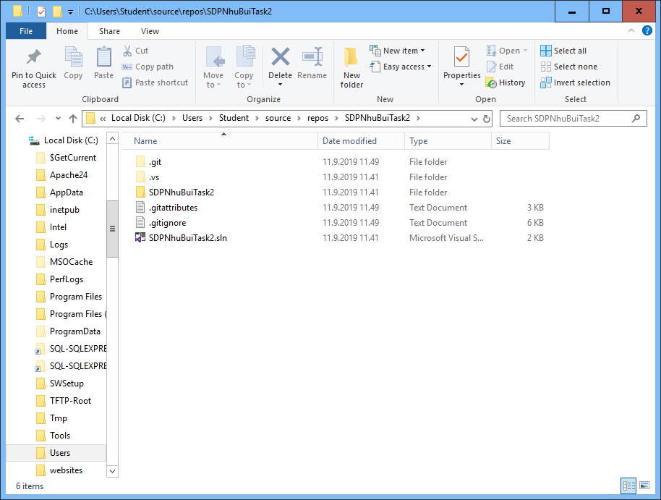

Then I make changes inside the folder

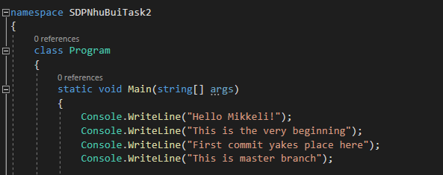

There is one change that has not been commit yet

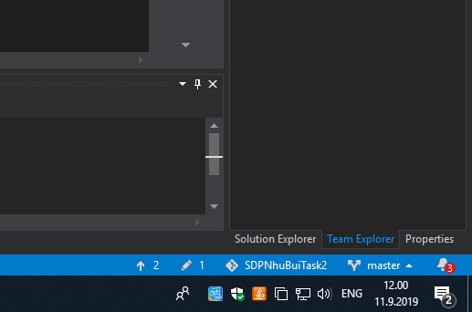

In order to commit, we need to add a comment to commit it

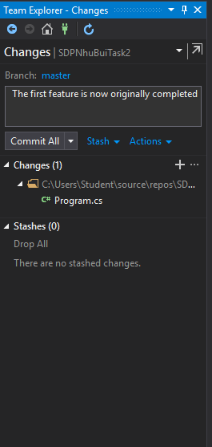

It’s now in the history that we have commited the change

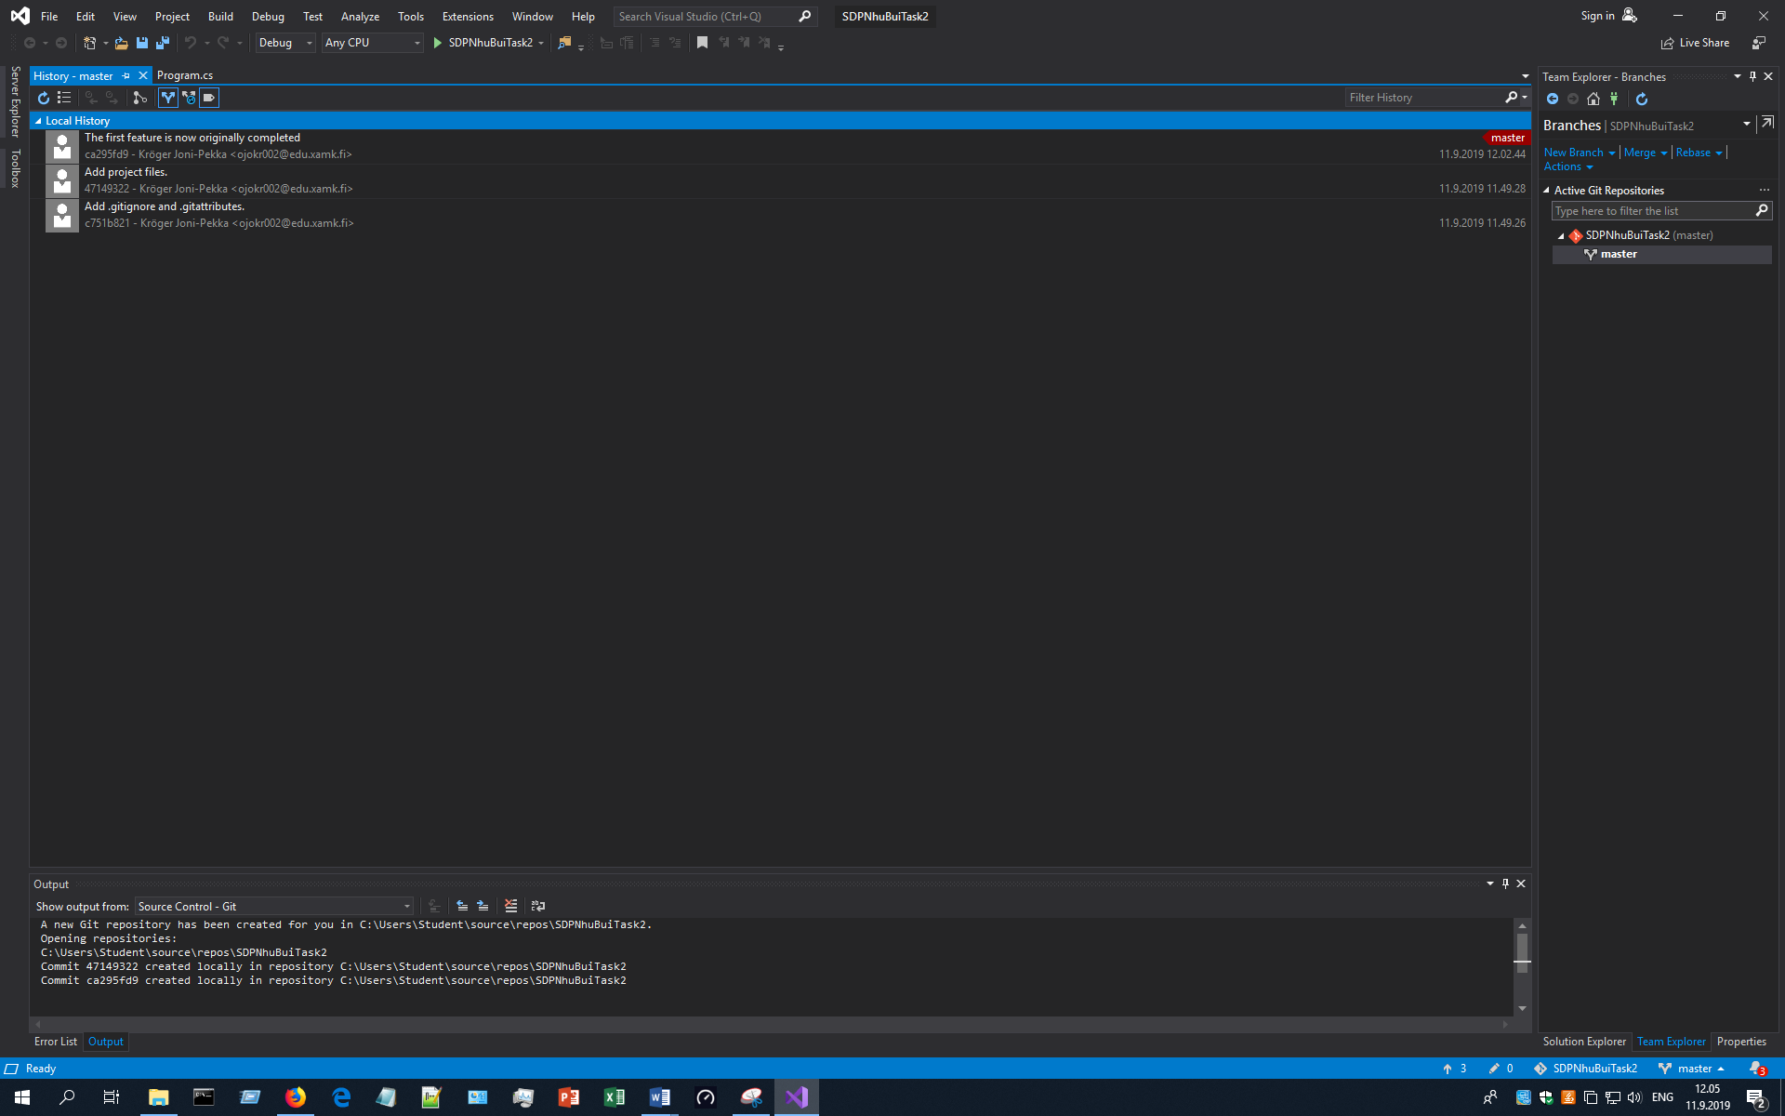

Next, I make a modification and again commit it

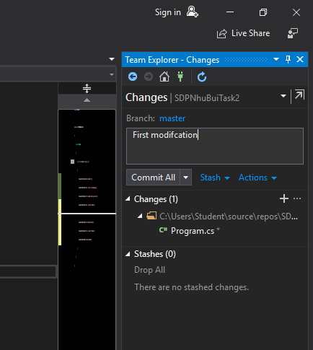

Next step is to add a new branch. I add a new branch all FirstBranch

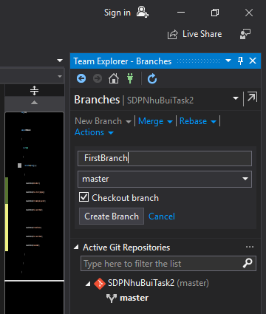

Then I add a new file and commit it

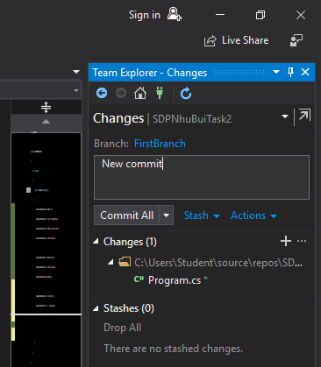

After all, I merge the FirstBranch into master

