2015

Aita Maryam Khorsani Uguudei Sukhbaatar Viktor Nyblom

2/4/2015

Assignment 2

Group 14: That’s All

# **A Meta model for Industrial Manufacturing system-Assignment2**

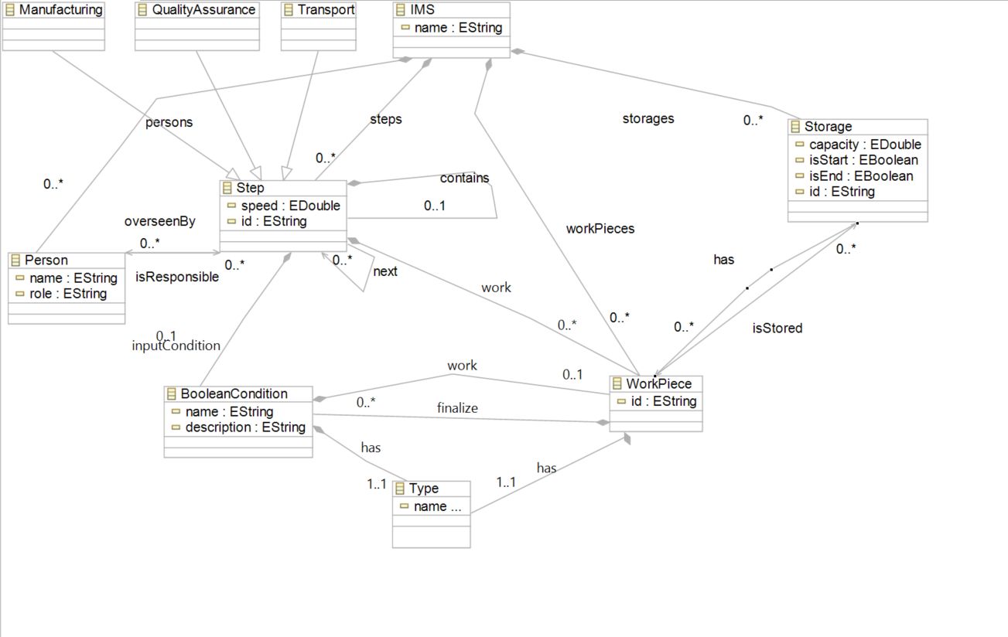

The Industrial Manufacturing System in this model supports classes: Manufacturing, Quality Assurance, Transport, IMS, Person, Step, Work Pieces, Boolean Condition, Storage and Type.

Class Step is very important in a way that work pieces are processed and transformed into the final result out of the manufacturing system. The model also supports hierarchy; Manufacturing Step is composed to Manufacturing, transport and Quality Assurance which are the subclasses of the Step. They can inherit both Public and Protected functions of class Step. The Quality Assurance is not suited for every Manufacturing Steps so it’s better to be a Sub-class off Class Step not as an attribute off it.  
IMS…………

Class Step can be repetitive so model supports a relation names next from Step to Step which could be zero to multiple. Class Step should have Input and output which are Work Pieces, therefore there exist two Types of Work Pieces which is clarified by Class Type. The relation between these two is an aggregation Relation and each Workpeice has a Type. WorkPiece class can have an aggregation relation with class Step as well which could be zero to multiple. Class Step should inherit data for an Input like which kind of work piece was used as an Input for example a piece of wood or a piece of metal then an output comes out relatively from Input material. Supporting this, the model has a Boolean condition class which has a relation both to WorkPiece class and class Step.

Our model starts with creating an IMS instance. From there, we can have a person assigned to one or many steps or have a step without any people assigned to it.

At class Step, Work Pieces which by Type could be defined as Input or output will be processed and transformed to another Work pieces. All Work Pieces can be stored in a Storage and each WorkPiece should have an Id as an attribute. Besides that a class of Boolean Condition should be defined for Work Pieces. The relation between Step and BooleanCondition is an aggregation named inputCondition. It has the multiplicity of zero to one to support the case of no input condition.

Each WorkPiece has an Identification number which is valid for class Storage. WorkPiece inherits all the Protected and Public functions from Storage. Storage can have zero to multiple number of a workPeice.

Each work piece can have a start and end point defined in a Storage. This gives a possibility to track a WorkPiece within the manufacturing steps and the IMS

All the steps from manufacturing to Transport should have a certain speed. This Speed describes the duration. It can be Overseen by Person or Persons. Steps in manufacturing system can be assigned to a Person who should have a unique name and role. Person is responsible for zero to multiple Steps or in other words each step can be overseen by zero Person or several Person to confirm the intended result.

# Example of our Meta model and detailed description

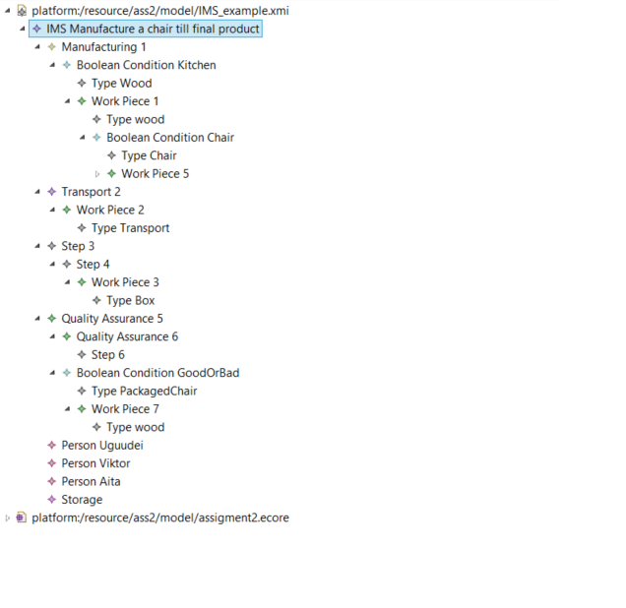

*Figure 1: XMI example*

The example shows us a couple of variations of what our model can do. It doesn’t make any sense but we tried to include all the complex situations as possible. IMS example consist of four steps in general. However depending on the complexity it has 6 (Figure 1). It’s because we have tried to make it more powerful and supportive for hierarchy where “Step” can have “Step”.   
  
In our model, Step is the superclass of Manufacturing, Quality Assurance and Transport. It enables us to use our existing “Step” where it could use multiple functions. We don’t need them in the given example but have included them in the model because of the given requirements.

Our first step is “Manufacturing 1”. This step has a Boolean condition. Depending on the input and the condition it can proceed or create another WorkPiece. Afterwards, should be stored in the storage or do something with it by creating a “WorkPiece”. This BooleanCondition class give us a lot of flexibility. For example:

Condition = false then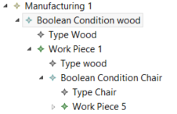

Create WorkPeice

Condition = false then

Create WorkPeice

….

This way, infinitive number of “conditions and WorkPiece” can be created on a WorkPeice.

“Step” contains “Step” and it has an attribute called next. This attributes links to the next step. This way we know the order. As shown below:  
  
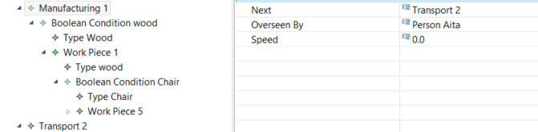  
  
Step “Transport 2“ where it should deliver to another place.   
Step “Step 3” Where it should package the finished product.

Step “Quality Assurance 5” is checks quality and decided if there is a need of more work by using the Boolean Condition.

# Appendix A: Ecore Tree

