2015

Aita Maryam Uguudei Sukhbaatar Viktor Nyblom

2/4/2015

Assignment 2

Group 14: That’s All

# **A Meta model for Industrial Manufacturing system-Assignment2**

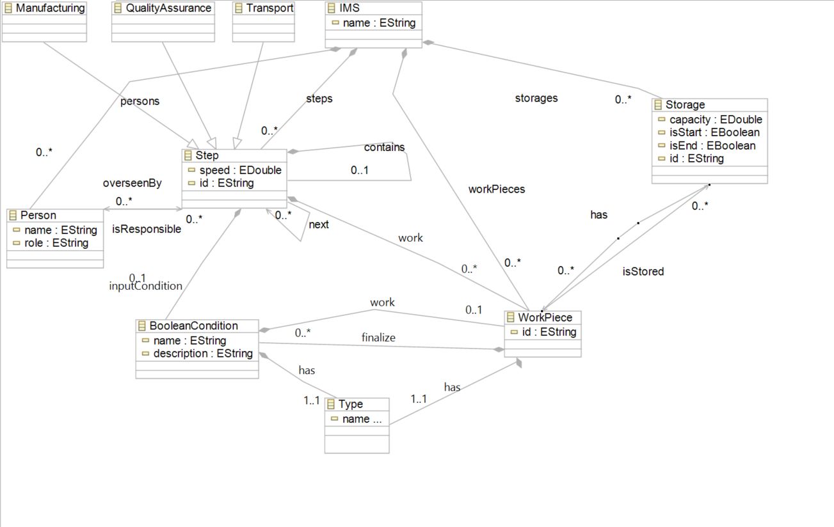

The Industrial Manufacturing System in this model supports classes: Manufacturing, Quality Assurance, Transport, IMS, Person, Step, Work Pieces, Boolean Condition, Storage and Type.

Class Step is very important in a way that work pieces are processed and transformed into the final result out of the manufacturing system. The model also supports hierarchy; Manufacturing Step is composed to Manufacturing, transport and Quality Assurance which are the subclasses of the Step. They can inherit both Public and Protected functions of class Step. The Quality Assurance is not suited for every Manufacturing Steps so it’s better to be a Sub-class off Class Step not as an attribute off it.  
IMS…………

Class Step can be repetitive so model supports a relation names next from Step to Step which could be zero to multiple. Class Step should have Input and output which are Work Pieces, therefore there exist two Types of Work Pieces which is clarified by Class Type. The relation between these two is an aggregation Relation and each Workpeice has a Type. WorkPiece class can have an aggregation relation with class Step as well which could be zero to multiple. Class Step should inherit data for an Input like which kind of work piece was used as an Input for example a piece of wood or a piece of metal then an output comes out relatively from Input material. Supporting this, the model has a Boolean condition class which has a relation both to WorkPiece class and class Step.

Our model starts with creating IMS instance. From there, we can have people assigned to step or without any people assigned to it.

At class Step, Work Pieces which by Type could be defined as Input or output will be processed, transformed to another Work pieces which can be stored in Storage and each Work Peice should have an Id as an attribute. Besides that a class of Boolean Condition should be defined for Work Pieces. The relation is an aggregation from Boolean Condition class to Step class and is named Input Condition which can be 0 in support of no Input to one Input at a time.

Each WorkPiece has an Identification number which is valid for class Storage. WorkPiece inherits all the Protected and Public functions from Storage. Storage can have zero to multiple number of a workPeice.

Each work piece can have a defined start and end point in Storage class which gives a possibility to track a start and end point of a Workpiece within the manufacturing steps.

All the steps from manufacturing to Transport should have a certain speed. This Speed describes the duration. It can be Overseen by Person or Persons. Steps in manufacturing system can be assigned to a Person who should have a unique name and role. Person is responsible for zero to multiple Steps or in other words each step can be overseen by zero Person or several Person to confirm the intended result.

# Example of our Meta model and detailed description

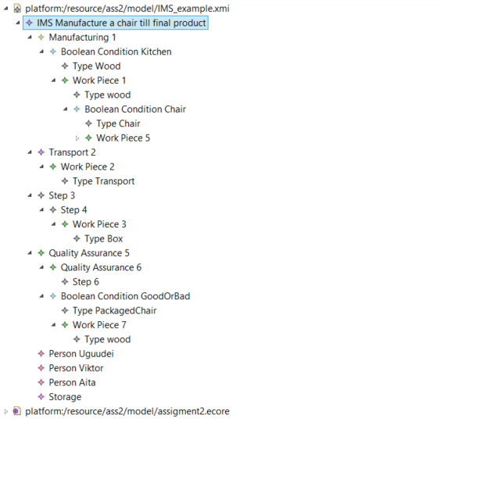

Figure 1: XMI example

The example shows us a couple of variations what our model can do with it. It could be it doesn’t make any sense but we tried to include complex situations as possible. IMS example consist of four steps in general. However depending on the complexity it has 6 (Figure 1). It’s because we have tried to make it more powerful and it supports hierarchy where steps can have steps.   
  
In our model, Step is the superclass of the Manufacturing, Quality Assurance and Transport. It enables us to use our existing “Step” where it have multiple functions. And we do consider them another steps for the manufacture. Generally, they are not needed and included because of the given requirements.

Our first step which is “Manufacturing 1” has a Boolean condition. Depending on the input type it can go as proceed or it can create another work piece where it store it in the storage or do something with it again by creating a “WorkPiece”. This BooleanCondition class give us a lot of flexibility. For example:

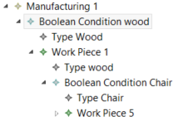Condition = false then

Create WorkPeice

Condition = false then

Create WorkPeice

….

This way, infinitive number of “conditions and WorkPiece” can be created on only one WorkPeice.

“Step” contains “Step” and it has an attribute called next. This attributes links to the next step.   
As shown below:  
  
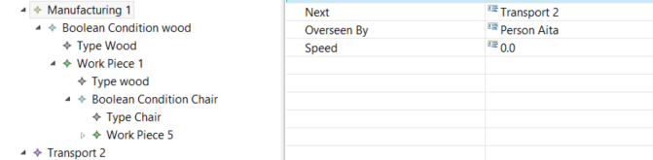  
  
Step “Transport 2“ where it should deliver to another place.   
Step “Step 3” Where it should package the finished product.

Step “Quality Assurance 5” is checks quality and decided if there is a need of more work by using the Boolean Condition.

# Appendix A: Ecore Tree

