A Failure Metric-Based Topology Control Algorithm for Mobile Wireless Sensor Networks

汪小威1,2 奚文杰1,2

(1.南宁学院 信息工程学院，广西 南宁 530200；2.广西大学 计算机与电子信息学院，广西 南宁 530004)

摘 要：To address issues in topology control for mobile wireless sensor networks (M-WSNs) under node mobility, including severe node constraints, low network survivability, and poor link stability, this paper proposes a topology control algorithm based on a failure metric assessment mechanism. First, by combining the factors of energy constraints and bandwidth, a failure index is designed to quantitatively assess the degree of node constraint. A failure metric, based on a joint two-dimensional modeling evaluation mechanism, is constructed to perform a failure assessment of the data transmission quality between nodes by incorporating the distance factor. Based on the mapping relationship between the failure index and node failure probability, a prediction mechanism is designed using a reliability prediction method. By introducing a time-periodic variable, we prove the existence of an upper bound for the node failure probability, which enables rapid node failure prediction. By combining the failure metric and failure prediction results, a topology stability control method is constructed based on the predicted reliability of interactions between nodes. This method optimizes the inoperability state of network nodes by considering both bandwidth and energy factors, thereby achieving stable control of the network topology. Simulation results demonstrate that, compared to a state-of-the-art hierarchical topology control algorithm based on affinity propagation (NREL-CHB) and a distributed energy-balanced topology control algorithm based on non-cooperative game theory (EB-NGTC), the proposed algorithm achieves a lower degree of node constraint, higher link stability, and a lower average jitter frequency per node, exhibiting superior topology control performance.

关键词：移动无线传感网，拓扑控制，失效评估，失能度量，可靠预测，时间周期变量

**作者简介：**汪小威(1985-)，男，博士，教授，研究方向为物联网、网络通信、算法分析、计算机应用。email:181260554@qq.com

**基金项目：**

**0 引言**

As a core technology for the development of the next-generation Internet of Things (IoT), Mobile Wireless Sensor Networks (M-WSNs) are characterized by flexible node deployment, high topological mobility, and efficient energy replenishment [1-2]. In large-scale deployments, the ability to flexibly control the network topology and maintain its structural stability is crucial for achieving reliable data transmission and reducing the probability of link jitter [1]. Currently, topology control in M-WSNs primarily relies on energy-aware control principles. These methods aim to improve topological stability by reducing node energy consumption, thereby achieving stable control over the network. For instance, Pramod [3] proposed a topology control scheme for M-WSNs that achieves high node connectivity through a selection mechanism based on residual node energy. This scheme periodically assesses residual energy and integrates connectivity prediction to optimize energy-efficient transmissions, thus mitigating topology collapse caused by energy constraints and enhancing stability [3]. However, this approach is primarily suited for scenarios with low topological variation and lacks the ability to dynamically predict node energy. Linda et al. [4] introduced a highly stable topology control algorithm based on a fault-tolerance prediction mechanism. This algorithm utilizes encoding for dynamic topology updates and employs a fault-tolerant mechanism to reduce the probability of node state misjudgment in highly mobile M-WSNs, demonstrating strong control and fault-tolerance capabilities [4]. Nevertheless, this work is focused on vehicular environments. Because vehicular networks typically exhibit fixed, linear movement patterns, the algorithm's applicability is limited and not well-suited for environments with frequent topological changes. Furthermore, Bei et al. [5] developed a topology control scheme using a capacity prediction method based on a capacity-congestion queue sorting mechanism. In this scheme, the sink node periodically predicts the residual energy and bandwidth of nodes, effectively reducing node failures from resource limitations and alleviating topology jitter under high-traffic conditions [5]. A key limitation, however, is the method's inability to perform timely topological adjustments when jitter occurs, leaving individual nodes vulnerable to transmission constraints caused by link instability.

To address the aforementioned limitations, this paper proposes a topology control algorithm for M-WSNs based on a failure metric assessment mechanism. First, by integrating energy and bandwidth factors, we design a failure index and construct a failure metric based on a joint two-dimensional modeling evaluation mechanism. This metric incorporates a distance factor to optimize the assessment of node failure probability and enhance the algorithm's adaptability to highly mobile nodes. Subsequently, by predicting node failure probability, we design a failure prediction method based on a reliable prediction assessment mechanism. This method derives the node failure probability under optimal topological conditions, which helps to accelerate the node assessment process. Finally, based on the predicted reliability of interactions among nodes, we design a topology stability control mechanism that integrates both energy and bandwidth to achieve significant network topology optimization.

**1 The Proposed M-WSN Topology Control Algorithm**

Due to the high degree of node mobility and topological changes characteristic of M-WSNs [6], resource constraints such as limited node energy and bandwidth are the primary causes for the difficulties in topology control [7]. It is therefore necessary to consider influencing factors such as energy and bandwidth and to make reasonable predictions based on the current topology to better adapt to these characteristics. To this end, this paper proposes a Failure Metric-based Topology Control Algorithm (FM-TCA) for M-WSNs. The algorithm consists of three main components: (1) a failure metric based on a joint two-dimensional modeling evaluation mechanism; (2) a failure prediction method based on a reliable prediction assessment mechanism; and (3) a topology stability control method that leverages interactions based on reliable failure predictions to optimize the topology by integrating both energy and bandwidth factors.

**1.1 Failure Metric Based on a Joint Two-Dimensional Modeling Evaluation Mechanism**

When a node is in a congested or energy-constrained state, if it also serves as a link relay, the topology related to this link will experience severe jitter, which primarily manifests as difficulties in data transmission [7]. Therefore, it is necessary to comprehensively consider factors such as energy and node bandwidth to enable a rapid measurement of a node's failure state.

To this end，this paper defines the failure index,for a transmitting node k as follows:

(1)

where represents the probability that node k is in an energy−constrained state, and represents the probability that node k is in a bandwidth-constrained state.

According to reference [8], the probabilitythat a node is in an energy−constrained state exhibits an exponential relationship with its initial energy, energy loss and operating time t ：

(2)

To apply Formula (2)，we first utilize the general energy consumption model for mobile sensor networks [9] to define the energy loss term. Let the data transmission bandwidth between node i and node j be B, and the distance between them be R (see Figure 1). The energy consumption during transmission, , is given by:

图1 节点通信示意图

Fig.1 Schematic diagram of node communication

 (3)

Figure 1. Schematic diagram of node communication.

The energy consumption of node j during reception, is also closely related to its electronics′ power consumption. Since all network nodes are standardized [10], the power consumption of the electronics for node j and node i are equal, both being .Thus, the function forbecomes:

(4)

By combining Equations (3) and (4), the total energy consumption of node i per unit cycle, is given by:

(5)

Considering that nodes in an M-WSN follow a uniform random distribution [11], we assume the nodes are deployed in a rectangular area S with M nodes. The probability density function (PDF) of node i's location, , is given by:

(6)

For any node j, the probability that it can receive data from node i (i.e., node j is within the communication range r of node i), , is given by:

Before any node i starts data transmission, its failure probability,, is given by:

where M represents the number of nodes in the network. By combining Equations (3) and (8), the relationship between the failure probability of any node k and its energy consumption can be obtained as:

(9)

By substituting Equation (9) into Equation (2), the probability that a node is in an energy-constrained state,,is given by:

(10)

where x and y are defined as:

(11)

(12)

In M-WSNs, bandwidth limitation is one of the primary factors causing topological changes [12]. During the data forwarding process, a comprehensive failure probability, which we define as , exists due to various factors such as link instability and node processing delays. Therefore, for a node with a total incoming bandwidth of B, the expected effective bandwidth that can be successfully forwarded,, can be modeled as:：

(13)

Since all nodes in the M-WSN are standardized, let the total capacity of each node be G. The probability that an arbitrary node k fails due to bandwidth constraints, can be measured by the ratio of the expected effective bandwidth to the total node capacity:

(14)

由于式(14)中和取值范围在0和1之间，因此，二者满足如下关系：

(15)

联立式(15)，并将式(12)和式(14)代人式(1)中，可得传输节点k的失能指数为：

(16)

式(16)即为基于联合二维建模评价机制的失能度量方法所规定的失能指数，对于任意节点k，通过计算其失能指数，可快速得知该节点的可靠性能，并可预估下一时刻的带宽及能量情况，从而准确裁决节点所处的状态。

**1.2 基于可靠预测评估的失能预估**

对于整个移动无线传感网而言，由模型(16)可知，其拓扑存续时间t应大于0。网络实际运行时至少应有最小的生命周期T，显然必有成立。因此，针对模型(16)而言，某节点k失效概率最小时，可以通过拓扑存续时间t的方式，尽量保持取值最小。

定理1：对任意网络而言，当其网络实际运行时间t与其最小的生命周期T满足时，若网络满足模型(15)，且网络中的节点失效概率取最小值，则节点k的失能指数必满足模型(17)所示的条件：

(17)

证明1：由可知，式(16)必定满足：

(18)

由于与必定满足如下关系：

(19)

联立式(18)和式(19)可得：

(20)

显然，失能指数满足式(15)时，式(20)取最小值。此时，网络节点的失效概率将取最大值。证明完毕。

由定理1可知取最小值时，网络中的节点失效概率与存在一一对应关系。因此当取最小值时，由式(16)可得：

(21)

由对数知识可知[13]，式(21)成立的充分条件为：

(22)

由式(22)可得：

(23)

由式(23)可知，最大值满足

(24)

根据式(24)可知，当网络运行最小周期为最小的生命周期T时，可通过式(24)将网络中节点失效概率控制在最小值，此时节点拓扑将处于稳定状态。

**1.3 基于失能可靠预测交互机制的拓扑稳定控制**

通过上述失能度量和失能预估过程，可迅速判断节点是否失效，并可将网络节点失效概率控制在较低水平。随后，对网络中正在进行数据传输的节点，按照基于联合二维建模评价机制的失能度量方法来逐个裁决其失效概率；再基于可靠预测评估机制的失能预估方法，将传输节点的失效概率控制在最小值，从而使得整个网络拓扑将处于稳定状态。详细过程如下：

Step 1：首先进行网络初始化，由sink节点收集网络中正在传输的节点信息，形成处于传输状态的节点集合。各处于传输状态的节点记录其邻居节点与自身的距离后，将距离通过数据报文至sink节点，见图2；

Step 2：sink节点收到数据报文后，将节点间距离进行解析并按升序方式进行排序；任意节点i同时将与自身有数据交互关系的节点加入传输链路中，并将该消息进行全网广播；

Step 3：按照节1.2所示的基于可靠预测评估机制的失能预估方案获取网络的节点失效概率，并通过1.1章节所示的基于联合二维建模评价机制的失能度量方法对节点进行逐个裁决，并同时执行Step 2，直到全部节点间建立传输链路并实现拓扑互通为止；

Step 4：传输周期结束后，网络处于休眠状态，直到下一个传输周期来临为止。

**2 实验与分析**

图2 基于失能可靠预测交互的拓扑稳定控制

Fig.2 Topology stability control based on failure reliable predictive interaction

为验证本文算法性能，采用MATLAB仿真实验环境进行测试[14]，并将其与当前移动无线传感网拓扑控制领域内常用的基于亲和传播并考虑节点剩余能量和减轻簇头负担机制的WSN分层拓扑控制算法[15](NREL-CHB算法)、基于非合作博弈的无线传感器网络分布式能量平衡拓扑控制算法[16](EB-NGTC算法)进行仿真实验对比，以便验证本文算法的有效性。其中，文献[15]算法主要是基于备用节点策略来设计基于亲和聚类的拓扑控制机制，引入最短路径簇间多跳方式来完成簇到基站的数据传输，当主簇头处于失效状态时，及时启用备用簇头承担区域传输及链路稳定功能，可以有效消除因节点移动而导致的传输抖动现象。文献[16]算法综合考虑能量及传输效率两个维度，采用基于帕累托最优的优化综合效用函数评估链路及传输过程中存在的抖动现象，当拓扑出现剧烈变化时，可根据评估得到的网络效用情况筛选出兼顾能量效率和平衡的节点，以便减缓网络出现的抖动，增强网络的抗干扰性。

整个网络节点分布在边长为2 000 m的矩形区域内，节点分布采用随机游走模式，节点均采用802.11协议进行链路传输，最大通信距离为20 m，而且传输过程采用周期模式。由于本文主要研究移动无线传感网领域内节点游走的部署领域，其节点具有随机移动特性，且拓扑变动的频次与节点分布密度呈现显著的正向趋同关系，即节点分布越密集，网络拓扑变动的频次也将越高。若其对拓扑变动的适应能力较强，则对应的节点密集度也将越高。因此本文仿真实验采用高密集度节点部署场景。由于本文节点分布环境为2 000 m的矩形区域，节点最大通信距离为20 m，因此为了确保任意节点之间能够处于其余某个节点的覆盖范围之内，并考虑到节点过于密集时可能会出现碰撞现象，综合文献[15]和文献[16]对节点密集度的承受能力，将本次实验中的整体网络节点总数设置为不低于500个。其余仿真参数见表1。

表1 仿真参数

Table1 Simulation parameters

|  |  |  |  |  |  |  |
| --- | --- | --- | --- | --- | --- | --- |
| network area/m | data link layer protocol | node transmission rate/M bps | network period/s | maximum communication distance of node/m | node distribution model | number of nodes |
| 2 000×2 000 | 802.11 protocol | ≤5 | ≥100 | 20 | Random walk | ≥500 |

仿真指标采用节点受限数量、网络链路稳定条数、网络最大存活时间三项指标，用以测试本文算法与对照组算法的网络拓扑性能。仿真实验开始后，记录网络中因能量受限和带宽受限而无法正常传输的节点数量，若受限节点数量超过网络节点总数20%，且网络链路稳定条数占总链路条数之比低于20%时，则可判定网络已经无法正常传输数据，此时记录下网络最大存活时间。

**2.1 节点受限数量**

图3为节点受限数量的仿真测试结果，由图可知本文算法节点受限数量处于较低水平，在节点传输速率较低(节点传输速率为0.5 Mbps)和较高(节点传输速率为5 Mbps)两种情形下均具有节点受限数量较低的特点，可显著改善因节点受限而导致的网络拓扑不稳定现象。这是由于本文基于能量和带宽两个维度设计了联合二维建模评价机制的失能度量方法，能够兼顾能量和带宽两个维度进行节点受限裁决，并通过基于可靠预测评估机制的失能预估方案将节点受限数量控制在较低水平，因此节点受限现象得到了有效的缓解。NREL-CHB算法主要采用双簇头控制方式进行主备节点更换，主要从能量角度优化传输链路质量，但该算法并未考虑簇头节点过载的实际应用场景，一旦网络中部分节点因流量过载而出现带宽受限现象，将导致节点受限数量显著增加。EB-NGTC算法主要采用能量平衡方式建立了拓扑控制博弈模型，采用经济学最优原理设计了一种改进的优化综合效用函数，能够有效缓解能量受限而导致的节点受限现象，然而该算法同样未考虑节点流量过载导致的带宽受限现象，致使网络节点传输速率提高时较本文算法更易发生节点受限现象，导致其节点受限数量较高。

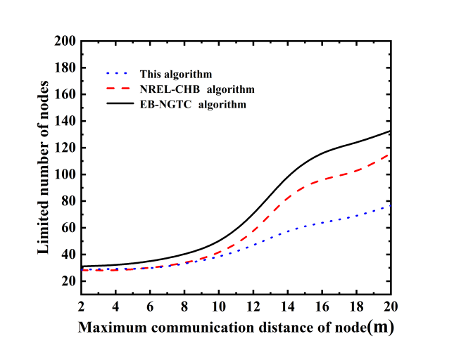

2 4 6 8 10 12 14 16 18 20

maximum communication distance of node/m

200

180

160

140

120

100

80

60

40

20

limited number of nodes

this algorithm

NREL-CHB algorithm

EB-NGTG algorithm

(a) transmission rate of the node is 0.5 Mbps

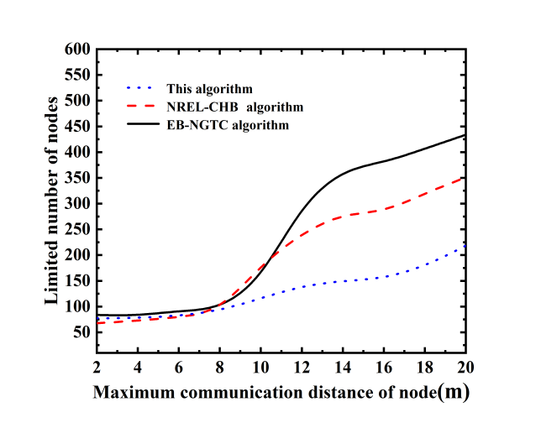

2 4 6 8 10 12 14 16 18 20

maximum communication distance of node/m

600

550

500

450

400

350

300

250

200

150

100

50

limited number of nodes

this algorithm

NREL-CHB algorithm

EB-NGTG algorithm

(b) transmission rate of the node is 5 Mbps

图3 节点受限数量的测试结果

Fig.3 Test results of limited number of nodes

**2.2 网络链路稳定条数**

图4为网络链路稳定条数的仿真测试结果，由图可知本文算法网络链路稳定跳数处于较高水平，在节点传输速率较低(节点传输速率为0.5 Mbps)和较高(节点传输速率为5 Mbps)两种情形下均具有网络链路稳定条数较高的特点，能够显著优化网络拓扑结构。这是由于本文可以通过能量和带宽两个维度进行节点失效评估，能够将单个节点失效概率控制在较低水平，并可有效改善因带宽过载而导致的链路抖动现象，因而网络链路稳定条数较高。NREL-CHB算法主要采用双簇头来稳定分簇区域内的数据传输，从能量角度优化节点因能量消耗过大而导致的失效现象，然而，由于该算法仅能优化分簇区域内网络链路，限制了网络链路稳定条数。EB-NGTC算法引入博弈控制模型，基于经济学最优原理来优化能量受限条件下的网络链路稳定性能，然而由于该算法并未针对带宽受限现象进行优化，容易发生因带宽受限而导致传输链路出现抖动的现象，使其网络链路稳定条数低于本文算法。

图4 网络链路稳定条数的测试结果

Fig.4 Test results of the number of stable network links

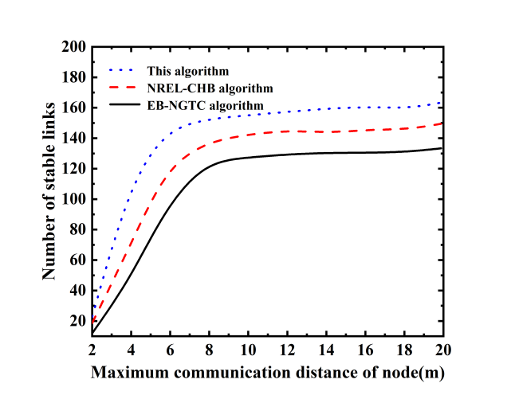

(a) transmission rate of the node is 0.5 Mbps

2 4 6 8 10 12 14 16 18 20

maximum communication distance of node/m

200

180

160

140

120

100

80

60

40

20

limited number of nodes

this algorithm

NREL-CHB algorithm

EB-NGTG algorithm

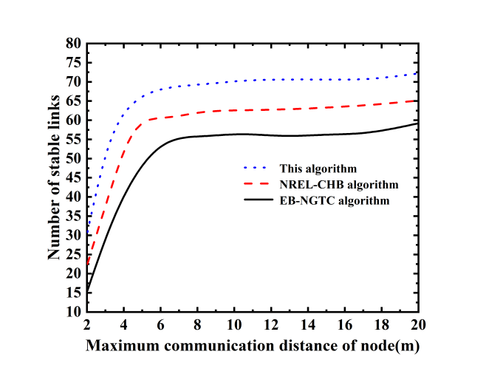

(b) transmission rate of the node is 5 Mbps

2 4 6 8 10 12 14 16 18 20

maximum communication distance of node/m

80

75

70

65

60

55

50

45

40

35

30

25

20

15

10

limited number of nodes

this algorithm

NREL-CHB algorithm

EB-NGTG algorithm

**2.3 网络单节点抖动频率**

为便于进行对比测试，在测试过程中传输周期内逐秒统计网络中处于抖动状态的节点总数，该数与网络传感节点总数的比值即为单节点平均抖动频率，频率越低说明网络节点运行性能越稳定，呈现出更高的网络拓扑控制性能。将网络第1次稳定运行时间设定为0时刻，按等分原则对运行时间进行对称分割，节点出现抖动时刻，若其处于流量收集阶段，则判定位正向抖动，对应的单节点抖动频率记录为正值。反之，则判定为逆向抖动，将其记录为负值。

图5是节点传输速度设定为10 Mbps下的网络单节点抖动频率的测试结果。由图可知，本文算法网络单节点抖动频次记录集中于0坐标附近，且频率数值远低于其他两个方法。而NREL-CHB算法出现明显的抖动背离现象，分布较为离散，EB-NGTC算法的离散度更为明显，说明本文算法具有较强的网络拓扑控制能力，可显著优化网络存活质量。这是由于本文算法通过能量和带宽两个维度同时改善传输节点受限现象，并稳定链路传输质量，可将带宽过载造成的链路抖动现象进行优化的同时，进一步减少因单个节点受限而导致的网络拓扑抖动现象，因此网络单节点抖动频率分布呈现出集中特性，且数值较低。NREL-CHB算法主要采用双簇头机制优化分簇区域内节点及链路质量，难以同时针对全网节点能量和带宽情况进行网络拓扑性能，因此网络存活质量较低，网络单节点抖动频率较高。EB-NGTC算法虽然引入了博弈机制优化节点传输质量，可在一定程度上维持网络拓扑状况基本稳定，然而由于该算法同样仅能够针对能量维度优化网络拓扑结构，无法改善因带宽过载而导致的拓扑抖动现象，因此网络生存质量要显著低于所提算法，导致网络单节点抖动频率更高。

**3 结论**

图5 网络单节点抖动频次的测试结果

Fig.5 Jitter frequency test results of single node in network

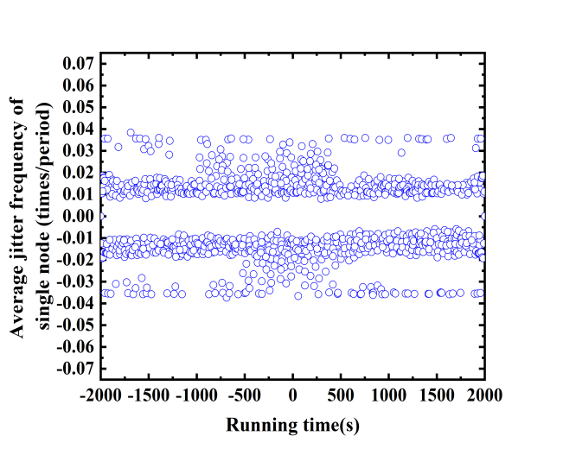

-2 000 -1 000 0 1 000 2 000

running time/s

0.07

0.06

0.05

0.04

0.03

0.02

0.01

0

-0.01

-0.02

-0.03

-0.04

-0.05

-0.06

-0.07

average jitter frequency of single node(times/period)

(b) NREL-CHB algorithm

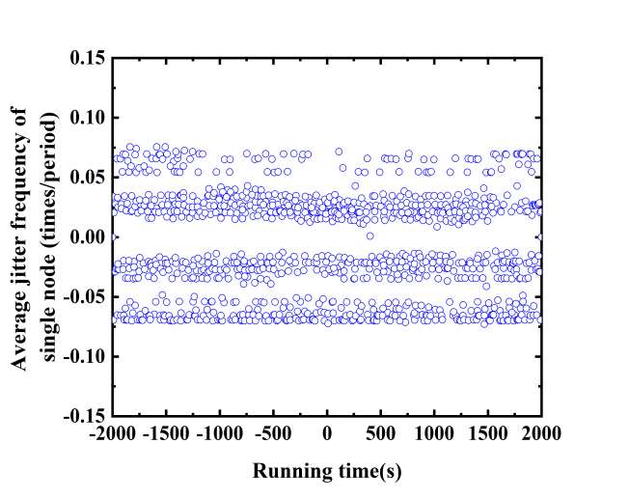

0.15

0.10

0.05

0

-0.05

-0.10

-0.15

average jitter frequency of single node(times/period)

-2 000 -1 000 0 1 000 2 000

running time/s

(c) EB-NGTC algorithm

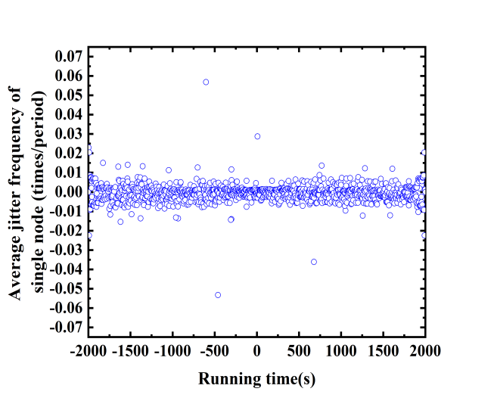

-2 000 -1 000 0 1 000 2 000

running time/s

0.07

0.06

0.05

0.04

0.03

0.02

0.01

0

-0.01

-0.02

-0.03

-0.04

-0.05

-0.06

-0.07

average jitter frequency of single node(times/period)

(a) This algorithm

为改善节点流动状态下无线传感网存在的节点受限严重、网络生存质量低、拓扑控制能力不强等不足，提出了一种基于失能度量评估机制的移动无线传感网拓扑控制算法。算法主要由三个部分构成：基于联合二维建模评价机制的失能度量、基于可靠预测评估机制的失能预估，以及基于失能可靠预测交互机制的拓扑稳定控制。实验数据显示所提算法可显著提高网络对拓扑的控制能力，优化网络生存质量，降低节点受限问题的发生概率，具有节点抖动频率较低的特性。下一步，本文拟引入欧里几何超流体拓扑稳定机制，通过建立分级拓扑管理机制，优化本文算法对实际环境的适应能力，促进本文算法在实际场合下的部署价值。

**参考文献：**

[ 1 ] DINA Deif,YASSER Gadallah. A comprehensive wireless sensor network reliability metric for critical internet of things applications[J]. EURASIP Journal on Wireless Communications and Networking, 2017,1(1):1-18.

[ 2 ] 马庆功,丁宪成. 基于拨备满足模型的无线传感网节点覆盖算法[J]. 太赫兹科学与电子信息学报, 2020,18(4): 625-632. (MA Qinggong,DING Xiancheng. Node coverage scheme for wireless sensor networks based on reserve satisfaction model[J]. Journal of terahertz science and electronic information, 2020,18(4):625-632.)

[ 3 ] PRAMOD Kumar,ASHVINI Chaturvedi. Spatial-temporal aspects integrated probabilistic intervals models of query generation and sink attributes for energy efficient WSN[J]. Wireless Personal Communications, 2017,96(2):119-127.

[ 4 ] LINDA F M,LAURIE L. Interference aware bandwidth estimation for load balancing in EMHR-energy based with mobility concerns hybrid routing protocol for VANET-WSN Communication[J]. Ad Hoc Networks,2017,66(8):1-15.

[ 5 ] GONG Bei,WANG Yubo,LIU Xiangang. A trusted attestation mechanism for the sensing nodes of internet of things based on dynamic trusted measurement[J]. Chinese Geographical Science, 2018,15(02):100-121.

[ 6 ] ETANCELIN J M,FABBRI A,GUINAND F. DACYCLEM:A decentralized algorithm for maximizing coverage and lifetime in a mobile wireless sensor network[J]. Ad Hoc Networks, 2018,2(11):92-105.

[ 7 ] RUCKEBUSCH Peter,Hoebeke Jeroen. Smart container monitoring using custom-made WSN technology:from business case to prototype[J]. EURASIP Journal on Wireless Communications and Networking, 2018,14(22):1-20.

[ 8 ] SINGH D P,GOUDAR R H. Energy efficient clearance routing in WSN[J]. International Journal of System Assurance Engineering and Management, 2017,8(2):199-207.

[ 9 ] LI Y Q,YIN R R,LIU B. Cascading failure scale-free fault tolerant topology in wireless sensor networks[J]. Journal of Beijing University of Posts and Tele-communications, 2014,37(2):74-78.

[10] TAREK Gaber,SARAH Abdelwahab,MOHAMED Elhoseny. Trust-based secure clustering in WSN-based intelligent transportation systems[J]. Computer Networks, 2018,9(15):1047-1066.

[11] RADOSLAW O S,MARCIN G. The channel for hidden data transmission in WSN[J]. International Journal of Electronics and Telecommunication, 2017,63(2):209-216.

[12] JOANA M,MARGARIDA S. Lagrangian mixing simulation and quantification of scales[J]. Chemical Engineering Science, 2018,2(12):199-210.

[13] MOUSA Yousefi. Analysis and design of colpitts oscillator for short-range WSN[J]. International Journal of Electronics and Telecommunications, 2016,62(3):279-282.

[14] WANG Weiping,HE Yudong,WAN Ming. Research on the energy balance algorithm of WSN based on topology control[J]. EURASIP Journal on Wireless Communications and Networking, 2018(1):1-5.

[15] SONG Ling,SONG Qidong,YE Jin. A hierarchical topology control algorithm for WSN, considering node residual energy and lightening cluster head burden based on affinity propagation[J]. Sensors(Basel, Switzerland), 2019,19(13):621-634.

[16] DU Yongwen,GONG Junhui,WANG Zhangmin. A distributed energy-balanced topology control algorithm based on a non-cooperative game for wireless sensor networks[J]. Sensors(Basel, Switzerland), 2018,18(12):199-207.

**Topology Control Algorithm for WSN Based on the Evaluation of Loss of Capability**

WANG Xiaowei1,2

(1.College of information engineering，Nanning University，Nanning Guangxi，530200；2.College of computer and electronic information，Guangxi University，Nanning Guangxi，530004)

Abstract：In order to solve the problems as serious node constraints, low quality of network life and poor link stability in mobile wireless sensor network topology control algorithm, a topology control algorithm based on the mechanism of loss measurement and evaluation is proposed. Combining the two factors of energy limitation and bandwidth, a failure index is designed to evaluate the quantitative degree of node constraint, and a failure measurement method based on the joint two-dimensional modeling evaluation mechanism is constructed to evaluate the data transmission quality between nodes by introducing the distance factor. According to the mapping relationship between failure index and node failure probability, a prediction mechanism based on reliable prediction method is designed. By introducing time period variable, the maximum upper bound of node failure probability is proved, which can be used to predict node failure rapidly. A topology stability control method is constructed by combining the results of loss of energy measurement and loss of energy prediction, based on the interaction relationship of reliable prediction of loss of energy between nodes. According to its bandwidth and energy factors, the fast evaluation of network nodes loss of energy state is further optimized to achieve the effect of stable control topology. The simulation results show that compared with the Wireless sensor network hierarchical topology control algorithm based on affinity propagation, and the distributed energy balance topology control algorithm based on non-cooperative game, this algorithm has lower node limitation, and higher link stability performance, as well as lower average jitter frequency of single node, which show the better topology control performance .

Keywords：Mobile wireless sensor network；Topology control；Failure assessment；Failure measurement；Reliability prediction；Time period variable