**DEPARTMENT OF INFORMATION TECHNOLOGY EDUCATION**

**MID SEMESTER EXAMINATION (MAY, 2020)**

|  |  |
| --- | --- |
| **COURSE CODE** | **ITC 243** |
| **COURSE TITLE** | **PROGRAMMING WITH VISUAL BASIC** |
| **SUBMISSION DATE/TIME** |  |
| **LECTURER** | **BOANSI, KUFUOR OLIVER & ADU-GYIMAH, SAMUEL** |
| **INSTRUCTIONS** | ***ATTEMPT ALL QUESTIONS.***  **Save your project with your index number and name. E.g. if your index number is 510708828 and your name is Don Joe, your project name should be 510708828DonJoe.**  **When submitting, create a .rar file to keep the project folder and submit it through the LMS.**  **Be mindful of copying someone’s solution. Copied work in any form will be dealt with. You will lose marks for copying, kindly take note and do not be a victim.** |

This paper involves two separate questions which is to be submitted in a single Visual Basic File. You are expected to design a similar form as in ***figure 1***. When the button labelled ‘***Question One’*** is clicked, your program should take us to the **solution for question one**. In the same way, when the button labelled ‘***Question Two***’ is clicked, it should be able to lead us to the **solution for question two**.

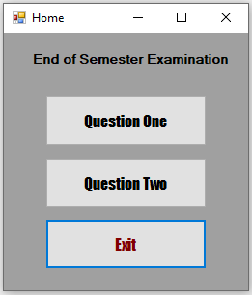

***Figure 1***

1. Coltek Solutions, a cell phone provider, sells the following packages:

|  |  |
| --- | --- |
| 800 minutes per month | GHc45.00 per month |
| 1500 minutes per month | GHc65.00 per month |
| Unlimited minutes per month | GHc99.00 per month |

Customers may also select the following options:

|  |  |
| --- | --- |
| Email | GHc25.00 per month |
| Unlimited text messaging | GHc10.00 per month |

The provider sells the following phones:

|  |  |
| --- | --- |
| Model 100 | GHc29.95 |
| Model 110 | GHc49.95 |
| Model 200 | GHc99.95 |

(A 10% sales tax applies to the sale of a phone.)

Additionally, the provider offers individual plans and family plans. With the Individual plan, the customer gets one phone. With the Family plan, the customer gets as many phones of the same model as he or she desires, and all the phones share the same minutes. Email and text messaging fees are charged for each phone purchased under the Family plan.

Create an application that calculates a customer’s plan cost. The application’s main form should look similar to the one shown in ***Figure 2***.

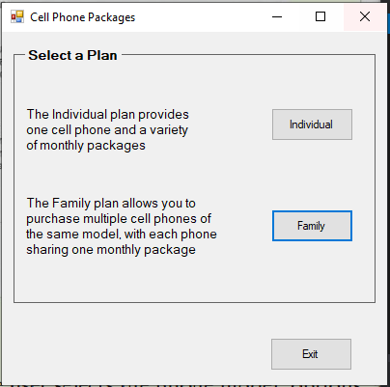

***Figure 2***

When the user clicks the Individual button, the form shown in ***Figure 3*** should appear.

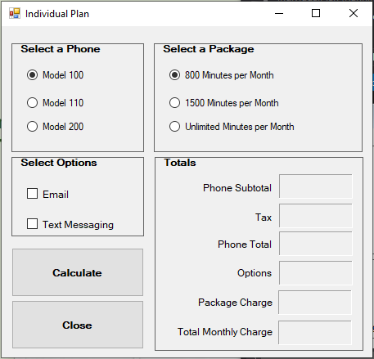

***Figure 3***

The user selects the phone model, options, and package. When the ***Calculate*** button is clicked, the charges are calculated and displayed.

When the user clicks the *Family* button on the main form, the form shown in ***Figure 4*** should appear.

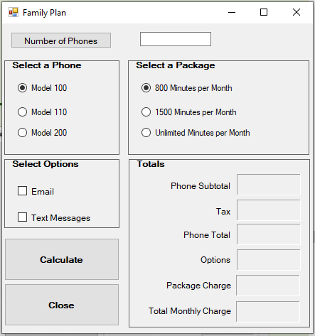

***Figure 4***

The user enters the number of phones, selects the phone model, options, and package. When the ***Calculate***button is clicked, the charges are calculated and displayed. Make sure to handle all exceptions. **[40 Marks]**

1. BMI is often used to determine whether a person with a sedentary lifestyle is overweight or underweight for their height. A person’s BMI is calculated with the following formula:

BMI = (weight * 703) / height2

In the formula, weight is measured in pounds and height is measured in inches. Create a VB application to calculate a user’s BMI by allowing users to enter their weight and height in the appropriate units. Display their BMI with an appropriate control. Display a message indicating whether the person has optimal weight, is underweight, or is overweight. A sedentary person’s weight is considered to be optimal if his or her BMI is between 18.5 and 25. If the BMI is less than 18.5, the person is considered to be underweight. If the BMI value is greater than 25, the person is considered to be overweight. Make sure to handle all exceptions. **[20 Marks]**