Power BI Dashboard
Superstore Sales Analysis
Web Scraping and Visualization Lab
BSc Data Science
Ankit Uniyal | A058 | Roll No. 86032400010

Dataset
Data Source
The primary dataset used for this project is the Superstore Sales dataset, a popular dataset on Kaggle. It contains 9,994 rows and 21 columns covering data from 2014 to 2017 across the United States.
Source: https://www.kaggle.com/datasets/vivek468/superstore-dataset-final
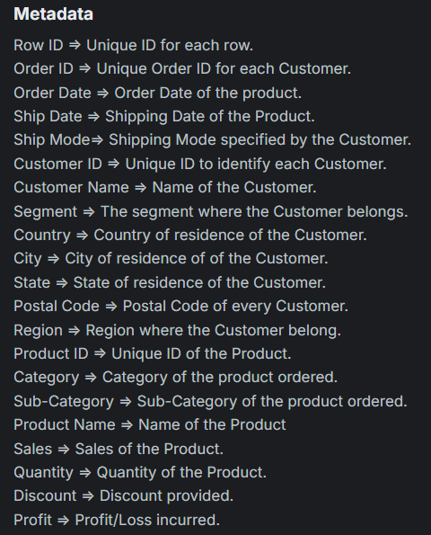

Intentional Data Dirtying
To demonstrate the data cleaning process in Power Query, the original dataset was modified/made dirty in Excel before import.
- Deleted 40 values in the Postal Code column to create null entries
- Duplicated rows 50–80 and added at at the bottom
- Changed 20 Order Date values to DD-MM-YYYY format to simulate mixed date formats
- Modified 10 Category values to inconsistent casing
- Added an empty column named Temp_Notes to simulate a junk column

Data Loading
Primary Dataset
The dirty file was loaded into Power BI Desktop, this is the main dataset for the dashboard.
Secondary Dataset (Custom CSV)
A second, manually created CSV file was loaded alongside the main dataset. This file contains regional sales targets.
They are artificially created.
Region, Sales_Target
West, 200000
East, 180000
Central,150000
South, 120000

Power Query Cleaning (Data Munging)
Everything was done inside Power Query Editor.

- Remove Duplicates on Order ID column
- Remove Rows where Postal Code is null
- standardized casing (Title Case)
- Order Date column type changed to Date
- Delete Temp_Notes column

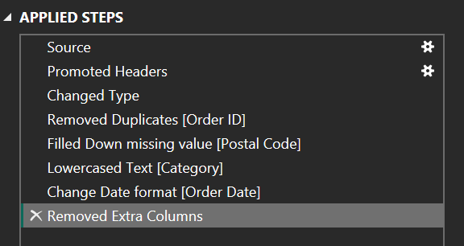
Normalization (Star Schema)
The original dataset was normalized by duplicating then remove unnecessary columns, in Power Query

Table | Columns Retained
Fact_Orders | Row ID, Order ID, Order Date, Customer ID, Product ID, Sales, Quantity, Discount, Profit
Dim_Customer | Customer ID, Customer Name, Segment, Country, City, State, Postal Code, Region
Dim_Product | Product ID, Product Name, Category, Sub-Category
Dim_Ship | Order ID, Ship Date, Ship Mode
Dim_Region | Region, Sales_Target (from secondary CSV)
Dim_Date | Date, Year, Month, Month Number, Quarter (calculated table)

A Star Schema is a data modeling approach where:
- One central Fact table contains transactional data (numbers, metrics)
- Multiple Dimension tables contain descriptive attributes (who, what, where, when)
“Without star schema, the dashboard would still work, but it would be slower, harder to maintain, and prone to incorrect aggregations.”

Normalization = remove redundancy + enforce logical grouping

“Each dimension isolates one business concept, reducing redundancy and enabling flexible analysis.”
Data Modeling
Relationships between the fact and dimension tables were created in Power BI's Model view.

- Fact_Orders[Customer ID] → Dim_Customers[Customer ID] (Many-to-One)
- A single customer places multiple order
- Fact_Orders[Product ID] → Dim_Product[Product ID] (Many-to-One)
- Same product sold multiple times
- Fact_Orders[Order Date] → Dim_Date[Date] (Many-to-One)
- Multiple transactions per day

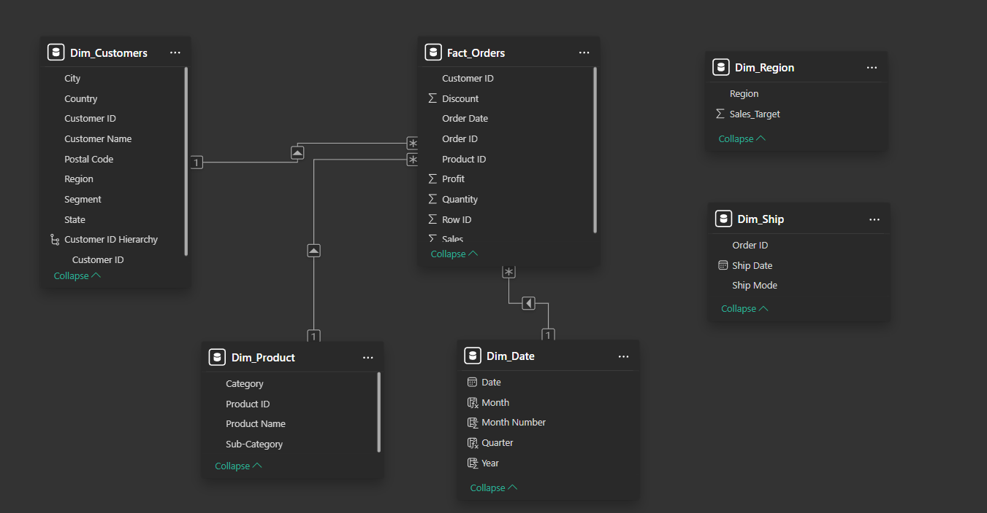

“Relationships are what turn raw tables into a semantic model — without them, visuals cannot interact meaningfully.”

DAX Measures
All measures were created inside Fact_Orders using the New Measure option, total 10.
Total Sales = SUM(Fact_Orders[Sales])
Total Profit = SUM(Fact_Orders[Profit])
Total Orders = DISTINCTCOUNT(Fact_Orders[Order ID])
Total Quantity = SUM(Fact_Orders[Quantity])
- Total Sales / Total Profit — simple column aggregations forming the foundation of all revenue and profitability visuals
- Total Orders — uses DISTINCTCOUNT to avoid inflating the count when multiple rows share the same Order ID
- Total Quantity — total units sold across all transactions
Profit Margin % = DIVIDE([Total Profit], [Total Sales], 0)
Avg Order Value = DIVIDE([Total Sales], [Total Orders], 0)
Avg Discount = AVERAGE(Fact_Orders[Discount])
- Profit Margin % — ratio of profit to revenue; DIVIDE is used instead of division operator to safely handle divide-by-zero
- Avg Order Value — average revenue per unique order; higher values indicate customers spending more per transaction
- Avg Discount — average discount rate applied; high values here directly compress profit margin
Sales LY =
CALCULATE(
[Total Sales],
SAMEPERIODLASTYEAR(Dim_Date[Date])
)

YoY Sales Growth % =
DIVIDE(
[Total Sales] - [Sales LY],
[Sales LY],
0
)
- Sales LY — recalculates Total Sales shifted back exactly one year using SAMEPERIODLASTYEAR; requires Dim_Date to be marked as a Date Table
- YoY Sales Growth % — percentage change between current and prior year sales; returns 0 for 2014 since no 2013 data exists in the dataset

Product Rank =
RANKX(
ALL(Dim_Product[Product Name]),
[Total Sales],
,
DESC,
DENSE
)
- Product Rank — ranks every product by Total Sales in descending order using DENSE ranking (no gaps in rank numbers); used with a Top N visual filter to display Top 10 products

Dashboard Pages
Page 1 — Executive Overview
Answers: How is the business performing overall?
- 4 KPI cards — Total Revenue, Total Profit, Total Orders, Profit Margin %
- Monthly Sales & Profit Trend — dual-axis line chart showing Sales and Profit by month
  - Identifies seasonality
- Sales by Category — donut chart (Furniture 33.82%, Office Supplies 31.48%, Technology 34.7%)
  - Shows contribution split
- Year and Category slicers for page-level filtering

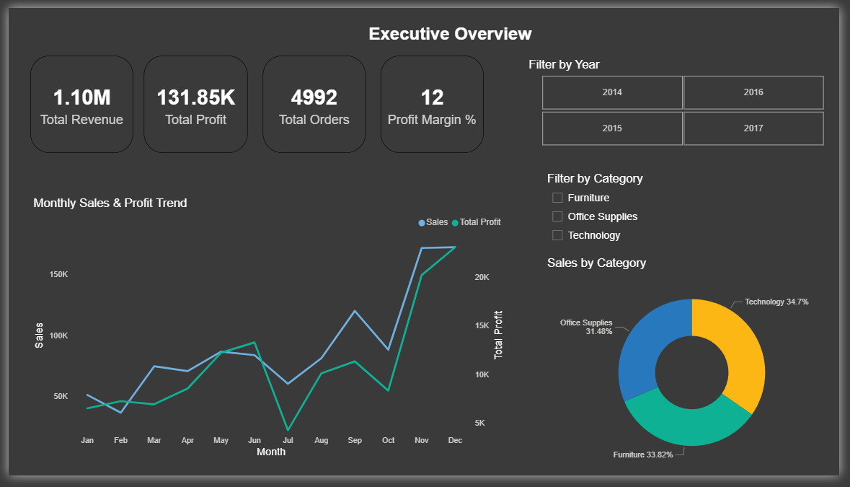

Page 2 — Sales Performance Over Time
Answers: When are we selling, when are we not, and how does this year compare to last?
- Year-over-Year Sales Comparison — clustered bar chart using Total Sales vs Sales LY
  - Compares growth vs last year
- Sales by Quarter — grouped column chart showing Q1–Q4 breakdown by year
  - Detects seasonal performance
- Monthly Sales Detail — table with conditional formatting on YoY Growth % (green = growth, red = decline)
  - Highlights anomalies (July dip)
- Key Insight text box highlighting Q4 peak pattern and July recurring dip

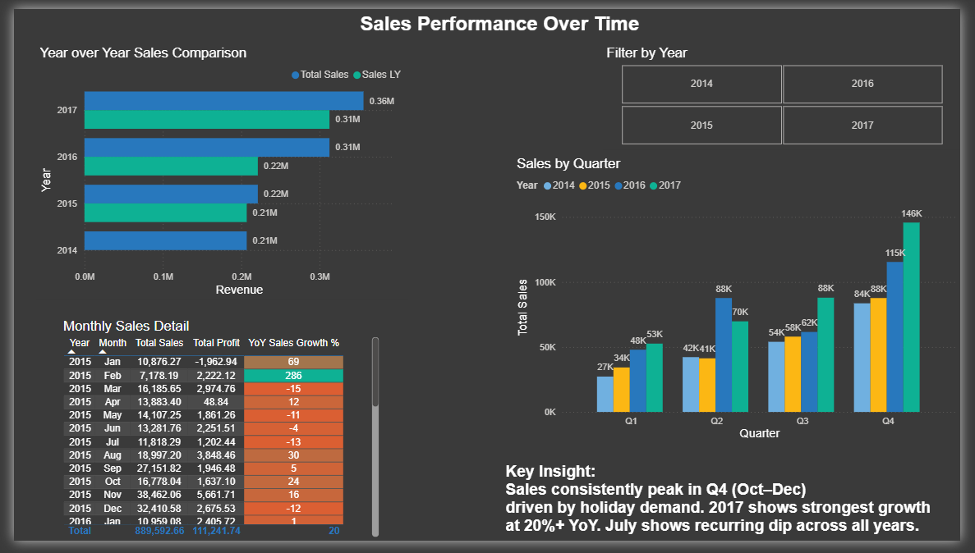

Page 3 — Product & Category Analysis
Answers: What should we sell more of, and what is losing us money?
- Top 10 Products by Revenue — horizontal bar chart with Top N filter
  - Identifies revenue drivers
- Profit Margin % by Sub-Category — column chart with conditional formatting (red = negative margin)
  - Shows profitability vs volume
- Sales vs Profit Scatter Plot — plots each sub-category by Sales and Profit, colour-coded by Category
  - High sales + low profit = problem
  - High profit + low sales = opportunity
- Bottom 5 Products by Profit — table showing worst-performing products
  - Directly shows loss-making products

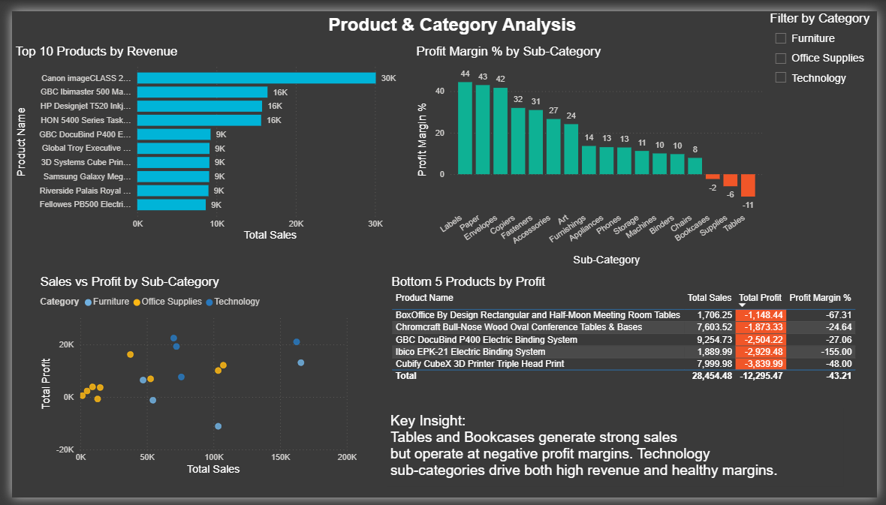

“The scatter plot is the most important because it reveals core business problem, high sales does not guarantee profitability.”

Page 4 — Regional & Customer Analysis
Answers: Who is buying, from where, and which segment is most valuable?
- Sales by State — filled map with color saturation by Total Sales
- Sales by Customer Segment — horizontal bar chart (Consumer 0.56M, Corporate 0.34M, Home Office 0.20M)
- Profit by Region — column chart (West 47K, East 39K, Central 32K, South 14K)
- Avg Order Value by Segment — column chart showing consistent ~220 across all segments
  - Pricing behavior insight
- Segment slicer for filtering the entire page

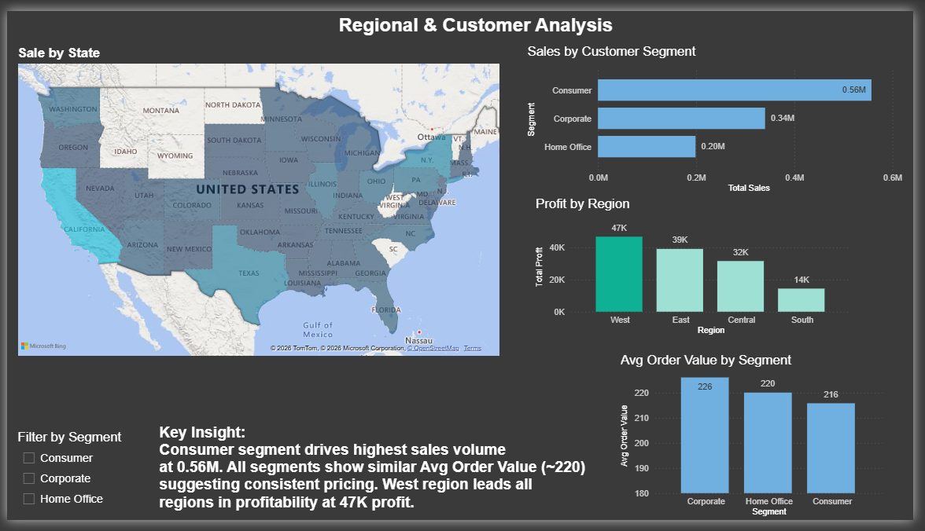

Closing Statement
"The core finding is — high sales do not mean high profit. This dashboard identifies exactly where the business is losing money despite revenue growth, which is the most actionable insight for any business decision."

Actionable Insights
The following two insights are derived directly from the dashboard data and represent recommendations a business could act on immediately.

Insight 1 — Discontinue or Reprice Tables & Bookcases
What the data shows: Tables are running at -11% profit margin and Bookcases at -6%. Both sub-categories appear in the Bottom 5 products list. Despite generating meaningful sales volume, every transaction in these sub-categories results in a net loss.
Recommended action: The business should either discontinue these sub-categories, increase prices by a minimum of 15% to reach breakeven, or renegotiate supplier costs. Continuing at current pricing means that scaling sales volume in these categories directly scales losses.

Insight 2 — Invest More in Q4, Reduce Q1 Marketing Spend
What the data shows: Q4 consistently delivers 40–50% higher sales than Q1 and Q2 across all 4 years in the dataset. This pattern is stable year-over-year — not a one-off spike — making it reliable enough to plan around.
Recommended action: Reallocate marketing and inventory budget to front-load Q4 preparation starting in October. Reduce spend during January–March, where conversion is consistently at its lowest. Predictable seasonality makes this a low-risk, high-return operational decision.

Publishing via Power BI Service
Account Setup
Power BI Service requires a Microsoft organizational account. Personal Gmail or Outlook accounts are not supported for publishing.

College Email Format: name.lastname[last 3 digits of SAP ID]@nmims.in
Example: ankit.uniyal010@nmims.in

1. Open Power BI Service — go to https://app.powerbi.com
2. Sign in using your NMIMS college email —
format: name.lastname[last 3 digits of SAP ID]@nmims.in
4. Once signed in, you will land on My Workspace — this is your personal publishing area
Publishing the Report from Power BI Desktop
1. Open the .pbix file in Power BI Desktop
2. Go to Home tab → click Publish (top right area of ribbon)
3. Sign in with your NMIMS college email if prompted
4. Select destination → — My Workspace → click Select

Important: Before publishing, ensure all slicers on all 4 pages are deselected. This ensures the teacher sees the full unfiltered dataset when they open the link.
Generating a Public Shareable Link
1. In Power BI Service (browser), open your published report
2. Go to File → Embed report → Publish to web (public)
3. Click "Create embed code" on the dialog that appears
4. Acknowledge the public access warning → click Publish
5. Copy the link provided — this is your shareable public URL

Published Dashboard Link
The dashboard has been successfully published and is accessible at the following public URL:

Power BI Dashboard — Superstore Sales Analysis (Public Link)
https://app.powerbi.com/view?r=eyJrIjoiNTQyYzkwYzAtMTIzNS00NmQwLThmZDEtNmU5ZGUzZmZjMTY4IiwidCI6ImQxZjE0MzQ4LWYxYjUtNGEwOS1hYzk5LTdlYmYyMTNjYmM4MSIsImMiOjEwfQ%3D%3D

