

“Machine Learning vs Traditional Actuarial Underwriting
When Applicants Hide Information”



Statistics Group for Research Development

Members:

Roll NO: SAP ID: Name:
A020 86032400003 Aaryan Jha
A055 86032400064 Soham Sinha
A056 86032400054 Ojas Taneja
A058 86032400010 Ankit Uniyal

Supervisor: Prof Shaishavi Sabnis

Index Page

- Introduction 3
- Objective 4
- Related Work 4
- Changes from proposal 5
- Dataset description 7
- Methodology 13
- Results and discussion 21
- Model comparison 23
- Additional insights 23
- Limitations and future scope 24
- Conclusion, references 25
- Appendices 26

1. Introduction

1.1 The problem
A life insurance company sells a policy: the customer pays a premium now, and the insurer pays a sum assured if the customer dies within the policy term. To set that premium correctly, the insurer must estimate how likely each applicant is to claim in the next 10 years.
There are two ways to make this estimate. The traditional actuarial method looks up a mortality table (by age and sex) and applies fixed multipliers for risk factors, for example a higher multiplier for smokers. The machine learning method trains a model on data and learns the pattern, including how risk factors strengthen (compound) each other, instead of using fixed multipliers.
The complication is that applicants can lie or leave things out, for example that they smoke. The insurer sees only what the applicant declares, not the truth. This is called information asymmetry.

1.2 Why we use a simulation
No real dataset records who lied on an insurance application. If someone hid smoking and was approved, that fact is not labelled anywhere, so we cannot train or test a method for catching liars on real data. We therefore built a simulated insurance world in which the true risk of every applicant is known, and compared the methods inside it.

1.3 Why it matters commercially
Small underwriting errors become serious when they are repeated across thousands of policies. If an applicant has several moderate risk factors, such as smoking, high blood pressure and high BMI, and the traditional method treats each factor separately, it may underestimate the combined risk. The insurer then charges less than the expected claim cost.
The problem is worse when applicants hide smoking or medical conditions. Two errors then reinforce each other: a pricing error (the risk is estimated wrongly) and a selection error (higher-risk people are more likely to obtain underpriced insurance). Medical verification reduces this problem, but it costs money. Verifying everyone wastes money, and verifying nobody lets concealment go undetected. The project therefore asks which applicants should be verified, and at what exam cost checking becomes worthwhile.

1.4 What we did
- We built a simulated world of insurance applicants in which we know the true risk of every person. Real data cannot tell us who lied, so this was the only way to measure the damage of lying.
- We built the traditional method and several statistical and machine learning methods and priced the same people with all of them.
- We hid facts for some applicants (smoking and diseases) and measured how much each method got wrong.
- We built two ways to flag suspicious applicants, and a game-theory model that tells us when checking is worth the cost and how big a penalty must be.
- We built a calculator that shows all of this for one applicant at a time.

1.5 The short answer
- Machine learning did not clearly win. A plain statistical model (GLM or Cox) did as well as or better than complex machine learning (XGBoost) at our data size.
- Lying changed the price much more than the choice of method did.
- Training the models on declared data (what an insurer really has) helps a lot, but it makes honest applicants pay more.
- Checking is worth it at realistic exam costs, and a smarter flagging rule makes it worth it for a wider range of costs.
Everything is simulated, so the results hold for this simulated world only.

1.6 About the numbers
All numbers in this document come from the result files in the docs folder of the code package. The data is simulated, so nothing here is a statement about real insurance companies. Every departure from the original proposal is collected in one place, Section 4.

2. Objective
The aim is to test both methods fairly and report whichever one wins, not to show that machine learning is better. The study answers four questions:
- When everyone is honest, which method prices risk more accurately?
- Do the premiums cover the expected claims (premium adequacy)?
- When applicants hide information, what happens to each method, and which method is better at spotting the liars?
- When is it worth paying to check an applicant, and how big must a penalty be to stop people from lying?
Questions 1 and 2 concern honest applicants, question 3 concerns lying applicants, and question 4 concerns the economics of checking.

3. Related Work / Conceptual Grounding
The sources below are conceptual references that shaped our framing and method. This is not a formal systematic literature review.

3.1 Why the study is still needed
It is already reported that machine learning beats actuarial methods in aggregate, but on clean, honestly declared data (for example in a systematic literature review and a MassMutual study). None of the papers we found tests what happens when applicants systematically lie, because real datasets cannot label who lied. The open question is therefore narrower: does the advantage of machine learning hold, shrink or reverse once concealment enters? It is possible that the advantage depends on clean data, and this can be tested here because we control the ground truth.
The paired synthetic design is a methodological contribution, not only a dataset choice. No public dataset reveals the concealed truth, so standard adverse-selection econometrics (for example the positive-correlation tests of Rothschild and Stiglitz, and of Chiappori and Salanié) can only test indirectly whether asymmetric information exists. They cannot measure how well a specific underwriting method detects and reprices a lie, because they never observe the lie. Our design, in which every applicant has a true record and a declared record, measures detection and repricing directly.
Game theory changes the question from which model scores higher to when checking is worth it. The output is an operating number (verify when the exam costs less than a stated amount), not only a leaderboard comparison.

3.2 Public sources for realism
We planned to use four public sources to make the simulated world realistic. The table shows the planned role of each and what was actually used.
Table 1: Public sources: planned role and actual use
Source | Planned role | What we actually used
SOA 2015 VBT / CDC life tables | Base mortality curves for the age shape of risk | The SOA insured-lives table was not available. A handful of CDC life-table values fixed the age shape of risk (b = 0.0633 per year).
NHANES (CDC) | Realistic joint distributions of BMI, blood pressure, cholesterol and smoking | Not downloaded. We built the relationships between features ourselves and checked them in the data validation (Section 5.4).
Prudential Kaggle (about 59,000 applications) | Template for which features an application holds and how risk is tiered. It has risk classes, not claim outcomes. | Conceptual template only. No figures from it are reported.
Medical Cost Kaggle | Rough plausibility check that smoking and high BMI raise charges | Plausibility idea only. No result from it is reported.

3.3 The traditional method is a simplification
We are not actuaries. The traditional arm (Arm A) is deliberately modelled as fixed multiplicative loadings on a 5-year age-band table. This is a simplification of real substandard-rating practice, and we state it to pre-empt a strawman criticism. The loadings were fixed from the literature before any result was seen.

4. Changes from proposal
This is the only section that explains changes from the proposal. Each row gives what was planned, what was done instead, and why. Section 6 then describes the final version of each phase without repeating the reasons.
Table 2: Changes from the proposal
No. | Phase | Planned | Changed to | Why
1 | 0 | Use AI agents and large language models | Dropped. The study compares machine learning with actuarial methods. | The team lacked the knowledge and time; a broken multi-step agent would take weeks to fix; this is a statistical study.
2 | 0 | Show that machine learning is better | Report whichever method wins | A study that tries to prove one answer is not trustworthy.
3 | 1 | About 30,000 applicants | 50,000 applicants per dataset | Too few claims in the smallest groups; more simulated data costs nothing. The smallest test group now has at least 88 claims.
4 | 1 | The honest 65% is the control group | Each liar is compared with himself or herself (true record against declared record) | People who can hide something are riskier from the start. A control group would mix the effect of lying with the effect of being riskier.
5 | 0, 3 | Normal smoking rates | Smokers oversampled to 35% of the cohort. About 66% of smokers lie, against about 43% in existing research. | The 65/15/12/8 mix needs 23% of the cohort hiding smoking, but only 11% to 14% of people smoke. It is a power-driven design choice. Effects are reported per concealment type, and portfolio results are re-weighted to a 10% liar share (Sections 5.3 and 6).
6 | 3 | Multi-field liars (unspecified) | The multi-field group is always smoking plus one diagnosis | Simpler to explain.
7 | 0, 4 | Simple additive loadings | Multiplicative loadings from rounded rating classes (nearest 0.25), on a 5-year age-band table, fixed before any result | Real risk factors multiply. Additive loadings would make the traditional method wrong even in a simple world and hand machine learning an easy win.
8 | 4 | (not planned) | Arm A treats a blood pressure of 140 or more, or an HbA1c of 6.5 or more, as that condition even if undeclared | A real underwriter would do the same, and both methods then see the same columns.
9 | 4 | A single table lookup | One scaling number k fitted on training data (about 0.53) | Matches average predicted risk to the real claim rate. The value shows the CDC-shaped table is a general-population table, not insured lives; the SOA table was not available.
10 | 5 | (not planned) | Arm A+: k set separately for each declared group (smoking, disease) | Prevents the traditional method from looking weak by construction; a real actuary would adjust by risk group.
11 | 4, 6 | Accept / Rate / Decline, plus Verify | Standard / Rated / Decline. Verify moved to the triggers (Phase 6). | Keeps pricing decisions and checking decisions separate.
12 | 5 | Train every model on honest records only | Honest records first; training on declared records added later (Phase 5b) | Honest-trained models never meet non-disclosure; models trained on declared records mirror what a real insurer has.
13 | 1, 3 | Separate truthful and concealed records | One row per applicant with true_ and declared_ columns | Leakage between training and test data becomes structurally impossible.
14 | 3 | Region, product type, payment mode and policy term as variables | Dropped. 16 risk features, 34 columns, term fixed at 10 years. | These variables have no effect on risk in our world and add noise.
15 | 3 | (not planned) | A lie can only hide something the person really has. How easy each lie is to spot was locked before results. | Models see only what a real insurer could see; locking prevents adjusting settings to get nicer answers.
16 | 0 | AUC and Brier score as main measures | Error against the true probability is primary; AUC and Brier score are secondary | Only about 5.5% claim within 10 years, so claim outcomes are very noisy. The true probability is a cleaner measuring stick.
17 | 2 | Sensitivity run with a nonlinear risk generator | Not in the primary design. Listed as a stretch goal; no results reported. | Keeps one clear simulated world.
18 | 2 | Hazard ratios from our notes (smoker 1.8 to 2.0, diabetes 1.57) | Smoker 2.4, diabetes 1.8 | These are the numbers we could verify.
19 | 2 | (not planned) | The base level of risk is reset at every gamma so that the average 10-year claim rate is 5.5% | Otherwise the traditional method would look bad only because its overall level was off. Only the shape of the risk changes with gamma.
20 | 2 | (not planned) | A hidden extra risk for every person, and a safety rule that stops models reading hidden columns | Without it, a flexible model could learn the true risk exactly, which is unrealistic. The rule prevents accidental cheating.
21 | 2 | Calibrate to SOA and NHANES | A handful of CDC life-table values; feature relationships built by us | The SOA and NHANES tables could not be downloaded.
22 | 6 | A plausibility check for machine learning only | Both methods get a trigger: rules for Arm A, a statistical consistency model for Arm B. The neutral and oracle triggers were cut. Triggers are compared at the same number checked and against random flagging. | A trigger given to one side only would decide the result by itself. A real insurer has no list of who lied. Comparing at the same number checked is the fair way.
23 | 1, 5 | Cox model as a main method | Cox kept as a reference model; left out of the calculator | A hazard-based simulation gives time-to-claim cheaply, so Cox costs little to include.
24 | 5 | (not planned) | 60/10/30 split by applicant; fixed XGBoost settings; no calibration adjustment (none needed); same medical cut-offs for GLM and Cox, no interaction terms; SHAP used only to describe XGBoost | A single fixed procedure means differences come from the data, not from tuning. SHAP describes what a model learned; it does not prove causes.
25 | 5 | (not planned) | Learning curve on an independent cohort of 335,000 applicants | To find out whether XGBoost was behind only because of data volume.
26 | 1 | One dataset | 15 datasets: 5 gamma values times 3 seeds | A result should not depend on one hidden setting or one lucky run. Where the 3 seeds disagree, the result is called unclear.
27 | 7 | Paired tests, bootstrap, AUC test, correction for many tests | Protocol written and frozen first; test data opened once; p-values from the bootstrap spread; Holm correction inside each family; portfolio results also at a 10% liar share; no confusion matrix | Prevents choosing tests after seeing results. The percentile method cannot reach very small p-values. The simulated world has no true underwriting decision to build a confusion matrix from.
28 | 8 | An equilibrium solution of the checking game | A deterrence threshold. The penalty L is the total loss when caught (saving taken back plus any surcharge). Added a marginal view and results by policy size, liar rate, exam accuracy and gamma. The liar rate of 10% is an assumption. | Standard audit-game logic, simple to explain, and it gives a number a decision maker can use. Checking costs about the same for every policy, but the gain grows with the sum assured.
29 | 9 | A calculator with several tabs | One page: a form for one applicant and one table comparing Arm A, GLM, XGBoost and the true price. Cox omitted. Age limited to 40 to 60. Only smoking can be hidden. | People understand a method better when they can try it on one person. Showing the exact value makes the limits of the shortcut honest.

Notation. The proposal used the letters p, q and d for the game-theory quantities. This document uses L (total loss when caught), r (share of liars flagged), v (exam accuracy) and d (premium saved by lying) throughout. The letter d now means the premium saved, not the exam accuracy.

5. Dataset description

5.1 Why 15 datasets
A single dataset could make one method look better only because it happens to match that dataset’s structure (our concern was mainly XGBoost). We therefore built 15 datasets, one for each combination of 5 interaction levels and 3 random seeds.
- Interaction level (gamma). We do not know how strongly risk factors compound in real life, so we test five levels: 0, 0.25, 0.5, 0.75 and 1. At gamma 0 risk factors simply multiply; at higher gamma, combined risks such as smoker plus high blood pressure plus high BMI are larger than the product of the single risks.
- Seeds. To make sure a result is not a fluke, every interaction level is generated 3 times with different random numbers.
We read the results at each of the 5 interaction levels and combine the 3 seeds. If the 3 seeds point in opposite directions, we call the outcome unclear because it is too unstable to trust.

5.2 Size and structure
Each dataset holds 50,000 applicants, with one row per applicant and 34 columns. Every column that can be lied about exists twice: a true_ version and a declared_ version. A lie is always a false value, never a blank, so no missing-value handling is needed. Both methods see exactly the same declared columns. The hidden extra risk cannot be read by any model. With 50,000 applicants, the smallest test group still has at least 88 claims.
Table 3: Selected columns (full list in the config folder of the code package)
Column | Meaning
age, sex | Applicant age (40 to 60) and sex (M or F)
bmi, sbp, cholesterol, hba1c | Body mass index, systolic blood pressure (mmHg), cholesterol (mg/dL), blood sugar (HbA1c, %)
true_smoker, true_pack_years | True smoking status and pack-years
true_diabetes, true_hypertension, true_cvd | True diabetes, hypertension and heart disease (0 or 1)
alcohol, family_history, hazardous_hobby, occupation_class | Other risk features (alcohol value 2 is heavy drinking; occupation class 4 is the highest-risk class)
declared_ columns | What the applicant tells the insurer; equal to the true_ value for honest applicants
concealment_type, concealed_fields | Honesty group (truthful, smoking, diagnosis, multiple) and which fields were hidden
true_p10 | True 10-year claim probability (the ground truth used for scoring)
claim_10yr | 1 if the applicant claimed within 10 years, otherwise 0

5.3 Honesty groups and the smoker oversampling
Every applicant belongs to one of four groups. The proportions are assumptions, loosely informed by published non-disclosure estimates; the exact split between categories is illustrative.
Table 4: Applicants by honesty group (per dataset)
Group | Share | Applicants | What is hidden
Honest | 65% | 32,500 | Nothing
Hides smoking | 15% | 7,500 | Smoking status
Hides a disease | 12% | 6,000 | One diagnosis
Hides both | 8% | 4,000 | Smoking plus one diagnosis

The problem. This mix needs 23% of the cohort (15% plus the 8% multi-field group) to be smokers who hide smoking. Only about 11% to 14% of the general population smoke, so random sampling could not give enough lying smokers.
What we did. We oversampled smokers to 35% of the cohort, and the 8% multi-field group always consists of smokers with a diagnosis. As a result about 66% of smokers lie, well above the roughly 43% seen in existing research. This is an intentional, power-driven design choice and an assumption.
How we limited the damage.
- Effects are reported separately for each type of concealment.
- Portfolio measures (loss ratio, profit) are re-weighted to a realistic 10% liar share (formula in Section 6, Phase 7).
- The 44% to 57% overcharge on honest non-smokers is stated as exaggerated by the high liar share.
Caveat. Re-weighting fixes the liar share but not the smoker prevalence. The cohort still has more smokers than the real world. This is listed as a limitation in Section 10.

5.4 Data validation (exploratory analysis)
Before using the simulated data, we looked at it to check that it behaves like real applicants and that the risks work as designed. This is validation, not discovery: the patterns were built in, and the purpose is to confirm they came out as intended. All figures use one dataset (seed 2026, gamma 0.5, 50,000 applicants, 2,786 claims), except Figure 5, which uses the five gamma versions of the same seed. The script is scripts/eda.py and the full tables are in docs/eda/eda_results.txt.
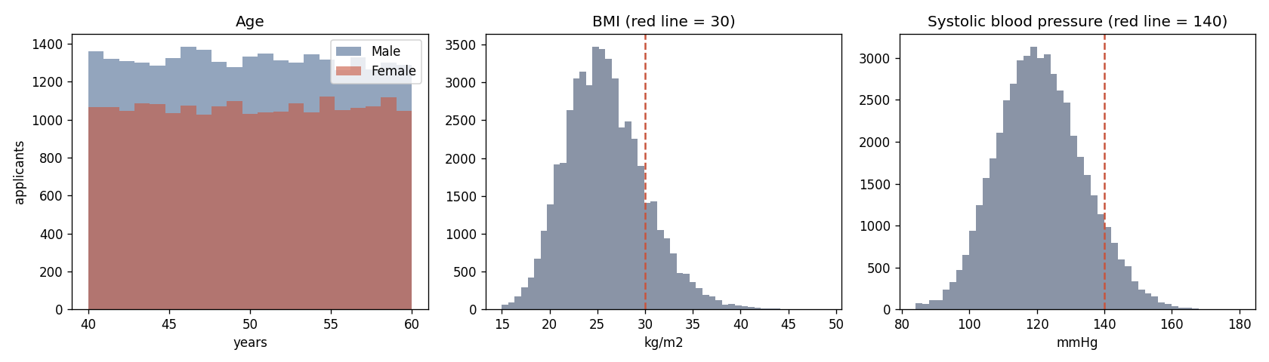
Figure 1: Age, BMI and systolic blood pressure of the applicants
What it shows. Ages are spread evenly from 40 to 60. BMI is bell-shaped with an average of 25.8, and 15.8% of applicants have a BMI of 30 or more. Systolic blood pressure averages 120.7. The red lines mark the cut-offs of 30 and 140 that the traditional method and the checking rules use.
Why it matters. The applicants look like a normal group of term-life buyers, and enough people sit on both sides of each cut-off for the rules to be tested properly.
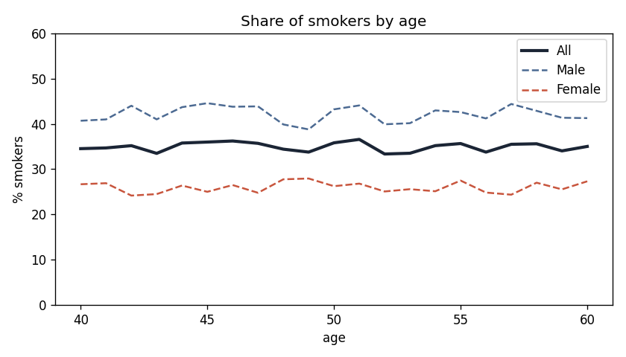
Figure 2: Share of smokers by age
What it shows. About 35% of applicants smoke at every age (42% of men and 26% of women).
Why it matters. We raised the smoker share on purpose (Section 5.3). It gives us enough smokers to measure, but it is higher than real life, so portfolio results are re-weighted to a realistic share of liars and this is listed as a limit.
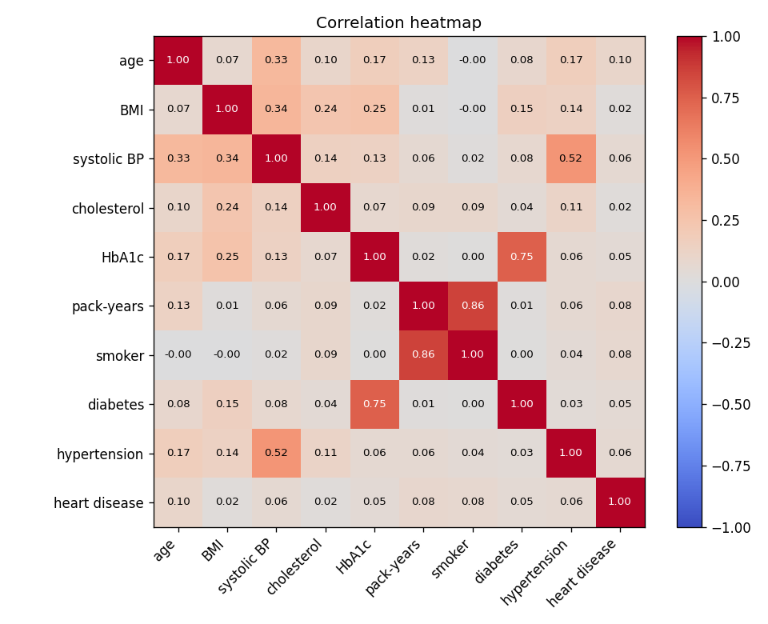
Figure 3: Correlation heatmap
What it shows. Risk factors move together as they do in real people: age and blood pressure (0.33), BMI and blood sugar (0.25), BMI and blood pressure (0.34). Smoker and pack-years are closely linked (0.86), blood sugar follows diabetes (0.75), and blood pressure follows hypertension (0.52).
Why it matters. The data was not made from unrelated random columns. The links between measured values and hidden conditions are also what let the checking tools find some liars. These relationships were built by us, not fitted to NHANES.
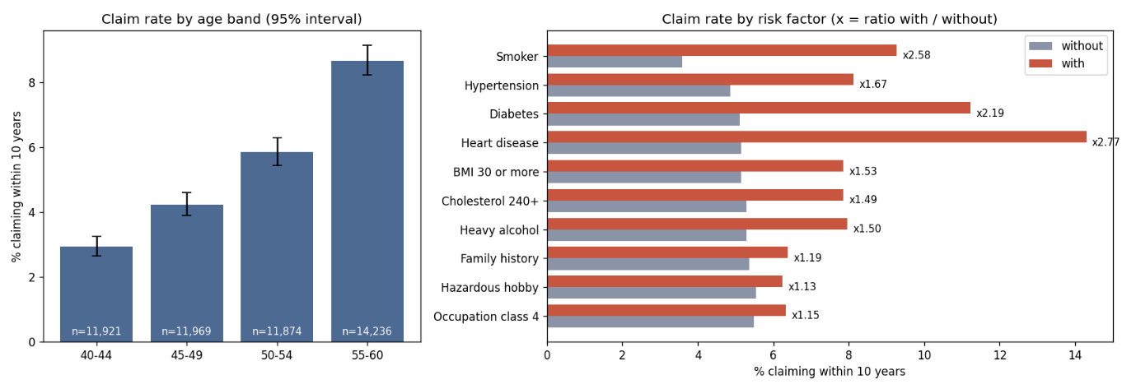
Figure 4: Claim rate by age band and by risk factor
What it shows. The claim rate within 10 years rises from 2.9% at ages 40 to 44 to 8.7% at ages 55 to 60. Compared with people without the factor, heart disease raises the claim rate 2.8 times, smoking 2.6 times, diabetes 2.2 times, hypertension 1.7 times and BMI of 30 or more 1.5 times.
Why it matters. The simulated risks go in the expected direction and size, and every group has enough claims to measure. These rates are not adjusted for other factors, so they mix in age and other risks.
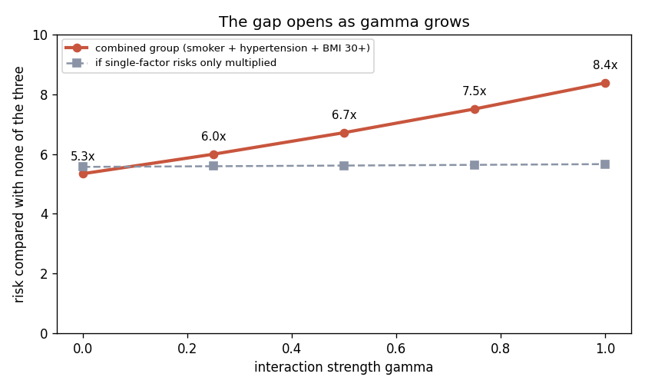
Figure 5: How the gap between combined and single risks grows with gamma
What it shows. For people who smoke and have high blood pressure and a high BMI, the risk compared with none of the three is 5.3 times at gamma 0 and 8.4 times at gamma 1. If the single risks only multiplied, it would stay near 5.6 times.
Why it matters. The gamma dial works. At gamma 0 risks simply multiply, so fixed rules should do well. At higher gamma, combined risks are larger than the rules assume. This is why we test every method at every gamma.
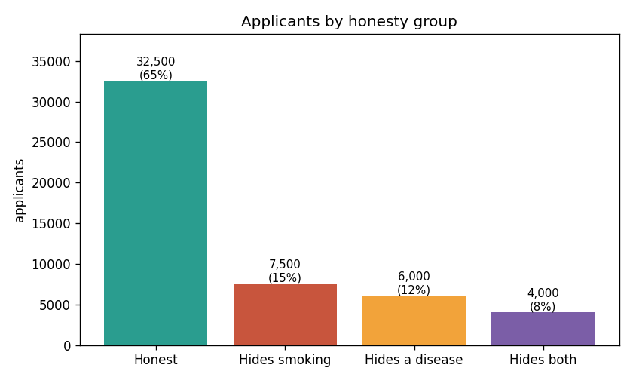
Figure 6: Applicants by honesty group
What it shows. 32,500 applicants are honest (65%), 7,500 hide smoking (15%), 6,000 hide a disease (12%) and 4,000 hide both (8%).
Why it matters. Each group is large enough to measure, even in the test data. The liar groups are riskier than the honest group before any lying, which is why we compare each liar with himself or herself.
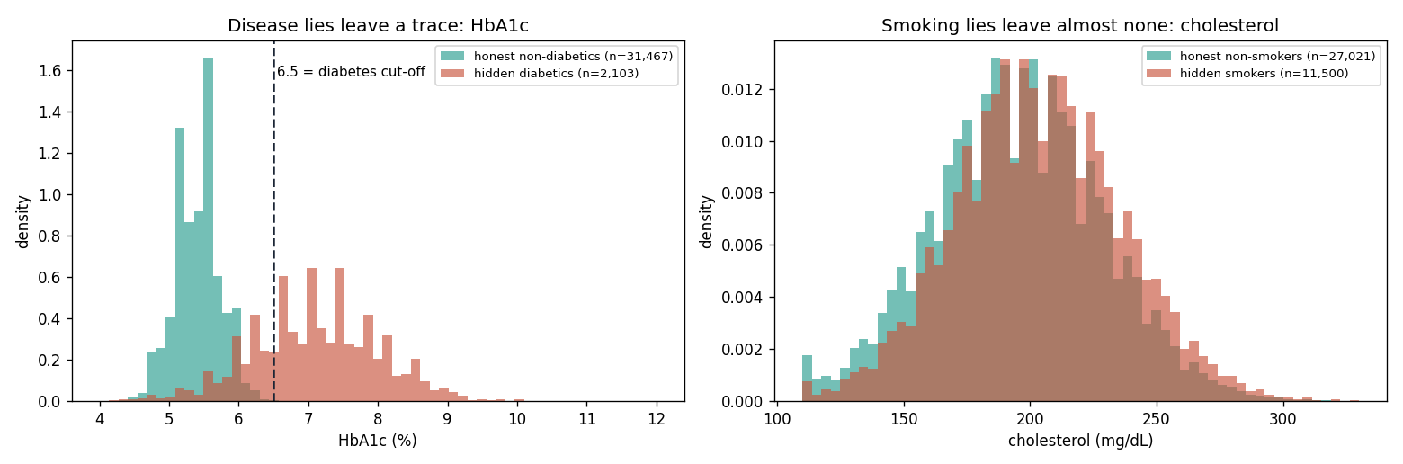
Figure 7: Why disease lies can be caught and smoking lies cannot
What it shows. Hidden diabetics have a median blood sugar (HbA1c) of 7.1 against 5.4 for honest non-diabetics, and 76% of them are above the 6.5 diabetes cut-off. Hidden smokers have almost the same cholesterol as honest non-smokers (203 against 195). Blood sugar alone separates the two groups well (AUC 0.96), while cholesterol hardly separates them (AUC 0.57).
Why it matters. It explains our checking results. The tools find many hidden diseases but only 2 to 4% of hidden smokers, and stopping smoking lies would need a very large penalty or a better test, such as a nicotine test. How strongly each lie leaves a trace is a property of our generator, fixed before results were seen.
Adjusted logistic regression of claims on smoking, age and sex. We asked whether smoking is linked to claims after allowing for age and sex (50,000 applicants, 2,786 claims).
Table 5: Adjusted logistic regression: claim within 10 years
Term | Odds ratio | 95% interval | p-value
Smoker compared with non-smoker | 2.56 | 2.37 to 2.77 | below 0.001
Age, per year | 1.079 | 1.072 to 1.087 | (2.15 per 10 years)
Male compared with female | 1.66 | 1.53 to 1.81

Smokers have about two and a half times the odds of a claim, close to the simulated risk of 2.4 times. It is not exactly 2.4 because this model adjusts only for age and sex and uses odds instead of hazards. Hiding smoking therefore hides a strong risk, which is why it is the most costly lie in our results.

6. Methodology
The work was done in ten phases, numbered 0 to 9. For each phase this section states what was done and gives the formulas used in that phase. The reasons for every change from the proposal are in Section 4, and the symbols are explained under each formula.

Phase 0: Fixing design problems before writing code
- Dropped the AI-agent idea; the study compares machine learning with actuarial methods.
- Fixed the concealment mix at 65% honest, 15% hiding smoking, 12% hiding a disease and 8% hiding several things, with smokers oversampled to about 35% (Section 5.3).
- Gave both methods a way to flag suspicious applicants, not only machine learning.
- Made the traditional method multiply its loadings instead of adding them.
- Set the main accuracy measure to be the error against the true probability, not against who actually claimed.
- Decided that models are first trained on honest records, so that the pure effect of lying can be seen (training on declared records was added later, Phase 5b).
- Set the goal as reporting whichever method wins.

Phase 1: Writing the plan down before looking at results
- Wrote the research questions, the two methods, the main measures and the tests in one short document before running anything.
- Set the cohort at 50,000 applicants, one row per applicant, with the true record and the declared record side by side.
- Compared each liar with himself or herself (true record against declared record) instead of with an honest control group.
- Kept the Cox model as a reference model.
- Recorded every later change, with its reason, in an amendments log (docs/amendments.md).

Phase 2: The simulated world
- Wrote our own formula for the true 10-year claim probability, because no real data has these features together with claim outcomes.
- Added the gamma dial: at gamma 0 risk factors simply multiply; at higher gamma they make each other worse.
- Set smokers at 2.4 times the risk of non-smokers and diabetes at 1.8 times, the numbers we could verify.
- Reset the base level of risk at every gamma so that the average 10-year claim probability stays at 5.5%.
- Added a hidden extra risk for every person (for things not on the form, such as depression). Both methods are blind to it, and a safety rule stops any model from reading the hidden columns.
- Used a handful of CDC life-table values for the age shape and built the relationships between features ourselves.
- Tested every method at every gamma value.

Formulas used in this phase
Risk of a claim at time t (years after the policy starts) for applicant i:
$$h_{i}\left(t\right)=Z_{i} A_{0} s_{i} e^{bt} e^{LP_{i}}, s_{i}=e^{b\left({age}_{i}-40\right)} {sexfactor}_{i}$$
A₀: base level of risk, set again for each gamma so that the average 10-year claim probability is 5.5%.
b = 0.0633 per year: how fast risk rises with age (fitted to CDC life-table values).
sexfactor: 1 for men and 0.60 for women (assumed).
Z_{i}: the hidden extra risk, with mean 1 and variance 0.25 (assumed). No model can see it.
The risk score combines single risk factors with interaction terms. The interaction dial gamma multiplies the second sum.
LPi=k​βkxik+γj,k​βjk xijxik, βk=lnHRk
x_{ik}: risk factors of applicant i; HR_{k}: hazard ratio of factor k (Table 6); β_{jk}: interaction terms (Table 7); γ: the interaction dial (0 to 1).
Table 6: Hazard ratios used in the simulated world
Factor | Hazard ratio | Factor | Hazard ratio
Smoker | 2.4 | Heavy alcohol | 1.25
Hypertension | 1.30 | Hazardous hobby | 1.10
BMI 30 or more | 1.26 | Occupation class 3 | 1.10
Diabetes | 1.80 | Occupation class 4 | 1.25
Heart disease | 2.0 | Family history | 1.15
Cholesterol 240 or more | 1.15

Table 7: Interaction terms (log-hazard at gamma = 1; assumed)
Interaction | Value
Smoker × age (per decade from age 50) | 0.08
Smoker × hypertension | 0.12
Smoker × BMI 30 or more | 0.10
Hypertension × BMI 30 or more | 0.10
Smoker × hypertension × BMI 30 or more | 0.18

Total risk over T years:
$$H_{i}\left(T\right)=\frac{A_{0} s_{i} e^{LP_{i}}\left(e^{bT}-1\right)}{b}$$
True claim probability within T years. This is our “truth” against which every method is scored:
$$p_{i}\left(T\right)=1-{\left(1+0.25 H_{i}\left(T\right)\right)}^{-1/0.25}$$
Actual claims are drawn from the probability given the hidden risk:
$$Pr\left(\text{claim within }T∣Z_{i}\right)=1-e^{-Z_{i}H_{i}\left(T\right)}$$
Time of claim:
$$T_{i}=\frac{1}{b}ln​\left(1+\frac{E_{i}}{Z_{i}}⋅\frac{b}{A_{0} s_{i} e^{LP_{i}}}\right)$$
E_{i}: a random number from the exponential distribution with mean 1. A claim within 10 years means T_{i} is 10 or less.

Result of the 1,000-applicant test
Before building the full datasets we simulated 1,000 applicants. It gave about 50 to 55 claims per 1,000 people, claim rates rising with age, and an effect of the gamma dial that grew as expected. For smoker plus high blood pressure plus high BMI, the risk compared with nobody having these was 5.3 times at gamma 0 and 8.4 times at gamma 1.

Phase 3: Building the datasets
- Built 15 datasets: 3 random seeds times 5 gamma values, each with 50,000 applicants and 34 columns.
- Gave every applicant a true record and a declared record, with the lie being a false value, never a blank.
- Removed region, product type and payment mode, because they do not affect risk in our world. The policy term is fixed at 10 years.
- Allowed lies to hide only something the person really has (a non-smoker cannot invent smoking).
- Locked how easy each lie is to spot before looking at results: diabetes is easy because of the blood sugar test, blood pressure is fairly easy, and smoking is hard because there is no nicotine test in our setup.
- Checked that the smallest test group still has at least 88 claims.

Phase 4: The traditional method (Arm A)
- Looks up a base death rate from a table by 5-year age band and sex, applies fixed loadings for risk factors, makes a decision, and calculates a premium.
- The loadings were fixed before any result was seen and rounded to the nearest 0.25, as real rating tables do.
- If the blood pressure reading is 140 or more, or the blood sugar (HbA1c) reading is 6.5 or more, the engine treats the person as having that condition even if they did not declare it.
- The decisions are Standard, Rated (higher price) and Decline. The Verify decision belongs to Phase 6.
- One scaling number k is fitted on training data so that the average predicted risk matches the average claim rate. It came out at about 0.53, which means the CDC-shaped table is a general-population table, not a table for insured lives.

Formulas used in this phase
p10=1-exp​-10 k hband M, M=j​loadingj
p₁₀: 10-year claim probability from the traditional method; h_{band}: base yearly rate for the applicant’s age band and sex (Table 8); M: product of the loadings that apply to the applicant (Table 9); k: the fitted scaling number. In Arm A+, k is set separately for each declared group.
Decision: Standard if M is 1.25 or less, Rated if M is up to 5.0, Decline above 5.0.
Table 8: Base yearly rate h_{band} (women: men’s rate × 0.60)
Age band | 40–44 | 45–49 | 50–54 | 55–60
Men | 0.00335 | 0.00460 | 0.00632 | 0.00895

Table 9: Loadings used by Arm A (all others are 1.00)
Factor | Loading | Factor | Loading
Smoker | 2.5 | Heavy alcohol | 1.25
Hypertension | 1.25 | Occupation class 4 | 1.25
BMI 30 or more | 1.25 | Family history | 1.25
Diabetes | 1.75 | Cholesterol 240 or more | 1.25
Heart disease | 2.0

Yearly premium, for any probability p (true or estimated):
$$P=\left(1+0.15+0.10\right) \frac{p SA}{T}$$
SA: sum assured; T: policy term in years; 0.15: expense loading and 0.10: profit loading (both assumed). The true premium uses the true p.

Phase 5: The statistical and machine learning methods (Arm B)
Arm B is a ladder of three models trained independently and compared side by side, not a pipeline in which one feeds the next.
- Trained a logistic GLM, a Cox model and XGBoost on honest (true) records.
- Used a 60/10/30 split (training, validation, test) partitioned by applicant, so that both versions of an applicant always land in the same part.
- Locked all model settings before running: a small fixed list of XGBoost settings and one shared procedure to decide whether calibration is needed. After testing, no model needed calibration adjustment.
- Gave the GLM and Cox models the same medical cut-offs as the traditional method (BMI 30, blood pressure 140, cholesterol 240, HbA1c 6.5), without interaction terms.
- Used SHAP only to describe the patterns XGBoost learned.

Formulas used in this phase
lnp1-p=b0+j​bjxj
p: probability of a claim within 10 years; x_{j}: the risk factors; b_{j}: fitted coefficients.
ht∣x=h0t ej​bjxj, p10=1-exp​-H010 ej​bjxj
h₀(t): baseline hazard; H₀(10): baseline total risk over 10 years. The Cox model gives a full survival curve and handles time to claim.
$$ln\frac{p}{1-p}=\sum_{m=1}^{M}{f_{m}}\left(x\right)$$
f_{m}: the output of one small decision tree; learning rate 0.05, depth 2 to 4, trees added until the validation loss stops improving. Trees can capture interactions without being told about them.

Phase 5b: training on declared records, Arm A+ and the learning curve
- Added a second training regime in which models are trained on declared records, which is what a real insurer has.
- Created Arm A+, the traditional method with the scaling number k set separately for each declared risk group (smoking status and presence of disease).
- Ran a learning curve on an independent cohort of 335,000 applicants to see how performance changes with the number of training applicants (results in Section 9).

Phase 6: Catching liars
- Both methods have a trigger that flags applicants whose answers look inconsistent.
- Arm A uses two rules: declared no high blood pressure but a reading of 140 or more, and declared no diabetes but an HbA1c of 6.5 or more.
- Arm B uses a statistical consistency model. It predicts each declared condition from the other columns and adds up how likely it is that something declared “no” is really “yes”. It is trained on declared data only and never sees who lied.
- The triggers are compared at the same number of applicants checked, and against random flagging.
- The code gives the triggers only the declared columns, so they cannot read any hidden column.
- The value of catching a liar is measured by the loss the lie hides.

Formulas used in this phase
Consistency score of applicant i (Arm B trigger); applicants are ranked by this score:
Si=f ∈ fields declared no​Prf is really yes∣other columns
Hidden loss, the value of catching applicant i:
$${HL}_{i}={SA}_{i}\left(p_{i}-{\tilde{p}}_{i}\right)$$
SA_{i}: sum assured; p_{i}: true probability; p̃_{i}: the probability the true hazard gives to the declared record.
Chance that an applicant is lying, adjusted to a liar share π (the liar share in the data is s = 35%):
$${odds}_{π}={odds}_{\text{data}}⋅\frac{π/\left(1-π\right)}{s/\left(1-s\right)}$$

Phase 7: The experiments and the tests
We ran five experiments: honest comparison, concealed comparison, the effect of lying inside each method, subgroup results, and checking strategies.
- Wrote the full test protocol first and froze it. The test data was opened only once.
- Confidence intervals come from resampling applicants 1,000 times (bootstrap), pooling the 3 seeds. Resampling is by applicant, so each person’s true and declared records stay together and the comparison stays paired.
- A nonparametric bootstrap was chosen over a parametric one (fit a distribution, then draw synthetic samples). Our measures have no clean parametric form, so assuming a Normal shape would be unjustified.
- P-values come from the bootstrap spread, because the percentile method cannot reach the small values needed for the multiple-testing correction. The Holm correction is applied inside each family of tests.
- Portfolio results are also shown for a realistic 10% of liars instead of the 35% in the simulated cohort.
- No confusion matrix of decisions was made, because the simulated world has no true underwriting decision.

Formulas used in this phase: measures
$$RMSE=\sqrt{\frac{1}{n}\sum_{i=1}^{n}{{\left({\hat{p}}_{i}-p_{i}\right)}^{2}}}$$
p̂_{i}: predicted probability; p_{i}: true probability; n: number of applicants. Lower is better.
$$\text{Premium error}=\frac{1}{n}\sum_{i=1}^{n}{\left|{\hat{P}}_{i}-P_{i}\right|}$$
P̂_{i}: predicted premium; P_{i}: true premium.
$$\text{Bias \%}=\frac{1}{n}\sum_{i=1}^{n}{100} \frac{{\hat{p}}_{i}-p_{i}}{p_{i}}$$
Positive means overcharged.
Underpricing %=1nLi∈liars​100 pi-pipi
Positive means underpriced; n_{L} is the number of liars.
Loss ratio=i​pi SAi/10i​Pi
A correctly priced book gives 1 / 1.25 = 0.80.
$$w_{\text{liar}}=\frac{π}{s}, w_{\text{honest}}=\frac{1-π}{1-s}$$
Re-weighting to a liar share π: s is the liar share in the data (35%).
$$AUC=Pr\left({\hat{p}}_{\text{claim}}>{\hat{p}}_{\text{no claim}}\right)$$
The chance that a random applicant who claimed gets a higher predicted risk than a random applicant who did not.
Brier score=1ni​pi-yi2
Log loss=-1ni​yilnpi+1-yiln1-pi
y_{i}: 1 if the applicant claimed, otherwise 0.
$$logitPr\left(y=1\right)=a+b ln\frac{\hat{p}}{1-\hat{p}}$$
Calibration slope b and intercept a come from a logistic regression of the outcome on the predicted log-odds. Perfect values are 1 and 0.

Formulas used in this phase: tests
Bootstrap: draw applicants with replacement, same size as the data, 1,000 times, and recompute the measure each time. The 95% interval is the 2.5th to 97.5th percentile. The p-value uses the spread of the 1,000 values:
$$z=\frac{\hat{θ}}{{SD}_{\text{boot}}}, p=2\left(1-Φ\left(\left|z\right|\right)\right)$$
θ̂: the estimated difference; SD_{boot}: standard deviation of the 1,000 bootstrap values; Φ: normal distribution function.
Holm correction: sort the m p-values from smallest to largest, p₍₁₎ to p_{(m)}. The adjusted value is
$${\tilde{p}}_{\left(i\right)}=\max_{j≤i} min\left\{1, \left(m-j+1\right) p_{\left(j\right)}\right\}$$
DeLong test, comparing two AUCs on the same applicants:
$$z=\frac{{AUC}_{1}-{AUC}_{2}}{\sqrt{{Var}_{1}+{Var}_{2}-2 Cov}}$$
Var and Cov come from the DeLong covariance estimate.
Wilcoxon signed-rank test: compares paired absolute errors of two methods without assuming a normal shape.
Difference-in-differences (question 3), where A is Arm A and M is a model:
$$DiD=\left[{RMSE}_{A}^{\text{decl}}-{RMSE}_{M}^{\text{decl}}\right]-\left[{RMSE}_{A}^{\text{true}}-{RMSE}_{M}^{\text{true}}\right]$$
A positive value means the model’s advantage grows when applicants lie; a negative value means it shrinks.

An important limit
The confidence intervals treat the trained models as fixed, so they are narrower than the real uncertainty. We have only 3 seeds. We therefore also report how many of the 3 seeds agree, and treat results where the seeds disagree as unclear.

Phase 8: The game of checking and lying
The applicant chooses to tell the truth or to lie. The insurer chooses whether to check, at an exam cost. If a lie is caught, the applicant loses L. This is the standard audit-game structure, the same logic as tax-audit and fraud-detection models. We call the result a deterrence threshold, not an equilibrium, and we keep a liar rate of 10% as an assumption.
- The penalty is defined as the total loss when caught: the saving that is taken back plus any extra charge.
- The equations are written in closed form in one small code file (game_theory/model.py).
- A marginal view ranks applicants by suspicion and checks one only if the exam cost is below the expected gain from checking that applicant.
- Results are given by policy size, liar rate, exam accuracy and gamma, with confidence intervals.

Formulas used in this phase
r: share of liars the trigger flags; v: exam accuracy (base case 1.0); detection chance = r × v.
d: premium saved by lying over the term; L: total loss when caught; c: exam cost;
f: share of honest applicants wrongly flagged; σ: chance the insurer checks a flagged applicant.
Gain to the applicant from lying:
$$G=d-σ r v L$$
Truthful disclosure is a best response when the gain is not positive. The smallest total loss that achieves this, and the extra surcharge needed on top of the saving, are:
$$P^{*}=\frac{d}{r v}, F^{*}=P^{*}-d$$
P* = d / (r·v) is the smallest total loss when caught that makes truthful disclosure a best response if the insurer always checks flagged applicants (σ = 1). If the insurer checks only with probability σ, the needed loss is d / (σ·r·v).
The insurer should check a flagged applicant only if the exam cost is below the expected recovery:
$$c<Pr\left(\text{lying}∣\text{flagged}\right)⋅v⋅d$$
In the balanced (mixed) solution the insurer checks flagged applicants with probability σ*, and a share θ* of candidates lies. The share θ* exists only if v × d is greater than c:
$$σ^{*}=\frac{d}{r v L}, θ^{*}=\frac{c f}{r \left(v d-c\right)+c f}$$

Phase 9: The calculator
- A one-page Streamlit calculator: a form for one applicant and one table that compares the traditional method, a GLM and XGBoost with the true price.
- The models are trained only for a 10-year window. For other terms the calculator converts the 10-year probability into a constant yearly risk and compounds it. This is an extrapolation assumption layered on top of the model output, not a prediction the model makes directly.
- The true price in the table is exact for every term, so the error of the shortcut for terms other than 10 years shows in the gap column.
- Small export files are saved so that the app does not need the large data files. The Cox model is left out. Age is limited to 40 to 60, and the app warns when the age at the end of the term is above 85.
- The calculator can hide only smoking. Hiding other facts is a limit of the calculator; the research covers all types of lies.

Formulas used in this phase
$$λ=-\frac{ln\left(1-p_{10}\right)}{10}, p_{T}=1-{\left(1-p_{10}\right)}^{T/10}$$
p₁₀: the 10-year probability from the model; λ: implied yearly risk; p_{T}: probability for a term of T years (5 to 30).
Details of the calculator and how to run it are in Appendix A.

7. Results and discussion

7.1 Questions 1 and 2: honest applicants
- XGBoost was worse than the traditional method when gamma was 0.75 or lower, and about equal at gamma 1.
- The GLM and Cox models were slightly better than the traditional method at every gamma. They won clearly in all 3 seeds from gamma 0.75. At low gamma the seeds did not agree, so we call it unclear.
- The same pattern held for premium errors. XGBoost was off by 0.5 to 2.7 thousand rupees a year more than the traditional method. The GLM and Cox models were 0.4 to 1.4 thousand rupees better.
- The AUC measure could not separate the methods after the correction. No method can go above about 0.71 to 0.73 because claims are mostly luck.
Table 10: Error against the true probability, honest records (RMSE difference; negative means the first method is better)
Comparison | Gamma | Difference | 95% interval | p-value | Seeds agreeing
XGBoost minus Arm A | 0 | +0.0055 | 0.0052 to 0.0059 | < 0.001
XGBoost minus Arm A | 0.5 | +0.0041 | 0.0037 to 0.0044 | < 0.001
XGBoost minus Arm A | 1 | −0.0002 | −0.0006 to 0.0002 | 0.43
GLM minus Arm A | 0 | −0.0006 | −0.0008 to −0.0004 | < 0.001 | 1 of 3
GLM minus Arm A | 0.5 | −0.0012 | −0.0014 to −0.0010 | < 0.001 | 2 of 3
GLM minus Arm A | 1 | −0.0036 | −0.0039 to −0.0032 | < 0.001 | 3 of 3
XGBoost minus GLM | 0 | +0.0061 | 0.0058 to 0.0064 | < 0.001
XGBoost minus GLM | 0.5 | +0.0053 | 0.0050 to 0.0055 | < 0.001
XGBoost minus GLM | 1 | +0.0034 | 0.0031 to 0.0037 | < 0.001

Table 11: Premium error, rupees per year, honest records
Comparison | Gamma | Difference | 95% interval | p-value
XGBoost minus Arm A | 0.5 | +2,014 | 1,904 to 2,122 | < 0.001
GLM minus Arm A | 0.5 | −605 | −689 to −522 | < 0.001
XGBoost minus Arm A | 1 | +528 | 407 to 642 | < 0.001
GLM minus Arm A | 1 | −1,037 | −1,139 to −938 | < 0.001

7.2 Question 3: when applicants lie
- When models are trained on honest records, all three statistical and machine learning models are worse than the traditional method on declared records. The traditional method still uses the measured readings. The advantage of machine learning disappears or reverses.
- Liars are underpriced a lot (Table 13).
- Lying changes decisions. Of the liars the traditional method would decline on the true record, 92.5% get accepted. Lying lowers the yearly premium by about 37 to 40 thousand rupees for hiding smoking and 74 to 85 thousand rupees for hiding smoking plus disease.
- Training on declared records makes every model much better (error down by 0.003 to 0.009). But the GLM is only about equal to Arm A+, and XGBoost is worse than Arm A+.
- The price is that honest non-smokers pay 44% to 57% more, because they share a group with hidden smokers. This is exaggerated by the high liar rate in the simulation. At a realistic 10% of liars these models overcharge (loss ratio 0.62 to 0.65, against a correct 0.80), while models trained on honest records undercharge (0.86 to 0.91).
Table 12: Difference-in-differences of RMSE, models trained on honest records (negative means the model’s advantage shrinks when applicants lie)
Model | Gamma | Difference | 95% interval | p-value
GLM | 0 | −0.0026 | −0.0029 to −0.0023 | < 0.001
GLM | 1 | −0.0059 | −0.0063 to −0.0056 | < 0.001
XGBoost | 0 | +0.0034 | 0.0030 to 0.0037 | < 0.001
XGBoost | 1 | −0.0026 | −0.0030 to −0.0022 | < 0.001

Table 13: Underpricing of liars at gamma 0.5 (average % below the true probability)
Type of lie | Arm A | XGBoost | GLM
Hidden disease | 19% | 22% | 33%
Hidden smoking | 56% | 54% | 59%
Hidden smoking plus disease | 67% | 69% | 73%

Table 14: Underpricing of liars, model minus Arm A, in percentage points
Model | Gamma 0 | Gamma 0.5 | Gamma 1
GLM | +5.1 (4.9 to 5.3) | +7.2 (7.0 to 7.4) | +9.5 (9.2 to 9.7)
XGBoost | −0.9 (−1.2 to −0.7) | +0.4 (0.2 to 0.6) | +2.8 (2.6 to 3.0)

Table 15: Models trained on declared records, gamma 1 (change in RMSE; all p < 0.001 unless stated)
Comparison | Difference | 95% interval
Arm A, improvement versus honest-record training | −0.0036 | −0.0039 to −0.0034
GLM, improvement versus honest-record training | −0.0089 | −0.0094 to −0.0085
XGBoost, improvement versus honest-record training | −0.0076 | −0.0081 to −0.0071
GLM minus Arm A+ (p = 0.0001) | −0.0006 | −0.0008 to −0.0003
XGBoost minus Arm A+ | +0.0009 | 0.0005 to 0.0012

7.3 Catching liars
- Looking at about 8% of applicants, the statistical trigger catches 26.0% of the hidden loss and the rule trigger 23.3%. Random checking would catch 8.3%.
- The statistical trigger is about 2.7 points better (interval 1.9 to 3.5, p < 0.001, at gamma 0.5). Both find about 20% of the liars; the difference in the share of liars found is +0.15 points (−0.24 to 0.53, p = 1.0), so there is no difference there.
- Hidden smoking is almost impossible to catch with these tools (2 to 4% found).

7.4 Question 4: is checking worth it?
- Checking everyone pays only if the exam costs less than about 37 thousand rupees per applicant.
- Checking the most suspicious applicants (the statistical trigger, about 5% of a realistic book) pays up to about 2.2 lakh rupees per exam. The rule trigger pays up to about 1.6 lakh.
- The break-even cost grows with policy size, from about 5.5 thousand rupees for a 10 lakh policy to about 111 thousand rupees for a 2 crore policy (checking everyone).
- It also grows with gamma for the statistical method (from about 1.95 lakh to 2.43 lakh) and falls when fewer applicants lie.
- To make truthful disclosure the best choice, the total loss when caught must be about 2.5 to 3 times the premium saved for hidden diseases and for several hidden facts. For hidden smoking it must be 27 to 54 times, which is not realistic without a better test such as a nicotine test.

7.5 What we can claim and what we cannot
We can claim: in this simulated world, learning from data beats fixed rules when there is enough data, but complex machine learning gave no extra gain over a GLM at our data size; lying matters more than the method; checking pays at realistic costs.
We cannot claim: that these numbers are true for real insurers, or that machine learning is better or worse in general.

8. Model comparison
The table brings the results of the five methods together. Gamma values are given where the result depends on them.
Table 16: Summary of the methods
Method | Honest applicants (RMSE against Arm A) | Training applicants needed to pass Arm A | Liars, honest-trained: underpricing at gamma 0.5 (disease / smoking / both) | Trained on declared records, gamma 1
Arm A (traditional, fixed rules) | Reference | Does not learn; error stays flat | 19% / 56% / 67% | Improves by 0.0036 (with its scaling number)
Arm A+ (traditional, k per declared group) | Reference for declared-record training | Does not learn | Not reported | Reference: GLM is 0.0006 better, XGBoost is 0.0009 worse
GLM | Slightly better at every gamma (−0.0006, −0.0012, −0.0036 at gamma 0, 0.5, 1) | Between 15,000 and 30,000 | 33% / 59% / 73% | Improves by 0.0089; about equal to Arm A+
Cox (reference) | Same pattern as the GLM | Between 15,000 and 30,000 | Not reported separately | Not reported separately
XGBoost | Worse at gamma 0.75 or lower (+0.0055, +0.0041 at gamma 0, 0.5); about equal at gamma 1 (−0.0002, p = 0.43) | 30,000 to 90,000 at gamma 1; 90,000 to 270,000 at gamma 0 | 22% / 54% / 69% | Improves by 0.0076; worse than Arm A+

No method wins on every measure. A GLM is the simplest method that beats the fixed rules on honest data at our data size, XGBoost needs far more data, and when models are trained on honest records and applicants lie, the traditional method, which uses the measured readings, is hardest to beat.

9. Additional insights

9.1 What more data does (learning curve)
To see whether XGBoost was behind only because of data volume, we trained all methods on increasing numbers of applicants, using an independent cohort of 335,000 applicants.
- The traditional method does not learn, so its error stays flat.
- The GLM and Cox models passed it between 15,000 and 30,000 training applicants.
- XGBoost passed it between 30,000 and 90,000 applicants at gamma 1, and between 90,000 and 270,000 at gamma 0. It only matched the GLM at 270,000 applicants (gamma 1).

9.2 Error of the calculator’s term shortcut
The models are trained for 10 years. For other terms the calculator uses the constant-yearly-risk shortcut (Phase 9). The true price in the calculator is exact for every term, so the error of the shortcut can be measured.
Table 17: Claim probability: simulation against the shortcut, in the calculator’s example applicant
Policy term | Simulation (exact) | Shortcut | Comment
20 years | 17.8% | 12.9% | The yearly premium is about 28% too low
30 years | 34.7% | 18.7% | Very large error

The shortcut understates longer terms because risk rises with age, while the shortcut assumes a constant yearly risk. The 20-year and 30-year quotes therefore carry a large and disclosed error. A term-aware version of the calculator would need a time-varying hazard.

10. Limitations and future scope

10.1 Limitations
- The data is simulated. The risk numbers, the interaction effects, the 35% liar share in the data and the 10% liar share for the portfolio are assumptions.
- The cohort has more smokers than the real world (35%, against about 11% to 14%). Re-weighting fixes the liar share but not the smoker prevalence.
- The traditional method is a simple version of real practice, and we did not have the real SOA insured-lives table. NHANES was not used.
- Only 3 seeds were run, and the intervals ignore the uncertainty from training the models.
- The simulation has no policies that lapse, no discounting, no changes by the insurer in response to lying, and no repeated play.
- The 20-year and 30-year calculator quotes carry a large and disclosed error, and the calculator can hide only smoking.
- We did not test fairness across groups beyond age, sex and risk-band calibration, and we did not include the running cost of machine learning. This is a deliberate scope limit.
- Premium saved by lying is measured with models trained on honest records.

10.2 Future scope
- Use real insured-lives mortality tables (for example SOA VBT or the Indian assured-lives table) and real data.
- Add an alternative, nonlinear risk generator to test how sensitive the findings are.
- Run more seeds, and include the uncertainty from training the models in the intervals.
- Test fairness across protected groups.
- Include the running and compliance cost of machine learning.
- Add a nicotine or biomarker test, since hidden smoking was almost undetectable.
- Extend the game with policy lapses, discounting and repeated play.
- Make the calculator term-aware with a time-varying hazard instead of the constant-risk shortcut.

11. Conclusion, references

11.1 Conclusion
We built a simulated insurance world with known true risk and compared traditional actuarial rules with statistical and machine learning models, for honest and lying applicants. In short:
- Built a simulated world with a hidden true risk (hazard model, gamma dial, hidden extra risk).
- Generated 15 datasets (3 seeds times 5 gamma values, 50,000 applicants each), each with a true and a declared record.
- Built Arm A (multiplicative loadings fixed beforehand) and Arm A+.
- Built GLM, Cox and XGBoost, trained on honest records first and then on declared records.
- Built two lie-flagging triggers (rules against a consistency model), compared at equal numbers checked.
- Evaluated with the bootstrap, the Holm correction and the DeLong test.
- Solved the audit game for deterrence thresholds.
- Built a one-page calculator.
Machine learning did not clearly win. A plain GLM did as well as or better than XGBoost at our data size, lying changed prices much more than the choice of method, and checking suspicious applicants pays at realistic exam costs. These conclusions hold for this simulated world only.

11.2 References
1. Jha P, et al. (2013). 21st-century hazards of smoking and benefits of cessation in the United States. New England Journal of Medicine, 368, 341-350. (smoker hazard ratio)
2. Emerging Risk Factors Collaboration (2011). Diabetes mellitus, fasting glucose, and risk of cause-specific death. New England Journal of Medicine, 364, 829-841. (diabetes hazard ratio 1.80)
3. National Center for Health Statistics. United States Life Tables, 2023. National Vital Statistics Reports. (age shape of risk)
4. Cox, D.R. (1972). Regression models and life-tables. Journal of the Royal Statistical Society B, 34, 187-220.
5. Chen, T. and Guestrin, C. (2016). XGBoost: a scalable tree boosting system. Proceedings of KDD 2016.
6. Lundberg, S. and Lee, S.-I. (2017). A unified approach to interpreting model predictions. NeurIPS 2017. (SHAP)
7. Efron, B. (1979). Bootstrap methods: another look at the jackknife. Annals of Statistics, 7, 1-26.
8. Holm, S. (1979). A simple sequentially rejective multiple test procedure. Scandinavian Journal of Statistics, 6, 65-70.
9. DeLong, E.R., DeLong, D.M. and Clarke-Pearson, D.L. (1988). Comparing the areas under two or more correlated receiver operating characteristic curves. Biometrics, 44, 837-845.
10. Sun, X. and Xu, W. (2014). Fast implementation of DeLong's algorithm for comparing the areas under correlated ROC curves. IEEE Signal Processing Letters, 21, 1389-1393.
11. Vaupel, J.W., Manton, K.G. and Stallard, E. (1979). The impact of heterogeneity in individual frailty on the dynamics of mortality. Demography, 16, 439-454. (hidden extra risk)
12. Townsend, R.M. (1979). Optimal contracts and competitive markets with costly state verification. Journal of Economic Theory, 21, 265-293. (checking game)
13. Becker, G.S. (1968). Crime and punishment: an economic approach. Journal of Political Economy, 76, 169-217. (penalty and deterrence)

12. Appendices

Appendix A: The calculator

What it does
- One page. The user fills in a form for one applicant: age, sex, sum assured, policy term, BMI, blood pressure, cholesterol, blood sugar, smoking, diabetes, high blood pressure, heart disease and family history. An optional box holds occupation class, alcohol and hazardous hobby.
- A table shows the claim chance and the yearly premium from the traditional method (Arm A), a statistical model (GLM) and a machine learning model (XGBoost), next to the true price, which is known only because the data is simulated. A gap column shows how far each method is from the true price.
- Three example applicants and a Reset button are included.
- A switch lets the applicant hide smoking. The calculator then shows the prices the insurer sees next to the prices if the applicant told the truth, and how much yearly premium the lie saves.
- Models are trained for a 10-year window. For other terms (5 to 30 years) the calculator turns the 10-year chance into a constant yearly risk and compounds it. This is an assumption, and the gap column shows that accuracy gets worse for longer terms.
- The calculator uses one fixed simulated world (interaction strength 0.5) and models trained on honest records.

Limits of the calculator
- It can hide only smoking. The research itself covers hiding diseases and several facts together.
- Age is limited to 40 to 60, the range the models were trained on.

How to run it
1. pip install -r requirements_lock.txt
2. streamlit run calculator/app.py
Online link: [https://rdproject-calculator-rd.streamlit.app/]

Libraries needed to run the calculator
- streamlit 1.66.0: the web page, input boxes and tables.
- pandas 2.3.3 and numpy 2.4.4: tables and calculations.
- scipy 1.17.1: used by the risk (hazard) code.
- scikit-learn 1.8.0: used by the data code.
- xgboost 3.4.1: loads the saved XGBoost model.
- PyYAML 6.0.3: reads the settings file.

Libraries used by the rest of the project (not needed for the calculator)
- joblib 1.5.3 (saved models)
- statsmodels 0.15.0 (GLM and calibration checks)
- lifelines 0.30.3 (Cox model)
- shap 0.54.1
- matplotlib 3.10.8 (figures)
- tabulate 0.10.0 (tables in reports)
Python version: tested on Python 3.12 and 3.13.

Appendix B: How to run the code

Set up
1. Make one folder. Unzip rd_project_code_docs.zip into it, and then rd_project_datasets.zip into the same place. You now have one folder called rd_project.
2. Open a terminal in the rd_project folder and run: pip install -r requirements_lock.txt
3. Open the calculator: streamlit run calculator/app.py

Folder guide
Folder | What it holds
config | Every setting of the simulated world
data_generation | The hazard model, the applicants and the lies
actuarial_engine | The traditional method (Arm A and Arm A+)
ml_models | The GLM, Cox and XGBoost models
verification | The two triggers and the hidden-loss measure
evaluation | Statistics code (bootstrap, Holm, DeLong, calibration)
game_theory | The equations of the checking game
calculator | The Streamlit app and its small data files
scripts | One script per step of the pipeline
docs | The written reports, tables and figures. amendments.md lists every change with its reason.

Appendix C: Words in simple terms
Term | Meaning
Hazard | The yearly probability of an insurance claim at any specific point in time.
Gamma | The dial controlling how intensely multiple risk factors compound together.
Loading | A predefined multiplier applied to the baseline risk or premium for a specific risk factor.
True and declared record | The actual situation of an applicant against what they report on the form.
Paired design | Every applicant exists in a true and a declared version, so the pure effect of lying is measured on the same person.
Seed | The starting number of the random generator. Three seeds give three independent versions of each dataset.
Arm A, Arm A+ | The traditional method; Arm A+ sets its scaling number separately for each declared risk group.
Arm B | The ladder of statistical and machine learning models: GLM, Cox and XGBoost.
Footprint | An indirect trace of a hidden disease in visible lab results (for example, a high HbA1c showing hidden diabetes).
GLM and Cox | Statistical models that add up risk variables; Cox accounts specifically for time to claim.
XGBoost | A machine learning model that finds complex patterns using many small decision trees.
Calibration | How accurate a model’s probabilities are (whether a predicted 5% risk means 5 in 100 people claim).
RMSE | The average size of the error between predicted and true risk probabilities. Lower is better.
AUC | A ranking measure: how reliably a model scores high-risk applicants above low-risk ones.
Bootstrap | Resampling the data many times to get reliable confidence intervals.
Holm correction | An adjustment that prevents false discoveries when many tests are run at once.
Hidden extra risk (frailty) | Unobserved background risk (for example depression) that no model can see.
Trigger | An automated rule or secondary model that flags suspicious applications for a medical check.
Deterrence threshold | The penalty size or exam cost at which truthful disclosure becomes the applicant’s best choice, or checking becomes worthwhile for the insurer.
Loss ratio | The share of collected premiums paid out as claims. A correctly priced book gives 0.80.

