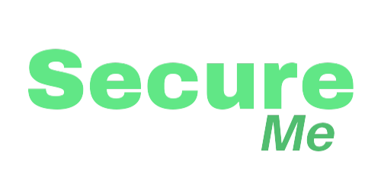

**Jasper Haas**

has earned the

SecureMe Online Safety Certification

on

*October 17, 2024*

Program Director