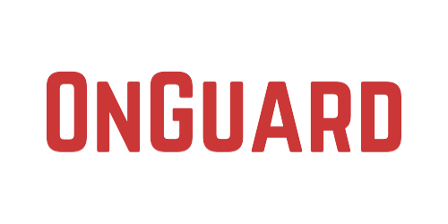

**Jasper Haas**

has earned the

OnGuard Online Safety Certification

on

*none*

Program Director