PHENIKAA UNIVERSITY
FACULTY OF ELECTRICAL AND ELECTRONIC ENGINEERING
ADVANCED DEEP LEARNING COURSE
FACIAL EMOTION RECOGNITION
Midterm Report
Full name: Nguyễn Quang Trung
Student ID: 22011211
Advisor: Ph.D Minhhuy Le
Hanoi, October 6, 2026

ADVANCED DEEP LEARNING COURSE REPORT
Abstract
Facial emotion recognition (FER) from still images supports human–computer interaction, driver monitoring and affective computing, but it remains difficult on small, in-the-wild faces. In this midterm study we build a clean and exactly balanced seven-class dataset of 53,088 grayscale 48×48 face images from four sources (a FER2013-style local set, RAF-DB, AffectNet and CK+), remove near-duplicate images that leaked across the training, validation and test splits, and split CK+ by subject. We design EmotionCNN, a 4.7 M-parameter convolutional network with batch normalization, dropout and dilated convolutions trained from scratch, and compare it with two ImageNet-pretrained networks fine-tuned end to end, ResNet18 and MobileNetV2. Every model is trained with three random seeds and evaluated once on a held-out test set of 1,351 images. EmotionCNN reaches 68.0 ± 1.0% accuracy (macro-F1 0.679), on par with ResNet18 (68.3 ± 1.0%) and MobileNetV2 (67.8 ± 0.9%), while needing only 13.5 ms per image on a laptop CPU. Averaging the nine trained models raises the test accuracy to 71.8%. Accuracy ranges from 91% on laboratory-posed CK+ faces to 62% on the noisy FER2013-style images, and fear is the hardest emotion (F1 0.52), mostly confused with surprise. These results suggest that label noise, more than model capacity, now limits performance, which motivates relabeling with FER+ annotations, Grad-CAM analysis and a real-time webcam application in the final report.

Table of Contents
Chapter 1. INTRODUCTION 5
1.1. Project Definition 5
1.2. Project Objective 5
Chapter 2. LITERATURE REVIEW 5
2.1. Project Background 5
2.1.1. Convolutional Neural Networks 5
2.1.2. Batch Normalization and Dropout 6
2.1.3. Dilated Convolution 6
2.1.4. Residual and Efficient Architectures 6
2.1.5. Transfer Learning and Training Objective 6
2.2. Related Works 7
Chapter 3. SOLUTIONS/ METHODS 7
3.1. Dataset 7
3.2. Network Architecture 9
3.3. Experiments 11
Chapter 4. RESULTS AND DISCUSSION 12
4.1. Learning Behaviour 12
4.2. Test Performance 12
4.3. Ensemble and Test-Time Augmentation 13
4.4. Error Analysis 14
4.5. Comparison with Published Results 16
Chapter 5. CONCLUSION AND RECOMMENDATION 17
5.1. Conclusion 17
5.2. Recommendation 17
REFERENCES 17

List of Figures
Fig. 1 Example test images of each emotion and their source 8
Fig. 2 Number of images per emotion and source in each split 9
Fig. 3 Architecture of EmotionCNN 10
Fig. 4 Learning curves of the three models (seed 42); the dotted line marks the best validation epoch 12
Fig. 5 Test accuracy of the three models (mean ± std over 3 seeds) and of the 9-run ensemble 13
Fig. 6 Row-normalized confusion matrices on the test set (%); single models sum the three seeds 14
Fig. 7 F1 per emotion (a) and accuracy per image source (b) on the test set 15
Fig. 8 Correct predictions of the ensemble with their confidence p 15
Fig. 9 Incorrect predictions of the ensemble (true label, predicted label, confidence p) 16

List of Tables
Table. 1 IMAGE SOURCES (ORIGINAL IMAGES, ALL SPLITS) 7
Table. 2 TRAIN / VALIDATION / TEST SPLIT 8
Table. 3 DETAILED STRUCTURE OF EMOTIONCNN 10
Table. 4 THE THREE MODELS 10
Table. 5 TRAINING SETTINGS 11
Table. 6 TEST RESULTS (MEAN ± STD OVER 3 SEEDS) 12
Table. 7 ENSEMBLES ON THE TEST SET (AVERAGED SOFTMAX OUTPUTS) 13
Table. 8 COMPARISON WITH PUBLISHED RESULTS (APPROXIMATE, DIFFERENT PROTOCOLS) 16

Chapter 1. INTRODUCTION

1.1. Project Definition
Facial expressions are one of the most direct signals of a person's emotional state. Recognizing them automatically enables applications such as adaptive human–computer interfaces, driver drowsiness and distraction monitoring, e-learning engagement analysis and mental-health screening. The task is usually framed as classifying a face image into the seven basic emotions: angry, disgust, fear, happy, neutral, sad and surprise.
Although deep convolutional networks have made FER practical, faces captured in the wild vary strongly in pose, illumination, occlusion, age and image quality. Public datasets also differ widely: laboratory datasets such as CK+ contain posed, frontal expressions, while web-collected datasets such as FER2013 contain small 48×48 grayscale images whose labels are known to be noisy. A reliable FER system therefore depends as much on careful data preparation and honest evaluation as on the network architecture.

1.2. Project Objective
The midterm phase of the project focuses on building a sound baseline before the real-time application of the final phase. Its objectives are:
- to build a clean, exactly balanced and leakage-free seven-class dataset from several public sources;
- to design and train a convolutional network from scratch (EmotionCNN) using the techniques of the course: batch normalization, dropout and dilated convolutions;
- to compare it with two transfer-learning baselines, ResNet18 and MobileNetV2, under one reproducible protocol: three random seeds, a bootstrap confidence interval, and a test set that is used only once per final model;
- to analyze the remaining errors per emotion and per image source, in order to decide what the final phase should improve.

Chapter 2. LITERATURE REVIEW

2.1. Project Background

2.1.1. Convolutional Neural Networks
A convolutional layer slides a set of learnable kernels over its input and computes, at every position, the weighted sum of the covered values [6], [7]. For an input x with C channels and the k-th kernel W_{k} of size K×K, the output feature map is:
y_{k}(i, j) = Σ_{c} Σ_{m} Σ_{n} W_{k}(m, n, c) · x(i + m, j + n, c) + b_{k} (1)
Weight sharing makes the layer translation-equivariant and far cheaper than a fully connected layer. Each convolution is followed by the non-linearity ReLU and, periodically, by max pooling, which halves the spatial resolution and enlarges the receptive field:
ReLU(z) = max(0, z) (2)

2.1.2. Batch Normalization and Dropout
Batch normalization [8] normalizes every channel with the mean μ_{B} and variance σ²_{B} of the mini-batch and then rescales it with learnable parameters γ and β. It stabilizes and speeds up training and allows larger learning rates:
x̂ = (x − μ_{B}) / √(σ²_{B} + ε), y = γ · x̂ + β (3)
Dropout [9] randomly sets activations to zero during training with probability p, which prevents co-adaptation of neurons and acts as an ensemble of thinned networks. Spatial dropout (Dropout2d) drops whole feature maps, which suits convolutional layers:
h̃ = (m ⊙ h) / (1 − p), m ~ Bernoulli(1 − p) (4)

2.1.3. Dilated Convolution
A dilated convolution [10] inserts gaps of size r between the kernel taps. With the same number of weights it covers a (K + (K − 1)(r − 1))-wide region, so the receptive field grows without further pooling and without losing resolution:
y(i, j) = Σ_{m} Σ_{n} W(m, n) · x(i + r·m, j + r·n) (5)

2.1.4. Residual and Efficient Architectures
ResNet [11] learns a residual function F on top of an identity shortcut, which keeps gradients flowing through very deep networks:
y = F(x, {W_{i}}) + x (6)
MobileNetV2 [12] replaces standard convolutions with depthwise separable convolutions inside inverted residual blocks with linear bottlenecks. For a K×K kernel and N output channels, the computational cost relative to a standard convolution is:
cost ratio = 1/N + 1/K² (7)
so a 3×3 depthwise separable layer is roughly 8–9 times cheaper. This makes MobileNetV2 a natural candidate for real-time applications on a CPU.

2.1.5. Transfer Learning and Training Objective
Networks pretrained on ImageNet [13] already contain generic edge, texture and shape detectors; fine-tuning them on a target task usually converges faster than training from scratch. The network outputs logits z, turned into class probabilities by the softmax function, and is trained with cross-entropy against label-smoothed targets q [14], which discourages over-confident predictions:
p_{k} = exp(z_{k}) / Σ_{j} exp(z_{j}) (8)
L = − Σ_{k} q_{k} · log p_{k}, q_{k} = (1 − ε) · 1[k = y] + ε / K (9)
We optimize with AdamW [15], which decouples weight decay from the gradient update, and a cosine learning-rate schedule [16] after a short linear warm-up:
η_{t} = η_{min} + ½ (η_{max} − η_{min}) (1 + cos(π t / T)) (10)

2.2. Related Works
Early FER systems relied on hand-crafted descriptors such as local binary patterns [22], [25] or histograms of oriented gradients [23], followed by a support vector machine. They work well on posed laboratory data such as CK+ [4], where accuracies above 95% are commonly reported, but degrade on spontaneous, in-the-wild faces.
The FER2013 challenge [1] introduced 35,887 web-collected 48×48 grayscale faces; its organizers estimated human accuracy at about 65 ± 5%, reflecting both ambiguous expressions and noisy labels. Convolutional networks quickly surpassed this level: a tuned VGG-style network reaches 73.3% on the FER2013 test set [18], and ensembles of several CNNs reach about 75% [19]. Microsoft's FER+ [5] relabeled every FER2013 image with ten annotators, and training on the resulting majority or distribution labels gives markedly higher accuracy, which shows how much label noise limits FER2013.
Larger in-the-wild datasets followed. RAF-DB [2] provides about 15,000 crowd-annotated color images, on which transformer-based models such as POSTER++ [20] reach about 92% accuracy. AffectNet [3] contains more than one million web images; on its balanced seven-class validation set the best methods reach only about 67%, again illustrating how hard spontaneous expressions are. Most recent methods use high-resolution color images and large backbones pretrained on face recognition; our study instead targets small grayscale faces and models that can run in real time on a laptop.

Chapter 3. SOLUTIONS/ METHODS

3.1. Dataset
The dataset combines four sources of 48×48 grayscale face crops (Table. 1). All images are already aligned face crops, so no face detector is needed for training. Fig. 1 shows typical examples of each emotion.
Table. 1 IMAGE SOURCES (ORIGINAL IMAGES, ALL SPLITS)
Source | Type | Images | Emotions covered
local (FER2013-style) | In the wild, 48×48, noisy labels | 15,198 | all 7
RAF-DB [2] | In the wild, crowd-annotated | 9,979 | all 7
AffectNet [3] | In the wild | 3,133 | angry, disgust, fear
CK+ [4] | Posed, laboratory, 106 subjects | 922 | all except neutral
Total |  | 29,232

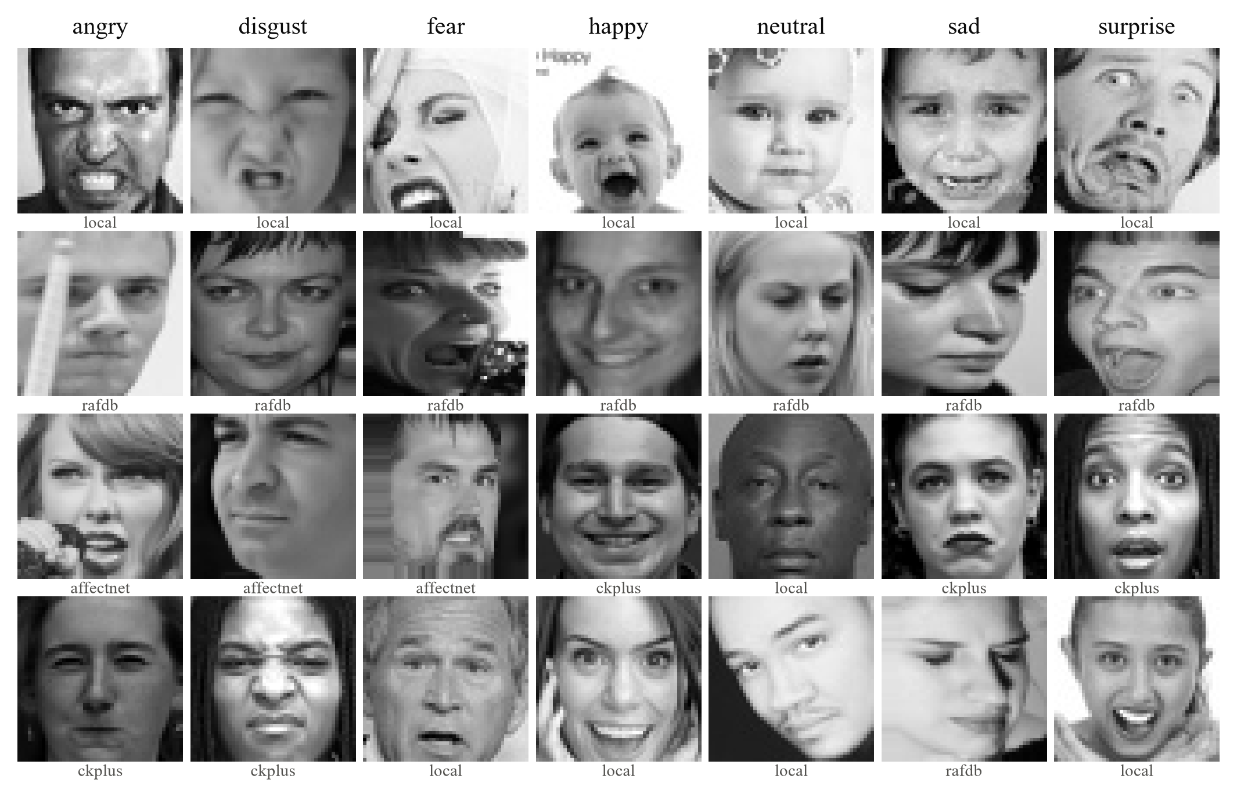
Fig. 1 Example test images of each emotion and their source
Cleaning and splitting. A first inspection revealed validation and test images that were near copies of training images (the same photograph re-cropped or re-exposed, hence a different file hash). Such leakage inflates the measured accuracy. We detected copies with a 64-bit difference hash (dHash) and confirmed them with the normalized cross-correlation of the pixels; 282 copies were moved out of the validation and test splits (not deleted), and 306 further images were trimmed at random so that every emotion keeps the same count. CK+ images were assigned to the splits by subject (84, 16 and 6 people for training, validation and test), so that no person appears in two splits. After cleaning, no exact, mirrored or near copy remains across splits.
Table. 2 TRAIN / VALIDATION / TEST SPLIT
Split | Original images | Augmented copies | Total | Per emotion
Train | 23,856 | 23,856 | 47,712 | 6,816
Validation | 4,025 | – | 4,025 | 575
Test | 1,351 | – | 1,351 | 193

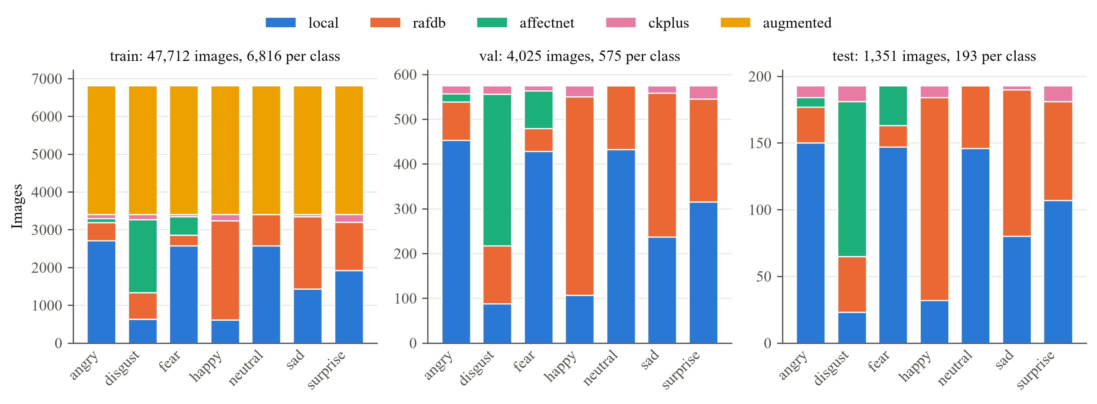
Fig. 2 Number of images per emotion and source in each split
Every split is exactly balanced (Fig. 2), so no emotion dominates the accuracy and no class weighting is needed. The validation split is used for all choices of the training recipe and of the checkpoint; the test split is used only once per final model.
Pre-processing and augmentation. Images are kept in grayscale. During training each image goes through a random resized crop (scale 0.85–1.0), horizontal flip (p = 0.5), rotation of up to 10°, brightness and contrast jitter of ±30% and random erasing (p = 0.25). Each training original also has one offline-augmented copy. The transforms run on the CPU at 48×48; each batch is then upsampled on the GPU to the model input size (96×96 for EmotionCNN, 224×224 for the pretrained networks).

3.2. Network Architecture
EmotionCNN (Fig. 3, Table. 3) is a compact VGG-style network designed for 48×48 faces. Four blocks of two 3×3 convolutions with batch normalization and ReLU extract increasingly abstract features; the first three blocks halve the resolution with max pooling, while the last block uses dilated convolutions (r = 2) to enlarge the receptive field to the whole face without further down-sampling. Spatial dropout grows from 0.10 to 0.25 with depth, and global average pooling followed by dropout 0.5 and a linear layer produces the seven class scores. Convolutions are initialized with Kaiming initialization [17].
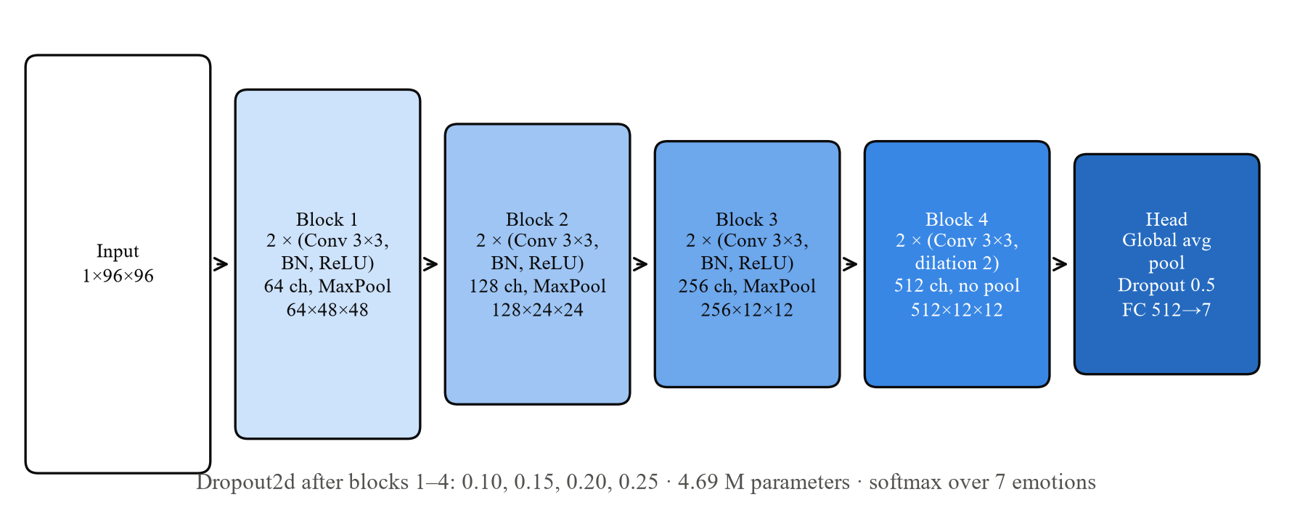
Fig. 3 Architecture of EmotionCNN
Table. 3 DETAILED STRUCTURE OF EMOTIONCNN
Stage | Layers | Output size
Input | Grayscale face, upsampled 48 → 96 | 1 × 96 × 96
Block 1 | [Conv 3×3 (64), BN, ReLU] × 2, MaxPool 2, Dropout2d 0.10 | 64 × 48 × 48
Block 2 | [Conv 3×3 (128), BN, ReLU] × 2, MaxPool 2, Dropout2d 0.15 | 128 × 24 × 24
Block 3 | [Conv 3×3 (256), BN, ReLU] × 2, MaxPool 2, Dropout2d 0.20 | 256 × 12 × 12
Block 4 | [Conv 3×3 (512), dilation 2, BN, ReLU] × 2, Dropout2d 0.25 | 512 × 12 × 12
Head | Global average pooling, Dropout 0.5, FC 512 → 7, softmax | 7
Parameters | 4,689,735 trainable (17.9 MB)

Transfer-learning baselines. ResNet18 [11] and MobileNetV2 [12] are initialized with ImageNet weights; their classifier is replaced by dropout 0.5 and a seven-way linear layer, and the grayscale input is replicated to three channels. They are fine-tuned in two stages: stage A trains only the new classifier for 3 epochs, then stage B fine-tunes the whole network for 20 epochs with layer-wise learning rates, small for the early generic layers and larger for the last block and the classifier (Table. 4). Fine-tuning every layer lets the low-level filters adapt to small grayscale faces, which differ strongly from ImageNet photographs.
Table. 4 THE THREE MODELS
Model | Pre-training | Input | Parameters | Trained layers
EmotionCNN | None (from scratch) | 1 × 96 × 96 | 4.69 M | All layers, 40 epochs
ResNet18 | ImageNet | 3 × 224 × 224 | 11.18 M | Classifier (3 epochs), then all layers (20 epochs)
MobileNetV2 | ImageNet | 3 × 224 × 224 | 2.23 M | Classifier (3 epochs), then all layers (20 epochs)

3.3. Experiments
Implementation details. All models share one PyTorch training loop driven by configuration files (Table. 5). Training ran on a laptop with an NVIDIA GeForce RTX 3050 Laptop GPU (4 GB), an Intel Core i5-11400H CPU and 16 GB of RAM, using mixed precision. One run takes about 50 minutes for EmotionCNN, 37 minutes for ResNet18 and 39 minutes for MobileNetV2. Early stopping was disabled: every run follows its full cosine schedule and the checkpoint with the best validation macro-F1 is kept, because stopping on a noisy validation curve often ended runs before the low-learning-rate phase in which the models still improved.
Table. 5 TRAINING SETTINGS
Setting | EmotionCNN | ResNet18 / MobileNetV2
Optimizer | AdamW | AdamW
Learning rate | 1 × 10⁻³ | Stage A 1 × 10⁻³; stage B 5 × 10⁻⁴ (classifier), 1 × 10⁻⁴ (last block), 3–5 × 10⁻⁵ (middle), 2 × 10⁻⁵ (early layers)
Weight decay | 5 × 10⁻⁴ | 5 × 10⁻²
Batch size | 64 | 32
Epochs | 40 | 3 + 20
Schedule | 1-epoch linear warm-up, cosine decay to 1 × 10⁻⁶ (per stage) | same
Loss | Cross-entropy, label smoothing 0.1 | same
Other | Gradient clipping 5.0, mixed precision, best validation macro-F1 checkpoint | same
Seeds | 42, 123, 2024 | 42, 123, 2024

Evaluation protocol. We report accuracy and macro-F1 (the unweighted mean of the seven per-class F1 scores, so that no emotion is neglected) as the mean ± standard deviation over the three seeds. The 95% confidence interval of each test score is estimated with 1,000 bootstrap resamples of the test set [24]. Inference time is measured with batch size 1 (20 warm-up and 200 timed passes) on the CPU and on the GPU. Ensembles and horizontal-flip test-time augmentation (TTA) were fixed before the test set was used and are reported separately from the single models.

Chapter 4. RESULTS AND DISCUSSION

4.1. Learning Behaviour
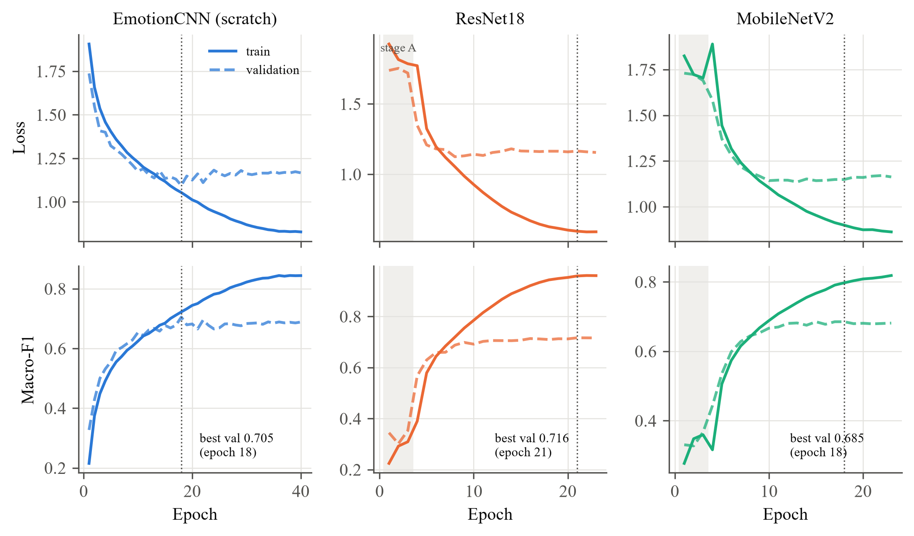
Fig. 4 Learning curves of the three models (seed 42); the dotted line marks the best validation epoch
Fig. 4 shows that all three models converge smoothly. EmotionCNN's training and validation curves stay close until about epoch 18, where it reaches its best validation macro-F1 (0.705); afterwards the training F1 keeps rising to 0.84 while the validation F1 levels off around 0.69, a mild overfitting that the best-checkpoint rule absorbs. The pretrained networks gain little in stage A (shaded): with frozen ImageNet features the validation macro-F1 stays near 0.35, which confirms that the features must be fine-tuned for small grayscale faces. In stage B, ResNet18 fits the training set almost perfectly (training F1 0.96) while its validation F1 settles near 0.71, the largest generalization gap of the three models.

4.2. Test Performance
Table. 6 TEST RESULTS (MEAN ± STD OVER 3 SEEDS)
Model | Params | Val. macro-F1 | Test accuracy (%) | Test macro-F1 | 95% CI (macro-F1) | CPU ms/img | GPU ms/img
EmotionCNN | 4.69 M | 0.700 | 68.0 ± 1.0 | 0.679 ± 0.012 | 0.654 – 0.702 | 13.5 | 1.5
ResNet18 | 11.18 M | 0.711 | 68.3 ± 1.0 | 0.683 ± 0.010 | 0.658 – 0.706 | 18.2 | 2.9
MobileNetV2 | 2.23 M | 0.684 | 67.8 ± 0.9 | 0.678 ± 0.009 | 0.653 – 0.701 | 13.0 | 5.9

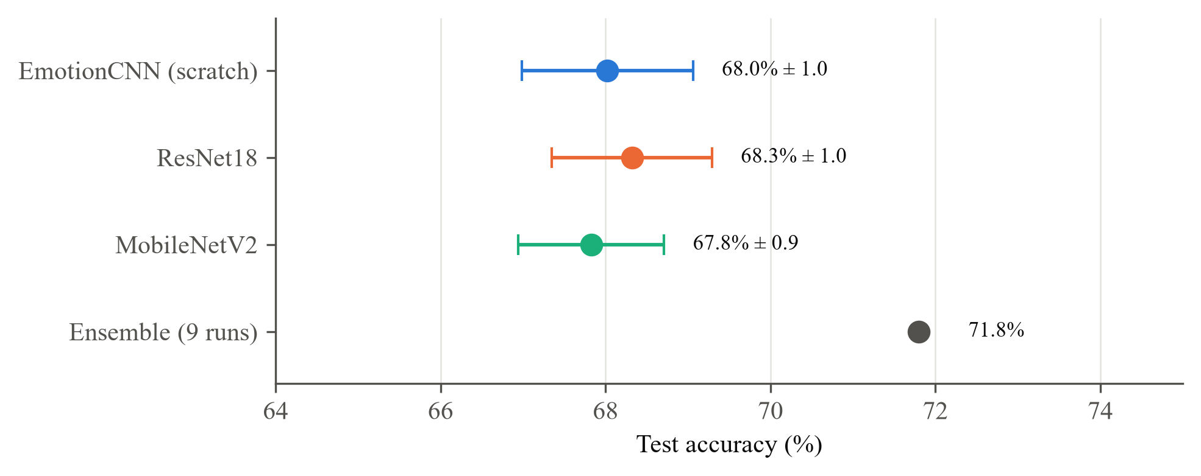
Fig. 5 Test accuracy of the three models (mean ± std over 3 seeds) and of the 9-run ensemble
The three models reach almost the same test accuracy (Table. 6, Fig. 5): the differences, below 0.5 percentage points, are smaller than the seed-to-seed standard deviation, and the bootstrap confidence intervals overlap almost entirely. The custom EmotionCNN trained from scratch therefore matches the two ImageNet-pretrained networks on this task, with 2.4 times fewer parameters than ResNet18. Test scores are about 2 points lower than validation scores, as expected, since the checkpoints were selected on the validation split. All models are fast enough for real-time use: 13–18 ms per image on the CPU, i.e. more than 50 frames per second.

4.3. Ensemble and Test-Time Augmentation
Table. 7 ENSEMBLES ON THE TEST SET (AVERAGED SOFTMAX OUTPUTS)
Ensemble | Runs | TTA | Accuracy (%) | Macro-F1
ResNet18, 3 seeds | 3 | yes | 72.4 | 0.723
All models, all seeds | 9 | yes | 71.9 | 0.717
All models, all seeds | 9 | no | 71.8 | 0.716
EmotionCNN, 3 seeds | 3 | no | 69.6 | 0.694
MobileNetV2, 3 seeds | 3 | yes | 69.4 | 0.693
Single model (mean) | 1 | no | 68.0 | 0.679

Averaging the softmax outputs of the nine trained models raises the test accuracy from 68.0% to 71.8% (95% CI 69.4–74.3%), because the models make partly different mistakes (Table. 7). Horizontal-flip TTA adds up to 1 more point for the pretrained models, but slightly lowers EmotionCNN (69.6% → 69.3%). These ensembles are reported separately; a real-time application would use a single model or a small ensemble.

4.4. Error Analysis
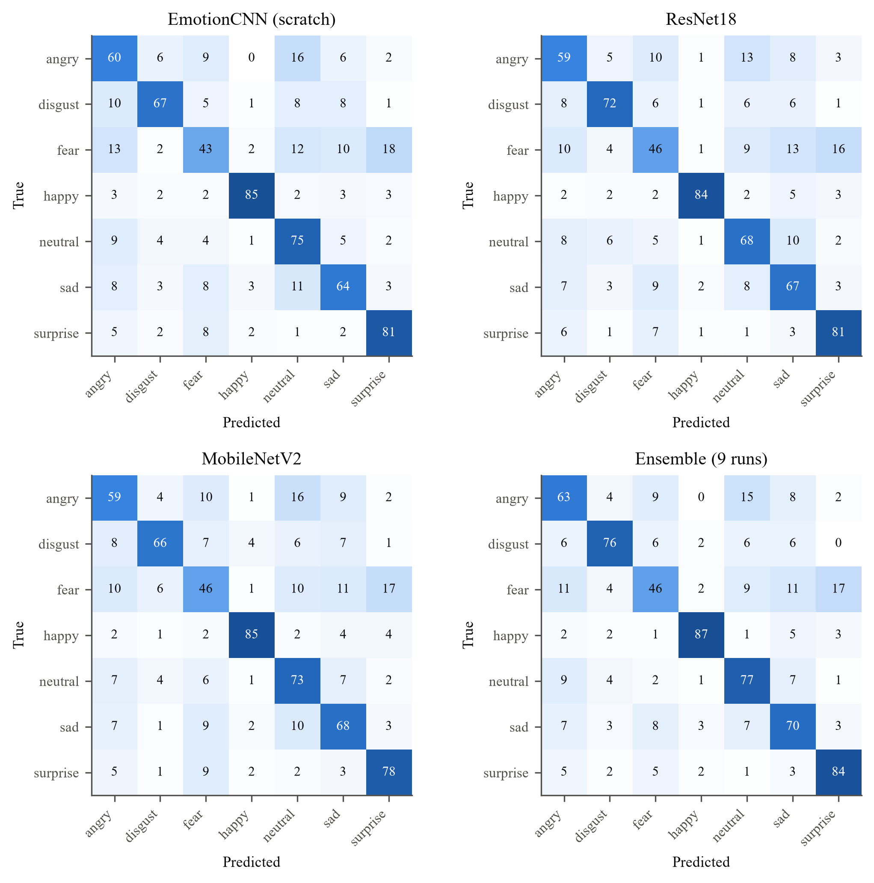
Fig. 6 Row-normalized confusion matrices on the test set (%); single models sum the three seeds
The confusion matrices (Fig. 6) show the same pattern for every model. Happy and surprise are recognized best (above 80%), while fear is the weakest emotion: only 43–46% of fear images are classified correctly, and 16–18% of them are taken for surprise, since both expressions open the eyes and the mouth. Angry is often predicted as neutral (13–16%), because a mild frown differs from a neutral face mostly in the eyebrows.
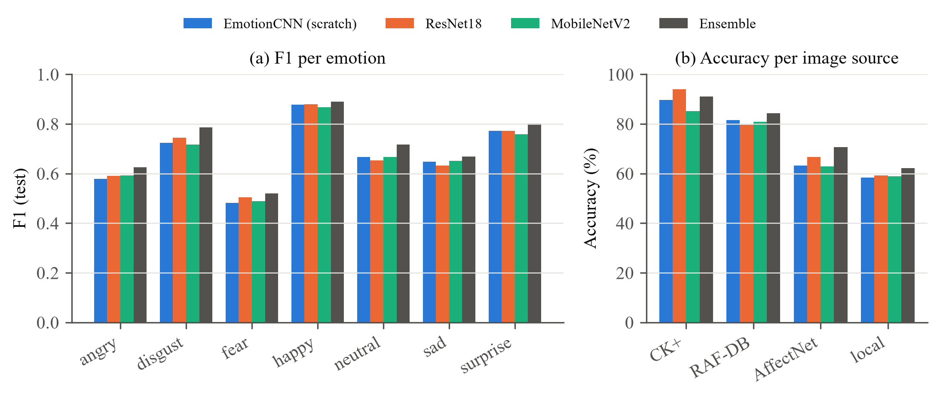
Fig. 7 F1 per emotion (a) and accuracy per image source (b) on the test set
Accuracy depends strongly on the image source (Fig. 7b): the ensemble reaches 91.1% on posed CK+ faces (45 test images only), 84.4% on RAF-DB and 70.6% on AffectNet, but only 62.2% on the FER2013-style local images, which make up half of the test set. The local images are the smallest, blurriest and most noisily labeled, so they bound the overall accuracy.
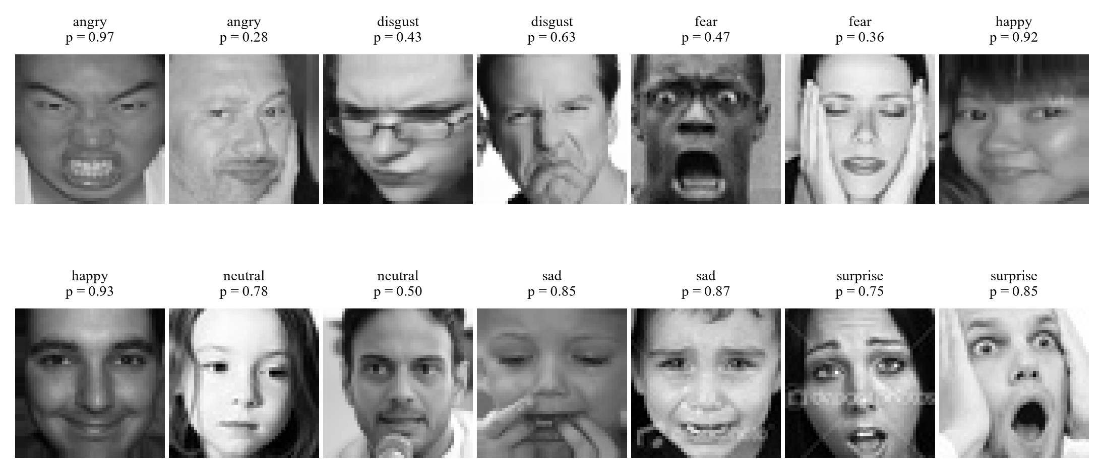
Fig. 8 Correct predictions of the ensemble with their confidence p
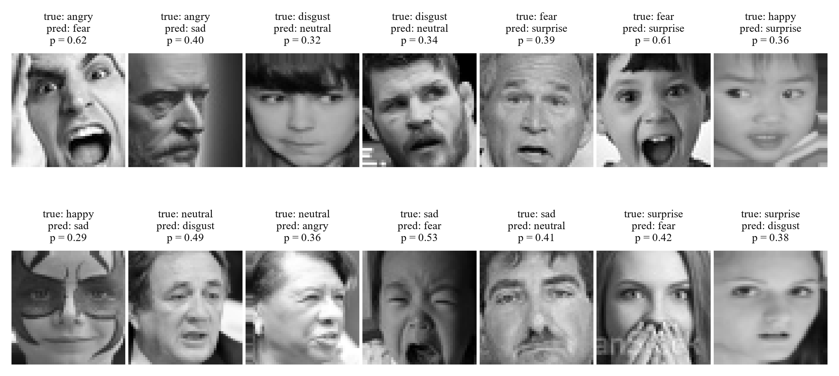
Fig. 9 Incorrect predictions of the ensemble (true label, predicted label, confidence p)
Correct predictions usually show a clear, typical expression, and 45% of them are made with a confidence above 0.8 (Fig. 8). Errors are mostly uncertain: 56% of the misclassified test images receive a confidence below 0.5 (Fig. 9). Several of them are genuinely ambiguous, for example a sad face crying with an open mouth predicted as fear, a surprised face with both hands over the mouth predicted as fear, or a weak smile under face paint. Some labels themselves are debatable, which is consistent with the known label noise of FER2013.

4.5. Comparison with Published Results
Table. 8 COMPARISON WITH PUBLISHED RESULTS (APPROXIMATE, DIFFERENT PROTOCOLS)
Dataset | Image type | Best published | This work (ensemble, test)
CK+ [4] | Posed, laboratory | > 95% | 91.1% (45 images, 6 subjects)
RAF-DB [2] | In the wild, color | ≈ 92% [20] | 84.4% (grayscale 48×48)
FER2013 [1] | In the wild, 48×48 grayscale | 73.3% single [18], ≈ 75% ensemble [19]; human ≈ 65% [1] | 62.2% (local FER2013-style images)
AffectNet [3] | In the wild | ≈ 67% (7 classes) [20] | 70.6% (3 emotions only, not comparable)

Table. 8 places the results in context. The published numbers come from different protocols, image resolutions and backbones, so the comparison is only indicative. On each source our models stay within roughly 7–12 points of the best published methods while using small grayscale images and models that run in real time on a laptop. The very high accuracies often quoted for FER (above 90%) hold for posed laboratory datasets; on in-the-wild faces, and on FER2013-style images in particular, accuracies around 70% are typical.

Chapter 5. CONCLUSION AND RECOMMENDATION

5.1. Conclusion
This midterm study built a clean, exactly balanced and leakage-free seven-class FER dataset of 53,088 grayscale images from four sources, and used it to train and compare three networks under one reproducible protocol. The custom EmotionCNN, trained from scratch with batch normalization, spatial dropout and dilated convolutions, reaches 68.0 ± 1.0% test accuracy and a macro-F1 of 0.679, statistically on par with fine-tuned ResNet18 (68.3%) and MobileNetV2 (67.8%), while having 2.4 times fewer parameters than ResNet18 and running in 13.5 ms per image on a CPU. Averaging the nine trained models raises the accuracy to 71.8%.
The error analysis shows that the remaining errors are concentrated on fear (F1 0.52), which is confused with surprise, and on the FER2013-style images, where accuracy is 62% against 84–91% on RAF-DB and CK+. Most errors are low-confidence predictions on ambiguous or debatably labeled faces, which indicates that label noise, rather than model capacity, is now the main limit.

5.2. Recommendation
For the final report we recommend the following steps, in order of expected benefit:
- Relabel the FER2013-style images with FER+ annotations [5]. Ten annotators per image allow wrong labels to be corrected and ambiguous images to be removed; this targets the largest and weakest part of the data.
- Explain the predictions with Grad-CAM [21]. Visualizing which facial regions drive each decision will show whether the models attend to the eyes, eyebrows and mouth, and may explain the fear–surprise confusion.
- Build the real-time webcam application. With 13 ms per image on a CPU, EmotionCNN or MobileNetV2 should run at about 30 frames per second including face detection, with temporal smoothing of the predictions to avoid flickering labels.
- Add more data for the weakest emotions, for example additional fear and disgust images, or the JAFFE dataset once access is granted by its authors.

REFERENCES
- I. J. Goodfellow et al., "Challenges in representation learning: A report on three machine learning contests," in Proc. ICONIP, 2013, pp. 117–124.
- S. Li, W. Deng, and J. Du, "Reliable crowdsourcing and deep locality-preserving learning for expression recognition in the wild," in Proc. IEEE CVPR, 2017, pp. 2852–2861.
- A. Mollahosseini, B. Hasani, and M. H. Mahoor, "AffectNet: A database for facial expression, valence, and arousal computing in the wild," IEEE Trans. Affective Computing, vol. 10, no. 1, pp. 18–31, 2019.
- P. Lucey, J. F. Cohn, T. Kanade, J. Saragih, Z. Ambadar, and I. Matthews, "The Extended Cohn-Kanade dataset (CK+): A complete dataset for action unit and emotion-specified expression," in Proc. IEEE CVPR Workshops, 2010, pp. 94–101.
- E. Barsoum, C. Zhang, C. C. Ferrer, and Z. Zhang, "Training deep networks for facial expression recognition with crowd-sourced label distribution," in Proc. ACM ICMI, 2016, pp. 279–283.
- Y. LeCun, L. Bottou, Y. Bengio, and P. Haffner, "Gradient-based learning applied to document recognition," Proc. IEEE, vol. 86, no. 11, pp. 2278–2324, 1998.
- A. Krizhevsky, I. Sutskever, and G. E. Hinton, "ImageNet classification with deep convolutional neural networks," in Advances in Neural Information Processing Systems 25, 2012.
- S. Ioffe and C. Szegedy, "Batch normalization: Accelerating deep network training by reducing internal covariate shift," in Proc. ICML, 2015, pp. 448–456.
- N. Srivastava, G. Hinton, A. Krizhevsky, I. Sutskever, and R. Salakhutdinov, "Dropout: A simple way to prevent neural networks from overfitting," J. Machine Learning Research, vol. 15, no. 1, pp. 1929–1958, 2014.
- F. Yu and V. Koltun, "Multi-scale context aggregation by dilated convolutions," in Proc. ICLR, 2016.
- K. He, X. Zhang, S. Ren, and J. Sun, "Deep residual learning for image recognition," in Proc. IEEE CVPR, 2016, pp. 770–778.
- M. Sandler, A. Howard, M. Zhu, A. Zhmoginov, and L.-C. Chen, "MobileNetV2: Inverted residuals and linear bottlenecks," in Proc. IEEE CVPR, 2018, pp. 4510–4520.
- J. Deng, W. Dong, R. Socher, L.-J. Li, K. Li, and L. Fei-Fei, "ImageNet: A large-scale hierarchical image database," in Proc. IEEE CVPR, 2009, pp. 248–255.
- C. Szegedy, V. Vanhoucke, S. Ioffe, J. Shlens, and Z. Wojna, "Rethinking the Inception architecture for computer vision," in Proc. IEEE CVPR, 2016, pp. 2818–2826.
- I. Loshchilov and F. Hutter, "Decoupled weight decay regularization," in Proc. ICLR, 2019.
- I. Loshchilov and F. Hutter, "SGDR: Stochastic gradient descent with warm restarts," in Proc. ICLR, 2017.
- K. He, X. Zhang, S. Ren, and J. Sun, "Delving deep into rectifiers: Surpassing human-level performance on ImageNet classification," in Proc. IEEE ICCV, 2015, pp. 1026–1034.
- Y. Khaireddin and Z. Chen, "Facial emotion recognition: State of the art performance on FER2013," arXiv preprint arXiv:2105.03588, 2021.
- C. Pramerdorfer and M. Kampel, "Facial expression recognition using convolutional neural networks: State of the art," arXiv preprint arXiv:1612.02903, 2016.
- J. Mao, R. Xu, X. Yin, Y. Chang, B. Nie, and A. Huang, "POSTER++: A simpler and stronger facial expression recognition network," arXiv preprint arXiv:2301.12149, 2023.
- R. R. Selvaraju, M. Cogswell, A. Das, R. Vedantam, D. Parikh, and D. Batra, "Grad-CAM: Visual explanations from deep networks via gradient-based localization," in Proc. IEEE ICCV, 2017, pp. 618–626.
- T. Ojala, M. Pietikäinen, and T. Mäenpää, "Multiresolution gray-scale and rotation invariant texture classification with local binary patterns," IEEE Trans. PAMI, vol. 24, no. 7, pp. 971–987, 2002.
- N. Dalal and B. Triggs, "Histograms of oriented gradients for human detection," in Proc. IEEE CVPR, 2005, pp. 886–893.
- B. Efron and R. J. Tibshirani, An Introduction to the Bootstrap. New York: Chapman & Hall, 1993.
- C. Shan, S. Gong, and P. W. McOwan, "Facial expression recognition based on local binary patterns: A comprehensive study," Image and Vision Computing, vol. 27, no. 6, pp. 803–816, 2009.

