PHENIKAA UNIVERSITY
FACULTY OF ELECTRICAL AND ELECTRONIC ENGINEERING

ADVANCED DEEP LEARNING COURSE

REAL-TIME FACIAL EMOTION RECOGNITION FOR MEDICAL AND ARTISTIC APPLICATIONS
STUDENTS:
22011211 – Nguyễn Quang Trung
22011103 – Nguyễn Tiến Thành

Advisor: Ph.D Minhhuy Le
Hanoi, November 2026

ADVANCED DEEP LEARNING COURSE REPORT

Team
Nguyễn Quang Trung – 22011211
Nguyễn Tiến Thành – 22011103

Advisor Sponsor
Ph.D Minhhuy Le None

Abstract

Recognizing facial expressions of emotion helps clinicians follow the emotional state of patients who cannot easily say how they feel, and helps film and theatre professionals judge acting and find the emotional moments of long recordings. Doing this by eye is slow and subjective, public models are trained mostly on Western faces, and cloud services are a privacy problem for patient video. This project builds a real-time facial emotion recognition system for Vietnamese faces that runs entirely on a consumer laptop. Faces are found with YuNet, aligned to a landmark template measured on the CK+ dataset, and classified into seven classes (angry, disgust, fear, happy, neutral, sad, surprise) by a convolutional network that reads a 48×48 grayscale crop. Three networks were compared over three seeds each (EmotionCNN trained from scratch, ResNet-18 and MobileNetV2). On the 53,088-image course dataset ResNet-18 reached 68.3 ± 1.0% test accuracy, and in subject-independent 10-fold cross-validation on CK+ it reached 94.3%. A new dataset of 16,550 faces of 352 people was extracted from Vietnamese TV dramas and split by person. Its labels are still suggestions of public models, so results on it are reported as agreement (83.6%), not accuracy. A ResNet-18 trained only on these TV faces reached 53.4% on human-labeled RAF-DB test faces; adding the course dataset's human-labeled faces raised this to 79.4 ± 0.9% (macro-F1 0.713) and surprise recall from 11% to 81%. The final model drives a browser application that opens any video or image, seeks and jumps to any time, keeps the user's time marks and scans a whole film for its strongest emotional moments, at 13–17 analyzed frames per second on 1080p video. Human review of the TV labels and pilot studies with clinicians and artists are the next steps.
Keywords: facial expression recognition, transfer learning, ResNet-18, Vietnamese faces, affective computing, healthcare, film analysis, real-time application.

Table of Contents
1. Problem situation and Problem definition 7
1.1. Problem situation 7
1.2. Problem definition 8
2. State of art 9
2.1. Existing products/solutions 9
2.2. Scientific/engineering publication/whitepapers 9
3. Objectives 11
3.1. General objectives 11
3.2. Specific objectives 11
4. Proposed solution 12
4.1. Description of proposed solution/design 12
4.1.1. Block diagram 12
4.1.2. Operation description 13
4.1.3. Proposed devices and components 15
4.2. Solution limitations 15
4.3. Expected results 16
4.4. Design approach and implementation methodology 16
5. Potential impact and consideration 19
5.1. Technical viability 19
5.2. Economic feasibility 19
5.3. Social viability 19
5.4. Operational viability 19
5.5. Environmental feasibility 20
5.6. Alternatives solution/approach 20
5.7. Codes of ethics (IEEE) 20
6. Weekly project development schedule 22
6.1. Member roles 22
6.2. Schedule and plan 22
7. Project progress 24
7.1. Topic 1: Datasets 24
7.1.1. Theoretical basis 24
7.1.2. Calculation/analysis 24
7.1.3. Results 26
7.2. Topic 2: Models, training and transfer 27
7.2.1. Theoretical basis 27
7.2.2. Calculation/analysis 28
7.2.3. Results 28
7.3. Topic 3: Real-time application 30
7.3.1. Theoretical basis 30
7.3.2. Calculation/analysis 31
7.3.3. Results 31
8. Results and Discussion 34
8.1. Results 34
8.2. Evaluation 36
8.3. Discussion 36
9. Risk analysis 38
9.1. Risk factor inputs 38
9.1.1. Risk factors 38
9.1.2. Probability and impact scales 38
9.2. Risk analysis method 38
9.2.1. Scenarios method 38
9.2.2. Risk score matrix 39
9.3. Risk analysis result 40
9.3.1. Levels of risks 40
9.3.2. List of priority risks 40
10. Financial and economic report 41
11. Conclusions 42
12. Standards 43
13. References 44
14. Appendices 48

List of Figures
Figure 1: Block diagram of the application and its intended uses 12
Figure 2: Training path: ImageNet → CK+ → target data (stages A–E of Chapter 8) 13
Figure 3: Project schedule (2026): done (blue) and planned (hatched) 22
Figure 4: Construction of the Vietnamese TV face dataset 25
Figure 5: Aligned 48×48 VTV test faces per suggested class (random sample) 26
Figure 6: CK+ cross-validation confusion matrix of ResNet-18 (all seeds pooled, row-normalized) 29
Figure 7: Learning curves of the stage E ResNet-18, seed 42 (loss and macro-F1) 30
Figure 8: The browser application (interface in Vietnamese) after scanning a 41-minute episode of the drama Người Phán Xử 32
Figure 9: Frames annotated by the demo on four Vietnamese programs (first stage E run); gray boxes mark faces outside the training conditions 33
Figure 10: Accuracy on human-labeled test faces (error bars: std over 3 seeds) 34
Figure 11: Recall per class on the RAF-DB test faces 35
Figure 12: Confusion matrix of the application model (stage E, seed 42) on the full mix test set (3,688 faces; row-normalized) 35
Figure 13: Risk score matrix (probability × impact) 39

List of Tables
Table 1: Requirements of the system 8
Table 2: Existing products and open tools for facial emotion analysis 9
Table 3: Hardware and software components 15
Table 4: The three compared networks (inference time per image at batch size 1) 15
Table 5: Training configuration of the pretrained networks 18
Table 6: Alternative approaches 20
Table 7: IEEE ethics principles and how the project applies them 21
Table 8: Roles 22
Table 9: Weekly work and outputs 23
Table 10: Course dataset after de-duplication 24
Table 11: First failed gate of the detected faces in the main extraction run 25
Table 12: VTV dataset (suggested labels): real faces per split 26
Table 13: Mix dataset (stage E) by source 27
Table 14: Stage A: course dataset test set (1,351 images, human labels), mean ± std over 3 seeds 28
Table 15: Stage B: CK+ subject-independent 10-fold CV (927 images, 6 classes), mean ± std over 3 seeds 29
Table 16: Stages C and D: VTV test agreement with the suggested labels, mean ± std over 3 seeds 29
Table 17: Stage E runs (ResNet-18); the application uses the seed with the best validation macro-F1 30
Table 18: Application functions and their use in medicine and art 32
Table 19: Results of all stages (ResNet-18 unless noted; mean ± std over 3 seeds) 34
Table 20: Objectives and expected results compared with what was achieved 36
Table 21: Risk factors 38
Table 22: Probability and impact scales 38
Table 23: Risk scores and levels 40
Table 24: Priority risks and their mitigation 40
Table 25: Project costs 41
Table 26: Applicable standards and regulations 43
Table 27: Main commands 48
Table 28: Keyboard shortcuts of the browser application 48

- Problem situation and Problem definition
  - Problem situation
People show much of what they feel on their faces, and many professions depend on reading those signals well. This project starts from two of them: medicine and art. In both, emotions are read today mostly by eye, during a short meeting or while watching a recording, and the observations are rarely written down in a form that can be measured or compared. Affective computing, the study of systems that recognize and respond to human emotion [1], offers tools to make this work faster and more consistent.
Medicine. Psychiatrists, psychologists and nurses observe a patient's affect (flat, sad, anxious, irritable) as part of every mental-state examination. For patients who cannot report how they feel, such as young children, people after a stroke, people with dementia or patients in intensive care, the face is one of the few available signals of pain and distress [2]. Facial behavior has also been studied as a marker of depression [3], and children with autism have practiced recognizing expressions with assistive tools that classify faces in real time [4]. Therapy and telemedicine sessions are increasingly recorded, but nobody has the time to watch hours of video and note when a patient looked sad, frightened or relieved.
Art. Film, television and theatre are built on emotion. Directors and acting teachers judge whether an actor's expression fits the scene, editors choose takes by the strength of a reaction, and researchers study the emotional arc of stories [5] and the facial responses of audiences [6]. Finding every angry, fearful or joyful moment in a 45-minute episode by hand takes hours, and two viewers often disagree.
Automatic facial emotion recognition (FER) can do the tedious part of this work: find every face in every frame, estimate its expression, and summarize a long recording on a timeline that a professional then checks. Three problems stand in the way for a Vietnamese user:
- Faces and data. Public FER models are trained mostly on Western faces in web photos or on posed laboratory images, while expressions differ between cultures [7]. Vietnamese faces, TV lighting and the spontaneous expressions of Vietnamese dramas are hardly represented.
- Privacy. Commercial services send video to the cloud. Face images are personal data under Vietnamese law [8], and patient video must not leave the clinic.
- Trust. Some vendors have withdrawn emotion recognition: Microsoft began retiring the emotion attribute of its Azure Face service in 2022 [9]. A tool for professionals must show what it looked at and say when it is unsure, instead of returning a single confident label.
  - Problem definition
The project solves the following problem. Given a video (a file or a webcam) or a still image, detect every face and estimate for each one the probabilities of seven expression classes: the six basic emotions of Ekman [10] plus neutral, i.e. angry, disgust, fear, happy, neutral, sad, surprise. The system must run in real time on a consumer laptop, and present its results so that a clinician or an artist can work through a long recording: play and seek, jump to any time, set their own time marks, and find the strongest moments of each emotion.
Table 1: Requirements of the system
Aspect | Requirement
Input | Any video the browser can play (MP4, WebM), still images (JPG, PNG), a webcam; files of any length
Output | Per face: box, the 7 class probabilities, the top class, and a flag when the face is outside the conditions the model was trained for
Accuracy | Measured on faces with human labels; macro-F1 as the main metric so that rare emotions count as much as frequent ones
Speed | At least 10 analyzed frames per second on 1080p video with a 4 GB laptop GPU
Faces | Vietnamese adults in TV and film conditions, frontal or slightly turned
Privacy | All processing on the local computer; no upload, no account
Usability | Open, switch and seek files freely; jump by typed time; own marks; whole-film summary

Scope. The system recognizes facial expressions, not the feelings behind them: the same expression can come from different inner states, and the link between them depends on context and culture [11]. Its output supports the judgment of a professional and never replaces it. It is a research prototype, not a medical device.
- State of art
  - Existing products/solutions
Table 2 lists the tools closest to this project. Commercial products are mature but closed, paid and usually tied to a cloud service or a license; open-source tools are free but give either action units or models trained on other populations.
Table 2: Existing products and open tools for facial emotion analysis
Tool | Type | What it does | Limits for this project
FaceReader [12] | Commercial desktop software | Basic expressions and action units; used in psychology and consumer research | Paid license; closed model; not tuned to Vietnamese faces
AFFDEX SDK [13] | Commercial SDK | Real-time multi-face expression analysis; used for media and advertising tests | License; vendor-controlled models
Azure Face emotion [9] | Cloud API | Returned emotion scores per face | Retired from 2022 for responsible-AI reasons; cloud upload
OpenFace 2.0 [14] | Open-source toolkit | Landmarks, head pose, gaze and action units | No emotion classes; rules are needed on top
HSEmotion [15] | Open-source models | EfficientNet emotion models trained on AffectNet | Western-dominated training data; used here only to suggest labels
FER+ model [16] | Open ONNX model | 8-class model trained on re-labeled FER2013 | 64×64 web faces; weak on angry and fear in our tests

  - Scientific/engineering publication/whitepapers
Emotion theory. Ekman and Friesen proposed six basic emotions recognized across cultures [10] and the Facial Action Coding System that describes expressions as combinations of muscle actions [17]. Later work showed that facial movements are less universal and less specific than this view assumes [7, 11], which is why this report speaks of expressions, not emotions.
Datasets. CK+ contains posed expression sequences recorded in a laboratory [18]. FER2013 collected 35,887 web faces at 48×48 pixels, and its authors estimated human accuracy at about 65% [19]; FER+ re-labeled it with ten annotators per image [16]. RAF-DB [20] and AffectNet [21] collected faces in the wild with crowd-sourced labels. On such in-the-wild data, accuracy stays far below that on posed sets such as CK+ [22].
Methods. Deep convolutional networks dominate FER [22]. Networks pretrained on ImageNet [23] and fine-tuned on faces converge faster than networks trained from scratch; ResNet adds identity shortcuts that make deep networks trainable [24], and MobileNetV2 uses inverted residual blocks with depthwise separable convolutions for mobile devices [25]. A FER pipeline also needs a face detector such as YuNet [26], an alignment step that maps facial landmarks onto a template with a similarity transform [27], and for dataset building a face-recognition embedding such as SFace [28] to keep the same person out of both training and test sets. Grad-CAM shows which image regions drive a decision [29].
Applications. Facial expression analysis has been used to detect pain [2], to study depression [3], to teach children with autism [4] and to measure audience responses to video [6]. These works show the value of the technology, and also that each application needs data from its own population.
Gap. No public model or dataset targets Vietnamese faces in TV and film conditions, and most published results are measured on the same kind of data the models were trained on. This project builds such a dataset, measures accuracy only on human labels, and packages the model in a local application.
- Objectives
  - General objectives
Build and evaluate a real-time facial emotion recognition system for Vietnamese faces that helps medical and artistic professionals review recordings, from data collection to a working application on a consumer laptop.
  - Specific objectives
- Data: build a dataset of Vietnamese TV faces with a reproducible pipeline that splits by person, with at least 1,000 faces per class, and combine it with the course dataset.
- Models: compare three CNNs (EmotionCNN from scratch, ResNet-18, MobileNetV2) in the same pipeline, three seeds each, with macro-F1 and bootstrap 95% confidence intervals.
- Transfer: pre-train on CK+ (clean, posed labels), measure subject-independent accuracy on it by 10-fold cross-validation, and fine-tune on the target data.
- Honest evaluation: report accuracy only on human-labeled faces; report results on model-suggested labels as agreement.
- Application: a local application with at least 10 analyzed frames per second on 1080p video that opens any file, seeks, jumps to any time, keeps the user's marks and summarizes a whole film.
- Responsible use: flag faces outside the training conditions, show the crop the model sees, keep data on the computer, and document the limits.
- Proposed solution
  - Description of proposed solution/design
    - Block diagram
The solution has two parts. The offline part (Figure 2) builds the data and trains the models: a ResNet-18 pretrained on ImageNet is trained first on CK+ and then on the target faces. The online part (Figure 1) is the application: a page in the browser plays the file and sends frames to a local server, which runs the same face pipeline that prepared the training faces.
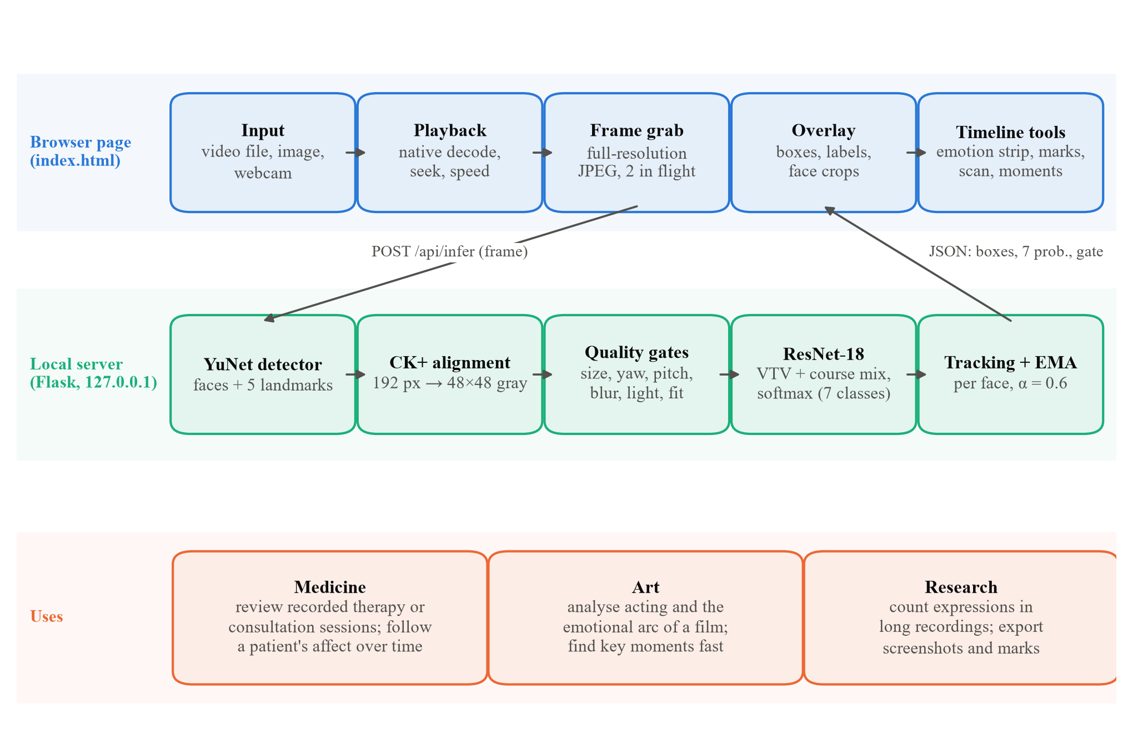
Figure 1: Block diagram of the application and its intended uses
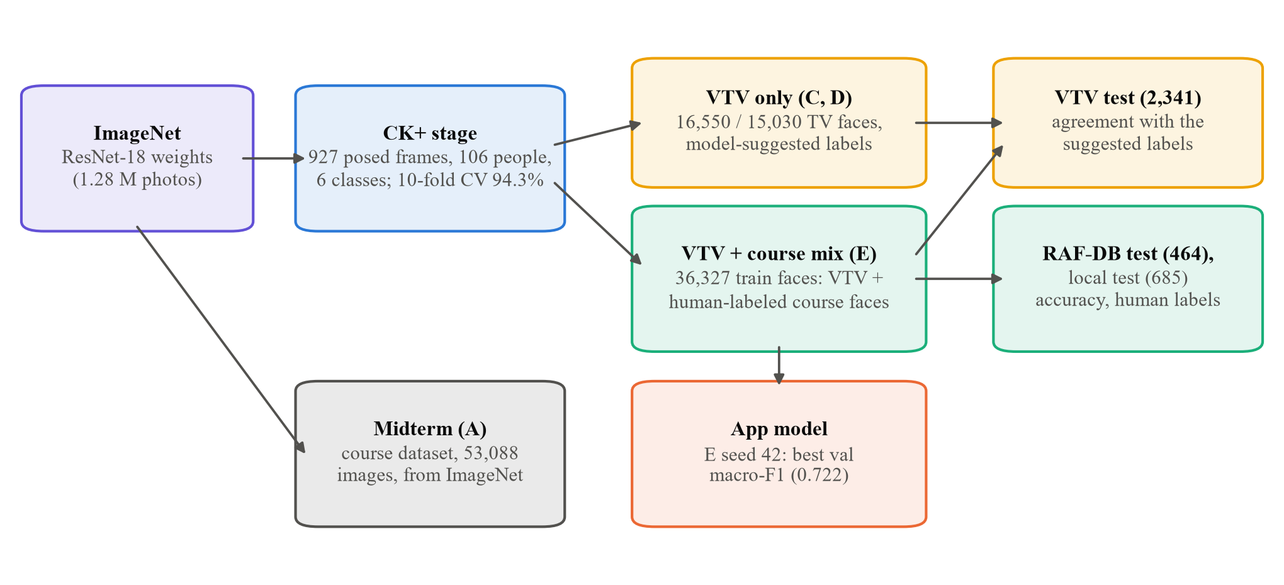
Figure 2: Training path: ImageNet → CK+ → target data (stages A–E of Chapter 8)
    - Operation description
A user opens a video or image (button, drag and drop, or the list of films on the computer). The browser decodes and plays it natively, so seeking, speed and volume work as in any video player. For every analyzed frame the following steps run:
- Frame grab. The page draws the current frame on a canvas and encodes it as JPEG at full resolution. Two frames are in flight at once: while the server analyzes one, the browser encodes the next.
- Detection. YuNet [26] finds the faces and five landmarks (eyes, nose tip, mouth corners) on the frame scaled to at most 960 pixels on the long side.
- Alignment. The five landmarks are mapped onto the mean landmark layout of the CK+ 48×48 crops by the similarity transform of Eq. (1) [27]; the face is cut out at 192×192 pixels, converted to grayscale and resized to 48×48, exactly as the training faces were prepared.
- Quality gates. Each face is measured: eye distance at least 20 pixels, yaw |y| ≤ 0.20 (about 20°), pitch and landmark fit within the CK+ range, brightness, contrast, at most 12% outside the frame, and sharpness. A face that fails is still classified but drawn gray with the reason (turned, small, blurred, dark…), because the model never trained on such faces.
- Classification. The crop goes through the model's validation transform (grayscale copied to three channels, resized to 224×224 on the GPU, ImageNet normalization) and ResNet-18; Eq. (2) turns the outputs into probabilities.
- Tracking and smoothing. Faces are matched to the previous frame by box overlap and their probabilities are smoothed over time by Eq. (3), which removes flicker between frames.
- Display. The server returns boxes, raw and smoothed probabilities, the gate result and the 48×48 crop as JSON. The page draws the boxes over the video, the seven bars, the face crop next to the crop the model saw, and colors the timeline by the dominant emotion of each watched part.
$\left(ŝ, R̂, t̂\right) = \underset{s, R, t}{arg min} \sum_{i=1}^{5}{{\left\|s R x_{i} + t - y_{i}\right\|}^{2}}$ (1)
where x_{i} are the detected landmarks, y_{i} the template landmarks, s a scale, R a rotation and t a translation.
$p_{c} = \frac{\exp\left(z_{c}\right)}{\sum_{k=1}^{7}{\exp\left(z_{k}\right)}}$ (2)
$s_{t} = α p_{t} + \left(1 - α\right) s_{t-1}, α = 0.6$ (3)
Here z are the network outputs (logits), p the class probabilities, and s the smoothed probabilities of one tracked face; α = 0.6 gives the new frame slightly more weight than the history.
Besides the live view, the application has tools for long recordings, which are the core of the medical and artistic use:
- Jump to any time. A box accepts 1:23:45, 83:20, 300 (seconds), 50%, and relative steps such as +30 or -1:00; keys move by 5 s, 10 s, 1 min or one frame, and 0–9 jump to 0–90% of the file.
- Own time marks. A mark stores the current time and a label (by default the emotion of the selected face). Marks appear on the timeline and in a list where they can be renamed, moved or deleted, and are saved per file.
- Whole-film scan. A hidden second video element samples one frame every 1, 2, 5 or 10 seconds, so the whole timeline is colored by emotion. The six strongest moments of each emotion (probability ≥ 0.55, at least 4 s apart) are listed with a thumbnail; a click jumps there. The scan result is saved per file.
- Follow one face. A click on a face pins it; the panel then shows only that person.
- Evidence. A screenshot with the boxes is saved to the project folder, for a case note or an editing log.
    - Proposed devices and components
Table 3: Hardware and software components
Component | Choice | Role
Laptop | ASUS TUF FX706HC: NVIDIA RTX 3050 Laptop GPU (4 GB), 16 GB RAM, Windows 11 | Data pipeline, most training, the application
Cloud GPU | Google Colab, NVIDIA T4 (free tier) | CK+ cross-validation (90 runs), VTV transfer runs
Deep learning | Python 3.14, PyTorch 2.14 with CUDA 13.0 [30], torchvision | Models, training, inference
Vision | OpenCV [31]: YuNet detector, SFace embeddings | Face detection, landmarks, person grouping
Label suggestion | ONNX Runtime: FER+ and two HSEmotion models | Suggested labels for the TV faces only
Evaluation | scikit-learn [32], NumPy, pandas, Matplotlib | Metrics, splits, figures
Application | Flask (local server), HTML/JavaScript page, Chrome app window | Real-time interface
Camera (optional) | Any USB or built-in webcam | Live use

Table 4: The three compared networks (inference time per image at batch size 1)
Network | Training | Parameters | CPU (ms) | GPU (ms)
EmotionCNN (cnn_scratch) | from scratch, 1-channel 96×96 | 4.69 M | 13.5 | 1.5
ResNet-18 [24] | ImageNet → two-stage fine-tuning, 224×224 | 11.18 M | 18.2 | 2.9
MobileNetV2 [25] | ImageNet → two-stage fine-tuning, 224×224 | 2.23 M | 13.0 | 5.9

EmotionCNN has four blocks of two 3×3 convolutions with batch normalization [33] and dropout [34]; the last block uses dilated convolutions to widen the receptive field without losing resolution. ResNet-18 and MobileNetV2 replace their classifier with dropout 0.5 and a 7-way linear layer. Times are from the midterm evaluation on the laptop.
  - Solution limitations
- Expression is not emotion. The model sees muscle movements in one frame; a polite smile and real joy look alike, and masked or culturally shaped expressions are missed [11].
- Seven discrete classes. No intensity, valence or arousal, no action units, and no pain or confusion class, which some clinical uses would need.
- Frontal faces only. Faces turned by more than about 20°, smaller than 20 pixels between the eyes, blurred or badly lit are flagged gray; in crowd scenes many faces are gray.
- 48×48 grayscale input. Fine details and color cues (blushing, tears) are lost.
- Training population. The TV faces are actors performing emotions; the course faces are web photos. There are no patients, few children or elderly people, and no clinical validation.
- Unchecked TV labels. The labels of the Vietnamese TV faces are suggestions of public models; no human has checked a TV test set yet, so accuracy on Vietnamese TV faces is still unknown.
- Frame rate. The application analyzes 13–17 frames per second, so on 25–30 fps video it analyzes about every second frame; very short expressions can be missed.
  - Expected results
At the start of the final phase the following results were expected; Chapter 8 compares them with what was achieved.
- Subject-independent accuracy above 90% on CK+, where expressions are posed and clear.
- Accuracy of at least 70% on human-labeled in-the-wild faces, above the label-suggestion models.
- A Vietnamese TV dataset of more than 10,000 faces, at least 1,000 per class, with no person in two splits.
- A real-time application with at least 10 analyzed frames per second at 1080p on the laptop.
- Deliverables: dataset pipeline, trained models, application, and this report.
  - Design approach and implementation methodology
The work followed an iterative loop: build a baseline, measure it on human labels, find the weakest point, fix it, and measure again (Figure 2). The midterm baseline trained three networks on the course dataset; the final phase added the CK+ stage, the Vietnamese TV dataset, and the application. When the first demo looked weak on films, the model was scored against human labels, which revealed the cause (Section 7.2.3), and the training data was fixed.
Rules applied in every experiment:
- Fixed splits, chosen by person. The course dataset keeps its own split; CK+ and the TV faces are split so that no person appears in two splits. Near-duplicate images across splits were removed before training.
- Selection on validation only. Hyperparameters, epochs and checkpoints are chosen on the validation set; each test set is used once per final model.
- Three seeds (42, 123, 2024) per configuration; results are reported as mean ± standard deviation, with macro-F1 (Eq. (6)) and a bootstrap 95% confidence interval [35].
- Sanity checks before every full run: a two-batch dry run and an overfit-one-batch test.
- Configuration files hold every path and hyperparameter; each run directory stores its merged config, log, best checkpoint, curves and test metrics.
Training uses cross-entropy with label smoothing [36] (Eq. (4)), AdamW [37] without weight decay on biases and batch-norm parameters, and a one-epoch linear warm-up followed by cosine decay [38] (Eq. (5)), stepped every iteration.
$L = - \sum_{c=1}^{7}{q_{c} \log{p_{c}}}, q_{c} = \left(1 - ε\right) 1[c = y] + \frac{ε}{7}, ε = 0.1$ (4)
$η_{t} = η_{min} + \frac{1}{2}\left(η_{0} - η_{min}\right)\left(1 + \cos{\frac{π t}{T}}\right)$ (5)
${F1}_{macro} = \frac{1}{7}\sum_{c=1}^{7}{\frac{2 P_{c} R_{c}}{P_{c} + R_{c}}}$ (6)
In Eq. (4) y is the true class and ε spreads 10% of the target over all classes, which discourages over-confident outputs on noisy labels. In Eq. (5) η₀ is the stage's initial learning rate, η_{min} = 10⁻⁶ and T the number of iterations of the stage. In Eq. (6) P_{c} and R_{c} are the precision and recall of class c.
Table 5: Training configuration of the pretrained networks
Item | Setting
Stage A (head warm-up) | Backbone frozen, classifier only; 3 epochs, learning rate 1e-3
Stage B (fine-tuning) | ResNet-18: layer3 5e-5, layer4 1e-4, classifier 5e-4; MobileNetV2: features[7:14] 5e-5, features[14:] 1e-4, classifier 5e-4; 20 epochs; earlier layers frozen
Regularization | Dropout 0.5, weight decay 5e-2 (tuned on validation: 1e-4 over-fitted, train macro-F1 0.95 vs validation 0.69), label smoothing 0.1
Batch, precision | Batch 32; mixed precision (AMP) on CUDA; gradient clipping at norm 5
Early stopping | On validation macro-F1, patience 6 epochs; best.pt = best validation macro-F1
Augmentation | Random resized crop (scale 0.85–1), horizontal flip, rotation ±10°, brightness and contrast ±0.3, random erasing (p = 0.25); applied at 48×48, then resized on the GPU
Not used | Vertical flips, rotations above 15°, CutMix (it can cut away the eyes or mouth)

- Potential impact and consideration
  - Technical viability
The whole system runs on a laptop GPU with 4 GB of memory. The final ResNet-18 needs 2.6 ms per face on the GPU and 17 ms on the CPU, and its checkpoint is 43 MB, so a clinic or studio PC without a GPU can still run it, more slowly. The application uses only a browser and a local Python server, with no internet connection. The main technical risks are the label quality of the TV data and faces outside the training conditions, both discussed in Chapter 9.
  - Economic feasibility
All software is open source and all compute was free (the laptop already owned and the free Colab tier), so the project cost almost nothing in cash (Chapter 10). Reviewing a recording with the application is much faster than by eye: a whole 41-minute episode is scanned at one frame every 10 seconds in about 70 seconds, after which the user jumps straight to the listed moments. For a hospital or a film school this means a free tool on existing computers instead of a paid license.
  - Social viability
The benefits are a tool tuned to Vietnamese faces, and time saved for clinicians, editors and teachers. The risks are misuse for surveillance, and over-trust: treating a label as a diagnosis or as proof of what someone feels. The design limits both: data never leaves the computer, every label comes with its probability and the crop the model saw, faces outside the training conditions are gray, and the documentation states that the output supports, not replaces, a professional. Use on people requires their informed consent.
  - Operational viability
The application starts with a double click on a launcher, opens its own window and stops when the window is closed. Files are added from a list, a dialog or by drag and drop; marks, scan results and the last position are remembered per file in the browser. The model can be switched in the window among all finished training runs. Retraining needs only the configuration files and one command per seed; the dataset pipeline is resumable and runs one process at a time so that it fits in 16 GB of memory.
  - Environmental feasibility
Training and data preparation used about 20 GPU hours on the laptop (Chapter 10), roughly 3 kWh of electricity, plus free Colab time. The deployed model is small, runs on existing hardware, and processes video locally instead of streaming it to a data center. No new hardware was bought.
  - Alternatives solution/approach
Table 6: Alternative approaches
Alternative | Advantage | Why not chosen (now)
Cloud emotion API | No training; maintained by a vendor | Uploads patient or film video; services have been withdrawn [9]; cost per call
Commercial software (e.g. FaceReader) | Validated in research, action units | License cost; closed model; not tuned to Vietnamese faces
Action units (OpenFace) + rules | Interpretable, standard FACS output | Rules for 7 classes are brittle; AU detectors also trained on other populations
Larger models (EfficientNet, ViT) | Higher accuracy on AffectNet-scale data | Slower on a 4 GB laptop; small target dataset; harder to explain
Video (temporal) models | Use motion, catch short expressions | Need labeled clips; the EMA smoothing already gives temporal stability
Multimodal (voice, physiology) | More reliable emotion estimate | Extra sensors and data; outside the course scope

  - Codes of ethics (IEEE)
The IEEE Code of Ethics [39] asks engineers to hold paramount the safety, health and welfare of the public, to protect privacy, to be honest and realistic in stating claims, and to treat all persons fairly. Table 7 shows how the project applies these principles. The EU AI Act [40] prohibits emotion recognition in workplaces and schools except for medical or safety reasons; this project's focus on medicine and art is consistent with that line, and uses such as employee or student monitoring are out of scope.
Table 7: IEEE ethics principles and how the project applies them
Principle | Application in this project
Safety, health, welfare | Not a medical device; output is advisory; gray flag and probability on every face; limits stated in the application guide and this report
Privacy | Local processing only; no account, no upload; screenshots only when the user asks; TV frames and datasets kept private and not redistributed
Honesty of claims | Results on model-suggested labels are called agreement, never accuracy; failed or incomplete runs are reported but kept out of the means; test sets used once
Fairness | Training data extended to Vietnamese faces; fairness across age, gender and skin tone not yet measured, listed as a risk [41]
Disclosure of tools | An AI coding assistant (Claude Code) helped write code and run experiments under the students' direction; its own visual screen of labels was tested and rejected (Section 7.1.3)
Intellectual property | Public datasets used under their research licenses; TV episodes used only for research; open-source software credited

- Weekly project development schedule
  - Member roles
Table 8: Roles
Person / tool | Role | Main tasks
Nguyễn Quang Trung (22011211) and Nguyễn Tiến Thành (22011103) | Students, team members | Data collection and checks, model design and training, evaluation, application, report (shared)
Ph.D Minhhuy Le | Advisor | Course supervision, review of methods and report
Claude Code (AI assistant) | Tool | Drafting code and scripts, running long jobs, figures, under the students' review
Google Colab | Tool | Free T4 GPU for the CK+ cross-validation and transfer runs

  - Schedule and plan
Figure 3 shows the weeks of the project, reconstructed from the run logs and file dates, and the work planned after this report. Table 9 lists the output of each week.
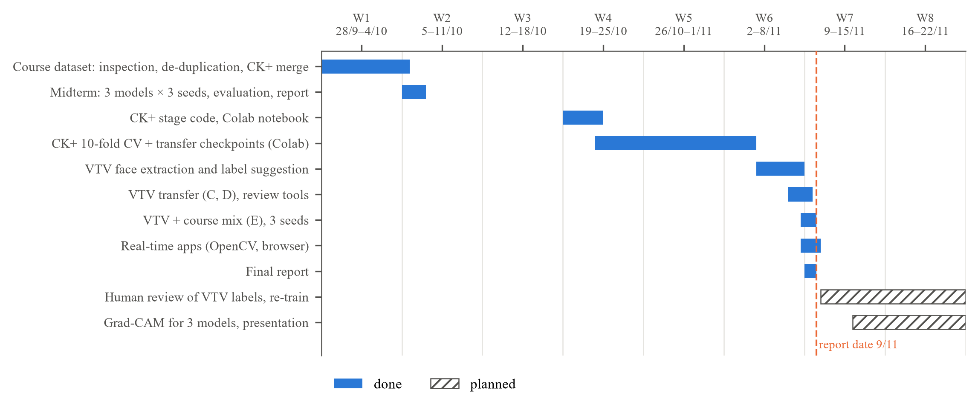
Figure 3: Project schedule (2026): done (blue) and planned (hatched)
Table 9: Weekly work and outputs
Week (2026) | Work | Output
W1, 28/9–4/10 | Course dataset inspection, cross-split de-duplication, CK+ merge by person, training loop and sanity checks | Clean splits (567 near copies moved), shared code
W2, 5–11/10 | Midterm: 3 networks × 3 seeds, evaluation, ensemble | Midterm report (6/10)
W4, 19–25/10 | CK+ stage: folds by person, configurations, Colab notebook | CK+ pipeline (21/10)
W5, 26/10–1/11 | CK+ 10-fold CV (90 runs) and 9 transfer checkpoints on Colab | CK+ results (3/11)
W6, 2–8/11 | TV face extraction, label suggestion, review page, dataset build; transfers C and D; human-label check; first mix run; OpenCV demo | VTV dataset (7/11), demo (8/11)
W7, 9–15/11 | Mix model with 3 seeds, browser application, this report; then human review of TV labels | Final model and application (9/11)
W8, 16–22/11 | Retraining on reviewed labels, Grad-CAM for 3 networks, presentation (planned) | Presentation

- Project progress
  - Topic 1: Datasets
    - Theoretical basis
Three properties of FER data decide how far results can be trusted. Identity leakage: if the same person is in training and test, the model can recognize the person instead of the expression, and test scores are inflated; splits must therefore be made by person, and near-duplicate images across splits removed. Label noise: annotators disagree on in-the-wild faces (human accuracy on FER2013 is about 65% [19]), and labels suggested by models are noisier still, so a test set with model labels measures agreement with those models, not accuracy. Domain shift: a model trained on posed laboratory faces or web photos loses accuracy on TV faces with other lighting, pose and population.
    - Calculation/analysis
Course dataset. 53,088 grayscale 48×48 faces in 7 balanced classes (Table 10), from four sources: a local FER2013-style collection (15,198 originals), RAF-DB (9,979), AffectNet (3,133, only angry, disgust and fear) and CK+ (922). A near-duplicate search (perceptual hash plus pixel correlation over small shifts and a flip) found validation and test images that were copies of training images; 567 files were moved out and the splits re-balanced. CK+ frames were assigned by person (train 84 people, validation 16, test 6).
Table 10: Course dataset after de-duplication
Split | Images | Per class | Content
Train | 47,712 | 6,816 | 23,856 originals + one augmented copy each
Validation | 4,025 | 575 | Originals only
Test | 1,351 | 193 | Originals only

CK+. 927 frames (the last three frames of 309 labeled sequences) of 106 people in 6 classes; CK+ has no neutral class and contempt was dropped. Folds were built with StratifiedGroupKFold over people [32].
Vietnamese TV dataset (VTV). Figure 4 shows the pipeline. Six TV programs (12 video files: dramas, a comedy show and an old film) and 20,718 trailer frames were sampled at 10 frames per second. In the main run, YuNet found 414,003 faces, of which only 7,258 (1.8%) passed all gates (Table 11): most faces were too small, turned or repeated. Every source together kept about 32.7 thousand aligned faces for review.
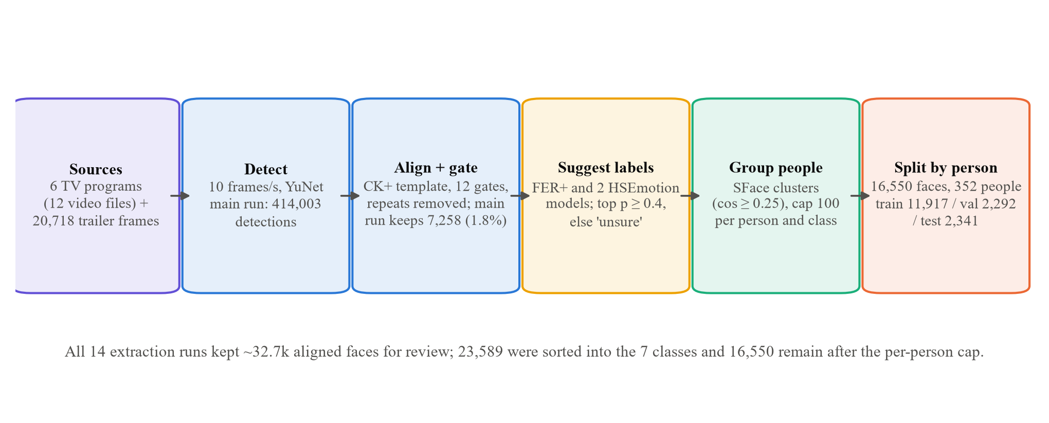
Figure 4: Construction of the Vietnamese TV face dataset
Table 11: First failed gate of the detected faces in the main extraction run
Gate | Faces | Gate | Faces
small (eye distance < 20 px) | 171,031 | dark or bright | 4,294
detector score < 0.80 | 82,290 | pitch | 3,299
yaw (turned) | 81,081 | outside the frame | 2,892
repeat of a kept face | 32,548 | landmark fit | 1,293
blur | 15,723 | roll | 1,093
contrast | 10,430 | recheck on the crop | 771
kept | 7,258 | total detections | 414,003

Labels. FER+ alone recognized only 13% of CK+ angry and 8% of CK+ fear faces, so labels are suggested by the average of FER+ and two HSEmotion models. Measured on faces prepared exactly like the TV crops, this ensemble raised accuracy from 0.659 to 0.887 on CK+ and from 0.548 to 0.670 on RAF-DB compared with FER+ alone. Faces whose top probability is below 0.4 go to an 'unsure' folder; at this threshold the ensemble sorted 84% of RAF-DB faces with 74% accuracy, and 74% of the TV faces.
People and splits. Actors appear in many episodes, so faces are grouped by person with SFace embeddings [28] and average-linkage clustering. The threshold was calibrated on the data: two faces in one frame (different people) had a median cosine similarity of 0.11, the same person in other shots 0.54–0.76. At 0.40, 6% of test faces still had five or more near-identical training faces; at 0.25, none. One comedy performer made up 14% of all faces and 86% of the test set until a cap of 100 faces per person and class was added. The split uses StratifiedGroupKFold with 7 folds over people (test = fold 0, validation = fold 1).
    - Results
The VTV dataset has 16,550 real faces of 352 people (Table 12); the identity leak check found 1.8% of validation and 1.3% of test faces with five or more similar training faces. Classes with fewer than 1,000 faces received 614 augmented copies of their training faces, so that every class has at least 1,000; validation and test faces are all real. Figure 5 shows test faces with their suggested labels.
Table 12: VTV dataset (suggested labels): real faces per split
Class | Train | Validation | Test
angry | 788 | 149 | 156
disgust | 506 | 85 | 113
fear | 672 | 111 | 112
happy | 2,816 | 563 | 563
neutral | 4,629 | 926 | 926
sad | 1,920 | 364 | 364
surprise | 586 | 94 | 107
total (people) | 11,917 (247) | 2,292 (54) | 2,341 (51)

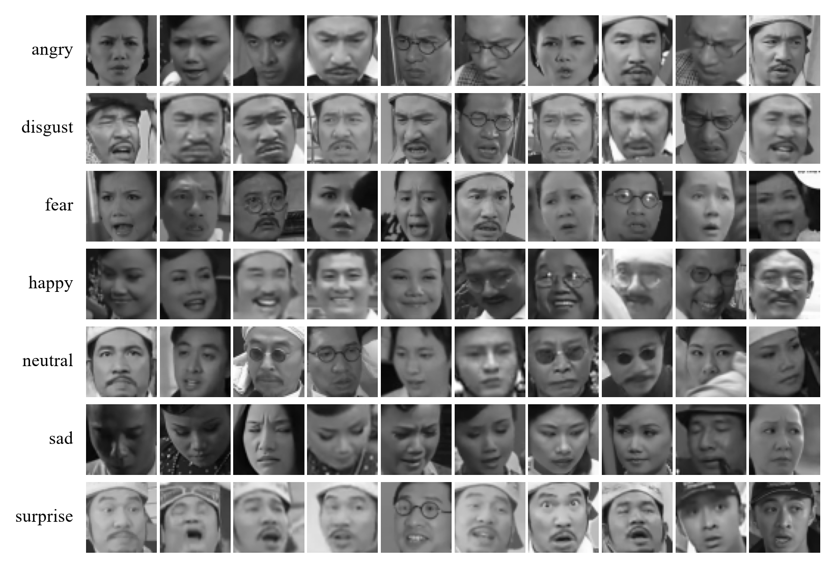
Figure 5: Aligned 48×48 VTV test faces per suggested class (random sample)
A screen that hurt. To speed up the review, the AI assistant screened the four weakest classes by eye and removed 1,844 of 4,196 faces (blurred, turned, or a doubtful emotion). On 48 RAF-DB faces its eye was less reliable than the ensemble (58% vs 71%). Models trained on the screened version (D) agreed less with the labels on the 440 test faces both versions share (ResNet-18: 79.7% → 75.8%), with the loss in exactly the screened classes (surprise 63–76% → 26–39%). Removing faces made the rare classes too small; the unscreened version (C) remained the main TV dataset.
Mix dataset. For stage E, the course dataset's real faces (not its augmented copies) were aligned the same way as the TV faces and joined with the VTV build (Table 13). Each part keeps its own split, so the RAF-DB and local test faces stay unseen. The rare classes grow from 500–800 to about 4,200 training faces.
Table 13: Mix dataset (stage E) by source
Source | Train | Validation | Test | Labels
VTV (Vietnamese TV) | 11,917 + 614 aug. | 2,292 | 2,341 | model suggestions
local (course) | 12,453 | 2,060 | 685 | human
RAF-DB | 8,049 | 1,396 | 464 | human
AffectNet | 2,538 | 441 | 153 | human
CK+ | 756 | 121 | 45 | human
total | 36,327 | 6,310 | 3,688

  - Topic 2: Models, training and transfer
    - Theoretical basis
A convolutional network learns local filters whose responses are combined layer by layer into features such as eyebrow shape or mouth opening. Batch normalization [33] stabilizes training and dropout [34] reduces over-fitting. Residual connections [24] let gradients pass through deep networks; inverted residual blocks with depthwise separable convolutions [25] cut computation. Transfer learning re-uses features learned on a large source task: here ImageNet [23] gives general visual features, CK+ teaches clean, posed expressions of the six basic emotions, and the target data adapts the model to TV faces and adds the neutral class. Only the classifier is re-initialized at each step (6 → 7 outputs); every other tensor whose name and shape match is copied. Training in two stages, first the new head with a frozen backbone and then the upper blocks with smaller learning rates, protects the pretrained features from large early gradients.
    - Calculation/analysis
Compute. On the laptop RTX 3050 one epoch of the course dataset took about 45, 65 and 75 seconds for EmotionCNN, ResNet-18 and MobileNetV2, about 4 hours for all 9 midterm runs. The CK+ cross-validation (3 networks × 3 seeds × 10 folds = 90 runs) ran on Colab. Each mix run trained all 23 epochs in about 29 minutes (2026-11-09, 02:11–03:38 for three seeds).
Tuning on validation. The first ResNet-18 configuration (dropout 0.3, weight decay 1e-4) over-fitted: training macro-F1 0.95 against 0.69 on validation. AdamW scales its decoupled weight decay by the learning rate, so 1e-4 barely regularized; weight decay 5e-2 and dropout 0.5 kept validation macro-F1 (0.693) with a better-regularized model. For MobileNetV2, the final configuration (more unfrozen blocks, dropout 0.5, weight decay 5e-2) raised validation macro-F1 from 0.665 to 0.679. On CK+, which gives about 35 times fewer steps per epoch, MobileNetV2 needed five times larger learning rates (validation macro-F1 0.872 → 0.905).
Statistics. With 1,351 test images and about 70% accuracy, the 95% interval of the accuracy is about ±2.4 points, wider than the gap between the networks. Every result is therefore the mean ± standard deviation over three seeds, with a bootstrap interval from 1,000 resamples of the test set [35].
    - Results
Stage A, course dataset (midterm). The three networks are statistically tied (Table 14); averaging the nine runs with horizontal-flip test-time augmentation reaches 71.87%. EmotionCNN trained from scratch is as accurate as the pretrained networks on this large, 48×48 dataset.
Table 14: Stage A: course dataset test set (1,351 images, human labels), mean ± std over 3 seeds
Network | Accuracy (%) | Macro-F1 | Macro-F1 95% CI
EmotionCNN | 68.02 ± 1.04 | 0.679 ± 0.012 | [0.654, 0.702]
ResNet-18 | 68.32 ± 0.97 | 0.683 ± 0.010 | [0.658, 0.706]
MobileNetV2 | 67.83 ± 0.88 | 0.678 ± 0.009 | [0.653, 0.701]
Ensemble of 9 runs + flip TTA | 71.87 | 0.717 | [0.694, 0.741]

Stage B, CK+ 10-fold cross-validation. Every image is tested once by a model that never saw its person (Table 15). ResNet-18 is the most accurate and the most stable; its lowest per-class F1 scores are sad (0.87), angry (0.88) and fear (0.90) (Figure 6).
Table 15: Stage B: CK+ subject-independent 10-fold CV (927 images, 6 classes), mean ± std over 3 seeds
Network | Pooled accuracy (%) | Pooled macro-F1 | Worst / best fold (%)
EmotionCNN | 90.36 ± 1.18 | 0.867 ± 0.015 | 76.7 / 100.0
ResNet-18 | 94.28 ± 0.39 | 0.926 ± 0.006 | 83.9 / 100.0
MobileNetV2 | 93.38 ± 0.53 | 0.903 ± 0.012 | 83.9 / 100.0

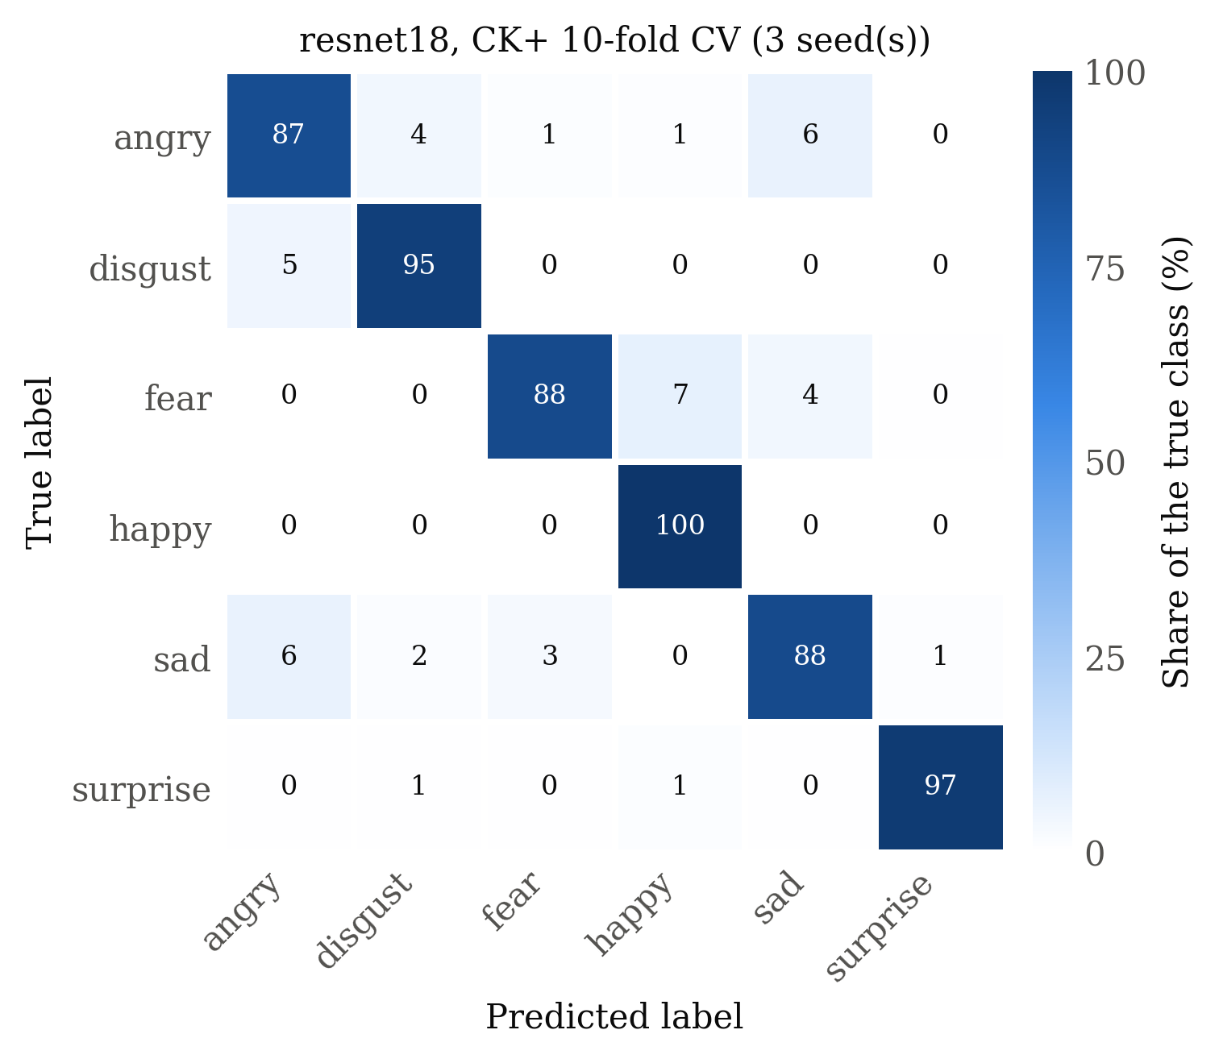
Figure 6: CK+ cross-validation confusion matrix of ResNet-18 (all seeds pooled, row-normalized)
Stages C and D, CK+ → VTV. Fine-tuned on the suggested TV labels, ResNet-18 again was best and most stable (Table 16). These numbers are agreement with the label-suggestion ensemble. The weakest classes were disgust (57%, confused with angry), fear (66%) and surprise (74%, confused with fear), the classes with the fewest real faces and the least reliable suggestions.
Table 16: Stages C and D: VTV test agreement with the suggested labels, mean ± std over 3 seeds
Network | C: agreement (%) | C: macro-F1 | D: agreement (%) | D: macro-F1
EmotionCNN | 80.29 ± 1.73 | 0.731 ± 0.027 | 77.31 ± 3.22 | 0.614 ± 0.042
ResNet-18 | 83.64 ± 0.66 | 0.765 ± 0.003 | 83.64 ± 0.66 | 0.701 ± 0.011
MobileNetV2 | 80.21 ± 0.88 | 0.733 ± 0.013 | 81.41 ± 0.85 | 0.663 ± 0.025

Diagnosis on human labels. When the first demo (stage D model) was tried on films, the recognition looked weak. Scored on RAF-DB faces with human labels, prepared exactly like the TV crops, the model reached only 53.4% on the RAF-DB test faces, below the ensemble that produced its labels (68.8%), and recalled 11% of surprise faces. High agreement had hidden a weak model: it had learned the ensemble's habits from a few hundred rare-class faces.
Stage E, VTV + course mix. Trained on the mix dataset, ResNet-18 (three seeds, each starting from the CK+ checkpoint of the same seed) converged in 14–17 epochs (Figure 7). On the full mix test set (3,688 faces) it scored 77.11 ± 0.59% / macro-F1 0.728 ± 0.004; per seed, see Table 17. Chapter 8 compares it with the earlier stages on human labels.
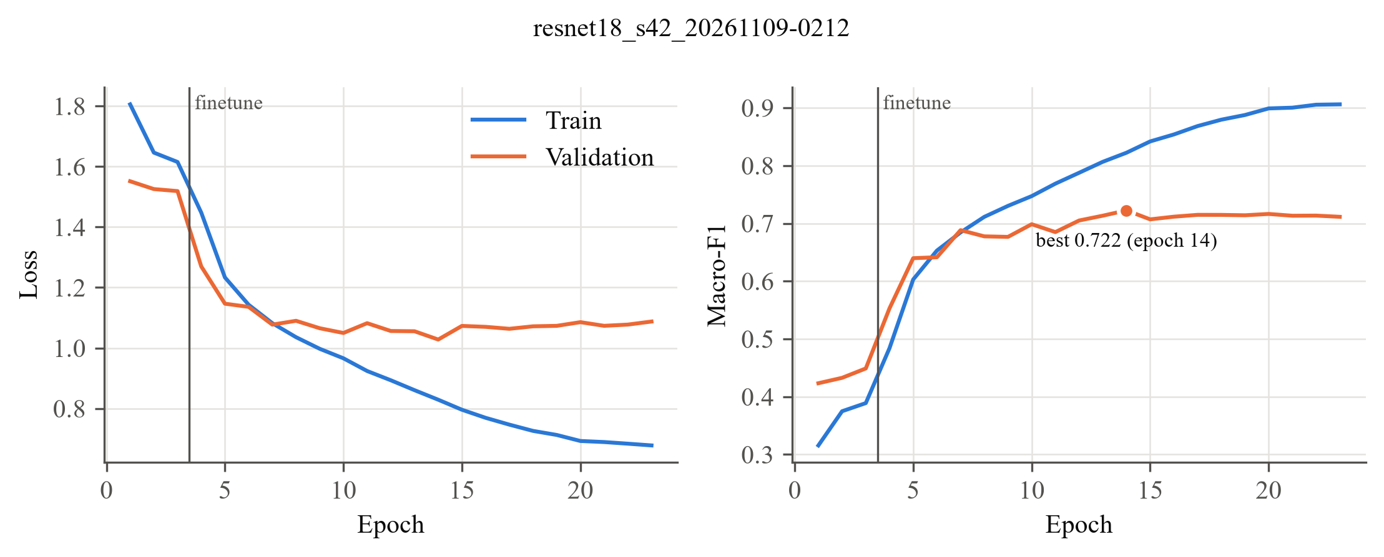
Figure 7: Learning curves of the stage E ResNet-18, seed 42 (loss and macro-F1)
Table 17: Stage E runs (ResNet-18); the application uses the seed with the best validation macro-F1
Seed | Best epoch | Val. macro-F1 | Mix test acc. (%) | RAF-DB test acc. (%) | RAF-DB macro-F1
42 | 14 | 0.722 | 76.71 | 80.4 | 0.727
123 | 15 | 0.715 | 77.79 | 79.1 | 0.708
2024 | 17 | 0.711 | 76.84 | 78.7 | 0.705

  - Topic 3: Real-time application
    - Theoretical basis
A real-time pipeline is limited by its slowest stage. When stages run one after another, the frame rate is the inverse of their summed time; when two frames are in flight, the browser encodes frame n+1 while the server analyzes frame n, and the rate approaches the inverse of the slowest stage (Eq. (7)). Results can then arrive out of order, so the page drops any result older than the frame already shown and any result from before a seek. Seeking in large files works because the server answers HTTP range requests [42], so the browser loads only the part it plays.
${FPS}_{seq} = \frac{1000}{t_{enc} + t_{net} + t_{srv}}, {FPS}_{pipe} ≈ \frac{1000}{\max\left(t_{enc}, t_{srv}\right)}$ (7)
    - Calculation/analysis
On 1080p AV1 films, JPEG encoding of a full-resolution frame takes about 40 ms (t_{enc}) and the server about 46–49 ms (t_{srv}: decoding, detection, alignment, gates, and the network for every face). The first, sequential version reached 8 analyzed frames per second. With two frames in flight Eq. (7) gives an upper bound of about 20 frames per second, and 15–17 were measured (13 in scenes with many faces). Frames are sent at full resolution on purpose: the quality gates count pixels (eye distance ≥ 20 px), and a downscaled frame would turn many valid faces gray. The network itself is a small part of the budget: 2.6 ms per face on the GPU.
The whole-film scan reads one frame per step with a hidden second video element, without tracking. The application estimates 0.4 s per sampled frame; in the test for Figure 8 a 41-minute episode at one frame per 10 s (248 frames) took 70 s. The older OpenCV version of the demo, which decodes the video itself, runs at 17–38 frames per second depending on the number of faces.
    - Results
Figure 8 shows the application on a Vietnamese drama after a whole-film scan. The left column lists the files; the center shows the video with one confident face (angry 67%) and one gray face (turned); the timeline under it is colored by the scanned emotions and carries three user marks; the right panel shows the seven probabilities, the face crop next to the 48×48 crop the model saw, the user's marks and the strongest moments per emotion. Table 18 maps these functions to the two target fields. Figure 9 shows frames annotated by the demo on four Vietnamese programs.
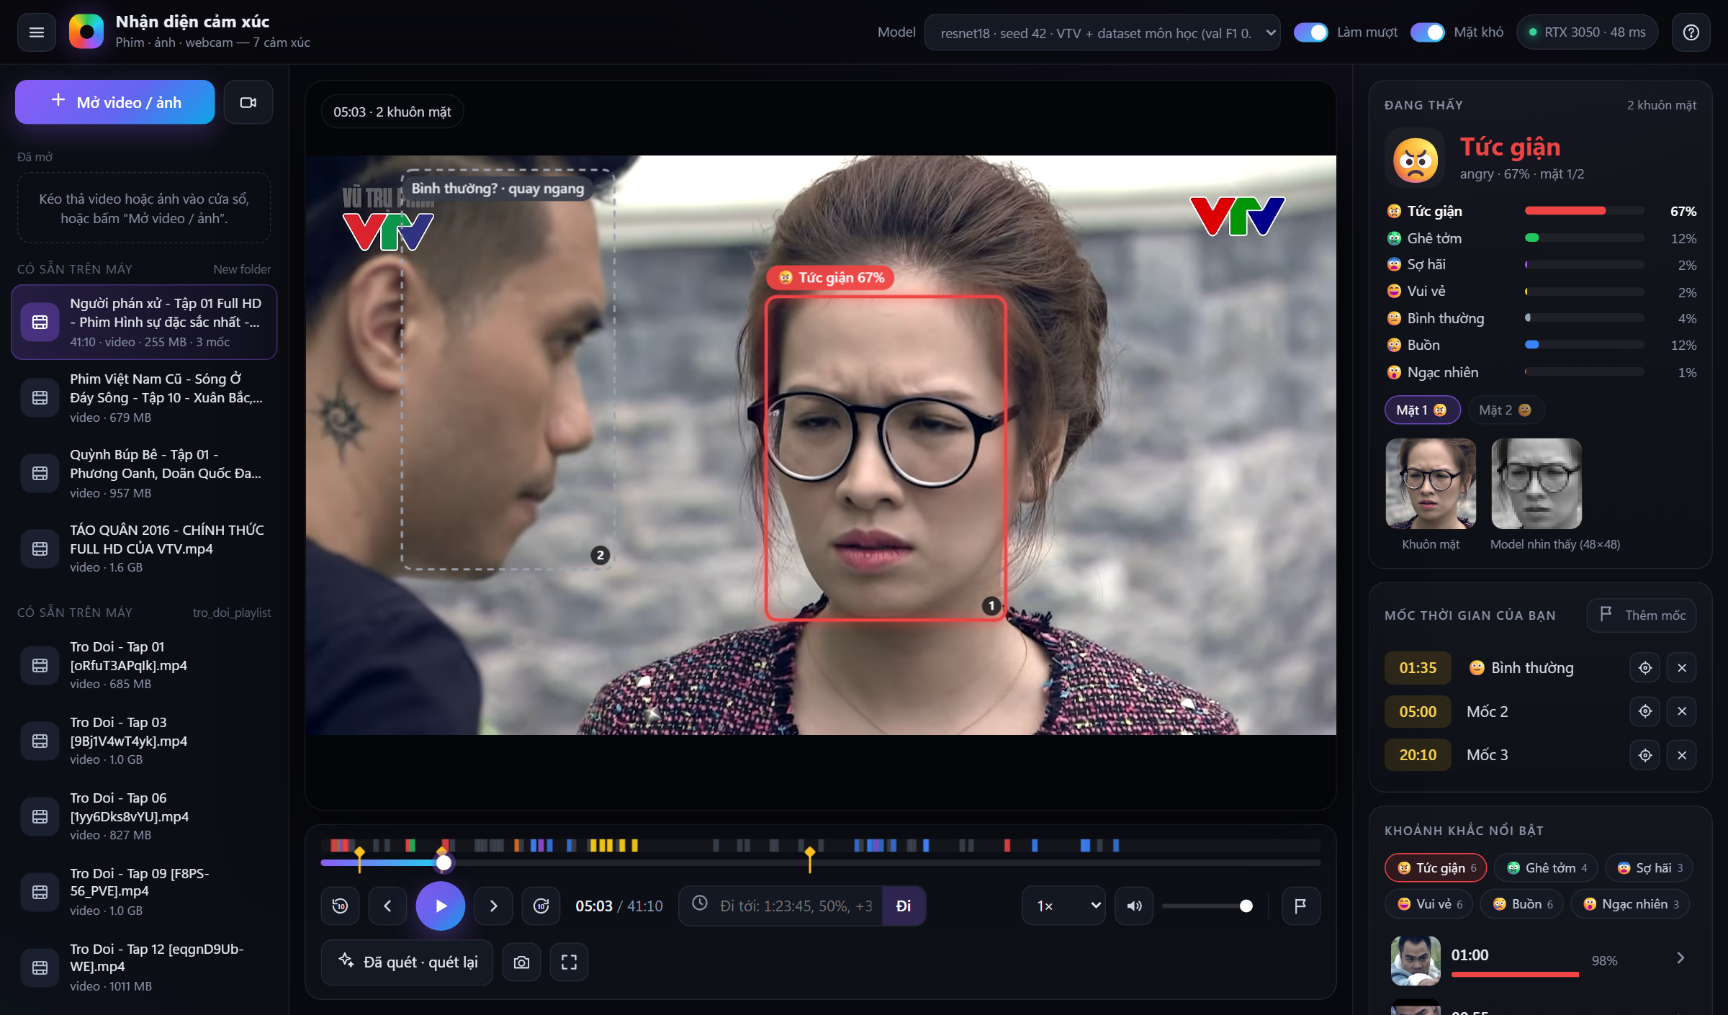
Figure 8: The browser application (interface in Vietnamese) after scanning a 41-minute episode of the drama Người Phán Xử
Table 18: Application functions and their use in medicine and art
Function | Medical use | Artistic use
Live view with probabilities | Follow a patient's expressions during a video consultation (with consent) | Feedback for an actor rehearsing in front of a webcam
Whole-file scan + emotion strip | Overview of affect across a recorded therapy session | Emotional arc of an episode; compare scenes or takes
Strongest moments per emotion | Jump to moments of distress for review | Find the strongest reactions for editing or teaching
Own time marks with labels | Clinician's notes at time points | Editor's or director's cue list
Gray faces and 48×48 crop | Shows when not to trust the output | Shows when lighting or angle defeats the model
Screenshot with boxes | Evidence for a case note | Material for a scene analysis

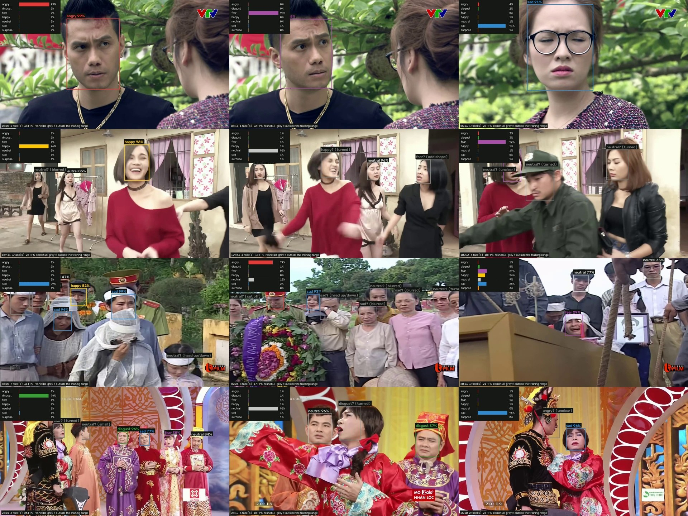
Figure 9: Frames annotated by the demo on four Vietnamese programs (first stage E run); gray boxes mark faces outside the training conditions
- Results and Discussion
  - Results
Table 19 collects the results of all stages. Only rows marked human are accuracy; rows marked suggested are agreement with the labels of the suggestion ensemble.
Table 19: Results of all stages (ResNet-18 unless noted; mean ± std over 3 seeds)
Stage | Test data | Labels | Accuracy / agreement (%) | Macro-F1
A Midterm | Course test, 1,351 | human | 68.32 ± 0.97 (ensemble 71.87) | 0.683
B CK+ CV | CK+, 927 (10 folds) | human | 94.28 ± 0.39 | 0.926
C CK+ → VTV | VTV test, 2,341 | suggested | 83.64 ± 0.66 | 0.765
D CK+ → VTV screened | RAF-DB test, 464 | human | 53.4 (seed 2024) | 0.391
E CK+ → mix | RAF-DB test, 464 | human | 79.4 ± 0.9 | 0.713
E CK+ → mix | local test, 685 | human | 60.8 ± 0.9 | 0.610
E CK+ → mix | VTV test of C, 2,341 | suggested | 82.44 ± 1.24 | 0.748
Suggestion ensemble | RAF-DB test / local test | human | 68.8 / 55.0 | 0.590 / 0.538

Figure 10 compares the models on the two human-labeled test sets that no model trained on, and Figure 11 shows the recall per class on RAF-DB. Adding about 4,200 human-labeled faces per rare class lifted surprise recall from 11% to 81%, disgust from 14% to 49%, angry from 30% to 65% and sad from 59% to 91%.
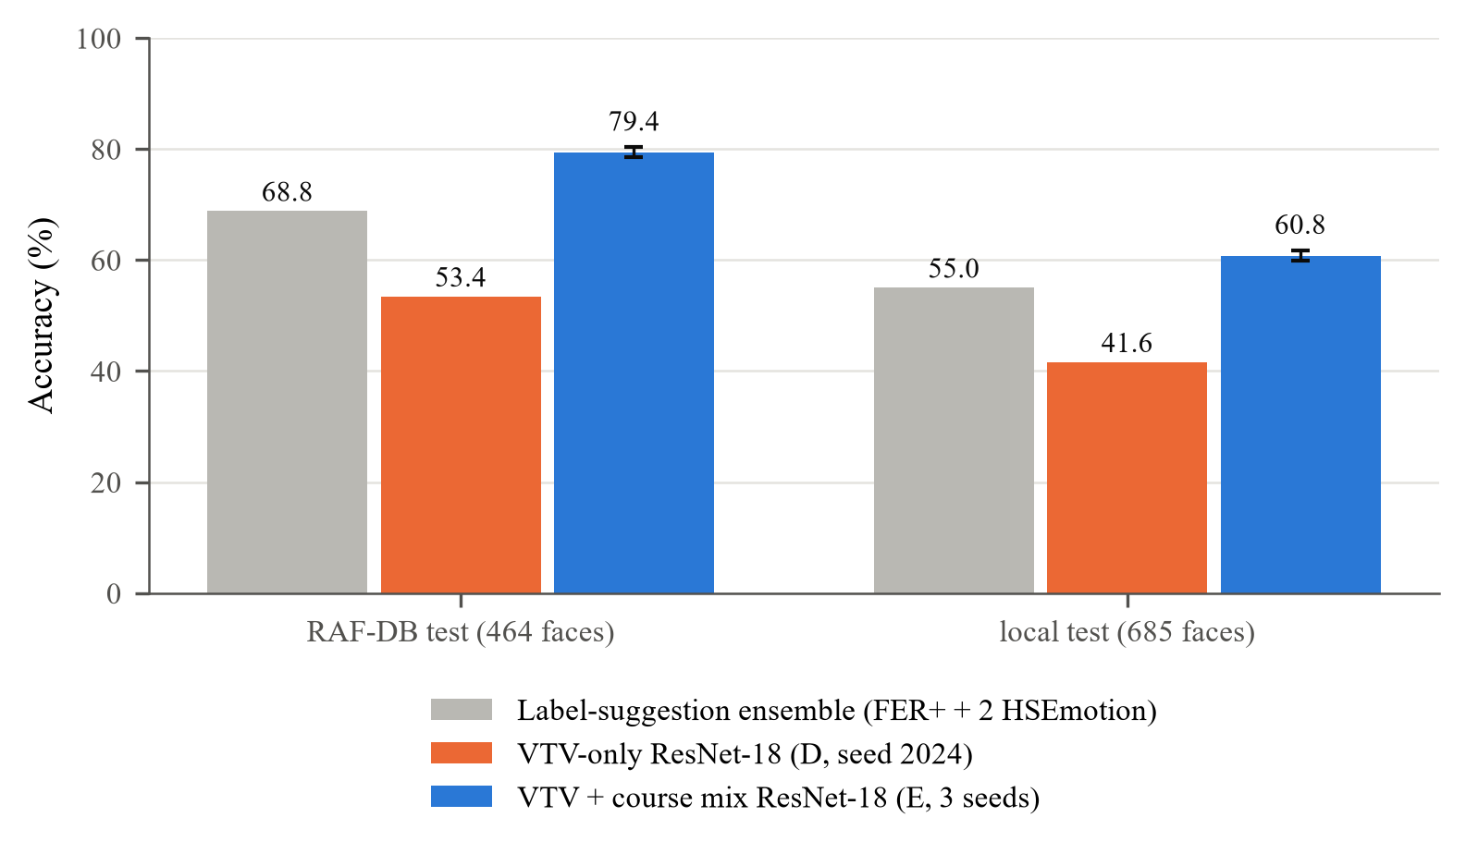
Figure 10: Accuracy on human-labeled test faces (error bars: std over 3 seeds)
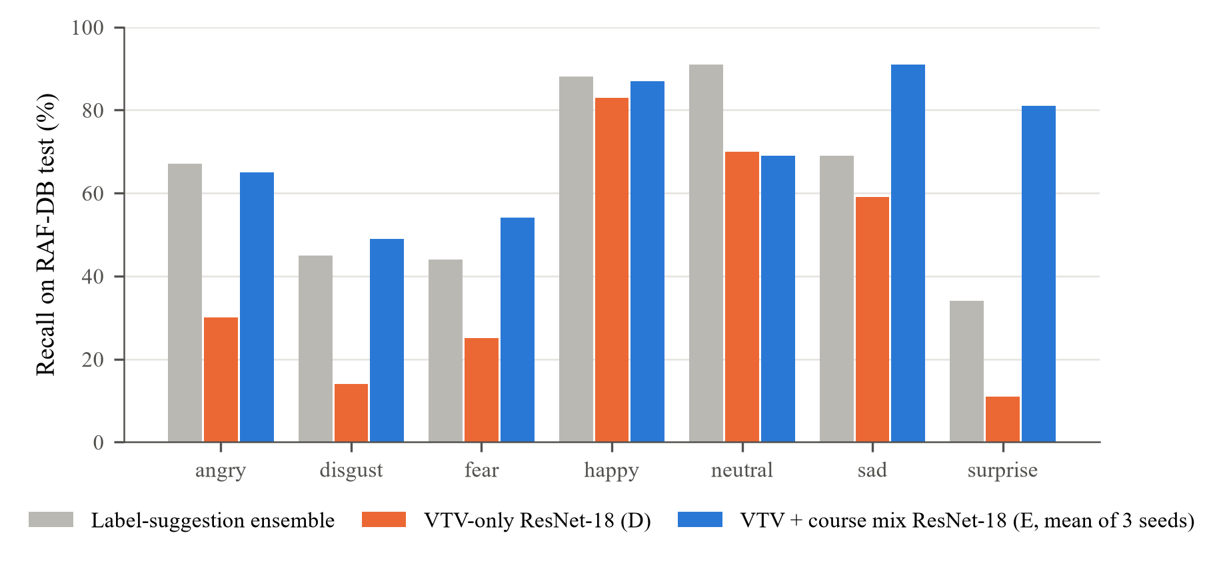
Figure 11: Recall per class on the RAF-DB test faces
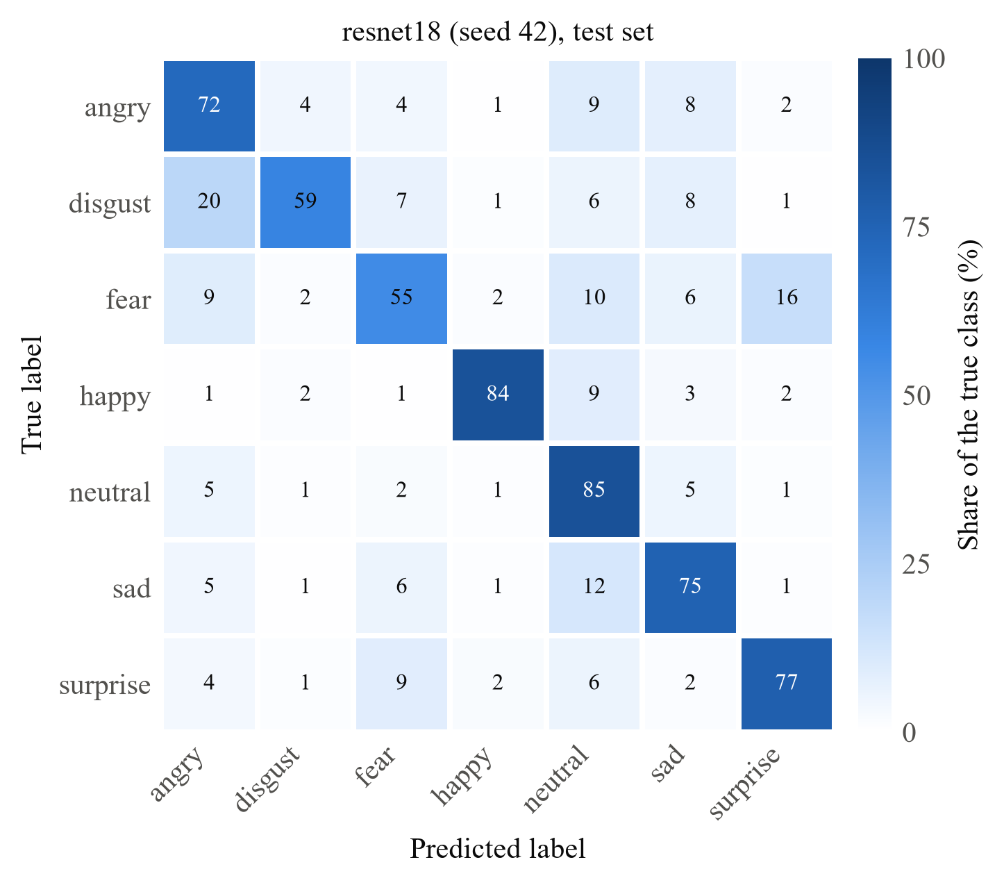
Figure 12: Confusion matrix of the application model (stage E, seed 42) on the full mix test set (3,688 faces; row-normalized)
Figure 12 shows the confusion matrix of the application model on the full mix test set. The largest confusions are disgust taken for angry (20%), fear for surprise (16%) and neutral (10%), and sad for neutral (12%): the same pairs on which human annotators disagree most.
  - Evaluation
Table 20: Objectives and expected results compared with what was achieved
Objective / expectation | Achieved | Status
CK+ subject-independent accuracy > 90% | 94.3% (ResNet-18), 93.4%, 90.4% | met
≥ 70% on human-labeled in-the-wild faces, above the label suggestions | 79.4% on RAF-DB test vs 68.8%; 60.8% on local test vs 55.0% | met on RAF-DB; local is harder
TV dataset > 10,000 faces, ≥ 1,000 per class, split by person | 16,550 faces, 352 people; leak check 1.3% of test | met (labels not yet human-checked)
Three networks × three seeds with CIs | Stages A–C; stage E for ResNet-18 only | met / partly
≥ 10 analyzed frames/s at 1080p | 13–17 frames/s (browser), 17–38 (OpenCV) | met
Seek, jump, marks, whole-film summary, local only | All in the browser application | met
Accuracy on Vietnamese TV faces | Not measurable yet (no human-checked TV test set) | open

The midterm accuracy of 68–72% on a mix of mostly in-the-wild 48×48 faces is in the range of human agreement on FER2013 (about 65% [19]). CK+ at 94% confirms that clear posed expressions are easy for all three networks. The 79.4% on RAF-DB test faces is the most relevant number for real use, with one caveat: model E trained on other RAF-DB and local faces, so part of the gain over model D is in-distribution. On the TV test set, model E agrees slightly less with the suggested labels than model C (82.4% vs 83.6%; the seed ranges touch), because it learned from human labels that differ from the ensemble's habits.
  - Discussion
Labels matter more than architecture. The three networks were within one point of each other on every dataset, but the choice of training labels moved RAF-DB accuracy by 26 points (53% → 79%). High agreement with model-suggested labels (83.6%) did not mean high accuracy: only a test set with human labels revealed the problem. For the same reason, removing doubtful faces (stage D) hurt, because it emptied the rare classes instead of fixing their labels.
Medicine. The application already supports reviewing a recorded session: the scan gives an overview, the moment list leads to the strongest expressions, and marks hold the clinician's notes. Before any clinical use, three things are missing: data from patients (with consent and ethics approval), classes that clinicians need (pain, flat affect, intensity), and a validation study against clinicians' ratings. The gray flags will be frequent in clinical video, where patients lie down or turn away.
Art. For film and theatre the tool is closer to use: the emotional arc of a whole episode is visible in about a minute, and editors or acting teachers can jump between the strongest reactions and compare takes. Its labels describe what the face shows, which is exactly what an actor performs; the limits are crowd scenes, profiles and stylized make-up (see the comedy-show frames in Figure 9). The four demo programs were also sources of training faces, so a film outside the dataset would give a fairer impression.
- Risk analysis
  - Risk factor inputs
    - Risk factors
Table 21: Risk factors
ID | Risk | Cause | Consequence
R1 | Noisy TV labels | Labels suggested by models, not checked by people | Model learns the suggesters' errors; TV accuracy unknown
R2 | Domain shift in use | Patients, children, elderly people, hospital lighting, profiles | Lower accuracy than measured
R3 | Over-interpretation or misuse | A label read as a feeling or a diagnosis; surveillance use | Wrong decisions about people; harm to trust
R4 | Privacy breach | Patient or actor video copied or uploaded | Legal and ethical violation
R5 | Bias | Unequal accuracy across age, gender, skin tone [41] | Unfair results for some groups
R6 | Low memory on the laptop | 16 GB RAM shared by data jobs and training | Killed runs (happened once)
R7 | Cloud quota | Free Colab GPU time runs out | Delays (happened once; runs moved to the laptop)
R8 | Licenses of data | TV episodes and research datasets | Material cannot be published
R9 | Slow analysis | Many faces, 4K video, CPU-only computers | Missed short expressions
R10 | Identity leakage | Same person in training and test | Inflated results

    - Probability and impact scales
Table 22: Probability and impact scales
Score | Probability P | Impact I
1 | Rare: not expected during the project or first use | Negligible: no visible effect
2 | Unlikely: could happen once | Minor: small delay or loss of accuracy
3 | Possible: may happen a few times | Moderate: results or schedule clearly affected
4 | Likely: expected to happen | Major: main results or users seriously affected
5 | Almost certain: already happening | Severe: harm to people or the project fails

  - Risk analysis method
    - Scenarios method
For the highest risks, three scenarios were considered: the expected case, a worst case and the case after mitigation.
- R1, noisy labels. Expected: the model copies the ensemble's habits on TV faces (seen in stage D). Worst: a confident wrong label leads a user to a false conclusion. Mitigated: training mixes in human-labeled faces (stage E) and all TV results are called agreement; a human-checked TV test set will give the real accuracy.
- R2, domain shift. Expected: accuracy in a clinic is below the 79% measured on RAF-DB. Worst: most faces are gray or wrong. Mitigated: quality gates flag faces outside the training conditions; a pilot with consented local data must come before any real use.
- R3, misuse. Expected: users read the top label as the person's feeling. Worst: the tool is used to judge employees or students. Mitigated: probabilities and crops are always shown, the guide states the limits, and such uses are excluded (they are prohibited under the EU AI Act [40]).
    - Risk score matrix
Each risk is scored by Eq. (8) and placed in the matrix of Figure 13: scores 1–4 are low, 5–9 medium, 10–16 high and 20–25 critical.
$S = P × I$ (8)
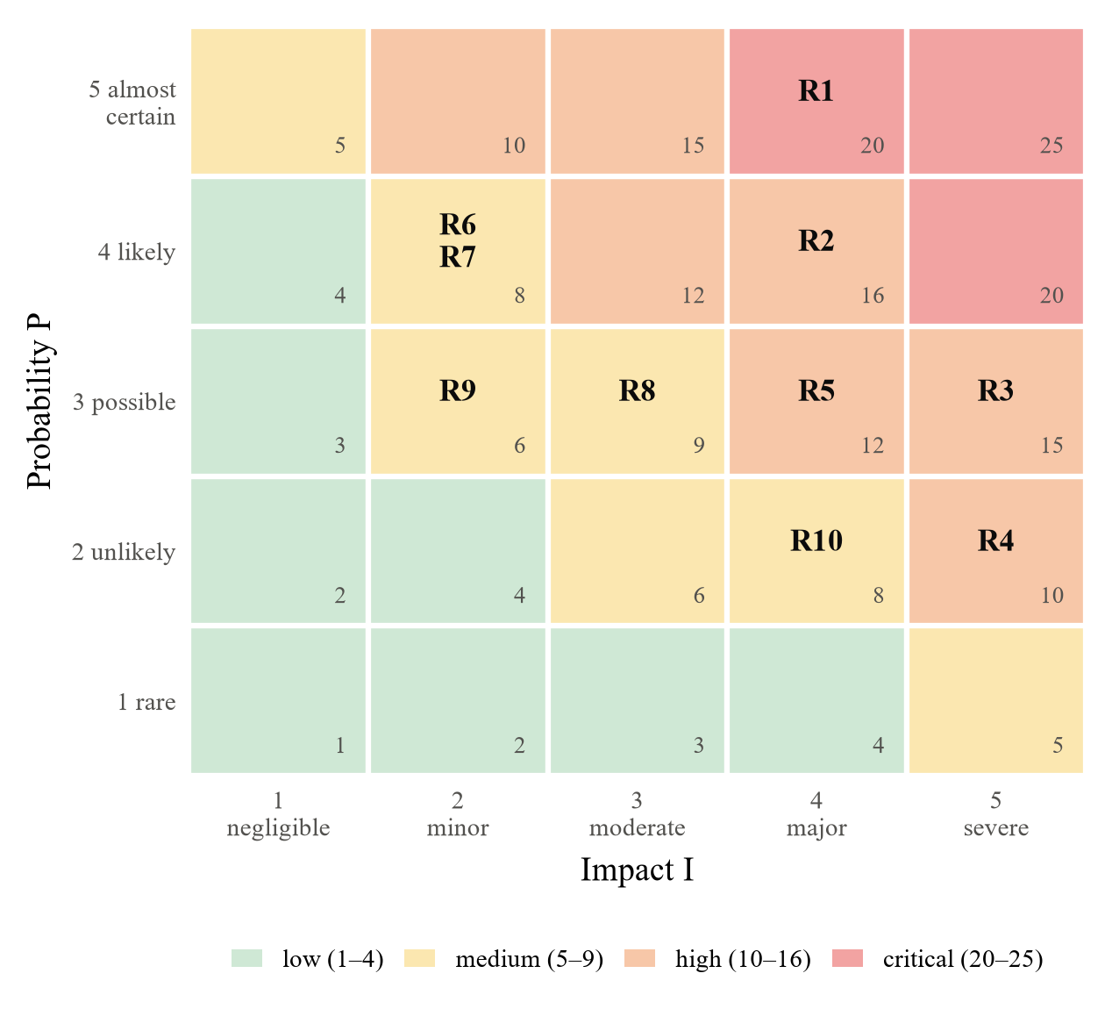
Figure 13: Risk score matrix (probability × impact)
  - Risk analysis result
    - Levels of risks
Table 23: Risk scores and levels
ID | Risk | P | I | S = P × I | Level
R1 | Noisy TV labels | 5 | 4 | 20 | critical
R2 | Domain shift in use | 4 | 4 | 16 | high
R3 | Over-interpretation or misuse | 3 | 5 | 15 | high
R5 | Bias | 3 | 4 | 12 | high
R4 | Privacy breach | 2 | 5 | 10 | high
R8 | Licenses of data | 3 | 3 | 9 | medium
R6 | Low memory on the laptop | 4 | 2 | 8 | medium
R7 | Cloud quota | 4 | 2 | 8 | medium
R10 | Identity leakage | 2 | 4 | 8 | medium
R9 | Slow analysis | 3 | 2 | 6 | medium

    - List of priority risks
Table 24: Priority risks and their mitigation
ID | Mitigation | Status
R1 | Human review of the TV faces (review page logs every checked face); human-checked TV test subset; train with human-labeled faces (stage E) | partly done
R2 | Quality gates with gray flags; pilot on consented local data before use; report accuracy per condition | gates done; pilot planned
R3 | Probabilities and model crop always shown; guide and report state limits; no workplace or school use | done
R5 | Measure accuracy by age, gender and skin tone on a labeled subset; add data where it is low | planned
R4 | Local server bound to 127.0.0.1; no upload; consent for any recording; data kept private | done
R10 | Splits by person with SFace clustering; leak check per build; de-duplication of the course data | done

- Financial and economic report
Table 25 lists the real costs of the project. Values marked estimate are calculated from stated assumptions, not from bills.
Table 25: Project costs
Item | Quantity / basis | Cost (VND)
Laptop (RTX 3050, 16 GB) | Already owned by a team member | 0 (no purchase)
Google Colab | Free tier (T4 GPU) | 0
Software | Open source: Python, PyTorch, OpenCV, Flask, scikit-learn | 0
Datasets and models | Public research datasets and models; TV episodes publicly available | 0
Electricity (estimate) | ≈ 20 h of GPU load × ≈ 0.13 kW ≈ 2.6 kWh at ≈ 3,000 VND/kWh | ≈ 8,000
Total cash cost |  | ≈ 8,000 (under 1 USD)

The 20 GPU hours are estimated from the logged laptop jobs: about 4 h for the midterm runs, about 9 h of face extraction from the TV episodes, about 3.5 h for the laptop transfer and mix runs, and about 3 h of tests and the application. The students' time (about seven weeks of part-time work) is the real cost of the project and is not priced here.
Deployment. A clinic, school or studio can run the application on an existing Windows PC. Without a GPU the network needs about 17 ms per face on the CPU, so the application stays usable at a lower frame rate; a desktop with an entry-level NVIDIA GPU gives the speed reported here. The software has no license fee, in contrast with the commercial tools of Table 2. The main cost of a real deployment would be the validation study and the human labeling of local data, not hardware.
- Conclusions
This project built a complete facial emotion recognition system for Vietnamese faces, from data to a real-time application, aimed at reviewing recordings in medicine and art.
- Three networks were compared under one pipeline with three seeds each. ResNet-18 was the most accurate and most stable: 68.3% on the course test set, 94.3% in subject-independent CK+ cross-validation.
- A dataset of 16,550 Vietnamese TV faces of 352 people was built with a reproducible pipeline that aligns faces like CK+, filters them with quality gates and splits them by person.
- Measuring on human labels exposed a model that only agreed with its label suggesters (53% on RAF-DB). Training on TV faces together with human-labeled course faces raised this to 79.4 ± 0.9%, with the largest gains on the rare emotions.
- A local browser application opens any video or image, seeks and jumps to any time, keeps marks, scans a whole film for its strongest moments and runs at 13–17 analyzed frames per second on 1080p video.
The main open point is accuracy on Vietnamese TV faces, which needs a human-checked test set. Future work, in order: (1) human review of the TV labels and retraining; (2) Grad-CAM [29] maps for the three networks to check that the models look at eyes, brows and mouth; (3) a faster MobileNetV2 version of the mix model; (4) more real faces for the rare classes; (5) valence, arousal and intensity outputs; and (6) pilot studies with clinicians and film professionals, with consent and ethics approval.
- Standards
Table 26 lists the standards and regulations that apply to the project or to a later deployment.
Table 26: Applicable standards and regulations
Standard / regulation | Topic | Relevance
IEEE Std 7000-2021 [43] | Ethical concerns in system design | Method used to list stakeholder values (privacy, honesty, fairness) in Section 5.7
IEEE Std 7014-2024 [44] | Ethics of emulated empathy in AI systems | Directly about systems that recognize human emotion
ISO/IEC 23894:2023 [45] | AI risk management | Structure of the risk analysis in Chapter 9
ISO/IEC 42001:2023 [46] | AI management systems | For an organization that deploys the tool
IEC 62304 [47], ISO 14971 [48] | Medical device software and risk management | Required if the tool ever becomes a medical device; not claimed now
Decree 13/2023/ND-CP [8], Law 91/2025/QH15 [49] | Vietnamese personal data protection | Face images are personal data; consent and local processing
GDPR [50], EU AI Act [40] | EU data protection and AI rules | Biometric data; emotion recognition banned in workplaces and schools except medical or safety use
RFC 9110 [42]; JPEG, PNG, MP4 | HTTP range requests; image and video formats | Seeking in large files; frame and screenshot formats
IEEE reference style | Citations and references | Format of the references in Chapter 13

- References
[1] R. W. Picard, Affective Computing. Cambridge, MA, USA: MIT Press, 1997.
[2] P. Lucey, J. F. Cohn, K. M. Prkachin, P. E. Solomon, and I. Matthews, "Painful data: The UNBC-McMaster shoulder pain expression archive database," in Proc. IEEE Int. Conf. Automatic Face and Gesture Recognition (FG), 2011, pp. 57–64.
[3] J. F. Cohn et al., "Detecting depression from facial actions and vocal prosody," in Proc. 3rd Int. Conf. Affective Computing and Intelligent Interaction (ACII), 2009, pp. 1–7.
[4] J. Daniels et al., "Exploratory study examining the at-home feasibility of a wearable tool for social-affective learning in children with autism," npj Digital Medicine, vol. 1, art. 32, 2018.
[5] A. J. Reagan, L. Mitchell, D. Kiley, C. M. Danforth, and P. S. Dodds, "The emotional arcs of stories are dominated by six basic shapes," EPJ Data Science, vol. 5, art. 31, 2016.
[6] D. McDuff, R. el Kaliouby, and R. W. Picard, "Crowdsourcing facial responses to online videos," IEEE Transactions on Affective Computing, vol. 3, no. 4, pp. 456–468, 2012.
[7] R. E. Jack, O. G. B. Garrod, H. Yu, R. Caldara, and P. G. Schyns, "Facial expressions of emotion are not culturally universal," Proceedings of the National Academy of Sciences, vol. 109, no. 19, pp. 7241–7244, 2012.
[8] Government of Vietnam, Decree No. 13/2023/ND-CP on Personal Data Protection, Apr. 17, 2023.
[9] S. Bird, "Responsible AI investments and safeguards for facial recognition," Microsoft Azure Blog, Jun. 21, 2022.
[10] P. Ekman and W. V. Friesen, "Constants across cultures in the face and emotion," Journal of Personality and Social Psychology, vol. 17, no. 2, pp. 124–129, 1971.
[11] L. F. Barrett, R. Adolphs, S. Marsella, A. M. Martinez, and S. D. Pollak, "Emotional expressions reconsidered: Challenges to inferring emotion from human facial movements," Psychological Science in the Public Interest, vol. 20, no. 1, pp. 1–68, 2019.
[12] M. J. den Uyl and H. van Kuilenburg, "The FaceReader: Online facial expression recognition," in Proc. Measuring Behavior 2005, Wageningen, The Netherlands, 2005, pp. 589–590.
[13] D. McDuff, A. Mahmoud, M. Mavadati, M. Amr, J. Turcot, and R. el Kaliouby, "AFFDEX SDK: A cross-platform real-time multi-face expression recognition toolkit," in Proc. CHI Conf. Extended Abstracts on Human Factors in Computing Systems, 2016, pp. 3723–3726.
[14] T. Baltrušaitis, A. Zadeh, Y. C. Lim, and L.-P. Morency, "OpenFace 2.0: Facial behavior analysis toolkit," in Proc. IEEE Int. Conf. Automatic Face and Gesture Recognition (FG), 2018, pp. 59–66.
[15] A. V. Savchenko, "Facial expression and attributes recognition based on multi-task learning of lightweight neural networks," in Proc. IEEE 19th Int. Symp. Intelligent Systems and Informatics (SISY), 2021.
[16] E. Barsoum, C. Zhang, C. Canton Ferrer, and Z. Zhang, "Training deep networks for facial expression recognition with crowd-sourced label distribution," in Proc. 18th ACM Int. Conf. Multimodal Interaction (ICMI), 2016, pp. 279–283.
[17] P. Ekman and W. V. Friesen, Facial Action Coding System: A Technique for the Measurement of Facial Movement. Palo Alto, CA, USA: Consulting Psychologists Press, 1978.
[18] P. Lucey, J. F. Cohn, T. Kanade, J. Saragih, Z. Ambadar, and I. Matthews, "The extended Cohn-Kanade dataset (CK+): A complete dataset for action unit and emotion-specified expression," in Proc. IEEE Conf. Computer Vision and Pattern Recognition Workshops (CVPRW), 2010, pp. 94–101.
[19] I. J. Goodfellow et al., "Challenges in representation learning: A report on three machine learning contests," in Proc. Int. Conf. Neural Information Processing (ICONIP), LNCS vol. 8228, 2013, pp. 117–124.
[20] S. Li, W. Deng, and J. Du, "Reliable crowdsourcing and deep locality-preserving learning for expression recognition in the wild," in Proc. IEEE Conf. Computer Vision and Pattern Recognition (CVPR), 2017, pp. 2852–2861.
[21] A. Mollahosseini, B. Hasani, and M. H. Mahoor, "AffectNet: A database for facial expression, valence, and arousal computing in the wild," IEEE Transactions on Affective Computing, vol. 10, no. 1, pp. 18–31, 2019.
[22] S. Li and W. Deng, "Deep facial expression recognition: A survey," IEEE Transactions on Affective Computing, vol. 13, no. 3, pp. 1195–1215, 2022.
[23] O. Russakovsky et al., "ImageNet large scale visual recognition challenge," International Journal of Computer Vision, vol. 115, no. 3, pp. 211–252, 2015.
[24] K. He, X. Zhang, S. Ren, and J. Sun, "Deep residual learning for image recognition," in Proc. IEEE Conf. Computer Vision and Pattern Recognition (CVPR), 2016, pp. 770–778.
[25] M. Sandler, A. Howard, M. Zhu, A. Zhmoginov, and L.-C. Chen, "MobileNetV2: Inverted residuals and linear bottlenecks," in Proc. IEEE Conf. Computer Vision and Pattern Recognition (CVPR), 2018, pp. 4510–4520.
[26] W. Wu, H. Peng, and S. Yu, "YuNet: A tiny millisecond-level face detector," Machine Intelligence Research, vol. 20, no. 5, pp. 656–665, 2023.
[27] S. Umeyama, "Least-squares estimation of transformation parameters between two point patterns," IEEE Transactions on Pattern Analysis and Machine Intelligence, vol. 13, no. 4, pp. 376–380, 1991.
[28] Y. Zhong, W. Deng, J. Hu, D. Zhao, X. Li, and D. Wen, "SFace: Sigmoid-constrained hypersphere loss for robust face recognition," IEEE Transactions on Image Processing, vol. 30, pp. 2587–2598, 2021.
[29] R. R. Selvaraju, M. Cogswell, A. Das, R. Vedantam, D. Parikh, and D. Batra, "Grad-CAM: Visual explanations from deep networks via gradient-based localization," in Proc. IEEE Int. Conf. Computer Vision (ICCV), 2017, pp. 618–626.
[30] A. Paszke et al., "PyTorch: An imperative style, high-performance deep learning library," in Advances in Neural Information Processing Systems (NeurIPS), vol. 32, 2019, pp. 8024–8035.
[31] G. Bradski, "The OpenCV library," Dr. Dobb's Journal of Software Tools, 2000.
[32] F. Pedregosa et al., "Scikit-learn: Machine learning in Python," Journal of Machine Learning Research, vol. 12, pp. 2825–2830, 2011.
[33] S. Ioffe and C. Szegedy, "Batch normalization: Accelerating deep network training by reducing internal covariate shift," in Proc. 32nd Int. Conf. Machine Learning (ICML), 2015, pp. 448–456.
[34] N. Srivastava, G. Hinton, A. Krizhevsky, I. Sutskever, and R. Salakhutdinov, "Dropout: A simple way to prevent neural networks from overfitting," Journal of Machine Learning Research, vol. 15, pp. 1929–1958, 2014.
[35] B. Efron and R. J. Tibshirani, An Introduction to the Bootstrap. New York, NY, USA: Chapman & Hall, 1993.
[36] C. Szegedy, V. Vanhoucke, S. Ioffe, J. Shlens, and Z. Wojna, "Rethinking the Inception architecture for computer vision," in Proc. IEEE Conf. Computer Vision and Pattern Recognition (CVPR), 2016, pp. 2818–2826.
[37] I. Loshchilov and F. Hutter, "Decoupled weight decay regularization," in Proc. Int. Conf. Learning Representations (ICLR), 2019.
[38] I. Loshchilov and F. Hutter, "SGDR: Stochastic gradient descent with warm restarts," in Proc. Int. Conf. Learning Representations (ICLR), 2017.
[39] IEEE, "IEEE Code of Ethics," IEEE Policies, Section 7.8, 2020.
[40] European Parliament and Council, Regulation (EU) 2024/1689 laying down harmonised rules on artificial intelligence (Artificial Intelligence Act), Official Journal of the European Union, Jul. 12, 2024.
[41] J. Buolamwini and T. Gebru, "Gender shades: Intersectional accuracy disparities in commercial gender classification," in Proc. Conf. Fairness, Accountability and Transparency (FAT*), PMLR vol. 81, 2018, pp. 77–91.
[42] R. Fielding, M. Nottingham, and J. Reschke, "HTTP Semantics," RFC 9110, IETF, Jun. 2022.
[43] IEEE Standard Model Process for Addressing Ethical Concerns during System Design, IEEE Std 7000-2021, 2021.
[44] IEEE Standard for Ethical Considerations in Emulated Empathy in Autonomous and Intelligent Systems, IEEE Std 7014-2024, 2024.
[45] Information technology — Artificial intelligence — Guidance on risk management, ISO/IEC 23894:2023, 2023.
[46] Information technology — Artificial intelligence — Management system, ISO/IEC 42001:2023, 2023.
[47] Medical device software — Software life cycle processes, IEC 62304:2006+AMD1:2015, 2015.
[48] Medical devices — Application of risk management to medical devices, ISO 14971:2019, 2019.
[49] National Assembly of Vietnam, Law on Personal Data Protection No. 91/2025/QH15, Jun. 26, 2025 (in force Jan. 1, 2026).
[50] European Parliament and Council, Regulation (EU) 2016/679 (General Data Protection Regulation), Official Journal of the European Union, L 119, May 4, 2016.
- Appendices
Appendix A: Main commands (from the project folder D:\Project\facial emotion).
Table 27: Main commands
Task | Command
Open the application | app_nhan_dien.bat or python -m src.demo.app
OpenCV demo with a file dialog | python -m src.demo.webcam --pick
Train one run | python -m src.train --config configs/transfer/resnet18_mix.yaml --seed 42 --init <CK+ run>
Evaluate on the test set | python -m src.evaluate --run <run directory>
Score against human labels | python -m src.eval_wild --runs "runs/transfer_mix/resnet18_s*" --splits test
Collect results | python -m src.aggregate --runs runs/transfer_mix --out reports/transfer_mix_results.csv
TV dataset pipeline | python -m src.data.vtv_pipeline --status, then --detach

Appendix B: Keyboard shortcuts of the application.
Table 28: Keyboard shortcuts of the browser application
Key | Action | Key | Action
Space / K | play, pause | B | add a time mark
← / → | back / forward 5 s | G or / | type a time to jump to
Shift + ← / → | back / forward 1 min | S | screenshot with boxes
J / L | back / forward 10 s | F | full screen
, / . | one frame back / forward | M | mute
0 … 9 | jump to 0 … 90% | PgUp / PgDn | previous / next file
O | open a file | ? | help

Appendix C: Deliverables. The project folder contains the code (src/), the configurations (configs/), the reports and figures (reports/), and a summary folder tong_hop_ket_qua/ with copies of every result table, the training runs of all stages, the application with its guide, and the application model (models/resnet18_mix_s42_app_model/). The TV frames and the research datasets are covered by licenses and are kept private.

