PHENIKAA UNIVERSITY
PHENIKAA SCHOOL OF ENGINEERING
Faculty of Electrical and Electronic Engineering (EEE)
Artificial Intelligence and Robotics (AI&RB)
REINFORCEMENT LEARNING COURSE PROJECT REPORT
TOPIC 13: MULTI-DELIVERY ROBOT
A robot delivering multiple parcels – tabular Q-learning and Monte Carlo
Student: Nguyen Quang Trung
Student ID: 22011211
Supervisor: MSc. Vu Hoang Dieu
Hanoi, October 2026

TABLE OF CONTENTS
1. Problem statement 3
2. MDP model 3
2.1. State 3
2.2. Actions and rewards 4
2.3. Transition function 4
2.4. Termination 4
2.5. Extra variables that keep the state Markov 4
3. State encoding and state-space size 5
4. The four settings and their maps 7
5. Algorithms 8
5.1. ε-greedy policy 8
5.2. Q-learning (off-policy TD) 8
5.3. First-visit Monte Carlo (on-policy) 8
5.4. Two Q-learning variants and the optimal reference 9
6. Experimental results 10
6.1. Effect of the number of episodes 12
7. Final policies 12
8. Q-learning vs. Monte Carlo and failure analysis 14
9. Changing rewards and environment parameters 15
10. Conclusion and running the demo 17

1. Problem statement
A robot moves on a square grid, picks up several parcels at pickup cells (P) and delivers them to drop cells (D); the agent learns by itself the pickup and delivery order that maximizes the total reward. The environment is a custom gymnasium.Env that follows the logic of Taxi-v3, and the agent learns a Q table (Q-learning and Monte Carlo), with no DQN or function approximation.
The source code is in D:\Project\Project_RL:
Table 1. Source code layout
File / folder | Role
configs/*.json | 4 maps/settings (grid, parcels, capacity, deadline, booster cell, rewards, training parameters)
delivery_env.py | The MultiDeliveryEnv environment: state encoding, transition function, rewards
agents.py | Q-learning and first-visit Monte Carlo, ε-greedy policy, greedy policy rollout
planner.py | Value Iteration to compute the optimal return used as a reference
experiments.py | Runs every experiment (5 seeds) and saves the results to results/
plots.py | Draws maps, learning curves, policies and reward experiments into figures/ (--lang en writes English labels to figures_en/)
demo.py | Runs one episode with the learned policy and prints every step
README.md | Explains each file, the formulas and how to run the code (in Vietnamese)

2. MDP model
At each step the robot is in state s, chooses action a, receives reward r and moves to state s′; the environment is deterministic, so (s, a) always leads to exactly one s′.

2.1. State
The state is a tuple with 5 components:
$$s=\left(\text{row, col},σ_{1},…,σ_{N},τ,b\right)$$
$$σ_{i}∈\{0, 1, 2\}, τ∈\{0,…,T_{d}\}, b∈\{0, 1, 2\}$$
- σᵢ is the status of parcel i: 0 = not picked up, 1 = being carried, 2 = delivered.
- τ is the deadline clock (setting 3 only) and b is the booster status (setting 4 only): 0 = unused, 1 = active, 2 = used up.

2.2. Actions and rewards
There are 6 actions: Up, Down, Left, Right, Pickup, Drop.
Table 2. Default rewards
Event | Reward
Each step (including bumping into a wall) | −1
Delivering a parcel correctly (per-order reward) | +20
Pickup/Drop in the wrong place or over capacity | −10 (plus the step penalty)
Deadline parcel still undelivered when τ reaches T_{d} (paid once) | −30

2.3. Transition function
- Move: if the new cell is inside the grid and is not a wall, the robot moves there; otherwise it stays put. Stepping on the booster cell when b = 0 sets b = 1.
- Pickup: if parcel i is waiting at the current cell and the robot carries fewer parcels than its capacity (2 if b = 1, otherwise capacity), then σᵢ: 0 → 1.
- Drop: if the robot carries parcel i and the current cell is its destination, then σᵢ: 1 → 2 and the order reward is paid. If b = 1 and the robot has just become empty-handed, b = 2 (the booster trip is over).
- Clock: if the deadline parcel has been delivered, τ = T_{d}; otherwise τ increases by 1 (capped at T_{d}), and the late penalty is paid at the moment it reaches T_{d}.

2.4. Termination
An episode is terminated when every σᵢ = 2 and truncated when max_steps runs out (100 / 150 / 200 / 200 for S1–S4). Truncation is a time limit on the run, not a terminal state, so Q-learning still bootstraps on the last step.

2.5. Extra variables that keep the state Markov
- τ: the late penalty depends on how many steps have been taken, so without τ two visits to the same cell with the same parcel statuses could have different futures. Once the deadline parcel is delivered, τ is merged into T_{d} because time no longer affects the reward.
- b: the capacity depends on whether the robot has passed the booster cell and whether that trip is over; position and σ alone cannot tell.
- σ = 1 (carrying) replaces a separate "current load" variable: the number of parcels carried = the number of σᵢ equal to 1.

3. State encoding and state-space size
The statuses of the N parcels are read as an N-digit base-3 number, and the whole tuple is then packed into a single integer that serves as the row index of the Q table (encode / decode in delivery_env.py).
$$\text{code}=\sum_{i=1}^{N}{σ_{i}·3^{i-1}}∈\{0,…,3^{N}-1\}$$
$$\text{idx}=\left(\left(\left(\text{row}·W+\text{col}\right)·3^{N}+\text{code}\right)·T+τ\right)·B+b$$
The size of the encoded state space is the product of the number of values of each component:
$$|S|=H·W·3^{N}·T·B$$
$$T=\left\{\begin{aligned}&T_{d}+1,\text{ if one parcel has a deadline} \\ &1,\text{ otherwise}\end{aligned}\right.$$
$$B=\left\{\begin{aligned}&3,\text{ if the map has a booster cell} \\ &1,\text{ otherwise}\end{aligned}\right.$$
For S3 and S4 this gives:
$$\begin{aligned}{|S|}_{\text{S3}}&=6·6·3^{3}·19·1=\text{18,468} \\ {|S|}_{\text{S4}}&=7·7·3^{3}·1·3=\text{3,969}\end{aligned}$$
Example on S3 (6x6 grid, N = 3, T = 19, B = 1): the robot is at row 2, column 3, A is delivered (σ₁ = 2), B is being carried (σ₂ = 1), C is not picked up (σ₃ = 0) and τ = 7:
$$\begin{aligned}\text{code}&=2·3^{0}+1·3^{1}+0·3^{2}=5 \\ \text{idx}&=(((2·6+3)·27+5)·19+7)·1+0 \\ &=(15·27+5)·19+7=410·19+7=7797\end{aligned}$$
decode reverses this with successive divmod operations, taking one component off the right at a time:
$$\begin{aligned}7797&=410·19+7⇒τ=7 \\ 410&=15·27+5⇒\text{code}=5⇒\left(σ_{1},σ_{2},σ_{3}\right)=\left(2, 1, 0\right) \\ 15&=2·6+3⇒\text{row}=2,\text{ col}=3\end{aligned}$$
Table 3. State-space and action-space size
Setting | Grid | Parcels | Capacity | T | B | Encoded |S| | Reachable (BFS) | |A|
S1 – 2 independent parcels | 5x5 | 2 | 2 | 1 | 1 | 225 | 186 | 6
S2 – 3 parcels, carry 1 | 5x5 | 3 | 1 | 1 | 1 | 675 | 364 | 6
S3 – parcel C deadline 18 | 6x6 | 3 | 1 | 19 | 1 | 18,468 | 2,825 | 6
S4 – booster cell | 7x7 | 3 | 1 (2 when boosted) | 1 | 3 | 3,969 | 2,347 | 6

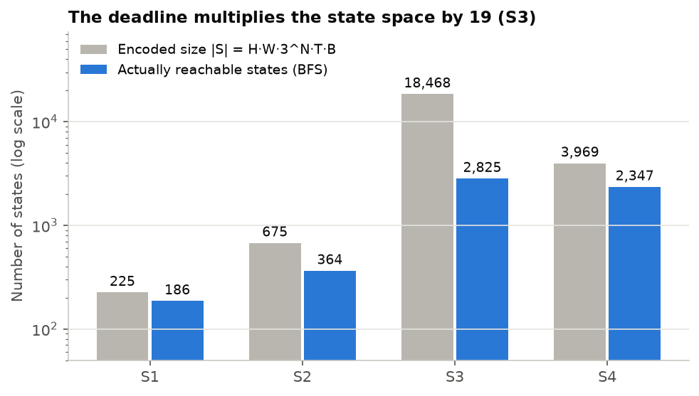
Figure 1. Encoded size and actually reachable states of the four settings (log scale)
The number of reachable states is smaller than |S| because wall cells can never be occupied, capacity 1 rules out combinations with two σᵢ = 1 (20 of the 27 combinations remain), and τ and b only take values that can actually be reached. For simplicity the Q table still allocates all |S| rows; the largest is 18,468 x 6 floats (about 0.9 MB).

4. The four settings and their maps
The four maps correspond to the 4 mandatory settings and get harder in grid size, number of parcels and constraints. Each map is a JSON file in configs/, so switching maps needs no code change.
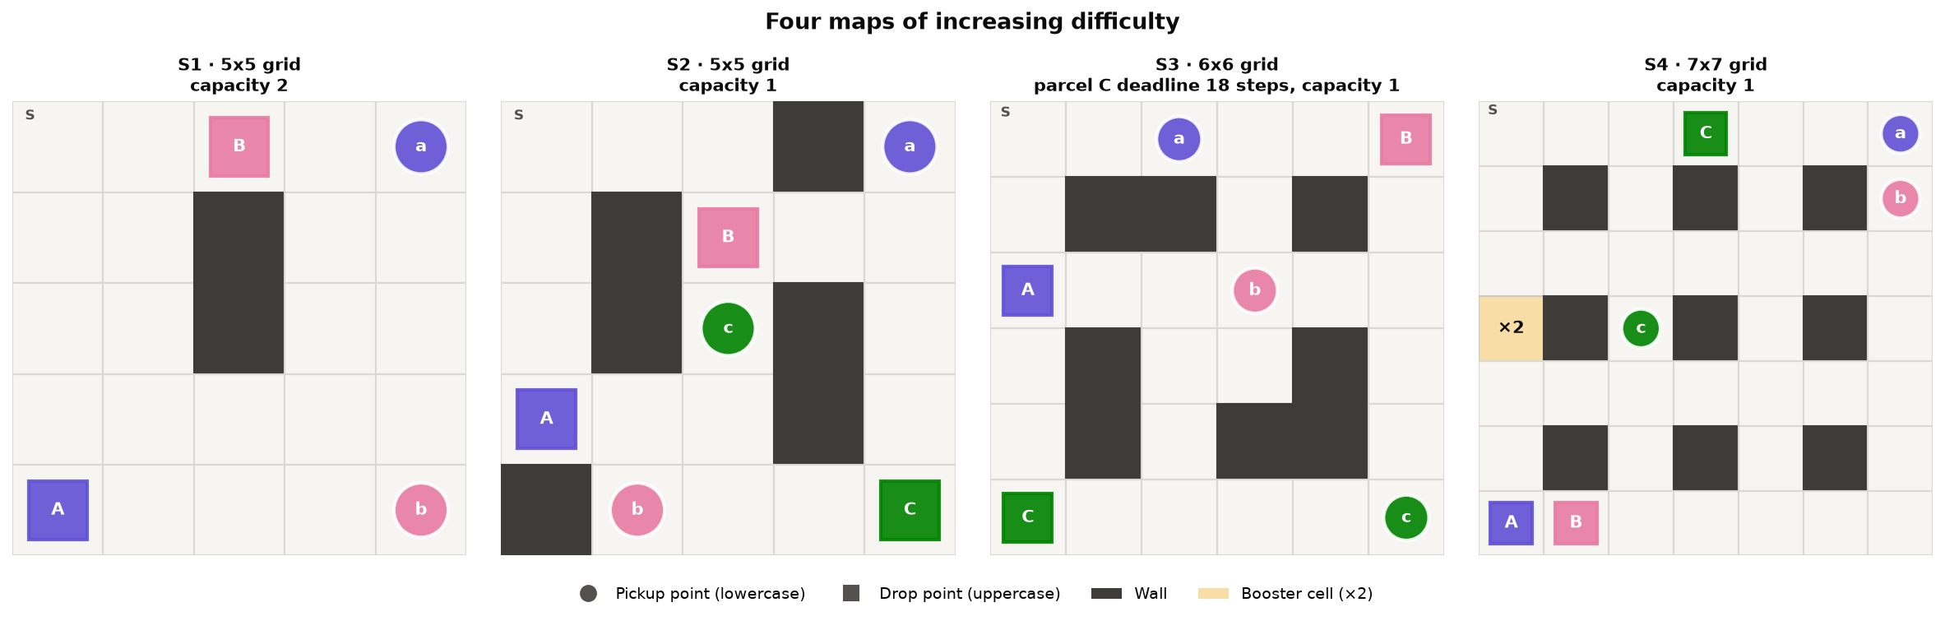
Figure 2. The four maps: pickup points are circles (lowercase), drop points are squares (uppercase), walls are dark, the ×2 booster cell is yellow
Table 4. The four settings and their optimal routes (Value Iteration)
Setting | Grid | Parcels | Capacity | Special feature | Optimal route | max_steps
S1 | 5x5 | 2 | 2 | Two independent parcels that can be carried together | Pick A, pick B, drop A, drop B: 22 steps, return 18 | 100
S2 | 5x5 | 3 | 1 | Each parcel is picked up and delivered one at a time | C → B → A: 31 steps, return 29 | 150
S3 | 6x6 | 3 | 1 | Parcel C must be delivered within the first 18 steps | C → B → A: 38 steps, return 22 | 200
S4 | 7x7 | 3 | 1 | After the booster cell the robot can carry 2 parcels for one trip | C → B → A using the booster: 38 steps, return 22 | 200

Difficulty grows with the number of reachable states (186 → 364 → 2,825 → 2,347) and with the length of the optimal route (22 → 31 → 38 → 38 steps). S3 and S4 also force a trade-off: in S3 the far parcel (C) must be delivered first even though the total route is longer; in S4 the robot must detour through the booster cell to save 8 steps later.
The "one trip" rule in S4: the booster trip starts when the robot steps on the booster cell and ends the first time the robot is empty-handed after a Drop; the cell can be used only once per episode.

5. Algorithms
Both algorithms store a Q table of size |S| x 6 and choose actions ε-greedily; they differ only in how they compute the "target" used to update Q.

5.1. ε-greedy policy
With probability ε the agent picks one of the 6 actions at random, otherwise it picks argmax Q(s, ·) (ties broken at random). ε decays linearly from 1.0 to 0.05 over the first 70% of the episodes and then stays fixed:
$$ε(\text{ep})=ε_{\text{start}}+\min\left(1,\frac{\text{ep}}{0.7·n_{\text{ep}}}\right)·\left(ε_{\text{end}}-ε_{\text{start}}\right)$$
For example, on S3 (100,000 episodes) at episode 35,000:
$$\begin{aligned}ε&=1+\min\left(1,\frac{\text{35,000}}{\text{70,000}}\right)·(0.05-1) \\ &=1+0.5·(-0.95)=0.525\end{aligned}$$
The final policy is the greedy policy: in each state it picks the action with the largest Q value. This policy is used for evaluation, for the demo and for the policy figures:
$$π(s)=\underset{a}{arg max}{Q(s,a)}$$

5.2. Q-learning (off-policy TD)
$$Q(s,a)←Q(s,a)+α\left[r+γ\max_{a'}{Q(s',a')}-Q(s,a)\right]$$
Q is updated after every step. The target depends on whether the step really ends the episode:
$$\text{target}=\left\{\begin{aligned}&r,\text{ if s' is terminal (all parcels delivered)} \\ &r+γ\max_{a'}{Q(s',a')},\text{ otherwise}\end{aligned}\right.$$
Being cut off by max_steps is a time limit, not a terminal state, so it uses the second case. Example with α = 0.5, γ = 0.99, Q(s,a) = 0, r = −1 and max Q(s′,a′) = 10:
$$\begin{aligned}\text{target}&=r+γ\max_{a'}{Q(s',a')}=-1+0.99·10=8.9 \\ Q(s,a)&←Q(s,a)+α\left(\text{target}-Q(s,a)\right)=0+0.5·(8.9-0)=4.45\end{aligned}$$

5.3. First-visit Monte Carlo (on-policy)
$$G_{t}=r_{t+1}+γG_{t+1}$$
$$N(s,a)←N(s,a)+1, Q(s,a)←Q(s,a)+\frac{1}{N(s,a)}\left[G_{t}-Q(s,a)\right]$$
The agent plays the whole episode, computes the return backwards from the end and updates only the first occurrence of each (s, a) pair, using the 1/N sample average. Example with γ = 0.99, where the last three rewards are −1, −1 and +19 (the step that delivers a parcel earns −1 + 20 = +19):
$$\begin{aligned}G_{T-1}&=r_{T}=19 \\ G_{T-2}&=r_{T-1}+γG_{T-1}=-1+0.99·19=17.81 \\ G_{T-3}&=r_{T-2}+γG_{T-2}=-1+0.99·17.81=16.63\end{aligned}$$
The "Monte Carlo 4x" variant uses 4 times as many episodes and decays ε more slowly (1.0 → 0.1 over 90% of the episodes).

5.4. Two Q-learning variants and the optimal reference
The two Q-learning variants differ only in their initial value: Q₀ = 0 (below the true values, which are roughly +10 to +20) and Q₀ = 30 (optimistic: untried actions look attractive, so the agent explores on its own). Value Iteration (planner.py) iterates the Bellman optimality equation over every reachable state to find the best achievable return; it is not a learning algorithm, only the "optimal" reference line:
$$V(s)=\max_{a}\left[r(s,a)+γV(s')\right]$$
Table 5. Hyperparameters
Hyperparameter | Value
γ (discount) | 0.99
Q-learning α | 0.5 (the environment is deterministic, so a large α is fine)
Monte Carlo step size | 1/N(s, a)
ε | 1.0 → 0.05, decayed over 70% of the episodes
Episodes | S1: 20,000 · S2: 40,000 · S3: 100,000 · S4: 100,000 (4 times as many for Monte Carlo 4x)
Seeds | 5 seeds (0–4) per algorithm
Training start cell | A random free cell, all parcels waiting (as in Taxi-v3)
Evaluation | Greedy policy (ε = 0) run from cell S every 100–500 episodes

6. Experimental results
Q-learning with Q₀ = 30 reaches exactly the optimal return in 5/5 seeds on all 4 maps. With the same number of episodes, Monte Carlo delivers every parcel in only 12/20 runs (4 maps x 5 seeds), fails completely on S4 and is always late on S3.
Measurement: every 100–500 training episodes, the greedy policy (ε = 0) is run from cell S and its return is recorded; this is repeated with 5 seeds.
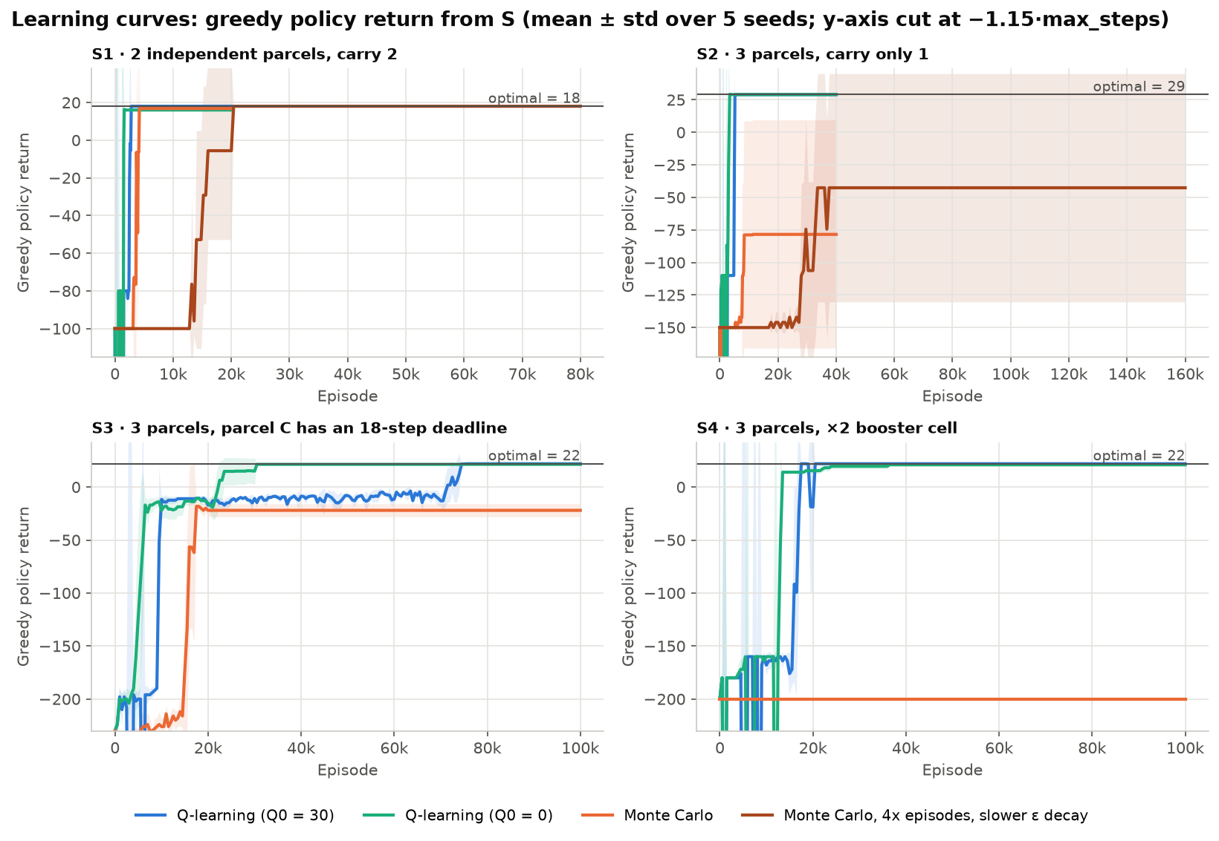
Figure 3. Learning curves: greedy policy return per episode, mean ± standard deviation over 5 seeds; the horizontal line is the optimal return
Table 6. Final results (greedy policy, 5 seeds)
Map | Variant | Episodes | Final return per seed | All delivered | Optimal | First optimal at episode
S1 (optimal 18) | Q-learning Q₀ = 30 | 20,000 | 18 in all 5 seeds | 5/5 | 5/5 | 2,500–2,700
S1 | Q-learning Q₀ = 0 | 20,000 | 16 in all 5 seeds | 5/5 | 0/5 | 1,400–1,500, then lost
S1 | Monte Carlo | 20,000 | 16, 18, 16, 18, 16 | 5/5 | 2/5 | 3,500–3,700
S1 | Monte Carlo 4x | 80,000 | 18 in all 5 seeds | 5/5 | 5/5 | 13,200–20,400
S2 (optimal 29) | Q-learning Q₀ = 30 | 40,000 | 29 in all 5 seeds | 5/5 | 5/5 | 5,000–5,200
S2 | Q-learning Q₀ = 0 | 40,000 | 29 in all 5 seeds | 5/5 | 5/5 | 2,800–3,400
S2 | Monte Carlo | 40,000 | −150, 29, −150, −150, 29 | 2/5 | 2/5 | 7,800–11,400
S2 | Monte Carlo 4x | 160,000 | −150, 29, 29, −150, 29 | 3/5 | 3/5 | 28,000–29,600
S3 (optimal 22) | Q-learning Q₀ = 30 | 100,000 | 22 in all 5 seeds | 5/5, on time | 5/5 | 71,000–75,500
S3 | Q-learning Q₀ = 0 | 100,000 | 22, 21, 21, 22, 21 | 5/5, on time | 2/5 | 22,000–30,500
S3 | Monte Carlo | 100,000 | −27, −31, −19, −19, −14 | 5/5, all late | 0/5 | –
S4 (optimal 22) | Q-learning Q₀ = 30 | 100,000 | 22 in all 5 seeds | 5/5 | 5/5 | 16,500–17,500
S4 | Q-learning Q₀ = 0 | 100,000 | 21 in all 5 seeds | 5/5 | 0/5 | –
S4 | Monte Carlo | 100,000 | −200 in all 5 seeds | 0/5 | 0/5 | –

A return of −150 / −200 means the policy loops until max_steps. Time per seed: Q-learning 14–149 seconds, Monte Carlo 10–219 seconds (12-core machine, seeds run in parallel); the full set of experiments takes about 22 minutes.
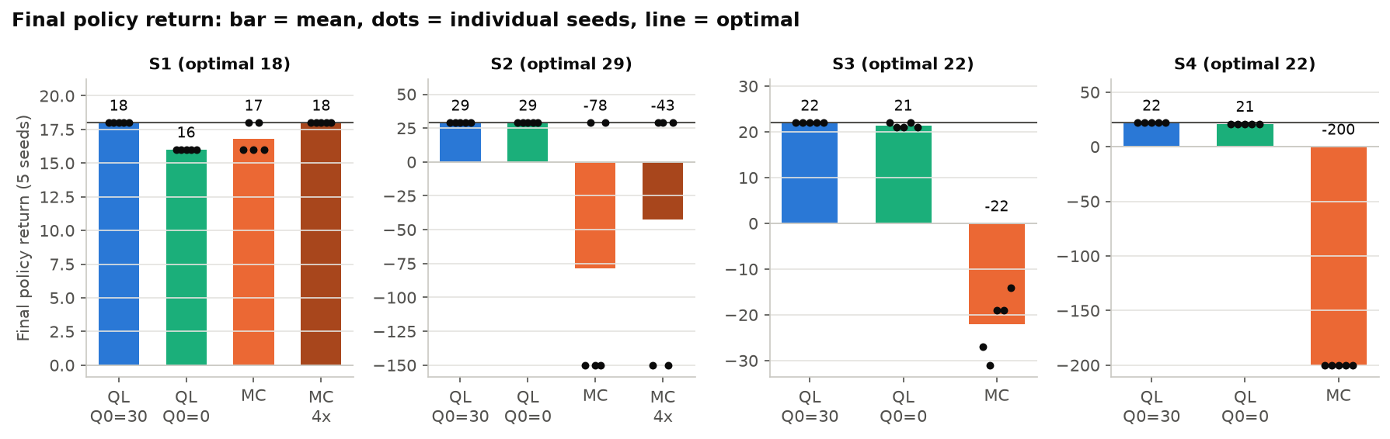
Figure 4. Final policy return: bar = mean, dots = individual seeds, horizontal line = optimal

6.1. Effect of the number of episodes
The first run used fewer episodes (S1 5,000, S2 10,000, S3 40,000, S4 30,000). More episodes clearly help Q-learning, while Monte Carlo only improves on the small maps.
Table 7. Fewer vs. more episodes
Case | Fewer episodes | More episodes
S3, Q-learning Q₀ = 30 | 40,000: optimal 2/5, 1 seed late | 100,000: optimal 5/5
S4, Q-learning Q₀ = 0 | 30,000: return 14, booster not used | 100,000: return 21, booster used
S1, Monte Carlo | 5,000: all delivered 3/5 | 20,000: all delivered 5/5, optimal 2/5
S2, Monte Carlo | 10,000: 1/5 | 40,000: 2/5
S4, Monte Carlo | 30,000: 0/5 | 100,000: 0/5

Q₀ = 0 converges earlier but easily gets stuck on a worse route: on S1 it always picks up B first (24 steps instead of 22), and on S4 it takes 1 extra step. Q₀ = 30 makes untried actions look attractive, so the agent explores on its own; the price is that it needs more episodes, especially on S3, where the τ dimension multiplies the number of states by 19.

7. Final policies
The policy learned on S4 matches the optimal solution: the robot goes through the booster cell right at the start, carries two parcels in one trip and finishes in 38 steps.
How to read the figure: each panel is one "phase" (a combination of parcel statuses and booster status). Grey arrows show the action the policy would choose if the robot stood in that cell during this phase; P/D mark Pickup/Drop. The coloured line is the path actually taken: its colour shows the parcel being carried, grey means empty-handed and black means carrying two parcels.
Sequence on S4:
- Go down to the ×2 cell to turn on the booster.
- Pick up C.
- Go to the top row and pick up A, now carrying C + A.
- Deliver C on the way.
- Still carrying A, so the booster trip is not over yet: pick up B as well.
- Carry A + B down to the bottom corner, deliver B, then A.
The agent discovered and exploited the "a trip ends when the robot is empty-handed" rule on its own.
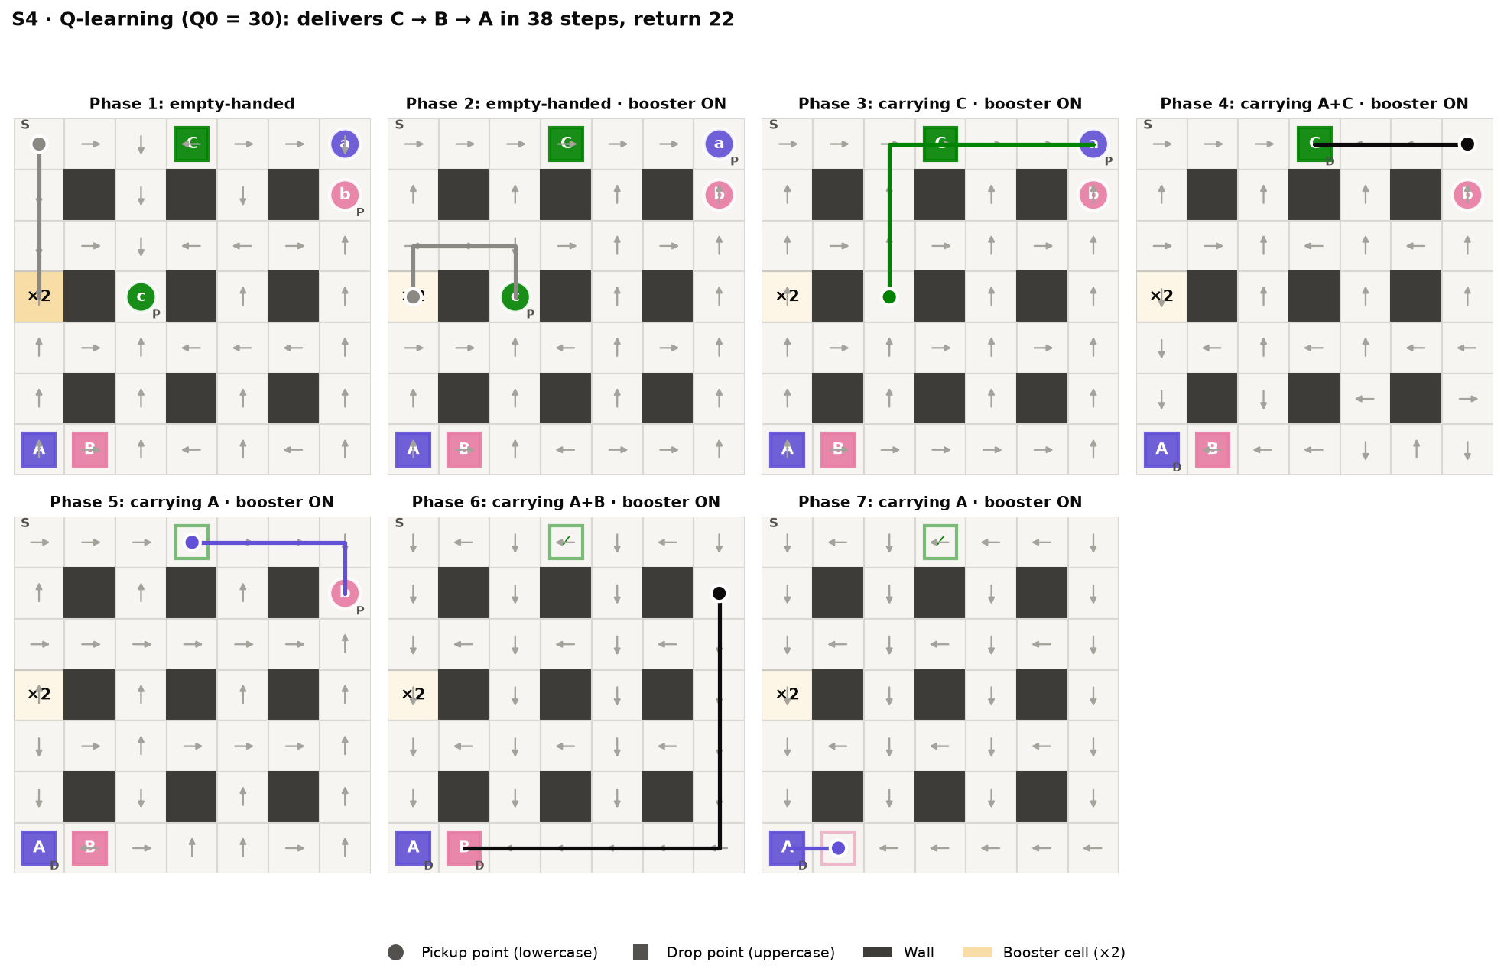
Figure 5. S4 policy (Q-learning Q₀ = 30): 7 phases from empty-handed to the last delivery
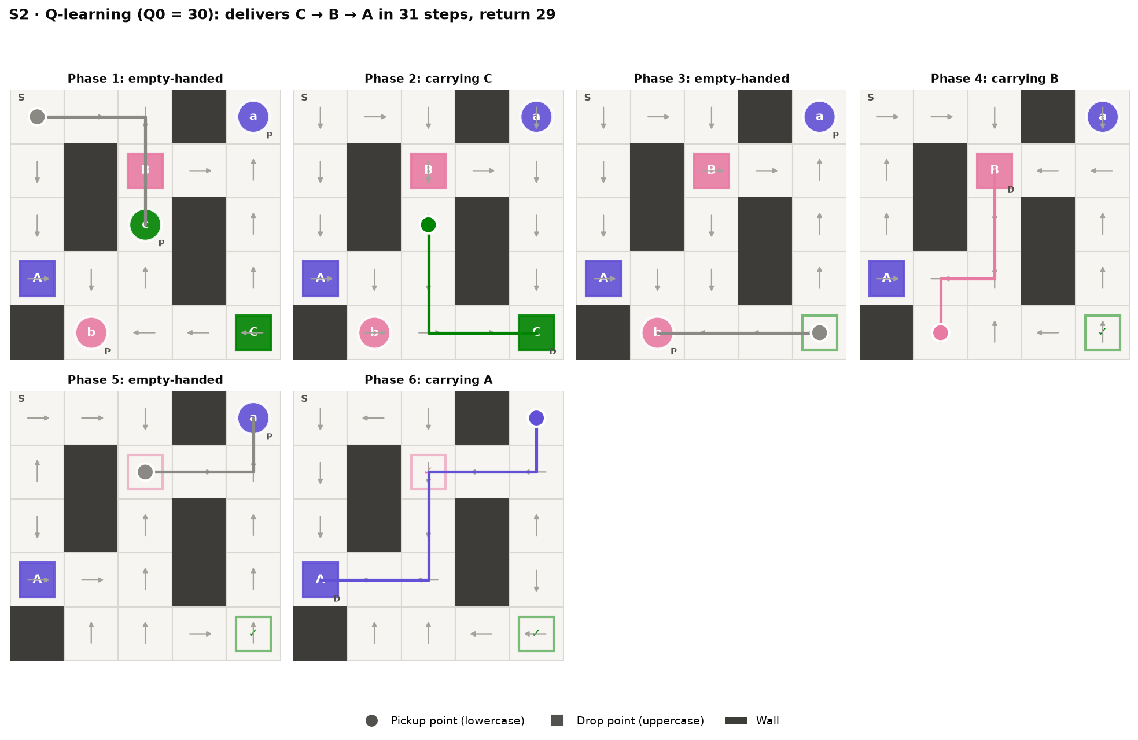
Figure 6. S2 policy (Q-learning Q₀ = 30): 6 phases, delivers C → B → A in 31 steps
On S2 the policy delivers in the order C → B → A (31 steps, return 29, equal to the optimum): it first picks up the parcel closest to S, and after each delivery the next pickup point is close to the drop it has just made. The arrows in cells off the path also point the right way, because training starts from random cells. The S3 policy figure is in figures_en/policy_S3.png.

8. Q-learning vs. Monte Carlo and failure analysis
Monte Carlo fails for two structural reasons: there is no learning signal when episodes rarely finish, and returns are too noisy compared with the gaps between action values. More episodes only rescue the smallest map: MC 4x is optimal in 5/5 seeds on S1 but only 3/5 on S2.
Table 8. Q-learning vs. Monte Carlo
 | Q-learning | First-visit Monte Carlo
Update | After every step | After the whole episode
Target | r + γ·max Q(s′), noise-free because the environment is deterministic | Return G, which depends on every random action that follows
Episode cut off at max_steps | Still learns from every step, including each +20 delivery | Return ≈ −max_steps, almost no signal
Policy being learned | Greedy (off-policy) | ε-greedy (on-policy)
Result (same number of episodes) | All delivered in 20/20 runs, optimal in 20/20 (Q₀ = 30) | All delivered in 12/20 runs, optimal in 4/20

Case 1 – no signal (S4). A random walk almost never delivers all 3 parcels within 200 steps, so MC episodes are cut off with a very negative return. The MC curve on S4 (Figure 7) stays flat at 200 steps until about episode 36,000 and then only drops to around 185 steps. Q-learning still learns because every time a parcel happens to be delivered, the +20 propagates back to earlier states through bootstrapping, even though that episode never finishes.
Case 2 – looping policy (S2). In a deterministic environment, an action that wastes a step (bumping into a wall, standing still) is only about 1–2 points worse than the best action, while MC returns vary by tens of points because of ε-exploration later in the episode. If a single cell on the path ranks its actions in the wrong order, the greedy policy keeps bumping into the wall until max_steps (return −150). In a 10,000-episode test run on S1, every MC Q value at the pickup cell of parcel A was between −72 and −108 (true values +16 to +18), and "Up" (into the wall) had the largest Q.
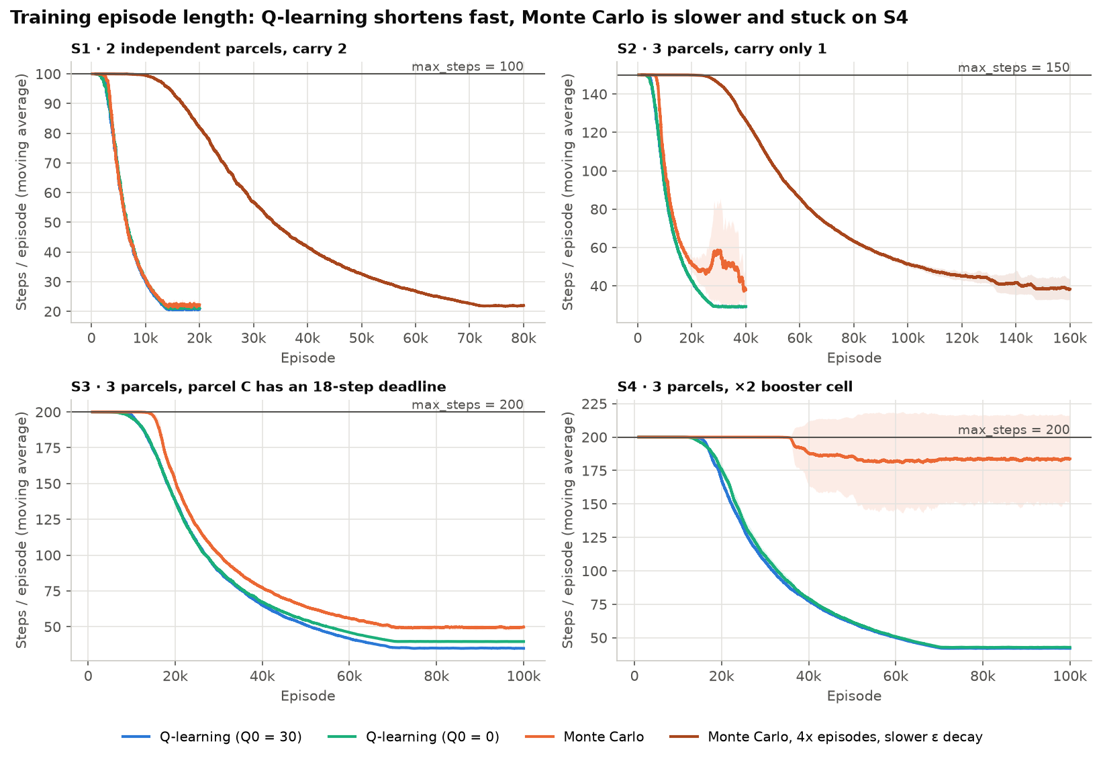
Figure 7. Steps per training episode: Q-learning shortens quickly, Monte Carlo more slowly and stays near 200 steps on S4
Case 3 – the 1/N average remembers the past. Returns from the early phase (ε ≈ 1) weigh as much as later ones, so Q adjusts very slowly once the policy has improved. This is also why MC on S3 delivers every parcel but always delivers parcel C last and misses the deadline.
MC results vary a lot. MC 4x on S2 reached 5/5 with 40,000 episodes in the first run, but only 3/5 with 160,000 episodes in this run. More episodes do not reliably fix the looping problem.
Q-learning has a weakness too: with Q₀ = 0 it quickly converges to the first route it finds and misses better ones (S1: 16 instead of 18; S4: 21 instead of 22, and with 30,000 episodes it does not use the booster at all). The cause is that the true values (+10 to +20) are above 0, so untried actions are underestimated and, once ε is small, never tried again.

9. Changing rewards and environment parameters
All three changes shift the policy exactly as the optimal solution predicts, in 5/5 seeds: removing the late penalty or extending the deadline to 35 steps changes the delivery order from C → B → A to A → B → C, and removing the booster cell makes the route 8 steps longer. Each variant uses Q-learning Q₀ = 30 with twice the episodes of the base map (200,000).
Table 9. Results of the reward and environment experiments
Variant | Optimal (Value Iteration) | Learned by the agent (5 seeds)
Base S3: deadline 18, late penalty 30 | C → B → A, 38 steps, return 22 | C → B → A, 38 steps, on time
S3: late penalty 30 → 0 | A → B → C, 29 steps, return 31 (late) | A → B → C, 29–30 steps
S3: deadline 18 → 35 | A → B → C, 29 steps, return 31 (on time) | A → B → C, 29–30 steps, on time
Base S4: with booster cell | C → B → A, 38 steps, return 22 | Same as optimal
S4: booster cell removed | B → C → A, 46 steps, return 14 | Same as optimal

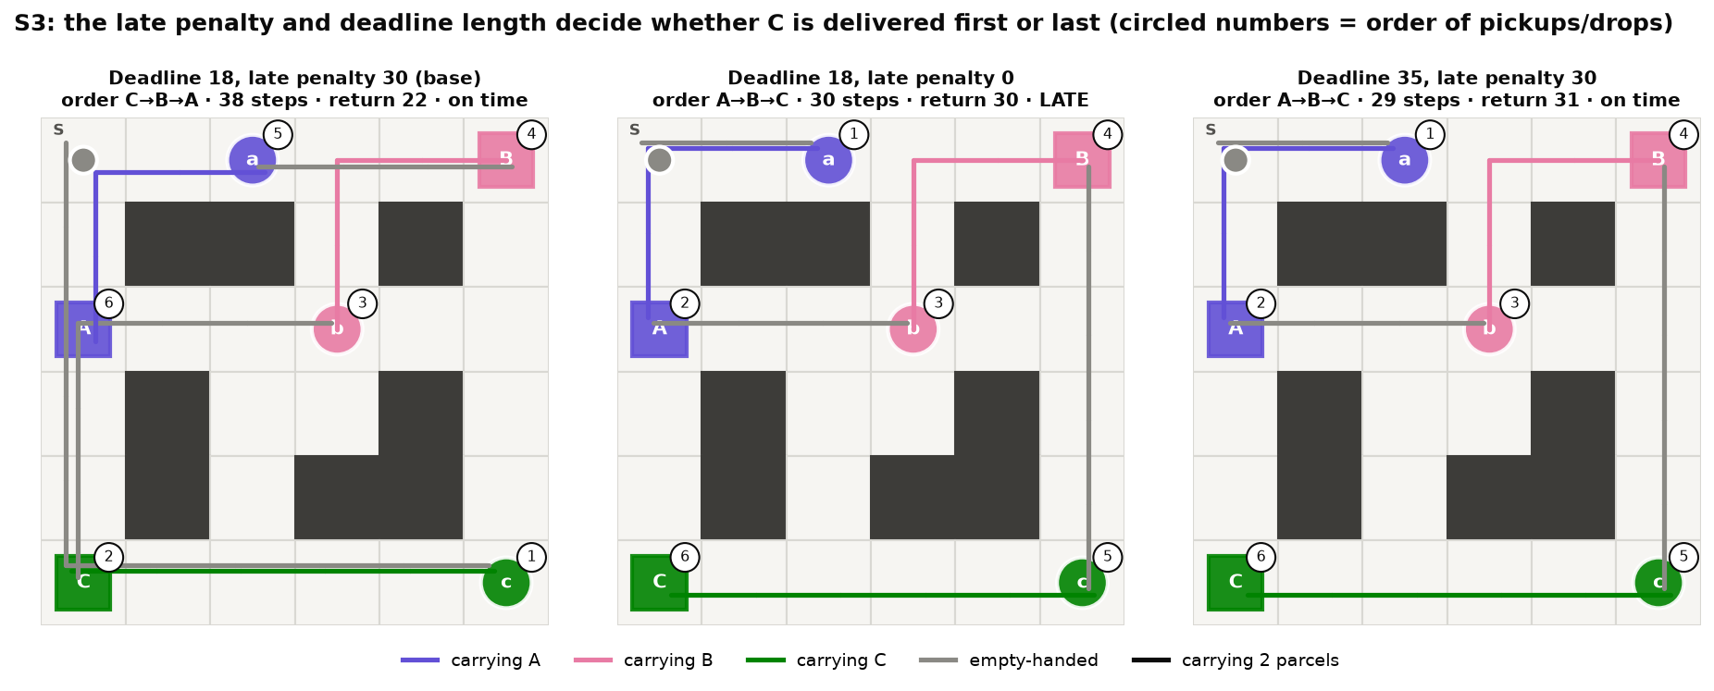
Figure 8. S3 under three configurations: the base case delivers C first, late penalty 0 and deadline 35 both deliver A first; circled numbers give the order of pickups and drops
Late penalty 30 → 0 (reward configuration). When being late costs nothing, the route A → B → C is 9 steps shorter, so the agent stops prioritising parcel C and accepts a late delivery.
Deadline 18 → 35 (environment parameter). Delivering C last is still on time, so the agent also switches to the shorter A → B → C route without any penalty. In the first run (Q₀ = 0, 80,000 episodes) the agent did not switch and still delivered C first: the number of reachable states grows from 2,825 to 8,210, so optimistic initialization and more episodes are needed to escape the old "safe" solution.
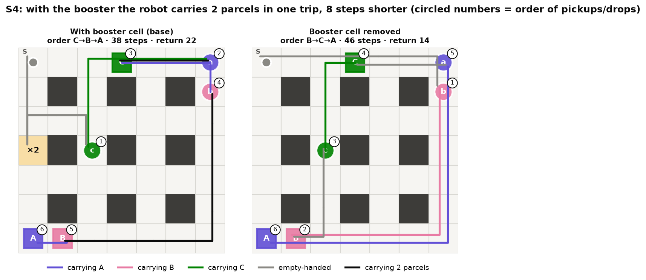
Figure 9. S4 with and without the booster cell
With / without the booster cell (environment parameter). Without the booster, the robot has to make three separate trips, B → C → A (46 steps). With the booster, it accepts a 2-step detour to turn it on, then carries two parcels at once and changes the order to C → B → A (38 steps).

10. Conclusion and running the demo
With a state space of under 20,000 states and enough episodes, tabular Q-learning finds the optimal delivery order on all 4 settings by itself, including prioritising the deadline parcel and exploiting the booster cell. Monte Carlo only keeps up on the smallest map.
- Q-learning with Q₀ = 30 is optimal in 5/5 seeds on S1, S2, S3 and S4.
- Optimistic Q initialization drives exploration; Q₀ = 0 gets stuck on worse routes on S1, S3 and S4.
- The number of episodes matters: S3 needs about 75,000 episodes; with 40,000 episodes only 2/5 seeds are optimal.
- Monte Carlo delivers every parcel in 12/20 runs and is optimal in 4/20, because episodes rarely finish and returns are too noisy; its results vary strongly with the seed.
- Changing the reward (late penalty) and the environment (deadline, booster cell) both change the delivery order exactly as the optimal solution predicts.
Limitations. The τ variable makes the state space grow linearly with the deadline length, so S3 needs the most episodes. The agent must be retrained from scratch for every map because the Q table is tied to a specific grid. The hyperparameters (α, ε, Q₀) were only tried on a small set of values.
Future work. Keep τ only while the deadline parcel is undelivered and not yet late (it is already partly merged). Try Sarsa or Q(λ) for a wider comparison. Use MC with a constant step size combined with optimistic initialization.
Re-running everything (in D:\Project\Project_RL):
pip install gymnasium numpy matplotlib
python experiments.py # ~22 min on 12 CPU cores; --quick for a fast test
python plots.py # 11 figures into figures/
python plots.py --lang en # English labels, into figures_en/
python demo.py # one S4 episode with the learned policy, step by step
python demo.py --config configs/s3_deadline.json --gif
The demo prints a text map after every step (@ robot, a/b/c waiting parcels, A/B/C destinations, * delivered, + booster cell) together with the action, reward and event; on S4 it finishes at step 38 with return 22. Event messages are printed in Vietnamese without accents, for example lay kien A = picked up parcel A and giao kien A = delivered parcel A.

