[UNIVERSITY NAME]
[FACULTY NAME]
REINFORCEMENT LEARNING – COURSE PROJECT REPORT
TOPIC 13: MULTI-DELIVERY ROBOT
A robot that delivers several parcels – tabular Q-learning, SARSA and Monte Carlo
Student: [Full name]
Student ID / Class: [Student ID] / [Class]
Supervisor: [Lecturer's name]
[City], October 2026

TABLE OF CONTENTS
1. Problem statement 4
2. MDP formulation 5
2.1. State 5
2.2. Actions and rewards 5
2.3. Transition function 5
2.4. Termination 6
2.5. Extra variables for the Markov property 6
3. State encoding and state-space size 6
4. Four levels and maps 8
5. Algorithms 10
5.1. Exploring starts and the ε-greedy policy 10
5.2. Q-learning (off-policy TD) 10
5.3. SARSA (on-policy TD) 11
5.4. Monte Carlo ES (on-policy) 11
5.5. Improvements over the old settings, and the optimal reference 12
6. Experimental results 12
6.1. Before and after the improvements 14
6.2. Effect of the number of episodes 15
7. Learned policy and value function 16
8. Comparing the three algorithms 19
9. Reward and environment-parameter experiments 22
10. When does the robot go wrong? 24
10.1. How a mistake is classified 24
10.2. Old settings: wrong even from the start cell 25
10.3. New settings: started in every reachable state 28
10.4. A typical SARSA mistake 29
10.5. What this means 31
11. Conclusion and how to run the demo 32
Appendix A. State codes of every wrong decision 33

1. Problem statement
A robot moves on a grid of square cells, picks up several parcels at their pickup cells (P) and delivers them to their drop cells (D); the agent learns by itself the pickup and delivery order that maximises the total reward. The environment is a custom gymnasium.Env that follows the logic of Taxi-v3. The agent learns a Q table with three algorithms: Q-learning, SARSA and Monte Carlo ES; no DQN or function approximation is used.
There are 4 maps of increasing difficulty, and each level adds one new mechanic: more parcels, capacity 1, a deadline, a booster cell. After improving exploration and increasing the number of episodes, all three algorithms find the optimal route from every start cell on all 4 maps, in 5/5 seeds. Section 10 then puts the robot in every reachable state, not only at a start cell, to find where each algorithm still goes wrong. The training loops are compiled with numba, so millions of episodes run in a few tens of seconds.
Table 1. Source code structure
File / folder | Role
configs/*.json | The 4 maps by level (grid, parcels, capacity, deadline, booster cell, rewards, number of episodes)
delivery_env.py | MultiDeliveryEnv environment: state encoding, transition function, rewards; precomputed transition tables NS, R, D
agents.py | Q-learning, SARSA and Monte Carlo ES (compiled with numba), ε-greedy, greedy policy rollout
planner.py | Value Iteration for the optimal return and Q* as a reference
experiments.py | Runs every experiment (5 seeds), including the old settings for comparison; saves to results/
convergence.py | Measures how the Q table converges to Q*
failure_cases.py | Puts the robot in every reachable state and finds where the greedy policy goes wrong (loops, late deliveries, illegal actions, longer routes); draws Figures 12–14
plots.py | Draws the maps, accuracy, learning curves, policies, value heatmaps and reward experiments
demo.py | Runs one episode with the learned policy and prints every step
play.py | Play the game yourself with the keyboard: W/A/S/D move, J picks up, K drops
colab_train.ipynb | Runs every experiment on Google Colab
README.md | Explains every file, the formulas and how to run them

2. MDP formulation
At each step the robot is in state s, takes action a, receives reward r and moves to state s′; the environment is deterministic, so (s, a) always leads to exactly one s′.

2.1. State
A state is a tuple with 5 components:
$$s=\left(\text{row, col},σ_{1},…,σ_{N},τ,b\right)$$
$$σ_{i}∈\{0, 1, 2\}, τ∈\{0,…,T_{d}\}, b∈\{0, 1, 2\}$$
- σᵢ is the status of parcel i: 0 = waiting, 1 = being carried, 2 = delivered.
- τ is the deadline clock (S3 and S4 only), and b is the booster status (S4 only): 0 = unused, 1 = active, 2 = used up.

2.2. Actions and rewards
There are 6 actions: Up, Down, Left, Right, Pickup, Drop.
Table 2. Default rewards
Event | Reward
Each step (including bumping into a wall) | −1
Correct delivery of one parcel (per-order reward) | +20
Pickup/Drop in the wrong cell or over capacity | −10 (plus the step penalty)
Deadline parcel not delivered when τ reaches T_{d} (once) | −30

2.3. Transition function
- Move: if the new cell is inside the grid and not a wall, the robot moves there; otherwise it stays in place. Entering the booster cell when b = 0 sets b = 1.
- Pickup: if a parcel i is waiting in the current cell and the robot carries fewer parcels than its capacity (2 if b = 1, otherwise capacity), then σᵢ: 0 → 1.
- Drop: if the robot carries parcel i and the current cell is its drop cell, then σᵢ: 1 → 2 and the order's reward is paid. If b = 1 and the robot has just become empty-handed, b = 2 (the booster trip is over).
- Clock: if the deadline parcel has been delivered, τ = T_{d}; otherwise τ increases by 1 (capped at T_{d}), and the late penalty is applied at the moment τ reaches T_{d}.

2.4. Termination
An episode is terminated when every σᵢ = 2 and truncated when max_steps runs out (100 / 150 / 200 / 300 for S1–S4). Truncation is a time limit, not a terminal state, so Q-learning and SARSA still bootstrap on the last step.

2.5. Extra variables for the Markov property
- τ: the late penalty depends on how many steps have passed, so without τ two visits to the same cell with the same parcel statuses could have different futures. Once the deadline parcel is delivered, τ is merged into T_{d} because time no longer affects the reward.
- b: the capacity depends on whether the robot has passed the booster cell and whether that trip is over; the position and σ alone cannot tell.
- σ = 1 (carrying) replaces a separate "current load" variable: the number of parcels carried is the number of σᵢ equal to 1.

3. State encoding and state-space size
The statuses of the N parcels are read as an N-digit base-3 number, and the whole tuple is then packed into a single integer that is the row index of the Q table (encode / decode in delivery_env.py).
$$\text{code}=\sum_{i=1}^{N}{σ_{i}·3^{i-1}}∈\{0,…,3^{N}-1\}$$
$$\text{idx}=\left(\left(\left(\text{row}·W+\text{col}\right)·3^{N}+\text{code}\right)·T+τ\right)·B+b$$
The size of the encoded state space is the product of the number of values of each component:
$$|S|=H·W·3^{N}·T·B$$
$$T=\left\{\begin{aligned}&T_{d}+1,\text{ if there is a deadline parcel} \\ &1,\text{ otherwise}\end{aligned}\right.$$
$$B=\left\{\begin{aligned}&3,\text{ if the map has a booster cell} \\ &1,\text{ otherwise}\end{aligned}\right.$$
For S3 and S4:
$$\begin{aligned}{|S|}_{\text{S3}}&=7·7·3^{3}·21·1=\text{27,783} \\ {|S|}_{\text{S4}}&=8·8·3^{4}·23·3=\text{357,696}\end{aligned}$$
Example on S3 (7x7 grid, N = 3, T = 21, B = 1): the robot is in row 2, column 3, A has been delivered (σ₁ = 2), B is being carried (σ₂ = 1), C is waiting (σ₃ = 0), τ = 7:
$$\begin{aligned}\text{code}&=2·3^{0}+1·3^{1}+0·3^{2}=5 \\ \text{idx}&=(((2·7+3)·27+5)·21+7)·1+0 \\ &=(17·27+5)·21+7=464·21+7=9751\end{aligned}$$
decode reverses this with successive divmod operations, splitting off one component from the right each time:
$$\begin{aligned}9751&=464·21+7⇒τ=7 \\ 464&=17·27+5⇒\text{code}=5⇒\left(σ_{1},σ_{2},σ_{3}\right)=\left(2, 1, 0\right) \\ 17&=2·7+3⇒\text{row}=2,\text{ col}=3\end{aligned}$$
In the code these are the two methods encode() and decode() of MultiDeliveryEnv in delivery_env.py (comments translated). The integer that encode() returns is the state code of the state: it is the row of the Q table and of the transition tables NS, R and D, and Section 10 and Appendix A use it to point at the exact states where the robot goes wrong.
def encode(self, state): # delivery_env.py, MultiDeliveryEnv
r, c, status, tau, boost = state
code = 0
for i, s in enumerate(status): # parcel statuses = base-3 digits
code += s * 3 ** i
idx = r * self.W + c # cell
idx = idx * self.n_codes + code # n_codes = 3^N
idx = idx * self.n_tau + tau # n_tau = T_d + 1 (1 if no deadline)
idx = idx * self.n_boost + boost # n_boost = 3 (1 if no booster)
return idx # state code = row of Q, NS, R, D

def decode(self, idx): # the reverse: one divmod per part
idx, boost = divmod(idx, self.n_boost)
idx, tau = divmod(idx, self.n_tau)
pos, code = divmod(idx, self.n_codes)
r, c = divmod(pos, self.W)
status = []
for _ in range(self.N):
code, s = divmod(code, 3)
status.append(s)
return (r, c, tuple(status), tau, boost)
Table 3. State-space and action-space size
Setting | Grid | Parcels | Capacity | T | B | Encoded |S| | Reachable (BFS) | |A|
S1 – level 1 | 5x5 | 2 | 2 | 1 | 1 | 225 | 186 | 6
S2 – level 2 | 6x6 | 3 | 1 | 1 | 1 | 972 | 535 | 6
S3 – level 3 | 7x7 | 3 | 1 | 21 | 1 | 27,783 | 4,027 | 6
S4 – level 4 | 8x8 | 4 | 1 (2 with booster) | 23 | 3 | 357,696 | 15,612 | 6

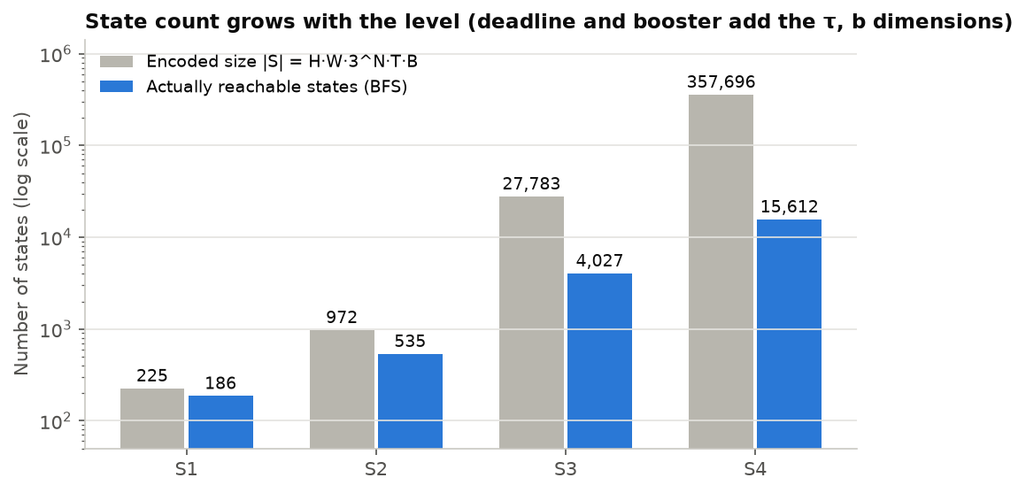
Figure 1. Encoded size and number of actually reachable states of the four maps (log scale)
The number of reachable states is far below |S| because walls can never be occupied, capacity 1 removes the combinations with two σᵢ = 1 (20/27 combinations remain with 3 parcels, 48/81 with 4), and τ and b only take values that can actually be reached. For simplicity the Q table still allocates all |S| rows; the largest is 357,696 × 6 floats on S4 (about 17 MB), compressed when saved because the unreachable rows are all zero.

4. Four levels and maps
The four maps are designed with increasing difficulty: each level adds one new mechanic to the previous one, and the grid grows from 5x5 to 8x8. Each map is a JSON file in configs/, so changing the map needs no code change.
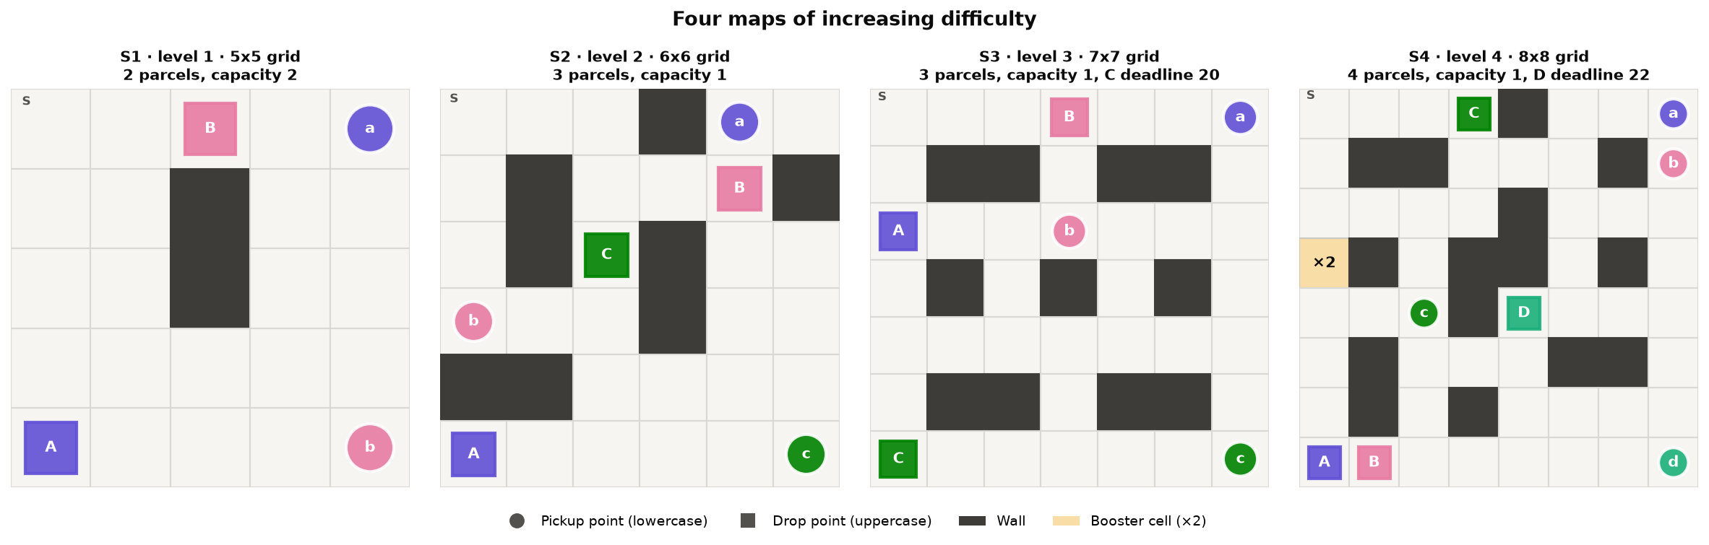
Figure 2. The four maps by level: pickup cells are circles (lowercase), drop cells are squares (uppercase), walls are dark, the ×2 booster cell is yellow
Table 4. The four levels and their optimal routes (Value Iteration)
Map | Grid | Parcels | Capacity | New mechanic | Optimal route | max_steps
S1 – level 1 (easy) | 5x5 | 2 | 2 | Two independent parcels that can be carried together | A → B: 22 steps, return 18 | 100
S2 – level 2 (medium) | 6x6 | 3 | 1 | Only 1 parcel at a time, so the order matters | B → A → C: 36 steps, return 24 | 150
S3 – level 3 (hard) | 7x7 | 3 | 1 | Parcel C must be delivered within the first 20 steps | C → B → A: 44 steps, return 16 | 200
S4 – level 4 (very hard) | 8x8 | 4 | 1 | Booster cell (carry 2 parcels for one trip) and a 22-step deadline for parcel D | D → C → B → A with the booster: 67 steps, return 13 | 300

Difficulty grows on every measure: reachable states (186 → 535 → 4,027 → 15,612) and optimal route length (22 → 36 → 44 → 67 steps). S3 and S4 also require trade-offs. On S3, without the deadline the route B → A → C would be 4 steps shorter, but the deadline forces the robot to deliver C first. On S4 the robot must deliver D first to meet its deadline, then detour via the booster cell to carry A and B in one trip, which saves 8 steps compared with no booster cell.
The "one trip" rule on S4: the booster trip starts when the robot enters the booster cell and ends the first time the robot is empty-handed after a Drop; the cell can be used only once per episode.

5. Algorithms
All three algorithms keep a Q table of size |S| × 6 and choose actions ε-greedily; they differ only in how the "target" used to update Q is computed. All three train with exploring starts (Section 5.1).

5.1. Exploring starts and the ε-greedy policy
Exploring starts. Every training episode starts in a randomly chosen reachable state (parcels carried or delivered, any τ and b), and the first action is also random. Every pair (s, a) is therefore updated directly, including states such as "carrying C at τ = 15" that a robot starting at τ = 0 rarely reaches. For evaluation the robot still starts with every parcel waiting.
ε-greedy. After the first action, with probability ε one of the 6 actions is chosen at random, otherwise argmax Q(s, ·) (ties broken at random). ε decays exponentially from ε_{start} to ε_{end} over the first f·n_{ep} episodes and then stays constant; each algorithm has its own schedule (Table 5):
$$ε(ep)=ε_{start}·{\left(\frac{ε_{end}}{ε_{start}}\right)}^{\min\left(1,\frac{ep}{f·n_{ep}}\right)}$$
Example: Q-learning on S3 (n_{ep} = 2,000,000, ε: 1 → 0.01, f = 0.8, so ε reaches its floor after 1,600,000 episodes), at episode 400,000:
$$ε=1·{\left(\frac{0.01}{1}\right)}^{\frac{400,000}{1,600,000}}={0.01}^{0.25}≈0.316$$
The final policy is the greedy policy: in every state it takes the action with the largest Q. This policy is used for evaluation, for the demo and for the policy figures:
$$π(s)=\underset{a}{arg max}{Q(s,a)}$$

5.2. Q-learning (off-policy TD)
$$Q(s,a)←Q(s,a)+α\left[r+γ\max_{a'}{Q(s',a')}-Q(s,a)\right]$$
The update is applied after every step. The target depends on whether that step really ends the episode:
$$\text{target}=\left\{\begin{aligned}&r,\text{ if s' is terminal (all parcels delivered)} \\ &r+γ\max_{a'}{Q(s',a')},\text{ otherwise}\end{aligned}\right.$$
Being cut off by max_steps is only a time limit, not a terminal state, so the second case still applies. The environment is deterministic, so the target has no noise and α = 1 can be used. Example with α = 1, γ = 0.99, Q(s,a) = 0, r = −1 and max Q(s′,a′) = 10:
$$\begin{aligned}\text{target}&=r+γ\max_{a'}{Q(s',a')}=-1+0.99·10=8.9 \\ Q(s,a)&←Q(s,a)+α\left(\text{target}-Q(s,a)\right)=0+1·(8.9-0)=8.9\end{aligned}$$

5.3. SARSA (on-policy TD)
$$Q(s,a)←Q(s,a)+α\left[r+γQ(s',a')-Q(s,a)\right]$$
SARSA differs from Q-learning in exactly one place: max Q(s′, a′) is replaced by Q(s′, a′), where a′ is the action the agent will actually take in s′ (chosen ε-greedily, possibly an exploratory step). SARSA therefore learns the value of the ε-greedy policy it is running (on-policy) and only matches Q* as ε → 0. Same example as above, but in s′ the agent draws an exploratory action with Q(s′, a′) = 2, and α = 0.5:
$$\begin{aligned}\text{target}&=r+γQ(s',a')=-1+0.99·2=0.98 \\ Q(s,a)&←Q(s,a)+α\left(\text{target}-Q(s,a)\right)=0+0.5·(0.98-0)=0.49\end{aligned}$$
SARSA's target is noisy because of the randomly drawn action, so α cannot be 1: α decays linearly from 0.5 to 0.1. ε decays exponentially to 10⁻⁵ during the first half of training, so the second half is almost greedy (the GLIE condition: explore infinitely often but become greedy in the limit).

5.4. Monte Carlo ES (on-policy)
$$G_{t}=r_{t+1}+γG_{t+1}$$
$$Q(s,a)←Q(s,a)+α\left[G_{t}-Q(s,a)\right], α=1$$
The agent runs the whole episode, computes the returns backwards from the end, and updates only the first occurrence of each pair (s, a) (first-visit). Example with γ = 0.99 and last three rewards −1, −1 and +19 (the delivery step gives −1 + 20 = +19):
$$\begin{aligned}G_{T-1}&=r_{T}=19 \\ G_{T-2}&=r_{T-1}+γG_{T-1}=-1+0.99·19=17.81 \\ G_{T-3}&=r_{T-2}+γG_{T-2}=-1+0.99·17.81=16.63\end{aligned}$$
The version used here is Monte Carlo ES (Sutton & Barto, Section 5.3): exploring starts for both s and a, then the greedy policy (ε = 0), so all exploration comes from the random start. The environment is deterministic and the policy greedy, so the return after (s, a) is a fixed number for the current policy. α = 1 (Q equals the latest return) is therefore used instead of the 1/N average, which would remember the very negative returns of the early phase forever. If the policy loops, the episode is cut at max_steps with a very negative return, so the action that caused the loop is penalised next time.

5.5. Improvements over the old settings, and the optimal reference
Old settings: a random empty start cell with τ = 0, b = 0; ε decaying linearly from 1.0 to 0.05 over the first 70% of episodes; Q₀ = 0; α = 0.5; Monte Carlo with 1/N averaging. The new settings use full exploring starts, ε and α schedules specific to each algorithm, more episodes (Table 5), and numba: the environment is deterministic, so the transition function is precomputed into three arrays NS, R, D, and the training loop only looks up these arrays and is compiled to machine code, about 150–180 times faster. Value Iteration (planner.py) iterates the Bellman optimality equation over every reachable state to obtain the best return and Q*; it is not a learning algorithm, only a reference:
$$V(s)=\max_{a}\left[r(s,a)+γV(s')\right]$$
Table 5. Hyperparameters (new settings)
Hyperparameter | Q-learning | SARSA | Monte Carlo ES
γ (discount) | 0.99
Step size α | 1 | 0.5 → 0.1 (linear decay) | 1
ε | 1 → 0.01, exponential decay over the first 80% | 1 → 10⁻⁵, exponential decay over the first 50% | 0 (always greedy)
Training start | Exploring starts: random reachable state and random first action
Q₀ | 0
Episodes | S1: 100,000 · S2: 300,000 · S3: 2,000,000 · S4: 6,000,000
Seeds | 5 seeds (0–4) per algorithm
Evaluation | 200 times per training run: greedy policy (ε = 0) from S and from every start cell

6. Experimental results
With the new settings, all three algorithms reach 100% accuracy on all 4 maps in 5/5 seeds (60/60 runs): from every start cell, the greedy policy reaches exactly the optimal return of Value Iteration. The difference is in learning speed: Q-learning is the fastest, Monte Carlo ES second and SARSA the slowest. Section 10 checks the harder case where the robot starts in any reachable state.
Measurement: each training run is evaluated 200 times. Each evaluation runs the greedy policy (ε = 0) from cell S (return, all parcels delivered or not) and from every empty cell with every parcel waiting. Accuracy is the percentage of start cells from which the policy reaches exactly the optimal return of Value Iteration from that cell; it is stricter than running from S only (Section 6.1).
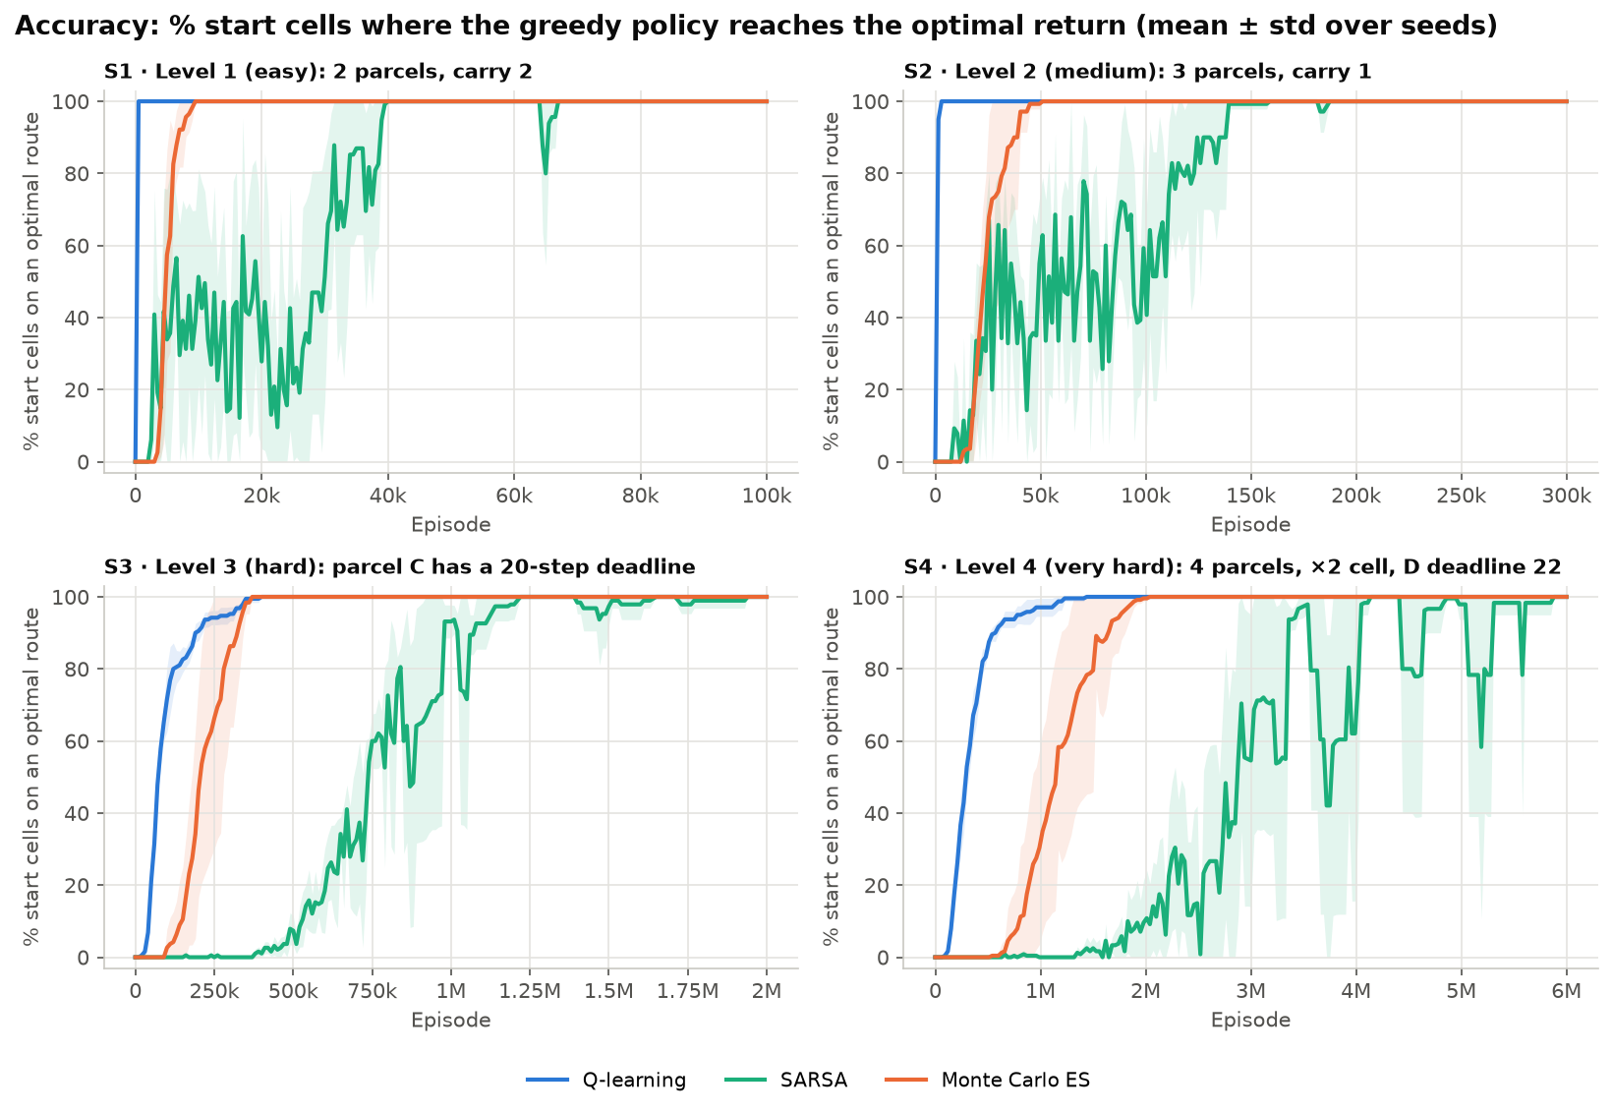
Figure 3. Accuracy over episodes: % of start cells where the greedy policy reaches the optimal return, mean ± standard deviation over 5 seeds
Table 6. Final results with the new settings (5 seeds)
Map | Algorithm | Episodes | Return from S | Accuracy | First reaches 100%
S1 (optimal 18) | Q-learning | 100,000 | 18 in all 5 seeds | 100% | 500
S1 | SARSA | 100,000 | 18 in all 5 seeds | 100% | 5,500 – 33,500
S1 | Monte Carlo ES | 100,000 | 18 in all 5 seeds | 100% | 7,000 – 9,500
S2 (optimal 24) | Q-learning | 300,000 | 24 in all 5 seeds | 100% | 1,500 – 3,000
S2 | SARSA | 300,000 | 24 in all 5 seeds | 100% | 64,500 – 159,000
S2 | Monte Carlo ES | 300,000 | 24 in all 5 seeds | 100% | 30,000 – 51,000
S3 (optimal 16) | Q-learning | 2,000,000 | 16 in all 5 seeds, on time | 100% | 340,000 – 400,000
S3 | SARSA | 2,000,000 | 16 in all 5 seeds, on time | 100% | 980,000 – 1,220,000
S3 | Monte Carlo ES | 2,000,000 | 16 in all 5 seeds, on time | 100% | 260,000 – 370,000
S4 (optimal 13) | Q-learning | 6,000,000 | 13 in all 5 seeds, on time | 100% | 840,000 – 1,440,000
S4 | SARSA | 6,000,000 | 13 in all 5 seeds, on time | 100% | 3,450,000 – 4,140,000
S4 | Monte Carlo ES | 6,000,000 | 13 in all 5 seeds, on time | 100% | 1,470,000 – 2,040,000

The Q tables also converge to Q*: the final mean error |Q − Q*| is 0 for Q-learning and Monte Carlo ES and 0.001–0.05 for SARSA (Figure 9). Time per seed on S4 (6 million episodes): Q-learning 38 s, SARSA 23 s, Monte Carlo ES 38 s; the full set of experiments, including the old settings and the reward experiments, takes 221 s on a 12-core machine.

6.1. Before and after the improvements
To isolate the effect of the improvements, experiments.py reruns all three algorithms with the old settings on the same 4 maps and with the same number of episodes.
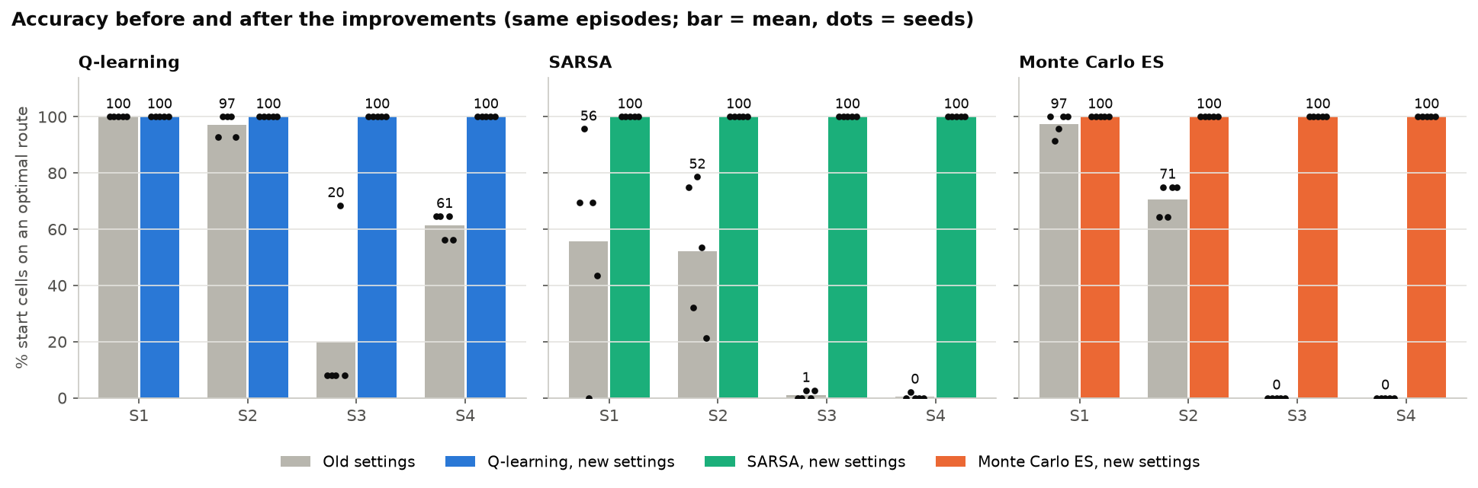
Figure 4. Final accuracy with the old settings (grey) and the new settings (colour), same number of episodes; bar = mean, dots = individual seeds
Table 7. Final accuracy: old settings → new settings
Map | Q-learning | SARSA | Monte Carlo
S1 | 100% → 100% | 55.7% → 100% | 97.4% → 100%
S2 | 97.1% → 100% | 52.1% → 100% | 70.7% → 100%
S3 | 20.0% → 100% | 1.1% → 100% | 0% → 100%
S4 | 61.3% → 100% | 0.4% → 100% | 0% → 100%

With the old settings, on S3 and S4 SARSA and Monte Carlo either deliver late (return −18 to −30 on S3) or fail to deliver everything before max_steps (return −290 to −330 in 3/5 SARSA seeds and 4/5 Monte Carlo seeds on S4). The old Q-learning follows the right route from S in all 5 seeds on S3 and S4, but is correct from only 20% and 61% of the start cells: it memorised one route rather than solving the task. The most important improvement is exploring starts: the τ and b dimensions multiply the number of states, and states off the familiar route are almost never updated if the robot always starts at τ = 0.

6.2. Effect of the number of episodes
Measured while tuning (same maps, same new settings, 5 seeds). ε decays in proportion to the number of episodes, so fewer episodes also means shorter exploration.
Table 8. Accuracy versus number of episodes
Case | Fewer episodes | More episodes
S3, Q-learning | 200,000: 98.9% | 2,000,000: 100%
S3, Monte Carlo ES | 200,000: 46.3% | 1,000,000: 100%
S3, SARSA | 1,000,000: 99.5% | 2,000,000: 100%
S4, Q-learning | 500,000: 83.8% | 2,000,000: 100%
S4, Monte Carlo ES | 500,000: 0%; 2,000,000: 99.6% | 5,000,000: 100%
S4, SARSA | 2,000,000: 41.2% | 5,000,000: 99.6%; 6,000,000: 100%

SARSA needs the most episodes (about 3 times Q-learning on S4) because it only learns Q* once ε is very small. To train even longer, run python experiments.py --scale 2.

7. Learned policy and value function
The policy learned on S4 (Q-learning) matches the optimal solution: the robot delivers parcel D first to meet its deadline, then detours via the booster cell to carry two parcels in one trip, and finishes in 67 steps with return 13.
How to read the figure: each small panel is one "phase" (a combination of parcel statuses and booster status). Grey arrows show the action the policy takes if the robot stands in that cell during this phase; P/D mean Pickup/Drop. The coloured line is the actual route, coloured by the parcel being carried: grey when empty-handed, black when carrying two parcels.
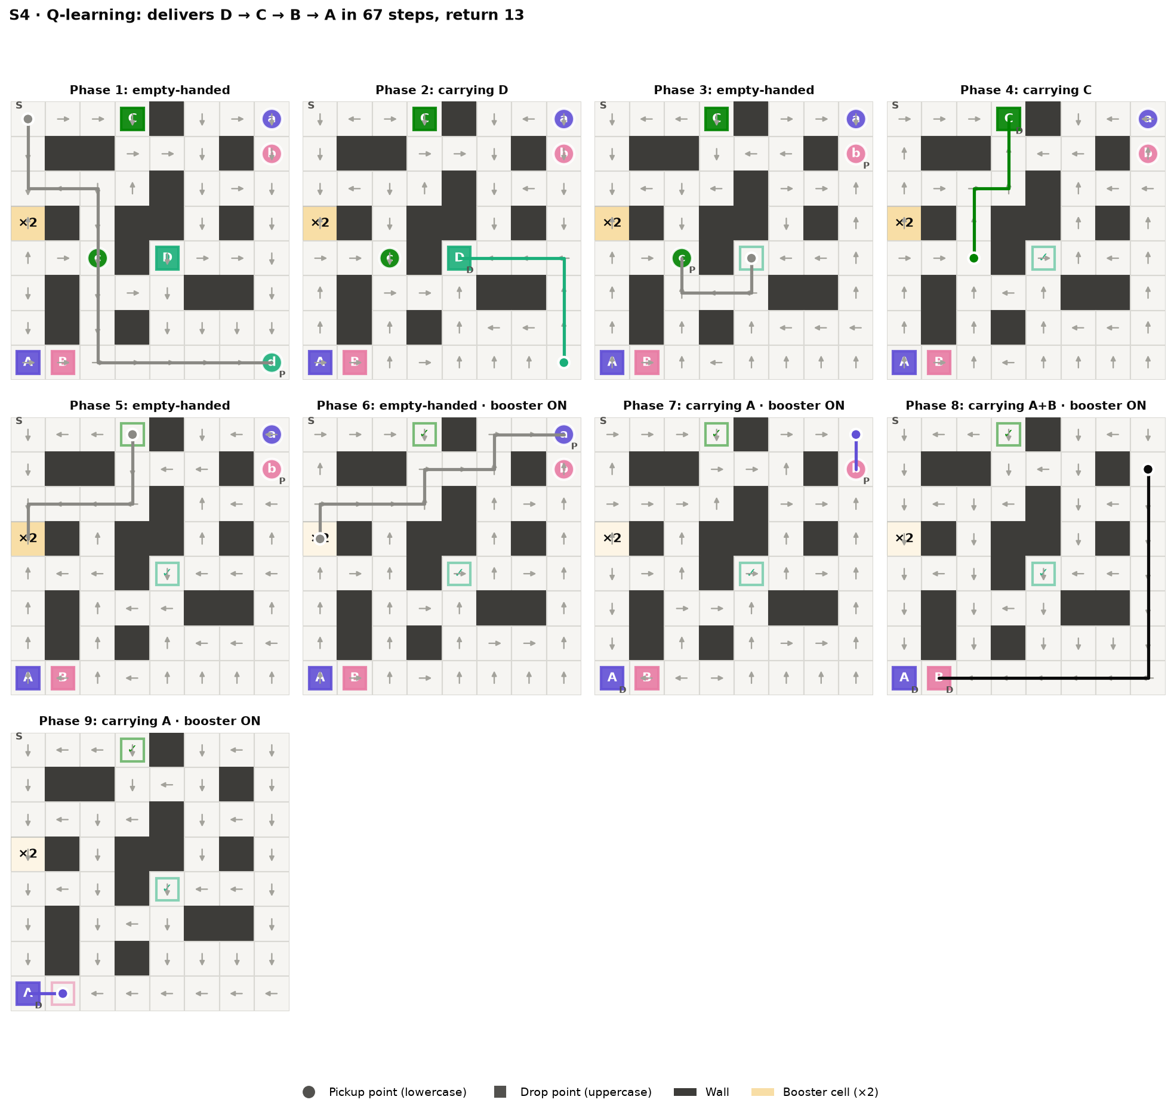
Figure 5. S4 policy (Q-learning): 9 phases from empty-handed to the last delivery
The sequence on S4:
- Pick up D in the bottom-right corner.
- Deliver D in the middle of the map, before its 22-step deadline.
- Pick up C, then deliver C on the top row.
- Go down to the ×2 cell to switch the booster on.
- Go to the top-right corner and pick up A, then B; the robot now carries A + B.
- Carry both to the bottom-left corner and deliver B, then A.
The agent learns both trade-offs by itself: it prioritises the deadline parcel even though it is far away, and it accepts a detour to use the booster cell.
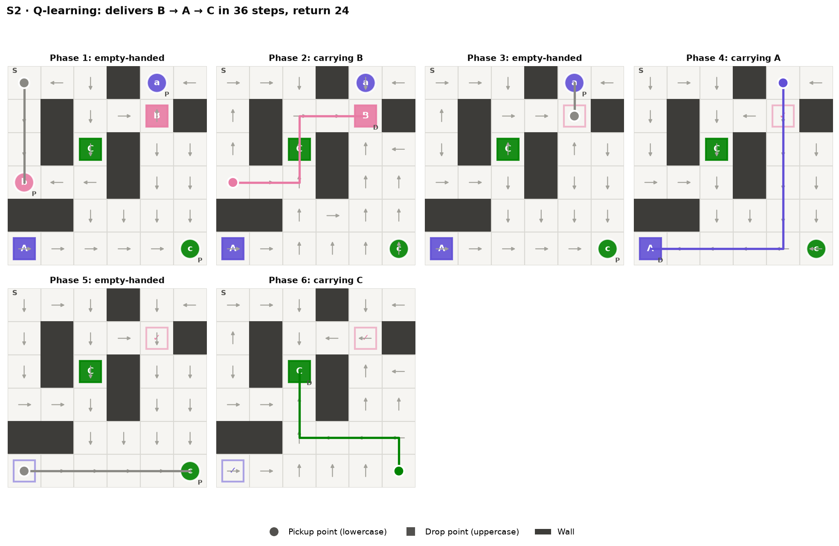
Figure 6. S2 policy (Q-learning): 6 phases, delivering B → A → C in 36 steps
On S2 the policy delivers in the order B → A → C (36 steps, return 24, equal to the optimum). The arrows in cells off the route also point the right way because exploring starts let the robot learn from every state. figures_en/policy_S3.png shows the S3 policy in the same way.
Value heatmaps. Figure 7 colours every cell by the learned value V(s) = max_{a} Q(s, a) when the robot starts there with every parcel waiting (τ = 0, b = 0): the darker the cell, the higher the expected return. V at S is 13.7, 17.8, 8.6 and 2.5 for S1–S4. These values are below the optimal returns (18, 24, 16 and 13) because V is discounted with γ = 0.99, so a +20 reward collected late is worth less.
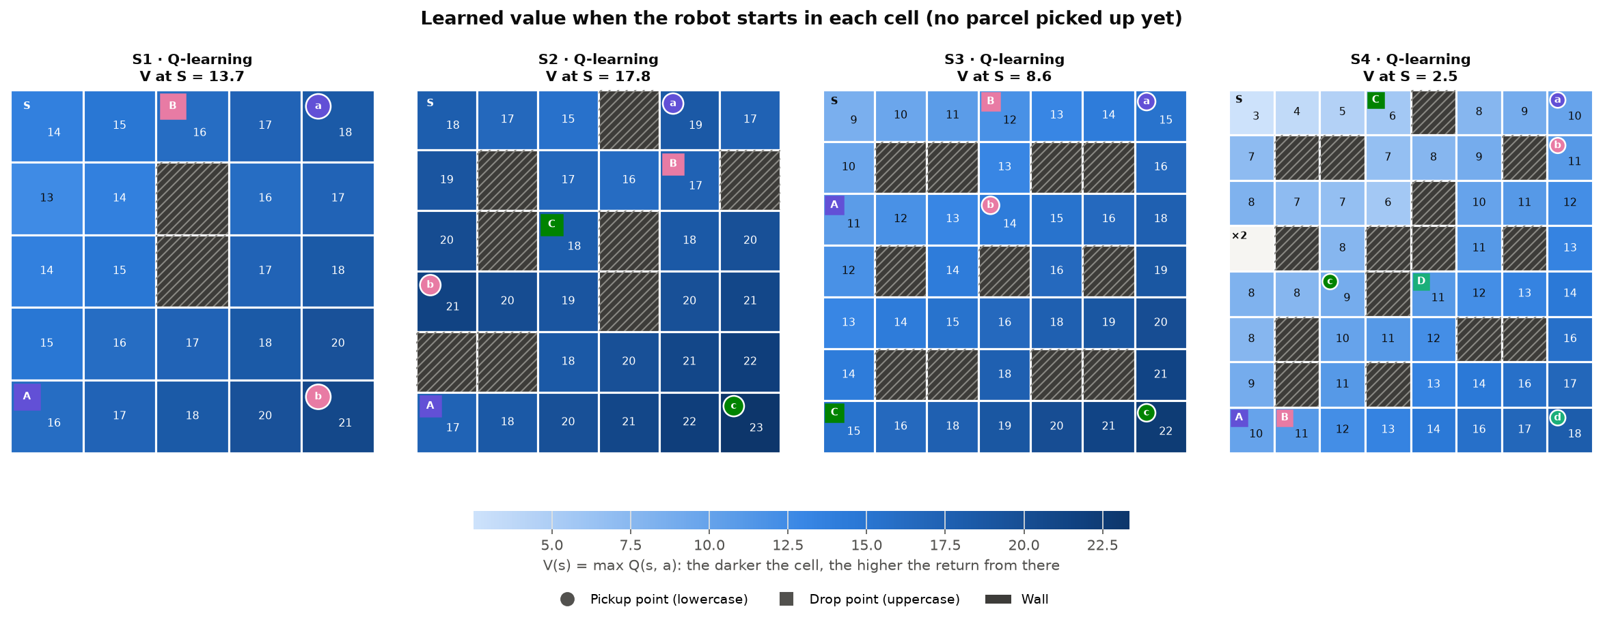
Figure 7. Learned start value V(s) = max Q(s, a) in every cell of the four maps (Q-learning, no parcel picked up yet); hatched cells are walls
Figure 8 repeats the heatmap for every phase of the S4 route, with the same phases as Figure 5. Within a phase, cells close to the current target (the parcel to pick up or the drop cell to reach) are darker, so the greedy policy walks toward darker cells. The deadline is directly visible: in phase 2 (carrying D, τ = 15) the cells far from D's drop cell fall to about −11, because from there D can no longer arrive in time and the −30 penalty is certain. In phase 8 (carrying A and B thanks to the booster) almost the whole map is dark, because two +20 rewards are only a few steps away. Phases that still have a deadline are drawn at the τ of the start of the phase.
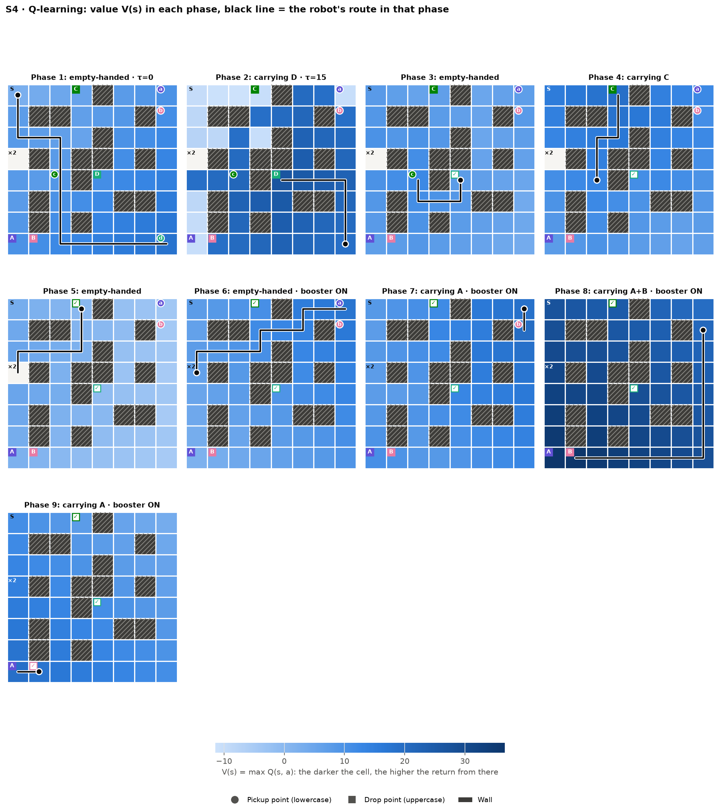
Figure 8. S4 (Q-learning): learned value V(s) in each of the 9 phases; black line = the robot's route in that phase

8. Comparing the three algorithms
All three reach 100%, so the comparison is about learning speed, stability and sensitivity to settings (Table 9, Figure 9).
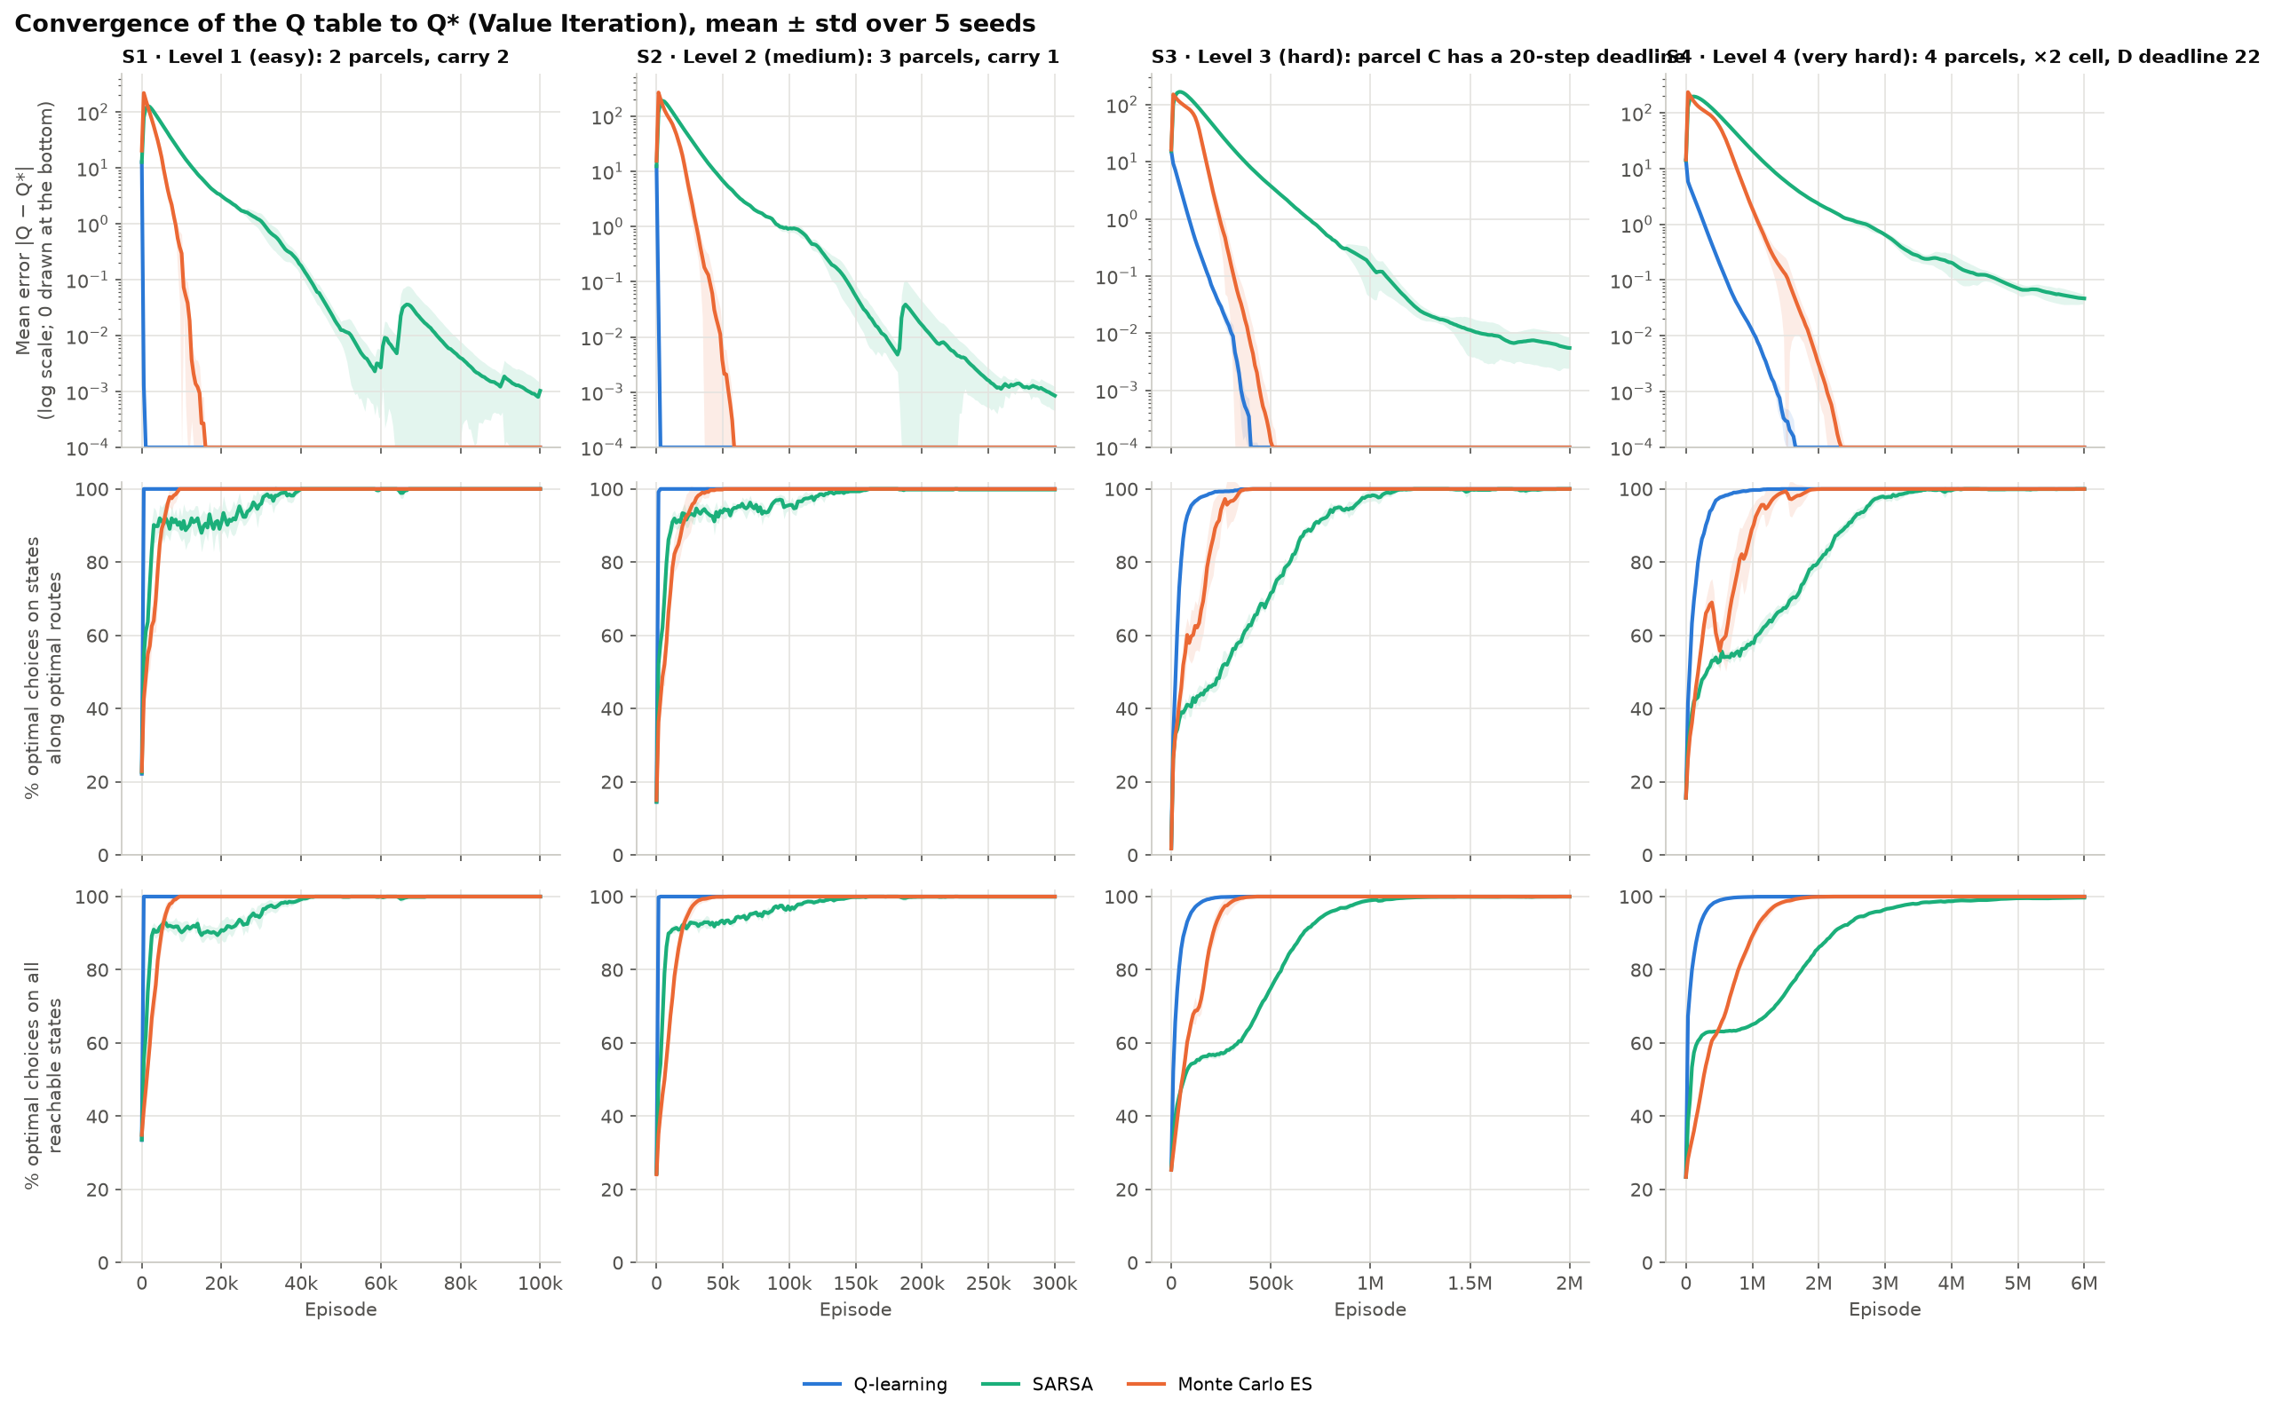
Figure 9. Convergence of the Q table to Q*: error |Q − Q*| (top row, log scale) and % of states choosing the optimal action, mean ± standard deviation over 5 seeds
Table 9. Comparison of the three algorithms
Criterion | Q-learning | SARSA | Monte Carlo ES
Update | After every step | After every step | After the whole episode
Target | r + γ·max Q(s′), no noise | r + γ·Q(s′, a′), noisy through a′ | Return G, no noise when ε = 0
Learns the value of | The optimal policy (off-policy) | The ε-greedy policy it runs (on-policy) | The current greedy policy (on-policy)
Episodes to 100% on S4 (median) | 1,140,000 | 3,570,000 | 1,740,000
Mean accuracy during training (S1 → S4) | 0.99 / 0.99 / 0.95 / 0.94 | 0.77 / 0.77 / 0.60 / 0.48 | 0.95 / 0.91 / 0.89 / 0.80
Drops below 100% after reaching it | Never | 9–19% of measurements | Never
Final error |Q − Q*| | 0 | 0.001 – 0.047 | 0
Wrong states when started anywhere (S3 / S4, Section 10) | 0 / 0 | 0.3% / 1.8% | 0 / 0
Time per seed on S4 | 38 s | 23 s | 38 s
Old settings (S1 → S4) | 100 / 97 / 20 / 61% | 56 / 52 / 1 / 0.4% | 97 / 71 / 0 / 0%

Q-learning is the fastest and most stable. Its target uses max Q(s′), so it learns Q* directly from every step, including random exploratory steps; the environment is deterministic, so the target has no noise and α = 1 gives the exact value at once. It is also the least sensitive to settings: with the old settings it still reaches 100% on S1 and 97% on S2.
Monte Carlo ES comes second. It must wait for the end of the episode before updating, so the early phase is slower, but a greedy policy in a deterministic environment gives noise-free returns, so once converged its Q is exactly right, like Q-learning. On S3 it even reaches 100% earlier than Q-learning (290,000 versus 350,000 episodes, median) because greedy training episodes are short. Its weakness is that it can only learn thanks to exploring starts: with the old settings it reaches 0% on S3 and S4.
SARSA is the slowest. Its target uses the action it will actually take, so SARSA learns the value of the exploring policy itself and only matches Q* once ε is very small. The noisy target makes actions with almost equal values swap back and forth, so the accuracy still fluctuates after reaching 100% and the Q table keeps a small error. Section 10 shows what that small error does: started off its usual route, SARSA takes a slightly longer route from 1.8% of the S4 states. Per second, though, a SARSA episode is the cheapest, because each step chooses an action only once.
Note. SARSA's usual advantage is behaving safely while it still explores (for example in cliff walking); it does not show here because the maps have no dangerous cells and a mistake only costs −10. The ranking above holds for a deterministic environment; if the robot's wheels could slip, Q-learning and Monte Carlo would lose the advantage of a noise-free target.

9. Reward and environment-parameter experiments
All three changes alter the policy exactly as the optimal solution predicts, in 5/5 seeds: removing the late penalty or relaxing the deadline to 45 steps changes the delivery order from C → B → A to B → A → C, and removing the booster cell makes the route 8 steps longer. Each variant uses Q-learning with the same number of episodes as the base map.
Table 10. Results of the reward / environment-parameter experiments
Variant | Optimum (Value Iteration) | Learned by the agent (5 seeds)
S3 base: deadline 20, late penalty 30 | C → B → A, 44 steps, return 16 | C → B → A, 44 steps, on time
S3: late penalty 30 → 0 | B → A → C, 40 steps, return 20 (late) | B → A → C, 40 steps
S3: deadline 20 → 45 | B → A → C, 40 steps, return 20 (on time) | B → A → C, 40 steps, on time
S4 base: with booster cell | D → C → B → A, 67 steps, return 13 | Same as the optimum
S4: booster cell removed | D → B → C → A, 75 steps, return 5 | Same as the optimum

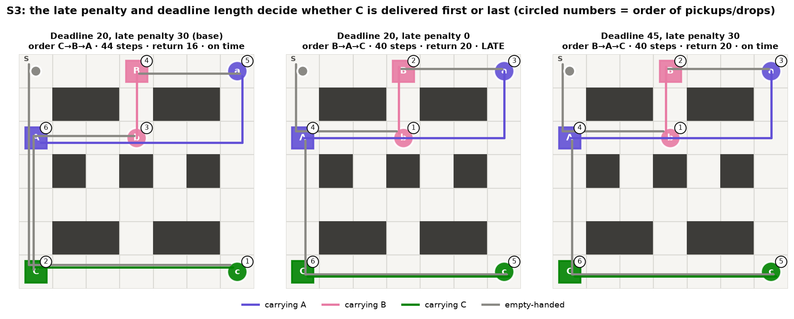
Figure 10. S3 with three configurations: the base delivers C first; late penalty 0 and deadline 45 both switch to B → A → C; circled numbers give the order of pickup/drop events
Late penalty 30 → 0 (reward configuration). When being late costs nothing, B → A → C is 4 steps shorter, so the agent stops prioritising parcel C and accepts a late delivery.
Deadline 20 → 45 (environment parameter). Delivering C last is still on time, so the agent also switches to the shorter route B → A → C without any penalty. The number of reachable states grows from 4,027 to 14,558, but Q-learning is still correct in 5/5 seeds.
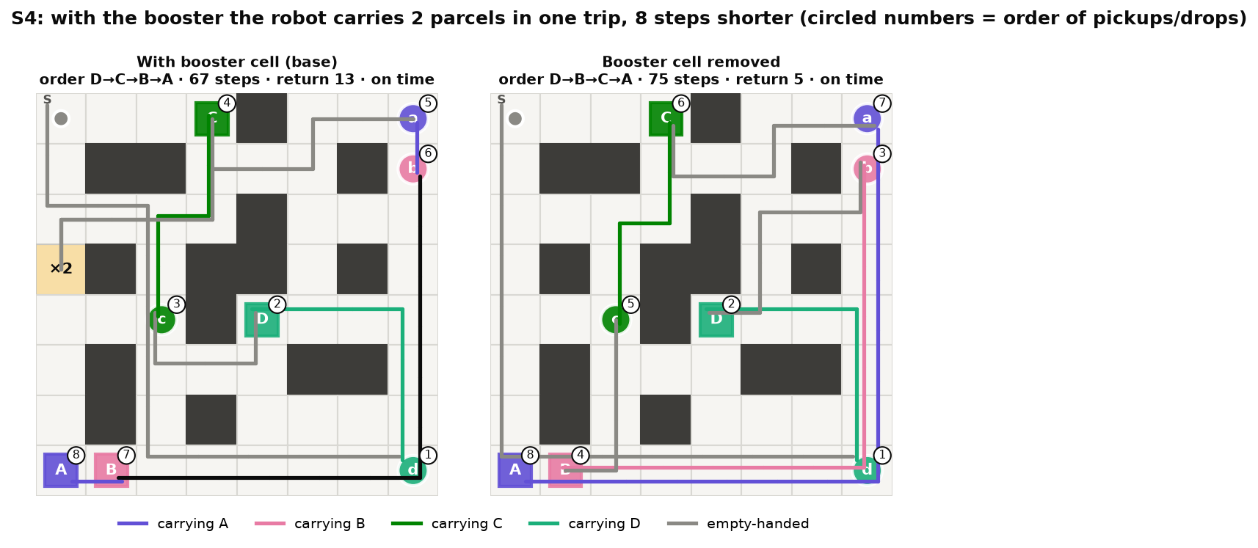
Figure 11. S4 with and without the booster cell
With / without the booster cell (environment parameter). Without the booster cell the robot needs four separate trips D → B → C → A (75 steps). With it, the robot still delivers D first to meet its deadline, delivers C, then detours via the ×2 cell to carry A and B together (67 steps).

10. When does the robot go wrong?
The accuracy of Section 6 starts the robot only in a start state: an empty cell, every parcel waiting, τ = 0 and the booster unused. A policy can be right there and still be wrong in states it seldom reaches: while carrying a parcel, after some deliveries, with the deadline clock running or with the booster on. Such states matter whenever the robot does not begin a task from scratch, for example after it has been pushed off its route or when it takes over a half-finished delivery. failure_cases.py therefore puts the robot in every reachable state that is not finished yet (184 states on S1 up to 15,604 on S4), runs the greedy policy from there and compares its return with the return of Value Iteration from the same state.
Four groups of runs are checked, 5 seeds each: the old and the new settings of Section 6.1 on all four maps, and on S3 and S4 two SARSA variants: twice as many episodes, and a final step size α = 0.02 instead of 0.1. Seed 0 of the new settings uses the Q tables saved by experiments.py; every other run is retrained with the same seed, which reproduces the runs of Section 6 exactly because training is deterministic for a given seed. The 140 runs take about 3 minutes on 12 cores; checking one Q table takes less than a second.

10.1. How a mistake is classified
A state is wrong when the greedy policy collects less than the optimal return from it. Each wrong state gets exactly one type, checked in the order of Table 11. This measure counts what a mistake costs over the rest of the episode. It differs from the share of states whose greedy action is not optimal (bottom row of Figure 9): an action that differs from Value Iteration's but leads to an equally short route is not counted as a mistake here.
Table 11. Types of mistakes, checked in this order
Type | What the robot does | Cost
Never finishes | max_steps runs out with parcels left. The policy and the environment are deterministic, so once the robot is back in a state it has already visited it repeats the same cycle forever | −1 per remaining step
Late | Pays the late penalty although the optimal route from the same state is on time | 30 or more
Illegal action | Makes at least one Pickup or Drop in the wrong cell | 10 or more per action
Longer route | Delivers everything, on time and without illegal actions, but with more steps than the optimal route | 1 per extra step

Every state has a state code: the integer idx = encode(s) of Section 3, which is also the row of the Q table. For each wrong state, failure_cases.py also follows the greedy route to the first state whose greedy action is not optimal under Q*; this wrong decision is where the robot actually turns the wrong way, and it can lie several steps after the start state. Every wrong state is written to results/failure_states.csv (4,930 rows) with its state code, the decoded tuple s = (row, col, σ₁, …, σ_{N}, τ, b), the type of mistake, the points lost, and the state code, tuple and actions of its wrong decision; for the old settings only the wrong start states are written, because there are tens of thousands of wrong states. In the code, rollout() runs the greedy policy from all states at once through the tables NS, R, D, analyse() classifies the mistakes, decisions() finds the wrong decisions and write_states() writes the CSV file. The core of the search for the wrong decision is shown below (comments translated, slightly shortened); Appendix A lists every wrong decision of SARSA with its state code.
# in analyse(): S = all reachable unfinished states, Qs = Q*
a = Q[S].argmax(axis=1) # greedy action of Q
wrong = np.zeros(env.n_states, dtype=bool)
wrong[S] = Qs[S, a] < Qs[S].max(axis=1) - 1e-6 # not optimal in Q*

def decisions(env, Q, wrong, starts): # failure_cases.py
NS, _, D = env.tables()
cur = np.asarray(starts, dtype=np.int64).copy()
dec = np.full(len(cur), -1) # wrong-decision code
dist = np.zeros(len(cur), dtype=np.int64)
live = np.ones(len(cur), dtype=bool)
for _ in range(env.max_steps):
hit = live & wrong[cur] # first wrong action
dec[hit] = cur[hit]
live &= ~hit
if not live.any():
break
act = Q[cur].argmax(axis=1) # follow the greedy route
live &= ~D[cur, act]
cur = np.where(live, NS[cur, act], cur)
dist += live # steps before it
return dec, dist

10.2. Old settings: wrong even from the start cell
With the old settings the mistakes already appear in the most common case, starting at S (Table 13, Figure 12). SARSA never finishes in 3/5 seeds on S1 and S4 and in one seed on S2; Monte Carlo never finishes in 4/5 seeds on S4; on S3 both deliver late in 5/5 seeds. Old Q-learning follows the optimal route from S in all 20 runs, but it is wrong in about a third of all reachable states on S3 and S4.
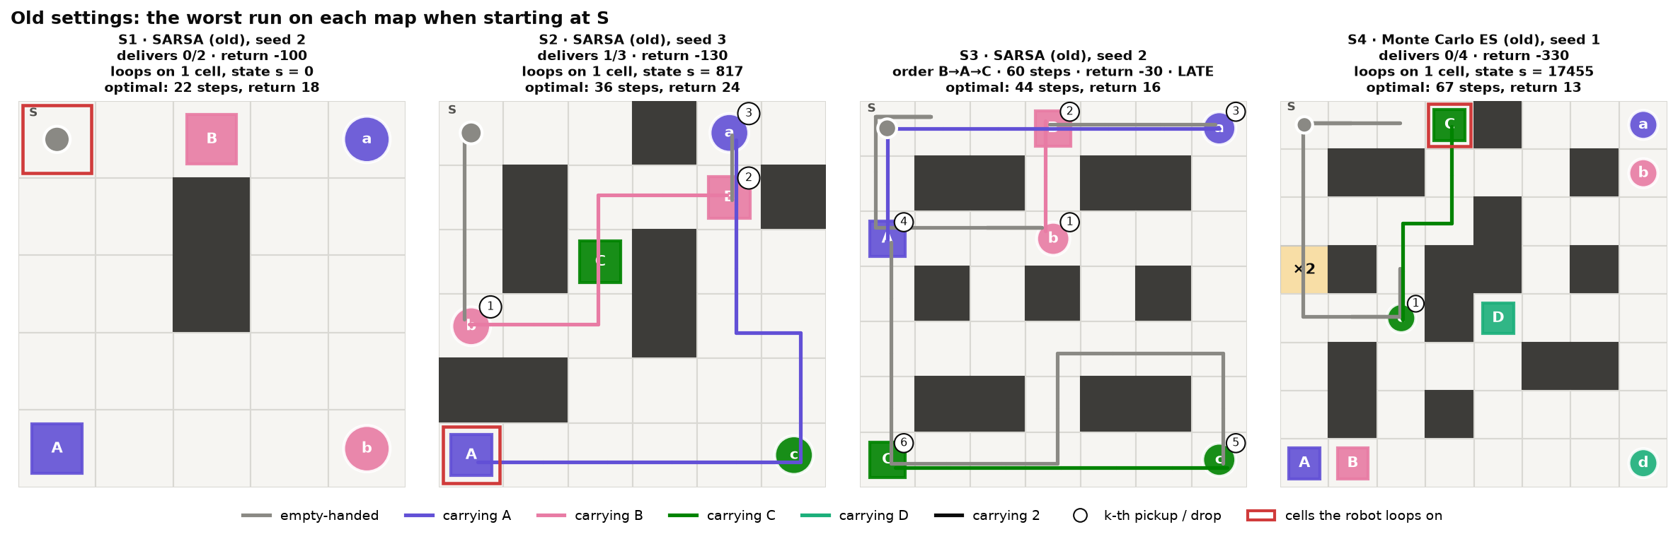
Figure 12. Old settings: the worst of the 15 runs on each map when the robot starts at S. Red frame = cell the robot loops on; circled numbers = order of pickups and drops
Table 12 lists the state where each of the 11 loops happens. In 10 of them the robot repeats a blocked move into a wall or the edge of the map, which leaves the state unchanged; in the others it steps back and forth between cells. On S1 the robot never leaves S (state code 0). On S2 it stands on A's drop cell carrying A (state 817) and keeps walking into the edge of the map instead of dropping: the learned Q(Down) = 13.71 is above Q(Drop) = 12.88. On S4 all four Monte Carlo loops happen in the same state, 17455: on C's drop cell, carrying C with the booster on. In every loop the action the robot repeats has a higher learned Q value than the optimal action, although Q* ranks it lower, and because the environment is deterministic the robot meets the same state again and repeats the mistake until max_steps.
Table 12. Old settings, starting at S: the state where each loop happens, with its state code, the action the robot repeats and the optimal action (learned Q values in brackets)
Map | Run | State code | State (row, col, σ…, τ, b) | Repeated action | Optimal action
S1 | SARSA, seed 2 | 0 | (0, 0, 0, 0, 0, 0) | Up (1.03) | Right (0.99)
S1 | SARSA, seed 3 | 0 | (0, 0, 0, 0, 0, 0) | Down (−1.55) | Right (−2.11)
S1 | SARSA, seed 4 | 202 | (4, 2, 1, 1, 0, 0) | Down (21.03) | Left (20.42)
S2 | SARSA, seed 3 | 817 | (5, 0, 1, 2, 0, 0, 0) | Down (13.71) | Drop (12.88)
S4 | SARSA, seed 2 | 337823 | (7, 4, 2, 2, 0, 1, 22, 2) | Down (14.50) | Up (13.99)
S4 | SARSA, seed 3 | 203687 | (4, 4, 2, 2, 0, 1, 22, 2) | Left (17.72) | Drop (16.92)
S4 | SARSA, seed 4 | 84178 | (1, 7, 1, 1, 0, 0, 22, 1) | Right (15.94) | Down (15.74)
S4 | Monte Carlo ES, seed 1 | 17455 | (0, 3, 0, 0, 1, 0, 22, 1) | Right (−139.84) | Down (−160.32)
S4 | Monte Carlo ES, seed 2 | 17455 | (0, 3, 0, 0, 1, 0, 22, 1) | Up (−128.04) | Down (−148.99)
S4 | Monte Carlo ES, seed 3 | 17455 | (0, 3, 0, 0, 1, 0, 22, 1) | Up (−129.35) | Down (−151.58)
S4 | Monte Carlo ES, seed 4 | 17455 | (0, 3, 0, 0, 1, 0, 22, 1) | Up (−141.27) | Down (−163.37)

Started in any reachable state, the old settings are wrong in 0.2–45% of the states on S1 and S2 and in 33–91% on S3 and S4 (grey bars in Figure 13). On S1 and S2 the mistakes are loops and longer routes; on S3 and S4 there are also late deliveries and illegal Pickup/Drop actions. When the robot always starts at τ = 0 with the booster unused, most of these states are almost never visited, so their Q values are barely trained; exploring starts remove exactly this problem.
Table 13. Old settings: share of reachable states that are wrong (mean of 5 seeds), the type of mistake, and the outcome when starting at S
Map | Algorithm | Wrong states | Never finishes / late / illegal / longer | From S (5 seeds)
S1 | Q-learning | 0.2% | 50% / 0% / 0% / 50% | optimal 5/5
 | SARSA | 45% | 69% / 0% / 0% / 31% | longer 2/5 (16), loops 3/5 (−100)
 | Monte Carlo ES | 11% | 65% / 0% / 0% / 35% | optimal 5/5
S2 | Q-learning | 5.9% | 25% / 0% / 0% / 75% | optimal 5/5
 | SARSA | 31% | 70% / 0% / 0% / 30% | optimal 4/5, loops 1/5 (−130)
 | Monte Carlo ES | 37% | 72% / 0% / 0% / 28% | optimal 5/5
S3 | Q-learning | 33% | 0% / 7% / 9% / 84% | optimal 5/5
 | SARSA | 79% | 22% / 5% / 14% / 58% | late 5/5 (−30 to −20)
 | Monte Carlo ES | 83% | 13% / 13% / 16% / 59% | late 5/5 (−25 to −18)
S4 | Q-learning | 36% | 28% / 6% / 5% / 62% | optimal 5/5
 | SARSA | 83% | 74% / 2% / 3% / 21% | late 2/5 (−24 to −22), loops 3/5 (−330 to −290)
 | Monte Carlo ES | 91% | 70% / 2% / 3% / 24% | late 1/5 (−36), loops 4/5 (−330)

10.3. New settings: started in every reachable state
With the new settings, Q-learning and Monte Carlo ES are right in every reachable state on all four maps, in all 5 seeds (40/40 runs, Table 14). This agrees with Figure 9: their Q tables equal Q*. SARSA is right everywhere on S1 and S2, but takes a longer route from 0–46 of the 4,024 states on S3 (0.3% on average) and from 273–301 of the 15,604 states on S4 (1.8%). Every one of these SARSA mistakes is a longer route: no loop, no late delivery and no illegal action, and the robot loses at most 6 points (6 extra steps). From the start states SARSA is still 100% correct, which is why Section 6 cannot see these mistakes.
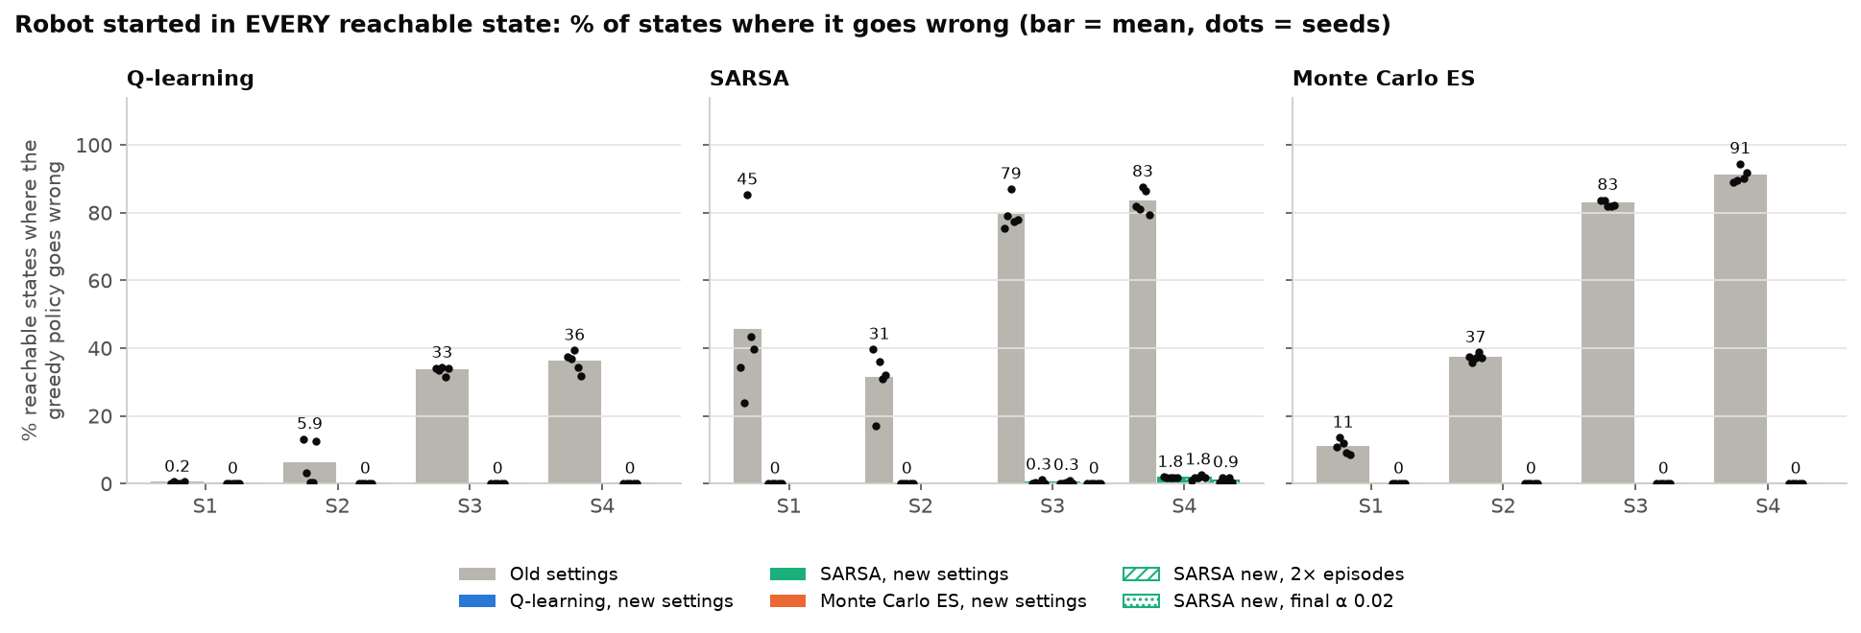
Figure 13. Robot started in every reachable state: % of states where the greedy policy goes wrong; bar = mean, dots = 5 seeds; for SARSA also with 2× episodes and with final α = 0.02
Table 14. Number of wrong states per seed (range over 5 seeds; mean share in brackets)
Map (reachable states) | Q-learning | SARSA | Monte Carlo ES | SARSA, 2× episodes | SARSA, final α 0.02
S1 (184) | 0 | 0 | 0 | – | –
S2 (532) | 0 | 0 | 0 | – | –
S3 (4,024) | 0 | 0–46 (0.3%) | 0 | 0–41 (0.3%) | 0
S4 (15,604) | 0 | 273–301 (1.8%) | 0 | 144–413 (1.8%) | 29–283 (0.9%)

10.4. A typical SARSA mistake
Figure 14 shows the costliest state of SARSA seed 0 on S4. The robot is in the top-left corner, carries parcel C and has the booster on, so it may carry two parcels; τ = 7, so D's deadline can no longer be met and both routes deliver D late. SARSA delivers C at once, three cells away. That ends the booster trip, so A, B and D are then carried one at a time: 61 steps, return −11. The optimal route first fetches A while still holding C, delivers C on the way back, then carries A and B together: 55 steps, return −5.
The right panel of Figure 14 shows that 90% of the 1,424 wrong states of the 5 seeds lie in the top-left part of the map, between the booster cell and C's drop cell, and 90% are states where the robot carries one parcel and has not delivered anything yet.
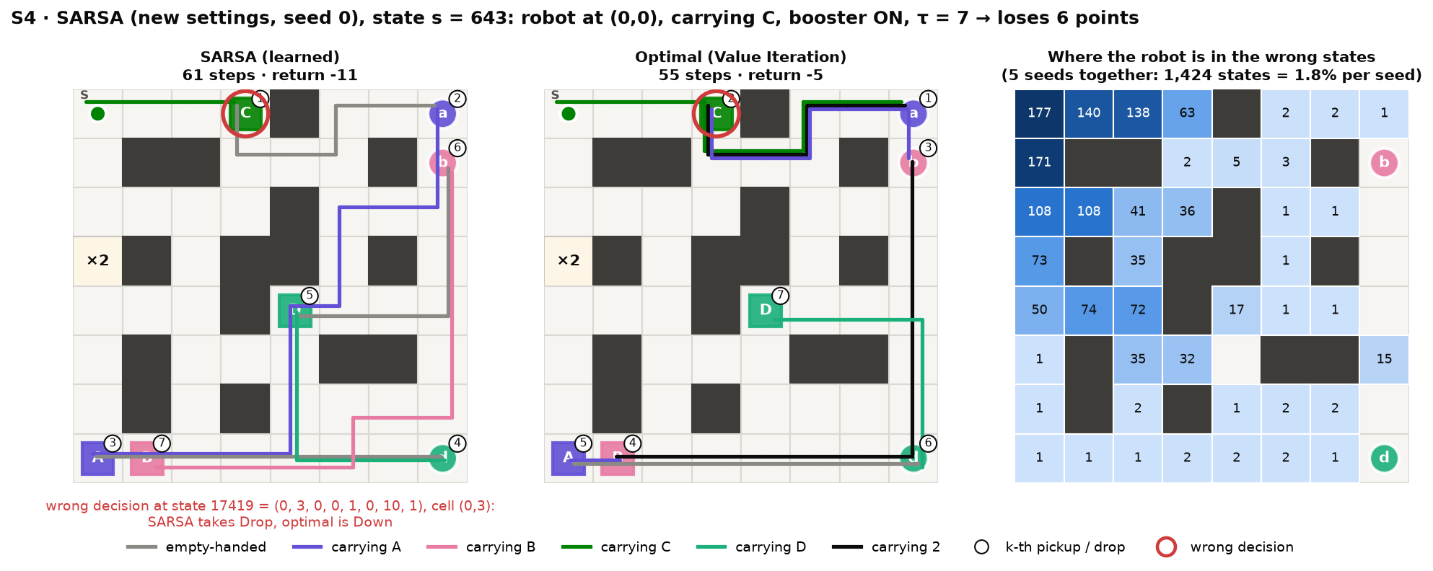
Figure 14. S4, SARSA (new settings): the costliest wrong state of seed 0, learned route (left) versus optimal route (middle), red ring = wrong decision; right: robot position in the wrong states of all 5 seeds
Where exactly does SARSA turn wrong? In the example the start state (code 643) is fine: SARSA's first action, Right, is optimal. The wrong decision comes 3 steps later, at state code 17419 = (0, 3, 0, 0, 1, 0, 10, 1) on C's drop cell (red ring in Figure 14): SARSA drops C, while the optimal action is Down. In Q* the two actions differ by only 0.04 (Down −9.89, Drop −9.93): with γ = 0.99, delivering C at once brings its +20 forward, which almost pays for the 6 extra steps it causes later. SARSA's Q values in this state are 0.12–0.24 below Q*, more than that gap, so the order of the two actions flips.
All 301 wrong states of seed 0 come from only 39 wrong decisions (29–39 over the 5 seeds), and the ten most common ones cover 74% of the wrong states (Table 15). They sit on just two cells: (4, 2), C's pickup cell, where the robot carries B and C with the booster on and SARSA goes Down instead of Up, and (0, 3), C's drop cell, where SARSA drops C instead of going Down. In each of them Q* separates SARSA's choice from the optimal action by at most 0.04, so a small error in SARSA's Q table is enough to pick the wrong one.
Table 15. S4, SARSA (new settings, seed 0): the ten most common wrong decisions, with their state code; values are given for SARSA's action / the optimal action
State code | State (row, col, σA, σB, σC, σD, τ, b) | Wrong states via it | SARSA takes | Optimal | True Q* | Learned Q
190921 | (4, 2, 0, 1, 1, 0, 22, 1) | 109 | Down | Up | 26.73 / 26.76 | 26.73 / 26.60
190915 | (4, 2, 0, 1, 1, 0, 20, 1) | 20 | Down | Up | −2.97 / −2.94 | −2.97 / −3.07
190918 | (4, 2, 0, 1, 1, 0, 21, 1) | 20 | Down | Up | −3.27 / −3.24 | −3.27 / −3.42
190909 | (4, 2, 0, 1, 1, 0, 18, 1) | 17 | Down | Up | −2.38 / −2.35 | −2.38 / −2.54
190912 | (4, 2, 0, 1, 1, 0, 19, 1) | 17 | Down | Up | −2.68 / −2.64 | −2.68 / −2.82
17455 | (0, 3, 0, 0, 1, 0, 22, 1) | 15 | Drop | Down | 16.93 / 16.97 | 16.92 / 16.82
190903 | (4, 2, 0, 1, 1, 0, 16, 1) | 7 | Down | Up | −1.80 / −1.77 | −1.80 / −1.91
190906 | (4, 2, 0, 1, 1, 0, 17, 1) | 7 | Down | Up | −2.09 / −2.06 | −2.09 / −2.21
17419 | (0, 3, 0, 0, 1, 0, 10, 1) | 5 | Drop | Down | −9.93 / −9.89 | −10.05 / −10.13
17422 | (0, 3, 0, 0, 1, 0, 11, 1) | 5 | Drop | Down | −10.21 / −10.17 | −10.21 / −10.40

Two variants test where the error comes from (Table 14, Figure 13). Twice as many episodes barely helps (S4: 1.8% → 1.8% of the states), so the mistakes are not caused by too short training. A smaller final step size helps: with α decaying to 0.02 instead of 0.1, SARSA becomes exact on S3 in all 5 seeds and the wrong states on S4 halve (0.9%, 29–283 per seed). This fits the explanation in Section 8: SARSA's target r + γ·Q(s′, a′) is noisy because a′ is sometimes random, a small α averages that noise out, and a gap of a few hundredths between two actions in Q* is easily swapped by the error that remains. Two quick tests on S4 (3 seeds each, outside failure_cases.py) point the same way: a constant α = 0.5 or α = 1 leaves 3,263–7,583 wrong states, and SARSA with Q-learning's ε schedule (ε → 0.01) leaves 2,442–2,649, because on-policy SARSA then learns the value of a policy that still explores.

10.5. What this means
- Accuracy from start cells is not the whole picture: a policy that is 100% correct from every start cell can still be wrong in states off its route. Checking every reachable state takes less than a second per Q table here and shows the difference.
- For this task Q-learning and Monte Carlo ES are the safe choices: their Q tables are optimal in every state, so the robot finds the best route again even from an unusual state.
- Every mistake can be traced to a state code. SARSA's few hundred wrong states on S4 come from a few dozen wrong decisions on two cells, where two actions are almost equally good in Q*; Appendix A lists all of them with their state code, and results/failure_states.csv lists every wrong state.
- SARSA's remaining mistakes are small (at most 6 points, never a loop) and do not go away with more episodes; a smaller final step size removes about half of them on S4 and all of them on S3.
- The serious mistakes (endless loops, late deliveries, illegal actions) only appear with the old settings, in up to 91% of the states; exploring starts and the per-algorithm ε schedule remove them.

11. Conclusion and how to run the demo
With 4 levelled maps, a state space of up to 357,696 encoded states (15,612 reachable) and enough episodes, all three tabular algorithms find the optimal delivery order by themselves, including prioritising the deadline parcel and exploiting the booster cell.
- Q-learning, SARSA and Monte Carlo ES: 100% accuracy in 5/5 seeds on all 4 maps (60/60 runs); the Q tables converge to Q*.
- Exploring starts and a per-algorithm ε schedule are the decisive improvements: with the same number of episodes, SARSA on S4 rises from 0.4% to 100%, and Monte Carlo on S3 and S4 from 0% to 100%.
- Q-learning learns the fastest and most stably; Monte Carlo ES is second; SARSA needs about 3 times as many episodes as Q-learning on S4 and still fluctuates.
- Started in every reachable state rather than only at a start cell, Q-learning and Monte Carlo ES are never wrong; SARSA takes a slightly longer route from 0.3% of the S3 states and 1.8% of the S4 states (at most 6 extra steps, never a loop), while the old settings loop, deliver late or make illegal moves in up to 91% of the states (Section 10).
- The number of episodes matters on hard maps: S4 needs 1–4 million episodes depending on the algorithm; numba makes this run in a few tens of seconds.
- Changing the reward (late penalty) or the environment (deadline, booster cell) changes the delivery order exactly as the optimal solution predicts.
- The learned values make the task visible: they rise toward the current target, and cells from which the deadline can no longer be met become negative.
Limitations. The τ variable makes the state space grow linearly with the deadline length. Exploring starts need a simulator that can put the robot in any state, which is hard with a real robot. The Q table is tied to one grid, so every map must be trained separately. The hyperparameters were tuned on these same 4 maps. The accuracy of Section 6 only covers start cells; Section 10 shows that SARSA can still be slightly wrong in states off its route.
Future work. Try a stochastic environment (wheel slip) to see whether the ranking of the three algorithms changes; try Expected SARSA or Q(λ), and a SARSA step-size schedule that is also exact off the route; replace the Q table with function approximation so that one model can serve several maps.
Running everything again
pip install gymnasium numpy matplotlib numba
python experiments.py # ~4 minutes on 12 CPU cores; --quick for a fast test
python plots.py --lang en # 17 figures with English labels in figures_en/
python convergence.py # measures how Q converges to Q*
python failure_cases.py # where each policy goes wrong (~3 min)
python demo.py # one S4 episode with the learned policy, step by step
python demo.py --config configs/s3_deadline.json --algo sarsa --gif
python play.py # play yourself: W/A/S/D move, J picks up, K drops
The demo prints a text map after every step (@ robot, a/b/c/d waiting parcels, A/B/C/D drop cells, * delivered, + booster cell) with the action, reward and event; on S4 it ends at step 67 with return 13. play.py uses the same rules but lets you drive the robot with the keyboard, and at the end compares your return with the optimal route. On Google Colab, open colab_train.ipynb and run the cells in order.

Appendix A. State codes of every wrong decision
Table 16 lists every different wrong decision of SARSA with the new settings over the 5 seeds: 4 states on S3 and 56 on S4. State code = encode(s) (Section 3); the state is written as (row, col, σ₁, …, σ_{N}, τ, b) with σ = 0 waiting, 1 carried, 2 delivered. "Q* gap" is how much worse SARSA's action is than the optimal one in the true values Q*. In 36 of the 60 wrong decisions the gap is at most 0.05, and these cause 92% of the wrong states: a small error in SARSA's Q table is enough to swap the two actions. The other 24 have a gap of 0.24–1.24 (at most about one extra step) and cause the remaining 8%. Q-learning and Monte Carlo ES make no wrong decision. The wrong start states of the old settings, with their wrong decisions, are in results/failure_states.csv.
Table 16. SARSA, new settings, 5 seeds: every wrong decision with its state code (sorted by map and by the number of wrong states that lead to it)
Map | State code | State (row, col, σ…, τ, b) | SARSA takes | Optimal | Q* gap | Seeds | Wrong states via it
S3 | 2408 | (0, 4, 0, 2, 0, 14, 0) | Down | Right | 1.07 | 3 | 46
S3 | 27547 | (6, 6, 0, 2, 1, 16, 0) | Down | Left | 1.09 | 1 | 13
S3 | 18153 | (4, 4, 0, 0, 0, 9, 0) | Up | Right | 0.25 | 0 | 2
S3 | 19851 | (5, 0, 0, 0, 0, 6, 0) | Up | Down | 0.24 | 0 | 1
S4 | 190921 | (4, 2, 0, 1, 1, 0, 22, 1) | Down | Up | 0.03 | all 5 | 543
S4 | 190915 | (4, 2, 0, 1, 1, 0, 20, 1) | Down | Up | 0.03 | all 5 | 98
S4 | 190918 | (4, 2, 0, 1, 1, 0, 21, 1) | Down | Up | 0.03 | all 5 | 98
S4 | 190909 | (4, 2, 0, 1, 1, 0, 18, 1) | Down | Up | 0.03 | all 5 | 85
S4 | 190912 | (4, 2, 0, 1, 1, 0, 19, 1) | Down | Up | 0.03 | all 5 | 83
S4 | 17455 | (0, 3, 0, 0, 1, 0, 22, 1) | Drop | Down | 0.04 | all 5 | 71
S4 | 190906 | (4, 2, 0, 1, 1, 0, 17, 1) | Down | Up | 0.03 | all 5 | 35
S4 | 17425 | (0, 3, 0, 0, 1, 0, 12, 1) | Drop | Down | 0.04 | all 5 | 25
S4 | 17431 | (0, 3, 0, 0, 1, 0, 14, 1) | Drop | Down | 0.04 | all 5 | 25
S4 | 17452 | (0, 3, 0, 0, 1, 0, 21, 1) | Drop | Down | 0.04 | all 5 | 25
S4 | 17437 | (0, 3, 0, 0, 1, 0, 16, 1) | Drop | Down | 0.04 | all 5 | 24
S4 | 17440 | (0, 3, 0, 0, 1, 0, 17, 1) | Drop | Down | 0.04 | all 5 | 24
S4 | 17443 | (0, 3, 0, 0, 1, 0, 18, 1) | Drop | Down | 0.04 | all 5 | 24
S4 | 17446 | (0, 3, 0, 0, 1, 0, 19, 1) | Drop | Down | 0.04 | all 5 | 24
S4 | 17449 | (0, 3, 0, 0, 1, 0, 20, 1) | Drop | Down | 0.04 | all 5 | 24
S4 | 190903 | (4, 2, 0, 1, 1, 0, 16, 1) | Down | Up | 0.03 | 0, 1, 2 | 21
S4 | 17422 | (0, 3, 0, 0, 1, 0, 11, 1) | Drop | Down | 0.04 | 0, 1, 3, 4 | 20
S4 | 17428 | (0, 3, 0, 0, 1, 0, 13, 1) | Drop | Down | 0.04 | 0, 1, 3, 4 | 20
S4 | 17434 | (0, 3, 0, 0, 1, 0, 15, 1) | Drop | Down | 0.04 | 0, 1, 3, 4 | 20
S4 | 17419 | (0, 3, 0, 0, 1, 0, 10, 1) | Drop | Down | 0.04 | 0, 1, 3, 4 | 19
S4 | 340962 | (7, 5, 0, 0, 0, 0, 11, 0) | Down | Right | 1.16 | 3 | 9
S4 | 73958 | (1, 5, 0, 0, 2, 0, 19, 2) | Down | Up | 0.24 | 2 | 8
S4 | 40418 | (0, 7, 0, 0, 2, 0, 17, 2) | Down | Pickup | 0.25 | 2 | 7
S4 | 292545 | (6, 4, 0, 0, 0, 1, 18, 0) | Left | Up | 1.24 | 1 | 7
S4 | 135025 | (3, 0, 0, 1, 1, 0, 20, 1) | Down | Up | 0.03 | all 5 | 5
S4 | 135028 | (3, 0, 0, 1, 1, 0, 21, 1) | Down | Up | 0.03 | all 5 | 5
S4 | 135031 | (3, 0, 0, 1, 1, 0, 22, 1) | Down | Up | 0.03 | all 5 | 5
S4 | 202093 | (4, 4, 0, 1, 1, 0, 20, 1) | Down | Right | 0.03 | all 5 | 5
S4 | 202096 | (4, 4, 0, 1, 1, 0, 21, 1) | Down | Right | 0.03 | all 5 | 5
S4 | 202099 | (4, 4, 0, 1, 1, 0, 22, 1) | Down | Right | 0.03 | all 5 | 5
S4 | 263572 | (5, 7, 0, 1, 1, 0, 20, 1) | Down | Up | 0.03 | all 5 | 5
S4 | 263575 | (5, 7, 0, 1, 1, 0, 21, 1) | Down | Up | 0.03 | all 5 | 5
S4 | 263578 | (5, 7, 0, 1, 1, 0, 22, 1) | Down | Up | 0.03 | all 5 | 5
S4 | 135022 | (3, 0, 0, 1, 1, 0, 19, 1) | Down | Up | 0.03 | 0, 1, 2, 3 | 4
S4 | 162732 | (3, 5, 0, 0, 1, 0, 10, 0) | Left | Up | 1.15 | 0 | 4
S4 | 73314 | (1, 5, 0, 0, 1, 0, 12, 0) | Right | Left | 1.18 | 0 | 3
S4 | 5647 | (0, 1, 0, 0, 0, 0, 19, 1) | Down | Right | 1.16 | 0 | 2
S4 | 12467 | (0, 2, 0, 0, 2, 0, 15, 2) | Up | Right | 0.97 | 0 | 2
S4 | 118023 | (2, 5, 0, 0, 1, 0, 11, 0) | Left | Up | 1.17 | 0 | 2
S4 | 182227 | (4, 0, 0, 1, 2, 1, 22, 1) | Down | Right | 0.27 | 0 | 2
S4 | 185320 | (4, 1, 0, 1, 1, 0, 18, 1) | Left | Right | 0.03 | 2, 3 | 2
S4 | 185323 | (4, 1, 0, 1, 1, 0, 19, 1) | Left | Right | 0.03 | 2, 3 | 2
S4 | 185326 | (4, 1, 0, 1, 1, 0, 20, 1) | Left | Right | 0.03 | 1, 2 | 2
S4 | 195062 | (4, 2, 0, 0, 2, 2, 22, 2) | Down | Up | 0.55 | 0 | 2
S4 | 298104 | (6, 5, 0, 0, 0, 1, 8, 0) | Up | Left | 1.23 | 1 | 2
S4 | 5725 | (0, 1, 1, 0, 0, 0, 22, 1) | Left | Right | 0.25 | 3 | 1
S4 | 67092 | (1, 4, 0, 0, 0, 0, 8, 0) | Right | Left | 0.93 | 2 | 1
S4 | 67728 | (1, 4, 0, 0, 1, 0, 13, 0) | Up | Left | 1.19 | 0 | 1
S4 | 68170 | (1, 4, 0, 2, 1, 0, 22, 1) | Left | Right | 0.26 | 2 | 1
S4 | 178866 | (4, 0, 0, 0, 0, 0, 6, 0) | Right | Up | 0.58 | 2 | 1
S4 | 185329 | (4, 1, 0, 1, 1, 0, 21, 1) | Left | Right | 0.03 | 3 | 1
S4 | 185332 | (4, 1, 0, 1, 1, 0, 22, 1) | Left | Right | 0.03 | 1 | 1
S4 | 203134 | (4, 4, 0, 0, 0, 1, 22, 1) | Drop | Down | 0.05 | 0 | 1
S4 | 240360 | (5, 3, 0, 0, 0, 0, 11, 0) | Right | Left | 0.96 | 2 | 1
S4 | 240591 | (5, 3, 0, 1, 0, 0, 19, 0) | Up | Left | 1.22 | 4 | 1
S4 | 279483 | (6, 2, 0, 0, 0, 0, 11, 0) | Down | Up | 0.96 | 2 | 1

