

**Title of the Thesis  
with subtitle, if applicable**

**Documentation**  
by  
**Alexander Grissinger**Matriculation number: 11006444

2019-07-03

SRH University Heidelberg  
School of Information, Media and Design  
Degree course "Applied Artificial Intelligence"  
Major field "Applied Computer Science (M.Sc.)"

Reviewers Dr. Simon Ziegler

**Table of Contents**

1 Introduction 5

1.1 Objective 5

1.2 Methodology 5

2 Chapter Heading 6

2.1 Sub-Chapter 6

2.1.1 Further Sub-Chapter 7

3 Conclusion and Outlook 8

Appendix 9

Bibliography 10

Ludography / Filmography or Similar (if required) 11

Index of Figures 12

Index of Tables 13

Index of Listings 14

# Introduction

In the introduction you should develop your topic and the scientific problem to be explored as concisely as possible. Here, you must explain your scientific motivation and, if applicable, you can also include your personal motivation.

## Objective

Please define your objective as precisely and concisely as possible in this section.

## Methodology

Here you should explain the methods by which you intend to tackle your subject and achieve your objective. If necessary, please break your objective down into sub-targets.

# Chapter Heading

In order to ensure that all content of your thesis is formatted correctly and uniformly, please use the templates (in Word under the "Home" tab) as follows: "Normal" (standard) for text blocks, "Heading 1-3" for the various headings, etc.

## Sub-Chapter

This is where you could enter your text.

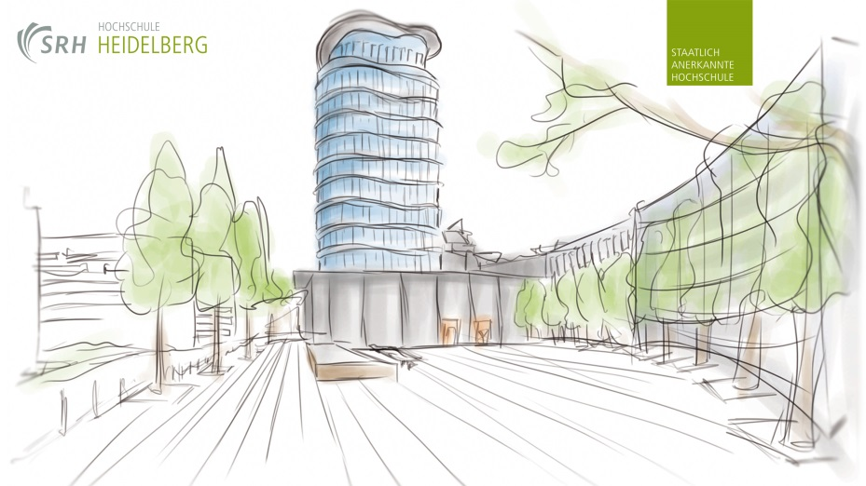

Fig. 2‑1: To generate an automatic caption, click right on the image and select "Insert caption".

### Further Sub-Chapter

This is the space for more text.

Insert source code as text with syntax highlighting. Please insert the caption – preferably automatically – as a listing. If you are using Visual Studio, you can copy the source code directly from there into Word. However, in Visual Studio under "Tools → Options → Environment → General → Visual Experience" you should set the colour theme to "Blue" or "Light", but on no account to "Dark"!

void init(void)

{{

glShadeModel( GL_SMOOTH ); // Enable smooth shading

glClearColor( 0.0f, 0.0f, 0.0f, 0.5f ); // Black background

glEnable ( GL_COLOR_MATERIAL );

glColorMaterial ( GL_FRONT, GL_AMBIENT_AND_DIFFUSE );

glEnable ( GL_TEXTURE_2D );

glPixelStorei ( GL_UNPACK_ALIGNMENT, 1 );

glGenTextures ( 3, texture_id );

}

Listing 2‑1: sample code

Table captions are positioned above rather than below the table:

Tab. ‑: Table caption

|  |  |  |
| --- | --- | --- |
| **Dummy** | **Dummy** | **Dummy** |
|  |  |  |
|  |  |  |
|  |  |  |

# Conclusion and Outlook

All theses should conclude with a chapter entitled "Conclusion and Outlook", "Summary" or similar.

# Appendix

The appendix should include firstly all data and information which you do not wish to or are not permitted to include in the main body, i.e. the chapters, of your thesis. Here in the appendix you can publish, for instance, raw data from interviews, completed questionnaires or extensive statistical evaluations. If there is no such data or information that you wish to transfer to an appendix, this page is omitted.

However, the order of the following indexes is prescribed:

* bibliography
* ludography (games index), filmography or similar (if required)
* index of figures
* index of tables
* index of listings (as necessary)
* glossary and index (as necessary)

To add an index in Word, under the "References" tab click "Insert Table of Figures". Under "General: Caption label" you can now choose the type of index you want to create.

# Bibliography

Here you must list all the sources referenced in your thesis. Ideally you should have the bibliography list generated directly by Citavi – this will save you a lot of work and avoid many potential errors.

# Ludography / Filmography or Similar (if required)

Subject to the specific topic and content of your thesis, you can add specialized indexes here between the bibliography and the index of figures.

# Index of Figures

Here you should list all the figures in your thesis. We urgently recommend you to have all indexes in your thesis generated automatically by Word and Citavi.

Fig. 2‑1: Automatic generation of caption by right click on the image and "Insert caption" 6

# Index of Tables

Here you should list all the tables in your thesis:

Tab. 2‑1: Table heading 7

# Index of Listings

Here you should list all the listings (fragments of source code) in your thesis:

Listing 2‑1: Sample code 7