武汉纺织大学

Java应用开发课程设计

**小学生算术运算测验系统**

**学 院： 数学与计算机学院**

**班 级： 软件11802班**

**姓 名： 邱梓贤**

**学 号： 1804240419**

**指导老师： 聂刚**

**成 绩：**

**完成日期： 2020年6月20日**

目录

1 需求分析 2

1.1用户登陆 2

1.2主菜单 2

1.3各项功能 3

1.3.1 出题 3

1.3.2 答题 3

1.3.3 查看成绩 3

1.3.4 排行榜 3

1.3.5 退出 3

2 系统设计 3

2.1用户用例图 3

2.2 ER图 4

2.3 UML类图（Class Diagram） 4

2.4 UML时序图（Sequence Diagram） 5

2.5 UML活动图（Activity Diagram） 7

2.5.1 登陆并显示菜单 7

2.5.2 出题功能模块 7

2.5.3 答题功能模块 8

2.5.4 查看成绩功能模块 9

2.5.5 排行榜功能模块 10

2.5.6 退出功能模块 11

3 系统实现 12

3.1 项目结构 12

3.2 配置文件 13

3.3 VO类Student.java 13

3.4 VO类Question.java 14

3.5 VO类Answer.java 15

3.6 文件操作类FileOperator.java 16

3.7 文件操作类No.java 18

3.8 主要功能实现类ShowQuestion.java 20

3.9 用户界面Driver.java 25

4 系统测试 27

4.1用户输入姓名 27

4.3出题功能 28

4.4答题功能 28

4.5查看成绩功能 29

4.6排行榜功能 29

4.7退出功能 30

5 系统总结 30

# 1 需求分析

开发一个简单的算术运算测验程序，完成两位数以内两个随机整数的加减乘除运算作答（注：两个数相除时取整）。程序运行时，首先提示输入测验人员的姓名，输入完毕后，显示以下主菜单。

## 1.1用户登陆

程序运行时，提示使用者先输入姓名，姓名输入完毕后，显示出可供选择的菜单。若未输入用户名或用户名为空，则提示“请先输入你的名字”。

## 1.2主菜单

当用户名输入完成时，进入系统主界面，如下：

简单算术运算测验系统

1.出题

2.答题

3.查看成绩

4.排行榜

5.退出

请选择（1-5）：

选择1，输入题目数量，随机产生指定数量的两位数以内两个随机整数的加减乘除运算题。

选择2：逐题显示随机产生的每道测试题，输入运算结果。答题完毕后以文件形式存放测验人的姓名，测验成绩，测验时间。

选择3：显示本次测验的所有题目，自己的答案，正确答案，以及获得的成绩（百分制，每题分值相同），正确率。

选择4：升序显示所有测验人员的排名，姓名，成绩，测验时间。

## 1.3各项功能

### 1.3.1 出题

当选择1时，系统各处提示“输入题目数量”，输入题目数量后，程序将随机产生指定数量的两位数以内两个随机整数的加减乘除运算题。

### 1.3.2 答题

当选择2时，系统将逐题显示随机产生的每道测试题，并给出提示“请输入你的答案”，使用者输入每道测试题的运算结果。答题完毕后，程序将以TXT文件的形式存放相关的信息，例如：测试人的姓名、测验成绩（百分制）以及测试的时间。

### 1.3.3 查看成绩

当选择3时，系统显示本次测验的所有题目，用户作答的答案，正确答案，以及所获得的成绩（百分制，每个题目的分值相同）。

### 1.3.4 排行榜

当选择4时，程序自动的将文件中学生信息按照升序做排序处理，并显示出所有参与测试的人员信息，如：排名、姓名、成绩和测试时间。

### 1.3.5 退出

当选择5时，退出程序。

# **2 系统设计**

## 2.1用户用例图

系统有使用者一个身份，其系统功能用例如下图2-1所示：

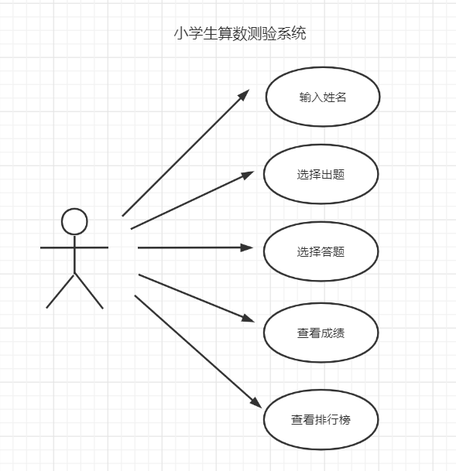

图2-1 用户用例图

## 2.2 ER图

此系统并不涉及到有关数据库的操作，因此此处无ER图。

此%3CmxGraphModel%3E%3Croot%3E%3CmxCell%20id%3D%220%22%2F%3E%3CmxCell%20id%3D%221%22%20parent%3D%220%22%2F%3E%3Cmysql.table%20entity.table.tableName%3D%22uses%22%20label%3D%22uses%22%20id%3D%222%22%3E%3CmxCell%20style%3D%22swimlane%3BfontStyle%3D0%3BchildLayout%3DstackLayout%3Bhorizontal%3D1%3Bhtml%3D1%3BstartSize%3D26%3BfillColor%3D%23b0e3e6%3BhorizontalStack%3D0%3BresizeParent%3D1%3BresizeParentMax%3D0%3BresizeLast%3D0%3Bcollapsible%3D1%3BmarginBottom%3D0%3BswimlaneFillColor%3D%23ffffff%3Balign%3Dcenter%3BfontSize%3D13%3BstrokeColor%3D%230e8088%3Brounded%3D0%3Bshadow%3D1%3Bcomic%3D0%3Bglass%3D0%3BgradientDirection%3Dsouth%3BgradientColor%3D%23ffffff%3B%22%20vertex%3D%221%22%20connectable%3D%220%22%20parent%3D%221%22%3E%3CmxGeometry%20x%3D%2260%22%20y%3D%2250%22%20width%3D%22310%22%20height%3D%22130%22%20as%3D%22geometry%22%2F%3E%3C%2FmxCell%3E%3C%2Fmysql.table%3E%3Cmysql.column%20entity.column.tableName%3D%22uses%22%20entity.column.name%3D%22userName%22%20entity.column.dataType%3D%22VARCHAR%22%20entity.column.PK%3D%22true%22%20label%3D%22%26lt%3Bimg%20title%3D%26quot%3BPrimary%20Key%26quot%3B%20src%3D%26quot%3Bimg%2Fdb%2Fkey1.png%26quot%3B%20width%3D%26quot%3B16%26quot%3B%20height%3D%26quot%3B16%26quot%3B%20align%3D%26quot%3Btop%26quot%3B%26gt%3B%26amp%3Bnbsp%3B%26lt%3Bfont%20size%3D%26quot%3B1%26quot%3B%20face%3D%26quot%3BTahoma%26quot%3B%26gt%3B%26lt%3Bspan%20style%3D%26quot%3Bfont-size%3A%2013px%26quot%3B%26gt%3B%26lt%3Bb%26gt%3Bid%20int%20primary%20key%26lt%3B%2Fb%26gt%3B%26lt%3B%2Fspan%26gt%3B%26lt%3B%2Ffont%26gt%3B%22%20entity.column.oldName%3D%22id%22%20entity.column.datalen%3D%2220%22%20entity.column.decimals%3D%22%22%20entity.column.autoIncreament%3D%22%22%20entity.column.unsigned%3D%22%22%20entity.column.bin%3D%22%22%20entity.column.ascii%3D%22%22%20entity.column.unicode%3D%22%22%20entity.column.unique%3D%22%22%20entity.column.isNotNull%3D%22NOT%20NULL%22%20entity.column.defaultValue%3D%22%22%20entity.column.comment%3D%22%22%20entity.column.enum%3D%22%22%20entity.column.set%3D%22%22%20entity.column.enumSetValue%3D%22%22%20id%3D%223%22%3E%3CmxCell%20style%3D%22text%3Bhtml%3D1%3BstrokeColor%3Dnone%3BfillColor%3Dnone%3BspacingLeft%3D4%3BspacingRight%3D4%3Boverflow%3Dhidden%3Brotatable%3D0%3BportConstraint%3Deastwest%3BfontSize%3D12%3BverticalAlign%3Dmiddle%3B%22%20vertex%3D%221%22%20parent%3D%222%22%3E%3CmxGeometry%20y%3D%2226%22%20width%3D%22310%22%20height%3D%2226%22%20as%3D%22geometry%22%2F%3E%3C%2FmxCell%3E%3C%2Fmysql.column%3E%3Cmysql.column%20entity.column.tableName%3D%22uses%22%20entity.column.name%3D%22chrName%22%20entity.column.datalen%3D%2220%22%20entity.column.dataType%3D%22VARCHAR%22%20label%3D%22%26lt%3Bimg%20title%3D%26quot%3BPrimary%20Key%26quot%3B%20src%3D%26quot%3Bimages%2Fspacer.gif%26quot%3B%20width%3D%26quot%3B16%26quot%3B%20height%3D%26quot%3B16%26quot%3B%20align%3D%26quot%3Btop%26quot%3B%26gt%3B%26amp%3Bnbsp%3B%26lt%3Bfont%20size%3D%26quot%3B1%26quot%3B%20face%3D%26quot%3BTahoma%26quot%3B%26gt%3B%26lt%3Bspan%20style%3D%26quot%3Bfont-size%3A%2013px%26quot%3B%26gt%3B%26lt%3Bb%26gt%3Bname%20varchar(10)%26lt%3B%2Fb%26gt%3B%26lt%3B%2Fspan%26gt%3B%26lt%3B%2Ffont%26gt%3B%22%20entity.column.oldName%3D%22name%22%20entity.column.decimals%3D%22%22%20entity.column.autoIncreament%3D%22%22%20entity.column.unsigned%3D%22%22%20entity.column.bin%3D%22%22%20entity.column.ascii%3D%22%22%20entity.column.unicode%3D%22%22%20entity.column.PK%3D%22false%22%20entity.column.unique%3D%22%22%20entity.column.isNotNull%3D%22%22%20entity.column.defaultValue%3D%22%22%20entity.column.comment%3D%22%22%20entity.column.enum%3D%22%22%20entity.column.set%3D%22%22%20entity.column.enumSetValue%3D%22%22%20id%3D%224%22%3E%3CmxCell%20style%3D%22text%3Bhtml%3D1%3BstrokeColor%3Dnone%3BfillColor%3Dnone%3BspacingLeft%3D4%3BspacingRight%3D4%3Boverflow%3Dhidden%3Brotatable%3D0%3BportConstraint%3Deastwest%3BfontSize%3D12%3BverticalAlign%3Dmiddle%3B%22%20vertex%3D%221%22%20parent%3D%222%22%3E%3CmxGeometry%20y%3D%2252%22%20width%3D%22310%22%20height%3D%2226%22%20as%3D%22geometry%22%2F%3E%3C%2FmxCell%3E%3C%2Fmysql.column%3E%3Cmysql.column%20entity.column.tableName%3D%22uses%22%20entity.column.name%3D%22password%22%20entity.column.datalen%3D%2250%22%20entity.column.dataType%3D%22VARCHAR%22%20label%3D%22%26lt%3Bimg%20title%3D%26quot%3BPrimary%20Key%26quot%3B%20src%3D%26quot%3Bimages%2Fspacer.gif%26quot%3B%20width%3D%26quot%3B16%26quot%3B%20height%3D%26quot%3B16%26quot%3B%20align%3D%26quot%3Btop%26quot%3B%26gt%3B%26amp%3Bnbsp%3B%26lt%3Bfont%20size%3D%26quot%3B1%26quot%3B%20face%3D%26quot%3BTahoma%26quot%3B%26gt%3B%26lt%3Bspan%20style%3D%26quot%3Bfont-size%3A%2013px%26quot%3B%26gt%3B%26lt%3Bb%26gt%3Bname%20varchar(10)%26lt%3B%2Fb%26gt%3B%26lt%3B%2Fspan%26gt%3B%26lt%3B%2Ffont%26gt%3B%22%20entity.column.oldName%3D%22chrName%22%20entity.column.decimals%3D%22%22%20entity.column.autoIncreament%3D%22%22%20entity.column.unsigned%3D%22%22%20entity.column.bin%3D%22%22%20entity.column.ascii%3D%22%22%20entity.column.unicode%3D%22%22%20entity.column.PK%3D%22false%22%20entity.column.unique%3D%22%22%20entity.column.isNotNull%3D%22%22%20entity.column.defaultValue%3D%22%22%20entity.column.comment%3D%22%E5%AF%86%E7%A0%81%22%20entity.column.enum%3D%22%22%20entity.column.set%3D%22%22%20entity.column.enumSetValue%3D%22%22%20id%3D%225%22%3E%3CmxCell%20style%3D%22text%3Bhtml%3D1%3BstrokeColor%3Dnone%3BfillColor%3Dnone%3BspacingLeft%3D4%3BspacingRight%3D4%3Boverflow%3Dhidden%3Brotatable%3D0%3BportConstraint%3Deastwest%3BfontSize%3D12%3BverticalAlign%3Dmiddle%3B%22%20vertex%3D%221%22%20parent%3D%222%22%3E%3CmxGeometry%20y%3D%2278%22%20width%3D%22310%22%20height%3D%2226%22%20as%3D%22geometry%22%2F%3E%3C%2FmxCell%3E%3C%2Fmysql.column%3E%3Cmysql.column%20entity.column.tableName%3D%22uses%22%20entity.column.name%3D%22role%22%20entity.column.datalen%3D%2220%22%20entity.column.dataType%3D%22VARCHAR%22%20label%3D%22%26lt%3Bimg%20title%3D%26quot%3BPrimary%20Key%26quot%3B%20src%3D%26quot%3Bimages%2Fspacer.gif%26quot%3B%20width%3D%26quot%3B16%26quot%3B%20height%3D%26quot%3B16%26quot%3B%20align%3D%26quot%3Btop%26quot%3B%26gt%3B%26amp%3Bnbsp%3B%26lt%3Bfont%20size%3D%26quot%3B1%26quot%3B%20face%3D%26quot%3BTahoma%26quot%3B%26gt%3B%26lt%3Bspan%20style%3D%26quot%3Bfont-size%3A%2013px%26quot%3B%26gt%3B%26lt%3Bb%26gt%3Bname%20varchar(10)%26lt%3B%2Fb%26gt%3B%26lt%3B%2Fspan%26gt%3B%26lt%3B%2Ffont%26gt%3B%22%20entity.column.oldName%3D%22chrName%22%20entity.column.decimals%3D%22%22%20entity.column.autoIncreament%3D%22%22%20entity.column.unsigned%3D%22%22%20entity.column.bin%3D%22%22%20entity.column.ascii%3D%22%22%20entity.column.unicode%3D%22%22%20entity.column.PK%3D%22false%22%20entity.column.unique%3D%22%22%20entity.column.isNotNull%3D%22%22%20entity.column.defaultValue%3D%22%22%20entity.column.comment%3D%22%E8%A7%92%E8%89%B2%22%20entity.column.enum%3D%22%22%20entity.column.set%3D%22%22%20entity.column.enumSetValue%3D%22%22%20id%3D%226%22%3E%3CmxCell%20style%3D%22text%3Bhtml%3D1%3BstrokeColor%3Dnone%3BfillColor%3Dnone%3BspacingLeft%3D4%3BspacingRight%3D4%3Boverflow%3Dhidden%3Brotatable%3D0%3BportConstraint%3Deastwest%3BfontSize%3D12%3BverticalAlign%3Dmiddle%3B%22%20vertex%3D%221%22%20parent%3D%222%22%3E%3CmxGeometry%20y%3D%22104%22%20width%3D%22310%22%20height%3D%2226%22%20as%3D%22geometry%22%2F%3E%3C%2FmxCell%3E%3C%2Fmysql.column%3E%3Cmysql.table%20entity.table.tableName%3D%22product%22%20label%3D%22product%22%20id%3D%227%22%3E%3CmxCell%20style%3D%22swimlane%3BfontStyle%3D0%3BchildLayout%3DstackLayout%3Bhorizontal%3D1%3Bhtml%3D1%3BstartSize%3D26%3BfillColor%3D%23b0e3e6%3BhorizontalStack%3D0%3BresizeParent%3D1%3BresizeParentMax%3D0%3BresizeLast%3D0%3Bcollapsible%3D1%3BmarginBottom%3D0%3BswimlaneFillColor%3D%23ffffff%3Balign%3Dcenter%3BfontSize%3D13%3BstrokeColor%3D%230e8088%3Brounded%3D0%3Bshadow%3D1%3Bcomic%3D0%3Bglass%3D0%3BgradientDirection%3Dsouth%3BgradientColor%3D%23ffffff%3B%22%20vertex%3D%221%22%20connectable%3D%220%22%20parent%3D%221%22%3E%3CmxGeometry%20x%3D%2260%22%20y%3D%22210%22%20width%3D%22310%22%20height%3D%22130%22%20as%3D%22geometry%22%2F%3E%3C%2FmxCell%3E%3C%2Fmysql.table%3E%3Cmysql.column%20entity.column.tableName%3D%22product%22%20entity.column.name%3D%22barcode%22%20entity.column.dataType%3D%22VARCHAR%22%20entity.column.PK%3D%22true%22%20label%3D%22%26lt%3Bimg%20title%3D%26quot%3BPrimary%20Key%26quot%3B%20src%3D%26quot%3Bimg%2Fdb%2Fkey1.png%26quot%3B%20width%3D%26quot%3B16%26quot%3B%20height%3D%26quot%3B16%26quot%3B%20align%3D%26quot%3Btop%26quot%3B%26gt%3B%26amp%3Bnbsp%3B%26lt%3Bfont%20size%3D%26quot%3B1%26quot%3B%20face%3D%26quot%3BTahoma%26quot%3B%26gt%3B%26lt%3Bspan%20style%3D%26quot%3Bfont-size%3A%2013px%26quot%3B%26gt%3B%26lt%3Bb%26gt%3Bid%20int%20primary%20key%26lt%3B%2Fb%26gt%3B%26lt%3B%2Fspan%26gt%3B%26lt%3B%2Ffont%26gt%3B%22%20entity.column.oldName%3D%22id%22%20entity.column.datalen%3D%2210%22%20entity.column.decimals%3D%22%22%20entity.column.autoIncreament%3D%22%22%20entity.column.unsigned%3D%22%22%20entity.column.bin%3D%22%22%20entity.column.ascii%3D%22%22%20entity.column.unicode%3D%22%22%20entity.column.unique%3D%22%22%20entity.column.isNotNull%3D%22NOT%20NULL%22%20entity.column.defaultValue%3D%22%22%20entity.column.comment%3D%22%22%20entity.column.enum%3D%22%22%20entity.column.set%3D%22%22%20entity.column.enumSetValue%3D%22%22%20id%3D%228%22%3E%3CmxCell%20style%3D%22text%3Bhtml%3D1%3BstrokeColor%3Dnone%3BfillColor%3Dnone%3BspacingLeft%3D4%3BspacingRight%3D4%3Boverflow%3Dhidden%3Brotatable%3D0%3BportConstraint%3Deastwest%3BfontSize%3D12%3BverticalAlign%3Dmiddle%3B%22%20vertex%3D%221%22%20parent%3D%227%22%3E%3CmxGeometry%20y%3D%2226%22%20width%3D%22310%22%20height%3D%2226%22%20as%3D%22geometry%22%2F%3E%3C%2FmxCell%3E%3C%2Fmysql.column%3E%3Cmysql.column%20entity.column.tableName%3D%22product%22%20entity.column.name%3D%22productName%22%20entity.column.datalen%3D%2250%22%20entity.column.dataType%3D%22VARCHAR%22%20label%3D%22%26lt%3Bimg%20title%3D%26quot%3BPrimary%20Key%26quot%3B%20src%3D%26quot%3Bimages%2Fspacer.gif%26quot%3B%20width%3D%26quot%3B16%26quot%3B%20height%3D%26quot%3B16%26quot%3B%20align%3D%26quot%3Btop%26quot%3B%26gt%3B%26amp%3Bnbsp%3B%26lt%3Bfont%20size%3D%26quot%3B1%26quot%3B%20face%3D%26quot%3BTahoma%26quot%3B%26gt%3B%26lt%3Bspan%20style%3D%26quot%3Bfont-size%3A%2013px%26quot%3B%26gt%3B%26lt%3Bb%26gt%3Bname%20varchar(10)%26lt%3B%2Fb%26gt%3B%26lt%3B%2Fspan%26gt%3B%26lt%3B%2Ffont%26gt%3B%22%20entity.column.oldName%3D%22name%22%20entity.column.decimals%3D%22%22%20entity.column.autoIncreament%3D%22%22%20entity.column.unsigned%3D%22%22%20entity.column.bin%3D%22%22%20entity.column.ascii%3D%22%22%20entity.column.unicode%3D%22%22%20entity.column.PK%3D%22false%22%20entity.column.unique%3D%22%22%20entity.column.isNotNull%3D%22%22%20entity.column.defaultValue%3D%22%22%20entity.column.comment%3D%22%22%20entity.column.enum%3D%22%22%20entity.column.set%3D%22%22%20entity.column.enumSetValue%3D%22%22%20id%3D%229%22%3E%3CmxCell%20style%3D%22text%3Bhtml%3D1%3BstrokeColor%3Dnone%3BfillColor%3Dnone%3BspacingLeft%3D4%3BspacingRight%3D4%3Boverflow%3Dhidden%3Brotatable%3D0%3BportConstraint%3Deastwest%3BfontSize%3D12%3BverticalAlign%3Dmiddle%3B%22%20vertex%3D%221%22%20parent%3D%227%22%3E%3CmxGeometry%20y%3D%2252%22%20width%3D%22310%22%20height%3D%2226%22%20as%3D%22geometry%22%2F%3E%3C%2FmxCell%3E%3C%2Fmysql.column%3E%3Cmysql.column%20entity.column.tableName%3D%22product%22%20entity.column.name%3D%22price%22%20entity.column.datalen%3D%229%22%20entity.column.dataType%3D%22DECIMAL%22%20label%3D%22%26lt%3Bimg%20title%3D%26quot%3BPrimary%20Key%26quot%3B%20src%3D%26quot%3Bimages%2Fspacer.gif%26quot%3B%20width%3D%26quot%3B16%26quot%3B%20height%3D%26quot%3B16%26quot%3B%20align%3D%26quot%3Btop%26quot%3B%26gt%3B%26amp%3Bnbsp%3B%26lt%3Bfont%20size%3D%26quot%3B1%26quot%3B%20face%3D%26quot%3BTahoma%26quot%3B%26gt%3B%26lt%3Bspan%20style%3D%26quot%3Bfont-size%3A%2013px%26quot%3B%26gt%3B%26lt%3Bb%26gt%3Bname%20varchar(10)%26lt%3B%2Fb%26gt%3B%26lt%3B%2Fspan%26gt%3B%26lt%3B%2Ffont%26gt%3B%22%20entity.column.oldName%3D%22price%22%20entity.column.decimals%3D%222%22%20entity.column.autoIncreament%3D%22%22%20entity.column.unsigned%3D%22%22%20entity.column.bin%3D%22%22%20entity.column.ascii%3D%22%22%20entity.column.unicode%3D%22%22%20entity.column.PK%3D%22false%22%20entity.column.unique%3D%22%22%20entity.column.isNotNull%3D%22%22%20entity.column.defaultValue%3D%22%22%20entity.column.comment%3D%22%22%20entity.column.enum%3D%22%22%20entity.column.set%3D%22%22%20entity.column.enumSetValue%3D%22%22%20id%3D%2210%22%3E%3CmxCell%20style%3D%22text%3Bhtml%3D1%3BstrokeColor%3Dnone%3BfillColor%3Dnone%3BspacingLeft%3D4%3BspacingRight%3D4%3Boverflow%3Dhidden%3Brotatable%3D0%3BportConstraint%3Deastwest%3BfontSize%3D12%3BverticalAlign%3Dmiddle%3B%22%20vertex%3D%221%22%20parent%3D%227%22%3E%3CmxGeometry%20y%3D%2278%22%20width%3D%22310%22%20height%3D%2226%22%20as%3D%22geometry%22%2F%3E%3C%2FmxCell%3E%3C%2Fmysql.column%3E%3Cmysql.column%20entity.column.tableName%3D%22product%22%20entity.column.name%3D%22supply%22%20entity.column.datalen%3D%2220%22%20entity.column.dataType%3D%22VARCHAR%22%20label%3D%22%26lt%3Bimg%20title%3D%26quot%3BPrimary%20Key%26quot%3B%20src%3D%26quot%3Bimages%2Fspacer.gif%26quot%3B%20width%3D%26quot%3B16%26quot%3B%20height%3D%26quot%3B16%26quot%3B%20align%3D%26quot%3Btop%26quot%3B%26gt%3B%26amp%3Bnbsp%3B%26lt%3Bfont%20size%3D%26quot%3B1%26quot%3B%20face%3D%26quot%3BTahoma%26quot%3B%26gt%3B%26lt%3Bspan%20style%3D%26quot%3Bfont-size%3A%2013px%26quot%3B%26gt%3B%26lt%3Bb%26gt%3Bname%20varchar(10)%26lt%3B%2Fb%26gt%3B%26lt%3B%2Fspan%26gt%3B%26lt%3B%2Ffont%26gt%3B%22%20entity.column.oldName%3D%22price%22%20entity.column.decimals%3D%22%22%20entity.column.autoIncreament%3D%22%22%20entity.column.unsigned%3D%22%22%20entity.column.bin%3D%22%22%20entity.column.ascii%3D%22%22%20entity.column.unicode%3D%22%22%20entity.column.PK%3D%22false%22%20entity.column.unique%3D%22%22%20entity.column.isNotNull%3D%22%22%20entity.column.defaultValue%3D%22%22%20entity.column.comment%3D%22%22%20entity.column.enum%3D%22%22%20entity.column.set%3D%22%22%20entity.column.enumSetValue%3D%22%22%20id%3D%2211%22%3E%3CmxCell%20style%3D%22text%3Bhtml%3D1%3BstrokeColor%3Dnone%3BfillColor%3Dnone%3BspacingLeft%3D4%3BspacingRight%3D4%3Boverflow%3Dhidden%3Brotatable%3D0%3BportConstraint%3Deastwest%3BfontSize%3D12%3BverticalAlign%3Dmiddle%3B%22%20vertex%3D%221%22%20parent%3D%227%22%3E%3CmxGeometry%20y%3D%22104%22%20width%3D%22310%22%20height%3D%2226%22%20as%3D%22geometry%22%2F%3E%3C%2FmxCell%3E%3C%2Fmysql.column%3E%3Cmysql.table%20entity.table.tableName%3D%22saleDetail%22%20label%3D%22saleDetail%22%20id%3D%2212%22%3E%3CmxCell%20style%3D%22swimlane%3BfontStyle%3D0%3BchildLayout%3DstackLayout%3Bhorizontal%3D1%3Bhtml%3D1%3BstartSize%3D26%3BfillColor%3D%23b0e3e6%3BhorizontalStack%3D0%3BresizeParent%3D1%3BresizeParentMax%3D0%3BresizeLast%3D0%3Bcollapsible%3D1%3BmarginBottom%3D0%3BswimlaneFillColor%3D%23ffffff%3Balign%3Dcenter%3BfontSize%3D13%3BstrokeColor%3D%230e8088%3Brounded%3D0%3Bshadow%3D1%3Bcomic%3D0%3Bglass%3D0%3BgradientDirection%3Dsouth%3BgradientColor%3D%23ffffff%3B%22%20vertex%3D%221%22%20connectable%3D%220%22%20parent%3D%221%22%3E%3CmxGeometry%20x%3D%22480%22%20y%3D%2280%22%20width%3D%22280%22%20height%3D%22208%22%20as%3D%22geometry%22%2F%3E%3C%2FmxCell%3E%3C%2Fmysql.table%3E%3Cmysql.column%20entity.column.tableName%3D%22saleDetail%22%20entity.column.name%3D%22lsh%22%20entity.column.dataType%3D%22VARCHAR%22%20entity.column.PK%3D%22true%22%20label%3D%22%26lt%3Bimg%20title%3D%26quot%3BPrimary%20Key%26quot%3B%20src%3D%26quot%3Bimg%2Fdb%2Fkey1.png%26quot%3B%20width%3D%26quot%3B16%26quot%3B%20height%3D%26quot%3B16%26quot%3B%20align%3D%26quot%3Btop%26quot%3B%26gt%3B%26amp%3Bnbsp%3B%26lt%3Bfont%20size%3D%26quot%3B1%26quot%3B%20face%3D%26quot%3BTahoma%26quot%3B%26gt%3B%26lt%3Bspan%20style%3D%26quot%3Bfont-size%3A%2013px%26quot%3B%26gt%3B%26lt%3Bb%26gt%3Bid%20int%20primary%20key%26lt%3B%2Fb%26gt%3B%26lt%3B%2Fspan%26gt%3B%26lt%3B%2Ffont%26gt%3B%22%20entity.column.oldName%3D%22id%22%20entity.column.datalen%3D%2220%22%20entity.column.decimals%3D%22%22%20entity.column.autoIncreament%3D%22%22%20entity.column.unsigned%3D%22%22%20entity.column.bin%3D%22%22%20entity.column.ascii%3D%22%22%20entity.column.unicode%3D%22%22%20entity.column.unique%3D%22%22%20entity.column.isNotNull%3D%22NOT%20NULL%22%20entity.column.defaultValue%3D%22%22%20entity.column.comment%3D%22%22%20entity.column.enum%3D%22%22%20entity.column.set%3D%22%22%20entity.column.enumSetValue%3D%22%22%20id%3D%2213%22%3E%3CmxCell%20style%3D%22text%3Bhtml%3D1%3BstrokeColor%3Dnone%3BfillColor%3Dnone%3BspacingLeft%3D4%3BspacingRight%3D4%3Boverflow%3Dhidden%3Brotatable%3D0%3BportConstraint%3Deastwest%3BfontSize%3D12%3BverticalAlign%3Dmiddle%3B%22%20vertex%3D%221%22%20parent%3D%2212%22%3E%3CmxGeometry%20y%3D%2226%22%20width%3D%22280%22%20height%3D%2226%22%20as%3D%22geometry%22%2F%3E%3C%2FmxCell%3E%3C%2Fmysql.column%3E%3Cmysql.column%20entity.column.tableName%3D%22saleDetail%22%20entity.column.name%3D%22barcode%22%20entity.column.datalen%3D%2210%22%20entity.column.dataType%3D%22VARCHAR%22%20label%3D%22%26lt%3Bimg%20title%3D%26quot%3BPrimary%20Key%26quot%3B%20src%3D%26quot%3Bimages%2Fspacer.gif%26quot%3B%20width%3D%26quot%3B16%26quot%3B%20height%3D%26quot%3B16%26quot%3B%20align%3D%26quot%3Btop%26quot%3B%26gt%3B%26amp%3Bnbsp%3B%26lt%3Bfont%20size%3D%26quot%3B1%26quot%3B%20face%3D%26quot%3BTahoma%26quot%3B%26gt%3B%26lt%3Bspan%20style%3D%26quot%3Bfont-size%3A%2013px%26quot%3B%26gt%3B%26lt%3Bb%26gt%3Bname%20varchar(10)%26lt%3B%2Fb%26gt%3B%26lt%3B%2Fspan%26gt%3B%26lt%3B%2Ffont%26gt%3B%22%20entity.column.oldName%3D%22barcode%22%20entity.column.decimals%3D%22%22%20entity.column.autoIncreament%3D%22%22%20entity.column.unsigned%3D%22%22%20entity.column.bin%3D%22%22%20entity.column.ascii%3D%22%22%20entity.column.unicode%3D%22%22%20entity.column.PK%3D%22false%22%20entity.column.unique%3D%22%22%20entity.column.isNotNull%3D%22%22%20entity.column.defaultValue%3D%22%22%20entity.column.comment%3D%22%22%20entity.column.enum%3D%22%22%20entity.column.set%3D%22%22%20entity.column.enumSetValue%3D%22%22%20id%3D%2214%22%3E%3CmxCell%20style%3D%22text%3Bhtml%3D1%3BstrokeColor%3Dnone%3BfillColor%3Dnone%3BspacingLeft%3D4%3BspacingRight%3D4%3Boverflow%3Dhidden%3Brotatable%3D0%3BportConstraint%3Deastwest%3BfontSize%3D12%3BverticalAlign%3Dmiddle%3B%22%20vertex%3D%221%22%20parent%3D%2212%22%3E%3CmxGeometry%20y%3D%2252%22%20width%3D%22280%22%20height%3D%2226%22%20as%3D%22geometry%22%2F%3E%3C%2FmxCell%3E%3C%2Fmysql.column%3E%3Cmysql.column%20entity.column.tableName%3D%22saleDetail%22%20entity.column.name%3D%22productName%22%20entity.column.datalen%3D%2250%22%20entity.column.dataType%3D%22VARCHAR%22%20label%3D%22%26lt%3Bimg%20title%3D%26quot%3BPrimary%20Key%26quot%3B%20src%3D%26quot%3Bimages%2Fspacer.gif%26quot%3B%20width%3D%26quot%3B16%26quot%3B%20height%3D%26quot%3B16%26quot%3B%20align%3D%26quot%3Btop%26quot%3B%26gt%3B%26amp%3Bnbsp%3B%26lt%3Bfont%20size%3D%26quot%3B1%26quot%3B%20face%3D%26quot%3BTahoma%26quot%3B%26gt%3B%26lt%3Bspan%20style%3D%26quot%3Bfont-size%3A%2013px%26quot%3B%26gt%3B%26lt%3Bb%26gt%3Bname%20varchar(10)%26lt%3B%2Fb%26gt%3B%26lt%3B%2Fspan%26gt%3B%26lt%3B%2Ffont%26gt%3B%22%20entity.column.oldName%3D%22productName%22%20entity.column.decimals%3D%22%22%20entity.column.autoIncreament%3D%22%22%20entity.column.unsigned%3D%22%22%20entity.column.bin%3D%22%22%20entity.column.ascii%3D%22%22%20entity.column.unicode%3D%22%22%20entity.column.PK%3D%22false%22%20entity.column.unique%3D%22%22%20entity.column.isNotNull%3D%22%22%20entity.column.defaultValue%3D%22%22%20entity.column.comment%3D%22%22%20entity.column.enum%3D%22%22%20entity.column.set%3D%22%22%20entity.column.enumSetValue%3D%22%22%20id%3D%2215%22%3E%3CmxCell%20style%3D%22text%3Bhtml%3D1%3BstrokeColor%3Dnone%3BfillColor%3Dnone%3BspacingLeft%3D4%3BspacingRight%3D4%3Boverflow%3Dhidden%3Brotatable%3D0%3BportConstraint%3Deastwest%3BfontSize%3D12%3BverticalAlign%3Dmiddle%3B%22%20vertex%3D%221%22%20parent%3D%2212%22%3E%3CmxGeometry%20y%3D%2278%22%20width%3D%22280%22%20height%3D%2226%22%20as%3D%22geometry%22%2F%3E%3C%2FmxCell%3E%3C%2Fmysql.column%3E%3Cmysql.column%20entity.column.tableName%3D%22saleDetail%22%20entity.column.name%3D%22price%22%20entity.column.datalen%3D%229%22%20entity.column.dataType%3D%22DECIMAL%22%20label%3D%22%26lt%3Bimg%20title%3D%26quot%3BPrimary%20Key%26quot%3B%20src%3D%26quot%3Bimages%2Fspacer.gif%26quot%3B%20width%3D%26quot%3B16%26quot%3B%20height%3D%26quot%3B16%26quot%3B%20align%3D%26quot%3Btop%26quot%3B%26gt%3B%26amp%3Bnbsp%3B%26lt%3Bfont%20size%3D%26quot%3B1%26quot%3B%20face%3D%26quot%3BTahoma%26quot%3B%26gt%3B%26lt%3Bspan%20style%3D%26quot%3Bfont-size%3A%2013px%26quot%3B%26gt%3B%26lt%3Bb%26gt%3Bname%20varchar(10)%26lt%3B%2Fb%26gt%3B%26lt%3B%2Fspan%26gt%3B%26lt%3B%2Ffont%26gt%3B%22%20entity.column.oldName%3D%22productName%22%20entity.column.decimals%3D%222%22%20entity.column.autoIncreament%3D%22%22%20entity.column.unsigned%3D%22%22%20entity.column.bin%3D%22%22%20entity.column.ascii%3D%22%22%20entity.column.unicode%3D%22%22%20entity.column.PK%3D%22false%22%20entity.column.unique%3D%22%22%20entity.column.isNotNull%3D%22%22%20entity.column.defaultValue%3D%22%22%20entity.column.comment%3D%22%22%20entity.column.enum%3D%22%22%20entity.column.set%3D%22%22%20entity.column.enumSetValue%3D%22%22%20id%3D%2216%22%3E%3CmxCell%20style%3D%22text%3Bhtml%3D1%3BstrokeColor%3Dnone%3BfillColor%3Dnone%3BspacingLeft%3D4%3BspacingRight%3D4%3Boverflow%3Dhidden%3Brotatable%3D0%3BportConstraint%3Deastwest%3BfontSize%3D12%3BverticalAlign%3Dmiddle%3B%22%20vertex%3D%221%22%20parent%3D%2212%22%3E%3CmxGeometry%20y%3D%22104%22%20width%3D%22280%22%20height%3D%2226%22%20as%3D%22geometry%22%2F%3E%3C%2FmxCell%3E%3C%2Fmysql.column%3E%3Cmysql.column%20entity.column.tableName%3D%22saleDetail%22%20entity.column.name%3D%22count%22%20entity.column.datalen%3D%229%22%20entity.column.dataType%3D%22INT%22%20label%3D%22%26lt%3Bimg%20title%3D%26quot%3BPrimary%20Key%26quot%3B%20src%3D%26quot%3Bimages%2Fspacer.gif%26quot%3B%20width%3D%26quot%3B16%26quot%3B%20height%3D%26quot%3B16%26quot%3B%20align%3D%26quot%3Btop%26quot%3B%26gt%3B%26amp%3Bnbsp%3B%26lt%3Bfont%20size%3D%26quot%3B1%26quot%3B%20face%3D%26quot%3BTahoma%26quot%3B%26gt%3B%26lt%3Bspan%20style%3D%26quot%3Bfont-size%3A%2013px%26quot%3B%26gt%3B%26lt%3Bb%26gt%3Bname%20varchar(10)%26lt%3B%2Fb%26gt%3B%26lt%3B%2Fspan%26gt%3B%26lt%3B%2Ffont%26gt%3B%22%20entity.column.oldName%3D%22price%22%20entity.column.decimals%3D%22%22%20entity.column.autoIncreament%3D%22%22%20entity.column.unsigned%3D%22%22%20entity.column.bin%3D%22%22%20entity.column.ascii%3D%22%22%20entity.column.unicode%3D%22%22%20entity.column.PK%3D%22false%22%20entity.column.unique%3D%22%22%20entity.column.isNotNull%3D%22%22%20entity.column.defaultValue%3D%22%22%20entity.column.comment%3D%22%22%20entity.column.enum%3D%22%22%20entity.column.set%3D%22%22%20entity.column.enumSetValue%3D%22%22%20id%3D%2217%22%3E%3CmxCell%20style%3D%22text%3Bhtml%3D1%3BstrokeColor%3Dnone%3BfillColor%3Dnone%3BspacingLeft%3D4%3BspacingRight%3D4%3Boverflow%3Dhidden%3Brotatable%3D0%3BportConstraint%3Deastwest%3BfontSize%3D12%3BverticalAlign%3Dmiddle%3B%22%20vertex%3D%221%22%20parent%3D%2212%22%3E%3CmxGeometry%20y%3D%22130%22%20width%3D%22280%22%20height%3D%2226%22%20as%3D%22geometry%22%2F%3E%3C%2FmxCell%3E%3C%2Fmysql.column%3E%3Cmysql.column%20entity.column.tableName%3D%22saleDetail%22%20entity.column.name%3D%22operator%22%20entity.column.datalen%3D%2220%22%20entity.column.dataType%3D%22VARCHAR%22%20label%3D%22%26lt%3Bimg%20title%3D%26quot%3BPrimary%20Key%26quot%3B%20src%3D%26quot%3Bimages%2Fspacer.gif%26quot%3B%20width%3D%26quot%3B16%26quot%3B%20height%3D%26quot%3B16%26quot%3B%20align%3D%26quot%3Btop%26quot%3B%26gt%3B%26amp%3Bnbsp%3B%26lt%3Bfont%20size%3D%26quot%3B1%26quot%3B%20face%3D%26quot%3BTahoma%26quot%3B%26gt%3B%26lt%3Bspan%20style%3D%26quot%3Bfont-size%3A%2013px%26quot%3B%26gt%3B%26lt%3Bb%26gt%3Bname%20varchar(10)%26lt%3B%2Fb%26gt%3B%26lt%3B%2Fspan%26gt%3B%26lt%3B%2Ffont%26gt%3B%22%20entity.column.oldName%3D%22count%22%20entity.column.decimals%3D%22%22%20entity.column.autoIncreament%3D%22%22%20entity.column.unsigned%3D%22%22%20entity.column.bin%3D%22%22%20entity.column.ascii%3D%22%22%20entity.column.unicode%3D%22%22%20entity.column.PK%3D%22false%22%20entity.column.unique%3D%22%22%20entity.column.isNotNull%3D%22%22%20entity.column.defaultValue%3D%22%22%20entity.column.comment%3D%22%22%20entity.column.enum%3D%22%22%20entity.column.set%3D%22%22%20entity.column.enumSetValue%3D%22%22%20id%3D%2218%22%3E%3CmxCell%20style%3D%22text%3Bhtml%3D1%3BstrokeColor%3Dnone%3BfillColor%3Dnone%3BspacingLeft%3D4%3BspacingRight%3D4%3Boverflow%3Dhidden%3Brotatable%3D0%3BportConstraint%3Deastwest%3BfontSize%3D12%3BverticalAlign%3Dmiddle%3B%22%20vertex%3D%221%22%20parent%3D%2212%22%3E%3CmxGeometry%20y%3D%22156%22%20width%3D%22280%22%20height%3D%2226%22%20as%3D%22geometry%22%2F%3E%3C%2FmxCell%3E%3C%2Fmysql.column%3E%3Cmysql.column%20entity.column.tableName%3D%22saleDetail%22%20entity.column.name%3D%22saleTime%22%20entity.column.datalen%3D%22%22%20entity.column.dataType%3D%22DATETIME%22%20label%3D%22%26lt%3Bimg%20title%3D%26quot%3BPrimary%20Key%26quot%3B%20src%3D%26quot%3Bimages%2Fspacer.gif%26quot%3B%20width%3D%26quot%3B16%26quot%3B%20height%3D%26quot%3B16%26quot%3B%20align%3D%26quot%3Btop%26quot%3B%26gt%3B%26amp%3Bnbsp%3B%26lt%3Bfont%20size%3D%26quot%3B1%26quot%3B%20face%3D%26quot%3BTahoma%26quot%3B%26gt%3B%26lt%3Bspan%20style%3D%26quot%3Bfont-size%3A%2013px%26quot%3B%26gt%3B%26lt%3Bb%26gt%3Bname%20varchar(10)%26lt%3B%2Fb%26gt%3B%26lt%3B%2Fspan%26gt%3B%26lt%3B%2Ffont%26gt%3B%22%20entity.column.oldName%3D%22count%22%20entity.column.decimals%3D%22%22%20entity.column.autoIncreament%3D%22%22%20entity.column.unsigned%3D%22%22%20entity.column.bin%3D%22%22%20entity.column.ascii%3D%22%22%20entity.column.unicode%3D%22%22%20entity.column.PK%3D%22false%22%20entity.column.unique%3D%22%22%20entity.column.isNotNull%3D%22%22%20entity.column.defaultValue%3D%22%22%20entity.column.comment%3D%22%22%20entity.column.enum%3D%22%22%20entity.column.set%3D%22%22%20entity.column.enumSetValue%3D%22%22%20id%3D%2219%22%3E%3CmxCell%20style%3D%22text%3Bhtml%3D1%3BstrokeColor%3Dnone%3BfillColor%3Dnone%3BspacingLeft%3D4%3BspacingRight%3D4%3Boverflow%3Dhidden%3Brotatable%3D0%3BportConstraint%3Deastwest%3BfontSize%3D12%3BverticalAlign%3Dmiddle%3B%22%20vertex%3D%221%22%20parent%3D%2212%22%3E%3CmxGeometry%20y%3D%22182%22%20width%3D%22280%22%20height%3D%2226%22%20as%3D%22geometry%22%2F%3E%3C%2FmxCell%3E%3C%2Fmysql.column%3E%3CmxCell%20id%3D%2220%22%20value%3D%221..n%22%20style%3D%22edgeStyle%3DentityRelationEdgeStyle%3BfontSize%3D12%3Bhtml%3D1%3BendArrow%3DERoneToMany%3BstrokeWidth%3D2%3BstrokeColor%3D%236c8ebf%3BexitX%3D1%3BexitY%3D0.25%3BentryX%3D0%3BentryY%3D0.5%3B%22%20edge%3D%221%22%20source%3D%224%22%20target%3D%2214%22%20parent%3D%221%22%3E%3CmxGeometry%20relative%3D%221%22%20as%3D%22geometry%22%2F%3E%3C%2FmxCell%3E%3CmxCell%20id%3D%2221%22%20value%3D%221..n%22%20style%3D%22edgeStyle%3DentityRelationEdgeStyle%3BfontSize%3D12%3Bhtml%3D1%3BendArrow%3DERoneToMany%3BstrokeWidth%3D2%3BstrokeColor%3D%236c8ebf%3BexitX%3D1%3BexitY%3D0.5%3BentryX%3D0%3BentryY%3D0.5%3B%22%20edge%3D%221%22%20source%3D%228%22%20target%3D%2216%22%20parent%3D%221%22%3E%3CmxGeometry%20relative%3D%221%22%20as%3D%22geometry%22%2F%3E%3C%2FmxCell%3E%3C%2Froot%3E%3C%2FmxGraphModel%

## 2.3 UML类图（Class Diagram）

对于用户功能模块，共设计如下7个类。

* 文件操作类FileOperate：对文本文档（.TXT）类文件进行读写操作的类。主要有方法getTXTAsArray、convertObject（类型转换函数）、arrayToTXT（将list写入txt文件函数）。通过以上的方法，实现List类型和TXT文件类型的转换，同时实现对文件的读写操作。
* VO实体类Student：主要属性为count（排名），name（姓名），score（得分），time（测验时间）。通过这个实体类实现对每个参加测试用户的声明和实体化操作。
* VO实体类question：主要属性为numberone（测试题中的第一个随机数）、numbertwo（测试题中的第二个随机数）、operator（测试题中的随机运算符）、result（测试题的结果）。通过这个实体类主要实现了对随机生成的测试题的定义声明和实体化，有便于后续对问题的输出、验证正确等操作。
* VO实体类answer：此类中唯一属性answer用于后续的测试题标答与用户作答进行比对操作。
* 主要功能实现类ShowQuestion：其中包含的主要方法有getQuestion（获取算式）、getOperator（获取随机操作符），randomQuestionMark（算式的不定项随机函数，实现不为单一的算式，缺项不定）、addCheck、multiCheck、subCheck、divideCheck（对四则运算结果的判断，确保结果在100以内，以实现小学生的能力水平）、getCount（获取题目数量），通过以上的方法实现对算式的生成。同时还有Time（记录测验时间）、Display（显示题目和作答结果）来完成整个运算系统的完善操作。
* 文件操作类No：其中的主要方法：writeFile和getList用于将用户信息写入文件，并做升序排序，以实现排行榜的排序和显示功能。
* 用户类Driver：通过Driver类获取用户的型姓名和提供菜单使用户进行功能的选择。

各类的结构及类之间的关系如图2-5所示：

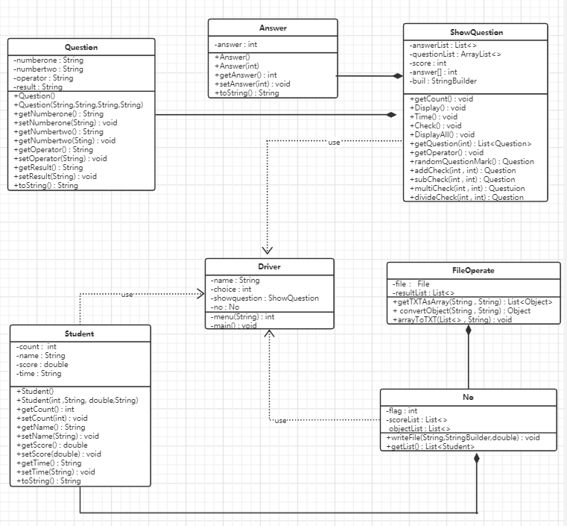

图2-2 用户功能类图

## 2.4 UML时序图（Sequence Diagram）

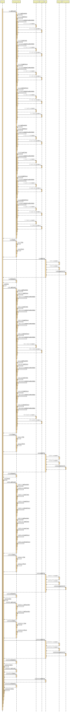

图2-3 UML时序图

## 2.5 UML活动图（Activity Diagram）

### 2.5.1 登陆并显示菜单

登陆操作需要用户输入自己的姓名，无需其他验证。如果未输入姓名，则给出提示“请先输入你的姓名”。若以成功完成姓名输入，系统给出以下菜单：

简单算术运算测验系统

1.出题

2.答题

3.查看成绩

4.排行榜

5.退出

请选择（1-5）：

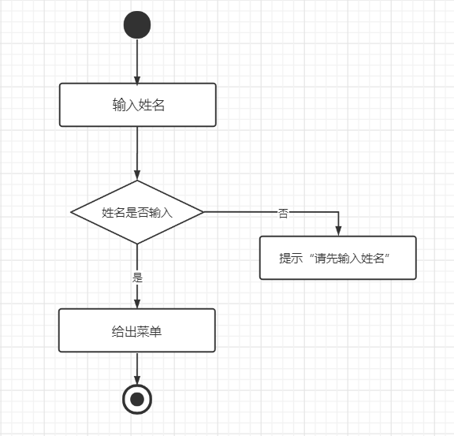

图2-4 登录流程图

### 2.5.2 出题功能模块

当选择1时，系统给出提示“请输入题目的数量”，完成输入数量之后，系统记录该数值。通过系统中的相关程序，随机生成指定数量的两位数以内的两个随机整数的加减乘除运算题。其中题目的缺项不定，实现并不是单一的1+1=？，可以有？+1=2等多种形式的运算题，能够使系统的功能更加有趣。

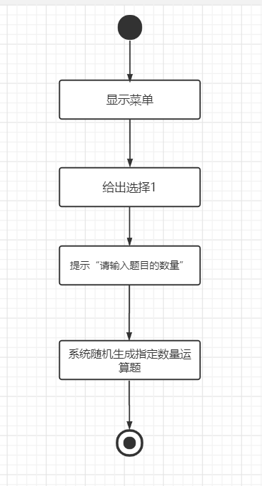

图2-5 出题功能活动图

### 2.5.3 答题功能模块

当选择2时，系统将逐题的显示随机产生的每一道测试题，同时给出提示“请输入答案”，用户根据提示输入运算结果。答题完毕后，系统将以TXT文件的形式，将测试人的姓名，测试成绩，测试时间存放起来。

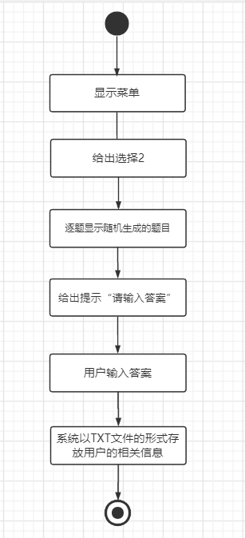

图2-6 答题功能活动图

### 2.5.4 查看成绩功能模块

当选择3时，系统将给出本次测验的所有题目，用户作答的答案，系统计算的标答，以及用户本次获得的成绩，成绩为百分制，每道题目的分值相同。

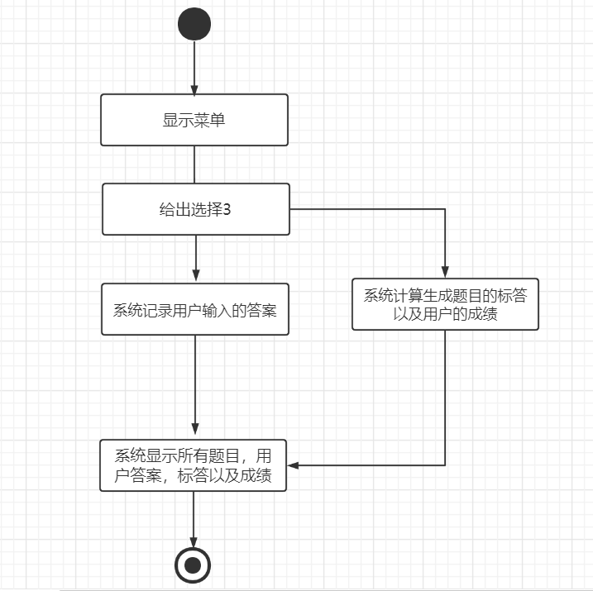

图2-7 查看成绩功能活动图

### 2.5.5 排行榜功能模块

当选择4时，系统将升序显示所有参与测验人员的排名，姓名，成绩和测试时间。

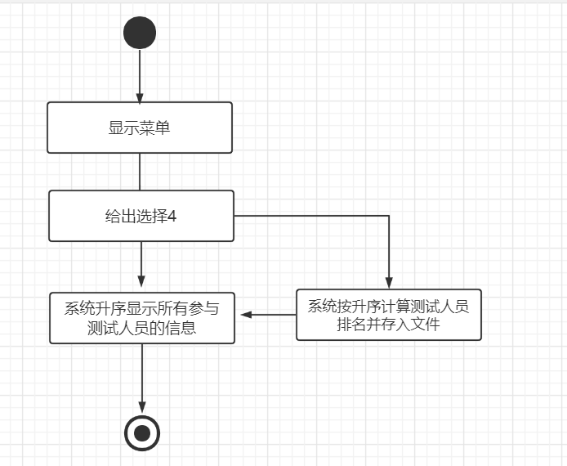

图2-8 查看排行榜功能活动图

### 2.5.6 退出功能模块 当选择5时，退出系统，实现文件内容的保留，给出提示“谢谢使用”。

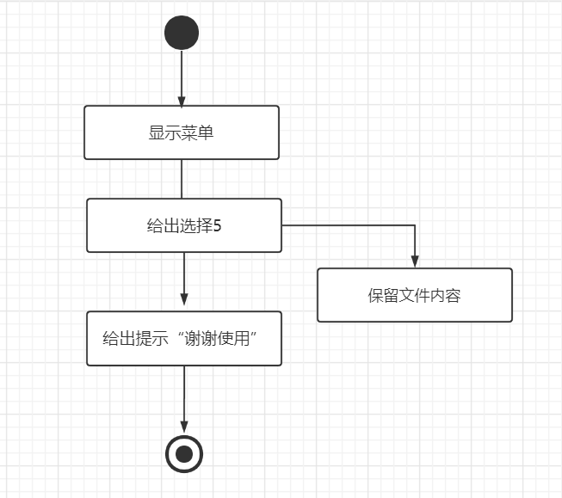

图2-9 退出功能活动图

# **3 系统实现**

## 3.1 项目结构

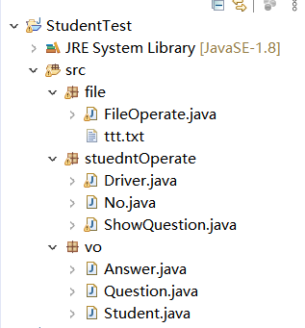

## 3.2 配置文件

该系统未涉及到配置文件。

## 3.3 VO类Student.java

**public** **class** Student {

**private** **int** count; //用户的排名

**private** String name;

**private** **double** score;

**private** String time; //用户测验的时间

**public** String getTime() {

**return** time;

}

**public** **void** setTime(String time) {

**this**.time = time;

}

**public** **double** getScore() {

**return** score;

}

**public** **void** setScore(**double** score) {

**this**.score = score;

}

**public** Student() {

**super**();

}

**public** Student(**int** count, String name, **double** score , String time) {

**this**.name = name;

**this**.count = count;

**this**.time = time;

**this**.score = score;

}

**public** String getName() {

**return** name;

}

**public** **void** setName(String name) {

**this**.name = name;

}

**public** **int** getCount() {

**return** count;

}

**public** **void** setCount(**int** count) {

**this**.count = count;

}

@Override

**public** String toString() {

**return** count + "\t" + name + "\t" + score + "\t" + time;

}

}

## 3.4 VO类Question.java

**public** **class** Question {

**private** String numberone; //随机生成第一个数字

**private** String numbertwo; //随机生成第二个数字

**private** String operator; //随机生成运算符

**private** String result; //算式的运算结果

**public** Question() {

}

**public** Question(String numberone, String numbertwo, String operator, String result) {

**this**.numberone = numberone;

**this**.numbertwo = numbertwo;

**this**.operator = operator;

**this**.result = result;

}

**public** String getNumberone() {

**return** numberone;

}

**public** **void** setNumberone(String numberone) {

**this**.numberone = numberone;

}

**public** String getNumbertwo() {

**return** numbertwo;

}

**public** **void** setNumbertwo(String numbertwo) {

**this**.numbertwo = numbertwo;

}

**public** String getOperator() {

**return** operator;

}

**public** **void** setOperator(String operator) {

**this**.operator = operator;

}

**public** String getResult() {

**return** result;

}

**public** **void** setResult(String result) {

**this**.result = result;

}

@Override

**public** String toString() {

**return** numberone + operator + numbertwo + "=" + result;

}

}

## 3.5 VO类Answer.java

**public** **class** Answer {

**private** **int** answer;

**public** Answer() {

}

**public** Answer(**int** result) {

**this**.answer = result;

}

**public** **int** getAnswer() {

**return** answer;

}

**public** **void** setAnswer(**int** result) {

**this**.answer = result;

}

@Override

**public** String toString() {

**return** String.*valueOf*(answer);

}

}

## 3.6 文件操作类FileOperator.java

**public** **class** FileOperate {

**public** **static** List<Object> getTXTAsArray(String path, String className)**throws** Exception {

List<Object> resultList = **new** ArrayList<Object>();

File file = **new** File(path);

BufferedReader br = **null**;

**try** {

br = **new** BufferedReader(**new** FileReader(file));

String title = br.readLine();

String titles[] = title.split("\\s+");

String aLine = "";

Class aClass = Class.*forName*(className);

**while** ((aLine = br.readLine()) != **null**) {

String datas[] = aLine.split("\\s+");

Object obj = aClass.newInstance();

**for** (**int** i = 0; i < titles.length; i++) {

String fieldName = titles[i];

Field field = aClass.getDeclaredField(fieldName);

String getMethodName = "set" + fieldName.substring(0, 1).toUpperCase() + fieldName.substring(1);

Method method = aClass.getMethod(getMethodName, field.getType());

method.invoke(obj, *convertObject*(datas[i], field.getType().getSimpleName()));

}

resultList.add(obj);

}

} **catch** (Exception e) {

e.printStackTrace();

} **finally** {

**if** (br != **null**) {

**try** {

br.close();

} **catch** (IOException e) {

e.printStackTrace();

}

}

}

**return** resultList;

}

/*类型转换函数*/

**public** **static** Object convertObject(String data, String type) { //类型转换函数

Object obj = **null**;

**switch** (type) {

**case** "String":

obj = **new** String(data);

**break**;

**case** "double":

**case** "Double":

obj = **new** Double(data);

**break**;

**case** "float":

**case** "Float":

obj = **new** Float(data);

**break**;

**case** "int":

**case** "Integer":

obj = **new** Integer(data);

**break**;

//后面可以扩充转换为其他数据类型

}

**return** obj;

}

/*将list写入txt文件函数*/

**public** **static** **void** arrayToTXT(List<Object> list, String path) { //list转TXT

File file = **new** File(path);

FileWriter fw = **null**;

BufferedWriter bw = **null**;

**try** {

**if** (list != **null** && list.size() != 0) {

fw = **new** FileWriter(file);

bw = **new** BufferedWriter(fw);

String str = "";

String keyValue = "";

Object obj = list.get(0);

Field[] fields = obj.getClass().getDeclaredFields();

**for** (**int** j = 0; j < fields.length; j++) {

str += fields[j].getName() + "\t";

}

str += "\n";

bw.write(str);

**for** (**int** i = 0; i < list.size(); i++) {

Object obj1 = list.get(i);

**for** (**int** j = 0; j < fields.length; j++) {

fields[j].setAccessible(**true**);

keyValue += fields[j].get(obj1).toString() + "\t";

}

keyValue += "\n";

}

bw.write(keyValue);

}

} **catch** (Exception e) {

e.printStackTrace();

} **finally** {

**if** (bw != **null**) {

**try** {

bw.close();

} **catch** (IOException e) {

e.printStackTrace();

}

**if** (fw != **null**) {

**try** {

fw.close();

} **catch** (IOException e) {

e.printStackTrace();

}

}

}

}

}

}

## 3.7 文件操作类No.java

**public** **class** No {

//将用户信息存入文件，并完成升序排名

**public** **static** **void** writeFile(String name , StringBuilder buil , **double** score) **throws** Exception {

**int** flag = -1;

String time = "" + buil;

List<Student> scoreList = *getList*();

List<Object> objectList = **new** ArrayList<>();

**for**(**int** i = 0 ; i < scoreList.size() ; i ++) {

**if**(scoreList.get(i).getScore() < score && flag == -1) {

flag = i + 1;

Student student = **new** Student(flag , name , score , time);

scoreList.add(student);

}

**if**(scoreList.get(i).getScore() < score) {

scoreList.get(i).setCount(scoreList.get(i).getCount() + 1);

}

}

**if**(flag == -1) {

Student student = **new** Student(scoreList.size() + 1 , name , score , time);

scoreList.add(student);

}

scoreList = scoreList.stream().sorted(Comparator.*comparing*(Student :: getCount)).collect(Collectors.*toList*());

**for**(Student student : scoreList) {

Object obj = (Object)student;

objectList.add(obj);

}

FileOperate.*arrayToTXT*(objectList, "src/file/ttt.txt");

}

**public** **static** List<Student> getList() **throws** Exception{ //获取排行榜信息函数

List<Object> list1 = FileOperate.*getTXTAsArray*("src/file/ttt.txt", "vo.Student");

List<Student> studentList=**new** ArrayList<>();

**for** (Object object : list1){

Student student = (Student)object;

studentList.add(student);

}

**return** studentList;

}

}

## 3.8 主要功能实现类ShowQuestion.java

**public** **class** ShowQuestion {

**public** **static** List<Answer> *answerList* = **new** ArrayList<>();

**public** **static** ArrayList<Question> *questionList* = **new** ArrayList<>();

**public** **static** **double** *score* = 0;

**public** **static** **int** *answer*[] = **new** **int**[100];

**public** **static** StringBuilder *buil* = **new** StringBuilder();

//获取题目的数量

**public** **static** **void** getCount() {

**int** count = 0;

System.***out***.println("输入题目的数量");

Scanner input = **new** Scanner(System.***in***);

count = input.nextInt();

*getQuestion*(count);

List<Question> questionList = *getQuestion*(count);

}

//显示题目并作答

**public** **static** **void** Display() {

Scanner input = **new** Scanner(System.***in***);

*buil* = *Time*();

**for**(**int** i = 0 ; i < *questionList*.size() ; i ++) {

System.***out***.println((i+1) + "." + *questionList*.get(i).toString());

System.***out***.println("请输入答案");

*answer*[i] = input.nextInt();

}

*Check*();

}

//计算时间

**public** **static** StringBuilder Time() {

StringBuilder builder = **new** StringBuilder();

DateFormat format = **new** SimpleDateFormat("yyyy/MM/dd/HH/mm/ss");

String[] timer = format.format(**new** Date()).split("/");

String[] names = {"年", "月", "日", "时", "分", "秒"};

**for** (**int** i = 0; i < timer.length; i++) {

builder.append(names[i]).append(":").append(timer[i]);

}

**return** builder;

}

//判断题目正确与否

**public** **static** **void** Check() {

**for**(**int** i = 0; i < *questionList*.size() ; i ++) {

**if**(*answerList*.get(i).getAnswer() == *answer*[i]) {

*score* += (100 / *questionList*.size());

}

}

}

//输出所有的题目

**public** **static** **void** DisplayAll() {

System.***out***.println("题目" + "\t" + "作答" + "\t" + "标答");

**for**(**int** i = 0 ; i < *questionList*.size() ; i ++) {

System.***out***.println(*questionList*.get(i).toString() + "\t" + *answer*[i] + "\t" + *answerList*.get(i).getAnswer());

}

System.***out***.println("本次测验的分数为：" + *score*);

//questionList.forEach(System.out :: println);

}

//获取算式

**public** **static** List<Question> getQuestion(**int** count){

**int** numberone, numbertwo;

*questionList* = **new** ArrayList<>();

*answerList* = **new** ArrayList<>();

**for**(**int** i = 0; i < count; i ++) {

//获得第一个随机数

numberone = (**int**)(Math.*random*()*100);

**if**(numberone == 0) {

numberone = (**int**)(Math.*random*()*100);

}

//生成第二个随机数

numbertwo = (**int**)(Math.*random*()*100);

**if**(numbertwo == 0) {

numbertwo = (**int**)(Math.*random*()*100);

}

//确保第一个数大于第二个数，便于减法和除法运算

**int** m = 0;

**if**(numberone < numbertwo) {

m = numbertwo;

numbertwo = numberone;

numberone = m;

}

Question question = **null**;

String operator = *getOperator*();

**switch**(operator) {

**case** "+" :

question = *addCheck*(numberone , numbertwo);

**if**(question == **null**) {

i = i - 1;

}

**break**;

**case** "-" :

question = *subCheck*(numberone , numbertwo);

**break**;

**case** "*" :

question = *multiCheck*(numberone , numbertwo);

**if**(question == **null**) {

i = i - 1;

}

**break**;

**case** "/" :

question = *divideCheck*(numberone , numbertwo);

**break**;

}

**if**(question != **null**) {

*questionList*.add(question);

}

}

**return** *questionList*;

}

//获取随机的操作符

**public** **static** String getOperator() {

String operator = "";

**double** flag = Math.*random*();

**if**(flag > 0 && flag <= 0.25) {

operator = "+";

}

**if**(flag > 0.25 && flag <= 0.5) {

operator = "-";

}

**if**(flag > 0.5 && flag <= 0.75) {

operator = "*";

}

**if**(flag > 0.75 && flag <= 1.0) {

operator = "/";

}

**return** operator;

}

/*问号位置随机函数*/

**public** **static** Question randomQuestionMark(**int** numberone,**int** numbertwo,**int** result,String operator){

Question question = **new** Question();

Random random = **new** Random();

**int** index = random.nextInt(3);

Answer answer = **new** Answer();

**switch** (index){

**case** 0:

answer.setAnswer(result);

question.setResult("?");

question.setNumberone(String.*valueOf*(numberone));

question.setNumbertwo(String.*valueOf*(numbertwo));

question.setOperator(operator);

**break**;

**case** 1:

answer.setAnswer(numbertwo);

question.setNumbertwo("?");

question.setNumberone(String.*valueOf*(numberone));

question.setOperator(operator);

question.setResult(String.*valueOf*(result));

**break**;

**case** 2:

answer.setAnswer(numberone);

question.setNumberone("?");

question.setNumbertwo(String.*valueOf*(numbertwo));

question.setOperator(operator);

question.setResult(String.*valueOf*(result));

**break**;

}

*answerList*.add(answer);

**return** question;

}

//确保加运算的结果在两位数

**public** **static** Question addCheck(**int** numberone , **int** numbertwo) {

Question question = **null**;

**int** result = numberone + numbertwo;

**if**(result < 100) {

question = *randomQuestionMark*(numberone , numbertwo , result , "+");

}

**return** question;

}

//确保乘运算的结果在两位数

**public** **static** Question multiCheck(**int** numberone , **int** numbertwo) {

Question question = **null**;

**int** result = numberone * numbertwo;

**if**(result < 100) {

question = *randomQuestionMark*(numberone , numbertwo , result , "*");

}

**return** question;

}

//减运算

**public** **static** Question subCheck(**int** numberone , **int** numbertwo) {

**int** result = numberone - numbertwo;

Question question = *randomQuestionMark*(numberone , numbertwo , result , "-");

**return** question;

}

//除运算

**public** **static** Question divideCheck(**int** numberone , **int** numbertwo) {

Question question = **null**;

**int** result = numberone / numbertwo;

**int** rest = numberone % numbertwo;

**if** (rest == 0){

*randomQuestionMark*(numberone , numbertwo , result ,"/");

}

**else**{

question = **new** Question();

Answer answer = **new** Answer();

question.setResult("?");

question.setNumberone(String.*valueOf*(numberone));

question.setNumbertwo(String.*valueOf*(numbertwo));

question.setOperator("/");

answer.setAnswer(result);

*answerList*.add(answer);

}

**return** question;

}

}

## 3.9 用户界面Driver.java

**public** **class** Driver {

**private** **static** ShowQuestion *showquestion* = **new** ShowQuestion();

**private** **static** No *no* = **new** No();

**public** **static** **void** main(String[] args) **throws** Exception {

Scanner input = **new** Scanner(System.***in***);

String name = "";

System.***out***.println("请输入你的姓名");

name = input.nextLine();

**while**(!name.equals("")) {

**int** choice = *menu*(name);

}

System.***out***.println("请先输入姓名");

}

**public** **static** **int** menu(String name) **throws** Exception {

**int** choice = 0;

System.***out***.println("简单算术运算测试系统");

System.***out***.println("1.出题");

System.***out***.println("2.答题");

System.***out***.println("3.查看成绩");

System.***out***.println("4.排行榜");

System.***out***.println("5.退出");

System.***out***.println("请选择（1-5）");

Scanner input = **new** Scanner(System.***in***);

choice = input.nextInt();

**while**(choice != 5) {

**switch**(choice) {

**case** 1 : *showquestion*.*getCount*();

**break**;

**case** 2 : *showquestion*.*Display*();

*no*.*writeFile*(name,ShowQuestion.*buil*,ShowQuestion.*score*;

**break**;

**case** 3 : *showquestion*.*DisplayAll*();

**break**;

**case** 4 : *no*.*getList*().forEach(System.***out*** :: println);

**break**;

**default** : System.***out***.println("输入的选择有误");

}

choice = *menu*(name);

}

System.***out***.println("感谢使用");

System.*exit*(0);

**return** choice;

}

}

# **4 系统测试**

**4.1用户输入姓名**

# 

**4.2显示菜单**

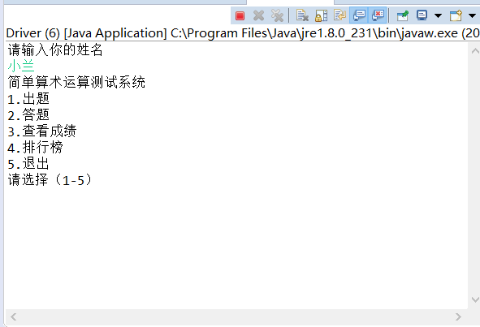

**4.3出题功能**

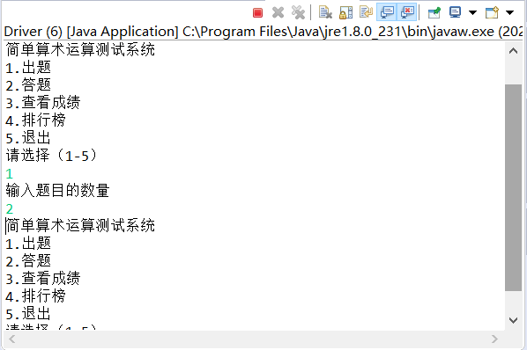

**4.4答题功能**

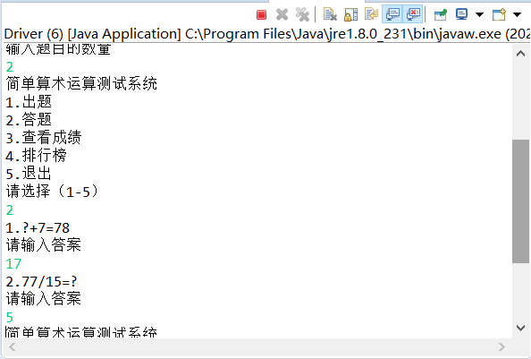

**4.5查看成绩功能**

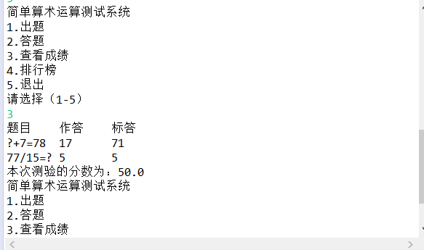

**4.6排行榜功能**

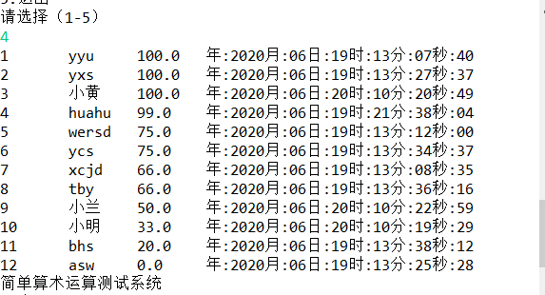

**4.7退出功能**

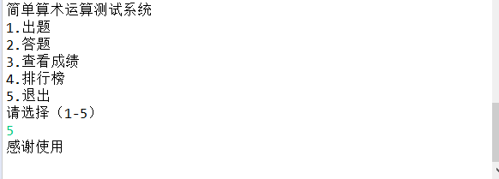

# **5 系统总结**

在本次课程设计过程中，涉及到的内容并不属于比较复杂和困难的部分。唯一比较复杂的是对于文件的操作，在这次课程设计中我也遇到了一些问题：

1. 一开始对于随机生成并不清楚该怎么进行操作，后续通过查阅一些资料后发现就是使用Random（）函数，然后通过加以相关的判断，配合switch语句，实现对操作符和数字的随机生成。
2. 在课程设计过程中，对于各个类的思路比较混乱，编程思想不够强大，将很多不该糅合在一起的类写在一起，例如Question和Answer，给自己后续对答案和问题的操作带来了很多麻烦。
3. 对文件的运用不够熟练，以至于在进行读写和排行榜功能时纠结了很久。

系统存在的不足：

1. 部分地方的显示并不符合期望，和心里的实现结果有部分的差异。
2. 没能把这个系统实现可视化，查阅资料的时候想试试使用swing框架，但是对自己而言难度有点大，所以并未实现。

收获：

在本次课程设计的过程中，虽未涉及到框架和数据库等复杂内容的操作，但是对我个人有了比较大的提升，主要在于自己的编程思想，对于程序层次的划分加强了理解。当然，自己对Java的编程能力还是有了提升，希望以后能更加深入的去学习这门语言。

课程建议：

通过一学期的Java学习，个人感觉刚开始还是比较轻松，并未涉及到Java语言的独特方面，后续感觉课程内容和作业不在一个层面，可能是自己对前面知识并未太稳固的掌握。课程上的内容，感觉可以更加细节一点。

发展方向和自评：

发展：希望自己能够考上一个比较好的研究生，来提升自己的能力。

自评：本次课程设计虽有遗憾，自己也付出了很多在里面，所以自评良好。