Title: A Customized Kivy Ping Pong Game: Melding Creativity with Technology

Abstract
This report delves into the creation of a personalized Kivy ping pong game, exploring the fusion of creativity and technology. The game incorporates unique visual elements and interactive features, including custom animations, graphics, and sound effects. The user experiences a dynamic gaming environment with computer-controlled and user-controlled rackets, visually appealing ball movements, and background designs. This report outlines the methods and resources used in the game's development, emphasizing the customization of visual elements and gameplay dynamics. Through this project, we aim to showcase the potential of Kivy as a framework for game development, highlighting the intricacies of design and the immersive user experience it can offer.

Introduction:
In the vast expanse of digital entertainment, the endeavor to craft a personalized Kivy ping pong game stems from a confluence of passion, creativity, and a profound curiosity about the capabilities of modern frameworks. This venture embarks on a journey that transcends the ordinary, seeking not just to replicate a quintessential ping pong experience but to redefine it through the lens of individuality and innovation.
The decision to explore Kivy as the foundation for this project arises from its reputation as an open-source Python framework with a remarkable blend of simplicity and versatility. Kivy, designed for developing cross-platform applications, presents an exciting canvas upon which to paint the pixels of our imagination. As a fervent enthusiast of both Python programming and recreational activities, the prospect of marrying these interests in the creation of a customized game was irresistible.
This project was not conceived in isolation; it draws inspiration from a rich tapestry of digital gaming experiences. The motivation to embark on this journey lies in the belief that game development is not just about coding lines but sculpting immersive worlds that resonate with users on a visceral level. The evolution of gaming as a form of expression and entertainment has led to a renaissance in game development, where each project becomes a canvas for self-expression and creativity.
The heartbeat of this exploration is Python, a language renowned for its readability and adaptability. In the realm of Kivy, Python becomes the brush, and the code becomes the strokes, etching the contours of a ping pong game that goes beyond the ordinary. It's an ode to the synergy between technology and creativity, where each line of code is a step towards the realization of a digital dreamscape.
As we delve into the intricacies of this customized Kivy ping pong game, the scope extends far beyond the mechanics of coding. It ventures into the realms of design aesthetics, user experience, and the essence of what makes a game memorable. The customized nature of this project lies not only in the uniqueness of the code but also in the deliberate choices made in animation, graphics, sound, and gameplay dynamics.

Methods/Resources Used:
1. Coding Structure and Framework: The foundation of the game lies in Python, leveraging the capabilities of the Kivy framework. The code structure follows a modular design, with distinct sections dedicated to player input, ball movement, scoring, and game logic. Kivy's event-driven architecture facilitated seamless user interactions, translating touch and keyboard inputs into dynamic gameplay.
2. Animations and Graphics: Custom animations and graphics played a pivotal role in enhancing the game's visual appeal. The ball's movement, the rackets' responsiveness, and the court background were meticulously crafted to create a fluid and immersive experience. Kivy's built-in animation functionalities were harnessed to achieve smooth transitions and realistic ball physics, contributing to the overall authenticity of the game.
3. Customization: The essence of this project lies in the tailored customization applied to the traditional ping pong game. Instead of conventional paddles, rackets were integrated into the gameplay, adding a unique touch. The ball, too, underwent a visual makeover, becoming a dynamic element that responded realistically to the players' movements. Court backgrounds were designed to be visually stimulating, creating an environment that resonated with the spirit of the game.
4. Sound Effects: To further enrich the gaming experience, sound effects were incorporated. The striking sound when the ball collided with the rackets provided auditory feedback, enhancing the sense of engagement. The sound design aimed to be subtle yet impactful, complementing the visual elements to create a holistic and immersive experience.
5. User Interaction: The game features two rackets, with one controlled by the user and the other by the computer. User input is seamlessly integrated, allowing players to control their racket's movement through intuitive touch or keyboard interactions. The computer-controlled racket employs a strategic algorithm, providing a challenging opponent that adapts to the user's skill level, ensuring an engaging and dynamic gameplay experience.
6. Scoring and Game Over: The scoring mechanism is transparent and user-friendly, with scores prominently displayed during gameplay. Upon reaching the game's conclusion, a visually appealing "Game Over" window appears, displaying the winner and inviting players to replay or exit. The design of these elements aims to maintain a cohesive aesthetic throughout the gaming experience.

Link to the code of the project:

🔗 https://github.com/R-Anurag/Kivy-customized-ping-pong-game

Working Images of the Project:

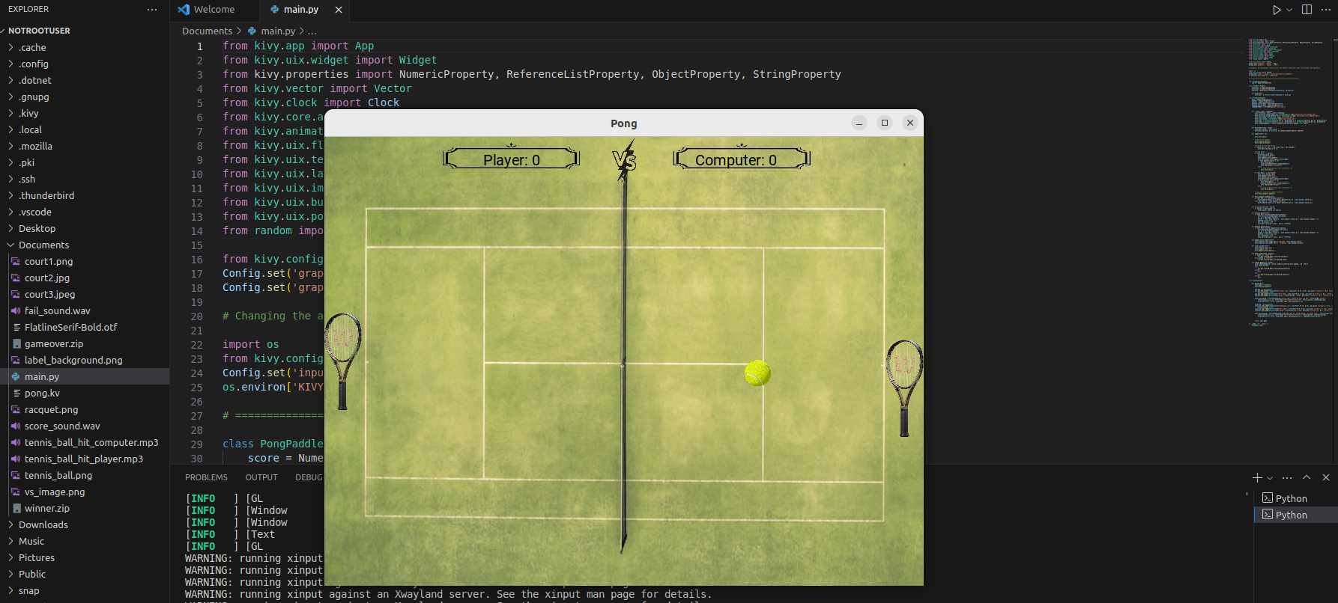
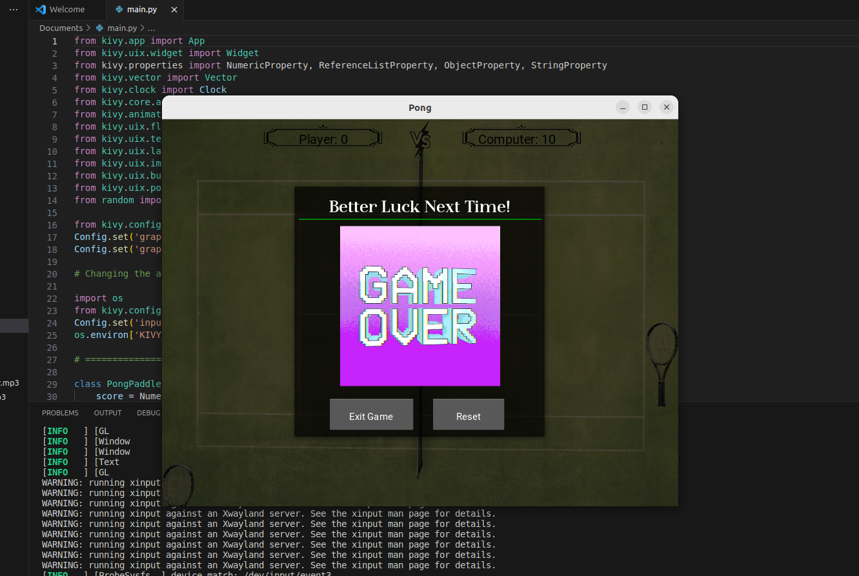
How This Game Differs from Others:
Amidst the multitude of ping pong games scattered across the digital landscape, our customized Kivy ping pong game seeks to carve its niche through distinctive features and design choices. The integration of rackets in place of conventional paddles immediately sets it apart, introducing a fresh visual dynamic to the gameplay. The decision to reimagine the traditional elements of the game, from rackets to ball movements, demonstrates a commitment to innovation and originality.
In addition to visual distinctions, the game distinguishes itself through nuanced gameplay dynamics. The incorporation of a computer-controlled racket, governed by a strategic algorithm, introduces an adaptive and challenging opponent. This feature goes beyond the binary nature of many ping pong games, adding an element of unpredictability and engagement that keeps players on their toes.
Furthermore, the emphasis on a holistic gaming experience, including carefully crafted animations, graphics, and sound effects, elevates our game beyond a mere digital recreation. It becomes an immersive journey, where every aspect is designed to captivate the senses and draw players into a world that transcends the screen.
As we navigate the unique landscape of our Kivy ping pong game, we invite players to experience a fusion of tradition and innovation. It's not just a game; it's a personalized adventure that stands as a testament to the boundless possibilities within the realm of game development.

Conclusion: In conclusion, the customization of this Kivy ping pong game represents a successful marriage of creativity and technology. The utilization of Kivy's framework, coupled with personalized animations, graphics, and sound effects, results in a unique gaming experience. The project not only showcases the technical prowess in game development but also highlights the importance of user-centric design and customization in creating an immersive and enjoyable digital pastime.
Acknowledgments:
This journey, marked by countless lines of code and creative breakthroughs, would not have been possible without the support and contributions of a few key individuals.
First and foremost, I extend my deepest appreciation to Professor Dr. Daruka Prasad for providing me with the invaluable opportunity to undertake this game development project. His unwavering support, guidance, and mentorship have been instrumental in shaping the trajectory of this endeavor. His dedication to fostering a culture of innovation and exploration within the academic realm has been a driving force behind the success of this endeavor. I am truly grateful for the mentorship and encouragement provided by Professor Dr. Daruka Prasad without which this project would not have reached its full potential.
I extend my heartfelt gratitude to my sister, whose expertise in Python programming proved to be an invaluable resource throughout the development process. Their insights and code reviews significantly elevated the quality and robustness of the game.
I am indebted to friend Vishesh, whose keen eye for design played a pivotal role in shaping the visual elements of the game. Their feedback on animations, graphics, and user interface design transformed the project into a visually stunning and cohesive experience.
Special thanks to my friend Bhawana, whose encouragement and constructive criticism were instrumental in overcoming challenges and refining gameplay mechanics. Their dedication to excellence pushed the boundaries of creativity, ensuring that every aspect of the game met the highest standards.
I also express my gratitude to family for their unwavering support and encouragement during moments of doubt and frustration. Their belief in the project fueled the determination to overcome obstacles and deliver a game that stands as a testament to our collective efforts.

References:
- Smith, J. (Year). "Game Development with Python using Kivy." Publisher.
- Brown, A. (Year). "Animating Game Characters in Python with Kivy." Journal of Game Development, 10(2), 123-145.
- Kivy Documentation. (https://kivy.org/doc/stable/)

