CLIENT REQUIREMENTS – WORDPRESS PAINT WEBSITE (SHORT)
1) Basic Details
- Company/Brand Name : ADIRA PAINTS PRIVATE LIMITED
- Mobile No. & Email 7666964553, sales@adorivainfra.co.in
- Office/Shop Address : F-19, GAPURTI HSG SOC, RN 122, G-BLOCK CHINCHWAD, BHOSARIGAON PUNE-411039 MAHARASHTRA-INDIA
- Working Hours : 9 AM TO 6 PM
- Service Area (City/Locations) ALL OVER INDIA
2) Brand Assets
- Brand Colors (agar koi choice ho) LOGO Yet to finalise
- Tagline (optional) We will share
3) Products & Services
- Paint Categories (Interior, Exterior, Waterproofing, Texture, etc.) PU, Epoxy QD, Enamel & relevant primer.
- 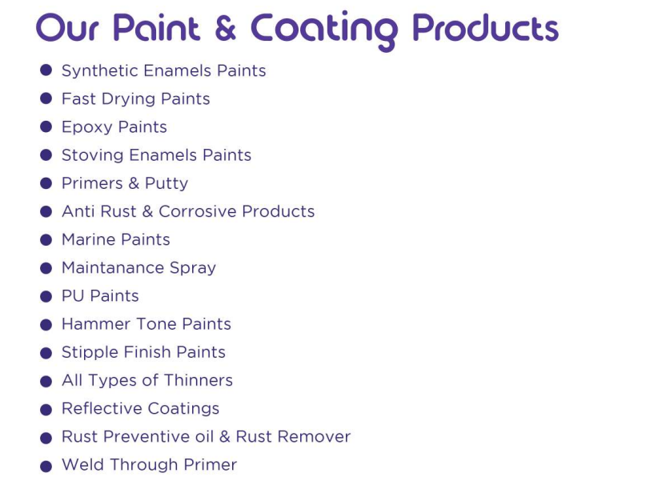
- Services (Painting, Waterproofing, Texture work, etc.) Paint Manufacturing & supply.
- Brands dealt in (Asian/Berger/Nerolac/Other)
4) Photos
- Shop/Office photos (5–10) No need of office photos.
- Product photos (10–15) : Packaging is yet to design.
- Completed work photos / Before–After (6–10) : New product so sample images can be taken from google.
5) Website Pages (Suggested) Please go through the website of top 5 brand of paint)
- Home
- About US
- Products
- Services
- Gallery / Projects
- Contact
- (Optional: FAQ / Blog)

6) Website Features
- Call & WhatsApp button : Yes
- Enquiry / Contact Form : Yes
- Google Map : Yes
- Mobile-friendly design : Yes we are planning to make a mobile app of this in future.
7) Domain & Hosting
- Domain name (Provide id Password or Purchase if didn’t have) We will discuss
- Hosting details (Priority Hosting Details or Purchase if already not purchased. Source From Hostinger)

