Software Requirements Specification for

HAVE IT – Habits and Goals Tracker with Journal

**Version <0.4>**

**Prepared by**

**Group Name: MALINTA KALIWA**

|  |  |  |
| --- | --- | --- |
| **BANTIGUE, RAMIEN** | **20-1142** | **aein032802@gmail.com** |
| **BERBA, DANIEL AUSTIN R.** | **20-1143** | **austin.ramirez30@gmail.com** |
| **DOLOT, RICHARD G.** | **20-1152** | **richarddolot66@gmail.com** |
| **JABONETE, JEAN ROSE T.** | **20-1157** | **jeanrosejabonete15@gmail.com** |
| **NIEVES, ZHIZHI MARO G.**  **SERRANO, JOHN JABEZ C.** | **20-1164**  **20-1176** | **zhizhimarogalolonieves@gmail.com**  **aeyameretard@gmail.com** |

|  |  |
| --- | --- |
| **Instructor:** | **Ms. Maria Mahaleel Bernardino** |
| **Course:** | **BSIT** |
| **Section:** | **3-3** |
| **Date:** | **March 30, 2023** |

**Revisions**

| **Project** | **Date** | **Reason for Changes** | **Version** |
| --- | --- | --- | --- |
| HAVE IT | March 11, 2023 | More focused specifications/features in the Product Scope and more terms in 1.3. | <0.1> |
| HAVE IT | March 17, 2023 | Revised Introduction with now two paragraphs and added more terms in 1.3. | <0.2> |
| HAVE IT | March 24, 2023 | Removed Nice to Haves in 2.2 and finalized all the product functionalities. | <0.3> |
| HAVE IT | April 20, 2023 | Changed font size to 12, added DFD Level 0 and 1, arranged the screenshots as figures, added definitions to 3.1.2 and 3.1.3, and elaborated 3.1.4. | <0.4> |
| HAVE IT | April 26, 2023 | Added more scenarios in 4.5. | <0.5> |

# Introduction

Helping people to list their habits and tasks can be a powerful tool for increasing productivity, improving mental clarity, and achieving personal goals. By taking the time to identify habits and tasks that are both beneficial and necessary, individuals can create a roadmap for success that can lead to greater happiness and fulfillment in their lives.

The introduction of the Software Requirements Specifications (SRS) of our project, **“HAVE IT – Habits and Goals Tracker with Journal”** provides an overview of the entire SRS such as purpose, scope, definitions, acronyms, abbreviations, intended audience, references, and overview of the entire SRS. The objective of this document is to collect and evaluate and give a profound insight of the full HAVE IT Web app. The complete requirements of the HAVE IT Web app are included in this document.

## Document Purpose

The document's purpose is to gather and evaluate all the concepts and complete requirements we have to determine about the project web app. This document aims to provide an overview of this web-based application. Moreover, the project can be used by anyone aged 16-40 years old. We will also discuss the scope and goal of the project. We must think and execute what kind of output we expect to deliver.

To sum up, everything that has been stated so far, the objective of this document is to give a complete overview goal and scope of the web app. The paper will describe the web app's features, what it will do, and its purpose as a whole. The document explains the target users of the project and the web app's functionality. The paper also describes how the user and developers test the product and the web app's functionality.

## Product Scope

First and foremost, the scope of the web app will be discussed in this section. It primarily focuses on how registered users use this web app to track their habits and goals and write their thoughts using the journal feature.

The proposed web app allows users to list their tasks, habits, and goals and write using the journal. Registered users can also delete the tasks, habits, goals, and journal once declared as done. The web app also allows users to set time during working/study hours to help them focus and be productive. Moreover, the web app has a calendar feature. This feature enables the users to create a task on the specific date they want to add. In the calendar, they can mark their task as to-do, on-going, and done. In addition, the web app also allows the users to check their progress bar, status, and see the analytics to let them know what they have achieved.

## Intended Audience and Document Overview

## This document is being created to provide a comprehensive overview of the web-based application project, including its scope, goals, target users, features, and functionality. The document also aims to describe the expected output of the project and how it will be tested by users and developers.

|  |  |
| --- | --- |
| **AUDIENCE** | **USE** |
| Students | The students will use this document as a reference for their project documentation. |
| Professors | The Professors will view the entire scope. The professors will also determine if the project is feasible or not. |
| Users | The users can verify and validate all the features and SRS of the web app discussed in this document. |

## Definitions, Acronyms and Abbreviations

* **Habits** – Habits are regular behavior or routine that is repeated often and tends to occur subconsciously. Habits can be either positive or negative, and they can be formed through repetition over time. Habits are often associated with personal growth and development, and they can help you to achieve your goals more easily.
* **Goals** – A goal is something that you aim to achieve in the future. It is a desired outcome that you work towards. Goals are usually long-term and require planning, effort, and commitment. Goals help you to focus your energy and efforts on what is important to you.
* **SRS** – System Requirement Specification
* Web App – Short for web application, is a type of website that offers a wide range of features and functionalities that can be accessed on any device with a web browser.
* **CSS** – is a style sheet language that enables how the elements of HTML can be displayed on the screen.
* **Vanilla JavaScript** - refers to the pure, unaltered form of the JavaScript programming language, without the use of any third-party libraries or frameworks.
* **PHP** – is a server-side programming language that is widely used for web development.
* **JavaScript** – is a programming language that is used for web, game development and applications. It allows the users to execute compelling features that cannot be executed using the HTML and CSS.
* **HTML** – is a Hyper Text Markup Language that describes the structure of the web. It enables users to display images, videos, files, and other categories of multimedia.
* Visual Code Studio – is a code editor for many programming languages such as Python, Java, C++, JavaScript, etc.

# Overall Description

## Product Perspective

## HAVE IT will be developed as a web application. It is a web app that provides various features that registered users can use and enjoy. The HAVE IT web app is a habits and goals tracker with a journal. It is a replacement or alternative for certain existing systems with similar features. This app is designed for people who love tracking their habits and goals, organizing and doing their tasks daily or weekly, and writing down their thoughts to wrap up their day. Additionally, this web app assists users to list down their tasks orderly, set a timer to help them focus, create and modify tasks in the calendar, track their goals and habits, mark their tasks as to-do, on-going, and done, and be able to write and delete using the journal feature. To be able to access all the stated features, an account registration is required, a stable internet connection, and an up-to-date web browser on a mobile or desktop device.

## Product Functionality

This section consists of the functional requirements for the web app HAVE IT:

**Calendar**

• The system shall display all the months and days in the calendar.

• The system shall allow the user to select a date in the calendar to create, view, edit, and delete goals.

**Goals in Calendar**

• The system shall allow the user to create, edit and delete an accessible goal.

• The system shall display and allow the user to put the title and details of the goals.

• The system shall allow the user to put the due time and date of each goal.

• The system shall allow users to put a color mark on each goal to find them easier.

• The system shall allow the user to select and edit the goal's status (to-do, ongoing, and done).

• The system shall display all the goals created by the user.

**Habits**

• The system shall allow the user to add, edit and delete a habit.

• The system shall display all the habits created by the user.

• The system shall allow the user to mark each habit as done.

**Writing Journal**

• The system shall allow the user to create and delete journals.

• The system shall enable users to set the journal as their favorites to easily locate the journals selected.

• The system shall enable users to put a title and details on the journal when needed.

• The system shall allow the user to optionally choose themes for the journal’s customization.

**Account Login**

• The system shall allow users to register by inputting the necessary personal information required by the system.

• The system shall allow the registered user to log in with their email or username and password.

• The system shall allow the user to log out of their account.

• The system shall allow the user to delete and remove their account anytime.

• The system shall enable the user to change their password once a month for security.

• The system shall allow the user to request a new password once forgotten by the user.

**Dashboard**

• The system shall enable the user to view all the tasks completed.

• The system shall enable users to see the tasks created.

• The system shall allow the users to track the journal created and view the progress bar.

**About**

• The system shall display the information about the web application, its goal and purpose, and its developers.

• The system shall display the Terms and Conditions and Privacy Policy regarding the usage of the web application and the collection of data.

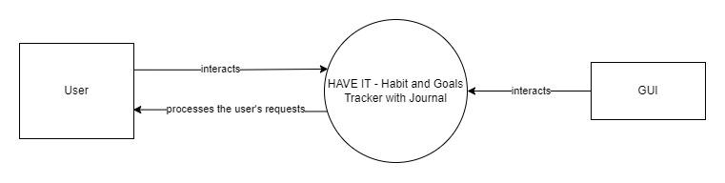

## Users and Characteristics

1. Men, Women, LGBTQ+

User Characteristics:

The usage of the users depends on how they frequently use the web app. Anyone can have an account by signing up to create and track their goals and habits, and write journals.

## Operating Environment

The HAVE IT will be accessible in any type of browser. The web app HAVE IT will be developed in a development environment. The web app does not require specific requirements for the hardware and software. Only a basic computer hardware setup is necessary, such as:

* 2 GB RAM minimum
* Stable Internet Connection
* Has an Up-to-date Web Browser Application

## Design and Implementation Constraints

* The HAVE IT web app implements security information and privacy for the users.
* The web app maintains an internet connection to keep the data updated in every account.

# Specific Requirements

## External Interface Requirements

### User Interfaces

The web app HAVE IT provides features that users can use for their daily and weekly routine. The UI layout contains responsive tabs and captivating patterns of design and colors for the appearance of the web app.

The registration and log-in page will have the following user interfaces in the form of a card:

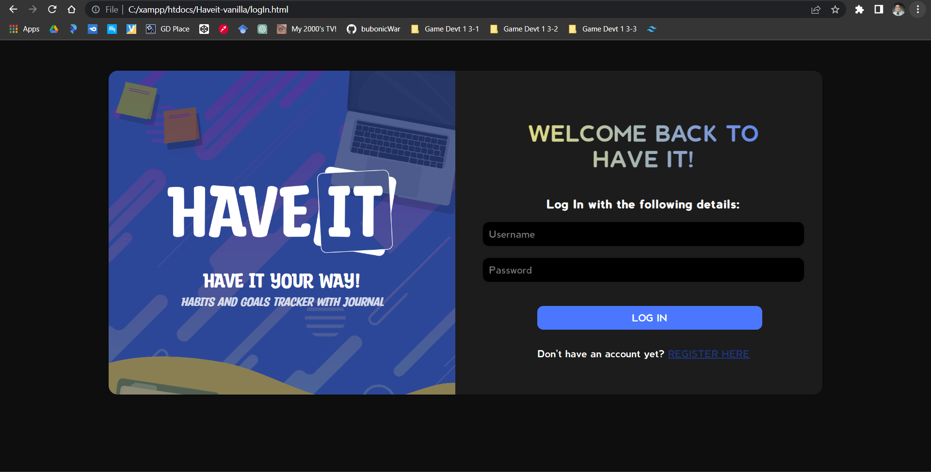***Figure 1****. Log In Page*

***Figure 2****. Registration Page*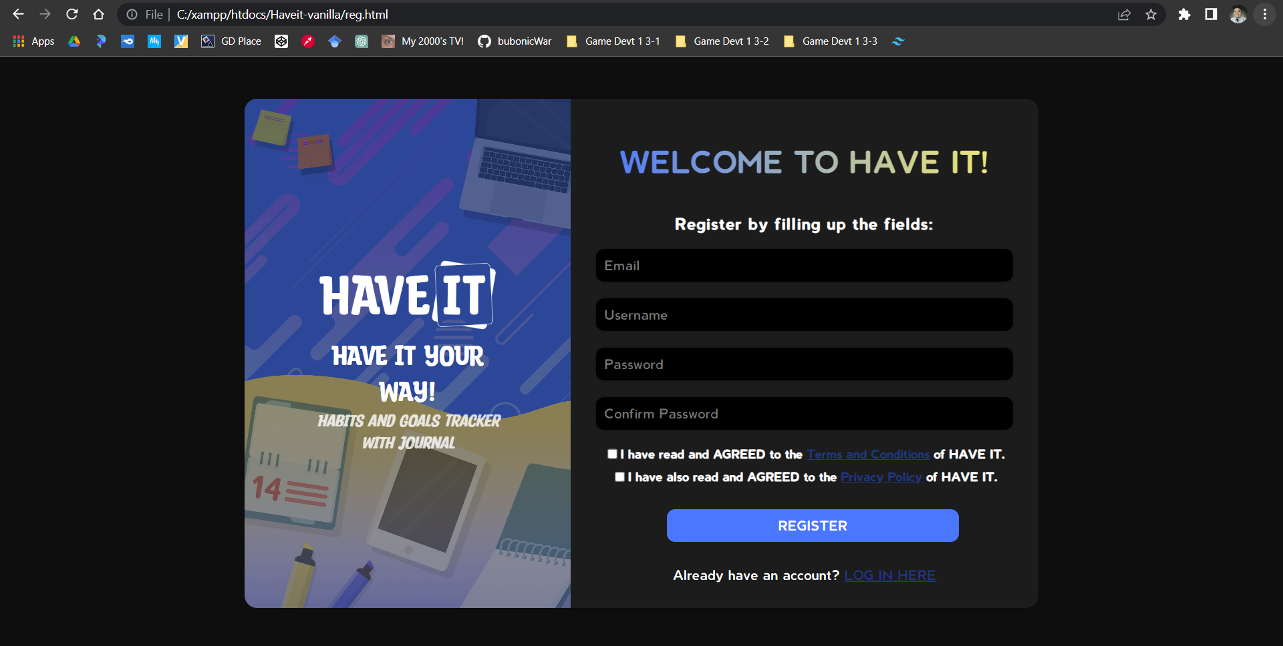

The landing or the home page will have a greeting and responsive tab beneficial to make the HAVE IT a user-friendly web app. The options will be as follows:

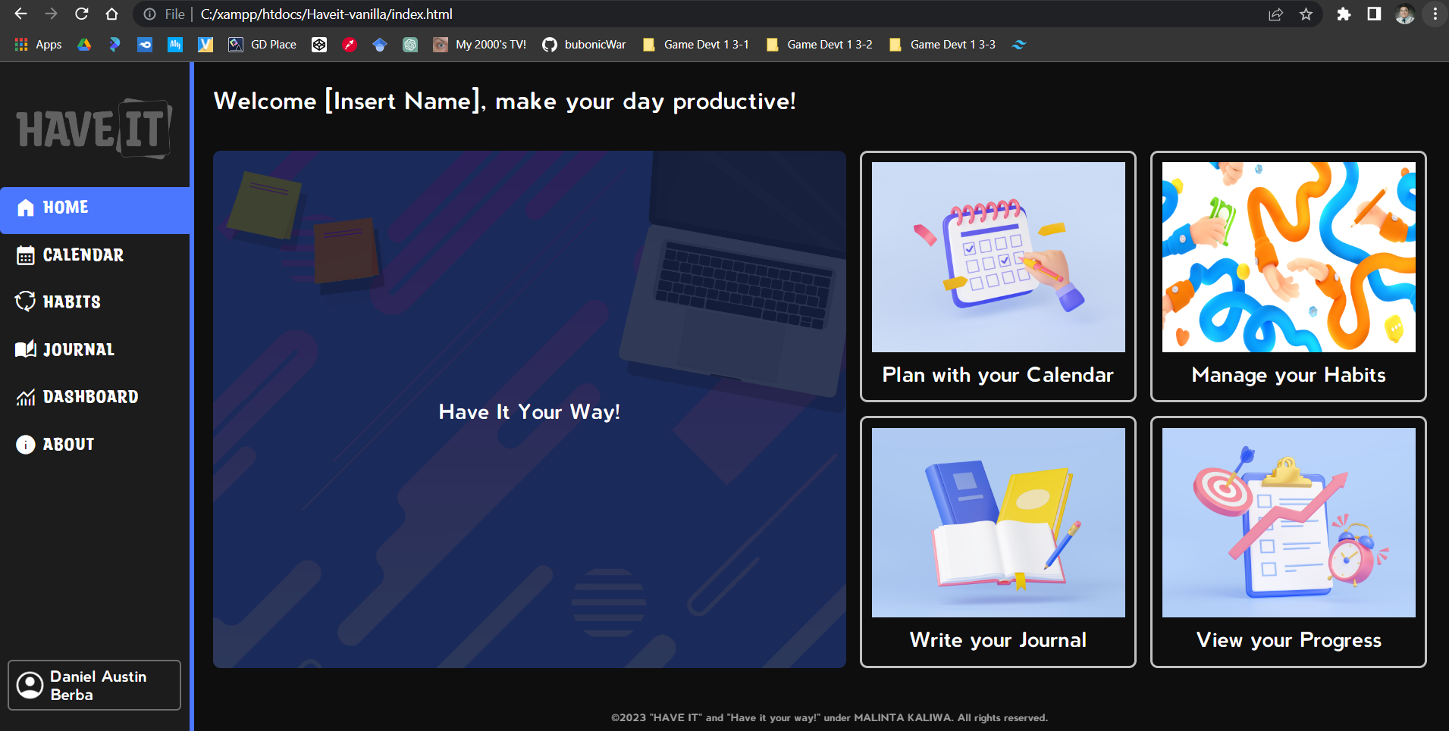

***Figure 3****. Home Page*

***Figure 4****. Calendar Page*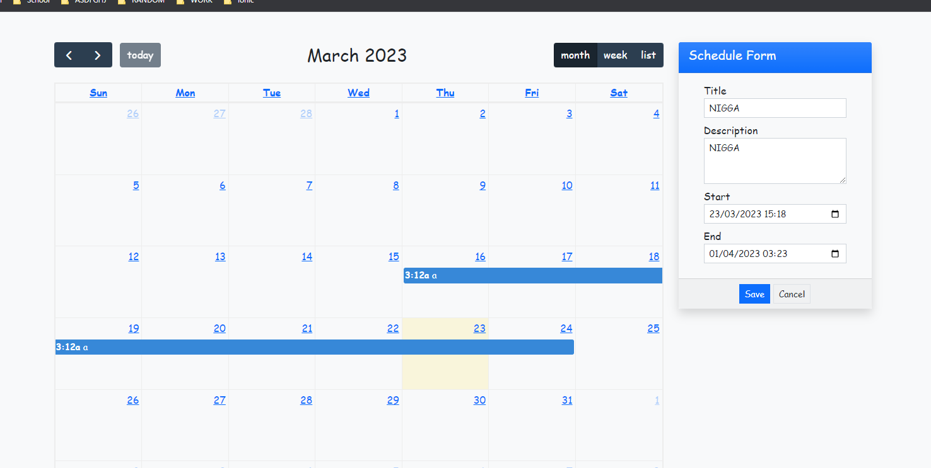

***Figure 5****. Habits Page*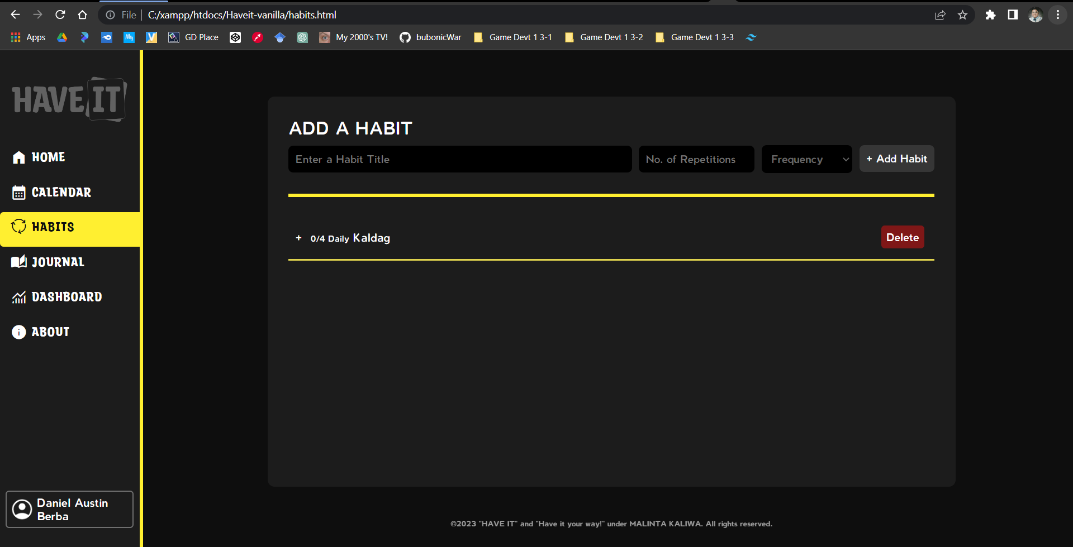

***Figure 6****. Journal Page*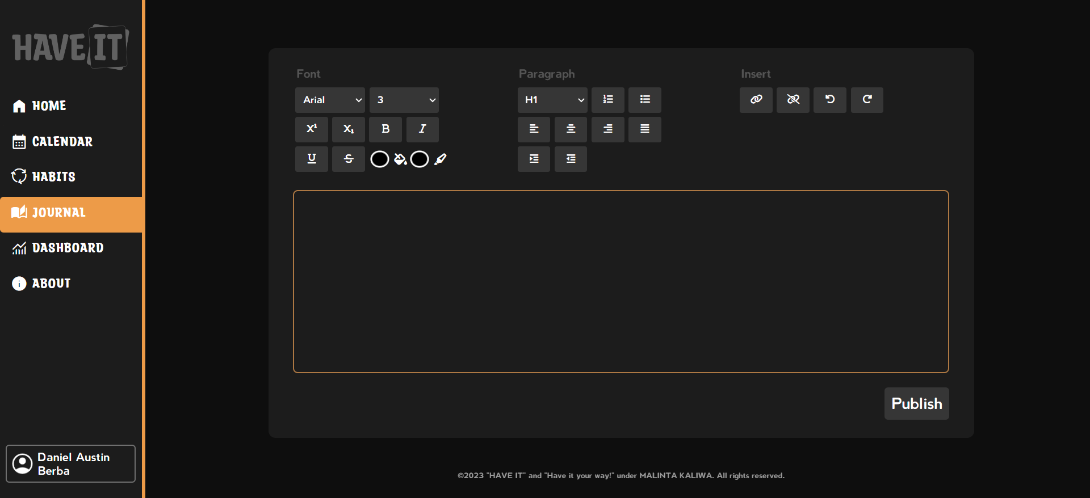

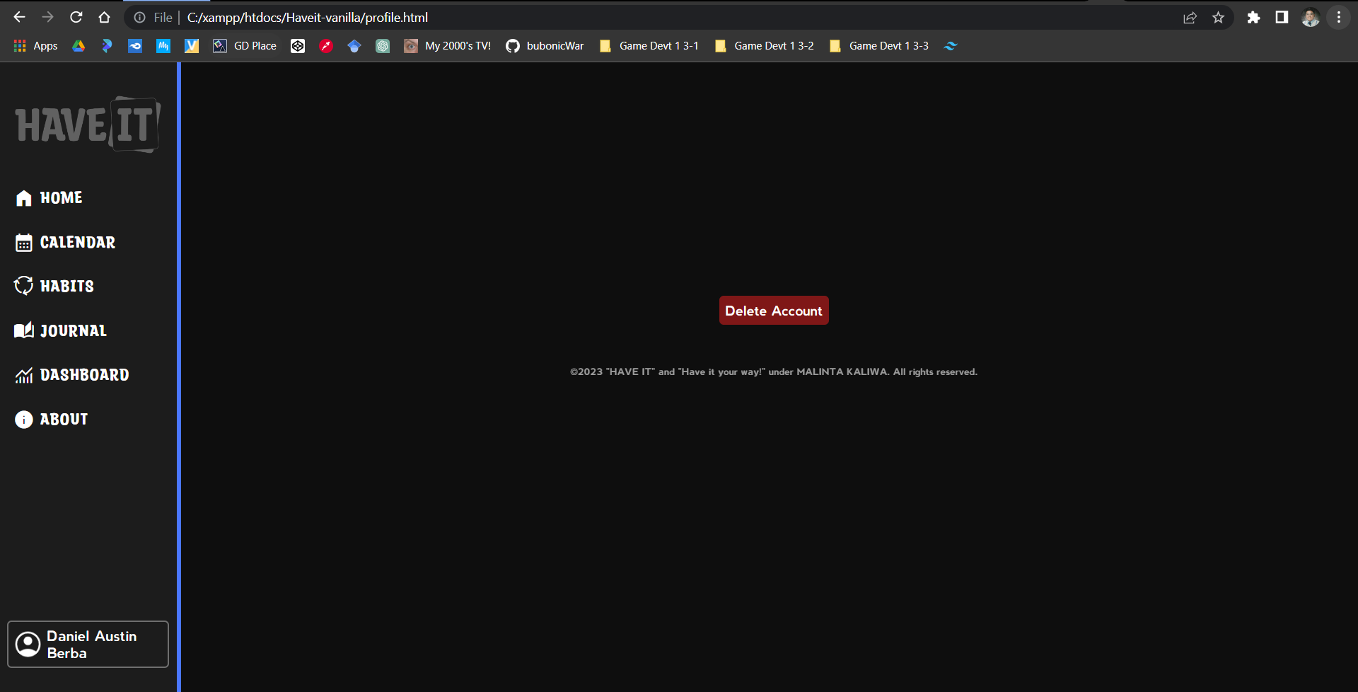

***Figure 7****. Profile Page*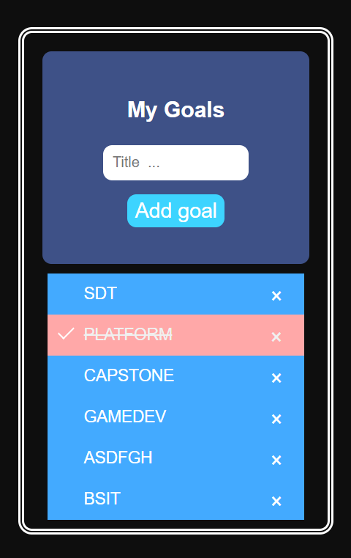

The calendar page will have a subsection on which the goal creator with checklist are integrated to the calendar:

***Figure 8.*** *Goals with Checklist*

### Hardware Interfaces

* Personal Computer - a type of computer designed for individual use, as opposed to a computer that is intended for use by a large organization or group of individuals.
* Mobile Device - a portable electronic device designed for personal use, which can be easily carried around and used while on the go.
* XAMPP Server - designed to simplify the process of setting up a web server environment on a local machine for development and testing purposes.

### Software Interfaces

* Up-to-date Web Browser - a browser that has the latest version installed, with all the latest security updates and bug fixes.
* HTML, CSS, JavaScript and PHP - are all programming languages used to develop websites and web applications.

### Communications Interfaces

The HAVE IT web app shall use the local host provided by the XAMPP PHPMyAdmin for local communication purposes. Which means that the web application and the database management system are running on the same machine, which can provide faster communication speeds and more secure data transfer. The HAVE IT web app can communicate with the local database management system, allowing it to access and manipulate data stored in the database in a secure and efficient manner.

# System Features

* 1. **Functionality**

These sections will outline a detailed list of requirements for the development of the HAVE IT - Habits and Goals Tracker with Journal, which will be categorized according to the features previously discussed in the document.

**4.1.1 Calendar**

* The system shall display all the months and days in the calendar.
* The system shall allow the user to select a date in the calendar to create, view, edit, and delete goals.

**4.1.2 Goals in Calendar**

* The system shall allow the user to create, edit and delete an accessible goal.
* The system shall display and allow the user to put the title and details of the goals.
* The system shall allow the user to put the due time and date of each goal.
* The system shall allow users to put a color mark on each goal to find them easier.
* The system shall allow the user to select and edit the goal's status (to-do, ongoing, and done).
* The system shall display all the goals created by the user.

**4.1.3 Habits**

* The system shall allow the user to add, edit and delete a habit.
* The system shall display all the habits created by the user.
* The system shall allow the user to mark each habit as done.

**4.1.4 Writing Journal**

* The system shall allow the user to create and delete journals.
* The system shall enable users to set the journal as their favorites to easily locate the journals selected.
* The system shall enable users to put a title and details on the journal when needed.
* The system shall allow the user to optionally choose themes for the journal’s customization.
* The system shall allow the user to provide any links they desire to input into the system.

**4.1.5 Account Login**

* The system shall allow users to register by inputting the necessary personal information required by the system.
* The system shall allow the registered user to log in with their email or username and password.
* The system shall allow the user to log out their account.
* The system shall allow the user to delete and remove their account anytime.
* The system shall enable the user to change their password once a month for security.
* The system shall allow the user to request a new password once forgotten by the user.

**4.1.6 Dashboard**

* The system shall enable the user to view all the tasks completed.
* The system shall enable users to see the tasks created.
* The system shall allow the users to track the journal created and view the bar.
  1. **Usability**

**4.2.1 Customizable Journals**

* The system allows the users to customize the words/texts and text colors of their journal. They can also insert and remove a link.

**4.2.2 Goal Streaks**

* The system should track habit streaks, which are consecutive days of successfully completing a habit, to motivate users to continue with their habits and maintain their progress.

**4.2.3 Habit and Goal Progress**

* The system allows the users to track their habits and goal progress, which could be located on the dashboard.

**4.2.4 Easy to Use**

* A good habits and goals tracker with a journal system should be easy to navigate, with a simple and intuitive interface that allows users to quickly and easily track their progress towards their goals and habits.

**4.2.5 Website Accessibility**

* Users should be able to access the system from their mobile or web browsers, allowing them to smoothly navigate the app and use the functions and features offered by the web app.
  1. **Reliability and Availability**
* The system should be available 24/7 to allow me to track my habits and goals anytime I want without any downtime. I need to be able to access the system from my computer, phone, or tablet whenever I need to, whether I'm at home or on the go.
  1. **Performance**
* The system should load quickly and respond to user inputs immediately.
* The ideal load time of the application must be 1-2 seconds and it should be able to display all the necessary features and functions for the users, before interacting with the web app.
  1. **Security**
* The password of every user must never be displayed by the back-end server of the system.
* The system should be user-friendly an

# Other Functional Requirements

* 1. **Performance Requirements**
* **Performance Efficiency** - The ideal load time of the application must be 1-2 seconds and it should be able to display all the necessary requirements for the users before using the web app.
* **Usability** - The application must be user-friendly with an appealing design, and smooth navigation and accessibility.
* **Reliability** - It must have a user data storage to protect the user's data and restore it if it is unintentionally deleted in some circumstances.
* **Security** - Must ensure the security of the web app.
  1. **Safety Requirements**
* **Scalability** - The system should be capable of supporting numerous concurrent users without noticeably affecting its performance.
* **Database Backup** - The software must have a backup such as a cloud server to continue accessing the data.
  1. **Security Requirements**
* **End-User** - The users must have consent to put all the necessary information in the app and must be aware that their information will be processed and stored in the database. The users must agree that some of the information will be displayed and others will not for privacy and protection reasons.
  1. **Software Quality Attributes**

**5.4.1 Functionality**

* The web app allows users to create, view, edit, and delete tasks, habits, goals, and journals. It also has a calendar feature that allows users to create tasks on specific dates, mark their status, and view progress. The web app also has an account login and dashboard feature for tracking tasks and journal progress.

**5.4.2 Usability**

* The web app should be user-friendly, easy to navigate, and provide a clear and concise interface for the users. It should also allow users to customize their journals by choosing themes and colors, making it more visually appealing.

**5.4.3 Reliability**

* The web app should be reliable and stable, with minimal errors or crashes. It should also save the users' data accurately and ensure that it is secure from unauthorized access or data loss.

**5.4.4. Security**

* The web app should be secure, with proper authentication and authorization protocols for the users. It should also allow users to change their passwords regularly and request a new password when forgotten, and an ability to delete their account.

**5.4.5 Performance**

* The web app should be efficient and responsive, with fast loading times and minimal lag. It should also be scalable to accommodate a growing number of users and data.

**5.4.6 Portability**

* The web app should be portable and compatible with different devices and platforms that have a web browser such as desktop and mobile devices, and also to work in different web browsers.