

Wi-Fi firmware for ESP32

Rafael Conceição, nº 41486, e-mail: A41486@alunos.isel.pt , tel.: 967568496
Eduardo Tavares, nº 49454, e-mail: A49454@alunos.isel.pt , tel.: 912400426

Advisors:
Diego Passos, e-mail: diego.passos@isel.pt
Fernanda Passos, e-mail: fernanda.passos@isel.pt

April 2025

Introduction

There has been an increase in the density of wireless networks caused by the increase of mobile devices, sensors, and actuators. Due to these there is a necessity to be able to test new techniques and protocols for such environments, which can be quite costly since the solutions usually employed are SDR (Software Defined Radio), which are very expensive devices.
This project will try to address this by creating a low cost platform to allow developers to experiment in high density wireless areas, using cheap low wattage micro-controller units. The hardware used in this project is fairly limited, not being able to match any standard already defined on IEEE 802.11, due to frequency and modulation of the signals required. Despite such limitations, our project’s implementation will still serve as a base for the spirit of Wi-Fi, which can be used to test the efficacy of various related techniques, with variations on the error rate and throughput derived from the hardware limitations mentioned before.
By the end of this project, we expect to have made simultaneous communication possible between multiple nodes of our network.

Functional Requirements

Traffic Generation Module:
The traffic generation module has been fully implemented, and can generate traffic with a constant given interval, or with a normal distribution.

CSMA/CA:
This part is mostly functional, but still needs some additional testing and improvements.

Original Plan:
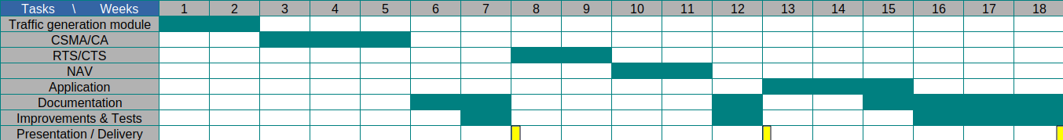
Figure 1: original chronogram

How It’s Going:
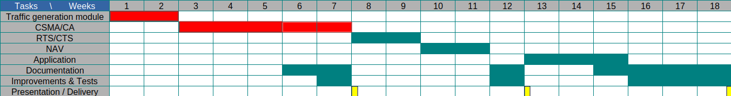
Figure 2: updated chronogram

Implementation

Radio details

The cc1101 module contains a reasonable amount of complexity, with the purpose of offering a flexible physical layer protocol, communication with the adjacent module through spi communication and pin signals, and as a way to control the state machine of the radio, as hardware limitations limit the radio to either being on transmitting or receiving data when active.

The specific cc1101 radio exposes 8 pins, as shown on the table below

Pin number | Name | Purpose
1 | GND | Ground
2 | VCC | Energy connection
3 | GDO0 | Bit sign
4 | CSN | SPI
5 | SCK | SPI
6 | MOSI | SPI
7 | MISO | SPI
8 | GDO2 | Bit sign

From these pins, the GDOx pins are the only ones with purpose not immediately recognizable. The meaning of these signals can vary depending on the state of each associated register of each GDOx pin. These are currently in use as a way to coordinate radio to controller communication during the handling of large packets (registers contained on the radio will not be able to contain a large packet in its entirety), and most vitally to signal an incoming packet. We could also, however, use them as a way to do clear channel assessment (cca), or checking the integrity of small packets.

Physical Channel

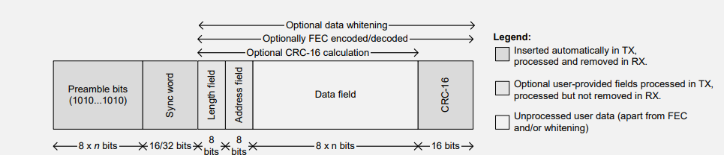
Figure 3: cc1101 packet format support

The related image, found on section 15.2 of the radio documentation[4] shows the possibility spectrum provided for packets, which fully covers for the Open Systems Interconnection (OSI) physical layer. At any time, every node will have to be coordinated on the size of the sync word, and whether the length and address fields are at use. As of writing, the length field is always present, allowing for the transmission of large packets, while the address field is not currently in use (the address can be contained exclusively in the ieee frame contained on the data field). These configurations are not set in stone, and may be either change or even be made configurable through the test application.

CC1101 Code

The implemented cc1101 driver contains the functions upon which the data is received and transmitted, along with the cca check. To achieve this functionality, it contains auxiliary code for GDOx and spi communication, functions to set the initial state, along with a considerable amount of macros related with the state and fifo registers. As a way to be as prepared as possible to receive packets, something which the timing will always be an external event, there should always be the responsibility of the function that change the state machine to, in the end, return the state to rx (done with a command strobe by current configurations).
The most complex part of this code is the transmission and retrieval of packets, as large packets won’t fit in the register. Luckily, section 15.2.2[4] contains a description of how to handle such a case, even maintaining the crc-16 bits from the physical layer. It also applies the usage of GDOx pins with GDO2 checking if there is either space on the fifo to write or if there was a delay and underflow/overflow occurred, and GDO0 on transmission to check if both preamble and sync bits were sent, as they automatically are on transmission state change.

CSMA

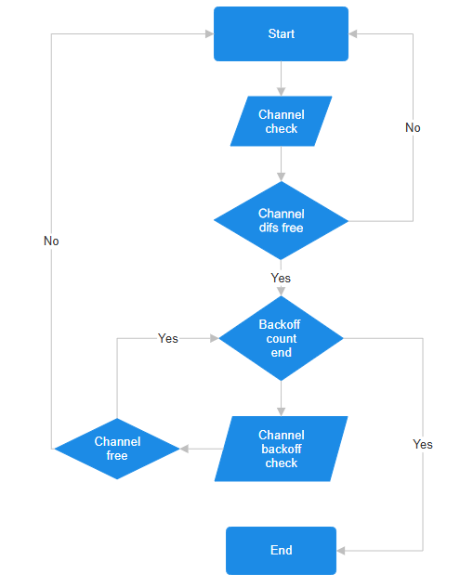
Figure nº2: csma wait rules

When our traffic generation module attempts to send a frame, it will do it with the support of the class CSMA_CONTROL, created in this project’s code. This class, created with a cca check received from our cc1101 code, is responsible to wait for the contention window defined randomly in its class, a feature accessed by waitForTurn function. Since this hardware cannot support the interframe space times from any standard, a measurement of the SIFS time was done through the use of 2 nodes, while other interframes were defined to be on a similar proportion to the ones in IEEE 802.11a. The code for this experiment can be found in the tag Sifs-1.0.
After the waitForTurn function call, the node will send the packet and do an active wait of SIFS duration. If it receives the packet received channel before this wait, it will check if it is an acknowledge directed to it, and indicate success if it is. Any failure will return the node back to the waiting step, but not before signaling CSMA_CONTROL about the failure, so it can readjust its contention window.

Traffic Generator

The base of this model consists in two parts, the configurable time wait between the transmission of the packets, and the function sendData given as a parameter, which should already act in accordance with csma/ca, created with the help of the other modules in this project. Considering the function given is a responsibility of the rest of the code, this class is already fully functional, containing methods to stop and start this module at will, and supports configurable wait times.

Top view

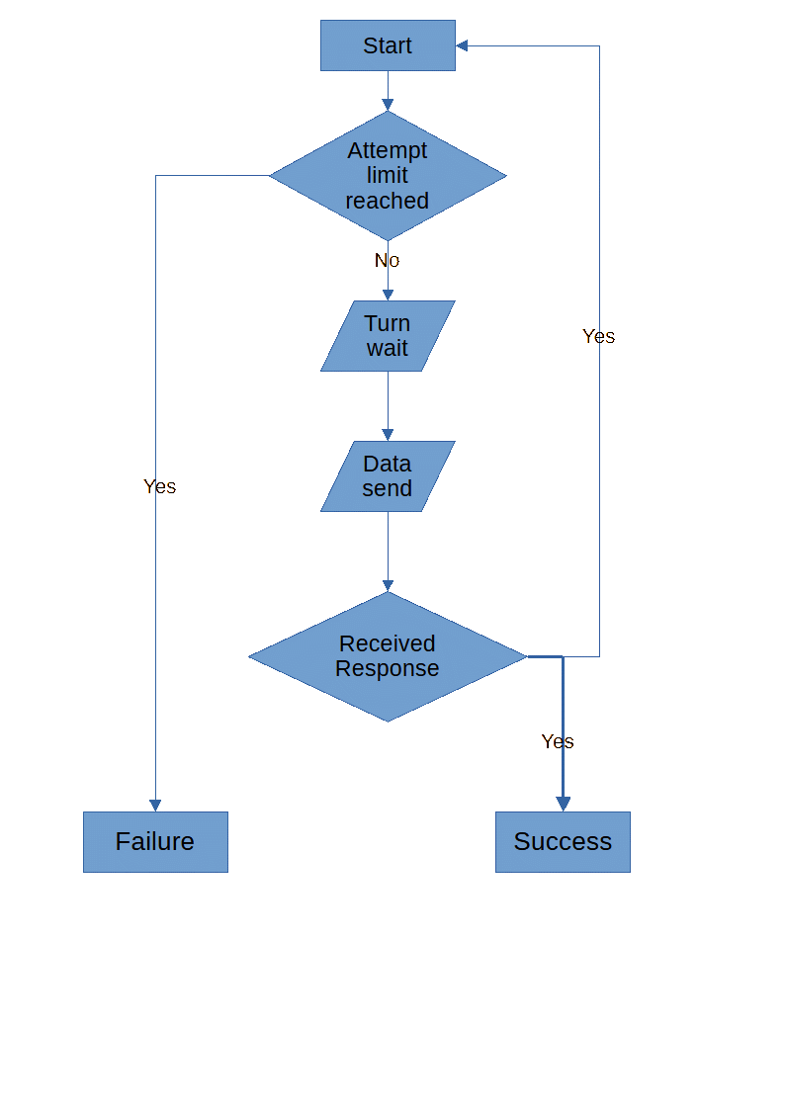
Figure 4: current data send flow chart

The endpoint of medium access control is the implementation of the send data to be given to the traffic generator. The image above shows the basic logic used in our current work, without NAV and RTS/CTS. The actual function, however, needs to account for the fact others may try to start communication themselves, and therefore needs to be able to accept interruptions from other sending their packets. As this is non predictable, any packet received when no acknowledge is expected will cause the use of a FreeRtos task, which will take precedence over the data send.
This task will consist of analyzing the packet to check if we are the intended destination for the packet. If we are, the it is our responsibility to send an acknowledge immediately. After the task is done, it will suspend itself as a way to give the traffic generator its turn.

What is next

RTS/CTS

Implementation of rts/cts is expected to be a fairly quick addition. The changes would involve adding the rts send and wait for cts response, while adding the retry counter addition and adding a funtion similar to ackAcknowledged to indicate either success or failure to CSMA_CONTROL.
As getting an rts frame is out of the node’s control, it will be handled in the same way as sending an ACK on received data is on the current code, i.e. letting the receiveAndAnswerTask handle it.

Network Allocation Vector

The NAV necessitates the usage of the duration header field found in the ieee frame. This field will be set in each frame, as a way to indicate, in micro-seconds, as a way to indicate for how long the data exchange is expected to last. Implementation of it will require proper measurement of the time to send packets at the chosen frequency, should the duration header contain an accurate value. This feature may give rise to a new defined class, or it may perhaps be part of CSMA_CONTROL.

Configuration Application

This application will consist of c/c++ code implemented for a regular computer, accessed through a regular terminal, capable of communicating with the nodes from regular wifi capabilities.
Although this requirement forces the addition of wifi capabilities, due to the esp hardware containing 2 cores, we can dedicate one core to deal with the radio at all times, ensuring it will not meddle with timing as much as possible.

Issues
We are also dealing with some unpredictable crashes that must still look into and fix. There appears to be more than one issue causing this: one might be our use of the radio and the timing, and another might be a bug the radio firmware.

