Harris Waseem
Luc Marest
BUS341W
April 26, 2026

Introduction
The purpose of this report is to explain a select few trades taken by me. This includes a basic rundown of the company/stock in the moment of the trade; the determination of entry and the mechanism behind it; the analysis of movement, both positive and negative; and inevitably, the exit determination and the thought process behind that.
Most of these trades were taken from the perspective of a trader with ~4+ years of experience trading options based on technical analysis (T.A). As such, much of the content discussed will be subjective, based on cherry-picked indicators and what many in the investment banking industry consider to be day-trading “voodoo” or “magic”.
The reality of technical analysis is that, ultimately, when you are trying to determine the right position to enter, what matters is whether that position is good. Not the best, but workable. The end-goal of any trade is to make profit. The point of technical analysis is to give you the edge in making profit, helping time both your entries and exits, separating your position from being up a couple hundred dollars from the thousands prior.

Initial Trades (Mutual Funds)
The first set of trades initiated were to learn more about mutual funds. As such, this challenge was taken with a grain of salt, as my primary goal was to learn about different types of mutual funds, how they operate, how they are traded in a simulated setting, and ultimately what value they could provide towards my portfolio.
One major thing I learned from investing in mutual funds was that they don’t trade immediately; instead initiating at the end-of-day. For some funds, you must place your order before 4:00 PM EST as the fund will fill at 6:00 PM; if you do not place your order prior, you will not enter a position and will need to wait until the next day at 6:00 PM to enter your position. They also, as far as I have traded thus far, do not use standard “shares” to indicate your buying a percentage of the fund. Instead, you decide directly how much money you want to invest. Meaning, you can invest $100,000 directly into the fund, rather than $100,000 in shares of the fund or any other means of security.
Following this, ~45% ($450,000) of my total portfolio was diversified into three major mutual funds: VASVX, INIIX, and FIQRX. This challenge was taken with a grain of salt rather than any intentions of making a substantial amount of revenue as I wanted to test out how mutual funds trade. As such, my portfolio ended with north of an 8% overall gain on a million dollars.
VASVX, also known as the “Vanguard Selected Value Fund”, is one of Vanguard’s higher performing mutual funds. As stated by the fund, it “employs an active management approach”, acquiring shares of stock determined by their advisor to be “undervalued” (Greenberg). My personal interest in this fund, aside from simply being Vanguard, was the fact that over a quarter of the fund was invested in Financial Services. Given the current state of the market shifting towards Data, Artificial Intelligence, and Financial Services, I believed there were long-term prospects in holding a fund that would profit off an “undervalued” section of the market that, in my eyes, was pivotal to the current economy.
INIIX, also known as the “VanEck International Investors Gold I”, is as expected one of VanEck’s gold-based mutual funds, with over “80%” of their net assets in securities related to gold (Casanova). It may already be expected, but VanEck’s fund was used to hedge my portfolio against market volatility, as there is generally the sentiment that gold (and commodities in general) move opposing to indicators like the VIX, VXX, SQQQ (movement cross-compared) and whatever else ProShares ETFs contain.
INIIX proved its worth down the line as in early March, there was a significant increase in market volatility due to the Iran conflict overseas; as such, natural resources like Oil, Gas, and precious commodities increased in value due to supply-chain concerns. Gold was affected similarly as many investors shifted towards safe-haven assets. This sent the price at which I purchased the security at $43.18 to a high of $51.33, offsetting losses from other, more volatile areas of my portfolio.
FIQRX, also known as the “Fidelity Advisor Global Commodity Stk Z”, is Fidelity’s version of a commodity-based mutual fund. Like INIIX, a minimum of 80% of the fund is in its respective category: this being energy, metals, and agricultural industries (Moulis). FIQRX acted as a diversifier and another potential hedge to my portfolio, which was targeted to heavily lean into Tech and Financial Services. FIQRX came to pay off in the highs of the conflict, going from my buy-in of $25.23 to a high of $28.25.

Prominent Trades
This section will be dedicated towards certain trades that I deem as important or exploratory enough to conduct technical analysis upon. The purpose here is to highlight areas where T.A and trading according to indicators can prove beneficial to any trader, regardless of volatility, market trends, or momentum. As such, I ask that you, the reader, keep an open mind about explanations of price, movement/volume analysis, or even candlestick patterns mentioned.

PayPal (PYPL)
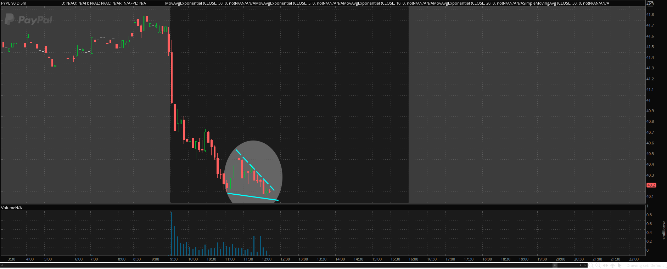
PYPL, also known as PayPal, was purchased on February 11th; 1500 shares for $40.20, totaling $60,300.
Figure 1: PayPal (PYPL) 5-min Price Chart with patterns drawn (Pre-Action). February 11, 2026.
Note: Chart created by author using data from ThinkorSwim
To explain my choice of purchase at this point, I must first explain what exactly is going on. PayPal is in a descending, bearish trend; it is currently dropping in value, objectively. Many technical analysts may consider this pattern to be a “bearish channel”, meaning that between two drawn parallel lines (usually using the tops & bottoms of the candles as points of reference), the price will gradually bounce between the channel edges, trending lower until the steady pressure of either buying or selling bleeds off for either a comeback or an even sharper downward trend.
Given this, one may then assume that buying here would be a risky choice, and in a sense it certainly is. If the channel continues unhindered, it may simply brush aside a pattern I will talk about and continue its gradual decline. Like I said however, there is another pattern to consider; two, in fact.
The first is the fact that PayPal is reaching daily lows, and that there was an initial “bounce”. This establishes something called “support”, which traders (both institutional and otherwise) use as a point of reference where “buyers will put pressure here” while “sellers don’t want to play here”. This leads to a phenomenon where the price has “support” as one side lowers pressure because of cost; they’ve already secured their profits for the day, as seen by the massive drop at the beginning of the day. With that in mind, seller mentality shifts, and volume spikes noticeably as that support is retained the second time around. This time though, that support is no longer a subjective test, but a respected stopping point given the price does not lower beyond it. This is what we call a “double-bottom”.
This is where the second trend I referred to comes into play. A channel is when two parallel lines are formed above and below stock price action, and the action follows that “channel” like a pinball, bouncing between. In this case however, the channel is not respected inherently due to the double-bottom putting pressure on the price action; after all, moving linearly/on a straight line in a channel shows a lack of respect for the pattern, and can make traders wary of a continued trend. Markets go where they want, and all patterns are subjective, even strong ones. Instead, we see something called “consolidation”, where the price action reaches a point where both buyers and sellers are slowly laying on the pressure as they both see upside/downside potential and want to swing the favor in their direction. In my case (the buyers/bullish side), we see a convergence of downward trend lines (“falling wedge”), and the price action slowly approaching the apex of said lines. This piles on the pressure from the bullish side, and in the instance where sellers falter or don’t catch the signs before it is too late, the price can be pushed up enough where the price “breaks out” of the pattern established and begins to either change or compound its trend.
Following this call, as expected there was an initial breakout of the stock bullishly. Given the nature of the timeframe used (5-min ticks), such momentum was understandably short-lived, however. It was during this trade that, embarrassingly, I remembered that I was not trading options contracts but rather shares of the stock directly. Whereas such movement would be extremely beneficial towards option-contract valuation due to volatility, this move has little impact on stock prices directly.
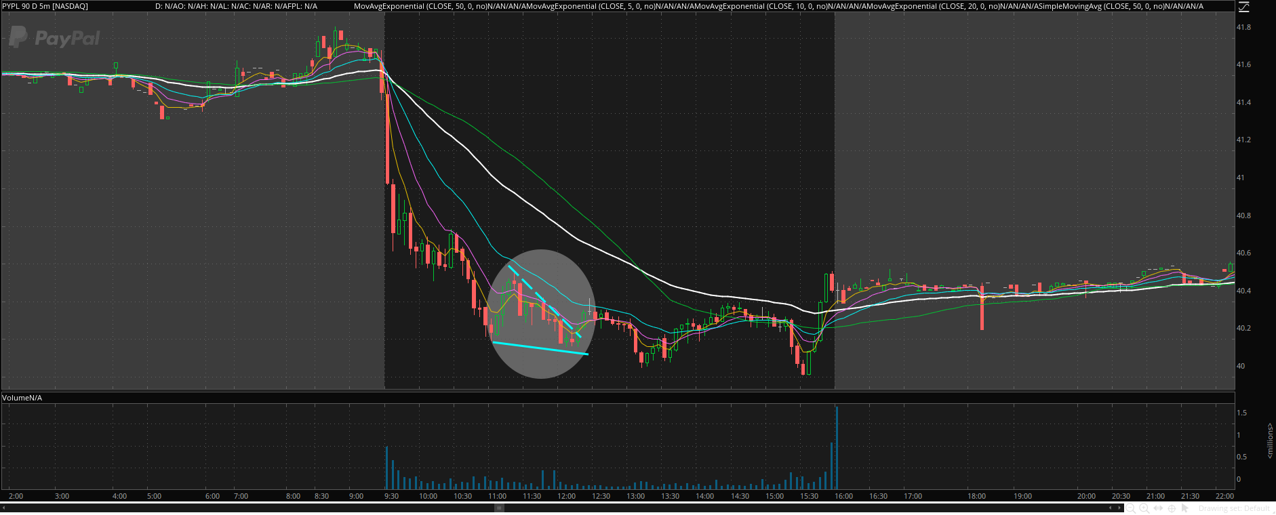
This is where the beauty of technical analysis shines; whereas I could claim the profits from this movement, I instead used this entry to begin a swing-position, as long-term I saw something interesting:
Figure 2: PayPal (PYPL) 5-min Price Chart with patterns drawn (Post-Action). February 11, 2026.
Note: Chart created by author using data from ThinkorSwim

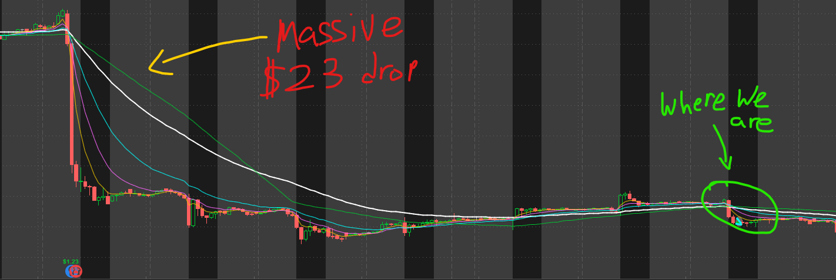
PayPal missed their earnings call by a few cents. Just 5-cents per share, but they dropped a staggering $23 in price. Now, whether this was an overreaction or not, I followed the simple principle: if there is a reaction, there will be an opposing reaction afterward. Seeing PayPal’s steady decline, I recognized the gradual downward momentum slowly decaying despite the seemingly endless bearish movement on the chart. Volume was drying up, and it was the next day when PayPal hit a multi-year low at $38.46 before quickly halting its momentum, did I reevaluate and double down my position by purchasing 750 more shares (half my initial investment) at $38.69.
Figure 3: PayPal (PYPL) Hourly Price Chart with patterns drawn. February 2 ~ February 11, 2026.
Note: Chart created by author using data from ThinkorSwim
Around 12 days later, I sold half my position for $47.28, a ~20% gain on half the initial investment. A month and a half later, I sold the rest for $50.80, for around a ~28% gain on the other half. I had intended on holding that half forever, but I wanted immediate liquidation for another trade; a concept I will discuss briefly regarding the next trade.

Uber (UBER)
I consider Uber to be a personal failing of mine as, despite making profit on the trade, it represented my failure to determine appropriate exits. What could have been a ~20% gain on $100k had quickly turned into a lesson in bag-holding and keeping over 20% of my own portfolio hostage, tied up in double-downs and reevaluations.
Using T.A, Uber looked like a good opportunity from the get-go. It had recently missed its earnings call by 9-cents in early February and looked primed in its initial descent to bounce off an established support. Unfortunately, and this is where many traders consider technical analysis to be speculative, it can be difficult to determine exactly where the support is when consolidation gets jumbled up and multiple different supports and resistances get tangled up on various timeframes. Supports and resistances work hand-in-hand with one another after all; today’s support can be tomorrow’s resistance if the price falls through, and vice versa. When they play so closely together on historical data, traders become speculative. It’s no longer definitive when it is no longer clear-cut, especially while volume is unusually high across the board for every point.
Even worse? I did not trade Uber as analytically as I wanted. I established a plan for trading it when I got the chance, but I never pulled it up officially on my brokerage platform (ThinkorSwim) to chart it properly. To put it simply, I eyeballed the stock, saw what I assumed to be good action, then ate dirt when my initial position went negative two days later.
Every low following was an average down in my position, but none were substantial enough to properly net value back in the original investment. 3% here, 7% there, 5% somewhere. By the time the challenge was over, I had 6 different orders on Uber averaging down, and only two selling orders where I secured profits on one and let the other ride.
The total amount I made on Uber was ~5% of the total investment (being around $200k) by the last sale. However, what I lost wasn’t immediately tangible; that $200k could have been better invested into XOM, which I had a substantial position in. I could have put a position in AMD, which I had been eyeing for a while. It could have even sat in my account for liquidity on something that just came across my scanner. Instead, it was tied up in an investment I should have planned better, or possibly even cut on a minor loss.
The reason I bring up Uber and am extremely critical of this trade is because of what it represents. The fundamental flaw in technical analysis isn’t the method, but the user; ego and emotion have no place in the markets. To reliably trade, especially with hundreds of thousands of dollars on the line (money that may not even be yours), you need to recognize your shortcomings and failures. Understanding where you went wrong helps you become a better trader in the long run; it isn’t an immediate gain. What you learn in one bad trade may not be directly relevant to your next ten trades; instead, it is how your judgement sharpens and your understanding of market forces instinctively grows. Most of my trades are eyeballed for example, but that instinct only developed over years of intense and brutal trading where price action is the least of my concerns; even then, that instinct isn’t foolproof as seen here, and your strategy can backfire spectacularly.

Lessons Learned
As mentioned, I have learned many things about the market over the years. Strategy, volume, momentum. How to read indicators, and how to anticipate price action. It is also over these years that I have been burned countless times; false breakouts, IV crushes, momentum traps. It is a demoralizing experience, and that emotion can bleed into your trading mentality; when that occurs, you have instances like what I experienced with Uber, where even if you make profit, the trade is not impactful in any other way than being a latent detriment to your account, taking up time, liquidity, and even mental baggage.
However, you learn and grow; as you take blows head-on, analyzing the trade from different perspectives, you begin to understand things you may not have understood entirely before. Trading is full of technical jargon after all, but when you cut through the excess, you eventually net trades like PayPal. Trades that follow recognizable patterns, where you begin to check fundamental forces like volume traded and volatility indicators as though it is second nature. That is when a budding mastery over the subject begins to show, and your account will feel it.
I have developed this report as a dive into my thought processes while trading actively volatile securities; wanting to keep it simple enough so the uninformed can understand actively applied concepts simply. I also allowed enough professional room for experienced traders to understand my perspective as to critically analyze my decisions, or what I could have done better. I sincerely hope that you, the reader, have taken away something new from my exploration of mutual funds, my analysis of the two prominent trades I mentioned, and my breakdown of the market mechanisms behind them. Trading using technical analysis is dependent on being a continuous learner who can look at different perspectives, and I hope my own was informational enough to help add to your foundation.

References

“Vanguard Selected Value Fund (VASVX) Company Profile & Facts - Yahoo Finance.” Yahoo Finance, 2026, finance.yahoo.com/quote/VASVX/profile/. Accessed 29 Apr. 2026.
“VanEck International Investors Gold I (INIIX) Company Profile & Facts - Yahoo Finance.” Yahoo Finance, 2026, finance.yahoo.com/quote/INIIX/profile/. Accessed 29 Apr. 2026.
“Fidelity Advisor Global Commodity Stk Z (FIQRX) Stock Price, News, Quote & History - Yahoo Finance.” Yahoo Finance, 2026, finance.yahoo.com/quote/FIQRX. Accessed 29 Apr. 2026.

