Joose Workshop 2

Task 1

We feel the current inheritance model is not the most optimal solution. The solution could be improved by application of appropriate design patterns and design principles. We must identify behaviour which are the same across the subclasses, and ensure that these are inherited by the subclasses. Any behaviours which do change in their implementation must be separated out as interfaces.

We will create a Board Interface as behaviours from Board Class are overridden by the subclasses, making inheritance from the Board class pointless. Instead the different types of board will implement the board interface and the behaviours defined within it. However, all boards inherit updateStock() so there should still be inheritance from a class to allow this behaviour to be inherited, so we will retain the Board Class with methods Board() and updateStock().

Piece should also be an interface as currently some behaviours in piece are being overridden in the inheriting classes so, as with Board, there is little point in inheritance. The paint() method will be moved to the interface. There will still be a piece class with some inherited behaviours.

Task 2

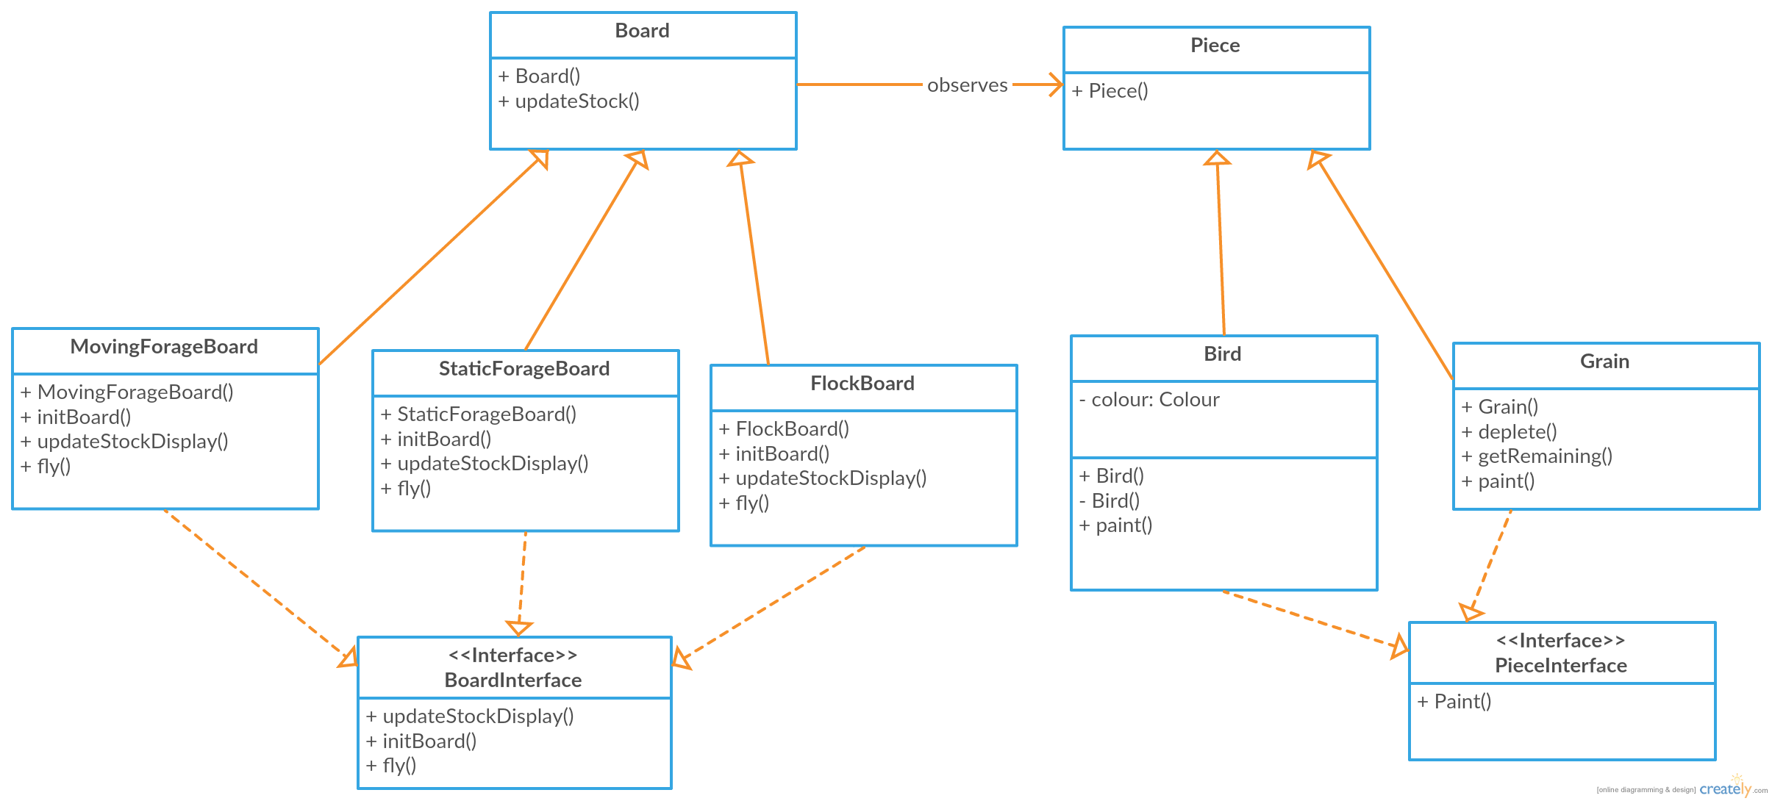

Task 5