JAVA PROJECT



Properties

Created By: Raj Kunwar

**Acknowledgement:**

I would like to express our special thanks of gratitude to **Nandita mam**  giving us such wonderful guidance so that we were able to learn new things and improve our skills. She taught us basics of java language to make the project during our six weeks training. It included the topics such as Event Handling, Collection Framework, SQL Databases etc which helped us to Property Dealing Project.

**Abstract:**

The research aim to design a computerize system to manage the Property dealing by using Java language to specialized companies in sale, buy the properties including creating effective website serve the work of these companies, where as we can listed all the properties and its details such as the name of the owner, his telephone, E-mail , sale price and the property qualification …etc , empower the person to know all information about the properties simply before the sale, buy decision . Finally the research presented many conclusions and recommendations due to it.

**Introduction:**

**“Infinity Property Dealing”** is our latest product offering that is a turnkey solution for Property Dealing companies. It includes everything needed to create an interactive, effective, and revenue generating web site for the Real Estate industry.

Property is one of the basic needs that the person requires in the day to day activity. Property can be the house in which a person lives or it can be the place of work. The agents make a lot of money in the property dealing or the real estate business. They even fool the people by obtaining more money than the required amount. To solve all these problem, the Online Property Dealer application can be developed. It helps in knowing the cost of the land in the particular area or the region. The people will have the knowledge of the cost of the land that they need so that they cannot be fooled easily by anyone.Each property listed has its own detail page filled with key information, including location of the property.

**Features:**

Online property may contain the following features:

* Property database management: The information of the properties that are available must be stored in the database in a well organized manner.
* Description of the property: Proper description of the property must be given so that every information regarding the property is covered.
* Categories: There will various categories of properties based on the areas or regions the that one wishes.
* Price: The price of the property should also be mentioned. This will avoid the bargaining about the price of the property.
* Sale the property: This application can also help the in selling property by uploading the information regarding it.

There will be middlemen who will be responsible in buying and selling of the goods. They get the commission both from the buyers and the sellers side. This application will help in solving the problem of giving commission to the middle person. The back end should be strong with the database related matter. The user interface must be simple and easy to understand. There can be a search option which will enable the people to easily search for the intended property.

**Modules:**

Module 1: (Password Module)

In this module, Member enters a password and the software checks its validity. If the password is valid then he is allowed to enter, otherwise “Invalid User/Password” message is displayed. Different data access rights are assigned to different users. A new member can also be registered in this module.

Module 2: (New User Registration Module)

In this module, new members can register themselves with proper information to the company to get the facilities provided by the company.

Module 3: (Posting or Sale of Properties)

Creating new Entities (Select State, Property Details)

In this module, a new property can be posted by anyone who is interested in selling or renting his/her property, with proper details.

Module 4: (Paying to view Properties for buy)

In this module, properly can be pay by credit or debit card and got the coins as per the convenient of the user to view properties details in their city.

Module 5: (Validation of Data Entered by the User & Error Handling)

In this module, the validity of data entered by the user during the various business processes is checked through various validation checks. For example, there should not be any characters entered in the numeric fields, likewise if there is any error occurs than it should handle that particular error and give the required messages.

**1.Registration and Login Page**

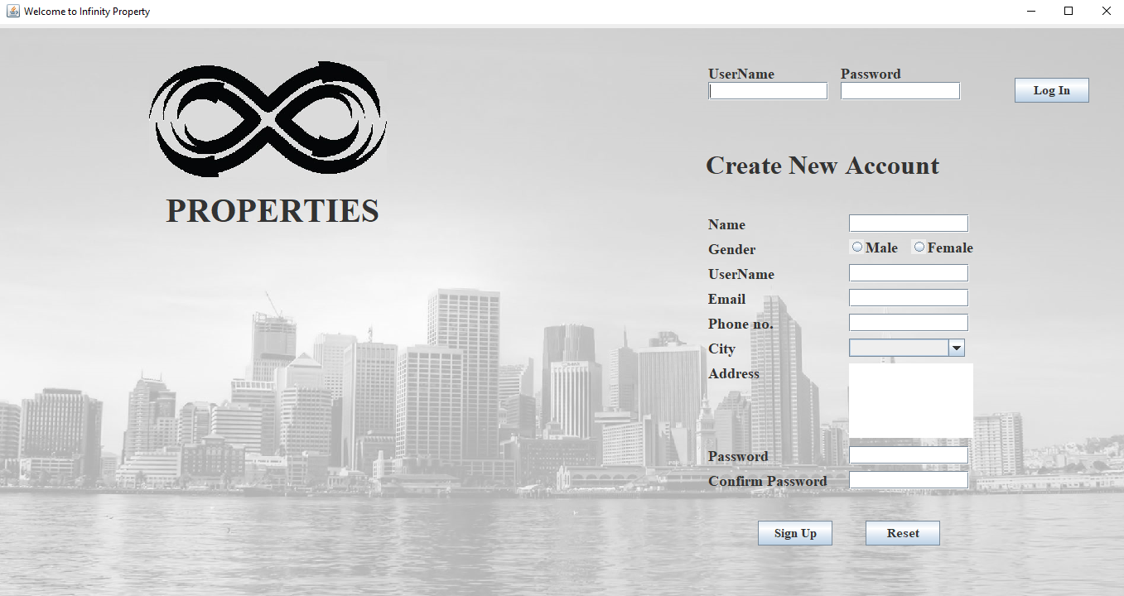

Figure 1

**2. Choice Page For Buy And Sale Properties**

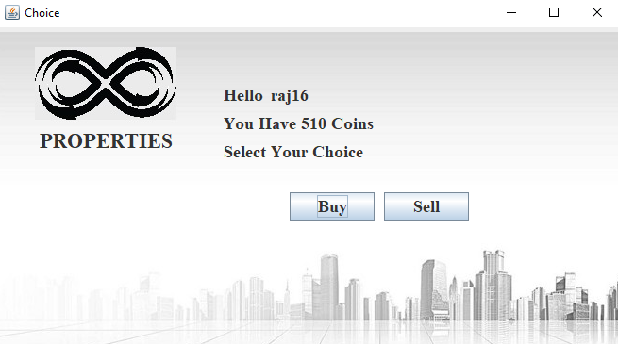

Figure 2

**3.Sale New Property**

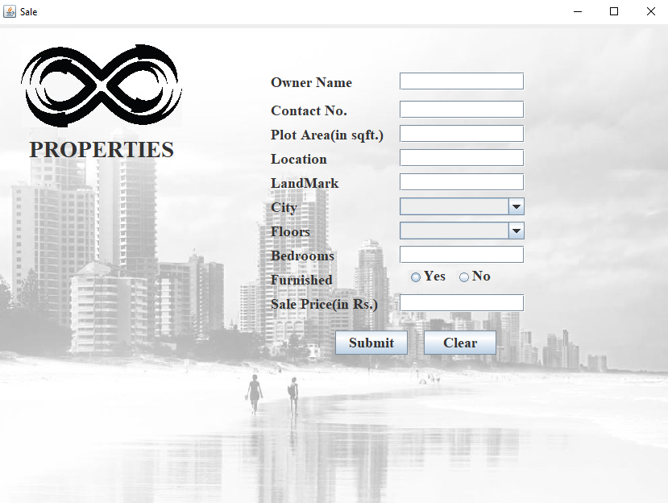 Figure 3

**4.PayMethod For New Users**

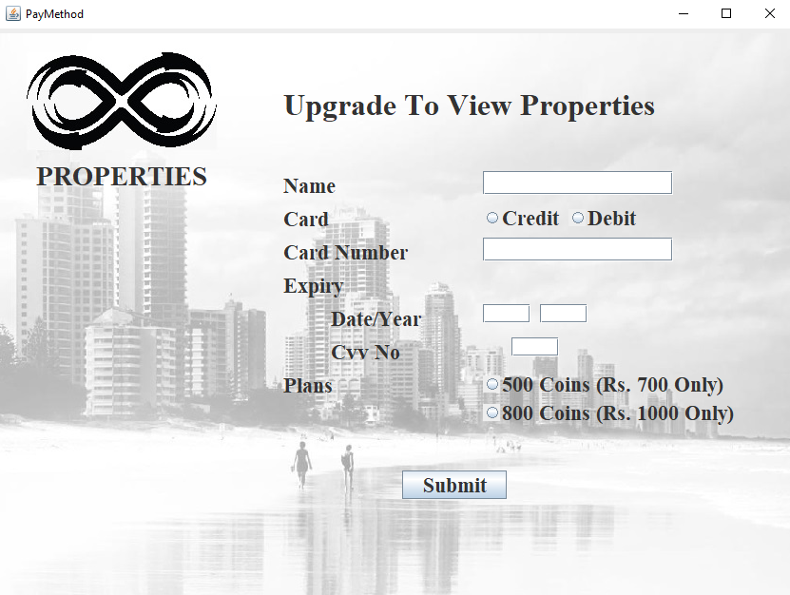

Figure 4

**5.Select your City**

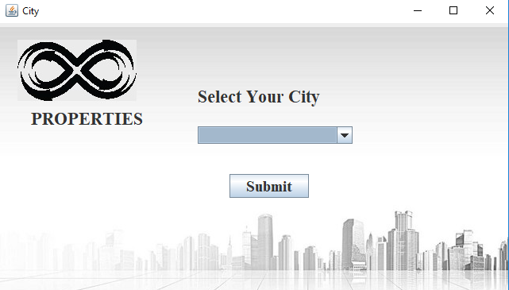

Figure 5

**6.Properties view**

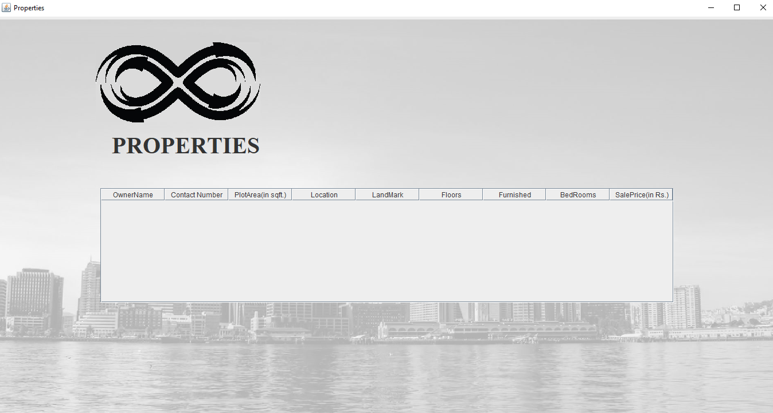

Figure 6

**Conclusion:**

This project has presented a challenging assignment to us. In addition it has been a great learning experience. Not only we have improved my Java skills but we have also been able to explore alternatives in creating Client/Server pairs. Using Java object serialization and native support for threads, we have learned that We could build much more powerful and flexible system with fewer lines of code. Above all this project has laid a strong foundation for making a improved system that can be used in real world.