CREATE JAVA APPLICATION

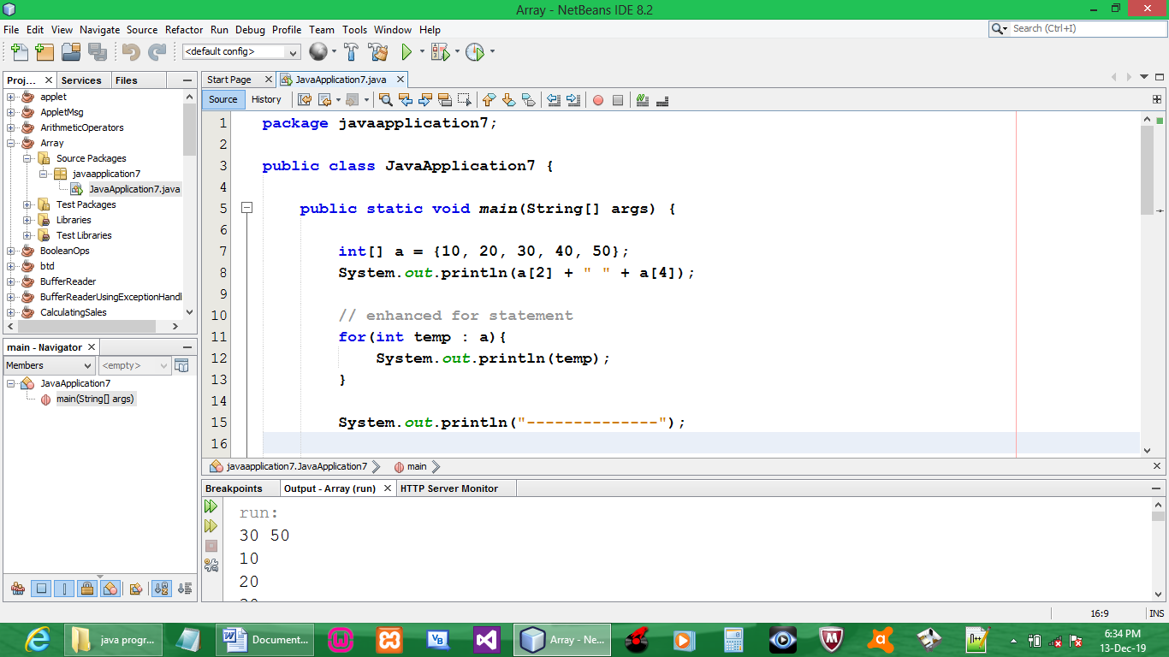

CODE:

package javaapplication7;

public class JavaApplication7 {

public static void main(String[] args) {

int[] a = {10, 20, 30, 40, 50};
System.out.println(a[2] + " " + a[4]);

// enhanced for statement
for(int temp : a){
System.out.println(temp);
}

System.out.println("--------------");

// declaring an array then assigning values after
int[] x = new int[5];

//then assigning values
x[3] = 25;
x[0] = 12;

for(int temp2 : x){
System.out.println(temp2);
}

System.out.println("--------------");

String[] st = {"one", "two", "three"};
for(String temp4 : st){
System.out.println(temp4);

System.out.println("--------------");

// declaring an array then assigning values after
String[] q = new String[5];

//then assigning values
q[3] = "25";
q[0] = "12";

for(String temp6 : q){
System.out.println(temp6);
}

}

}

}

OUTPUT:

