CREATE JAVA APPLICATION

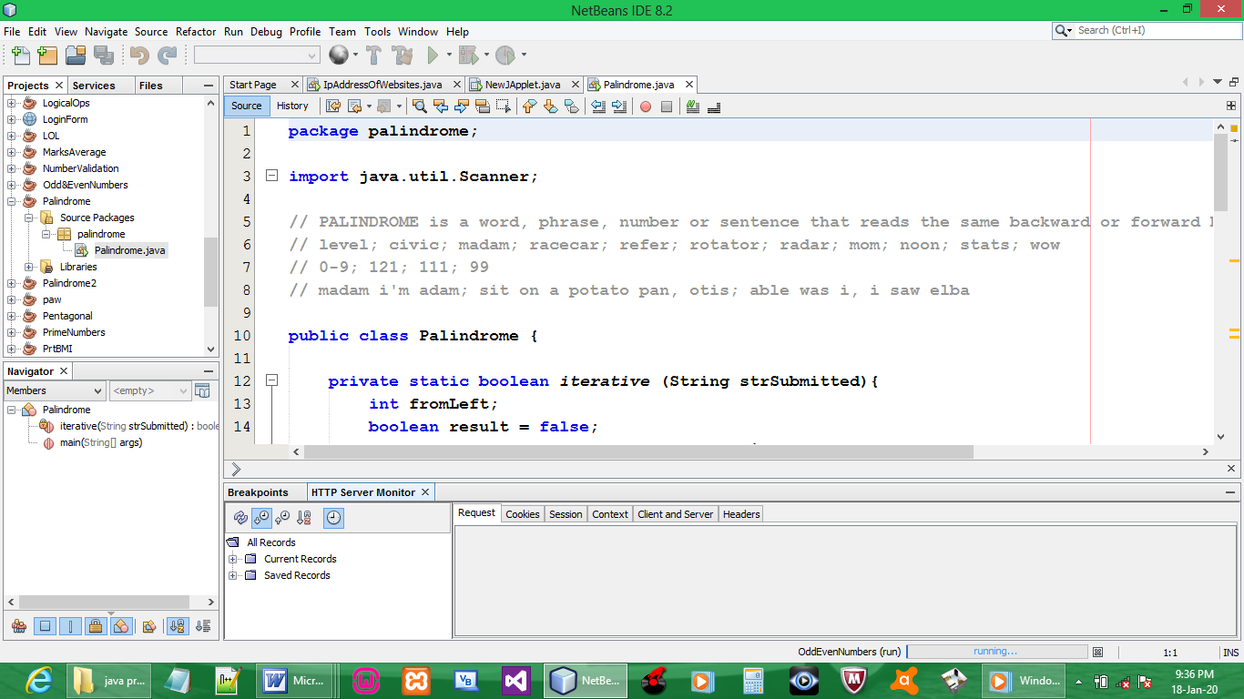

CODE:

package palindrome;

import java.util.Scanner;

// PALINDROME is a word, phrase, number or sentence that reads the same backward or forward but still has the same meaning
// level; civic; madam; racecar; refer; rotator; radar; mom; noon; stats; wow
// 0-9; 121; 111; 99
// madam i'm adam; sit on a potato pan, otis; able was i, i saw elba

public class Palindrome {

private static boolean iterative (String strSubmitted){
int fromLeft;
boolean result = false;
int fromRight = strSubmitted.length()-1;
if (strSubmitted.length()==1)
result = true;
else
{
for(fromLeft = 0;
fromLeft < strSubmitted.length();
fromLeft ++,fromRight--)
{
if(strSubmitted.charAt(fromLeft)==
strSubmitted.charAt(fromRight))
{
result = true;
}
else
result = false;
}
}
return result;
}

public static void main(String[] args) {
boolean is = false;
String sentence = "";
Scanner scnr = new Scanner(System.in);
System.out.println("Enter a word or sentence:");
sentence = scnr.nextLine();
is = iterative (sentence.toLowerCase());
if (is==true)
System.out.println (sentence+" is a palindrome");
else
System.out.println(sentence+" is not a palindrome");
}
}

OUTPUT:

