CREATE JAVA APPLICATION

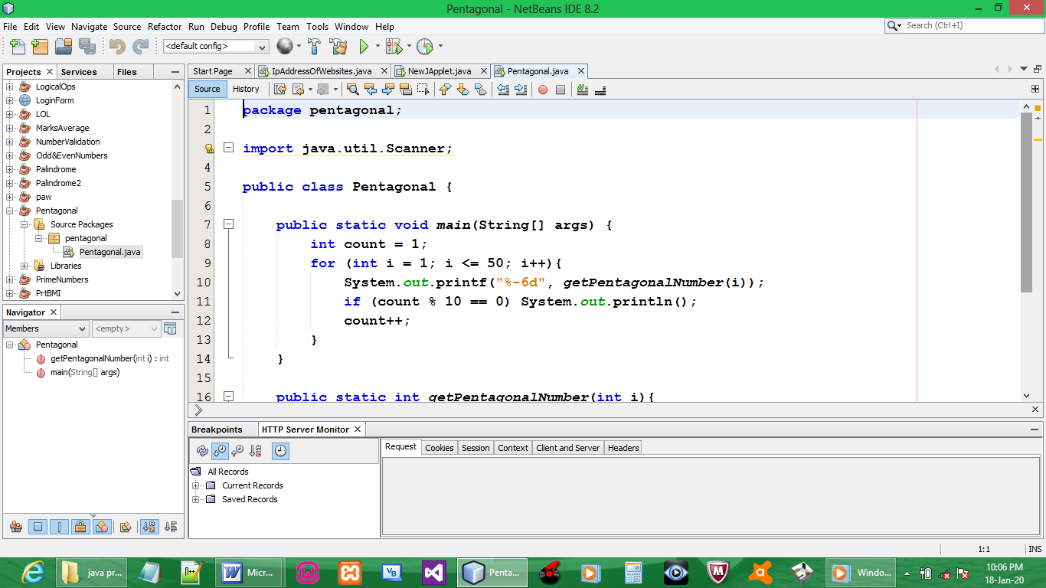

CODE:

package pentagonal;

import java.util.Scanner;

public class Pentagonal {

public static void main(String[] args) {
int count = 1;
for (int i = 1; i <= 50; i++){
System.out.printf("%-6d", getPentagonalNumber(i));
if (count % 10 == 0) System.out.println();
count++;
}
}

public static int getPentagonalNumber(int i){
return (i * (3 * i - 1))/2;
}
}

OUTPUT:

