CREATE JAVA WEB APPLICATION

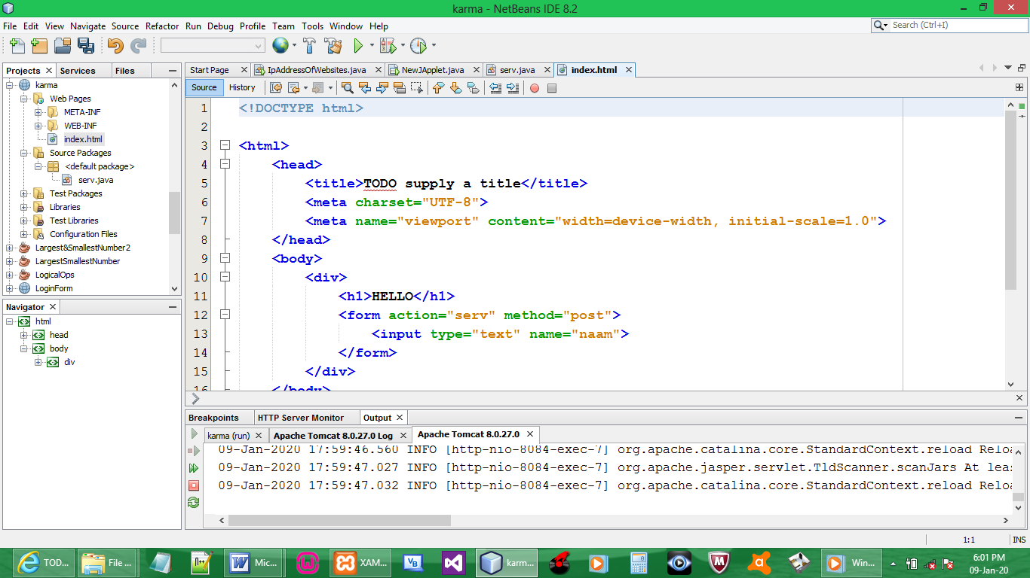

CODE:

<!DOCTYPE html>

<html>
<head>
<title>TODO supply a title</title>
<meta charset="UTF-8">
<meta name="viewport" content="width=device-width, initial-scale=1.0">
</head>
<body>
<div>
<h1>HELLO</h1>
<form action="serv" method="post">
<input type="text" name="naam">
</form>
</div>
</body>
</html>

CREATE SERVLET

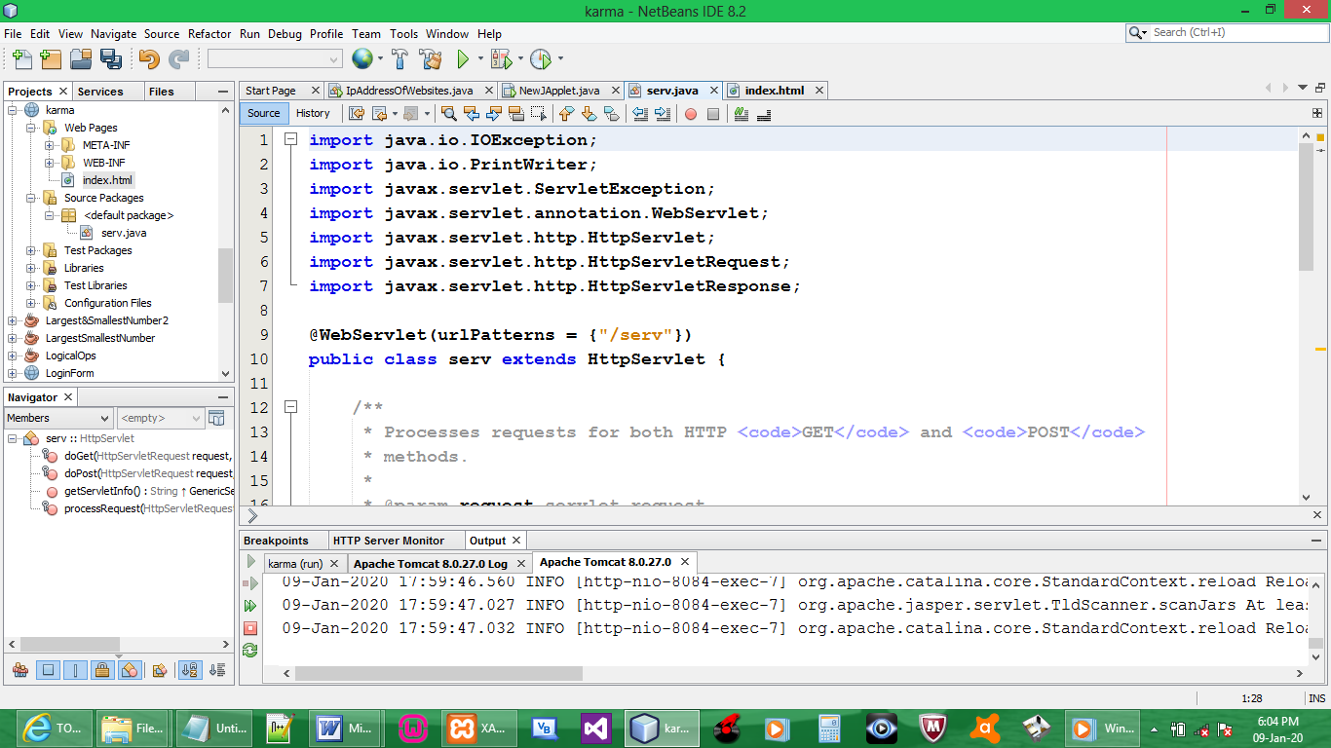

CODE:

import java.io.IOException;
import java.io.PrintWriter;
import javax.servlet.ServletException;
import javax.servlet.annotation.WebServlet;
import javax.servlet.http.HttpServlet;
import javax.servlet.http.HttpServletRequest;
import javax.servlet.http.HttpServletResponse;

@WebServlet(urlPatterns = {"/serv"})
public class serv extends HttpServlet {

protected void processRequest(HttpServletRequest request, HttpServletResponse response)
throws ServletException, IOException {
response.setContentType("text/html;charset=UTF-8");
try (PrintWriter out = response.getWriter()) {
String k;
k = request.getParameter("naam").toString();
out.println("welcome " + k);
}

catch (Exception e){

}
}
}

OUTPUT:

