

*Oral Pathology Tutor Management System*

*Team Members: Jingrong Liu; Yiyuan Xie; Xiangyu Ding; Zhaoxuan Ren*

*Client: Dr. Elizabeth Bilodeau from the School of Dental Medicine Collabotated with SIS Prof. Babichenko*

*Instructor: Peter Brusilovsky*

**I. Overview**

“Dental Game” is a website interactive system that allows students and scholars in University of Pittsburgh Medicine School to review their knowledge in a relaxed and pleasant way. The specific method is to choose the correct match between four image options and technical term, and according to the different levels of users, "Dental Game" is divided into three levels.

In this semester, we chose to develop “Dental Game” as mentioned before to be our final project of the interactive system design, through communication with the client, our group chose to increase the login interface and question management interface for this system. After about a month of cooperation, we have now completed the client's demand for the project. In the future, we will continue to improve our current interactive system..

This report is organized as follows: The instruction of the system is introduced in section II. The good features of our system is presented in section III and we list our improvement based on what we have done in this. In section IV generated our user study report. Acknowledgement included in section V. And the last part VI is our task division.

**II. System Instruction**

In the main question list page, users can view question lists from 3 different levels and deactivated questions by clicking on different tabs. You can add a new question by simply clicking on the “Add a new question” button.

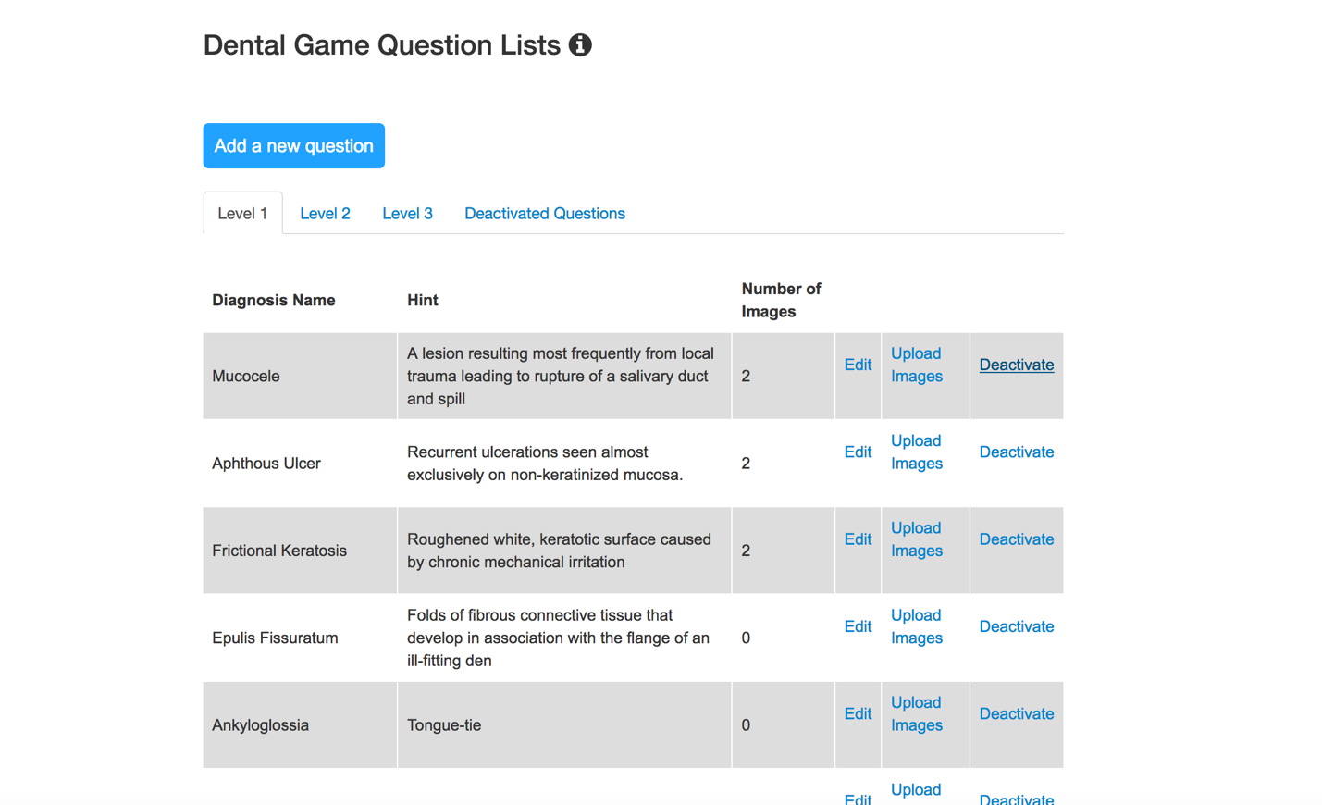

**1. Adding new questions**

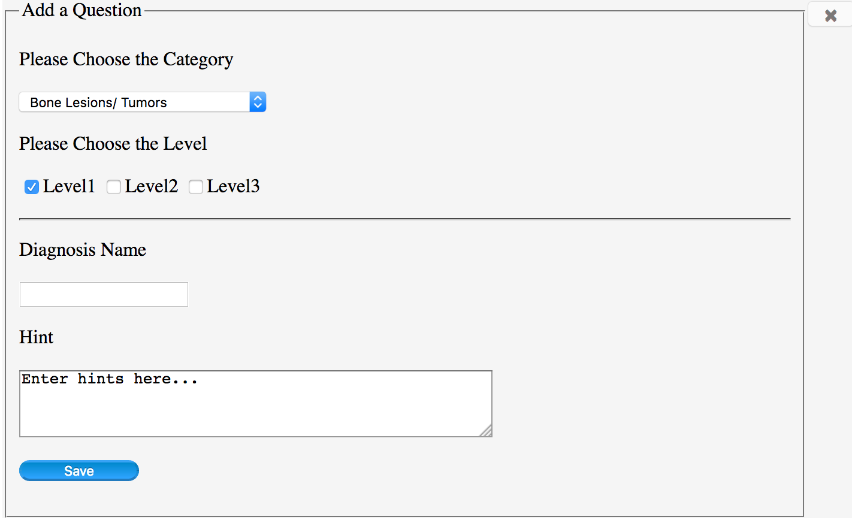

Users can choose a category, levels which the added question belongs to, users can also input a diagnosis name and the hint.

1. The default value of category Bone Lesions/Tumors and the default value of Level is level 1.

2. Users cannot leave the diagnosis name field empty.

3. Users cannot input a diagnosis name that already exists.

4. Hint field can be empty, and users can edit the hint later.

5. By clicking the “Save” button, users can submit a new question.

6. By clicking the “x” button in the top right of the form, users can back to question lists.

After save the basic information of the question, users can upload an image.

The requirements of the image include:

1. Users cannot upload same images repeatedly.

2. Users cannot upload images that are too large;

3. Users can only upload JPG, JPEG, PNG & GIF files.

After users upload an image, they can choose to back to question lists or add another image.

Any updated would show in the question list page.

**2. Edit questions**

Users can edit questions by clicking the “edit” after each question.

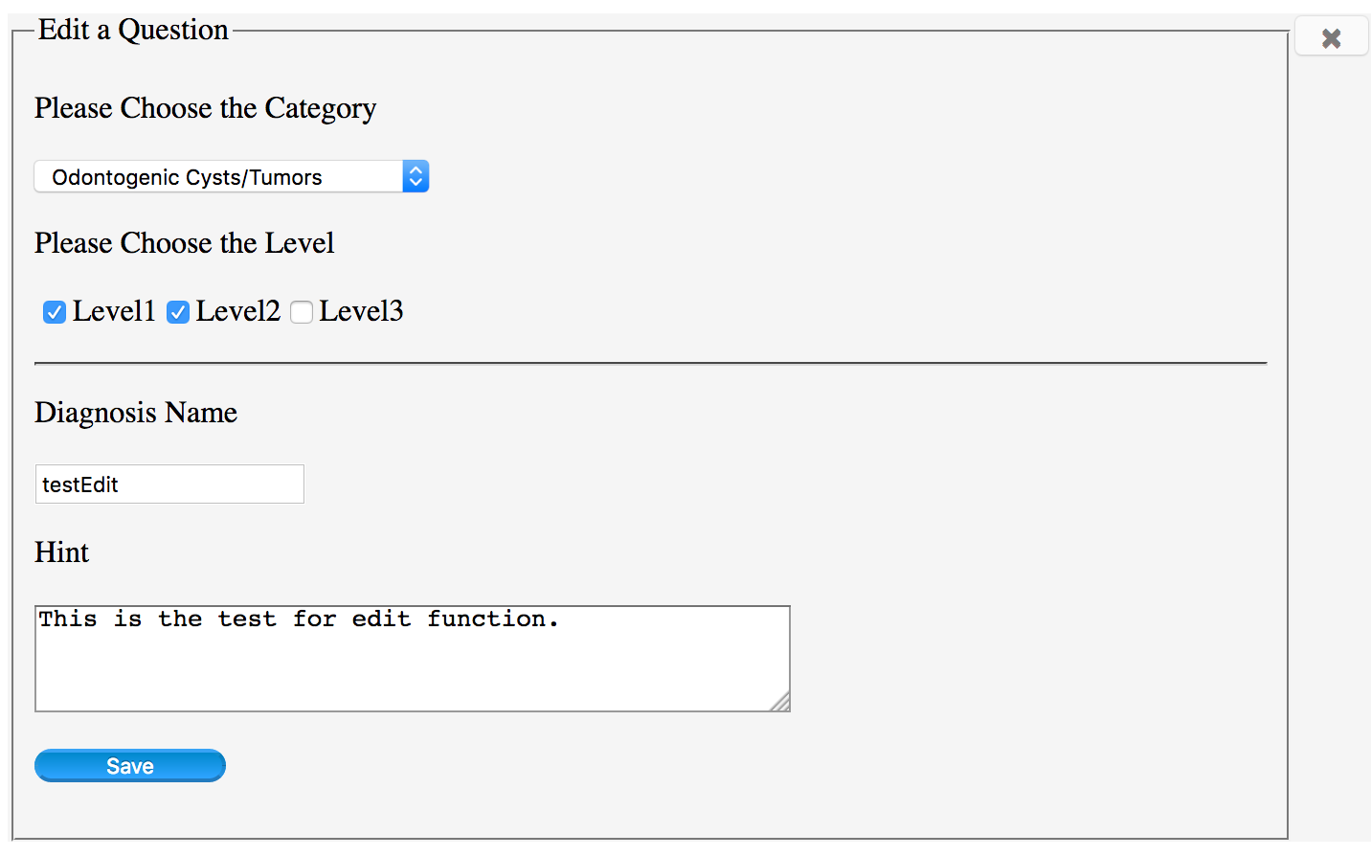

Users can edit category, levels, diagnosis name, and hint of the selected question.

1. The default values would be the original information of the selected question.

2. Users cannot leave the diagnosis name field empty.

3. Users cannot input a diagnosis name that already exists except that the selected diagnosis name keeps unchanged.

4. By clicking the “Save” button, users can update their edits.

5. By clicking the “x” button in the top right of the form, users can back to question lists.

**3. Upload images**

Users can also upload new images through the link after each question, other operations would be the same with the image uploading when adding a new question.

**4. Deactivate questions**

Questions would not be really deleted, by simply clicking the “Deactivate” after each question, the question would be deactivated and it would be moved to the deactivated question list.

**5. Activate questions**

Questions could be activated again by simply clicking the “Activate” link. Reactivated questions would show in the level lists again.

**III. Good features and Improvements**

**Good features**

We will update the current status information (Success or Failure)

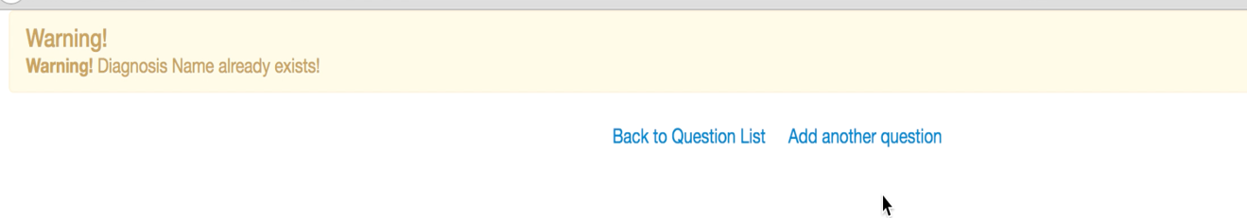

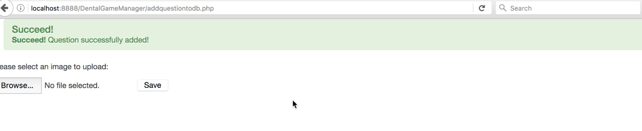

Can go back to main page via “x” button



We provide clearly error message for users which enable them to understand why they uploaded failed, as well as how to operate correctly.

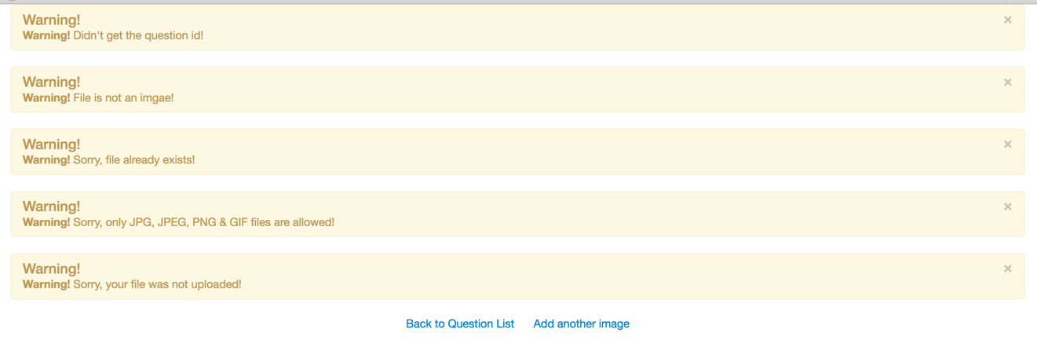We set default value in advance and do not allow users input null value



We use reasonable layout to store questions data, users can find what they need easily.

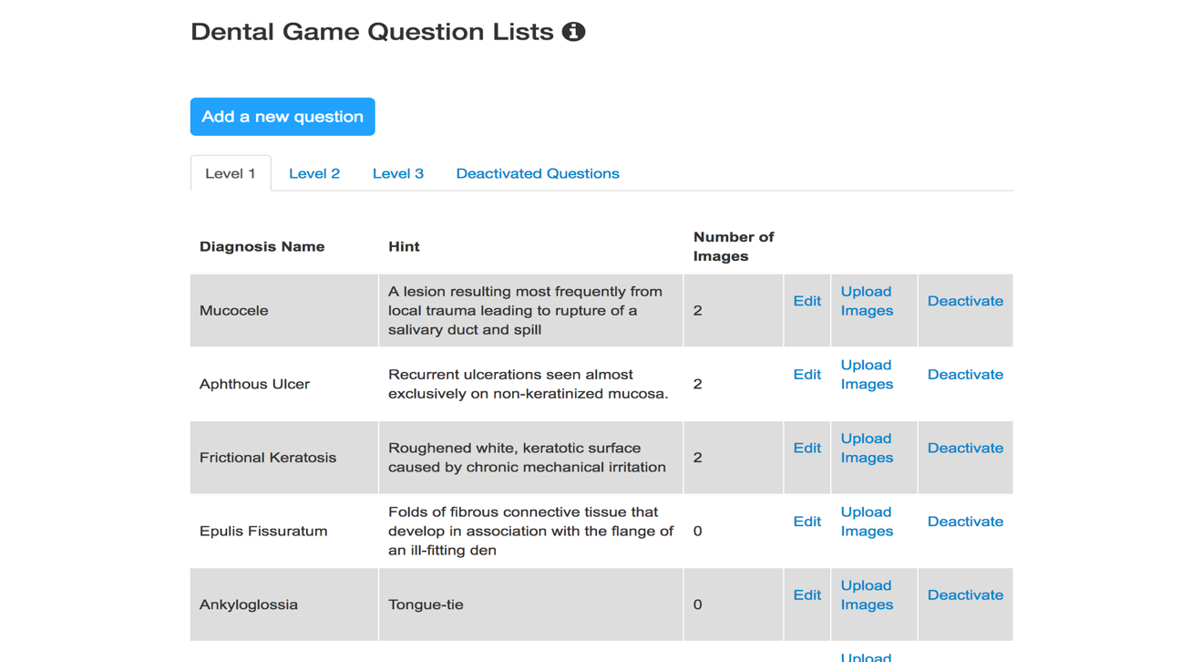

**Improvements**

1. We have improved the original level question from accordion form to tabbed label

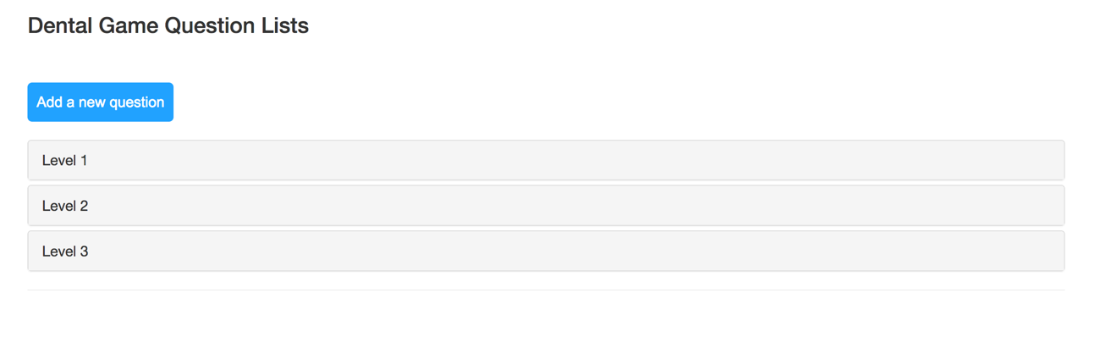

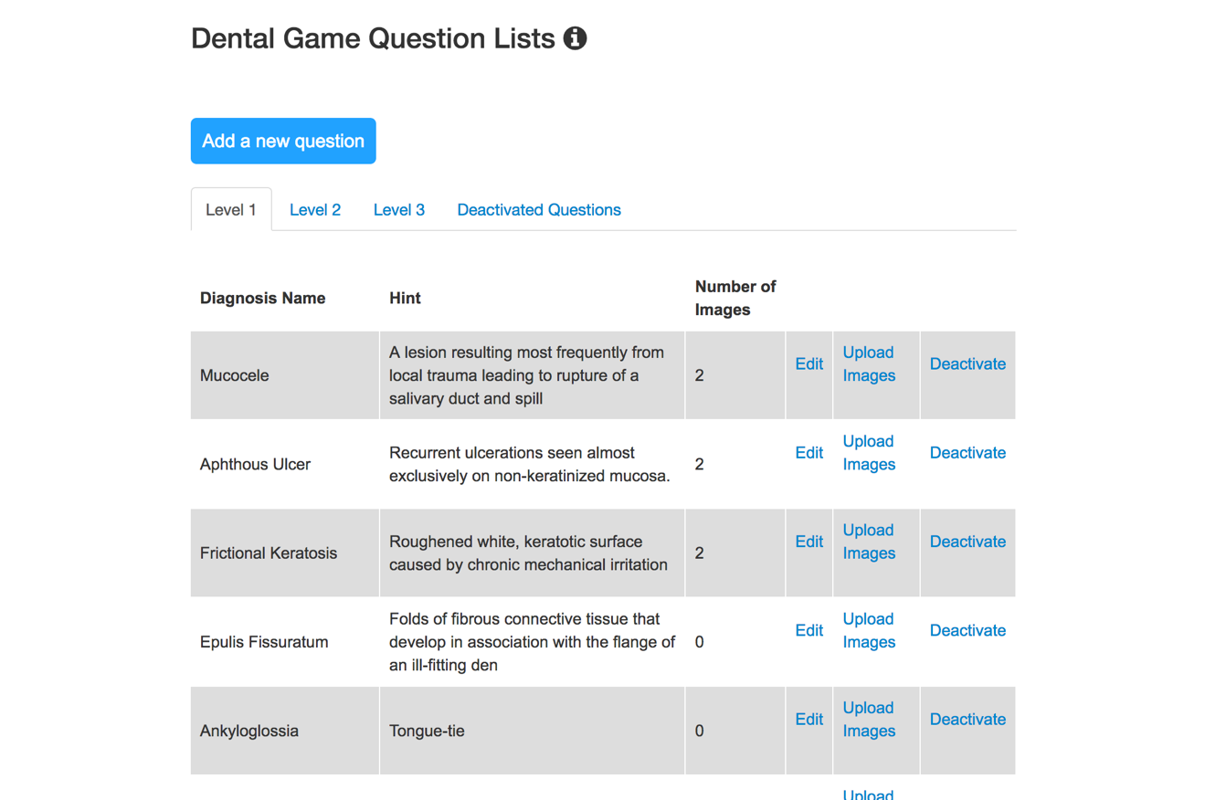

1. We have improved the questions modify approach from “button”to “link”

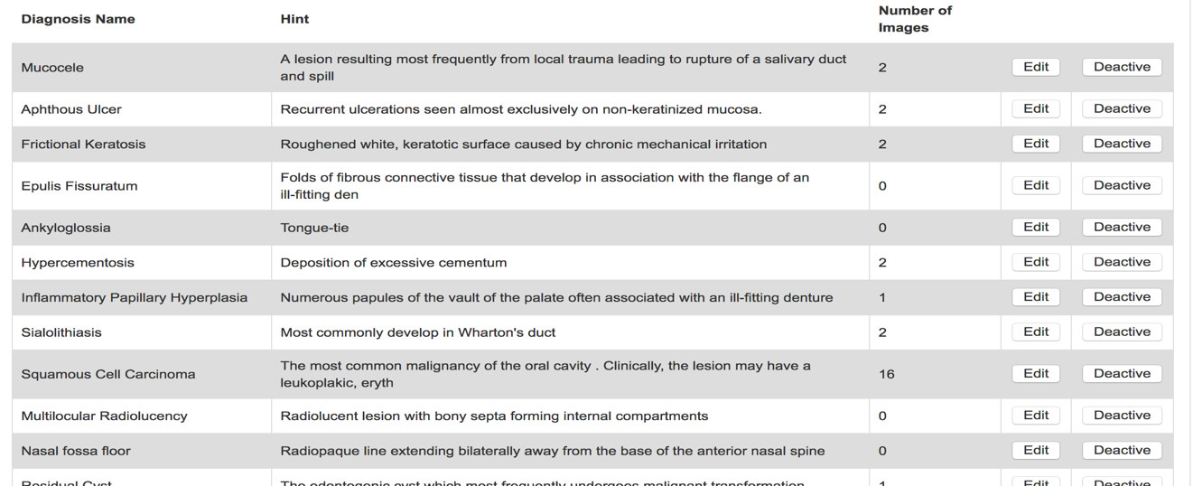

1. We have improved the multiple choice of question levels

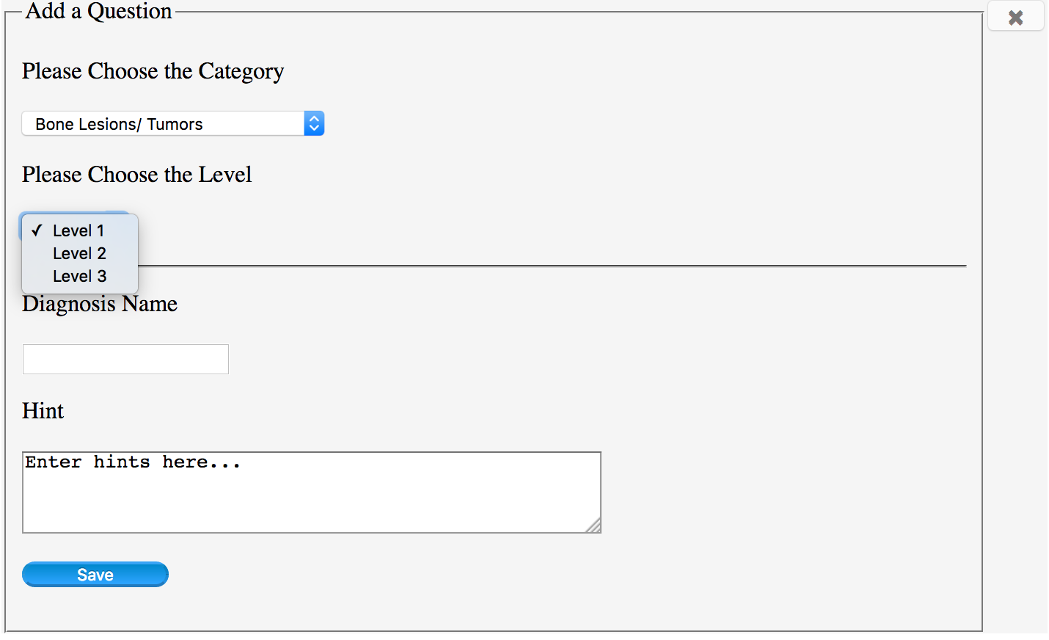

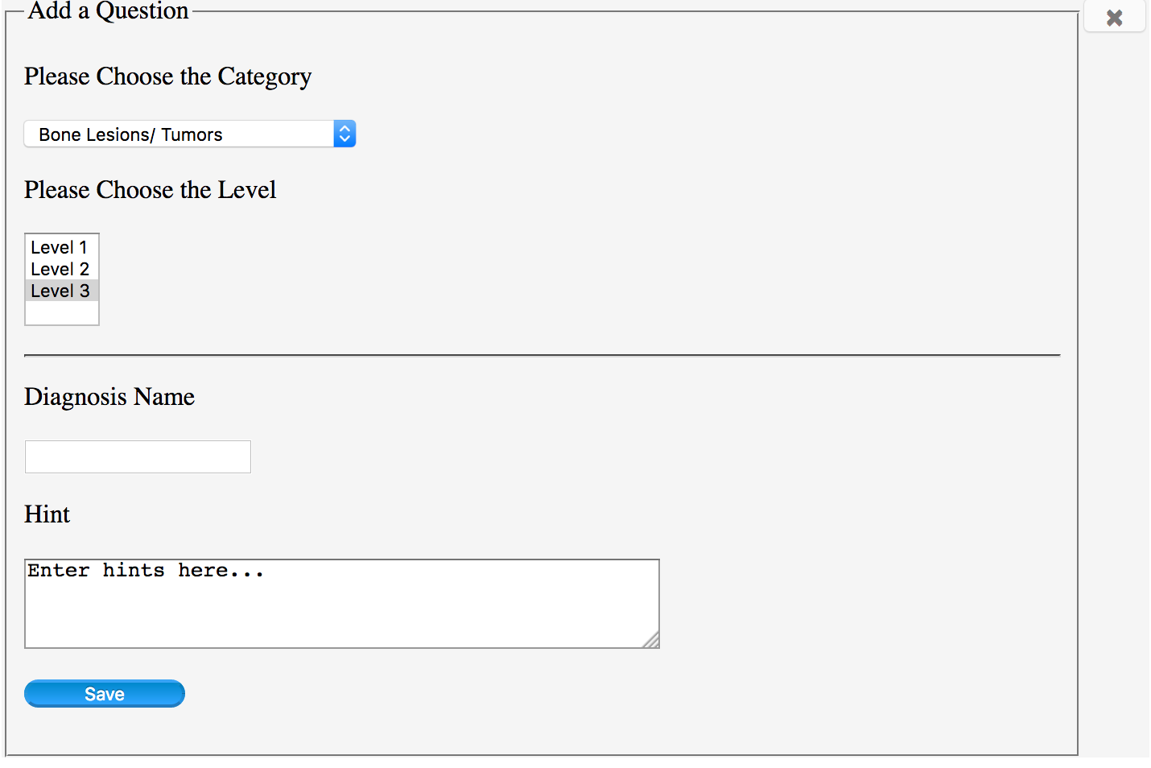



1. We have added “help”icon which enable to exhibite users instruction



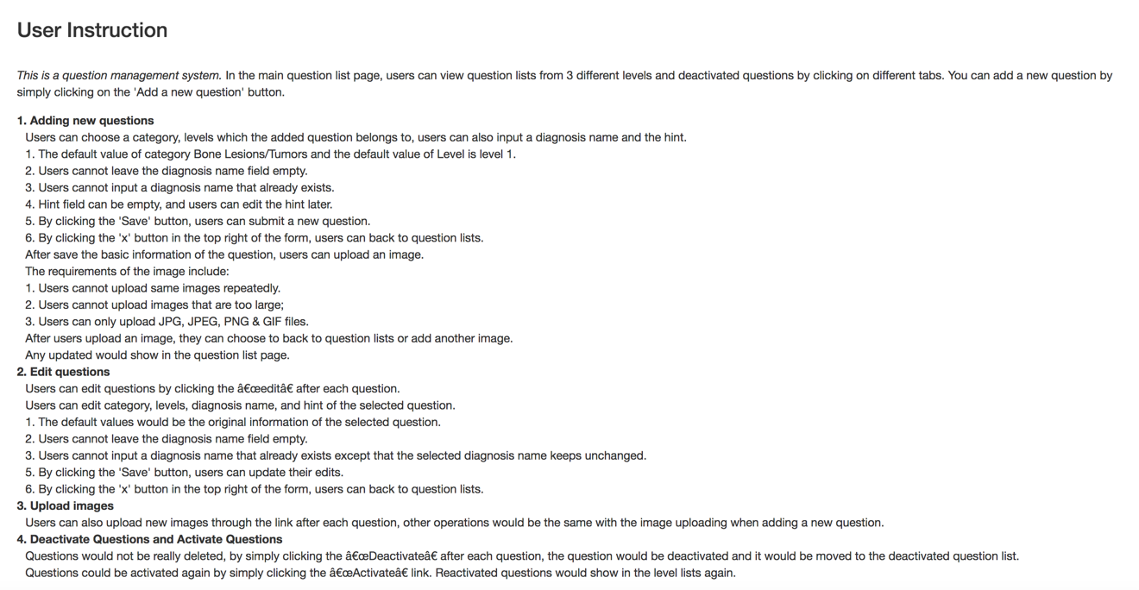

1. We have improved the information display function (Good error messages)
2. We have added upload links behind every questions, so users can always upload images whenever they want
3. We have improved default values and null values which make sure users input values
4. Question list can automatically sorted according to levels

**IV. User Study**

The purpose of this exploratory study is to get feedback of the system from potential users. The points we are focusing on are basically the functions our clients required. Each interviewee will be given a brief introduction of the whole system, then they will be required to use the system to complete some tasks in order to test the whole system. The tasks cover all the functions the client required. The interviewee will be required to complete a question list. After that, an interview according to the question list will be conducted.

**Introduction to the Interviewee:**

This system is designed to achieve the requirement of dental school of the University of Pittsburgh. In this project, we are aiming to design a system which can provide online quiz of identifying images of different categories of diseases. The client asks for a question management system which is able to upload new question and related images. The question list which the interview is required to complete is shown as below.

|  |  |  |  |  |  |  |
| --- | --- | --- | --- | --- | --- | --- |
| Background knowledge part | | | | | | |
| 1. Before I use this, I have worked with other database management system | | | | | | |
| A. Yes, actually I do it often | | B. Not often | | | C.Not at all | |
| 2. I have medical education background | | | | | | |
| A. Yes | |  | | | B. No | |
| Log in system part | | | | | | |
| 3. The log in interface has obvious instructions of account number and password input | | | | | | |
| A. Yes | | B. Neutral | | | C. No | |
| 4. A hint will show up to avoid users doing operations designer does not want them to do | | | | | | |
| A. Yes | | B. I can still make some unpredictable tricks | | | C. There is no hint | |
| Management interface part | | | | | | |
| 5. The visual nature of the system helped me to understand the functions of it | | | | | | |
| A.Strongly agree | B. Agree | | C. Neutral | C. Disagree | | D.against at all |
| 6. The interactive nature of this system helps me to learn | | | | | | |
| A.Strongly agree | B. Agree | | C. Neutral | C. Disagree | | D.against at all |
| 7. I can find multiple methods of upload images | | | | | | |
| A.Strongly agree | B. Agree | | C. Neutral | C. Disagree | | D.against at all |
| 8. A help button is shown in case of potential error | | | | | | |
| A.Strongly agree | B. Agree | | C. Neutral | C. Disagree | | D.against at all |
| 9. The interface is simple and minimize users’ memory load | | | | | | |
| A.Strongly agree | B. Agree | | C. Neutral | C. Disagree | | D.against at all |

Interviewee A

First one:

|  |  |  |  |  |  |  |
| --- | --- | --- | --- | --- | --- | --- |
| Background knowledge part | | | | | | |
| 1. Before I use this, I have worked with other database management system | | | | | | |
| A. Yes, actually I do it often | | **B. Not often** | | | C.Not at all | |
| 2. I have medical education background | | | | | | |
| A. Yes | |  | | | **B. No** | |
| Log in system part | | | | | | |
| 3. The log in interface has obvious instructions of account number and password input | | | | | | |
| **A. Yes** | | B. Neutral | | | C. No | |
| 4. A hint will show up to avoid users doing operations designer does not want them to do | | | | | | |
| A. Yes | | **B. I can still make some unpredictable tricks** | | | C. There is no hint | |
| Management interface part | | | | | | |
| 5. The visual nature of the system helped me to understand the functions of it | | | | | | |
| A.Strongly agree | **B. Agree** | | C. Neutral | C. Disagree | | D.against at all |
| 6. The interactive nature of this system helps me to learn | | | | | | |
| A.Strongly agree | B. Agree | | **C. Neutral** | C. Disagree | | D.against at all |
| 7. I can find multiple methods of upload images | | | | | | |
| A.Strongly agree | B. Agree | | C. Neutral | **C. Disagree** | | D.against at all |
| 8. A help button is shown in case of potential error | | | | | | |
| A.Strongly agree | B. Agree | | C. Neutral | **C. Disagree** | | D.against at all |
| 9. The interface is simple and minimize users’ memory load | | | | | | |
| A.Strongly agree | B. Agree | | **C. Neutral** | C. Disagree | | D.against at all |

Part of the records of explanations in the interview:

Q: Since you mentioned that you can still find some errors in question 4, we’d like to know if there are some BUGs we ignored before.

A: Sure! In the uploading part, I find that I can upload images and their related questions with the same name.

Q: Well, that was a mistake. We will focus on it and solve this problem. And could you explain about your choice of question 6 and 9?

A: I suggest that you can set some obvious warning when users make mistake, and show them why and how to prevent it. Also, some hints are preferred after a user uploaded an image to inform him/her that the operation is successful.

New version:

|  |  |  |  |  |  |  |
| --- | --- | --- | --- | --- | --- | --- |
| Log in system part | | | | | | |
| 3. The log in interface has obvious instructions of account number and password input | | | | | | |
| **A. Yes** | | B. Neutral | | | C. No | |
| 4. A hint will show up to avoid users doing operations designer does not want them to do | | | | | | |
| **A. Yes** | | B. I can still make some unpredictable tricks | | | C. There is no hint | |
| Management interface part | | | | | | |
| 5. The visual nature of the system helped me to understand the functions of it | | | | | | |
| A.Strongly agree | **B. Agree** | | C. Neutral | C. Disagree | | D.against at all |
| 6. The interactive nature of this system helps me to learn | | | | | | |
| A.Strongly agree | **B. Agree** | | C. Neutral | C. Disagree | | D.against at all |
| 7. I can find multiple methods of upload images | | | | | | |
| A.Strongly agree | **B. Agree** | | C. Neutral | C. Disagree | | D.against at all |
| 8. A help button is shown in case of potential error | | | | | | |
| A.Strongly agree | **B. Agree** | | C. Neutral | C. Disagree | | D.against at all |
| 9. The interface is simple and minimize users’ memory load | | | | | | |
| A.Strongly agree | B. Agree | | **C. Neutral** | C. Disagree | | D.against at all |

Feedback of the second interview:

A: I still find there are some things which can still be improved. Things will be better if a sorting function is available.

Interviewee B

First one:

|  |  |  |  |  |  |  |
| --- | --- | --- | --- | --- | --- | --- |
| Background knowledge part | | | | | | |
| 1. Before I use this, I have worked with other database management system | | | | | | |
| **A. Yes, actually I do it often** | | B. Not often | | | C.Not at all | |
| 2. I have medical education background | | | | | | |
| A. Yes | |  | | | **B. No** | |
| Log in system part | | | | | | |
| 3. The log in interface has obvious instructions of account number and password input | | | | | | |
| **A. Yes** | | B. Neutral | | | C. No | |
| 4. A hint will show up to avoid users doing operations designer does not want them to do | | | | | | |
| A. Yes | | **B. I can still make some unpredictable tricks** | | | C. There is no hint | |
| Management interface part | | | | | | |
| 5. The visual nature of the system helped me to understand the functions of it | | | | | | |
| A.Strongly agree | **B. Agree** | | C. Neutral | C. Disagree | | D.against at all |
| 6. The interactive nature of this system helps me to learn | | | | | | |
| A.Strongly agree | B. Agree | | **C. Neutral** | C. Disagree | | D.against at all |
| 7. I can find multiple methods of upload images | | | | | | |
| A.Strongly agree | B. Agree | | C. Neutral | **C. Disagree** | | D.against at all |
| 8. A help button is shown in case of potential error | | | | | | |
| A.Strongly agree | B. Agree | | **C. Neutral** | C. Disagree | | D.against at all |
| 9. The interface is simple and minimize users’ memory load | | | | | | |
| A.Strongly agree | B. Agree | | C. Neutral | **C. Disagree** | | D.against at all |

Part of the records of explanations in the interview:

Q: Could you explain about your choice of question 6 and 7?

A: In my opinion, the system should support multiple way of uploading picture. Not only showing buttons in different ways, but also with different meaning. (Pardon please?) I mean, you can upload images at the beginning of the uploading, or you can upload them when you check the interface. By the way, the two versions you displayed before, I love the second one( tabled level).

New version:

|  |  |  |  |  |  |  |
| --- | --- | --- | --- | --- | --- | --- |
| Log in system part | | | | | | |
| 3. The log in interface has obvious instructions of account number and password input | | | | | | |
| **A. Yes** | | B. Neutral | | | C. No | |
| 4. A hint will show up to avoid users doing operations designer does not want them to do | | | | | | |
| **A. Yes** | | B. I can still make some unpredictable tricks | | | C. There is no hint | |
| Management interface part | | | | | | |
| 5. The visual nature of the system helped me to understand the functions of it | | | | | | |
| A.Strongly agree | **B. Agree** | | C. Neutral | C. Disagree | | D.against at all |
| 6. The interactive nature of this system helps me to learn | | | | | | |
| A.Strongly agree | **B. Agree** | | C. Neutral | C. Disagree | | D.against at all |
| 7. I can find multiple methods of upload images | | | | | | |
| A.Strongly agree | **B. Agree** | | C. Neutral | C. Disagree | | D.against at all |
| 8. A help button is shown in case of potential error | | | | | | |
| A.Strongly agree | **B. Agree** | | C. Neutral | C. Disagree | | D.against at all |
| 9. The interface is simple and minimize users’ memory load | | | | | | |
| A.Strongly agree | B. Agree | | **C. Neutral** | C. Disagree | | D.against at all |

Feedback of the second interview:

A: Great! If you add some functions like turning pages when questions are too many, that will be perfect.

**V. Acknowledgement**

Thanks to Professor Dmitriy for presenting the initial system interface and question database through GitHub, as well as a weekly communication with us on the project process and where improvements are needed. Thanks to Professor Peter for the relevant expertise taught in this course, and the advice provided in our first presentation, so that we can logically improve the system. Thank each team member in this project to pay and effort. In the future, we will continue to improve our “Dental Game” question management system to improve the user experience.

**VI. Task Division**

Jinrong Liu: Responsible for the realization of the system function and the instruction of question management system.

Xiangyu Ding: Responsible for providing Heuristic evaluation analysis and improvement advice, as well as the writing of the report.

Yiyuan Xie: Responsible for user study and related conclusions as well as file generated.

Zhaoxuan Ren: Responsible for the function revise and system integrated as well as final report generated.