**Oral Pathology Tutor Management System**

Jinrong Liu, Xiangyu Ding, Yiyuan Xie, Zhaoxuan Ren

**#Overview**

The index file is **Homepage.html**.

You could login as a student or an admin.

If you log in as student, you would be navigated too the real Oral Pathology Tutor.

If you log in as admin, you would be able to see the question lists.

In question list page, you could add a question, edit a question, upload new images, deactivate questions, and activate questions.

**#Database Modification**

The database we used in this project was copied from the original database, we did not change any table names or attributes.

The connect database function is in **functions.php**.

The database information (host, username, password, and database name) is in the “**config.php**”, by modifying the variables in this file and the Project URL in Run Configuration, the project should also work.

Tables that this project would access or modify include table **categories**, table **questions**, table **questions_images**, and table **questions_levels**. We also created a new table called “**Manager**”, which was used to store the information of managers.

**#Project Structure**

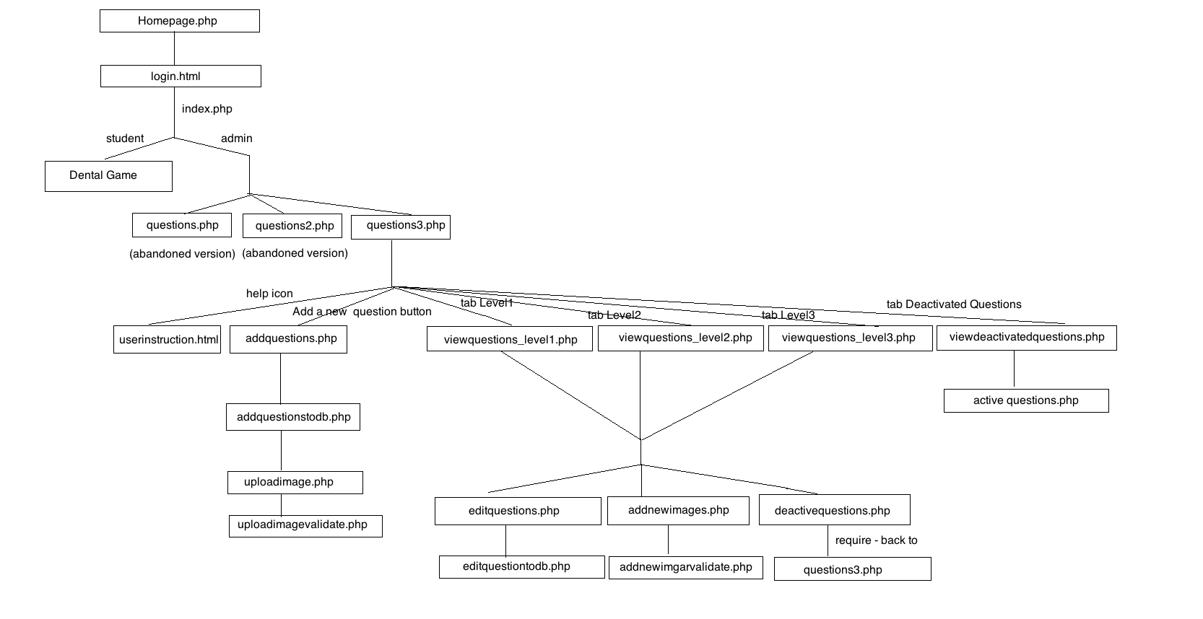

**#To be implemented**

1. Function “Forget Password” – findpswd.html

2. Attempted to merge three view questions functions to only one – viewquestions.php instead of viewquestions_level1.php + viewquestions_level2.php + viewquestions_level3.php.

3. Files can be deleted and would not influence the functions of the project – viewquestions_lebel1_2.php, questions.php, and questions2.php.