**DAY 4 - SELENIUM WEBDRIVER**

**TASK 1:**

**OUTPUT:**

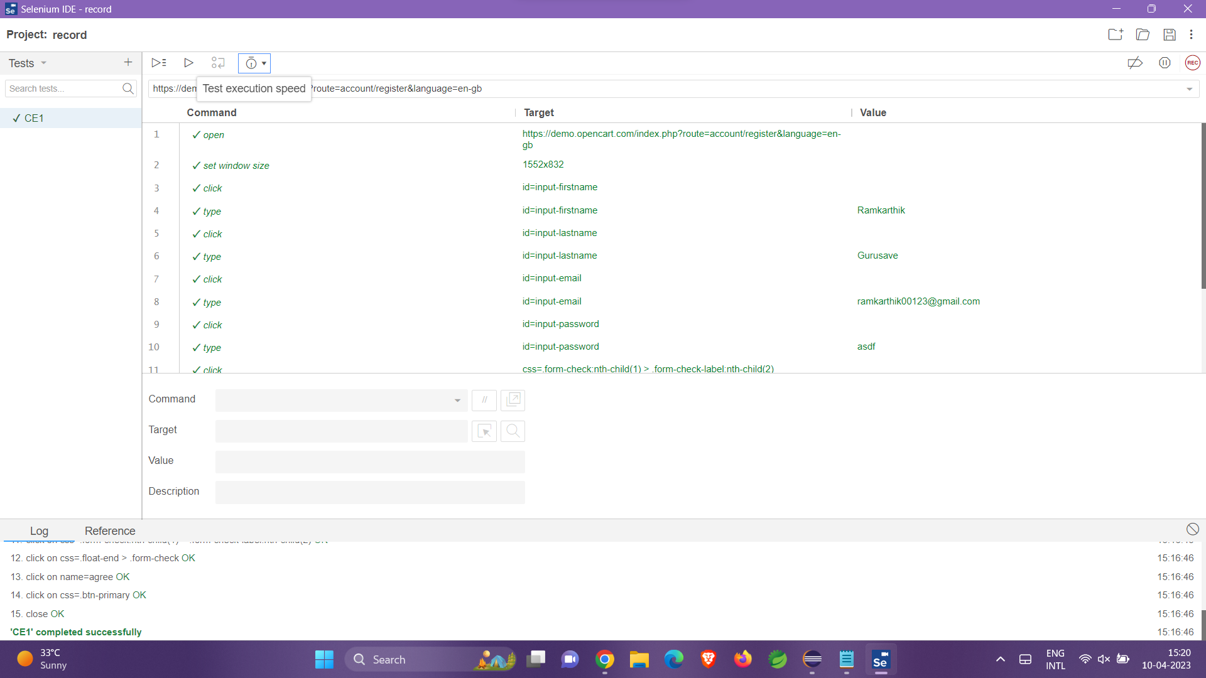

**TASK 2:**

**CODE:**

package pracWebElement;

import org.openqa.selenium.By;

import org.openqa.selenium.Keys;

import org.openqa.selenium.WebDriver;

import org.openqa.selenium.WebElement;

import org.openqa.selenium.chrome.ChromeDriver;

import org.openqa.selenium.chrome.ChromeOptions;

import io.github.bonigarcia.wdm.WebDriverManager;

public class ClassExercise1 {

public static void main(String[] args)

{

WebDriverManager.chromedriver().setup();

WebDriver driver;

ChromeOptions co=new ChromeOptions();

co.addArguments("--remote-allow-origins=*");

driver=new ChromeDriver(co);

driver.navigate().to("https://demo.opencart.com/index.php?route=account/register&language=en-gb");

WebElement firstname=driver.findElement(By.id("input-firstname"));

firstname.sendKeys("Malavika");

WebElement lastname=driver.findElement(By.id("input-lastname"));

lastname.sendKeys("R");

WebElement email=driver.findElement(By.id("input-email"));

email.sendKeys("abc@gmail.com");

WebElement pwd=driver.findElement(By.id("input-password"));

pwd.sendKeys("12345");

WebElement yesbutton=driver.findElement(By.id("input-newsletter-yes"));

yesbutton.click();

}

}

**OUTPUT:**

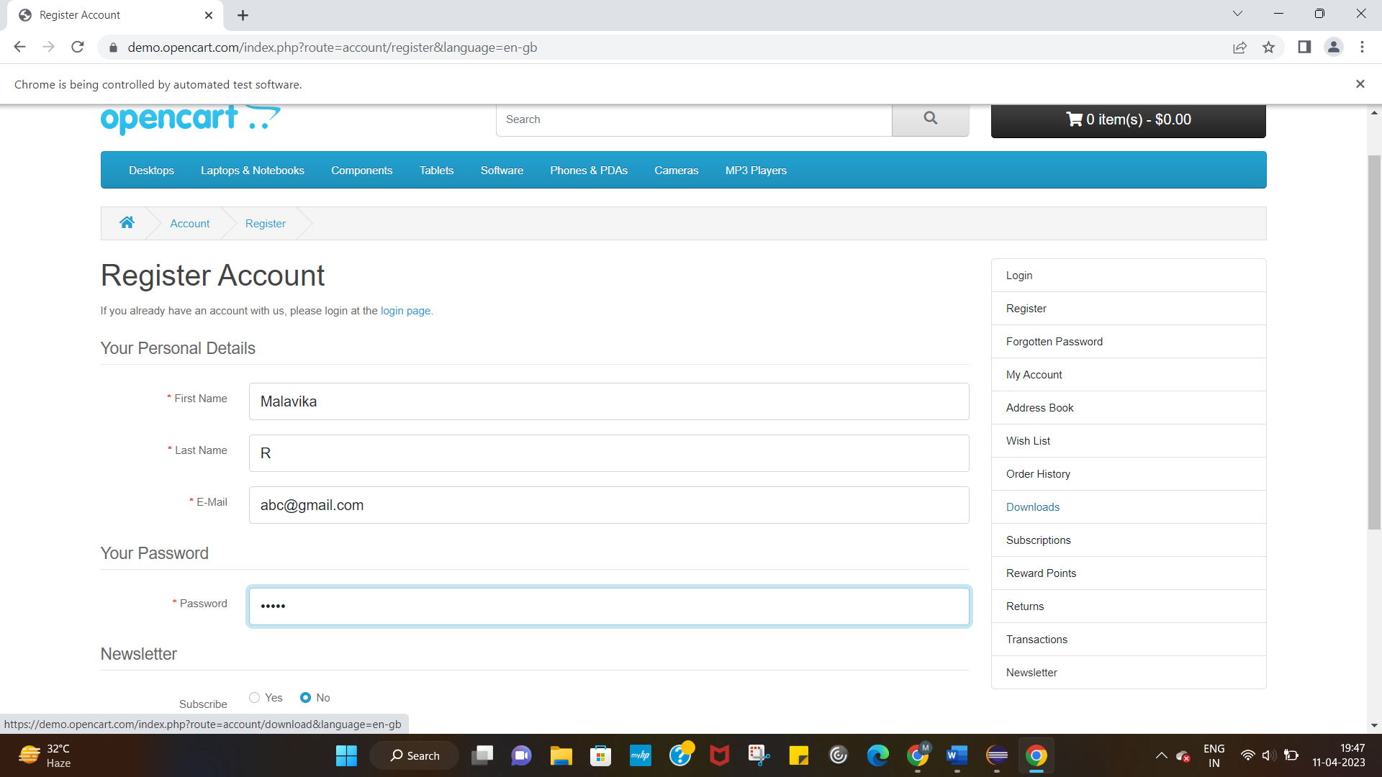

**TASK 3:**

**CODE:**

package pracWebElement;

import org.openqa.selenium.By;

import org.openqa.selenium.WebDriver;

import org.openqa.selenium.WebElement;

import org.openqa.selenium.chrome.ChromeDriver;

import org.openqa.selenium.chrome.ChromeOptions;

import io.github.bonigarcia.wdm.WebDriverManager;

public class ClassExercise3{

public static void main(String[] args) {

WebDriverManager.chromedriver().setup();

WebDriver driver;

ChromeOptions co=new ChromeOptions();

co.addArguments("--remote-allow-origins=*");

driver=new ChromeDriver(co);

driver.get("https://demo.opencart.com/index.php?route=checkout/voucher&language=en-gb");

WebElement name=driver.findElement(By.xpath("//*[@id=\"input-to-name\"]"));

name.sendKeys("Malavika");

WebElement email=driver.findElement(By.xpath("//*[@id=\"input-to-email\"]"));

email.sendKeys("727721euit084@gmail.com");

WebElement yname=driver.findElement(By.xpath("//*[@id=\"input-from-name\"]"));

yname.sendKeys("Malavika");

WebElement yemail=driver.findElement(By.xpath("//*[@id=\"input-from-email\"]"));

yemail.sendKeys("ma30@gmail.com");

WebElement bday=driver.findElement(By.xpath("//*[@id=\"input-theme-7\"]"));

bday.click();

//*[@id="input-message"]

WebElement mess=driver.findElement(By.xpath("//*[@id=\"input-message\"]"));

mess.sendKeys("Hello");

WebElement iun=driver.findElement(By.xpath("//*[@name=\"agree\"]"));

iun.click();

WebElement sub=driver.findElement(By.xpath("//*[@id=\"form-voucher\"]/div[8]/div/button"));

sub.click();

}

}

**OUTPUT:**

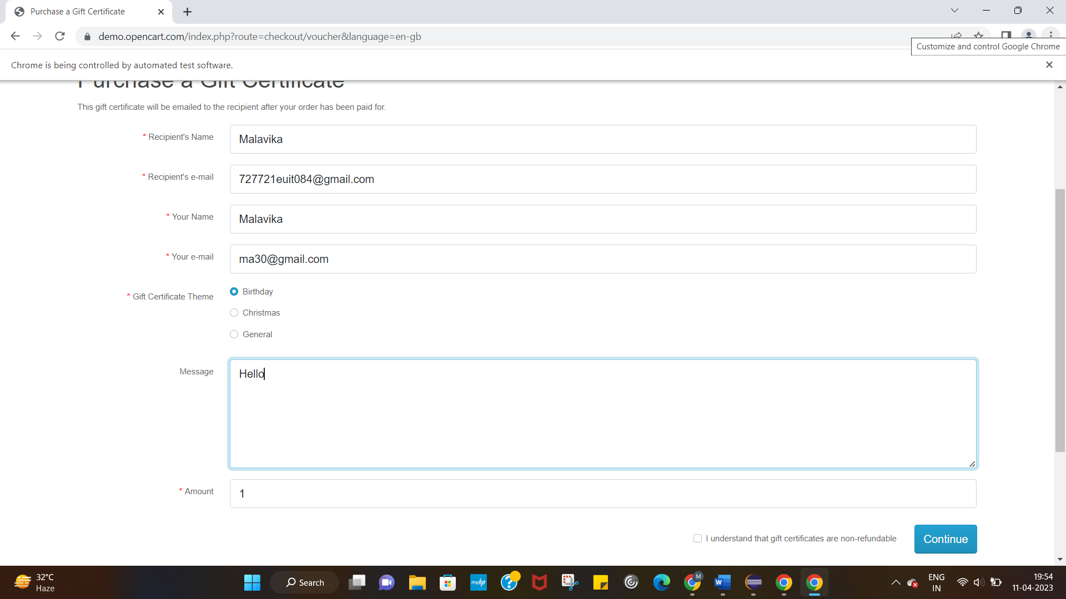

**TASK 4:**

**CODE:**

package pracWebElement;

import org.openqa.selenium.By;

import org.openqa.selenium.WebDriver;

import org.openqa.selenium.WebElement;

import org.openqa.selenium.chrome.ChromeDriver;

import org.openqa.selenium.chrome.ChromeOptions;

import io.github.bonigarcia.wdm.WebDriverManager;

public class classexercise4{

public static void main(String[] args) {

WebDriverManager.chromedriver().setup();

WebDriver driver;

ChromeOptions co=new ChromeOptions();

co.addArguments("--remote-allow-origins=*");

driver=new ChromeDriver(co);

driver.navigate().to("https://j2store.net/free/");

driver.manage().window().maximize();

WebElement bday=driver.findElement(By.xpath("//*[@id=\"Mod112\"]/div/div/ul/li[1]/h4/a"));

bday.click();

driver.navigate().back();

driver.navigate().forward();

driver.navigate().refresh();

driver.close();

}

}

**TASK 5.1:**

**CODE:**

package pracWebElement;

import org.openqa.selenium.By;

import org.openqa.selenium.WebDriver;

import org.openqa.selenium.WebElement;

import org.openqa.selenium.chrome.ChromeDriver;

import org.openqa.selenium.chrome.ChromeOptions;

import io.github.bonigarcia.wdm.WebDriverManager;

public class classexercise5{

public static void main(String[] args) {

WebDriverManager.chromedriver().setup();

WebDriver driver;

ChromeOptions co=new ChromeOptions();

co.addArguments("--remote-allow-origins=*");

driver=new ChromeDriver(co);

driver.navigate().to("https://j2store.net/free/");

String strUrl=driver.getCurrentUrl();

if(strUrl.contains("https://j2store.net/free/")){

WebElement bday=driver.findElement(By.xpath("//*[@id=\"Mod112\"]/div/div/ul/li[1]/h4/a"));

bday.click();

String getUrl=driver.getCurrentUrl();

if(getUrl.contains("https://j2store.net/free/index.php/shop?filter_catid=11")) {

}

}

}

}

**TASK 5.2:**

**CODE:**

package pracWebElement;

import java.util.List;

import org.openqa.selenium.By;

import org.openqa.selenium.JavascriptExecutor;

import org.openqa.selenium.WebDriver;

import org.openqa.selenium.WebElement;

import org.openqa.selenium.chrome.ChromeDriver;

import org.openqa.selenium.chrome.ChromeOptions;

import io.github.bonigarcia.wdm.WebDriverManager;

public class classexercise5_2{

public static void main(String[] args) throws InterruptedException {

// TODO Auto-generated method stub

WebDriverManager.chromedriver().setup();

ChromeOptions co=new ChromeOptions();

co.addArguments("--remote-allow-origins=*");

WebDriver driver=new ChromeDriver(co);

//open link and maximize

driver.get("https://j2store.net/free/");

driver.manage().window().maximize();

JavascriptExecutor js=(JavascriptExecutor) driver;

js.executeScript("window.scrollBy(0,1000)","");

driver.findElement(By.linkText("Clothing (5)")).click();

Thread.sleep(5000);

List<WebElement> l1=driver.findElements(By.xpath("//h2[@class='product-title']"));

for(WebElement link:l1)

{

System.out.println(link.getText());

}

}

}

**OUTPUT:**

