**DAY 5 – SELENIUM WEBHANDLERS**

**TASK 1:**

**CODE:**

package Day5;

import org.openqa.selenium.By;

import org.openqa.selenium.WebDriver;

import org.openqa.selenium.WebElement;

import org.openqa.selenium.chrome.ChromeDriver;

import org.openqa.selenium.chrome.ChromeOptions;

import org.openqa.selenium.interactions.Actions;

import io.github.bonigarcia.wdm.WebDriverManager;

public class classexercise_1 {

public static void main(String[] args) {

WebDriverManager.chromedriver().setup();

WebDriver driver;

ChromeOptions co=new ChromeOptions();

co.addArguments("--remote-allow-origins=*");

driver=new ChromeDriver(co);

driver.navigate().to("https://demoqa.com/droppable/");

WebElement drag1=driver.findElement(By.id("draggable"));

WebElement drop1=driver.findElement(By.id("droppable"));

Actions act=new Actions(driver);

act.dragAndDrop(drag1, drop1).build().perform();

}

}

**OUTPUT:**

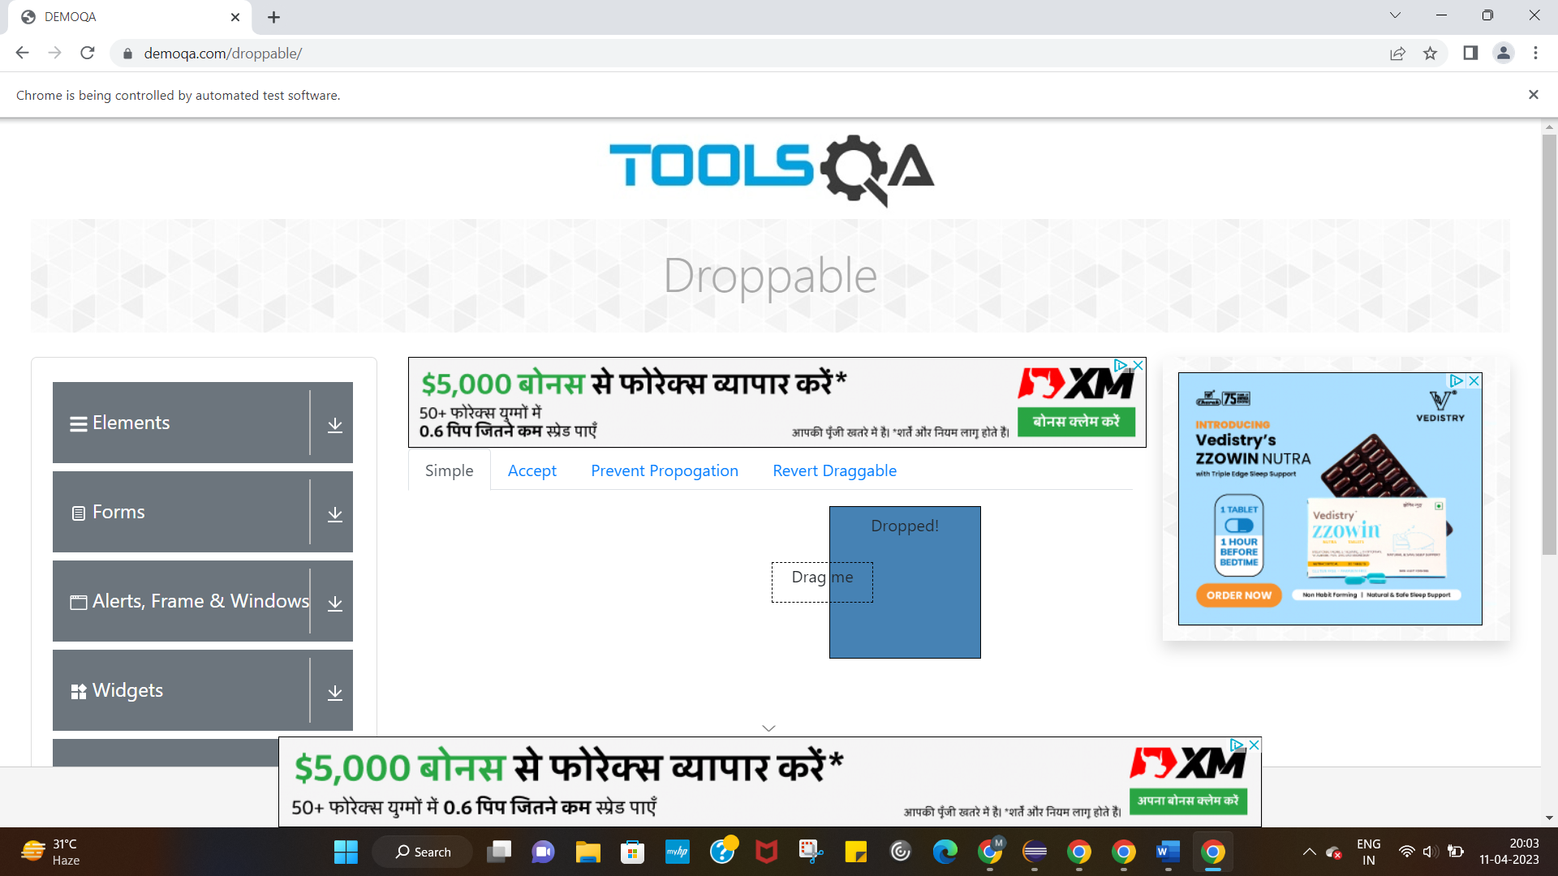

**TASK 2:**

**CODE:**

package Day5;

import org.openqa.selenium.By;

import org.openqa.selenium.WebDriver;

import org.openqa.selenium.WebElement;

import org.openqa.selenium.chrome.ChromeDriver;

import org.openqa.selenium.chrome.ChromeOptions;

import org.openqa.selenium.interactions.Actions;

import io.github.bonigarcia.wdm.WebDriverManager;

public class classexercise_2 {

public static void main(String[] args) {

WebDriverManager.chromedriver().setup();

WebDriver driver;

ChromeOptions co=new ChromeOptions();

co.addArguments("--remote-allow-origins=*");

driver=new ChromeDriver(co);

driver.navigate().to("https://jqueryui.com/droppable/");

driver.switchTo().frame(0);

WebElement drag1=driver.findElement(By.id("draggable"));

WebElement drop1=driver.findElement(By.id("droppable"));

Actions act=new Actions(driver);

act.dragAndDrop(drag1, drop1).build().perform();

driver.switchTo().defaultContent();

}

}

**OUTPUT:**

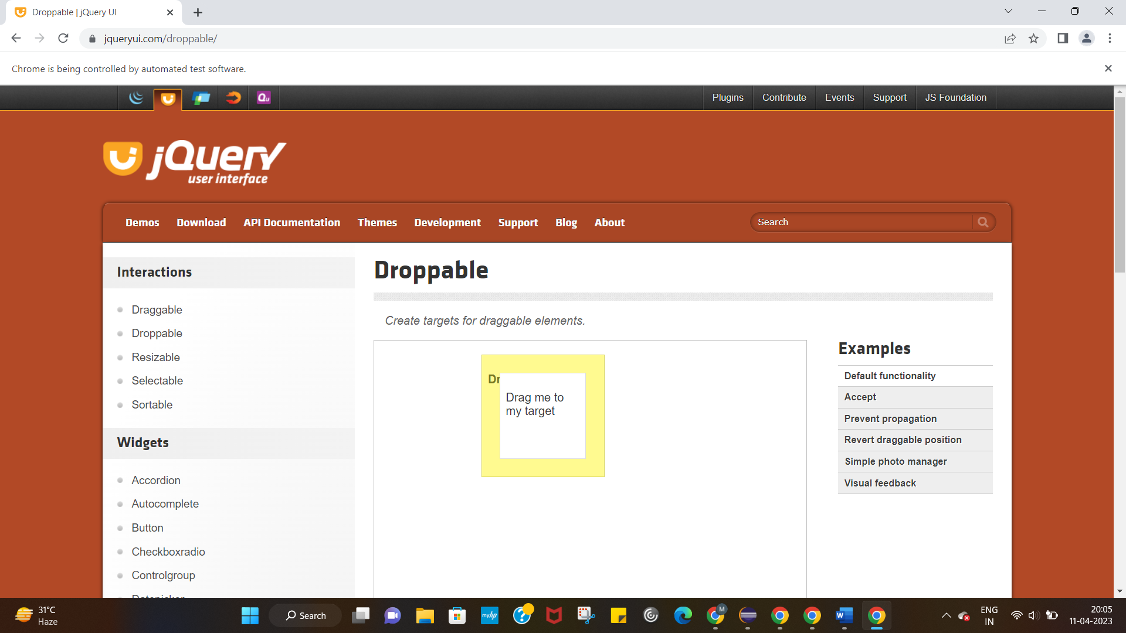

**TASK 3:**

**CODE:**

package Day5;

import org.openqa.selenium.Alert;

import org.openqa.selenium.By;

import org.openqa.selenium.WebDriver;

import org.openqa.selenium.WebElement;

import org.openqa.selenium.chrome.ChromeDriver;

import org.openqa.selenium.chrome.ChromeOptions;

import io.github.bonigarcia.wdm.WebDriverManager;

public class classexercise_3 {

public static void main(String[] args) throws InterruptedException {

WebDriverManager.chromedriver().setup();

WebDriver driver;

ChromeOptions co=new ChromeOptions();

co.addArguments("--remote-allow-origins=*");

driver=new ChromeDriver(co);

driver.navigate().to("https://demo.guru99.com/test/delete_customer.php");

driver.manage().window().maximize();

WebElement search=driver.findElement(By.name("cusid"));

search.sendKeys("401");

WebElement sub=driver.findElement(By.name("submit"));

sub.click();

Alert alert1=driver.switchTo().alert();

Thread.sleep(3000);

alert1.dismiss();

search.clear();

search.sendKeys("402");

sub.click();

Alert alert2=driver.switchTo().alert();

alert2.accept();

Alert alert3=driver.switchTo().alert();

String txt=alert3.getText();

alert3.accept();

System.out.println(txt);

}

}

**OUTPUT:**

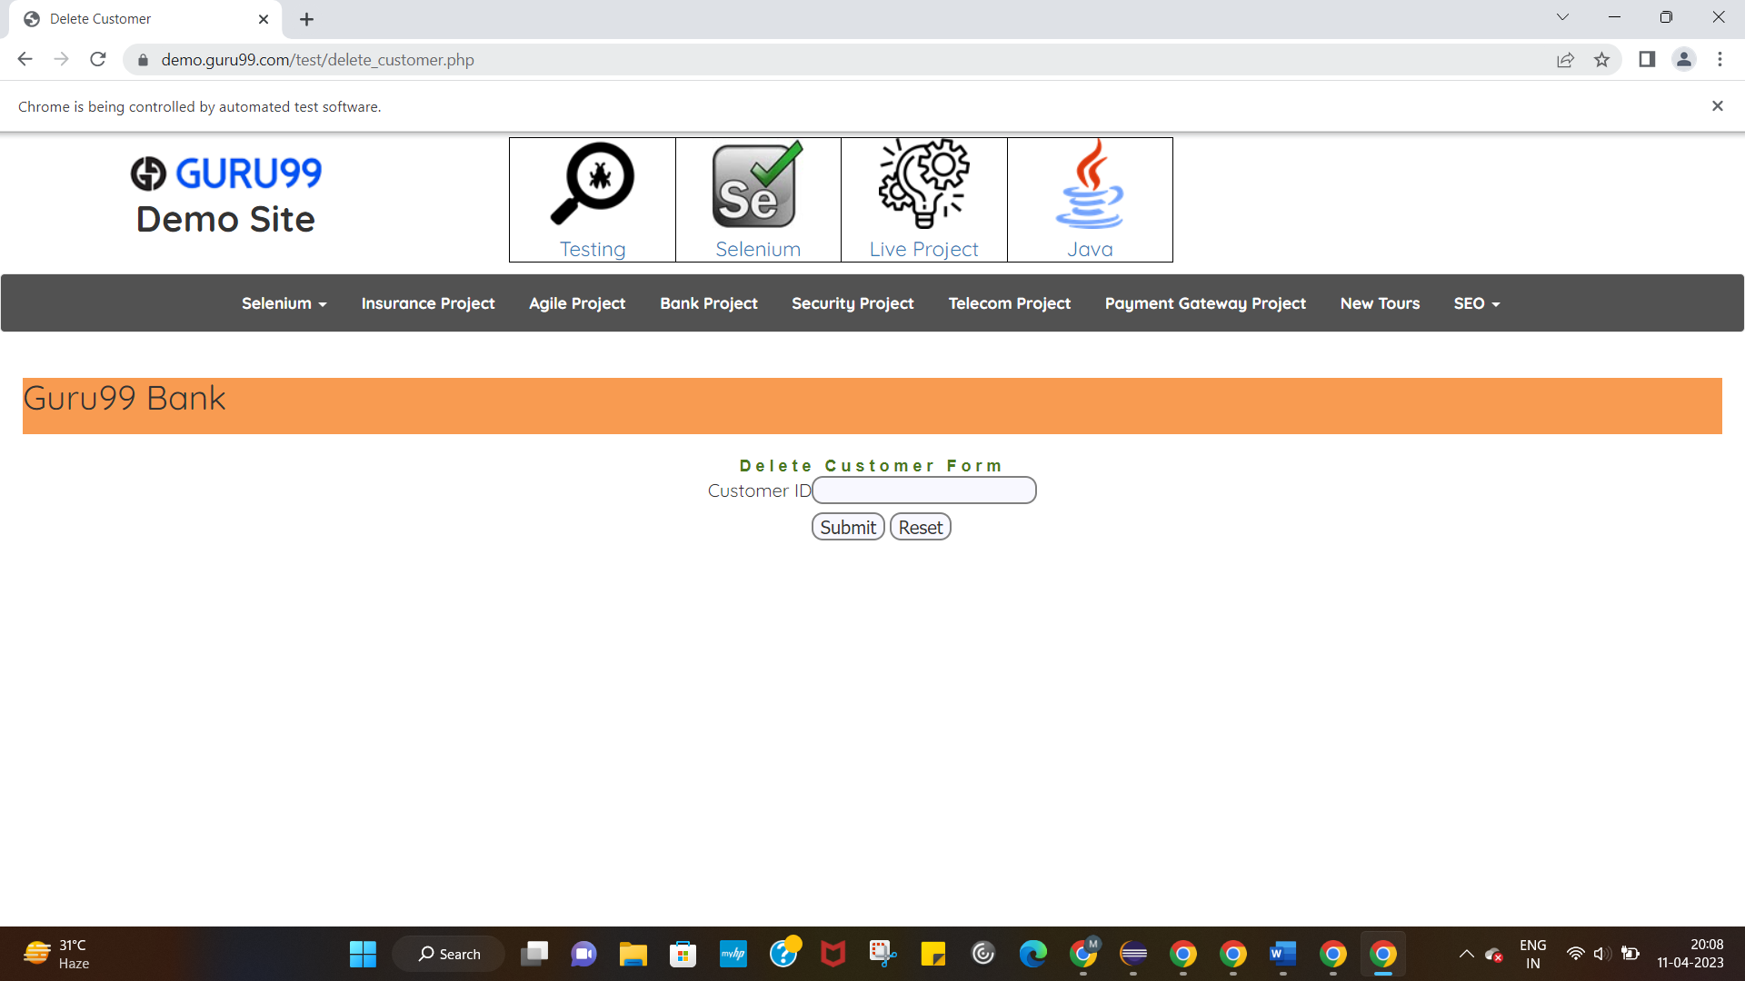

**TASK 4:**

**CODE:**

package Day5;

import org.openqa.selenium.By;

import org.openqa.selenium.JavascriptExecutor;

import org.openqa.selenium.Keys;

import org.openqa.selenium.WebDriver;

import org.openqa.selenium.WebElement;

import org.openqa.selenium.chrome.ChromeDriver;

import org.openqa.selenium.chrome.ChromeOptions;

import io.github.bonigarcia.wdm.WebDriverManager;

public class classexercise_4 {

public static void main(String[] args) throws InterruptedException {

WebDriverManager.chromedriver().setup();

WebDriver driver;

ChromeOptions co=new ChromeOptions();

co.addArguments("--remote-allow-origins=*");

driver=new ChromeDriver(co);

driver.navigate().to("https://www.abhibus.com/bus-ticket-booking");

WebElement leavedes=driver.findElement(By.xpath("//*[@id=\"source\"]"));

leavedes.sendKeys("Coimbatore",Keys.ENTER);

WebElement godes=driver.findElement(By.xpath("//*[@id=\"destination\"]"));

godes.sendKeys("Mumbai",Keys.ENTER);

WebElement datepicker=driver.findElement(By.xpath("//*[@id=\"datepicker1\"]"));

JavascriptExecutor js=(JavascriptExecutor) driver;

js.executeScript("arguments[0].setAttribute('value','10/05/2023')",datepicker);

}

}

**OUTPUT:**

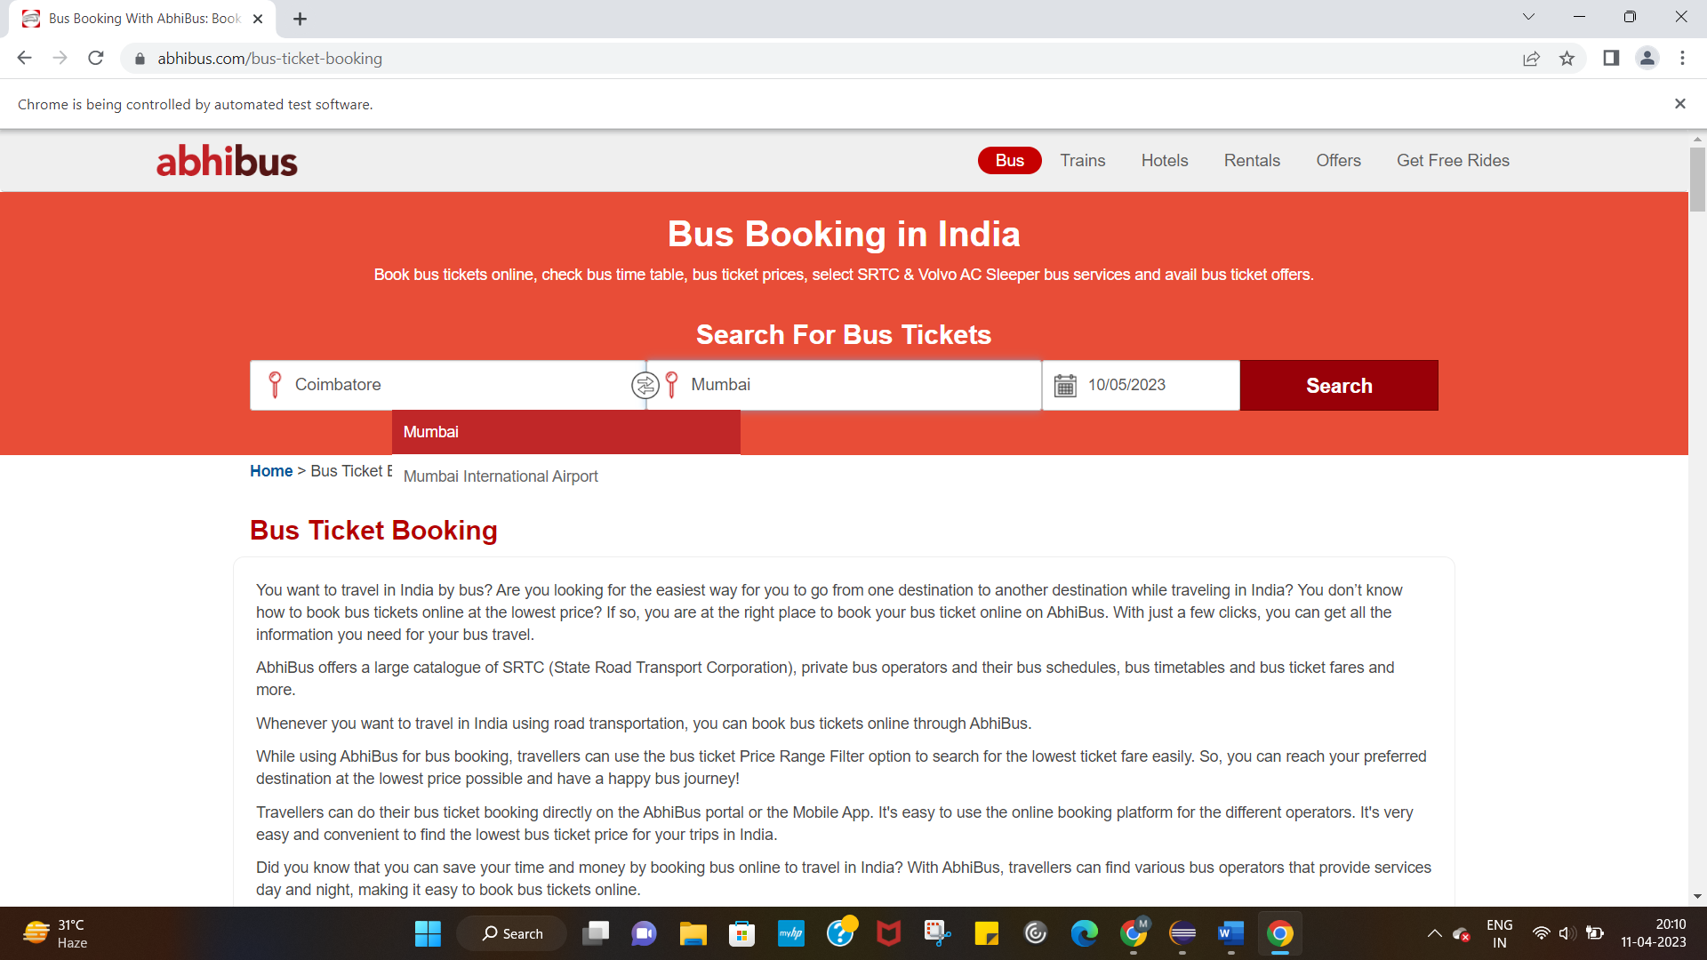

**TASK 5:**

**CODE:**

package Day5;

import java.util.Iterator;

import java.util.Set;

import org.openqa.selenium.By;

import org.openqa.selenium.JavascriptExecutor;

import org.openqa.selenium.Keys;

import org.openqa.selenium.WebDriver;

import org.openqa.selenium.WebElement;

import org.openqa.selenium.WindowType;

import org.openqa.selenium.chrome.ChromeDriver;

import org.openqa.selenium.chrome.ChromeOptions;

import io.github.bonigarcia.wdm.WebDriverManager;

public class classexercise_5 {

public static void main(String[] args) throws InterruptedException {

WebDriverManager.chromedriver().setup();

WebDriver driver;

ChromeOptions co=new ChromeOptions();

co.addArguments("--remote-allow-origins=*");

driver=new ChromeDriver(co);

driver.get("https://www.google.com");

driver.manage().window().maximize();

driver.findElement(By.name("q")).sendKeys("Apple");

driver.findElement(By.name("q")).sendKeys(Keys.ENTER);

String parent=driver.getWindowHandle();

System.out.println(parent);

System.out.println(driver.getTitle());

driver.switchTo().newWindow(WindowType.TAB);

driver.get("https://google.com");

driver.manage().window().maximize();

driver.findElement(By.name("q")).sendKeys("Selinium");

driver.findElement(By.name("q")).sendKeys(Keys.ENTER);

driver.switchTo().newWindow(WindowType.TAB);

driver.get("https://google.com");

driver.manage().window().maximize();

driver.findElement(By.name("q")).sendKeys("Cucumber");

driver.findElement(By.name("q")).sendKeys(Keys.ENTER);

Set<String>s=driver.getWindowHandles();

System.out.println(s.size());

}

}

**OUTPUT:**

