Removed setUser func and student_username var



Removed returnHome var

Added React to the import from ‘react’

Renamed class to className

Added React as an import from ‘react’

Removed peer_review and student_review_count

Removed code that set values to those variables with no other purpose



Removed setUser



Moved key to the highest tag in the map function,  
replaced `’` with &apos;

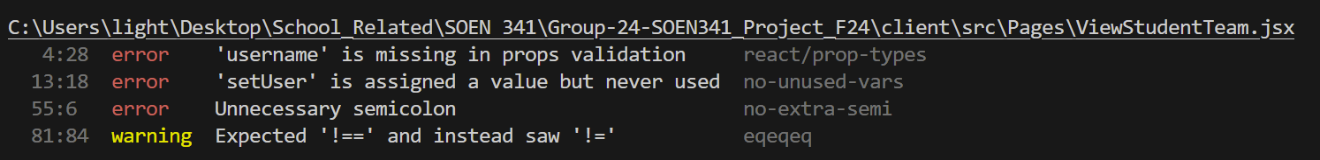

Installed prop-types inside project, defined username prop as string

Removed setUser

Removed ;

Replaced ‘!=’ with ‘!==’

Defined propTypes for TeamDropdown

Added React to import from ‘react’



Put both imported components into SCREAMING_SNAKE_CASE

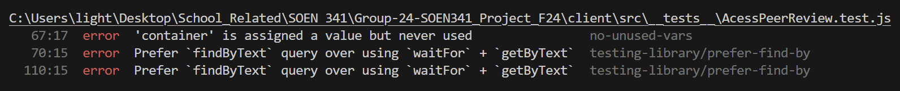

Removed container definition and solely kept render

Replaced await waitFor (() => getByText)  
with, await findByText



Removed waitFor from import



Removed axios from import



Removed act wrapping render func

Removed act from import



Removed replace var definition

Doubled waitFor blocks to accommodate one assertion each



Imported createRoot from ‘react-dom/client’

Removed import ReactDOM

Created a variable to contain the root element

Apply createRoot onto container storing into root variable

Render root with app