Removed setUser func and student_username var



Removed returnHome var

Added React to the import from ‘react’

Renamed class to className

Added React as an import from ‘react’

Removed peer_review and student_review_count

Removed code that set values to those variables with no other purpose



Removed setUser



Moved key to the highest tag in the map function,  
replaced `’` with &apos;

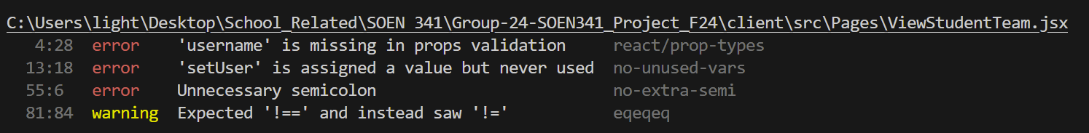

Installed prop-types inside project, defined username prop as string

Removed setUser

Removed ;

Replaced ‘!=’ with ‘!==’

Defined propTypes for TeamDropdown

Added React to import from ‘react’



Put both imported components into SCREAMING_SNAKE_CASE

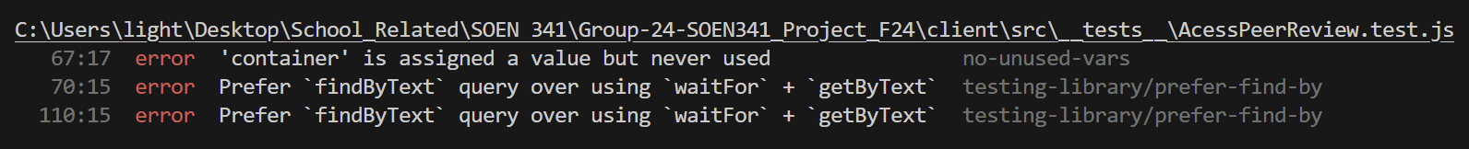

Removed container definition and solely kept render

Replaced await waitFor (() => getByText)  
with, await findByText



Removed waitFor from import



Removed axios from import



Removed act wrapping render func

Removed act from import



Removed replace var definition

Doubled waitFor blocks to accommodate one assertion each



Imported createRoot from ‘react-dom/client’

Removed import ReactDOM

Created a variable to contain the root element

Apply createRoot onto container storing into root variable

Render root with app

STYLELINT:

Applied lower-case to all class names and added a newline between from and to section for app-logo-spin

Removed quotes around font names

I changed the names to ca-label, ca-highlight and ca-button, changing the class names in their respective files

Fix hex color name to the given one

Removed random newline in footer, and deleted global.css

Changed label name recusively, modernised color-function notation, removed empty line

  
removed empty line

Changed class names recursively to kebab-case, fixed color hex code and changed order of selectors

Fix class names in css and jsx

Fix class names, modernise color function, fix hex code

Fix names and hex code

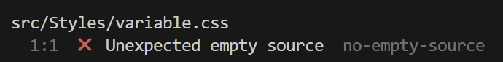

Remove variable.css

Fix class name and modernise color function

Fix class names

Modernise color func

Fix hex code