HARWARE

THE MAIN PCB COMPONENTS ARE AS FOLLOWS:

1. ON/OFF BUTTON – this is a backlit button. Turning on and off the dishwasher.

Recomended parts: [B3W-9002-HG1G](https://www.digikey.com/en/products/detail/omron-electronics-inc-emc-div/B3W-9002-HG1G/1765415)

[TL1240GQ1JCLR](https://www.digikey.com/en/products/detail/e-switch/TL1240GQ1JCLR/1805476)(preferred).

This button will operate as an interrupt button that initiates the on and off process from the micro-controller. Thus, it need not be a high voltage switch.

1. PT100 temperature sensors – one for the tank and one for the boiler.

Recommended parts: (probe type pt is recommended so that the fluid flows all around the sensor allowing more intuitive measurements)

* 3984(pt1000, more precise and higher resolution)
* uxcell PT100 RTD Temperature Sensor Probe 3 Wires Cable Thermocouple Stainless Steel(<https://www.amazon.com/uxcell-Temperature-Sensor-Thermocouple-Stainless/dp/B07PPV7M2S> ) - recommended.

1. The PT100 will be interfaced with the micro controller via the **MAX31865 ic.**  This an amplifier with an integrated signal processor (Wheatstone bridge).
2. Heating elements – single phase element:

* 3.5kW Heating Element 3500w

<https://processheatingservices.com/heating-elements/incoloy-800-heating-elements-for-air-heating-units-pei-range-250w-6kw/pei-range-incoloy-800-heating-elements-3500w-3-5kw/>

* 3phase element: 3 Phase 6kw autoclave boiler heater immersion heating element - ( <https://www.alibaba.com/product-detail/3-Phase-6kw-autoclave-boiler-heater_60703485472.html> )

These elements I connected in a delta configuration as shown below:

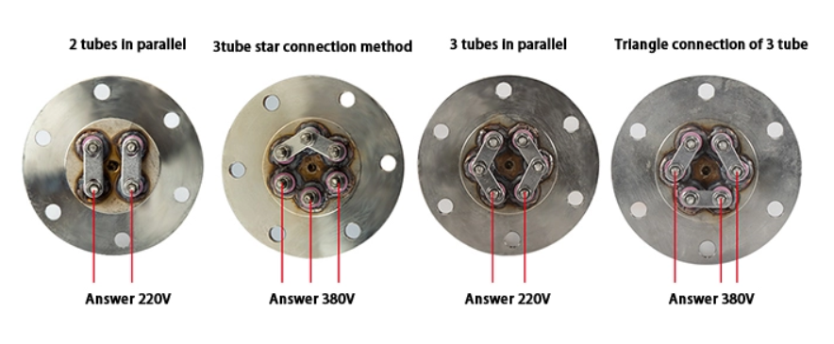

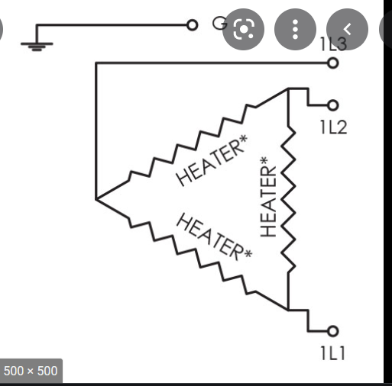

**Single phase and 3 phase control scheme –**

So, we calculate the expected current to flow through the heater element at any given moment.

V=ir and P/V=I, that means that the current for the 3-phase delta connection will be approximately 15A and star connection will be 25A.

We pic a >30A >500 triac to drive the load (this will allow flexibility in connection of the element either in delta or star). Triac will enable PWM regulation of the load and control.

Recommended triacs: [BTA30-600CW3G](https://www.digikey.com/en/products/detail/littelfuse-inc/BTA30-600CW3G/2194618), [Q6035NH5RP](https://www.digikey.com/en/products/detail/littelfuse-inc/Q6035NH5RP/528674) for control of all the elements.

Recommended driver (DIAC) for use with the triac is **MOC3021** .

According to this text for guidance purposes: <https://forum.arduino.cc/t/classic-optocoupler-triac-circuit-for-controlling-an-ac-load-with-arduino/442278>

<https://innovatorsguru.com/switching-ac-load-using-triac/>

<https://www.electronics-tutorials.ws/power/triac.html>

1. Display - for a more professional and easier to use screen a tft/oled screen is recommended. E.g.: 1.5" oled display : <https://learn.adafruit.com/1-5-and-2-4-monochrome-128x64-oled-display-module?view=all>
2. 2 - Peristaltic pump- a 230V pump such as: <https://www.metzger-technik-shop.de/Peristaltic-Pump-SR-25-10mH2O-230V> With a triac and Diac driver used as with the elements which will drive even higher rated pumps with precision. (a flow/detergent sensor to be considered incase the pump is running but the detergent does not reach the intended position or a design consideration in the delivery system to ensure this does not occur).
3. Buttons we will use the common tactile buttons for the set and arrow buttons :K2-1187SQ-D4SW-06
4. Start button: recommended [TL1240RQ1JCLR](https://www.digikey.com/en/products/detail/e-switch/TL1240RQ1JCLR/1805482) illuminated red led.(can change to green to keep the color scheme).
5. Solenoid input valve – using a 230V PLASTIC 230V AC Water Solenoid Valve. <https://www.indiamart.com/proddetail/230v-ac-water-solenoid-valve-20479405062.html>

~~mosfets:~~ [~~SI2302~~](https://www.lcsc.com/product-detail/MOSFETs_Guangdong-Hottech-SI2302_C181087.html)

driver for the solenoid will be a relay: HF46F-G/12-HS1T from LCSC which will be used in conjunction with a mosfets as a low side driver to the coil. mosfets: SI2302

1. Tank level sensor: high level sensor we can use a horizontal float switch – High Precision Side Mount Float Boiler Water Level Sensor link: <https://www.alibaba.com/product-detail/High-Precision-Side-Mount-Float-Boiler_1957259543.html?spm=a2700.details.0.0.3dd24c360m62hz>

Low level sensor we can use the non invasive optical/infrared sensor.( Infrared Water Liquid Tank Optical Level Sensor) link: <https://www.alibaba.com/product-detail/Customized-High-Accuracy-Small-Infrared-Water_1600173646115.html?spm=a2700.7724857.normal_offer.d_image.36fb3fa2imBH3D> Due to the requirement that it be located at a level very close to the bottom plate.

**POWER SUPPLY FOR THE LOW VOLTAGE COMPONENTS**

We will use 12V and then step down to the respective voltages. For the design of a 240-12v stepdown supply we utilize we-bench: link to the design is: <https://webench.ti.com/appinfo/webench/scripts/SDP.cgi?ID=EC37E7BE1641EA3A>

Inpt Ac filter link: <https://electronics.stackexchange.com/questions/374950/how-does-this-line-filter-work>

The supply gives a 12V at 2A(24W). the transformer parts are readily available and can be made.

Link to the parts: <https://product.tdk.com/en/search/ferrite/ferrite/ferrite-acc/info?part_no=B66208X1110T001>

And : <https://www.digikey.com/en/products/detail/epcos-tdk-electronics/B66317G0000X187/3914721>

and the other critical components are available as well for purchase on different sites.

For 5V supply we can utilize a buck converter for efficiency and reduce heat dissipation designs.

Link: <https://webench.ti.com/appinfo/webench/scripts/SDP.cgi?ID=5EE96937B05CB99D>

Main part: TPS563200 available at LCSC.

Magnetic Door Sensor: <https://www.amazon.com/Window-Magnetic-Contact-Detector-Security/dp/B07VQDMFFK>

**MICROCONTROLLER**

The preferred MCU is the ATMEGA2560 mcu from atmel.

An EEPROM will be considered to store the settings if need be to save on space within the flash area of MCU. Eeprom recommended: [BR24G16NUX-3ATTR](https://www.digikey.com/en/products/detail/rohm-semiconductor/BR24G16NUX-3ATTR/4879616)

**For other and pumps (drain and washing):**

Wash pump, drain pump, relay driver will be: HF46F-G/12-HS1T (features: General Purpose 12VDC SPST-NO 7A Non Latching Through Hole Power Relays ROHS). Since they will be run at a constant speed. Just on/off control is needed.

**CONNECTOR SELECTION**

The sensor will be connected via JST connectors to the board (from the field) eg. [B2B-XH-AM(LF)(SN)](https://www.digikey.com/en/products/detail/jst-sales-america-inc/B2B-XH-AM-LF-SN/1016630)

For the high power 400V: [HVH-280-2P-6.5DS](https://www.digikey.com/en/products/detail/hirose-electric-co-ltd/HVH-280-2P-6-5DS/13672050) at 30A and 600V which is effective in our use case

230V heater needs a high voltage high current connector: ATP15-2P-BM01GRY

230V connector to the field actuators we’ll use e.g., pump with lower current needs:

Alternatively, we can use smd pads for direct wire soldering of the high voltage lines.

**FIRMWARE DEVELOPMENT PROCEEDURE:**

THE FIRMWARE DEVELOPMENT WILL BE BROKEN DOWN INTO SECTIONS:

Notes: the menu configuration setting is needed to set operating parameters. This tutorial procedure can be adopted in firmware design: <https://www.youtube.com/watch?v=Q58mQFwWv7c&t=385s>

Menu configuration items:

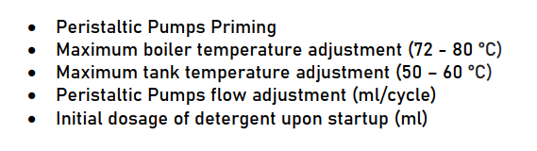

Once everything is adjusted we press the On/Off and the machine saves the settings and goes Off.

**PROCESS**

**HAPPENS ONLY ONCE AFTER START UP.**

1. First Start (Commissioning) –
   * We push the on/Off button and its backlit goes on. Then we push the START button which will flash on and off with 1 sec Interval and
   * The solenoid valve (which is normally closed) opens and water starts filling the machine until the top water level probe signals that the tank is full. There is also the lower water level probe which is used for other operations described later. The process starts if only the door is closed. If the door opens while running the machine will pause and continue after the door is closed again with a delay of 5 sec.
   * the display will show: FILLING until the following process completes
   * Once the above is complete, the machine will show GETTING READY, then simultaneously: The 2 heating elements go ON (one 1N in the Tank and one 3N in the boiler), the peristaltic pump for the detergent begins working for 50ml which is the initial startup dosage setting. (The time that the pump will work depends on the type of it). The whole second step applies even if the door is open
   * Once the temperature probe of the tank signals that it have reached 35 °C and the boiler’s 70 °C the machine will show READY and the START’s button backlit will light up still. From now on the tank’s heating element should keep the tank’s  
     temperature above 45 °C.
   * The machine display will show the programs’ icons which can be selected using the arrows and the SET button. If none is selected and the user pushes START, the machine will select the NORMAL program automatically. In idling the machine show the 2 temperatures and the READY message and the icon of a thermometer will show if the machine’s heating elements are working.

**THIS WILL BE WHERE THE LOOP REPEATS (**

1. DISPLAY OPTIONS FOR SELECTION BY THE USER –

This includes options such as:

* NORMAL 120 sec. Without drain pump – check the SF 50x50 DOC FOR THE PROCESS HERE IN such as: washing, add water for rinsing, add detergent, rinsing, .(ensure that the temperature levels are met before washing and rinsing).

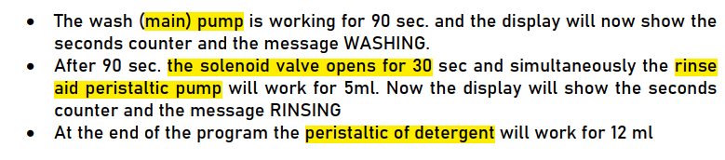

Note: if the temperatures are in the required range this options will be shown for 120 sec and if no option is selected the :screen will switch to show READY. While awaiting/listening for a press.

* Intensive 180 sec. Without drain pump – change the cleaning time
* Intensive 180 sec. Without drain pump.
* Utensils and Cookware 300 sec. Without drain pump
* Sensitive Glassware 200 sec. Without drain pump. – this is a special process with slightly different parameter and will require changing the tank temperature to 60 deg. While tank temp is rising, the display will show blinking icon in thermometer on the screen.

Its sequence is as follows:

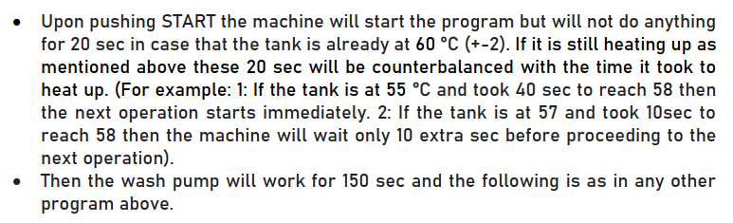

**NOTE:** During all programs the display should always display a reverse time counter so that the user know at all times how long will the program take to complete

**CONSIDERATION (optional in the requirements) –** We can add a drain pump to the system where: There is a drain function, once it is called, it checks the water level and if okay, it starts the drain pump. It then checks the 3rd extra level sensor (drain sensor). If the sensor reads low then it turns off the pump and re-initiates filling of the tank accordingly with fresh water and heating it to the required temperatures.

This happens after washing and before rinsing.

* SANITIZE DISHWASHER -this is the last option which will contain the process as mentioned in the doc and a sleeping function after such that all the processes are turned of after snitization.

**FUNCTIONS**

1. the on/off button wakes up the MCU. There will be a **wake up function** call that **set a flag** called **wakeup.** The flag will be checked in the main loop. If present then the commissioning process will start by calling the **commissioning function**. (process number 1).

Once done, the wake up flag will be reset back to zero and thus the commissioning will not be repeated in the loop.

1. After commissioning, call the **main_process function** in a loop. This is process number 2. Which will show the various options and check if the temperature are okay. It will also show ready on the screen according to the 120sec limit specified.

Structure of the **main process function** will be as follow (might change as we proceed) –

* + displays the various options.
  + If a certain option is selected then, it calls the function of the option which runs the cycle as specified within it. The function once done (because it is a linear process from start to end), it returns to the main loop via return 0. So, the option functions (name should be similar as those underlined above for easy monitoring of code flow), will be a Void function returning nothing. This will make sure that once the process is done, the main loop(void loop) takes over thus going back to displaying options menu once more.
  + Read various sensor inputs and update the icons and messages on the screen.
  + The special sanitization function will be a void function as well but it will perform all the necessary operations as described in the doc and then call the sleep_sequence function described below.

**Interrupt to listen to the set button** – once the set button is pressed, a function call to **set_parameters function** will be called. This is where the max and min temperatures will be set accordingly and saved

sleep_sequence function – this function will be called after the sanitization sequence or after pressing the on/off button once more. Thus it will also be called in the main loop after checking if there is an off flag present.

* The function does this: check if there is data that needs saving if so, call the **save_config_data function.**  This saves the components of the data that is set above in the set_parameters function.
* By default, this process will stop any active actuator by writing them low and turning them off. And halt any ongoing process. (This can be abstracted by writing a halt_function that handles turning off of all actuators and calling it here).
* Set the necessary interrupt pin for the wake up and call the go to sleep function helped by Arduino_low_power library.

- once the Arduino wakes up, it goes through the wakeup function, then the setup function.

- The setup function contains all the necessary pin assignment, retrieving configuration data from the flash/eeprom and saving number of on/off cycle to the non-volatile memory.

Use of flags to change between different processes (stored in different functions) is recommended or any other suitable method.