**Power BI Internship Project - Week 1 Assignment**

**Introduction**In this assignment, I worked on connecting to a CSV file, loading the data into Power BI, and performing basic data transformation tasks, including removing unnecessary columns and handling null values. Below is a detailed walkthrough of the steps I performed, along with screenshots to illustrate the process.

**Step 1: Connecting to the CSV File**

The first step involved connecting to the CSV file containing the data. I used the "Get Data" option in Power BI and selected the CSV file from my local machine. After selecting the file, I reviewed the data preview to ensure the correct file was loaded.

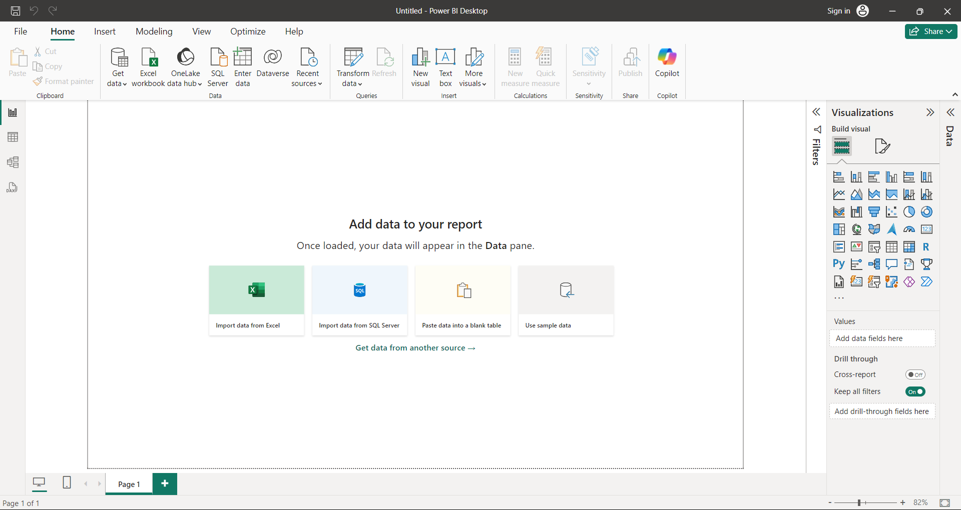

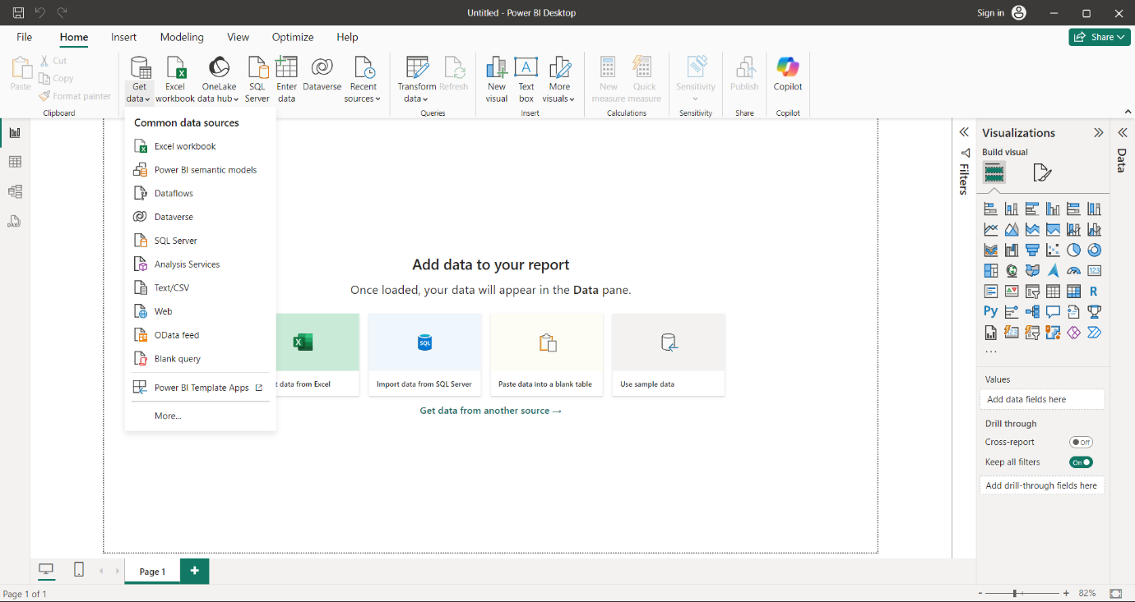

**Step 2: Loading the Data into Power BI**

Once the data source was selected, I loaded the data into Power BI. This step ensured that the data was available for transformation and visualization in the subsequent steps.

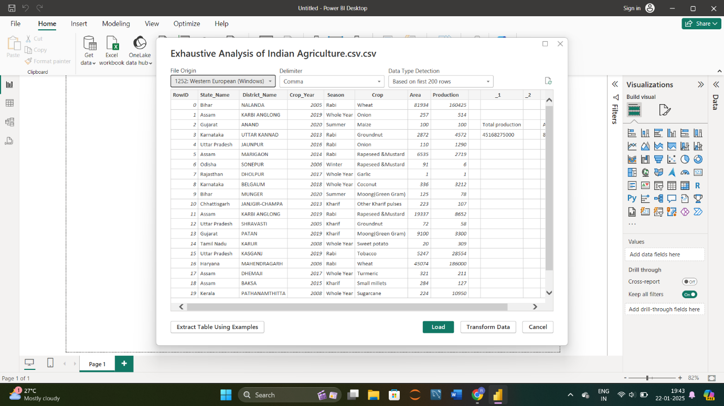

**Step 3: Transforming the Data - Removing Unnecessary Columns**

In this step, I used the Power Query Editor to clean the data. I identified and removed unnecessary columns that were not required for the analysis. This step helped reduce clutter and improve the dataset's relevance

**Step 4: Checking for Null Values**

To ensure data quality, I checked for null values by enabling the **Column Quality** feature in Power BI. This feature provided a quick overview of the data, showing the percentage of valid, error, and empty (null) values in each column. Based on this information, I identified columns with null values and decided whether to remove or handle them appropriately.

**Step 5: Saving and Finalizing the Data**

After completing the data transformation, I saved my work and exited the Power Query Editor. The clean and structured data was now ready for analysis and visualization in Power BI.

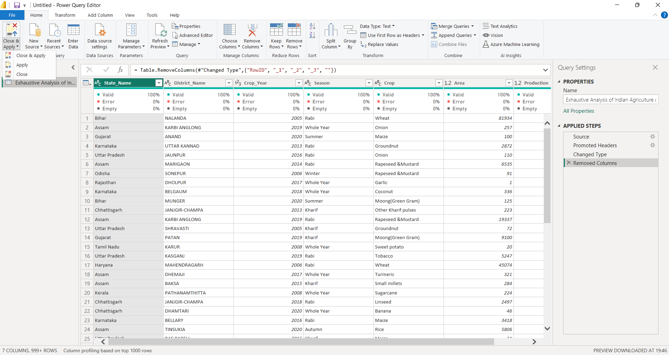

**Conclusion**

In this assignment, I demonstrated how to connect to a CSV file, load data into Power BI, and perform essential data transformations. These foundational steps are critical for preparing data for further analysis and visualization.