**GenAI CA2 assignment**

Name: Shriniwas Mahajan

PRN: 21070521076

Batch: 2021-2025

Semester: 7

Q4

Output:

1. Case1: All 6 months, positive balance

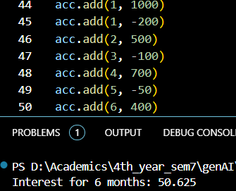

1. Case2: All 6 months, positive balance, try to withdraw with no balance

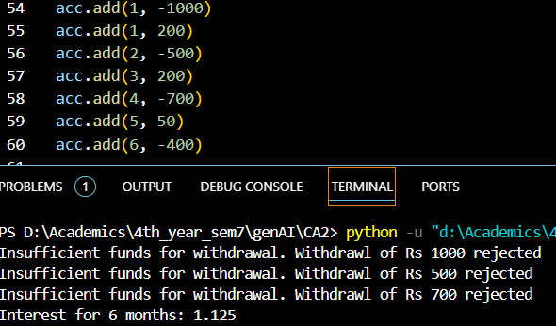

1. Case3: All 6 months, negative balance

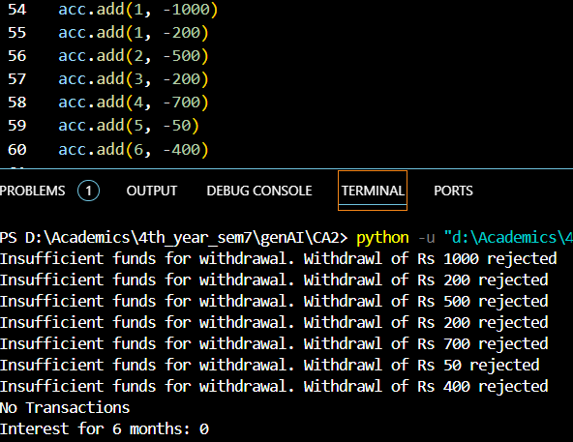

1. Case4: Some months

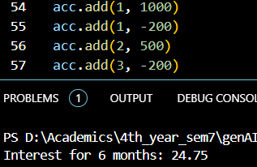

1. Case6: month not between 6 months

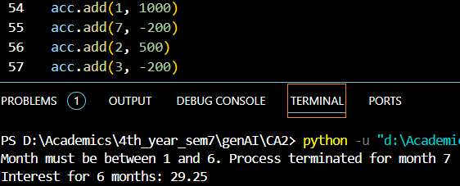

1. Extra

Q5

Output:

1. Sort by cold

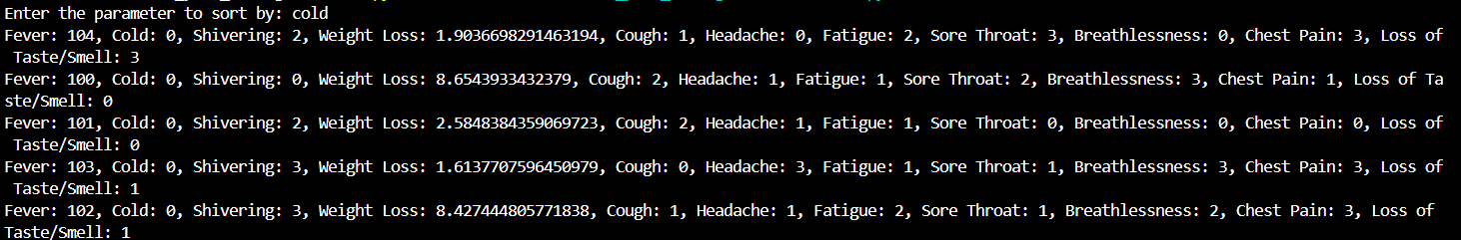

1. Sort by cough

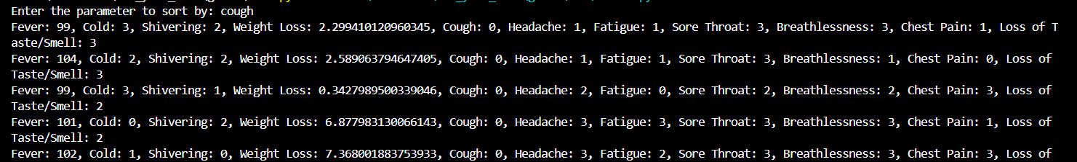

1. Sort by loss_of_taste_smell

