Raphael J. Sandor

IT325

Professor Tian

2/11/2018

Storyboard:

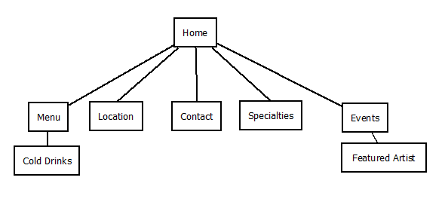

Home page:

The home page will contain some information about the coffee shop such as hours of operation. It will have some highlights of the month on the side of website. Links to Facebook and yelp.

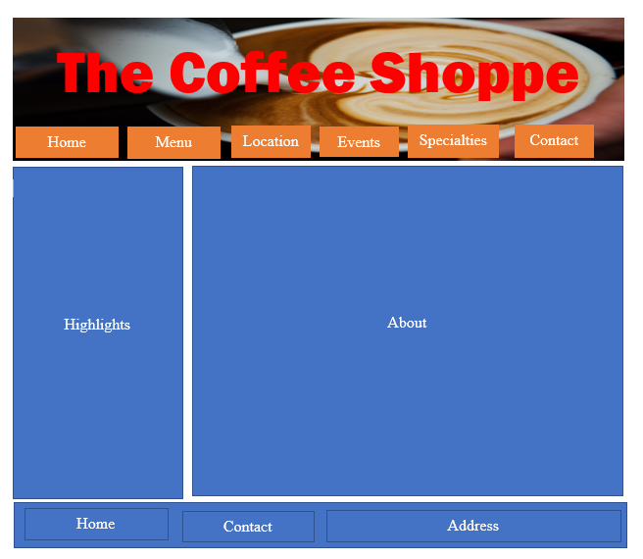

Menu:

The menu will have coffee beverages and any snacks that are for sale at the coffee shop. It will have links to cold drinks.

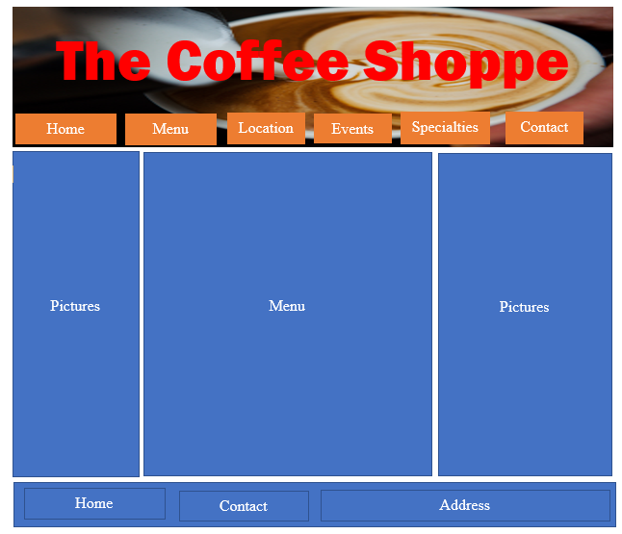

Cold Drinks:

This page is reserved for cold beverages served at the coffee shop. It is a separate page from the menu allowing the user to see a well-organized list of drinks.

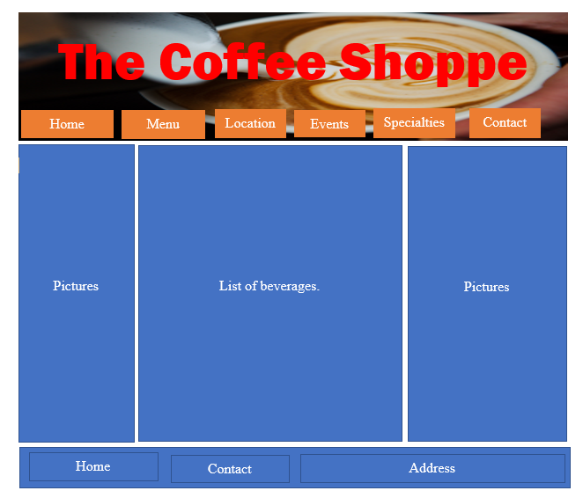

Location:

The location will have the address of the coffee shop and pictures taken from the street. A picture of its location on a map.

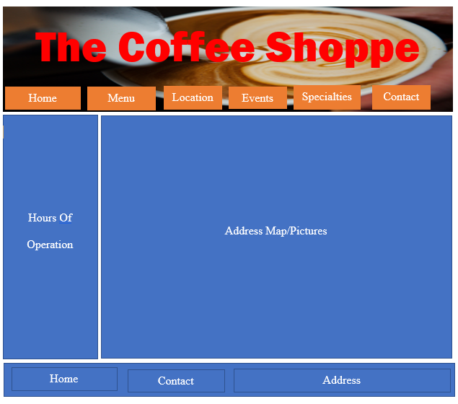

Hours of Operation

Contact:

This page contains contact information such email addresses, phone numbers, Facebook link.

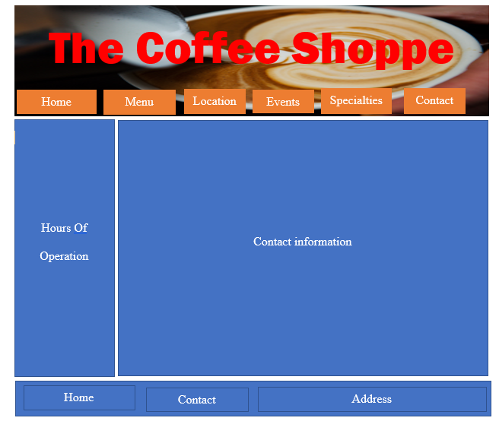

Hours of Operation

Specialties:

Specialties that the coffee shop offers such as fresh coffee beans, and flavored ice as well as new items.

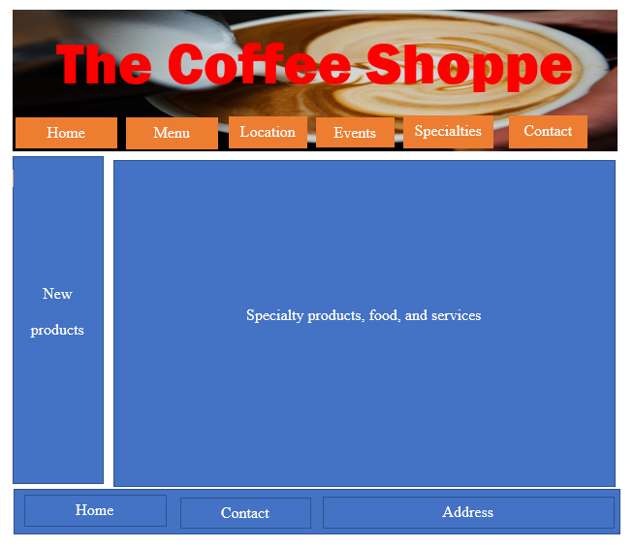

Events:

List of events that are taking place at the coffee shop.

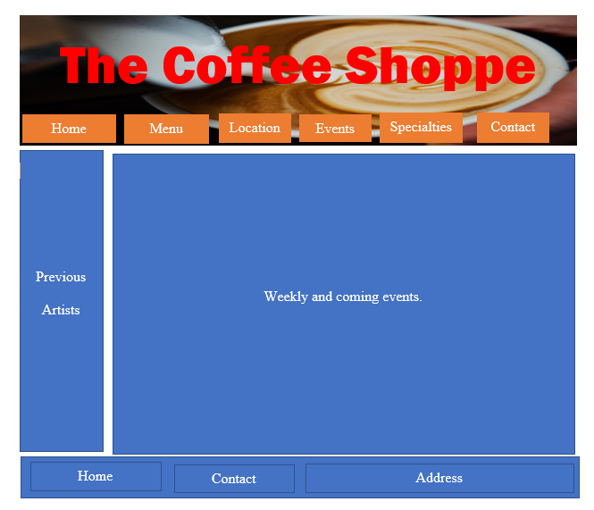

Artists:

The coffee shop has art displayed in the shop and changes artists periodically. Current, and previous artist’s work, and website links will be placed on this page.

