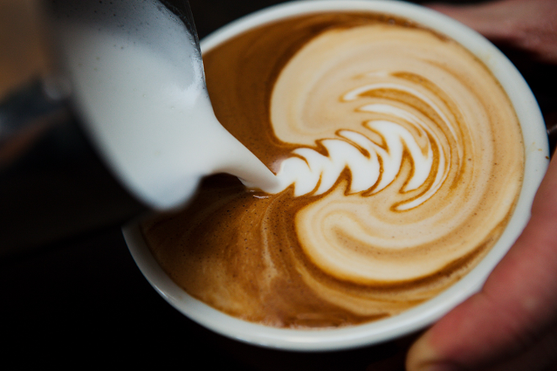

Address Map/Pictures

Hours Of Operation

Contact

Specialties

The Coffee Shoppe

Events

Location

Menu

Home

Address

Contact

Home