**DC ENERGY METER**

An Internship Work submitted to

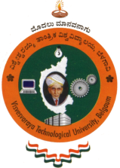

**VISVESVARAYA TECHNOLOGICAL UNIVERSITY**

in partial fulfilment of the requirements

for the award of degree of

**Bachelor of Engineering**

**in**

**Electronics and Communication Engineering**

**Submitted by**

**SHREYAS B R**

**1KG16EC091**

**For**

**Internship Carried out**

**At**

**ATEL DEVICES AND SYSTEMS**

**#29, Bharatha Ratna Sir M Vishweshwariah Industrial Area, Alahalli, Anjanapura Post, Bengaluru India, 560062**

|  |  |
| --- | --- |
| **Internal Guide**  **Mrs. Kripa K B**  **Assistant. Prof, Dept. of ECE**  **K S School of Engineering and Management** | **External Guide**  **Mr. Raghavendra Rao**  **Manager**  **Atel Devices and System** |



Department of Electronics and Communication Engineering

K.S. School of Engineering and Management

No. 15, Mallasandra, off Kanakapura Road, Bengaluru-560109

**2019-20**



**K.S. SCHOOL OF ENGINEERING AND MANAGEMENT**

**DEPARTMENT OF ELECTRONICS AND COMMUNICATION ENGINEERING**

**CERTIFICATE**

This is to certify that the internship work **DC ENERGY METER** is a Bonafede work carried out by **SHREYAS B R 1KG16EC091** in partial fulfilment for the award of **Bachelor of Engineering** in **Electronics and Communication Engineering** of **Visvesvaraya Technological University, Belagavi,** during the year 2019-20. It is certified that all the suggestions indicated during internal assessment have been incorporated in the report and this report satisfies the academic requirement with respect to **Internship (15EC84)** prescribed for the degree.

|  |  |  |  |
| --- | --- | --- | --- |
| **Internal Guide** | **External Guide** | **Head of the Department** | **Principal** |
|  |  |  |  |
| **Mrs. Kripa K B**  **Assistant.** Professor  Dept. of ECE | Mr.RaghavendraRao  Manager  Atel Devices and System | **Dr. Girish V Attimarad**  Professor& Head,  Dept. of ECE,  KSSEM, Bangalore. | **Dr.K. Rama Narasimha**  KSSEM, Bangalore. |

**Examiners**

_____________________________ ____________________________

Name and Signature of Examiner-1 Name and Signature of Examiner-2

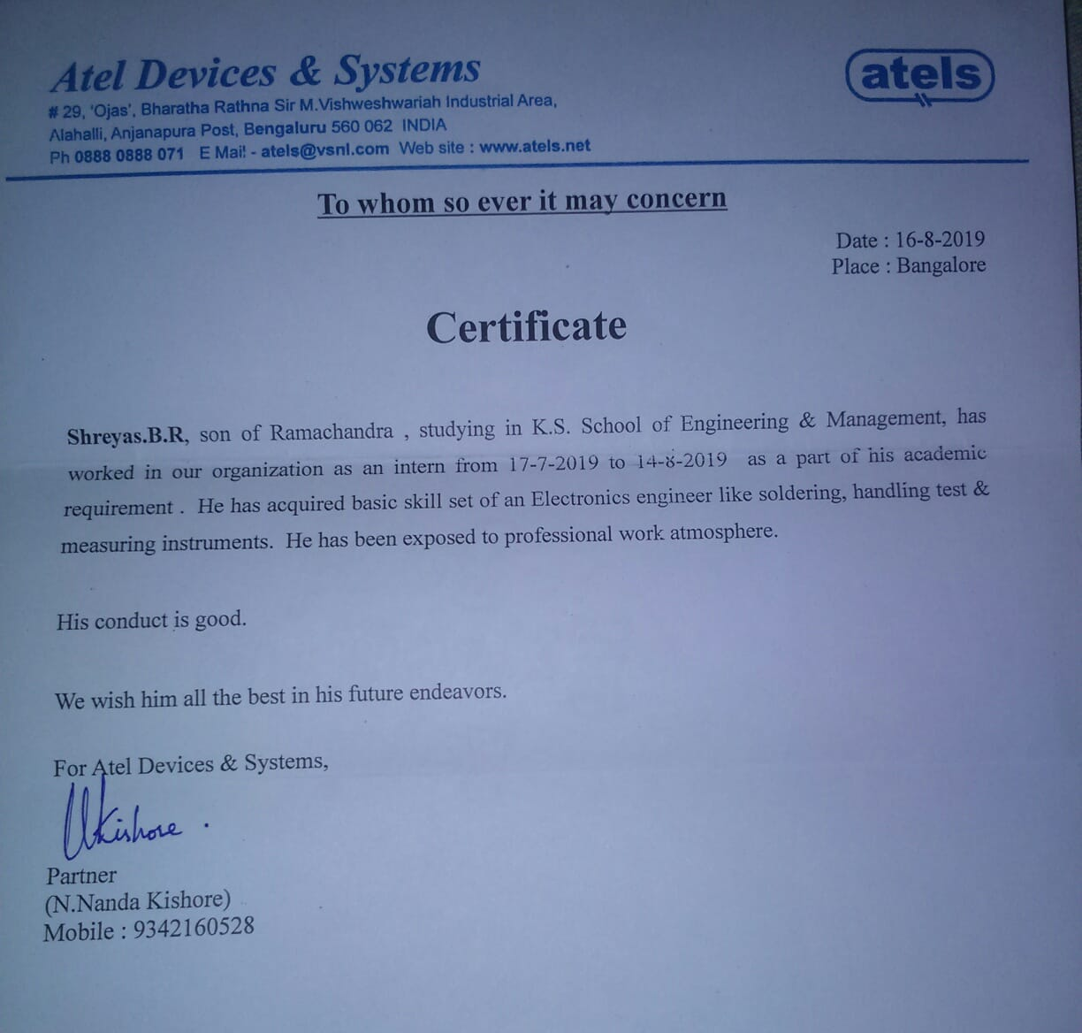



**K.S. SCHOOL OF ENGINEERING AND MANAGEMENT**

**DEPARTMENT OF ELECTRONICS AND COMMUNICATION ENGINEERING**

**DECLARATION**

I **SHREYAS B R 1KG16EC091,** the students of **BE VII Semester (Electronics and Communication Engineering)** declare that the internship report entitled **“DC ENERGY METER”** is carried out by me at **Atel devices and system** as a partial fulfilment of academic requirement of degree under **Visvesvaraya Technological University.** The content in the report are original and are free from plagiarism and other academic dishonesty and are not submitted to any other University either partially or wholly for the award of any other degree.

**SHREYAS B R**

**1KG16EC091**

Date:

Place: Bengaluru

# ACKNOWLEDGEMENT

The successful completion of this internship was made possible with the help of guidance received from our faculty members. We would like to avail this opportunity to express our sincere thanks and gratitude to all of them.

We express our profound gratitude to **Raghavendra Rao Manager of Atel devices and systems, #29, Bharatha Ratna Sir M Vishweshwariah Industrial Area, Alahalli, Anjanapura Post, Bengaluru**  for his/her keen interest and encouragement in the internship whose guidance made the internship into reality.

We are grateful to our management for providing the necessary infrastructure and an ambience environment to work. We express our profound gratitude to **Dr. K Rama Narasimha, Principal and Dr. Girish V Attimarad, Professor & Head of the Department, KSSEM, Bengaluru** for providing the necessary infrastructure and an ambience environment to work.

We are grateful to my guide **Mrs. Kripa K B Assistant Professor, Department of Electronics and Communication Engineering, KSSEM, Bengaluru** for her valuable suggestions and advice throughout our work period.

We would also like to thank all the staff members of Department of Computer Science and Engineering for their support and encouragement. Finally, we would like to thank all of our friends without whose help and encouragement this project would have been impossible.

Definitely most, we want to thank our family. Words cannot express our thanks to our family members for all their love and encouragement.

**SHREYAS B R**

**1KG16EC091**

# ABSTRACT

The developments in the day to day life have led to smartness in everything, including technology. DC energy meter are those devices which are controlled by receiving the signals either directly by the user or by another device. One such smart device is the Smart dc Energy Meter which provides the electricity consumption measurements and time-of-use information to the utilities and consumers. The requirements for these smart devices are also complex and increase in complexity day by day. the components required for the development of the DC energy meter are normal components like rectifier, transformer, resistors, TRAIC, voltage regulators. It displays the voltage, current, power, energy, time and date in the dc energy meter. The conventional electric meter uses a mechanical metering device, which records the user's power consumption by a mechanical counter, and is mostly installed outdoors, is relatively stable during use, and the recorded data is not easily lost. The traditional meter function is relatively simple, and often only has the function of metering and display, that is, it realizes stable and accurate measurement of the user's power consumption and display. A DC electric energy meter includes at least a detection module for sampling voltage and current, acquiring a voltage signal and a current signal, and converting the detection signal into a processing module, and processing a module for calculating the electric energy parameter according to the detection signal And storing in the storage module; the storage module is configured to store the calculated power parameter; the interaction module is configured to be connected to the processing module, and obtain and display the calculated power parameter.

# 

# TABLE OF CONTENTS

|  |  |  |
| --- | --- | --- |
|  | Acknowledgement | i |
|  | Abstract | ii |
|  | Table of Contents | iii |
|  | List of Figures | iv |
| **Chapter 1** | **Company profile** | 09 |
| 1.1 | Introduction | 09 |
| **Chapter 2** | **Designing of DC energy meter** | **10** |
| 2.1 | Introduction to DC energy meter | 10 |
| **Chapter 3** | **Work assigned** | **12** |
| 3.1 | Objectives | 12 |
| **Chapter 4** | **Work completed** | **13** |
| 4.1 | Components | 13 |
| 4.1.1 | Channel Display | 13 |
| 4.1.2 | DC Regulated Power Supply | 13 |
| 4.1.3 | RS-485 Serial Port | 14 |
| 4.1.4 | Digital Multi Meter | 15 |
| 4.2 | Execution | **16** |
| 4.2.1 | Hardware Test of MOD 2233 DCEM | 16 |
| 4.2.2 | Calibration Process | 17 |
| 4.2.3 | Burn-In | 18 |
| 4.2.4 | Final Test | 18 |
| **Chapter 5** | **Conclusion** | 19 |

# 

# LIST OF FIGURES

|  |  |  |
| --- | --- | --- |
| 2.1.1 | DC Energy meter | 10 |
| 4.1.1.1 | Channel Display | 13 |
| 4.1.1.2 | PCB Channel Display | 13 |
| 4.1.2.1 | DC Regulated Power Supply | 13 |
| 4.1.3.1 | RS-485 Serial Port | 14 |
| 4.1.4.1 | Digital Multi Meter | 15 |
| 4.2.1.1 | Dumping Software to Meter | 16 |
| 4.2.1.2 | PCB Board Sketch of DC Energy Meter | 17 |
| 4.2.2.1 | Output of DCEM | 18 |

# Chapter 1

# COMPANY PROFILE

## Introduction

ATEL DEVICES & SYSTEMS was established with an objective to bring in high-end engineering technology to the industrial sector at a time when the world is fast embracing it. The unit promoted in 1991 by Engineering professionals, Late N. Nagaraj Rao, N. Guru prasad and    N. Nanda Kishore has been to the forefront of its objective. Late N. Nagaraj Rao super annulated from Design Bureau, HAL, Bangalore as Manager. He Primarily worked on the Radar and Aeronautic Instrumentation during his Service at HAL, Scanning from 'Dakota' to 'Jaguar'. N. Guru Prasad served in Hi-Tech Electronic Industries for over Seven years in various capacities.



He worked on Electronic application Engineering with Master Professionals and   
N. Nanda Kishore came out of IISc, Bangalore after working with giants in Electronic Communication Engineering on Fibre optic GYRO for DRDO, Optical pressure sensors, etc. ATEL DEVICES & SYSTEMS is located at Bangalore, India, with about 8000 Square feet of Green space for production of Electronic Equipment’s. It houses a PCB assembly area, Product Assembly area, Product Calibration & Testing Area, Design & Development and Office.  ATEL DEVICES & SYSTEMS is located at Bangalore, India, with about 8000 Sq feet of Green space for production of Electronic Equipment’s. It houses a PCB assembly area, Product Assembly area, Product Calibration & Testing Area, Design & Development and Office.

# 

# Chapter 2

# DESIGNING OF DC ENERGY METER

## Introduction to DC energy meter

The Redcliffe Energy DCEM come handy with multiple benefits which makes the DC energy management a fulfilled and easy task. The class 1 accuracy metrology gives the accurate readings and inbuilt GPRS communication facilities the data at your NOC/TOC on real-time. This is not just a measurement meter but a manager by itself.

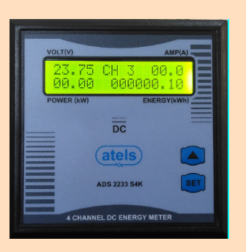

**Fig 2.1.1 DC Energy meter**

**Features of DCEM**

* Channel Integrated DC Energy Meter.
* User Selectable Current Input 50A-250A (optional 2500A).
* User Selectable Shunt mV Input (5mV-99mV).
* Wide Input Voltage 18-65V.
* Displays DC Voltage, Current, Power & Energy.
* 0.5% Accuracy on basic Parameters.
* 16X2 backlit Alphanumeric LCD Display.
* RS 485 Port for External communication.
* Built-in Data Logger with Time-Stamp.
* Sleek 96 X 96 X 23mm FR Enclosure.
* Easy installation and simple wiring.
* User configurable and editable password.
* Compact size and weight.
* Din Rail mounting
* Cleared parameters through key press
* Energy resetting at 99999999k x PT x CT Auto scaling and Auto scrolling
* Bi directional current measurement to study charging and discharging circuits
* Optional programmable relay output with tripping time up to 180sec.
* Current full scale programmable independently
* Data logging - Offers logs of parameters such as Energy, Load hours and Ampere hours both Import and Export (12am Snap shot for 45 days) – Optional.

# 

# Chapter 3

# WORK ASSIGNED

## Objectives

* DC 2233 is a Microcontroller based Integrated Digital Meter to measure Multiple parameters on DC power Management applications. The general range available is 48V DC & 100A DC.
* 4 input voltage channels will be connected to the DC energy meter.
* RS-485 serial port is connected to system in order to read the DC energy meter value to the system or software.
* Measures & Display DC Volt, DC Current, DC Energy, DC power, date and time of each channel.
* In case of hardware testing the output voltage, input voltage of the meter is checked. isolated voltage and the voltage of each channel is also verified.
* By calibration the values like power current energy voltage are verified are verified.

# 

# Chapter 4

# WORK COMPLETED

**4.1 COMPONENTS**

4.1.1 Channel display

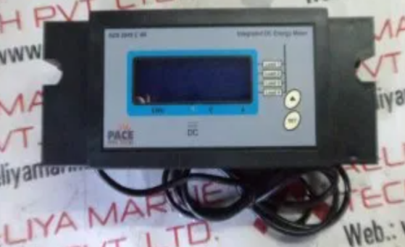 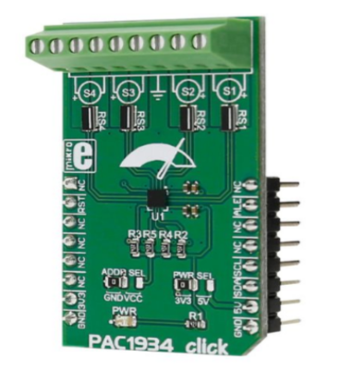

**Fig 4.1.1.1 Channel display**  **Fig 4.1.1.2 PCB Channel Display**

* It’s a 16x2 display.
* Voltage , Current , power and Energy are displayed in the channel.
* Four channels are used for the DC energy meter.

4.1.2 DC Regulated power supply

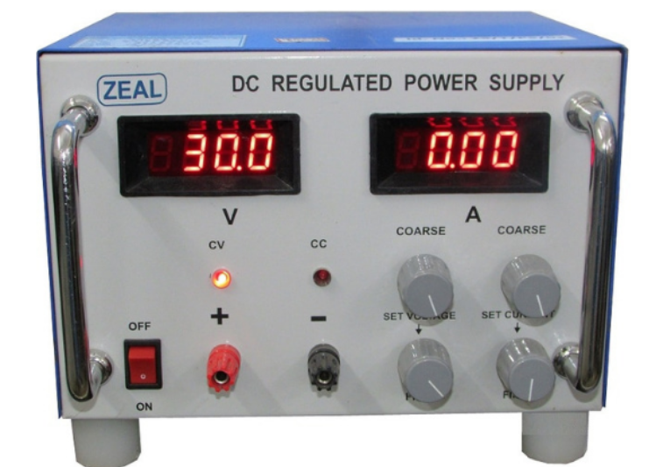

**Fig 4.1.2.1 DC regulated power supply**

Bidirectional DC power supplies offer two-quadrant operation with positive current/positive voltage as well as negative current/positive voltage, enabling both DC power output and regenerative DC loading. The absorbed energy feeds back to the grid with a conversion efﬁciency up to 93% and can operate in constant voltage, constant current, and constant power modes.

**FEATURES: -**

* Voltage rating: 0~100V/600V/1200V/1800V
* Current rating: 0~540A
* Power rating: 6kW/12kW/18kW
* Two quadrant operation: Power source and regenerative load
* High power density: 18KW in 3U
* Easy master/slave parallel & series operation up to 180kW
* Wide range of voltage & current combinations in constant power
* Auto sequencing programming
* Voltage & current slew rate control
* High speed transient response <1.5ms
* Low output noise and ripple
* CV/CC priority modes
* Intuitive touch screen
* Standard USB/LAN/LXI/APG interfaces, optional CAN/GPIB interfaces
* 3 Phase 4 wire universal AC power: 200~480Vac

**4.1.3 RS-485 SERIAL PORT**

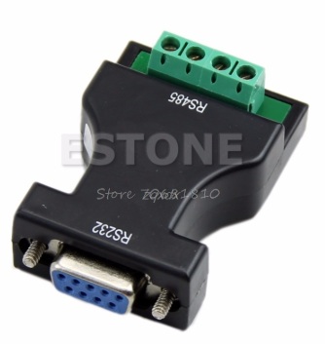

**Fig 4.1.3.1 RS-485 serial port**

RS-485, also known as TIA-485(-A) or EIA-485, is a standard defining the electrical characteristics of drivers and receivers for use in [serial communications](https://en.wikipedia.org/wiki/Serial_communication" \o "Serial communication) systems. Electrical signalling is [balanced](https://en.wikipedia.org/wiki/Balanced_line" \o "Balanced line), and [multipoint](https://en.wikipedia.org/wiki/Telecommunications_link" \l "Multipoint" \o "Telecommunications link) systems are supported. The standard is jointly published by the [Telecommunications Industry Association](https://en.wikipedia.org/wiki/Telecommunications_Industry_Association" \o "Telecommunications Industry Association) and [Electronic Industries Alliance](https://en.wikipedia.org/wiki/Electronic_Industries_Alliance" \o "Electronic Industries Alliance). Digital communications networks implementing the standard can be used effectively over long distances and in [electrically noisy environments](https://en.wikipedia.org/wiki/Electromagnetic_compatibility" \o "Electromagnetic compatibility). Multiple receivers may be connected to such a network in a linear, [multidrop bus](https://en.wikipedia.org/wiki/Multidrop_bus" \o "Multidrop bus). These characteristics make RS-485 useful in [industrial control systems](https://en.wikipedia.org/wiki/Industrial_control_system" \o "Industrial control system) and similar applications.it is used to communicate between meter and system.

**4.1.4 DIGITAL MULTI METER (DMM)**

A digital multi meter or DMM is one of the most widely used pieces of test equipment today. DMMs are available very cheaply and these digital multi meters can provide very high degrees of accuracy when measuring the parameters within an electronics or electrical circuit. As a result, DMMs are one of the most indispensable pieces of test equipment available today. Originally analogue multi meters were used, but these are only rarely used these days as digital technology has made digital multi meters cheaper, far more accurate and capable of providing many more capabilities beyond just measuring current, voltage and resistance.

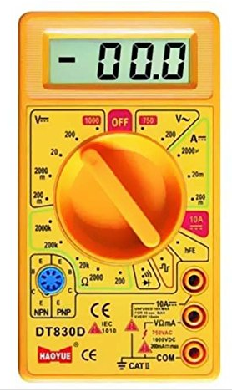

Fig 4.1.4.1 digital multi meter

**4.2 EXECUTION**

4.2.1 HARDWARE TEST OF MOD2233 DCEM

* Initially software will be dumped to the meter from Renesas flash programmer.
* 48V input is given to the meter from DC power supply.
* check the output voltage 5V with respect to J23 to ground.
* check the isolated voltage 5V with respect to J21 to ground.
* Check each channel voltage 1.25V with respect to J12, J13, J14 and J15 to ground.
* Check the average mean voltage with respect to J10 to ground.

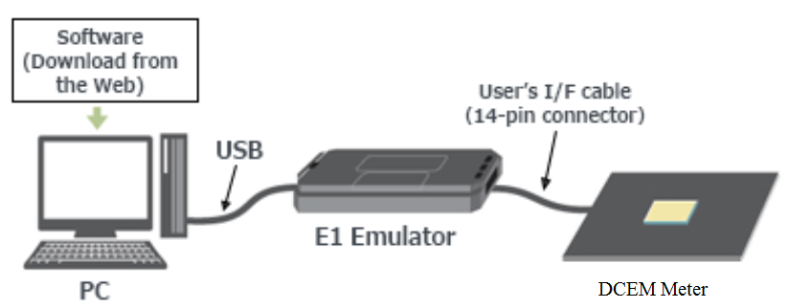

Fig 4.2.1.1 Dumping software to meter

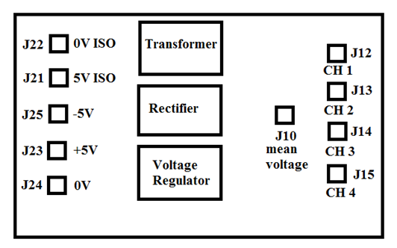

Fig 4.2.1.2 PCB board sketch of DC energy meter

4.2.2. CALIBRATION PROCESS

* RS-485 connector is used for communication between DC energy meter and system.
* 48v input is given to the meter from DC Regulated power supply.
* Initializing

🡪 DC energy meter

🡪 version 1.6

🡪 protocol 1

Then meter shows

voltage (48) CH1 amps (0.00)

power (0.00) energy (0000.00)

* Press SET switch

View log

System setting

* System settings (press SET)

Enter code: 215 (calibration code)

* It shows

48.8 [V] channel 1 96.5 [I]

04.71 [W] 000023.72[J]

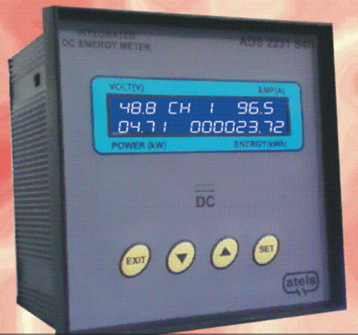

Fig 4.2.2.1 output DC energy meter

**4.2.3 BURN-IN**

It’s a process where DC energy meter will be subjected to 48V input for 2-3 hours to make sure current, voltage, power, energy, date and time are displayed.

**4.2.4 FINAL TEST**

Same calibration process will be done for the final test or it’s a verification test.

# Chapter 5

# CONCLUSION

* ATEL has been in the forefront of Embedded applications from over 20 years. This has been the core of all the products adding power & intelligence to routine measurements enabling ATEL as trendsetters at several points.
* Due to DC energy meters the communications are processing at the high rate and are used most efficiently where ever required.
* DC energy meters are safer than the AC energy meters.

Further work that could be done on the intelligent water

heater module could include the following. Wi-Fi access

to the unit could be provided using a USB dongle instead

of using a router. This will make the unit more cost

effective and reduce the footprint of the unit. Additionally,

data logging could be implemented in order to provide the

user with monthly or even yearly totals for power usag

The work in the paper presented the design of a smart water

geyser system. The goal of implementing our smart geyser

system is to optimize the use of electricity, hence energy

consumption and calculate the heating time for each user. So,

it is providing a low cost alternative to existing solutions. But,

one of the major drawbacks include not optimizing the water

usage. Implementing a design that can reduce the water usage

can have a huge impact and make the system more desirable

to customers.