Software Structure
The client side software contains of javascript files which are executed when the corresponding page opens. Each page has one javascript file.
The server side software is split into several files. The figure below shows the server side file hirarchy.

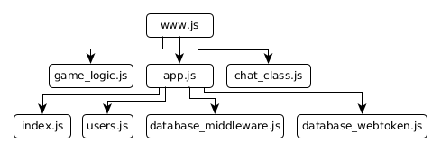Abbildung 1: Server Side Software Hirarchy
www.js
In this file the server itself which can be run is defined.
… [websocket description]

app.js
Here an express app is defined whch can be used tu run an http server.
… [websocket description]

chat_class.js
Contains a helper class for the chat communication. The clients who take place in the current game are put into a room [sockei.io] so it is possible to send messages to only that clients. So messages are not sent to unauthorised websockets.

game_logic.js
Here a class to represent the game is defined. It includes the game logic and manages the players positions, the scores and the items to be collected.

index.js
… [websocket description]

users.js
… [websocket description]

database_middleware.js
Helper for database usage.

database_webtoken.js
Helper for use of webtoken.

Communication
The communication of this application uses ajax requests for login, signum and getting the username.
The game communication and retrieving the total scoreboard from the server is done with websockets [sockie.io].
In the following the comminucation flow of the game itself is shown.
