**ClimateReady**

(A Mobile App for Climate-Related Emergency Preparedness)



**SE3080 – Software Project Management**

**Group - Y3S2-WE-09**

|  |  |
| --- | --- |
| **Member** | **IT Number** |
| W.A.N.I PERERA | IT22061348 |
| PREMATHILAKA G.G.R.T | IT22079628 |
| CASSIM T S | IT22217318 |
| FARTHAS A L M | IT22190734 |

**1. Project Selection and Justification**

**Selected Project**

**ClimateReady: A Mobile App for Climate-Related Emergency Preparedness**

**Justification**

**Real-World Relevance**  
Disasters such as floods, storms, and heatwaves are increasing, yet many communities lack timely alerts, safe-zone guidance, and preparedness knowledge. *ClimateReady* addresses this by offering climate alerts, SOS support, preparedness checklists, and community feedback — ensuring social impact and practical value.

**Agile Suitability**  
The project can be broken into epics and user stories (alerts, SOS, toolkit, community), making it ideal for iterative Scrum-based development. Each sprint delivers a functional increment (e.g., notifications, SOS, checklist), enabling stakeholder feedback.

**Scope & Collaboration**  
The scope is feasible within **4 sprints (4 weeks)**. Work is naturally divided among frontend, backend, database, and testing, allowing all members to contribute while rotating Scrum roles (PO, SM, Dev).

**Demo-Ready & Technology**  
Every sprint produces demo-ready outputs (alerts → SOS → toolkit → community). The tech stack — React Native, Node.js/Express, Firebase, and MongoDB — supports rapid, flexible, and incremental delivery.

**Compliance with Guidelines**

|  |  |
| --- | --- |
| **Guideline** | **How ClimateReady Meets It** |
| Real-world relevance | Tackles urgent disaster preparedness challenges. |
| Agile suitability | Features split into epics/user stories, delivered in sprints. |
| Scope manageability | Fits into 4 sprints, 4 weeks. |
| Team collaboration | Clear division of frontend, backend, DB, QA tasks. |
| Demo increments | Each sprint produces working features. |
| Tech flexibility | Uses modern, agile-friendly stack. |

**2. Project Charter (Product Vision)**

**Project Vision**

“To empower communities with a mobile solution that delivers timely climate alerts, safe-zone guidance, preparedness education, and community-driven support during emergencies.”

**Scope & Objectives**

* Provide **real-time disaster alerts** with severity levels.
* Enable **emergency SOS** with live location sharing.
* Offer a **preparedness toolkit** (checklists, scores, quizzes).
* Support **community feedback** through posts and comments.
* Ensure **multilingual and accessible** design (Sinhala/Tamil, voice).

**Stakeholders & Roles**

|  |  |
| --- | --- |
| **Stakeholder** | **Role / Interest** |
| End users (community) | Receive alerts, use SOS & toolkit |
| Emergency authorities | Provide verified alerts, safe zone data |
| Development team | Build and deliver product increments |
| Product Owner | Define backlog, prioritize features |
| Scrum Master | Facilitate Scrum process |
| Development Team members | Implement, test, and demo increments |

**Constraints**

* Development time limited to **4 sprints (~4 weeks)**.
* Mobile-first scope (React Native cross-platform).
* Dependent on reliable APIs (weather/climate data, maps).
* Limited resources — cloud storage & push notifications via Firebase.

**3. Initial Product Backlog**

|  |  |  |  |
| --- | --- | --- | --- |
| **Epic** | **User Story** | **Priority** | **Story Points** |
| **Real-time Climate Alerts** | As a user, I want to receive push notifications for floods/storms/heatwaves so I can act quickly. | High | 8 |
|  | As a user, I want to test alerts with mock notifications, so that the system can be validated during development | Low | 3 |
|  | As a user, I want alerts to be color-coded (green/yellow/red) to understand severity. | Medium | 5 |
|  | As a user, I want alerts to open into a detail screen, so I can read full information | Low | 3 |
|  | As a user, I want to set preferences (types of disasters, language) so I get only relevant alerts. | High | 8 |
|  | As a user, I want alerts in my preferred language, so that I can understand them. | Medium | 5 |
|  | As a visually impaired user, I want alerts as voice messages so I don’t miss warnings. | Medium | 5 |
| **Safe Zone Mapping & SOS** | As a user, I want a single prominent SOS button on the app so that I can immediately send my current location | High | 8 |
|  | As a user, I want SOS updates until canceled so responders can track me. | High | 8 |
|  | As a user, I want to see nearby safe zones & shelters on a map so I can go to a safe place. | High | 8 |
|  | As a user, I want to filter/search safe zones by type (hospital, shelter). | Medium | 5 |
|  | As a user, I want to add/edit emergency contacts so SOS goes to the right people. | Medium | 5 |
|  | As a user, I want to store a short safety profile (medical info, allergies, blood type) so responders have critical info. | Low | 3 |
|  | As a user, I want the app to notify me when I enter hazard zones or approach unsafe areas. | High | 8 |
|  | As a user, I want official alerts for my area so I get authoritative guidance. | Medium | 5 |
| **Preparedness Toolkit & Educational Content** | As a user, I want a disaster checklist with progress tracking. | High | 8 |
|  | As a user, I want a preparedness score (0–100) linked to my checklist. | Low | 3 |
|  | As a user, I want motivational badges/levels (Beginner, Expert). | Low | 3 |
|  | As a user, I want short localized safety tips (before/during/after disasters). | Low | 3 |
|  | As a learner, I want a quiz module to test disaster knowledge. | Medium | 5 |
|  | As a rural user, I want content in Sinhala/Tamil. | Low | 3 |
|  | As a low-vision user, I want text-to-speech for tips. | Low | 3 |
| **Community Support** | As a user, I want to create a post with text so that I can share my climate-related issue. | High | 8 |
|  | As a user, I want to attach an image to my post so that I can clearly explain my problem. | Medium | 5 |
|  | As a user, I want to add a comment under a post so that I can provide a solution or feedback. | High | 8 |
|  | As a user, I want to see posts/comments update in real-time. | Medium | 5 |
|  | As a user, I want notifications when someone comments on my post so that I can quickly check responses. | High | 8 |
|  | As a user, I want to upvote helpful comments. | Medium | 5 |
|  | As a post owner, I want to mark my post as resolved. | Low | 3 |

**4.Sprint Backlogs and Plans for Sprint 1 & 2**

**Sprint 1:**

|  |  |  |  |  |
| --- | --- | --- | --- | --- |
| **Epic** | **User Story** | **Priority** | **Story Points** | **Tasks** |
| Real-time Climate Alerts | As a user, I want to receive push notifications for floods/storms/heatwaves so I can act quickly. | High | 8 | -Integrate Firebase Cloud Messaging (FCM) with React Native app.  -Create backend API in Node.js/Express to send alerts.  -Connect frontend with backend. |
| Real-time Climate Alerts | As a user, I want alerts to be color-coded (green/yellow/red) to understand severity. | Medium | 5 | -Map severity levels from API → color codes.  -UI banner component in React Native  -Unit test to confirm correct color mapping |
| Safe Zone Mapping & SOS | As a user, I want a single prominent SOS button on the app so that I can immediately send my current location. | High | 8 | - Design SOS UI/UX.  - Implement client-side SOS handler .  - Implement backend SOS endpoint.  - Integrate push notifications and fallback SMS.  - Add telemetry/logging for delivered status and retries |
| Safe Zone Mapping & SOS | As a user, I want to see nearby safe zones & shelters on a map so I can go to a safe place. | High | 8 | - Choose & integrate mobile map SDK.  - Design map UI.  - Implement backend safe-zone store.  - Implement client geospatial query . |

**Sprint 2:**

|  |  |  |  |  |
| --- | --- | --- | --- | --- |
| **Epic** | **User Story** | **Priority** | **Story Ponits** | **Tasks** |
| Safe Zone Mapping & SOS | As a user, I want SOS updates until canceled so responders can track me. | High | 8 | - Implement background location polling .  - Implement update scheduler.  - Backend.  - UI: show “SOS active” status + Cancel button |
| Preparedness Toolkit & Educational Content | As a user, I want a disaster checklist with progress tracking. | High | 8 | - Design checklist.  - Implement tick/untick with progress bar.  - Save checklist state locally.  - Test on different screen sizes. |
| Preparedness Toolkit & Educational Content | As a user, I want a preparedness score (0–100) linked to my checklist. | Low | 3 | - Create scoring logic.  - Design score display.  - Integrate score updates with educational content/quiz.  - Unit test scoring logic. |
| Community Support | As a user, I want to create a post with text so that I can share my climate-related issue. | High | 8 | - Design post submission UI.  - Implement backend API for creating posts.  - Connect frontend with backend. |
| Community Support | As a user, I want to add a comment under a post so that I can provide a solution or feedback. | High | 8 | - Design comment input + display UI.  - Implement backend for storing comments  - Sync comments in real-time. |

**5.** **Defined Scrum Roles**

|  |  |  |
| --- | --- | --- |
| **Role** | **Member** | **Responsibilities** |
| Product Owner | Cassim | Define vision, prioritize backlog, represent stakeholders. |
| Scrum Master | Cassim (Sprint 1)  Nithika (Sprint 2)  Ruchira (Sprint 3)  Farthas (Sprint 4) | Manage sprint progress. |
| Development Team | Cassim, Nithika, Ruchira, Farthas | Build increments, test, document |

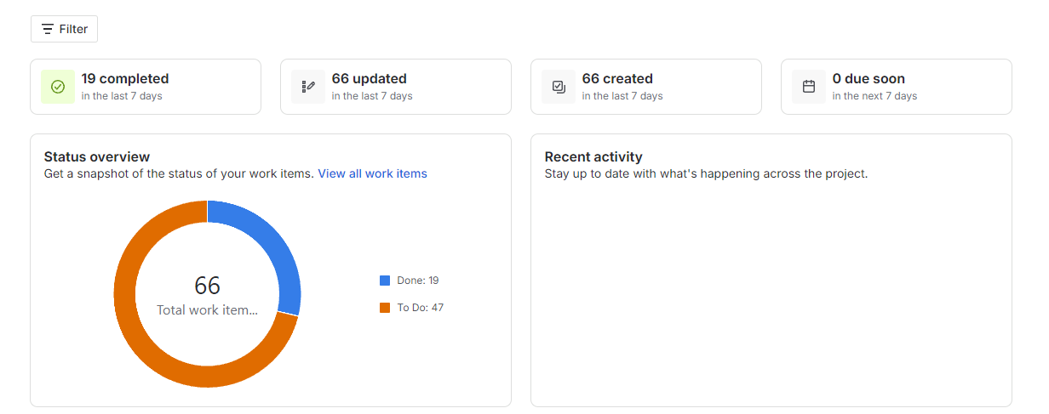**6.** **Evidence of Scrum Events**

Summary

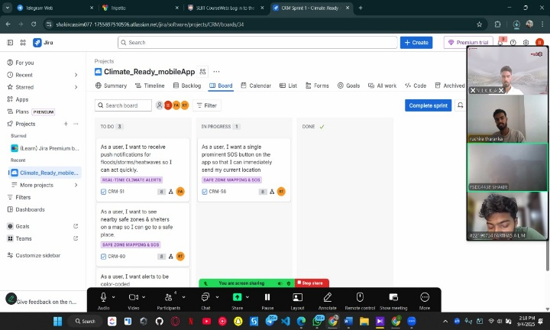

Zoom meetings

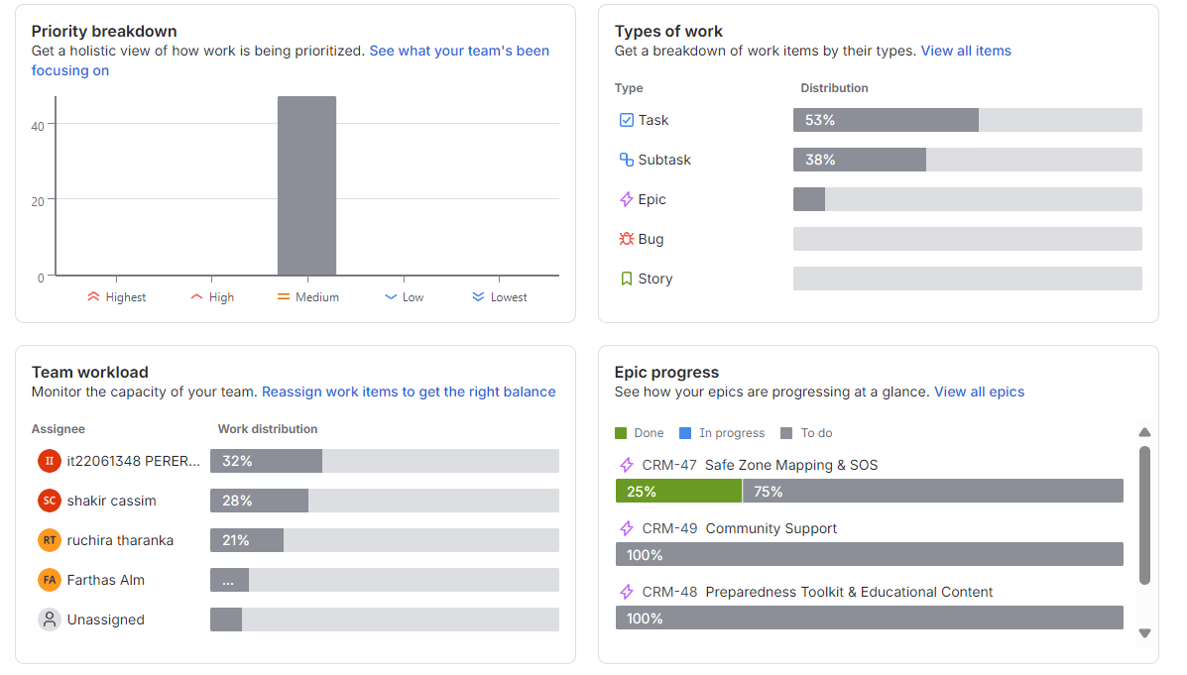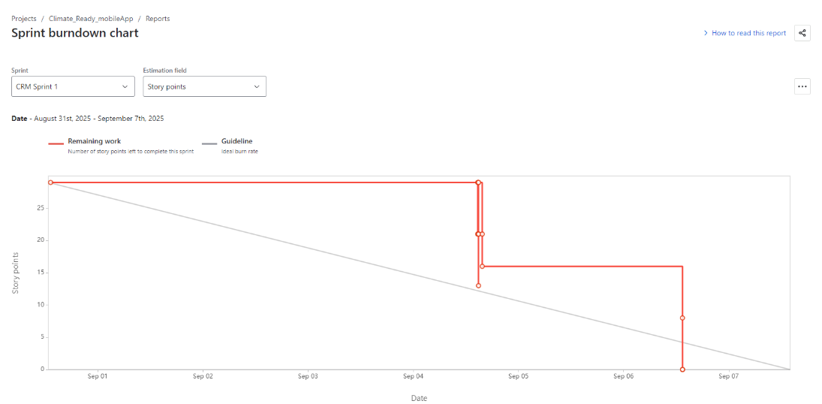

Summary

Burndown Chart