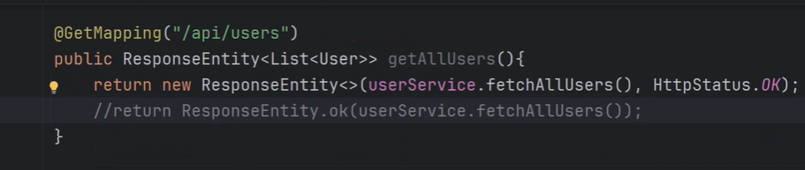
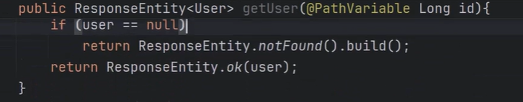
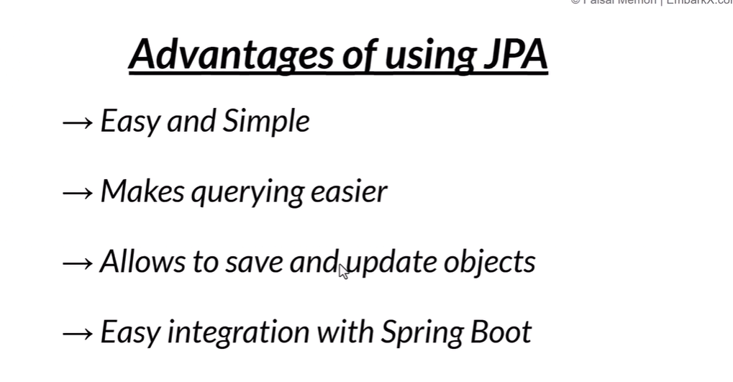
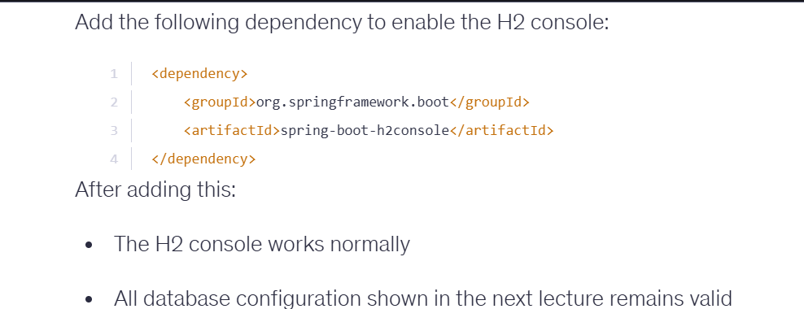
Add data-jpa, h2 db dependency
Spring.h2.console.enabled = true
Spring.datasource.url = jdbc:h2:mem:test
Spring.jpa.show-sql=true
Spring.jpa.hibernate.ddl-auto=create
Lombok data annotation
Jparepository vs crudrepository

